Thank you for your interest in becoming a vendor to the State of Louisiana. It is crucial that we avoid duplicate registrations to facilitate correct award and payment processing.

- Please go to https://lagoverpvendor.doa.louisiana.gov/irj/portal/anonymous?guest_user=self_reg and enter basic company information and click “continue”.

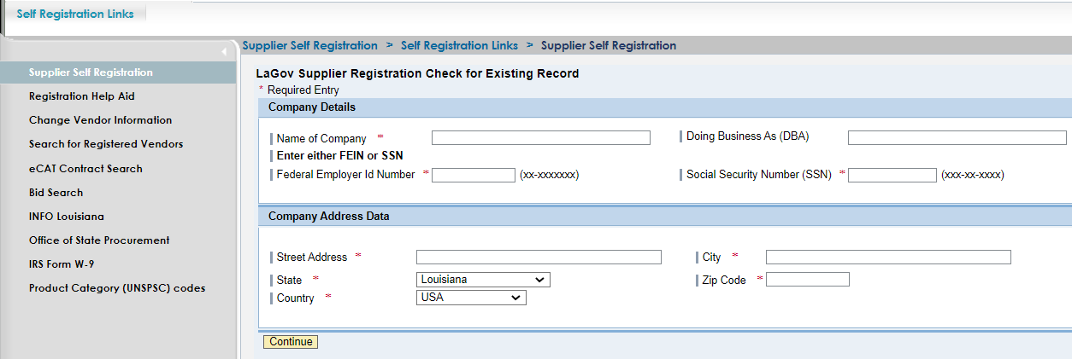

If there is no matching criterion, the full registration screen will appear to be completed. It will populate with the data already entered. Skip to step 4.

- If same or similar data exists, several companies may be displayed. If you are attempting to register on behalf of one of the companies shown, please contact the Vendor Administrator for that company. If you are listed as the Vendor Administrator, please login to your vendor record through the following link: https://lagoverpvendor.doa.louisiana.gov/irj/portal. If you have forgotten your password to your vendor record and/or require additional assistance, please call (225) 342-8010 or send an email to vendr_inq@la.gov.

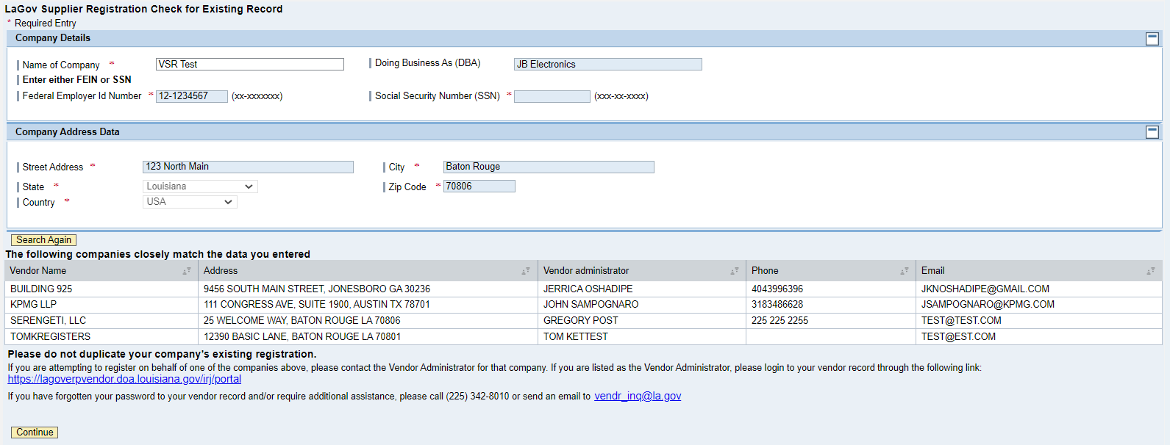

IMPORTANT, if your company simply moved, the contact person shown can change the address in the LaGov vendor portal through Supplier Administration.
If the companies shown are not your company or you need to enter another branch location, click “continue” and proceed with registration. Skip to step 4.
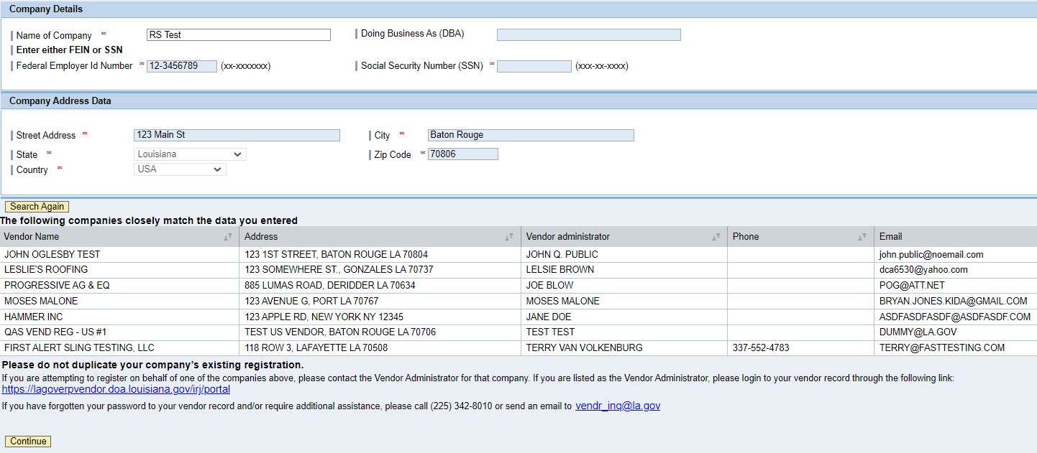

- Make any required changes to the company details by clicking the field, deleting unwanted text, and adding the updated information. NOTE: Effective 05/27/2015, the use of Building, Floor, and Suite/Room fields are no longer supported.

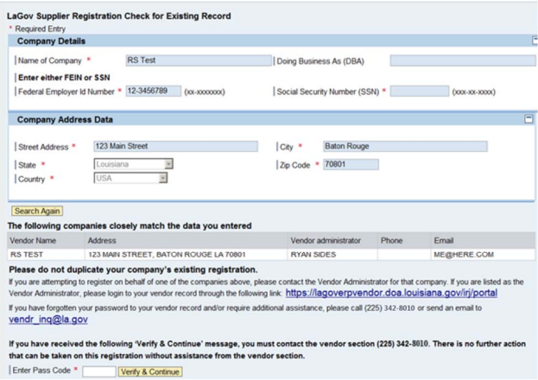
- Enter company details. All fields with asterisks (highlighted) are required.

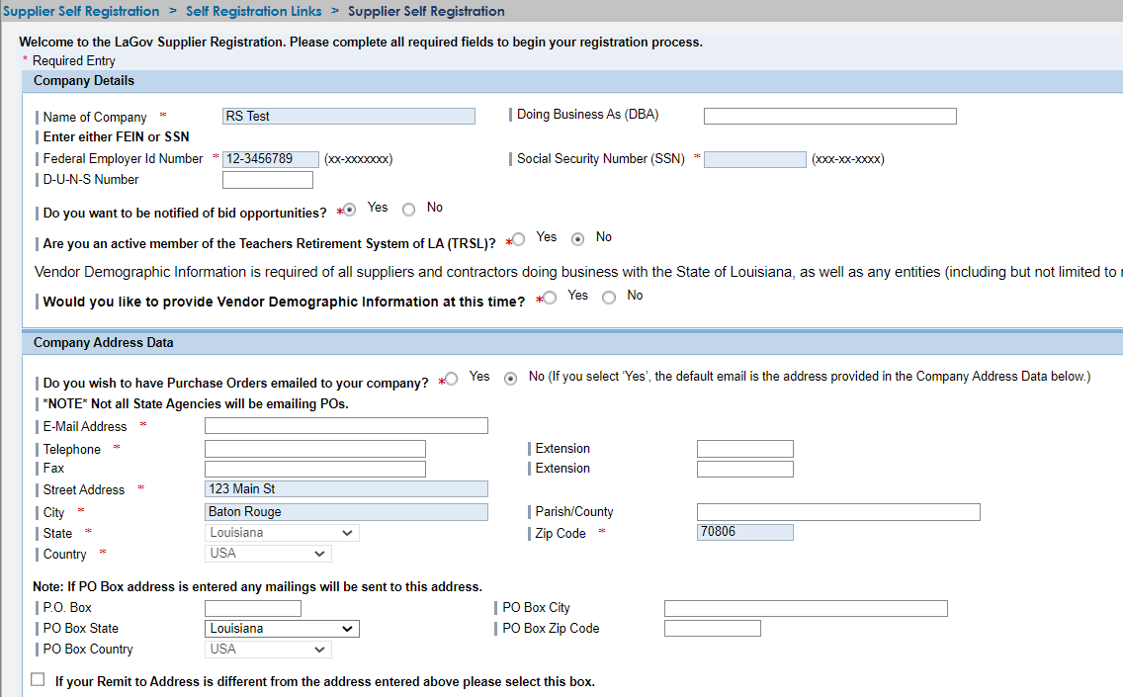

- Name of Company: Name that appears on your W-9 form.
- Doing Business As (DBA): Only complete if different than the legal name.
- Federal Employer ID Number OR Social Security Number: Hyphens required
- D-U-N-S Number: This is a five digit number issued by Dun and Bradstreet. If you do not have a DUNS number, you may leave this field blank.
- Do you want to be notified of solicitations? Click the appropriate radio button. Default is
“yes” but you may click “no”
o If you select “no”, you will not need to enter product categories later.
o If you select “yes”, the product categories will appear for you to select later.
- Are you an active member of the Teachers Retirement System of LA (TRSL)? Yes or No Default is “no” but you may click “yes” if an active member of Teachers Retirement System
- Would you like to provide Vendor Demographic Information at this Time? Yes or No
o If you select “yes”, additional sections will be available for completion

- During registration under the ‘Company Address Data’, there is an option to select receiving Purchase Orders via email. This option defaults to No and it is mandatory that either the Yes or No radio button is activated. Please note that not all State Agencies are participating in this functionality.
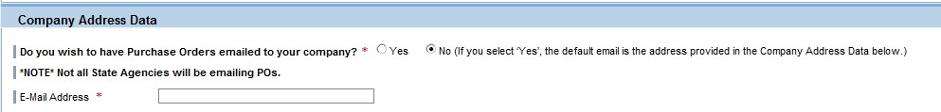
- E-mail address: Valid E-mail address. This is the company’s general email address. Solicitations and addenda notifications will NOT be sent here. They will be sent to each contact person (created later in this registration process).
- Telephone Number: 10 digit telephone number for the company separated by hyphens
- Extension: Leave blank if the company fax number does not have an extension.
- Street Address: Company’s street address where you would like orders to go.
- City: Company’s city
- Parish: Company’s parish/county
- State: Use the drop down box to select the company’s state
- Zip Code: Company’s zip code
- Country: Use the drop down box to select the company’s country
- P. O. Box: Company’s P. O. Box (P. O. Box will take preference over street address if both are entered)
- P. O. Box city: Company’s P. O. Box city
- P. O. Box State: Company’s P. O. Box state
- P. O. Box Zip: Company’s P. O. Box zip code
- P. O. Box Country: Company’s P. O. Box country
- ☑ If your remit to address is different from the address entered above, please select this box and enter your remittance address information. If you do not check the box you will not see the remittance address entry fields.

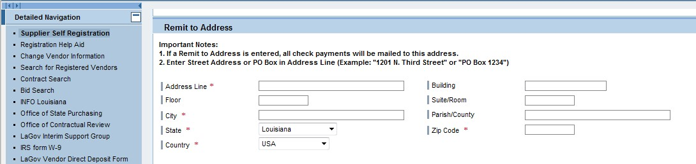

- Address Line: Enter street address or P. O. Box of remittance address
- City: City of remittance address
- Parish: Parish/county of remittance address
- State: State where remittance must be sent. Use drop down box if needed.
- Zip Code: Zip code of remittance address.
- Country: Country of remittance address. Use drop down box if needed.
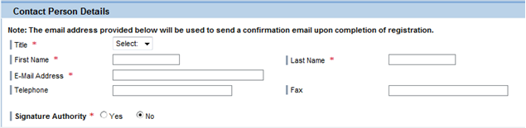

- Title: Use drop down box to select title of contact person
- First Name: Enter first name of contact person
- Last Name: Enter last name of contact person
- E-mail address: Enter the email address where you wish the confirmation email to be sent upon completion of registration. That email will provide the permanent vendor ID and require creation of a personal password. This email address will be used to send notifications of solicitations that are posted to the Louisiana Procurement and Contract Network (LaPAC) that match the Product Categories you selected.
- Telephone: Telephone number of contact person
- Fax: Fax number of contact person
- Signature authority: Click the “yes” or “no” radio button

- Select the Product Categories (commodities) you wish to be notified by clicking the box(es). You may use the search on the registration page which searches family and class level or there is another more detailed search located at https://wwwcfprd.doa.louisiana.gov/osp/lapac/pubMain.cfm
- Hint: If you use the detailed search and click on the box by “whole word”, it will narrow your search. Example if you enter “ice” it will bring up 4129 hits because it includes words like device, service, etc. If you select whole word, it will narrow your search to 37. When you locate the product or service you are looking for, make a note of the first 4 digits (family code). You will use these to select your product categories.
- The new vendor portal uses UNSPSC commodity codes (United Nations Standard Products and Services Code).
- Registration is at the family level (first 4 digits of the product category).
- Click on the box(es) on the right to select product categories.
- Select as many product categories as desired.
- Being a registered vendor does NOT guarantee the receipt of electronic notifications for all applicable solicitations. Vendors must routinely check our LaPAC Bids site for a listing of current business opportunities. The Division of Administration shall not be responsible if a vendor does not receive an electronic notification for any particular solicitation. This notification is provided as a convenience only. The Division of Administration neither accepts nor assumes responsibility for electronic notifications under any circumstances.

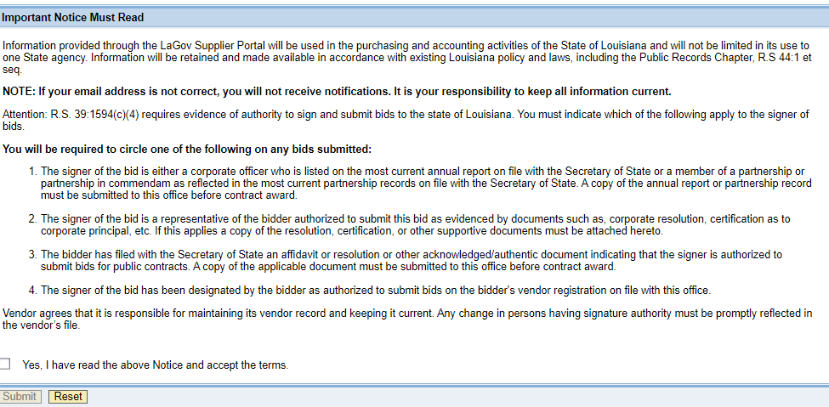

- After reading and reviewing the Important Notice, check the “yes” box.
- Click the “submit” button to continue.
NOTE: If there are any errors, you will see a message.
- You have successfully completed your initial registration and will need to create your permanent password to complete the process. Wait for an email with further instructions.
- Close your browser. Failure to do this may cause problems with creating your permanent password to complete the process.

5. You will receive a confirmation email stating that you have successfully completed your initial registration and that you need to create your personal password. The email will include your permanent vendor ID and a temporary password. Log in with your permanent vendor number and temporary password (case sensitive) to create your personal password at the URL provided in the email https://lagoverpvendor.doa.louisiana.gov/irj/portal. Your personal password must be at least 8 characters – combination of alpha and numeric using upper or lower case letters.
- Must be at least 8 characters long
- Must have at least 1 numeric character (0-9)
- Must have at least 1 alpha character, upper or lower case (A-Z or a-z)

Click “submit” and that will complete your registration. Keep a record of your permanent vendor ID and personal password.

While you are creating your personal password, you will also have the opportunity to perform any of the following tasks:
- Edit and manage your Product Category selections
- Edit and manage your company and user data
- Create and manage additional company contacts
- Create your remit to address

6. Once registration is complete you can manage your account and make changes by logging in at this same URL https://lagoverpvendor.doa.louisiana.gov/irj/portal with your permanent ID and personal password 24 hours a day 7 days a week. Details on each of the management functions are in separate help scripts on our website at http://www.doa.louisiana.gov/osp/vendorcenter/regnhelp/index.htm:
- Create Additional Users
- Manage User Data
- Manage Own Data
- Manage Company Data
- Manage Product Categories
- Create a Remittance Address
- Vendor Payments (inquiry)

We are pleased to welcome you as a supplier in our LaGov supplier Registration Portal.

