FY2020 Consolidated Annual Performance and Evaluation Report

CR-05 - Goals and Outcomes
Progress the jurisdiction has made in carrying out its strategic plan and its action plan. 91.520(a)
This could be an overview that includes major initiatives and highlights that were proposed and executed throughout the program year.

This Consolidated Annual Performance and Evaluation Report (CAPER) discusses program outcomes for the FY 2020 program year (April 1, 2020 thru March 31, 2021) utilizing State Community Development Block Grant (CDBG), HOME Investment Partnerships Program (HOME), National Housing Trust Fund (HTF), Emergency Solutions Grants Program (ESG) and Housing Opportunities for Persons with AIDS (HOPWA). This is the first of the five year Consolidated Plan cycle 2020-2024. As program year 2020 began, the State and the Nation became under attack from the COVID-19 Virus resulting in Congresses passing of the CARES Act, granting numerous economic stimuli for a country on the mend.
The State of Louisiana continued to make progress in increasing and preserving the supply of affordable housing, improving public infrastructure, and increasing public services, public facilities, and Rapid-Rehousing and crisis response services for eligible households across the State with a primary focus in non-entitlement CDBG, HOME, ESG, HOPWA and HTF communities. The State also continues to make strives toward affirmatively furthering fair housing in the administration of program funds. In addition to the data provided below, this CAPER discusses affordable housing outcomes, homelessness and special needs activities, program monitoring and other State actions in furtherance of the State's 2020 Consolidated Annual Action Plan. HOME funds were used to fund the following activities during the FY 2020 program year:
• Homebuyer activities (new construction for homebuyers);
• Rental housing (acquisition and or/ rehabilitation or new construction)
• Tenant based rental assistance (TBRA) Projects that were funded are in various stages of development.
Projects that were funded are in various stages of development and completion. Table 1 below provides a comparison of proposed FY 2020 program year goals versus actual outcomes. Outcomes are measured either in terms of units produced or the number of assisted households. Each activity funded under the 2020 CDBG Program must have met one of the three national objectives: principal benefit to low-to-moderate income persons; elimination or prevention of slums and blight; and meeting community development needs having a particular urgency. To accomplish these objectives, the State established the following goals:
To strengthen community economic development through the creation of jobs, stimulation of private investment, and community revitalization, principally for low-to-moderate income persons; to primarily benefit low-to-moderate income persons; to eliminate or aid in the prevention or elimination of slums and blight; or, provide for other community development needs having a particular urgency because existing conditions pose a serious and immediate threat to the health or welfare of the community and other financial resources are not available to meet such needs.
Comparison of the proposed versus actual outcomes for each outcome measure submitted with the consolidated plan and explain, if applicable, why progress was not made toward meeting goals and objectives. 91.520(g)
Categories, priority levels, funding sources and amounts, outcomes/objectives, goal outcome indicators, units of measure, targets, actual outcomes/outputs, and percentage completed for each of the grantee’s program year goals.

Goal | Category | Source / Amount | Indicator | Unit of Measure | Expected – Strategic Plan | Actual – Strategic Plan | Percent Complete | Expected – Program Year | Actual – Program Year | Percent Complete
Affordable Housing Development | Affordable Housing | CDBG: $0 / HOPWA: $ / HOME: $ / ESG: $0 / HTF: $ | Rental units constructed | Household Housing Unit | 110 | 12 | 10.91% | 22 | 0 | 0.00%
Affordable Housing Development | Affordable Housing | CDBG: $0 / HOPWA: $ / HOME: $ / ESG: $0 / HTF: $ | Rental units rehabilitated | Household Housing Unit | 85 | 58 | 68.24% | 17 | 0 | 0.00%
Affordable Housing Development | Affordable Housing | CDBG: $0 / HOPWA: $ / HOME: $ / ESG: $0 / HTF: $ | Homeowner Housing Added | Household Housing Unit | 30 | 14 | 46.67% | 6 | 0 | 0.00%
Affordable Housing Development | Affordable Housing | CDBG: $0 / HOPWA: $ / HOME: $ / ESG: $0 / HTF: $ | Homeowner Housing Rehabilitated | Household Housing Unit | 20 | 0 | 0.00% | 4 | 0 | 0.00%
Affordable Housing Development | Affordable Housing | CDBG: $0 / HOPWA: $ / HOME: $ / ESG: $0 / HTF: $ | Tenant-based rental assistance / Rapid Rehousing | Households Assisted | 0 | 601 |  | 50 | 0 | 0.00%
Affordable Housing Development | Affordable Housing | CDBG: $0 / HOPWA: $ / HOME: $ / ESG: $0 / HTF: $ | Homelessness Prevention | Persons Assisted | 250 | 0 | 0.00%
ED - Existing Business | Non-Housing Community Development | CDBG: $ | Jobs created/retained | Jobs | 100 | 0 | 0.00% | 100 | 0 | 0.00%
ED - Existing Business | Non-Housing Community Development | CDBG: $ | Businesses assisted | Businesses Assisted | 5 | 0 | 0.00% | 5 | 0 | 0.00%
ED - Local Government Loan to Business | Non-Housing Community Development | CDBG: $ | Businesses assisted | Businesses Assisted | 10 | 0 | 0.00% | 3 | 0 | 0.00%
ED - New Business | Non-Housing Community Development | CDBG: $ | Jobs created/retained | Jobs | 100 | 0 | 0.00% | 100 | 0 | 0.00%
ED - New Business | Non-Housing Community Development | CDBG: $ | Businesses assisted | Businesses Assisted | 5 | 0 | 0.00% | 5 | 0 | 0.00%
HMIS Reporting | Homeless | CDBG: $ / HOPWA: $ / HOME: $ / ESG: $ / HTF: $ | Other | Other | 7500 | 0 | 0.00% | 1500 | 0 | 0.00%
Homebuyer Assistance | Affordable Housing | CDBG: $ / HOPWA: $ / HOME: $ / ESG: $ / HTF: $ | Direct Financial Assistance to Homebuyers | Households Assisted | 50 | 14 | 28.00% | 10 | 0 | 0.00%
Homeless Prevention and Rapid Rehousing | Homeless  Non-Homeless Special Needs | CDBG: $ / HOPWA: $ / HOME: $ / ESG: $ / HTF: $ | Tenant-based rental assistance / Rapid Rehousing | Households Assisted | 2000 | 0 | 0.00% | 400 | 0 | 0.00%
Homeless Prevention and Rapid Rehousing | Homeless  Non-Homeless Special Needs | CDBG: $ / HOPWA: $ / HOME: $ / ESG: $ / HTF: $ | Homelessness Prevention | Persons Assisted | 1500 | 0 | 0.00% | 300 | 0 | 0.00%
Homeless Shelters | Homeless | CDBG: $ / HOPWA: $ / HOME: $ / ESG: $ / HTF: $ | Homeless Person Overnight Shelter | Persons Assisted | 12500 | 0 | 0.00% | 2500 | 0 | 0.00%
Homeowner Housing Rehabilitation | Affordable Housing | CDBG: $ / HOPWA: $ / HOME: $ / ESG: $ / HTF: $ | Homeowner Housing Rehabilitated | Household Housing Unit | 100 | 0 | 0.00% | 20 | 0 | 0.00%
PF - Existing Infrastructure/Service Connections | Non-Homeless Special Needs  Non-Housing Community Development | CDBG: $ / HOPWA: $ | Public Facility or Infrastructure Activities other than Low/Moderate Income Housing Benefit | Persons Assisted | 200000 | 68829 | 34.41% | 50000 | 68829 | 137.66%
PF - Existing Infrastructure/Service Connections | Non-Homeless Special Needs  Non-Housing Community Development | CDBG: $ / HOPWA: $ | Public Facility or Infrastructure Activities for Low/Moderate Income Housing Benefit | Households Assisted | 300 | 66 | 22.00% | 60 | 66 | 110.00%
PF - Existing Infrastructure/Service Connections | Non-Homeless Special Needs  Non-Housing Community Development | CDBG: $ / HOPWA: $ | HIV/AIDS Housing Operations | Household Housing Unit | 40 | 0 | 0.00%
PF - New Service Connections | Non-Housing Community Development | CDBG: $ | Public Facility or Infrastructure Activities for Low/Moderate Income Housing Benefit | Households Assisted | 60 | 8 | 13.33% | 12 | 8 | 66.67%
Planning | Non-Housing Community Development | CDBG: $ | Other | Other | 0 | 2 |  | 10 | 2 | 20.00%
Public Facilities-New Infrastructure | Non-Housing Community Development | CDBG: $ | Public Facility or Infrastructure Activities other than Low/Moderate Income Housing Benefit | Persons Assisted | 12000 | 84 | 0.70% | 6000 | 84 | 1.40%
Rental Assistance | Affordable Housing  Homeless  Non-Homeless Special Needs | CDBG: $ / HOPWA: $ / HOME: $ / ESG: $ / HTF: $ | Tenant-based rental assistance / Rapid Rehousing | Households Assisted | 3000 | 0 | 0.00% | 600 | 194 | 32.33%
Rental Assistance | Affordable Housing  Homeless  Non-Homeless Special Needs | CDBG: $ / HOPWA: $ / HOME: $ / ESG: $ / HTF: $ | Homelessness Prevention | Persons Assisted | 750 |  | % | 150 |  | %
Street Outreach | Homeless | CDBG: $ / HOPWA: $ / HOME: $ / ESG: $ / HTF: $ | Other | Other | 1000 | 0 | 0.00% | 200 | 0 | 0.00%
Table 1 - Accomplishments – Program Year & Strategic Plan to Date

Assess how the jurisdiction’s use of funds, particularly CDBG, addresses the priorities and specific objectives identified in the plan, giving special attention to the highest priority activities identified.
The outcomes reported in the tables above are based on HOME funded activities that were completed in the HUD Integrated Disbursement and Information System (IDIS) per the HUD PR 23 Report during the 2020 program year, April 1, 2020-March 31, 2021. Table 1 provides information regarding annual goals, activities and accomplishments for the FY 2020 program year. As seen in Table 1, during the FY 2020 program year, the state made progress in accomplishing its overall annual expectations for affordable housing except for owner occupied rehabilitation. Although the use of HOME funds for TBRA was an essential element of the overall five year funding strategy and annual action plans, the state only used HOME funds for this activity as the needs and market conditions were identified. As the COVID-19 Virus pandemic heathcare crisis progressed, the primary challenge of the state was to provide critical housing relief for some of the hardest hit residents and some assistance to businesses for encomomic substainability. Households most vulnerable were low income renters and homeowners, the homeless population and those impacted by natural disasters; i.e. hurricanes. Low income households that depended on jobs provided in the service industry were most severely impacted. Table 2 provides information and a comparison regarding the strategic goals and actual accomplishments relative to the FY 2020 - 2024 Consolidated Plan for the aforementioned HUD programs. Table 2 also provides an indication of the challenges the state continues to incur relative to the strategic provision of opportunities for homeownership. A slower recovery for struggling low income households, a more restrictive access to mortgage credit and a reduction in public and private resources as well as increase development and direct homebuyer assistance cost were factors that influenced the strategic outcomes for HOME funded homebuyer activity. Historically, HOME funds have been used in combination with MRB funding to provide lower rates to low income households. The lower outcome regarding rental housing activity was primarily due in part to activities that had been previously funded but were not completed during this annual and strategic reporting period. Construction and rehabilitation activity progressed at a much slower pace because of the pandemic. Several projects halted construction either due to healthcare precautions caused by the pandemic or due to a lack of available workforce.
The outcomes reported in the tables above are based on CDBG activities that were completed during the 2020 program year, April 1, 2020- March 31, 2021. The difference between expected and actual CDBG beneficiaries is the result of the LCDBG applications received, as well as the review and rating of those applications.

CR-10 - Racial and Ethnic composition of families assisted
Describe the families assisted (including the racial and ethnic status of families assisted). 91.520(a)

 | CDBG | HOME | HOPWA | ESG | HTF
White | 21 | 48 | 185 | 0 | 0
Black or African American | 37 | 268 | 466 | 0 | 6
Asian | 2 | 1 | 0 | 0 | 0
American Indian or American Native | 0 | 0 | 4 | 0 | 0
Native Hawaiian or Other Pacific Islander | 0 | 0 | 1 | 0 | 0

Total | 60 | 317 | 656 | 0 | 6

Hispanic | 0 | 4 | 14 | 0 | 0
Not Hispanic | 0 | 313 | 0 | 0 | 6
Table 2 – Table of assistance to racial and ethnic populations by source of funds

Narrative
The information provided in the table above summarizes the extent various race and ethnicity of families have applied for, participated in, or benefited from, any program or activity funded in whole or in part with HOME funds. This report includes as "Attachment 4", the IDIS PR 23 Report (HOME Summary of Accomplishments) for the FY 2020 reporting period ending 3/31/21. According to the report, the racial and ethnic household composition of HOME-assisted projects was as follow: slightly more than 15% White; slightly more than 84% Black or African American; less than 1% Asian; and 0% other multi-racial.
For HOPWA the information above represents individuals who are conisdered both HOPWA Eligibile clients and all other beneficiaries, or people living in households with the HOPWA eligible individual.
While CDBG maintains data on racial, ethnic, and gender characteristics of persons who are direct beneficiaries for CDBG-funded projects as shown above, IDIS does not allow data to be entered for projects with indirect beneficiaries.
The ESG totals in the chart above represent the racial and ethnic composition of the families served with ESG.

CR-15 - Resources and Investments 91.520(a)
Identify the resources made available
Source of Funds | Source | Resources Made Available | Amount Expended During Program Year
CDBG | public - federal | 27,224,317 | 15,749,781
HOME | public - federal | 14,091,510 | 12,692,768
HOPWA | public - federal | 2,218,142 | 1,961,661
ESG | public - federal | 2,496,383
HTF | public - federal | 3,609,159 | 5,445,136
Table 3 - Resources Made Available

Narrative
The State of Louisiana received $10,357,108 as a FY 2020 HOME fund allocation. IDIS's PR 09 (Receipt Fund Detail Report) revels the total amount of program income received during the reporting period from HOME funded activities was $1,062,009. The total amount of HOME funds made available at the begining of FY 2020 was $11,419,117. The state also received an award of $3,609,159 in National Housing Trust Funds during FY 2020. NHTF funds were awarded in conjunction with tax credits during the 2020 HOME and Housing Trust Fund NOFA. According to the PR 07 (HOME Drawdown Report by Voucher Number) dated 3/31/21, the amount of HOME funds expended during the FY 2019 was $12,692,768 which included program income and funds committed from prior years. In addition to HOME funds, the state also used non-federal resources including bond sale proceeds and housing tax credits with HOME funds to finance affordable housing activities.

Identify the geographic distribution and location of investments
Target Area | Planned Percentage of Allocation | Actual Percentage of Allocation | Narrative Description
CDBG-State of Louisiana | 97 | 57.85 | The geographic area for awarding CDBG funds encompasses all HUD Non-Entitlement Areas of Louisiana
ESG-State of Louisiana | 100 |  | Statewide
HOME-State of Louisiana | 100 | 100 | Other
HOPWA-State of Louisiana | 97 | 88.43 | Low income persons living with HIV who reside in parishes outside the New Orleans & Baton Rouge MSAs
National Housing Trust Fund - State of Louisiana | 100 | 100 | Other
Table 4 – Identify the geographic distribution and location of investments

Narrative
The FY 2020 Consolidated Annual Action Plan did not target any specific area of the state in connection with its overall investment of state HOME funds. However, in order to address a portion of the unmet housing needs, the state provided funding through five funding initiatives: 2020 CHDO Annual Awards Program (CHAAP), 2020 Nonprofit Open Cycle Affordable Housing Program (NOAH); 2020 Small Project Continuation NOFA; HOME TBRA NOAL CV; Healthcare Epidemic Assisted Lease Program (HELP) TBRA Program; and the HOME TBRA IDS. Although funding through these initiatives was offered statewide, additional selection criteria points were offered for proposed projects small cities and rural parishes. The state has observed that open funding programs, or programs using competitive funding criteria, serve the state best by allowing for the development of projects that meet local needs. Selection criteria are more favorable for projects that are proposed in those geographic areas of greatest needs being supported by market studies. The use of HOME funds for tenant based rental assistance was an essential element of the state's five year strategy and annual action plan. The state continued to used HOME funds for tenant based rental assistance as the needs and market conditions were identified. HOME funds were made available on a statewide basis to assist households transitioning from incarceration to work and resettlement into the public and those that were participants in the HUD Section 811 Supportive Housing for Persons with Disabilities Demonstration Program (security and utilities deposits).

Leveraging
Explain how federal funds leveraged additional resources (private, state and local funds), including a description of how matching requirements were satisfied, as well as how any publicly owned land or property located within the jurisdiction that were used to address the needs identified in the plan.
A match is not required for LCDBG except under the Economic Development program. Funds available through LCDBG are leveraged with other federal, state and local government funds. The additional funds are primarily used for administration and planning of projects, property acquisition and a portion of project construction costs.
Using its HOME allocation, the Louisiana Housing Corporation completed five (5) housing projects in FY 2020 producing a total of 590 affordable housing units (70 HOME units). All the units produced were rental. Overall, an investment of $7,957, 677 in HOME funds leveraged an additional $128,206,075 from various other sources resulting in an impressive leveraging ratio of 16 to 1. As the cost of housing continues to escalate due to the impact of COVID -19 and several natural disasters, creative leveraging is essential in furthering the production and preservation of affordable housing.
The state, as a participating jurisdiction (PJ) for the state administered HOME program, incurs a 25 percent match obligation during each Federal fiscal year based on the amount of HOME funds drawn down from its U.S. Treasury account. According to the HUD PR 33 report (HOME Match Liability Report) dated March 31, 2020 and the FY 2020 -HOME-Match-Reductions Report, there is no match requirement for the State of Louisiana administered HOME Program due to COVID 19 match reduction. The state recognized match contribution for FY 2020 as reported below and will continue to carry forward excess match credit to the next federal fiscal year.
HOPWA: Sponsors leveraged funds included housing, rental and utility assistance, case management and supportive services, housing choice vouchers, program income, fundraising, CARES Act, Ryan White, and other funds in the amount of $11,337,093 to support People Living with HIV become housed, stay housed, prevent homelessness, and access critical supportive and medical services to support viral suppresion.

Fiscal Year Summary – HOME Match
1. Excess match from prior Federal fiscal year | 118,067,038
2. Match contributed during current Federal fiscal year | 356,104
3. Total match available for current Federal fiscal year (Line 1 plus Line 2) | 118,423,141
4. Match liability for current Federal fiscal year | 0
5. Excess match carried over to next Federal fiscal year (Line 3 minus Line 4) | 118,423,141
Table 5 – Fiscal Year Summary - HOME Match Report

Match Contribution for the Federal Fiscal Year
Project No. or Other ID | Date of Contribution | Cash  (non-Federal sources) | Foregone Taxes, Fees, Charges | Appraised Land/Real Property | Required Infrastructure | Site Preparation, Construction Materials, Donated labor | Bond Financing | Total Match
2016-68 | 03/10/2021 | 275,000 | 0 | 0 | 0 | 0 | 0 | 275,000
2017-63 - 2020 HOME/MRB | 07/22/2020 | 0 | 0 | 0 | 0 | 0 | 234,415 | 58,604
2017-63 - 2020 HOME/MRB- C | 07/22/2020 | 2,500 | 0 | 0 | 0 | 0 | 0 | 2,500
2017/42/11713 | 03/11/2021 | 11,500 | 0 | 0 | 0 | 0 | 0 | 11,500
2018/56/11717 | 07/22/2020 | 8,500 | 0 | 0 | 0 | 0 | 0 | 8,500
Table 6 – Match Contribution for the Federal Fiscal Year

HOME MBE/WBE report
Program Income – Enter the program amounts for the reporting period
Balance on hand at begin-ning of reporting period  $ | Amount received during reporting period  $ | Total amount expended during reporting period  $ | Amount expended for TBRA  $ | Balance on hand at end of reporting period  $
3,555,569 | 4,384,835 | 3,454,823 | 1,268,730 | 4,485,581
Table 7 – Program Income

Minority Business Enterprises and Women Business Enterprises – Indicate the number and dollar value of contracts for HOME projects completed during the reporting period

 | Total | Minority Business Enterprises |  |  |  | White Non-Hispanic
 |  | Alaskan Native or American Indian | Asian or Pacific Islander | Black Non-Hispanic | Hispanic

Contracts
Dollar Amount | 71,471,727 | 0 | 0 | 0 | 0 | 71,471,727
Number | 5 | 0 | 0 | 0 | 0 | 5

Sub-Contracts
Number | 82 | 1 | 0 | 10 | 0 | 71
Dollar Amount | 48,904,079 | 42,300 | 0 | 1,792,816 | 0 | 47,068,963

 | Total | Women Business Enterprises | Male

Contracts
Dollar Amount | 71,471,727 | 0 | 71,471,727
Number | 5 | 0 | 5

Sub-Contracts
Number | 81 | 1 | 80
Dollar Amount | 48,904,079 | 36,001 | 48,868,078
Table 8 - Minority Business and Women Business Enterprises

Minority Owners of Rental Property – Indicate the number of HOME assisted rental property owners and the total amount of HOME funds in these rental properties assisted

 | Total | Minority Property Owners |  |  |  | White Non-Hispanic
 |  | Alaskan Native or American Indian | Asian or Pacific Islander | Black Non-Hispanic | Hispanic
Number | 0 | 0 | 0 | 0 | 0 | 0
Dollar Amount | 0 | 0 | 0 | 0 | 0 | 0
Table 9 – Minority Owners of Rental Property

Relocation and Real Property Acquisition – Indicate the number of persons displaced, the cost of relocation payments, the number of parcels acquired, and the cost of acquisition

Parcels Acquired | 0 | 0
Businesses Displaced | 0 | 0
Nonprofit Organizations Displaced | 0 | 0
Households Temporarily Relocated, not Displaced | 0 | 0

Households Displaced | Total | Minority Property Enterprises |  |  |  | White Non-Hispanic
 |  | Alaskan Native or American Indian | Asian or Pacific Islander | Black Non-Hispanic | Hispanic
Number | 0 | 0 | 0 | 0 | 0 | 0
Cost | 0 | 0 | 0 | 0 | 0 | 0
Table 10 – Relocation and Real Property Acquisition

CR-20 - Affordable Housing 91.520(b)
Evaluation of the jurisdiction's progress in providing affordable housing, including the number and types of families served, the number of extremely low-income, low-income, moderate-income, and middle-income persons served.

 | One-Year Goal | Actual
Number of Homeless households to be provided affordable housing units | 20 | 601
Number of Non-Homeless households to be provided affordable housing units | 238 | 84
Number of Special-Needs households to be provided affordable housing units | 45 | 47
Total | 303 | 732
Table 11 – Number of Households

 | One-Year Goal | Actual
Number of households supported through Rental Assistance | 200 | 601
Number of households supported through The Production of New Units | 22 | 28
Number of households supported through Rehab of Existing Units | 36 | 56
Number of households supported through Acquisition of Existing Units | 0 | 4
Total | 258 | 689
Table 12 – Number of Households Supported

Discuss the difference between goals and outcomes and problems encountered in meeting these goals.
The outcomes reported in the tables above are based on HOME funded activities completed last program year and reported in HUD's Integrated Disbursement and Information System (IDIS) PR 23 Report (April 1, 2020 - March 31, 2021). The large number of homeless and special need households assisted was primarily due to the COVID -19 pandemic and the completion of five (5) rental projects with units for special need households. HOME funds were mainly used to provide gap financing relative to the rehabilitation and construction of homeownership and multi-family rental housing developments in addition to tenant based rental assistance. Due to labor and material shortage attributed to the COVID -19 pandemic, larger developments tend to need more time to close and commence construction. Other factors that delayed the expected outcomes were either the multiple layering of finances or working through the development process.

Discuss how these outcomes will impact future annual action plans.
The State will to take advantage every available, reliable and up to date data with regards to housing needs and funding availability to forecast goals and outcomes. In addition, the State will continue to examine outcomes and internal processes to identify areas for improvement and provide community outreach and technical assistance to developers in order to achieve its housing goals.

Include the number of extremely low-income, low-income, and moderate-income persons served by each activity where information on income by family size is required to determine the eligibility of the activity.
Number of Households Served | CDBG Actual | HOME Actual | HTF Actual
Extremely Low-income | 0 | 650 | 2
Low-income | 0 | 685
Moderate-income | 0 | 0
Total | 0 | 1,335

Table 13 – Number of Households Served

Narrative Information
The outcomes as reported above are as seen in the HUD PR 23 and HUD PR 100 Reports dated 3/31/2021.

CR-25 - Homeless and Other Special Needs 91.220(d, e); 91.320(d, e); 91.520(c)
Evaluate the jurisdiction’s progress in meeting its specific objectives for reducing and ending homelessness through:
Reaching out to homeless persons (especially unsheltered persons) and assessing their individual needs
The state continues to work with sub-recipients and Continuums of Care to identify the unsheltered homeless through intensive street outreach efforts. These efforts have identified and linked over 200 persons to mainstream services including housing. All state homeless providers utilize the same assessment tool, which allows services to be individualized therefore meeting the client’s specific needs. The State work with each of the CoC's coordinated entry system to identify the needs of homeless persons, espcially unsheltered persons, and referring them to appropriate services to address their needs.
Addressing the emergency shelter and transitional housing needs of homeless persons
Addressing the emergency shelter and transitional housing needs of homeless persons the Emergency Solutions funding allocated to 11 homeless shelters to provide immediate Housing for those individuals and families experiencing homelessness. These shelters provided 25,278 nights of shelter stays. The implementation of the Vulnerability Index and Service Prioritization and Service Prioritization Decision Assistance Tool has ensured that the clients are routed to the best resource to meet there needs.
Helping low-income individuals and families avoid becoming homeless, especially extremely low-income individuals and families and those who are: likely to become homeless after being discharged from publicly funded institutions and systems of care (such as health care facilities, mental health facilities, foster care and other youth facilities, and corrections programs and institutions); and, receiving assistance from public or private agencies that address housing, health, social services, employment, education, or youth needs
The state made provisions for agencies to utilize ESG funding to provide homeless prevention assistance when it was necessary to prevent individuals and families from loss of housing and becoming homeless. These efforts also included identifying and servicing those individuals released from institutions. ESG funding provides financial assistance to households throughout the state to low income populations. These individuals and families must meet the eligibility criteria in accordance to the Federal Register rules and regulations. The State’s Interagency Council on Homeless continued the work outlined and adopted the Louisiana’s Ten year Plan to End Homelessness, Ma Maison (My Home). The plan, which is aligned with the United States Interagency Council on Homelessness’ Opening Doors. The plan outlines the goals for Louisiana CAPER 22 OMB Control No: 2506-0117 (exp. 07/31/2015) as: ï¿· Finish the job of ending chromic homelessness by 2016 ï¿· Prevent and end homeless among veterans by 2015· Prevent and end homelessness for families, youth and children by 2020: and · Set a path to ending all types of homeless The Governors Council on Homelessness was established in 2016. This council is playing an integral part in the development of discharge planning for hospitals, jails, and prisons. The councils goals are also aligned with the federal goals identified above.
Helping homeless persons (especially chronically homeless individuals and families, families with children, veterans and their families, and unaccompanied youth) make the transition to permanent housing and independent living, including shortening the period of time that individuals and families experience homelessness, facilitating access for homeless individuals and families to affordable housing units, and preventing individuals and families who were recently homeless from becoming homeless again
.
The Louisiana 10 year Plan to End Homelessness, Ma Maison steps have been outlined to identify chronically homeless individuals and families and link them to housing and services. The utilization of the VI-SPDAT by all CoC’s within the state ensures prioritization of resources to those homeless most in need. Quarterly Homeless Working Groups are held to continue this work and develop statewide strategies and goals: four meetings were conducted during the reporting period, resulting in multiple subgroup meetings to centime specific work assignments.
The state worked with cities and parish officials across the state to accept the White house Challenge: Mayors Challenge to End Homelessness. This challenge is to identify the veterans in each community and provide housing; the initial date was by the end of 2015; however, that was extended through 2016. The following cities accepted the challenge: City of Baton Rouge, City of New Orleans, City of Lake Charles, City of Shreveport, and Terrebonne Parish. The City of New Orleans has accomplished the goal in 2015. During 2016 Lake Charles, City of Shreveport and Terrebonne Parish met the goal of ending veteran homeless in their community. Many of our cities and parishes came close to meeting their goal, and will continue the work of identifying and housing homeless veterans. Additionally, the Project Based Voucher program continues to address homelessness by making individuals who are chronically homeless a preference. The PBV program has provided housing to 226 chronically homeless individuals.

CR-30 - Public Housing 91.220(h); 91.320(j)
Actions taken to address the needs of public housing
The state continues to develop and implement its strategy and a set of standards for identifying and preserving those affordable housing developments (including public housing) with the greatest need for preservation, e.g., at imminent risk of opting out of a contract or with the greatest need for physical improvements. The state has also committed to provide appropriate resources through its Multi-family Bond, Tax Credit, HOME and Housing Trust Funds programs to public housing authorities to preserve and modernize their public housing units or re-construct new units by providing preference to projects which preserve which preserve affordable housing in its Qualified Allocation Plan (QAP) and NOFA's; especially those participating in the Rental Assistance Demonstration (RAD) Program. The RAD Program is a U.S. Department of Housing and Urban Development (HUD) initiative for the conversion of public housing units to long term Project Based Vouchers (PBV) or Project Based Rental Assistance (PBRA) contracts. In addition, the state also provided a dedicated staff to facilitate and support PHAs through the RAD application and conversion process.
Actions taken to encourage public housing residents to become more involved in management and participate in homeownership
The State does not have any direct or indirect jurisdiction over the management or operations of public housing authorities regarding resident initiatives; however, the State maintains relationships with housing authorities throughout the state to provide homeownership opportunities to its tenants.
Actions taken to provide assistance to troubled PHAs
During the FY 2020 program year, the state provided resources in the form of technical and financial assistance to troubled public housing agencies upon request. Financial assistance was provided utilizing Low-Income Housing Tax Credits, Multi-family Bond and HOME Program funds for the preservation and modernization of public housing units or re-construction of new units.

CR-35 - Other Actions 91.220(j)-(k); 91.320(i)-(j)
Actions taken to remove or ameliorate the negative effects of public policies that serve as barriers to affordable housing such as land use controls, tax policies affecting land, zoning ordinances, building codes, fees and charges, growth limitations, and policies affecting the return on residential investment. 91.220 (j); 91.320 (i)
All agencies administering HUD programs in the state encourage, but cannot mandate, local governments to adopt policies, procedures, and processes that will reduce barriers to affordable housing. These include land use controls, tax policies affecting land, zoning ordinances, building codes, fees and charges, growth limitations, and policies affecting the return on residential investment.
The state through the Louisiana Housing Corporation encouraged partnerships between for-profit developers, nonprofit organizations, local governmental units, commercial lending institutions and State and federal agencies in an effort to reduce barriers and garner community support for affordable housing.

Actions taken to address obstacles to meeting underserved needs. 91.220(k); 91.320(j)
All of the activities that were funded under the State’s Community Development Block Grant Program, HOME Investments Partnerships Program, Housing Trust Funds, Emergency Solutions Grants Program, and State Formula Housing Opportunities for Persons With AIDS Program (HOPWA) addressed the goal of improving the living conditions of the State’s low and moderate income citizens in all regions of the State including underserved small cities and rural areas. State Formula HOPWA is specifically dedicated to preventing homelessness among low income persons who are living with HIV. These individuals struggle with the stigma of their medical condition, in addition to the challenges that come with poverty, when seeking medical care, employment, supportive services and even housing. State Formula HOPWA is an integral component of preventing homelessness in this target population.
The HOME, Housing Trust Funds, ESG, and State Formula HOPWA programs resources were used to assist in the provision of decent housing by improving existing housing units as well as expanding the availability of decent and attractive affordable housing. The Louisiana Community Development Block Grant (LCDBG) Program provided funding for infrastructure improvements which will improve the quality of life and raise the living standards of all of the citizens being served. The LCDBG Program also allocated funds for the expansion of economic opportunities with the primary purpose of creating jobs which are accessible to low and moderate income persons. Funds were made available to local governments for loans to private for-profit enterprises for specified industrial development uses and/or to use to make public improvements which support a private industrial expansion effort.
In addition, Low Income Home Energy Assistance Program (LIHEAP) and Weatherization Assistance Program (WAP) program funds were used to lessen the burden of high energy cost affecting low income households. The LIHEAP program targeted those households with the lowest incomes that pay a high proportion of household income for home energy, primarily in meeting their immediate home heating needs. The priority population for the WAP program includes low-income families with at least one member who is elderly (60 years of age and older), disabled, age five and under, high residential energy users and households with a high energy burden.

Actions taken to reduce lead-based paint hazards. 91.220(k); 91.320(j)
Almost half of the housing units in Louisiana were built before 1980 with more than 100,000 units having been constructed before 1940 and nearly 20% of all Louisiana residents currently live in poverty; including over 90,000 children under the age of 5. Also, minorities, particularly African Americans are disproportionately affected by lead poisoning and Louisiana has a large African American population (32.7%) compared to the U.S. (13.4%). Children within these impoverished minority households, who occupy older housing units, are especially at risk of developing intellectual, behavioral, and academic deficits as a direct result of lead exposure. Although lead screening is mandatory in Louisiana for all children aged six months to 72 months, only 14.7% of children were able to be screened in 2016; a 2.6% decrease in the number of children tested the year before.
The HOME program requires lead screening in housing built before 1978 for the Owner Occupied Rehabilitation Assistance Program. Rehabilitation activities fall into three categories:
- Requirements for federal assistance up to and including $5,000 per unit;
- Requirements for federal assistance from $5,000 per unit up to and including $25,000 per unit; and
- Requirements for federal assistance over $25,000 per unit.
Requirements for federal assistance up to and including $5,000 per unit are:
- Distribution of the pamphlet, "Protect Your Family from Lead in Your Home", is required prior to renovation activities;
- Notification within 15 days of lead hazard evaluation, reduction, and clearance must be provided;
- Receipts for notification must be maintained in the administrator’s file;
- Paint testing must be conducted to identify lead based paint on painted surfaces that will be disturbed or replaced or administrators may assume that lead based paint exist;
- Administrators must repair all painted surfaces that will be disturbed during rehabilitation;
If lead based paint is assumed or detected, safe work practices must be followed; and clearance is required only for the work area.
Louisiana Housing Corporation (LHC) in partnership with the Louisiana Department of Health’s The Louisiana Healthy Homes and Childhood Lead Poisoning Prevent Program (LHHCLPPP), applied for and was awarded $3 million from HUD’s Lead Hazard Reduction Grant Program and $300,000 from the Healthy Homes Supplement. The goal of the statewide program is to protect children under the age of six and their families from lead-based paint and home health hazards.

Actions taken to reduce the number of poverty-level families. 91.220(k); 91.320(j)
The state continued to use Weatherization Assistance Program and Low-Income Home Energy Assistance Program funds to assist low-income households to reduce energy costs; particularly the elderly, persons with a disability and households with children. Increasing the energy efficiency of homes has been an effective mean to reduce the number of poverty-level families by increasing the amount of funds that may be used for other household needs.

Actions taken to develop institutional structure. 91.220(k); 91.320(j)
The State continues to promote the development and capacity of Community Housing Development Organizations (CHDOs) to develop, own and sponsor affordable housing projects. The State also continued its coordination with local banks, mortgage lenders, and financial institutions in the development of affordable housing and economic development projects. The State also recognized that there were gaps in the service delivery system, particularly in rural areas. This is due either to the limitations of service delivery systems available in these areas or the unwillingness of developers, financial institutions, local contractors, and local governments to participate in the housing assistance programs offered by the State. The State continued its outreach efforts towards expansion into these non-urbanized areas by offering incentives and training to willing service providers.

Actions taken to enhance coordination between public and private housing and social service agencies. 91.220(k); 91.320(j)
The state through the Louisiana Housing Corporation (LHC) conducted several workshops on a statewide basis to provide information and technical assistance to local governmental units, nonprofit organizations, developers, lenders and real estate practitioners with emphasis on affordable housing programs and related issues. The State has also executed a Memorandum of Understanding (MOU) with the U.S. Department of Agriculture Rural Development staff. All affordable rental housing applications utilizing HOME funds were required to submit a certification that the local offices of HUD and Rural Development were contacted concerning the construction of the proposed project. Developers were required to acknowledge in writing that the construction of the proposed project will not have an adverse impact on existing multifamily housing developments which have been sponsored, subsidized, funded or insured by HUD or USDA.

Identify actions taken to overcome the effects of any impediments identified in the jurisdictions analysis of impediments to fair housing choice. 91.520(a)
The state will continue to inform the public in an effort to foster greater understanding and acceptance of the individual’s right to fair housing, as well as offer information to persons in need of the corporation’s services. The state encourages the development of all forms of quality low-cost housing in its mission to finance healthy, equitable and sustainable communities throughout Louisiana.
The state housing agency (Louisiana Housing Corporation) continues to provide training for its staff in matters of fair housing in order to address impediments and/or barriers to providing or accessing affordable housing. The purpose is to educate and equip staff with the tools necessary to recognize discriminatory activities or practices. Also, staff training identifies measures to be taken to stop or eliminate such discriminatory activities in accordance with the Affirmatively Furthering Fair Housing (AFFH) final rule published in the Federal Register by HUD on July 16, 2015.
The Louisiana Housing Corporation (LHC) continues to collaborate with the Louisiana Office of the Attorney General to provide fair housing and accessibility workshops statewide to inform developers, architects, engineers, property managers, and the general public and address the most common misconceptions regarding compliance under the Fair Housing Act with an emphasis on accessibility, design, and construction requirements.
With respect to the Low Income Housing Tax Credit Program, the Board of Directors of the Louisiana Housing Corporation (LHC) has adopted a fair housing discrimination policy that involves the filing of a complaint with the appropriate enforcement agency, i.e., HUD or the Department of Justice. Invoking this provision on the part of the developer provides for a reallocation of tax credits.

CR-40 - Monitoring 91.220 and 91.230
Describe the standards and procedures used to monitor activities carried out in furtherance of the plan and used to ensure long-term compliance with requirements of the programs involved, including minority business outreach and the comprehensive planning requirements

Citizen Participation Plan 91.105(d); 91.115(d)
Describe the efforts to provide citizens with reasonable notice and an opportunity to comment on performance reports.
The FY 2020 Consolidated Annual Performance and Evaluation Report (CAPER) was available to the public in accordance with the regulations set forth in 24 CFR Part 91. A public hearing was held virtually on June 14, 2021 to encourage participation from citizens throughout the state and to avoid large public gatherings due to COVID-19. The Consolidated Annual Performance and Evaluation Report was available for review beginning on June 14, 2021 on each agency’s website. Memos were distributed to parties interested in CDBG and a notice was published in The Advocate.
One person was in attendance for the virtual public hearing. The comment period was held from June 14, 2021 through June 29, 2021. No comments were received during the comment period.

CR-45 - CDBG 91.520(c)
Specify the nature of, and reasons for, any changes in the jurisdiction’s program objectives and indications of how the jurisdiction would change its programs as a result of its experiences.
Due to ongoing limitations to OCD’s staff capacity, the following changes are being proposed for the FY 2022 Program Year:
The Public Facilities Program is a competitive program where the majority of the State’s CDBG funds are allocated. Larger cities and parishes are eligible to apply for a higher grant amount. The threshold was increased from a population of 10,000 to 12,000.
Rating Points
Additionally, rating points have been proposed to be included for resiliency and past performance. Resilience is the ability to prepare and plan for, absorb, respond, recover from and more successfully adapt to adverse events. Applications that include a resiliency plan as a separate attachment to the project description and specific item(s) of improvements are included on the cost estimate that coincide with item(s) identified in the resiliency plan receive two points.
Applicants will receive two points unless one or more of the following is applicable when reviewing the past performance of any grants funded to the applicant during the 2016-2021 LCDBG program years: • A second contract or contract extension was required in order to complete and/or closeout the grant. • Penalties were assessed at any point during the grant due to failure to meet a required benchmark. • Finding of deficiency identified as “very serious” issued during the grant.
In order for CDBG funds to impact more communities, administration is no longer included in the Public Facilities Program. Points will no longer be awarded in rating to local governments paying the administrative fee costs.
It was clarified that points being awarded for consolidation of systems cannot be for systems that include purchase only.
Due to lack of interest in the self-help program, OCD proposes to remove LaSTEP effective FY 2021.
COVID-19 Impacts
The State’s Citizen Participation Plan was amended to allow for a shorter comment period for amendments to the Action Plan. It also allows for hearings via Zoom to lessen the spread of COVID-19.
The Office of Community Development noted some effects as a result of the shutdown. Funds were not awarded as quickly as they typically are. The State’s expenditure rate slowed as a result of construction projects coming to a complete stop.
CDBG-CV
The State received three rounds of CDBG-CV funding. The allocations were in the amounts of $13,443,720, $18,401,828 and $12,490,648 respectively. An amount equal to the first round or $13,443,720 must be spent in non-entitlements. As of June 2021, the State is administering a program to upgrade/modify HVAC systems to improve air quality and minimize the spread of airborne infectious diseases.
The State has also amended its FY 2019 Plan to use these funds for a business incubator project in Lafourche Parish.
The Office of Community Development modified its monitoring practice to the remote monitoring of files while the staff engineer monitored the project site. As offices throughout the state were closed due to hurricanes, flooding, and COVID-19, OCD granted extensions across the board to grantees.

Does this Jurisdiction have any open Brownfields Economic Development Initiative (BEDI) grants?
No
[BEDI grantees] Describe accomplishments and program outcomes during the last year.

CR-50 - HOME 91.520(d)
Include the results of on-site inspections of affordable rental housing assisted under the program to determine compliance with housing codes and other applicable regulations
Please list those projects that should have been inspected on-site this program year based upon the schedule in §92.504(d). Indicate which of these were inspected and a summary of issues that were detected during the inspection. For those that were not inspected, please indicate the reason and how you will remedy the situation.
A list of projects that were inspected during this reporting period is included in this report as "Attachment 3" (FY 2020 HOME Projects Monitoring Summary). The monitoring summary provides a list of all HOME assisted properties subject to inspection, date of inspection, finding (if any) and final closure. All properties were scheduled and inspected in accordance with 24CFR 92.504(d). Properties that are subject to inspection but were not scheduled to be inspected during the reporting period are also included in the monitoring summary.

Provide an assessment of the jurisdiction's affirmative marketing actions for HOME units. 92.351(b)
The Louisiana Housing Corporation, as the administrative agency for the state HOME program, continues to monitor affirmative marketing strategies submitted by developers of multi-family properties as well as resident selection criteria to ensure compliance with §92.351 (b) (Affirmative Marketing; Minority Outreach Program). When applicable, the state requires developers to submit an affirmative fair housing and marketing plan as part of the application for funding process. Owners must update their affirmative fair housing marketing plans every five years. This report includes as “Attachment 4", the IDIS PR 23 Report (HOME Summary of Accomplishments) for the FY 2020 reporting period ending 3/31/21. According to the report, the racial and ethnic household composition of HOME-assisted projects completed during the report period was as follow: 19% White, 72% Black or African American and 9% other multi-racial.

Refer to IDIS reports to describe the amount and use of program income for projects, including the number of projects and owner and tenant characteristics
Total Program Income available for FY 2018 was $10,145,800. This amount includes a beginning balance of $6,371,715 and $3,774,085 that was received during the program year. According to the PR 33 report dated 4/1/19, the state disbursed a total of $6,783,454 in HOME funds to affordable housing activities; $5,677,766 to affordable housing projects activities and $27,978 for tenant based rental assistance. In addition, $1,105,687 was retained for program administration. The affordable housing projects that were funded primarily targeted households earning between 30 – 50 percent and 60 – 80 percent AMI.

Describe other actions taken to foster and maintain affordable housing. 91.220(k) (STATES ONLY: Including the coordination of LIHTC with the development of affordable housing). 91.320(j)

CR-55 - HOPWA 91.520(e)
Identify the number of individuals assisted and the types of assistance provided
Table for report on the one-year goals for the number of households provided housing through the use of HOPWA activities for: short-term rent, mortgage, and utility assistance payments to prevent homelessness of the individual or family; tenant-based rental assistance; and units provided in housing facilities developed, leased, or operated with HOPWA funds.
Number of Households Served Through: | One-year Goal | Actual
Short-term rent, mortgage, and utility assistance to prevent homelessness of the individual or family | 400 | 403
Tenant-based rental assistance | 185 | 194
Units provided in permanent housing facilities developed, leased, or operated with HOPWA funds | 0 | 25
Units provided in transitional short-term housing facilities developed, leased, or operated with HOPWA funds | 40 | 0
Total | 625 | 622
Table 14 – HOPWA Number of Households Served

Narrative

CR-56 - HTF 91.520(h)
Describe the extent to which the grantee complied with its approved HTF allocation plan and the requirements of 24 CFR part 93.
The state received a $ 3,609,159 award of National Housing Trust Funds (NHTF) on August 10, 2020. NHTF funds were awarded in conjunction with tax credits during FY 2020. No projects funded with NHTF were completed during the reporting period.

Tenure Type | 0 – 30% AMI | 0% of 30+ to poverty line (when poverty line is higher than 30% AMI) | % of the higher of 30+ AMI or poverty line to 50% AMI | Total Occupied Units | Units Completed, Not Occupied | Total Completed Units
Rental | 2 | 0 | 0 | 2 | 0 | 2
Homebuyer | 0 | 0 | 0 | 0 | 0 | 0

Table 15 - CR-56 HTF Units in HTF activities completed during the period

CR-60 - ESG 91.520(g) (ESG Recipients only)
ESG Supplement to the CAPER in e-snaps
For Paperwork Reduction Act
1. Recipient Information—All Recipients Complete
Basic Grant Information
Recipient Name | LOUISIANA

Organizational DUNS Number | 965237944

EIN/TIN Number | 720809967

Indentify the Field Office | NEW ORLEANS

Identify CoC(s) in which the recipient or subrecipient(s) will provide ESG assistance | Lafayette/Acadiana CoC

ESG Contact Name
Prefix | Mr

First Name | Bradley

Middle Name | R

Last Name | Sweazy

Suffix | 0

Title | Interim Executive Director

ESG Contact Address
Street Address 1 | 2415 Quail Drive

Street Address 2 | 0

City | Baton Rouge

State | LA

ZIP Code | -

Phone Number | 2257638898

Extension | 365

Fax Number | 0

Email Address | bsweazy@lhc.la.gov

ESG Secondary Contact
Prefix | Ms

First Name | Winona

Last Name | Connor

Suffix | 0

Title | Housing Finance Manager

Phone Number | 2252421389

Extension | 0

Email Address | wconnor@lhc.la.gov

2. Reporting Period—All Recipients Complete
Program Year Start Date | 04/01/2020

Program Year End Date | 03/31/2021

3a. Subrecipient Form – Complete one form for each subrecipient
Subrecipient or Contractor Name
City
State
Zip Code
DUNS Number
Is subrecipient a vistim services provider
Subrecipient Organization Type
ESG Subgrant or Contract Award Amount

CR-65 - Persons Assisted
4. Persons Served
4a. Complete for Homelessness Prevention Activities
Number of Persons in Households | Total
Adults | 183
Children | 167
Don't Know/Refused/Other | 1
Missing Information | 3
Total | 354
Table 16 – Household Information for Homeless Prevention Activities

4b. Complete for Rapid Re-Housing Activities
Number of Persons in Households | Total
Adults | 65
Children | 39
Don't Know/Refused/Other | 1
Missing Information | 0
Total | 105
Table 17 – Household Information for Rapid Re-Housing Activities

4c. Complete for Shelter
Number of Persons in Households | Total
Adults | 731
Children | 213
Don't Know/Refused/Other | 0
Missing Information | 2
Total | 946
Table 18 – Shelter Information

4d. Street Outreach
Number of Persons in Households | Total
Adults | 425
Children | 66
Don't Know/Refused/Other | 0
Missing Information | 2
Total | 493
Table 19 – Household Information for Street Outreach

4e. Totals for all Persons Served with ESG
Number of Persons in Households | Total
Adults | 1,396
Children | 481
Don't Know/Refused/Other | 1
Missing Information | 6
Total | 1,884
Table 20 – Household Information for Persons Served with ESG

5. Gender—Complete for All Activities
 | Total
Male | 1,045
Female | 825
Transgender | 7
Don't Know/Refused/Other | 0
Missing Information | 0
Total | 1,877
Table 21 – Gender Information

6. Age—Complete for All Activities
 | Total
Under 18 | 481
18-24 | 120
25 and over | 1,276
Don't Know/Refused/Other | 1
Missing Information | 3
Total | 1,881
Table 22 – Age Information

7. Special Populations Served—Complete for All Activities
Number of Persons in Households
Subpopulation | Total | Total Persons Served – Prevention | Total Persons Served – RRH | Total Persons Served in Emergency Shelters
Veterans | 48 | 11 | 3 | 34
Victims of Domestic Violence | 6 | 0 | 2 | 4
Elderly | 90 | 12 | 7 | 71
HIV/AIDS | 16 | 2 | 0 | 14
Chronically Homeless | 233 | 0 | 2 | 231

Persons with Disabilities:
Severely Mentally Ill | 281 | 23 | 14 | 266
Chronic Substance Abuse | 139 | 3 | 4 | 128
Other Disability | 281 | 33 | 11 | 237
Total (Unduplicated if possible) | 1,094 | 84 | 43 | 985
Table 23 – Special Population Served

CR-70 – ESG 91.520(g) - Assistance Provided and Outcomes
10. Shelter Utilization
Number of New Units - Rehabbed | 0
Number of New Units - Conversion | 0
Total Number of bed-nights available | 0
Total Number of bed-nights provided | 0
Capacity Utilization | 0.00%
Table 24 – Shelter Capacity

11. Project Outcomes Data measured under the performance standards developed in consultation with the CoC(s)

CR-75 – Expenditures
11. Expenditures
11a. ESG Expenditures for Homelessness Prevention
 | Dollar Amount of Expenditures in Program Year
 | 2018 | 2019 | 2020
Expenditures for Rental Assistance | 153,233 | 0 | 177,075
Expenditures for Housing Relocation and Stabilization Services - Financial Assistance | 0 | 0 | 0
Expenditures for Housing Relocation & Stabilization Services - Services | 0 | 0 | 0
Expenditures for Homeless Prevention under Emergency Shelter Grants Program | 0 | 0 | 0
Subtotal Homelessness Prevention | 153,233 | 0 | 177,075
Table 25 – ESG Expenditures for Homelessness Prevention

11b. ESG Expenditures for Rapid Re-Housing
 | Dollar Amount of Expenditures in Program Year
 | 2018 | 2019 | 2020
Expenditures for Rental Assistance | 205,826 | 0 | 109,743
Expenditures for Housing Relocation and Stabilization Services - Financial Assistance | 0 | 0 | 0
Expenditures for Housing Relocation & Stabilization Services - Services | 0 | 0 | 0
Expenditures for Homeless Assistance under Emergency Shelter Grants Program | 0 | 0 | 0
Subtotal Rapid Re-Housing | 205,826 | 0 | 109,743
Table 26 – ESG Expenditures for Rapid Re-Housing

11c. ESG Expenditures for Emergency Shelter
 | Dollar Amount of Expenditures in Program Year
 | 2018 | 2019 | 2020
Essential Services | 0 | 0 | 0
Operations | 456,466 | 2,305,935 | 547,385
Renovation | 0 | 0 | 0
Major Rehab | 0 | 0 | 0
Conversion | 0 | 0 | 0
Subtotal | 456,466 | 2,305,935 | 547,385
Table 27 – ESG Expenditures for Emergency Shelter

11d. Other Grant Expenditures
 | Dollar Amount of Expenditures in Program Year
 | 2018 | 2019 | 2020
Street Outreach | 53,575 | 1,560 | 41,446
HMIS | 85,899 | 40,241 | 18,261
Administration | 128,178 | 0 | 66,576
Table 28 - Other Grant Expenditures

11e. Total ESG Grant Funds
Total ESG Funds Expended | 2018 | 2019 | 2020
4,391,399 | 1,083,177 | 2,347,736 | 960,486
Table 29 - Total ESG Funds Expended

11f. Match Source
 | 2018 | 2019 | 2020
Other Non-ESG HUD Funds | 0 | 0 | 0
Other Federal Funds | 5,743,096 | 0 | 171,193
State Government | 0 | 0 | 55,000
Local Government | 426,000 | 0 | 94,528
Private Funds | 1,629,781 | 0 | 541,751
Other | 1,800,685 | 0 | 555,521
Fees | 0 | 0 | 0
Program Income | 0 | 0 | 0
Total Match Amount | 9,599,562 | 0 | 1,417,993
Table 30 - Other Funds Expended on Eligible ESG Activities

11g. Total
Total Amount of Funds Expended on ESG Activities | 2018 | 2019 | 2020
15,408,954 | 10,682,739 | 2,347,736 | 2,378,479
Table 31 - Total Amount of Funds Expended on ESG Activities

Attachment
PR 28 Financial Summary
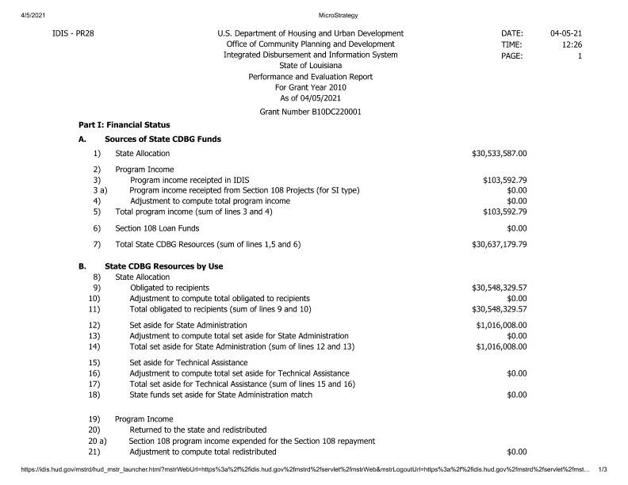
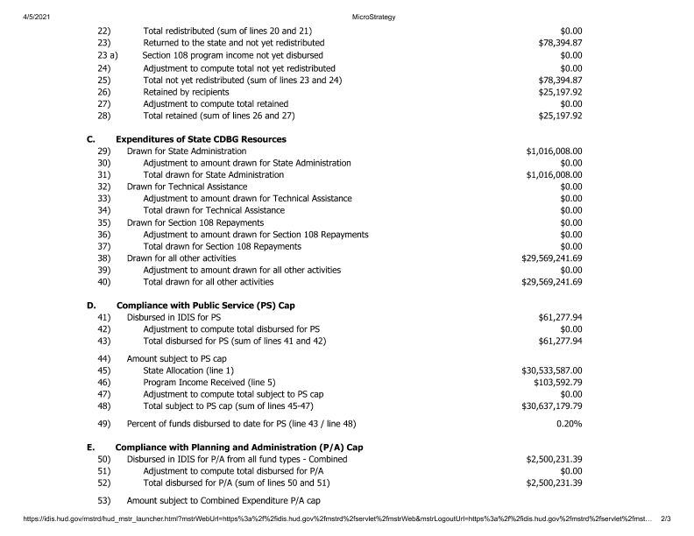
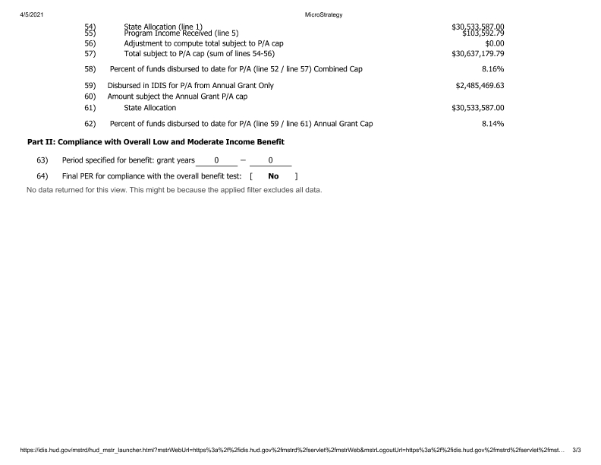
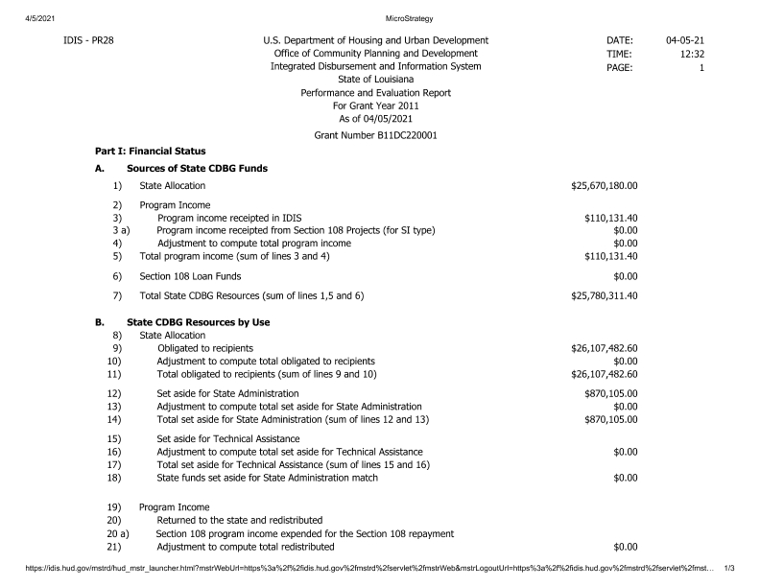
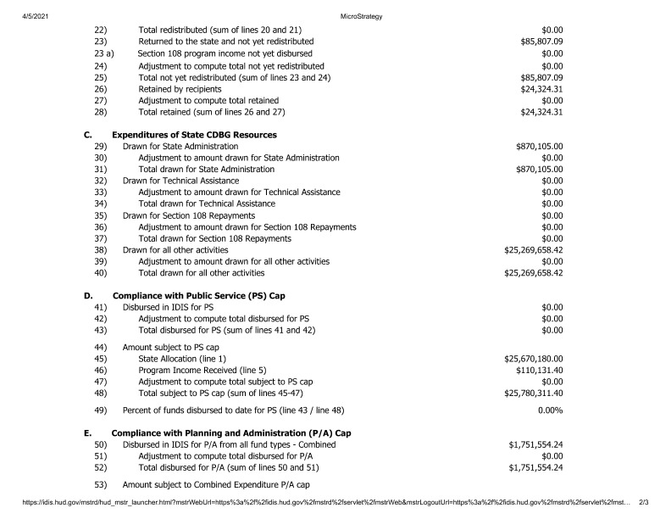
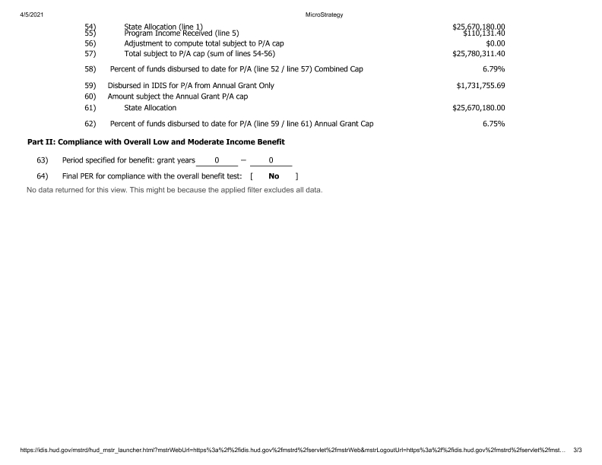
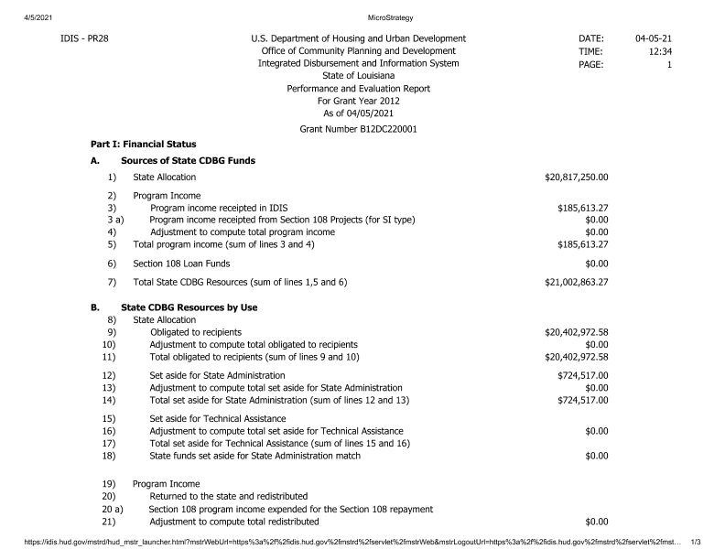
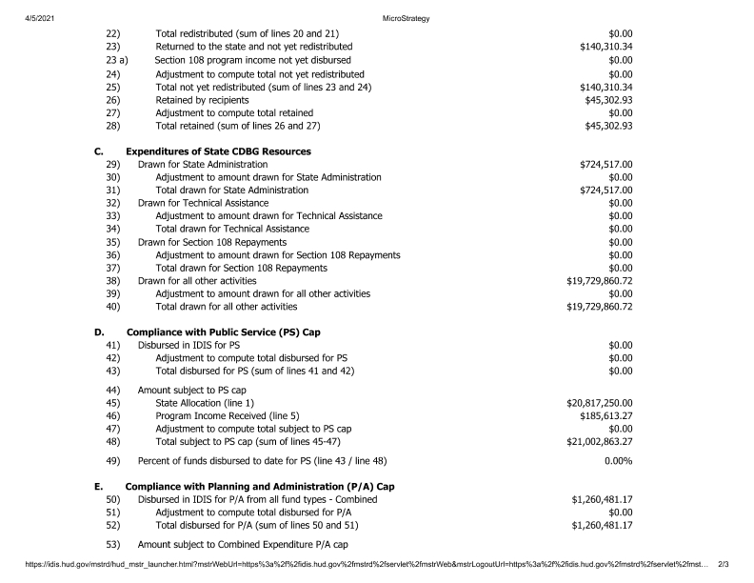
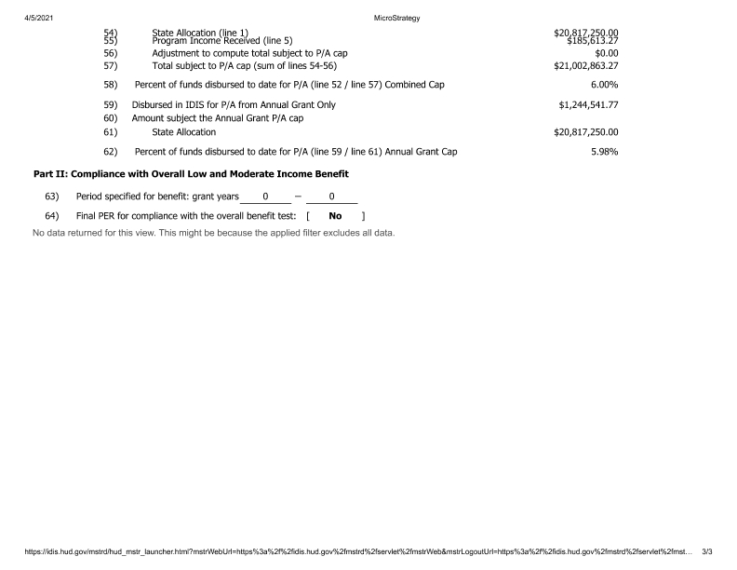
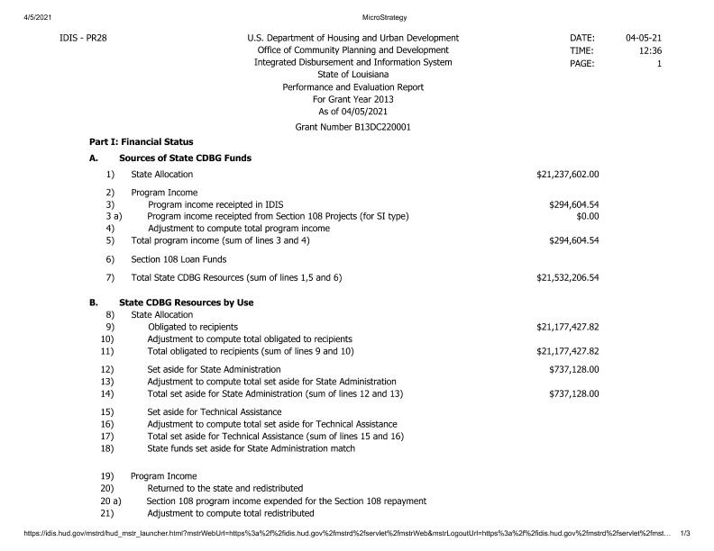
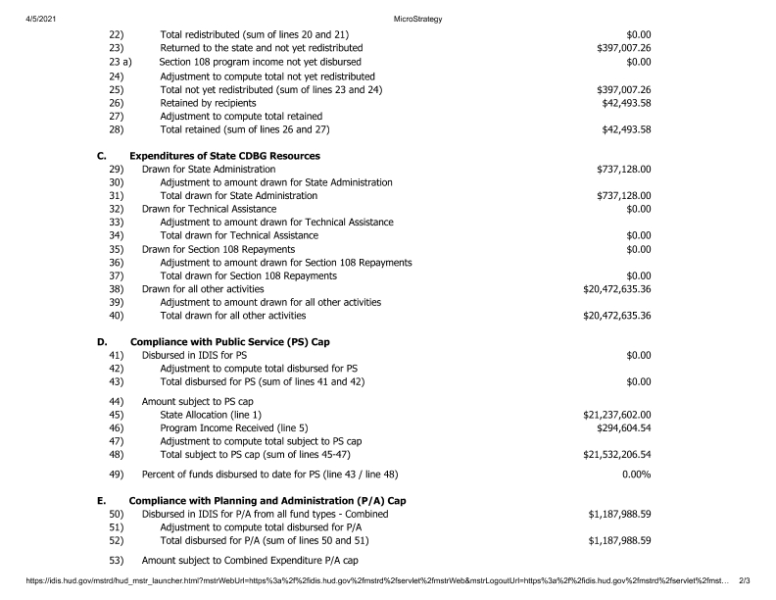
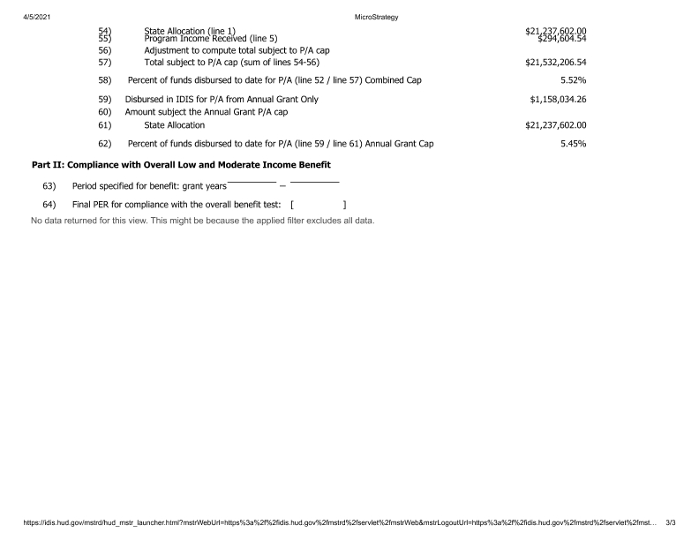
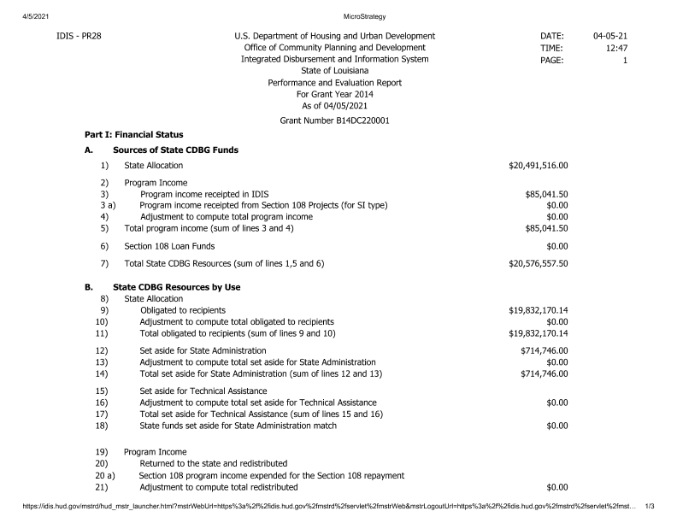
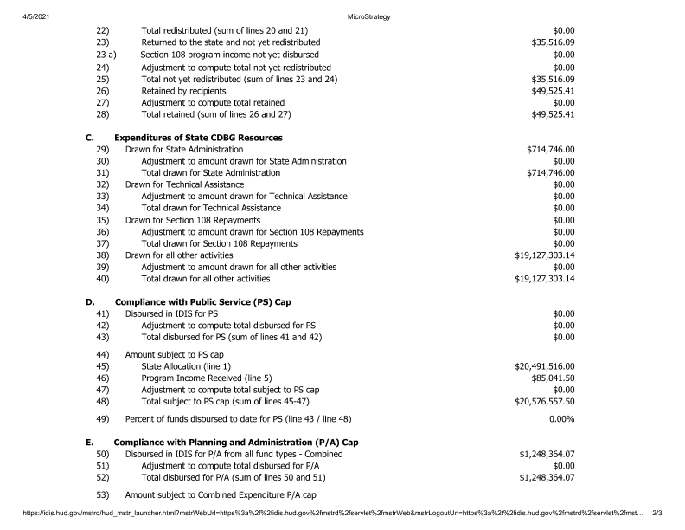
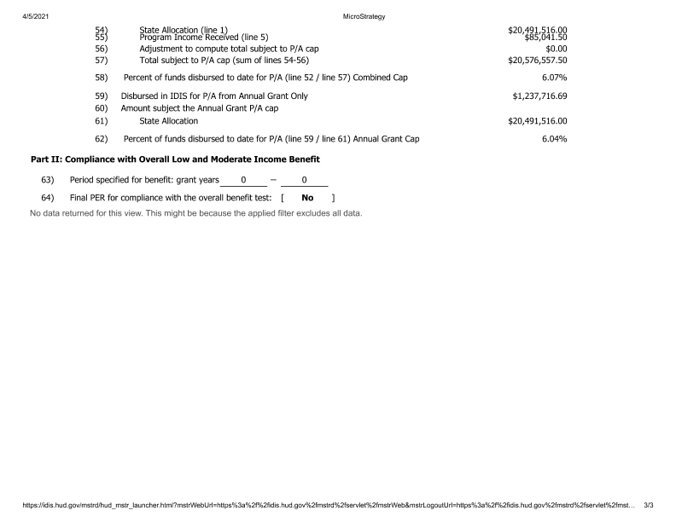
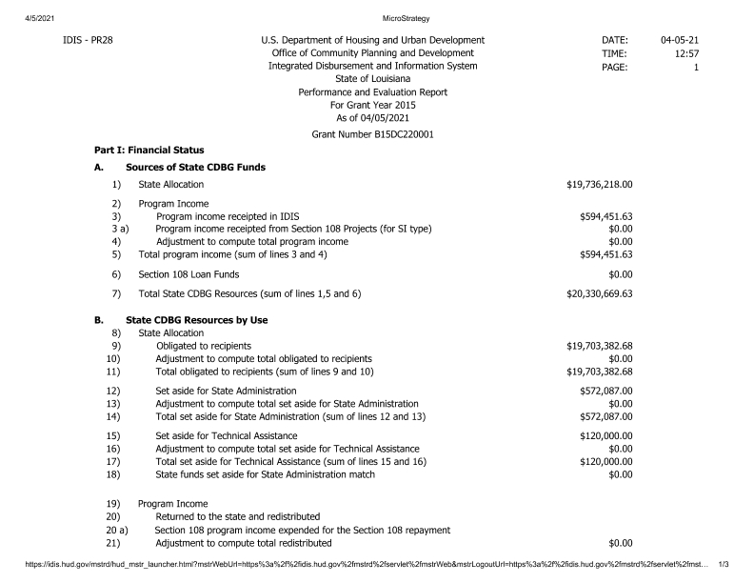
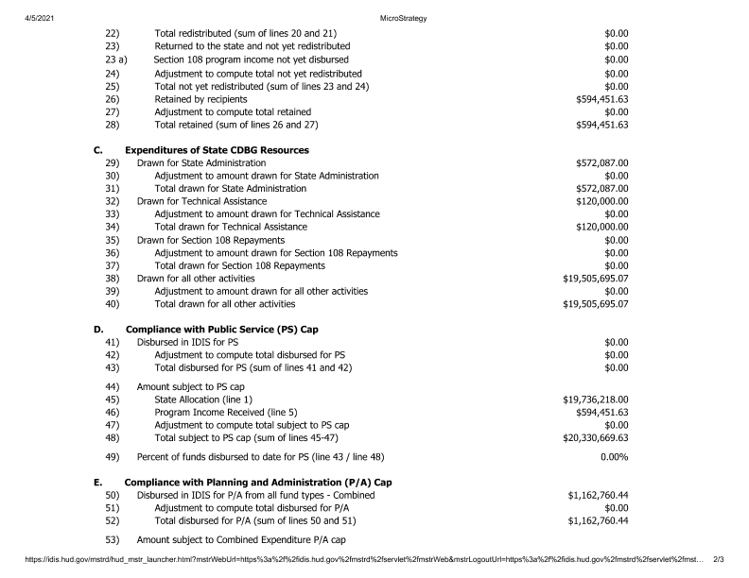
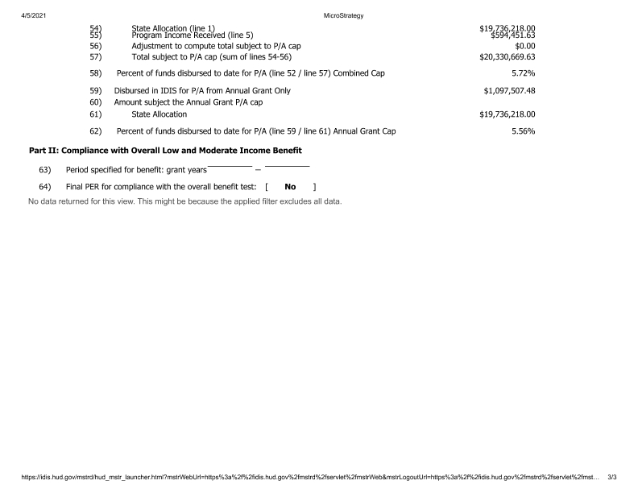
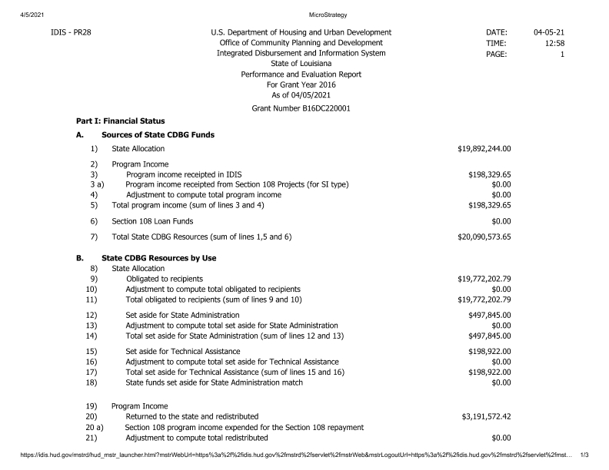
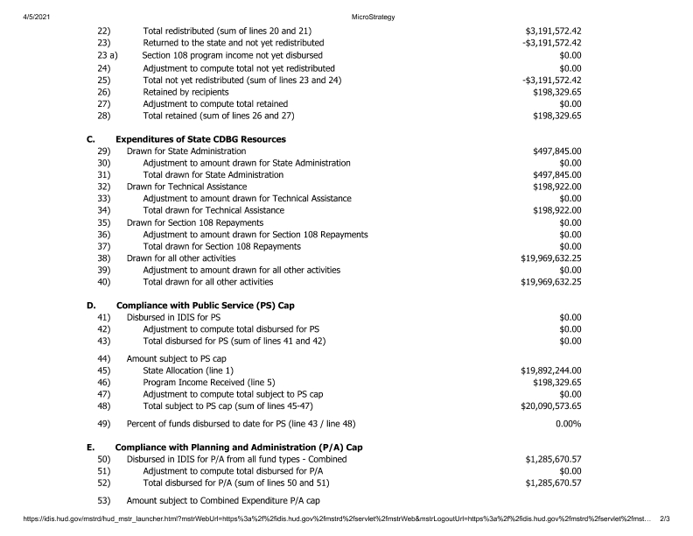
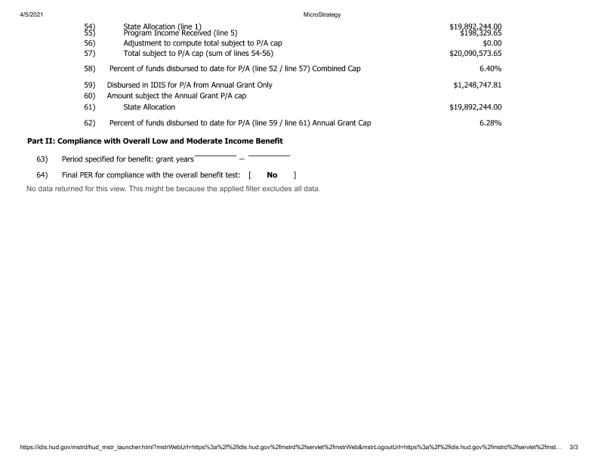
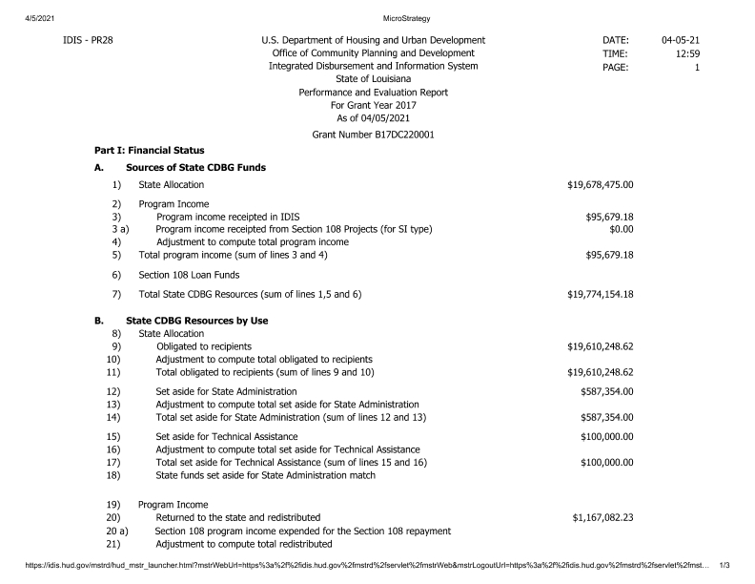
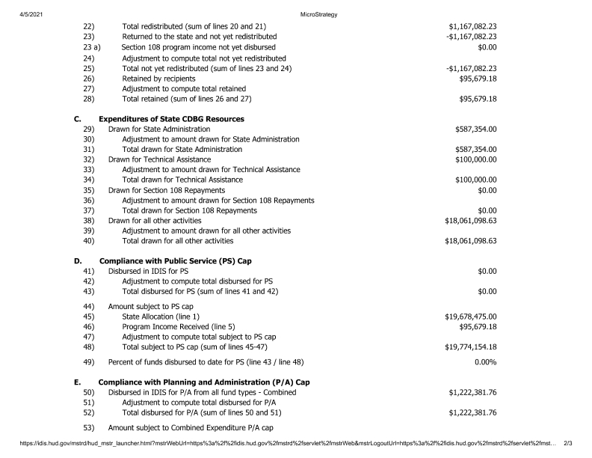
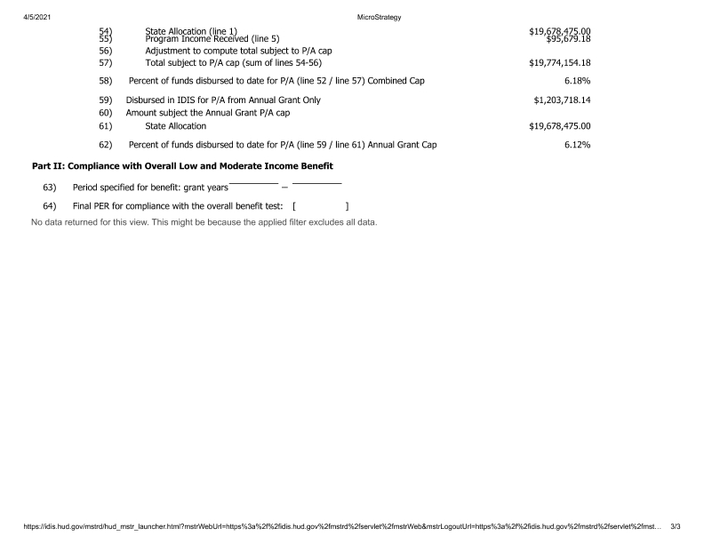
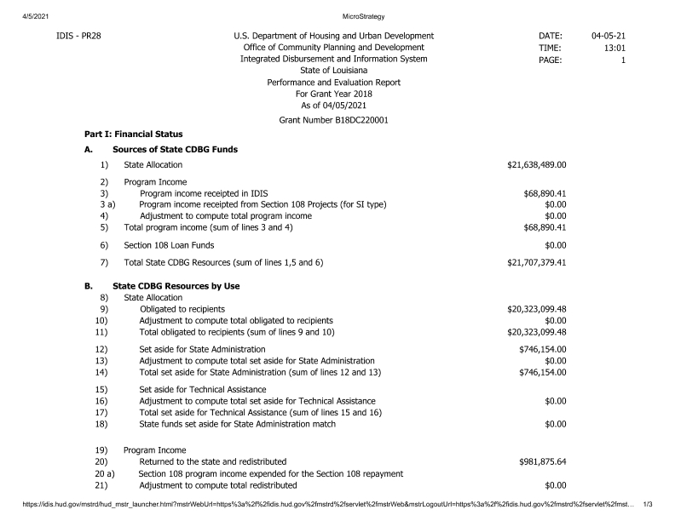
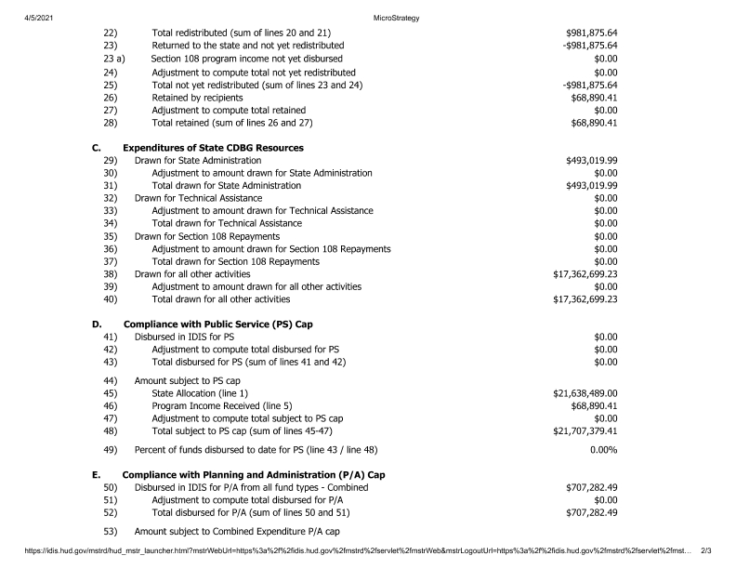
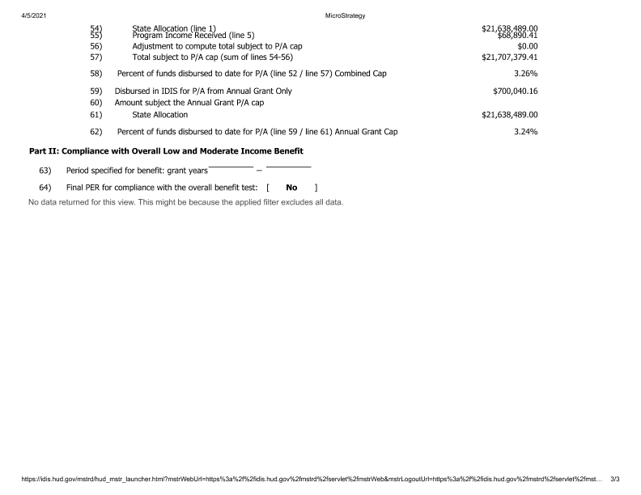
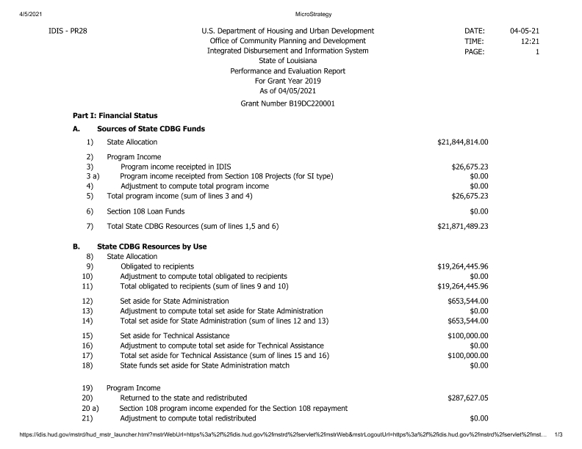
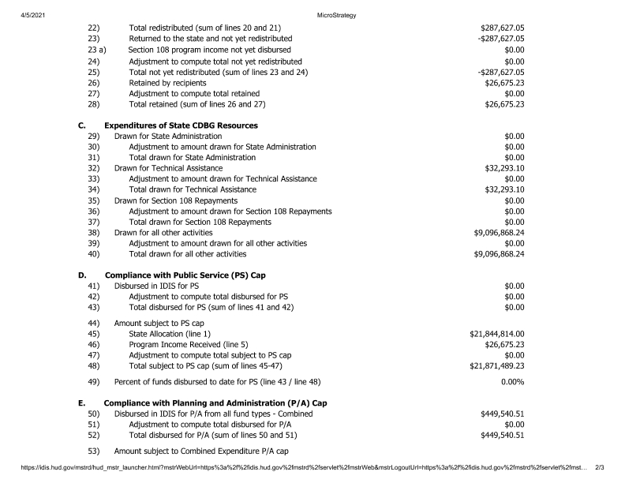
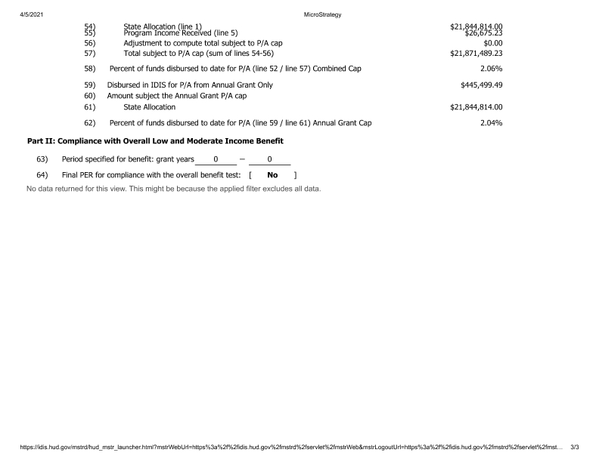
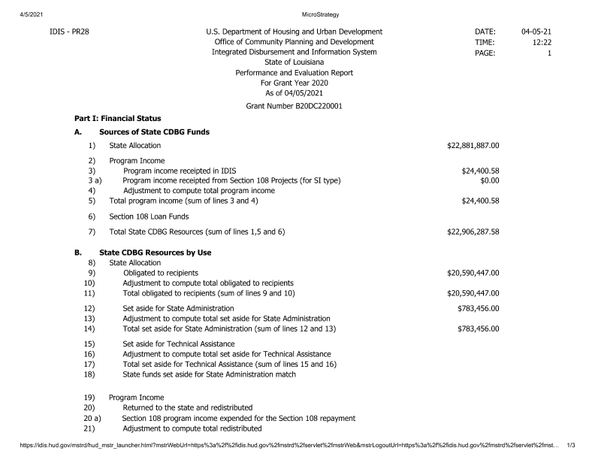
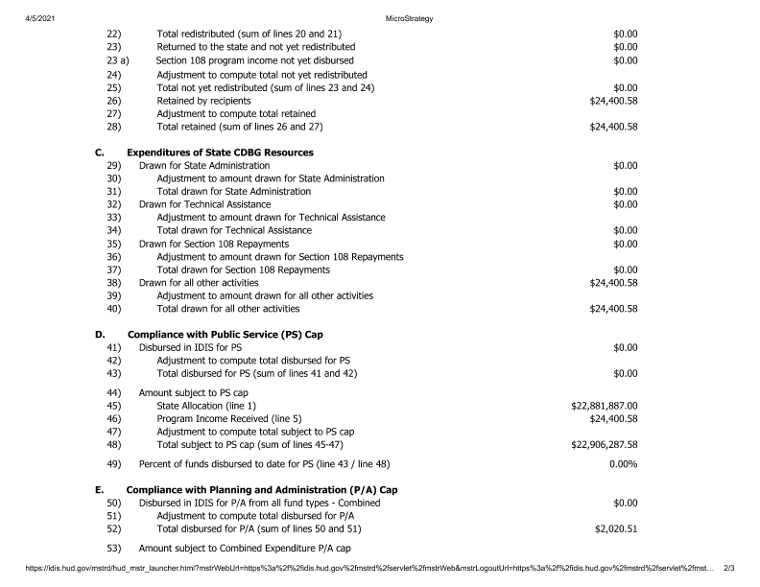
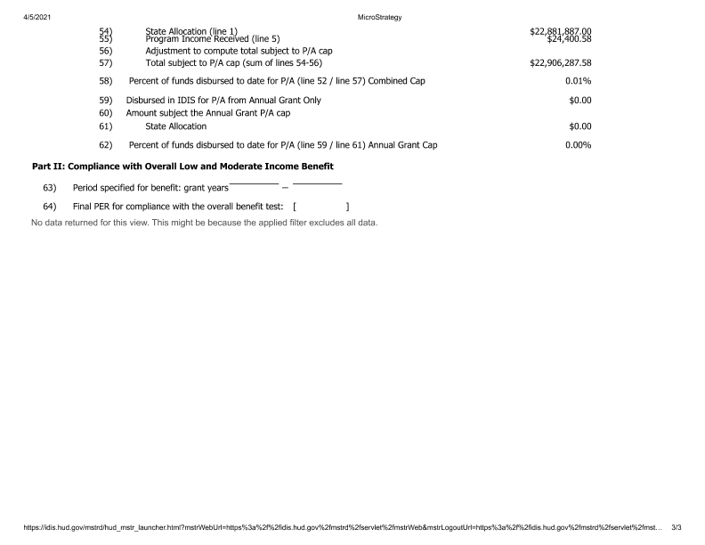

PR 28 Activity Summary
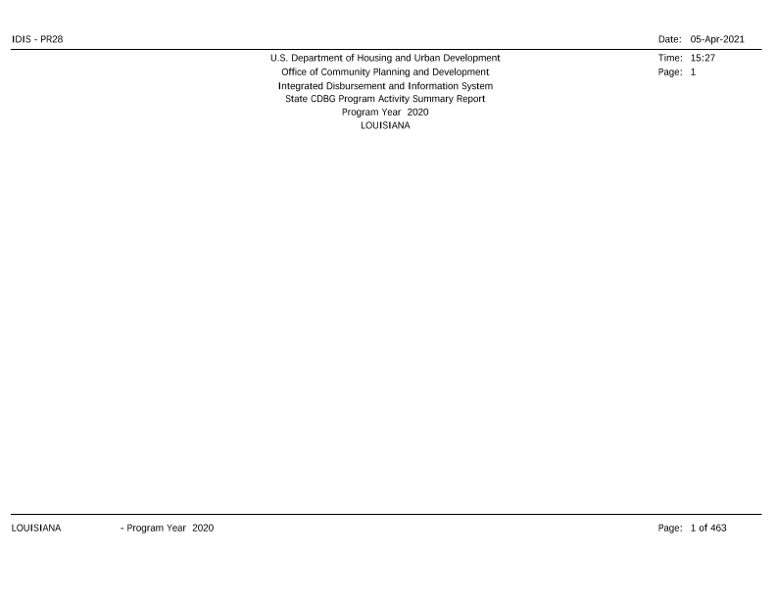
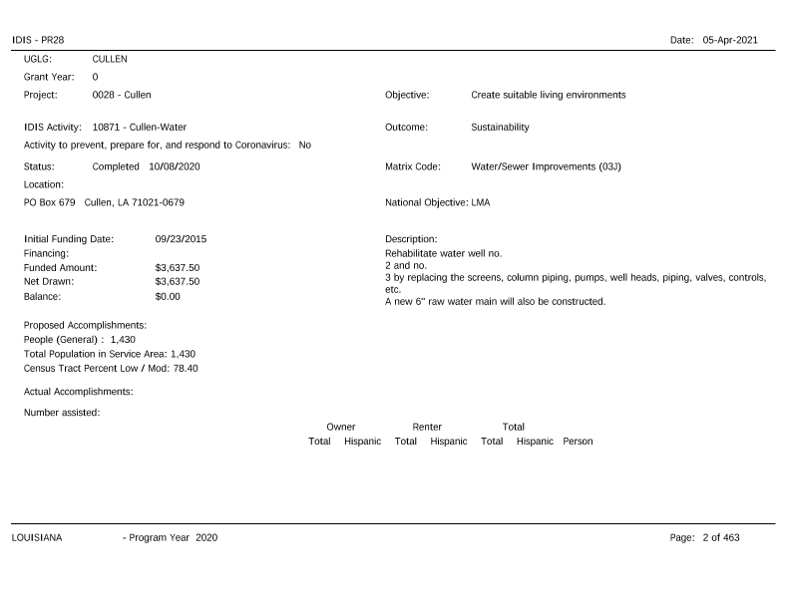
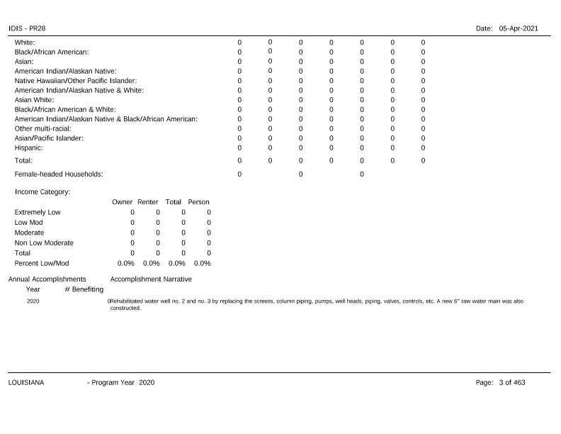
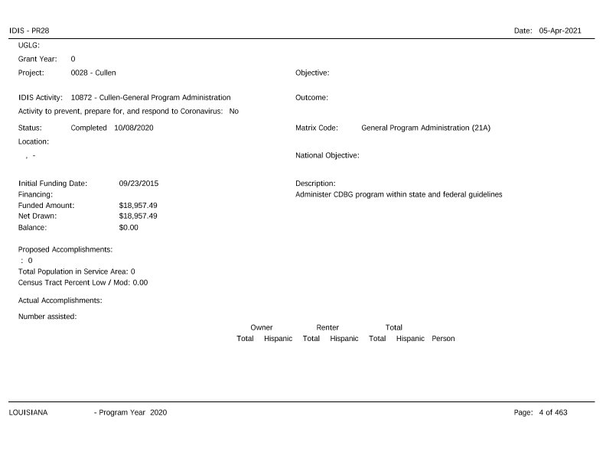
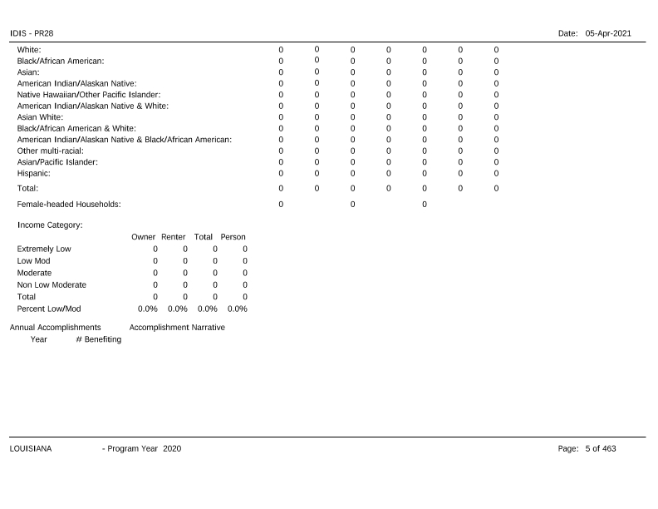
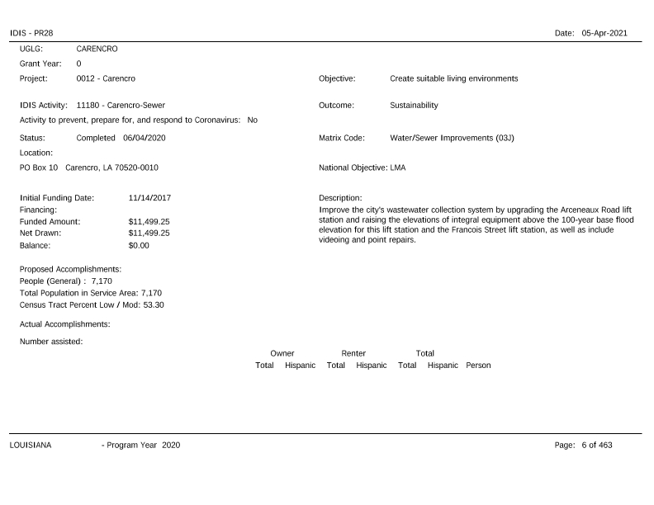
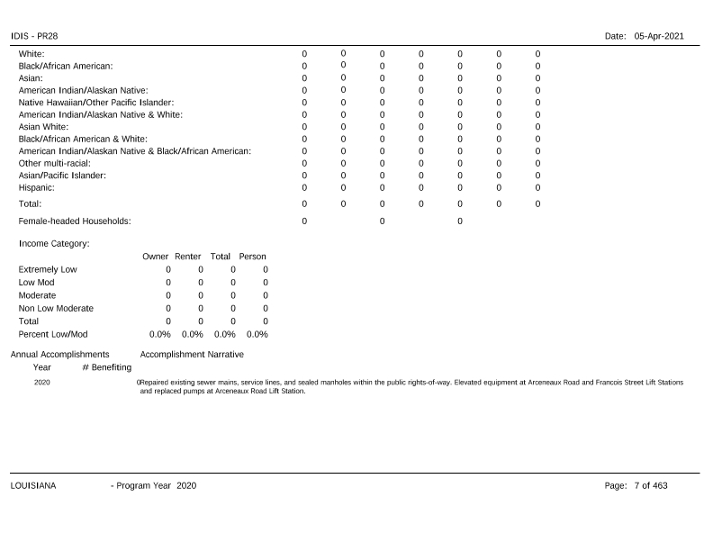
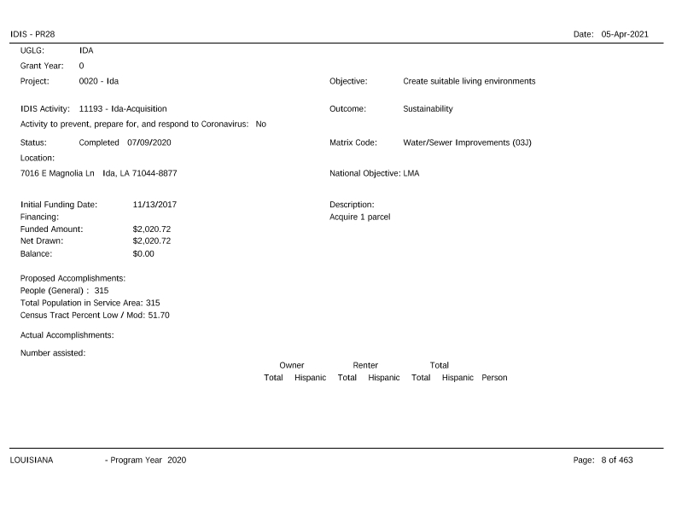
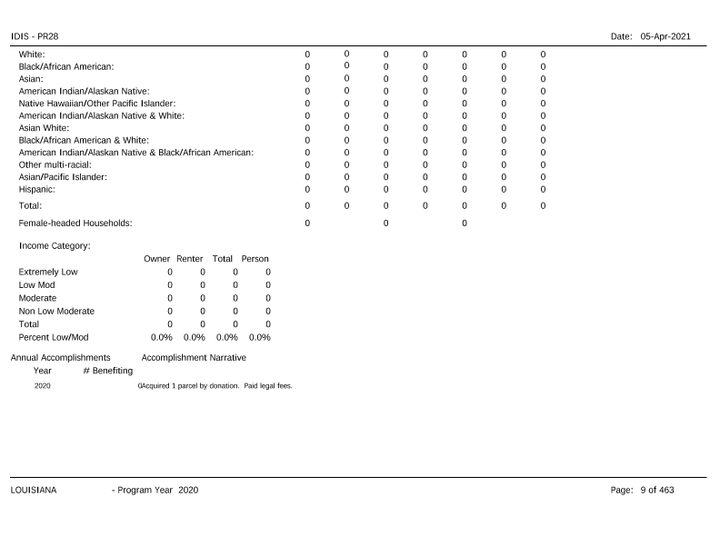
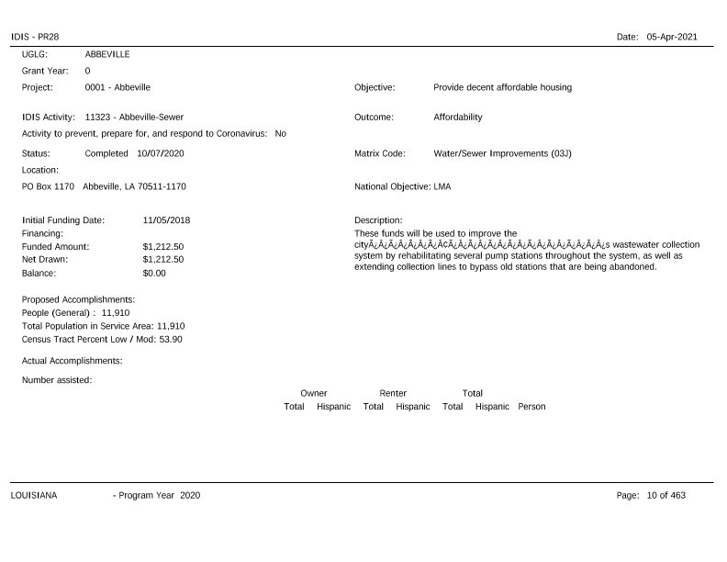
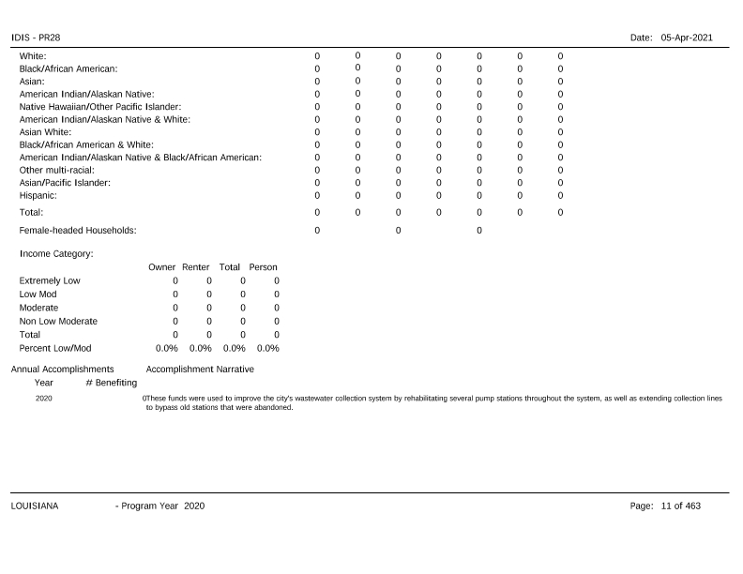
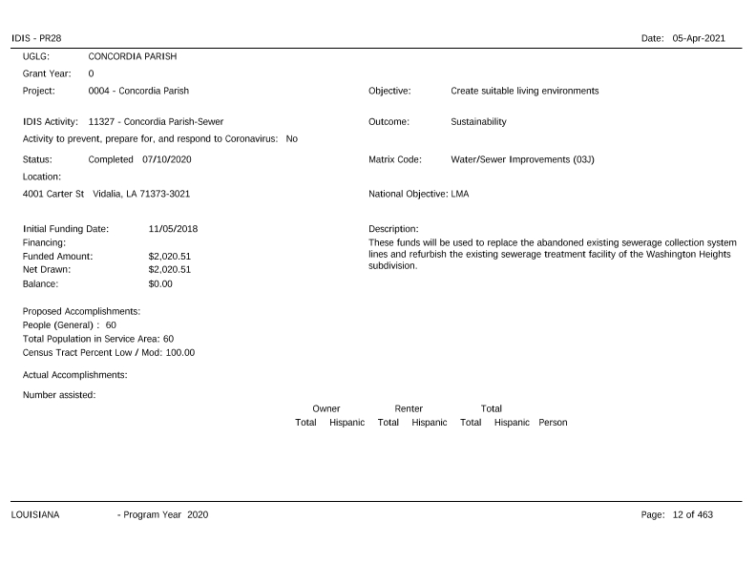
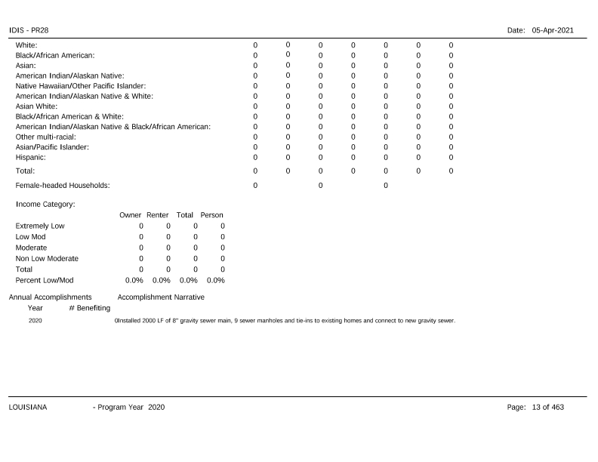
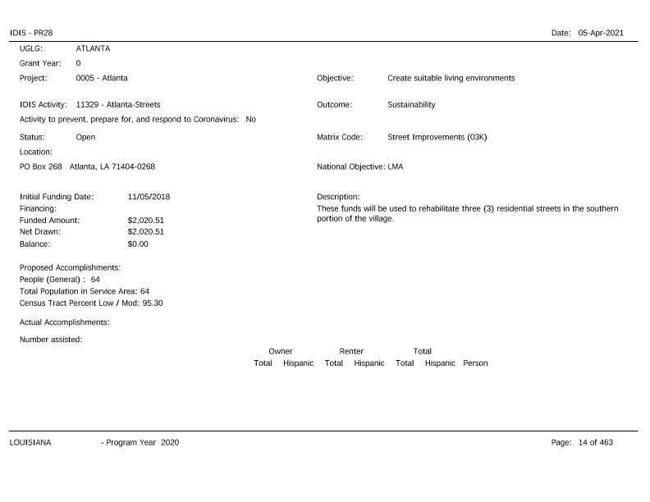
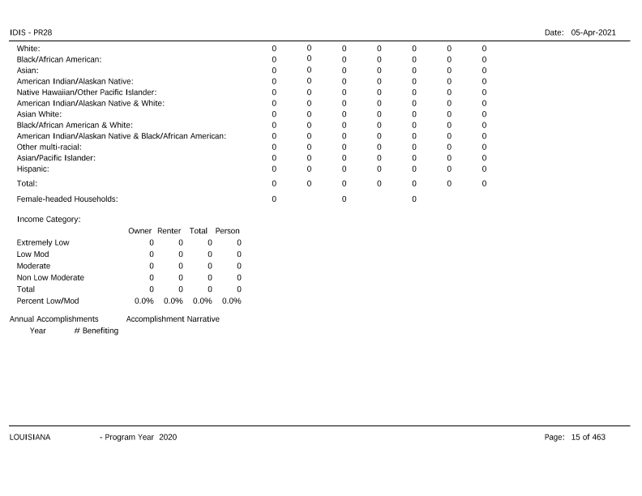
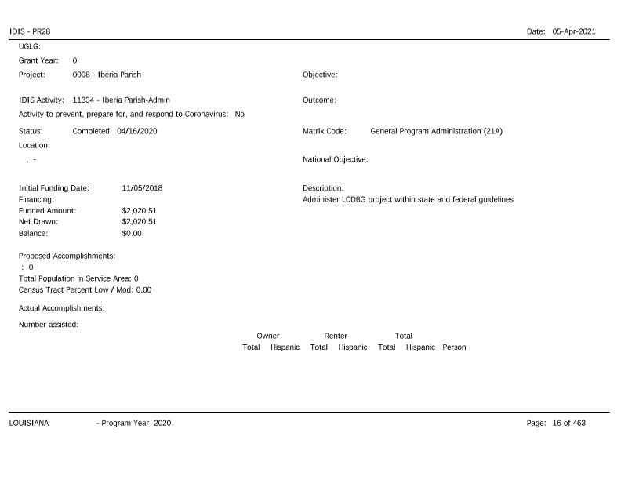
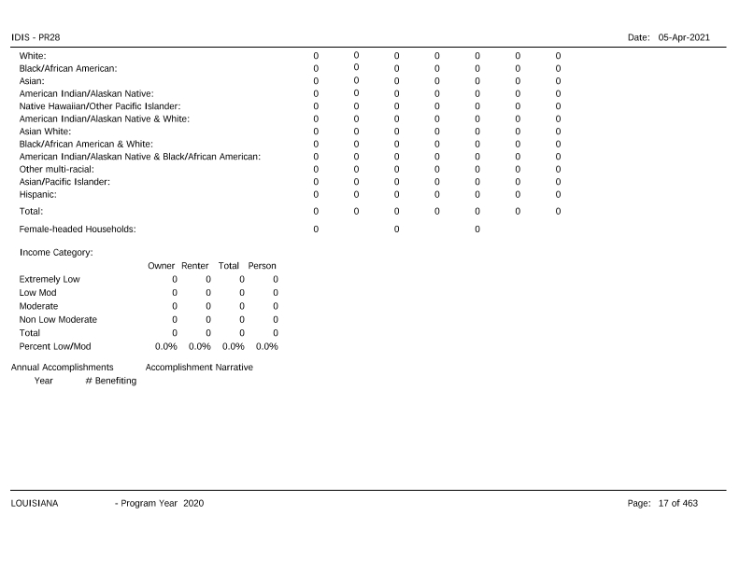
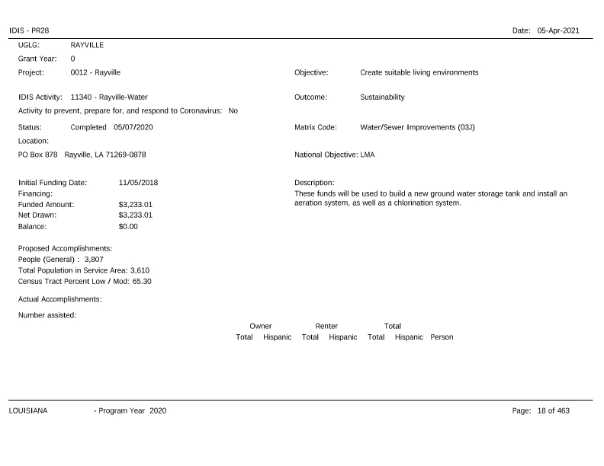
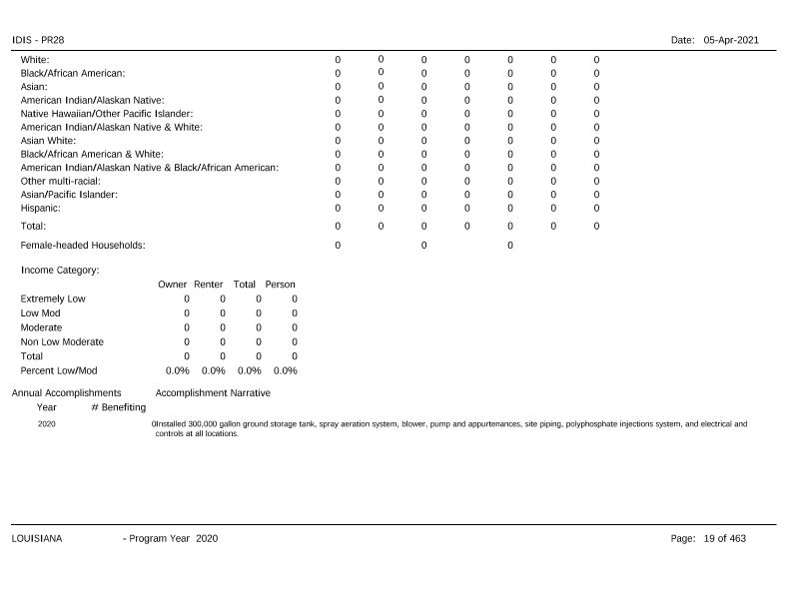
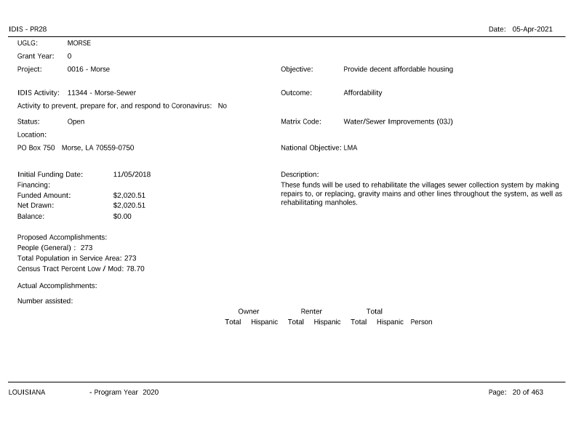
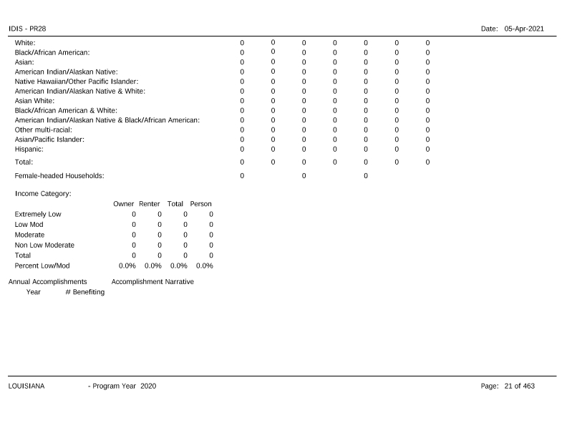
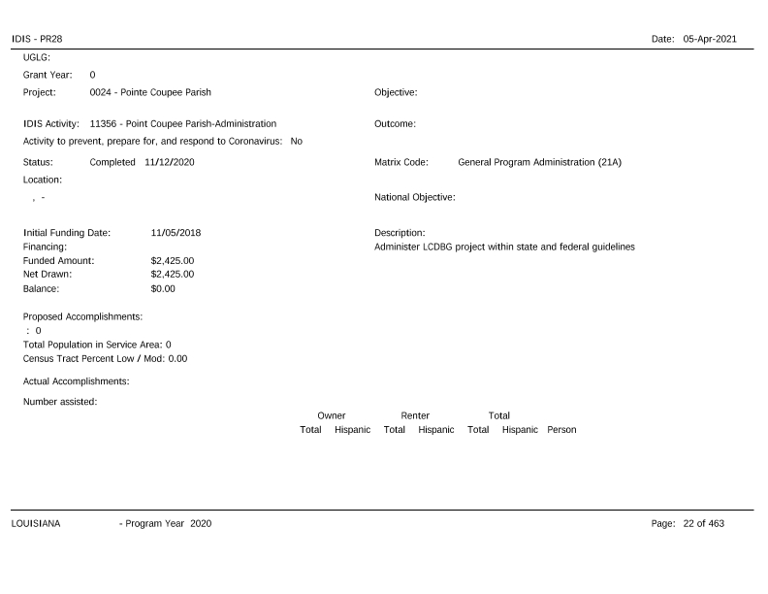
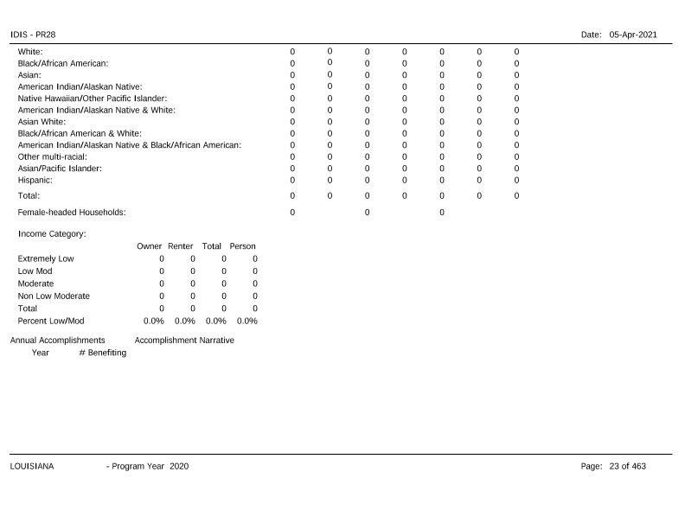
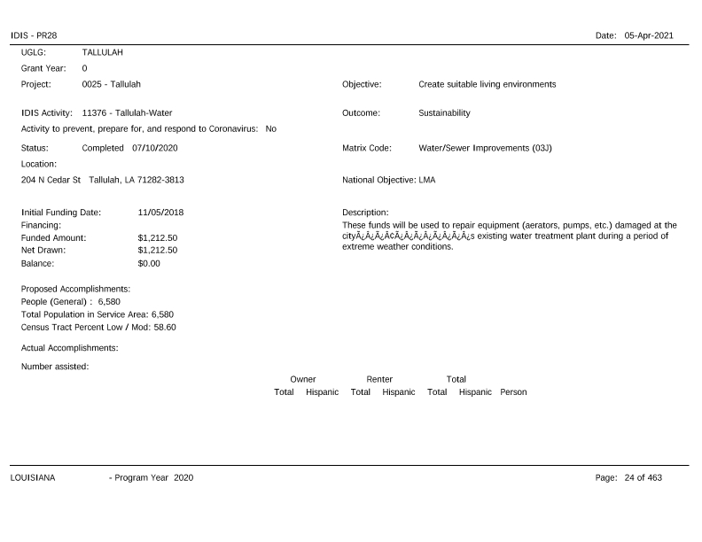
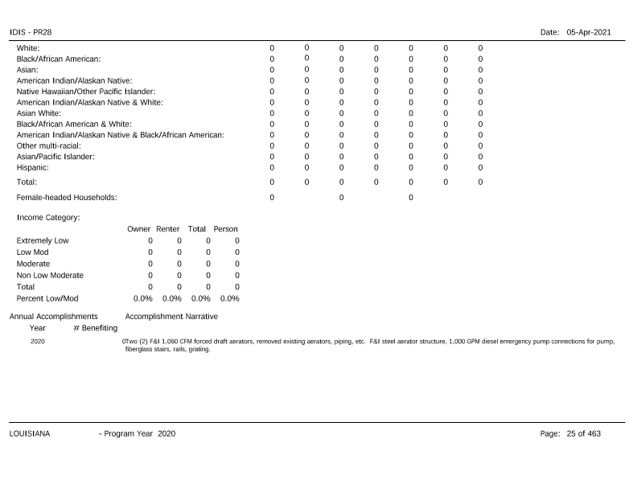
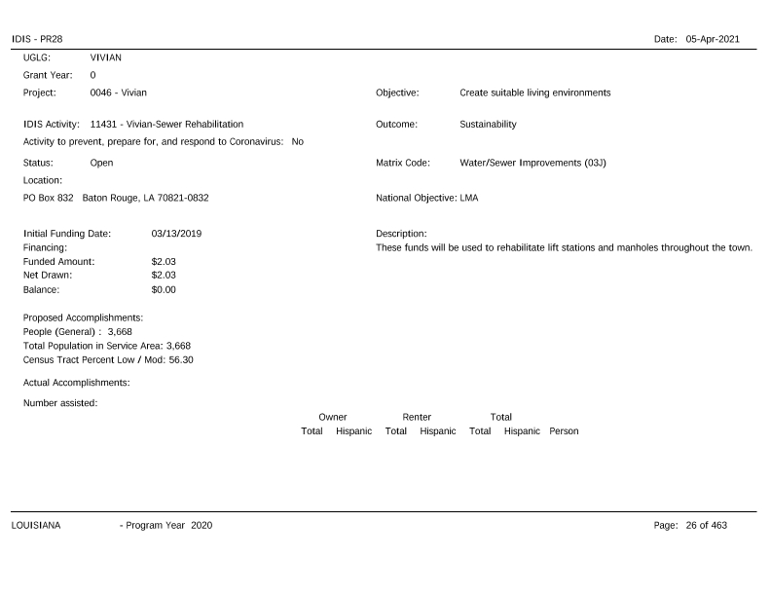
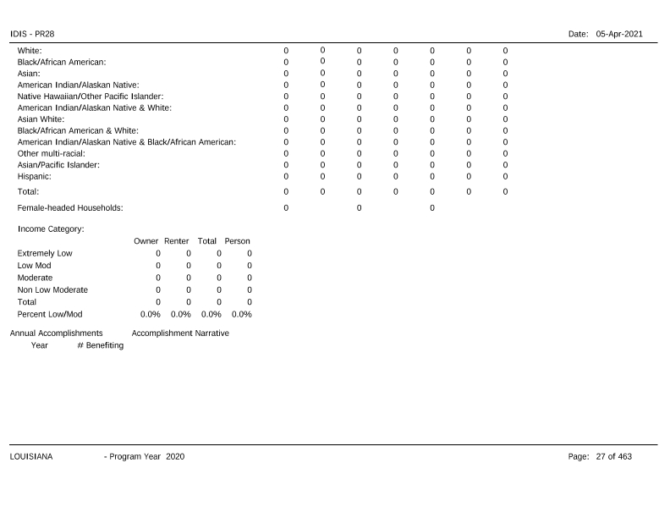
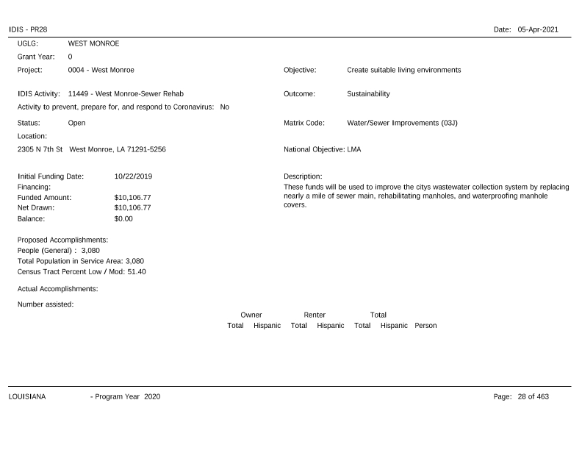
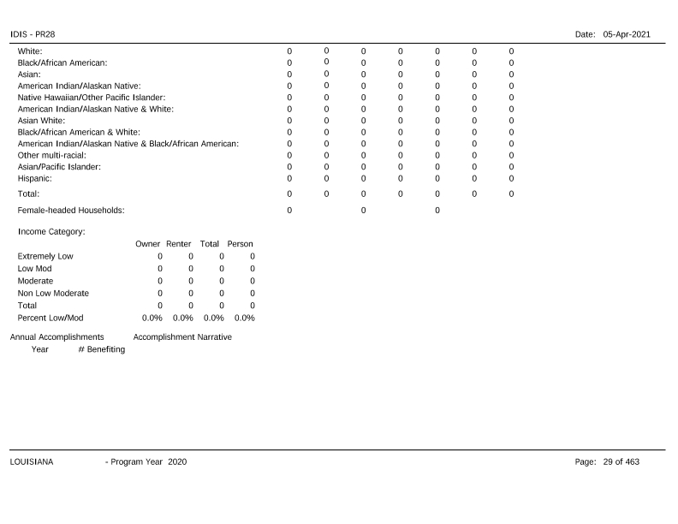
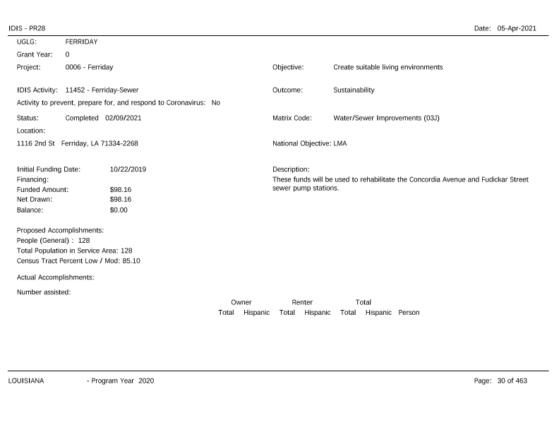
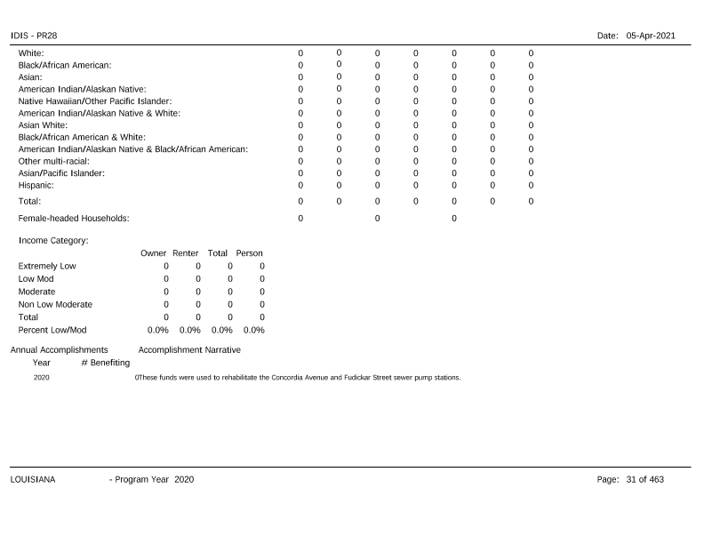
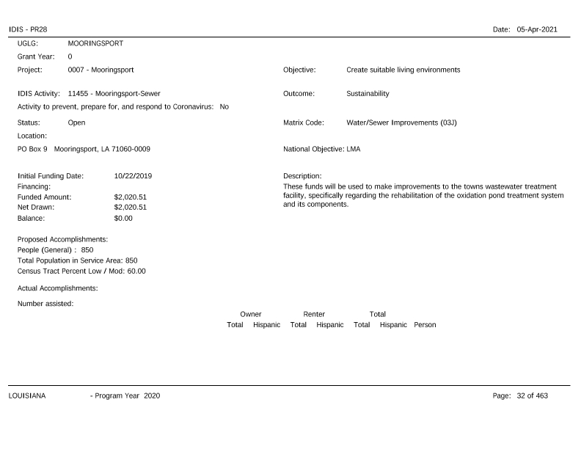
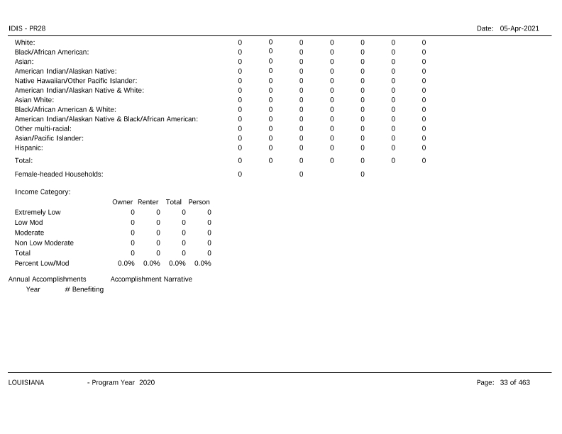
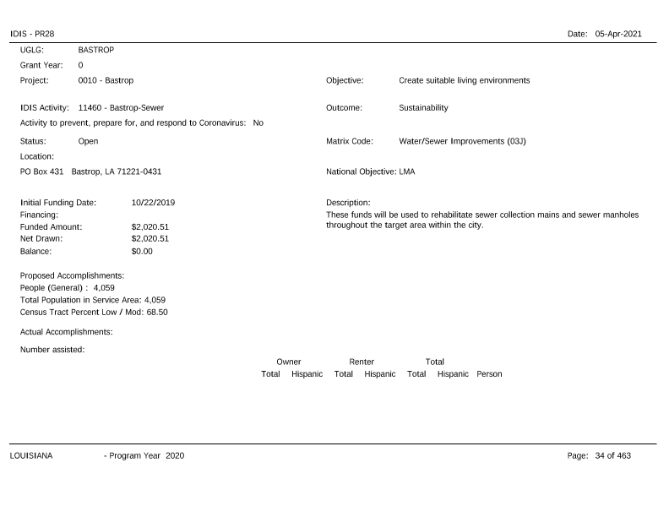
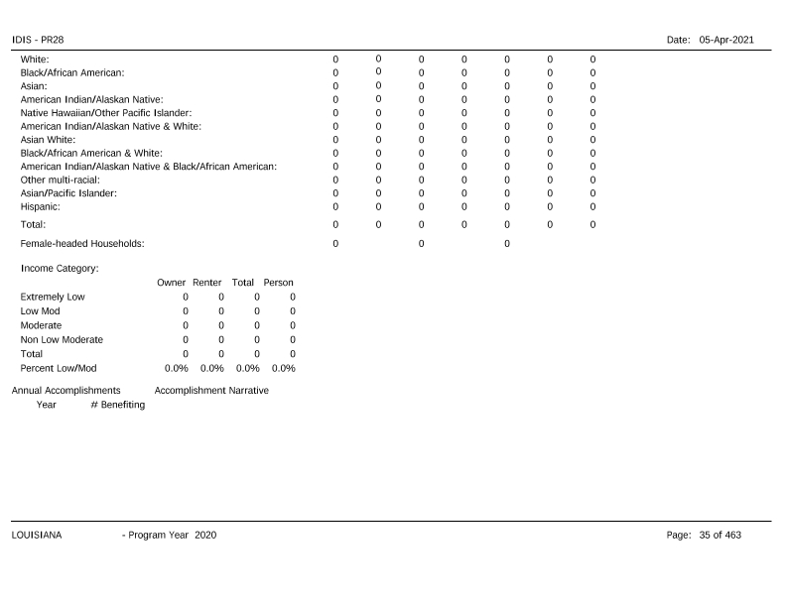
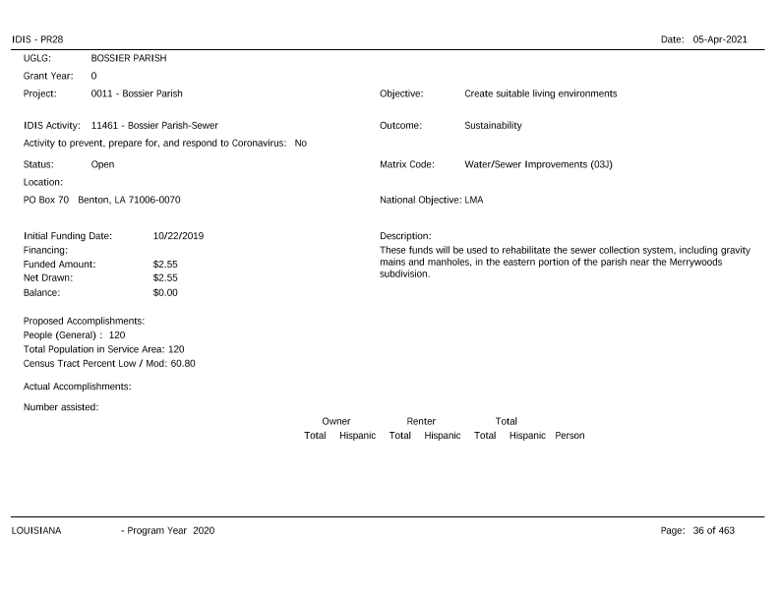
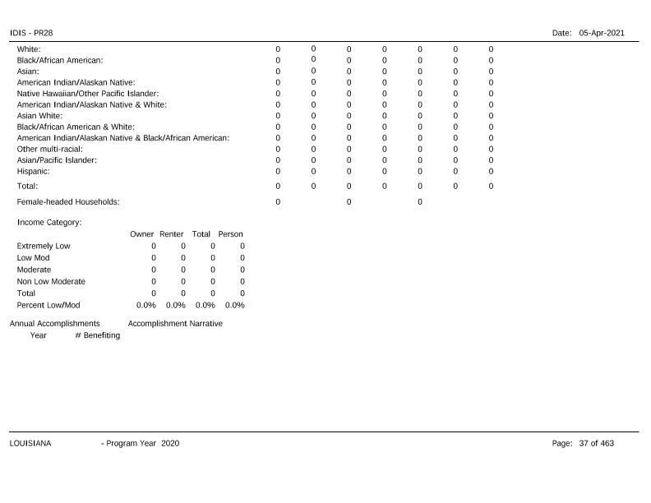
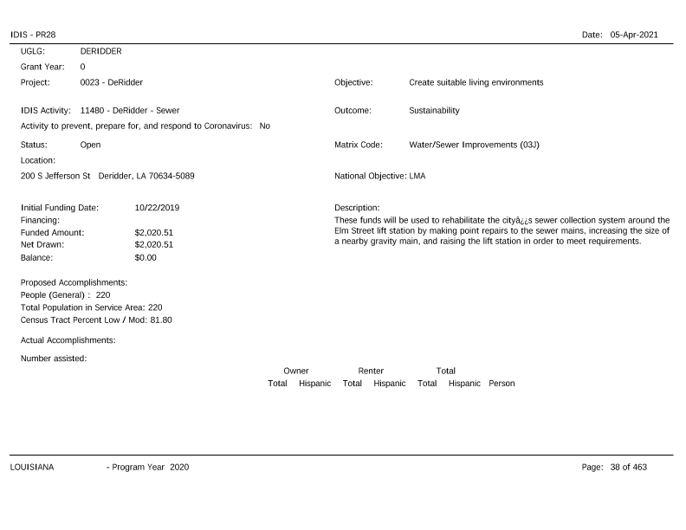
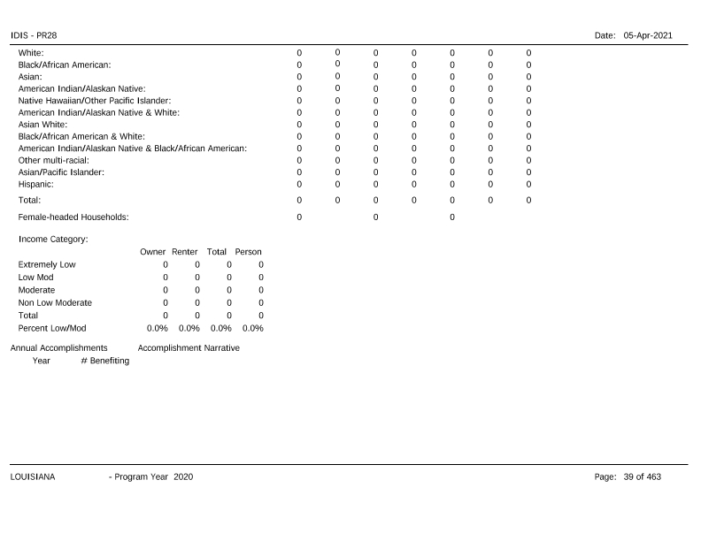
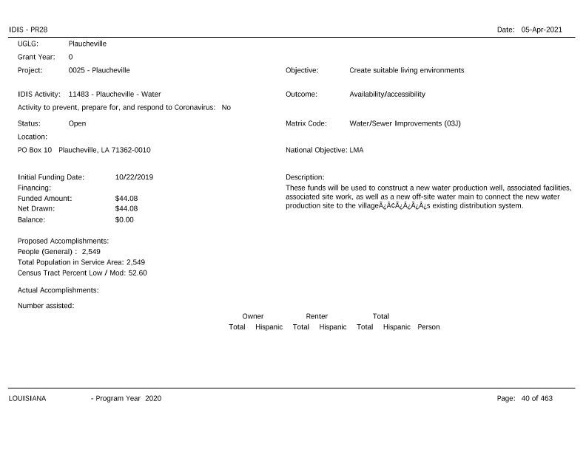
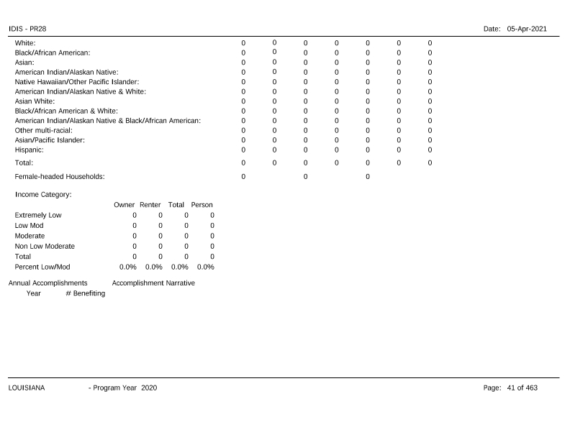
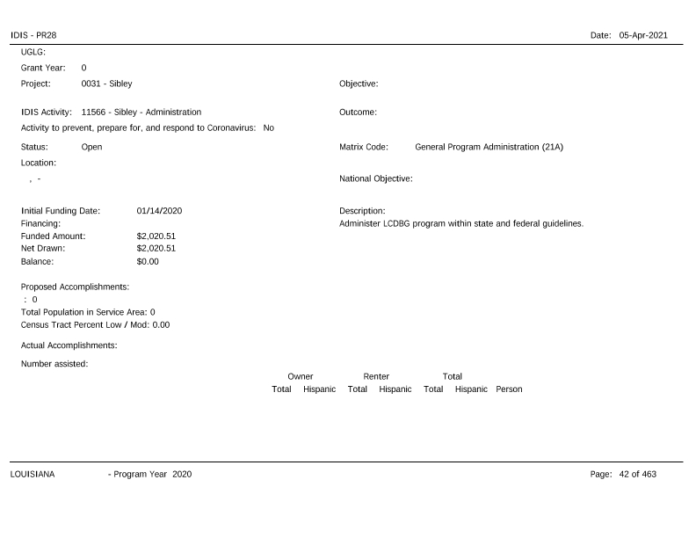
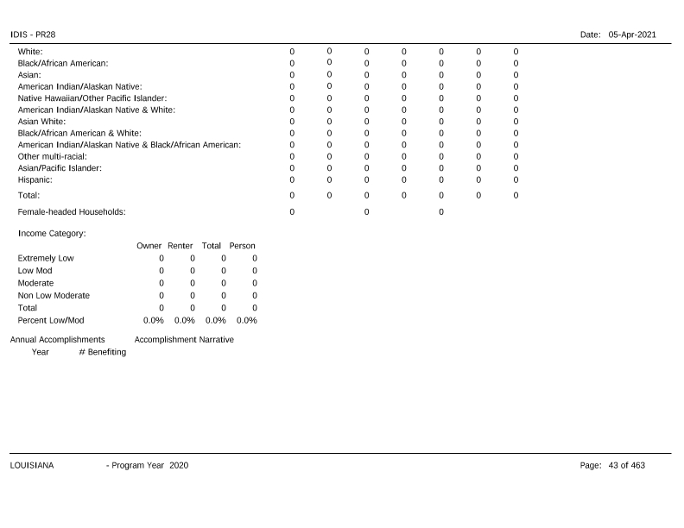
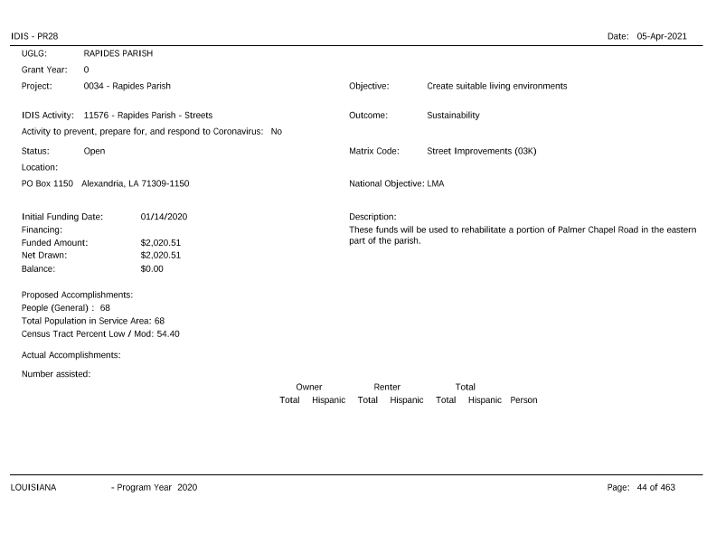
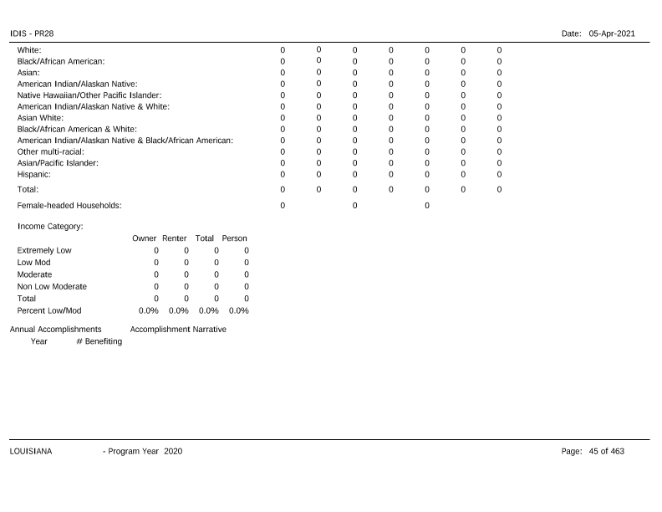
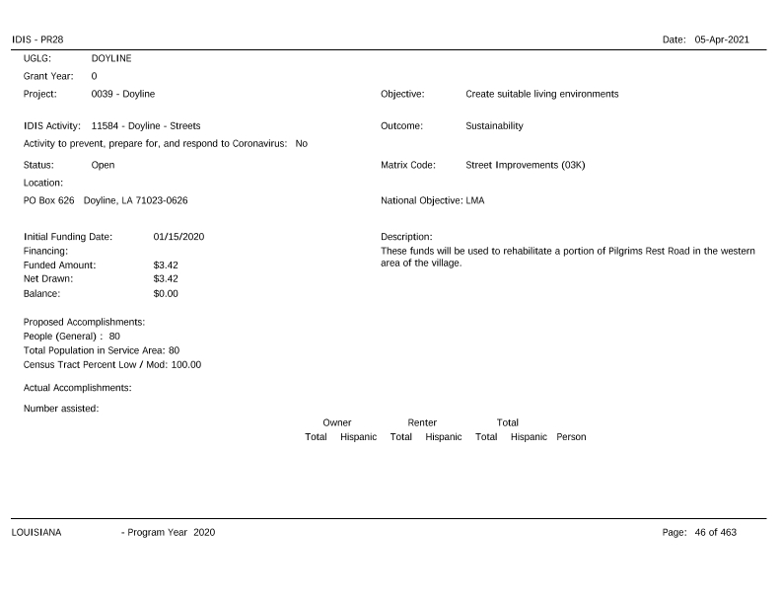
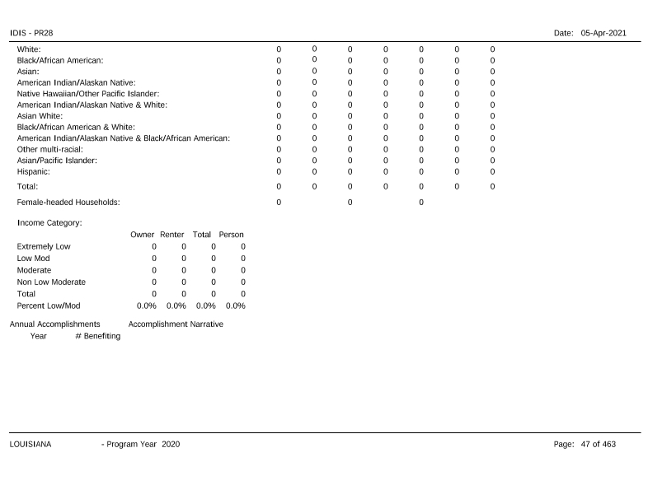
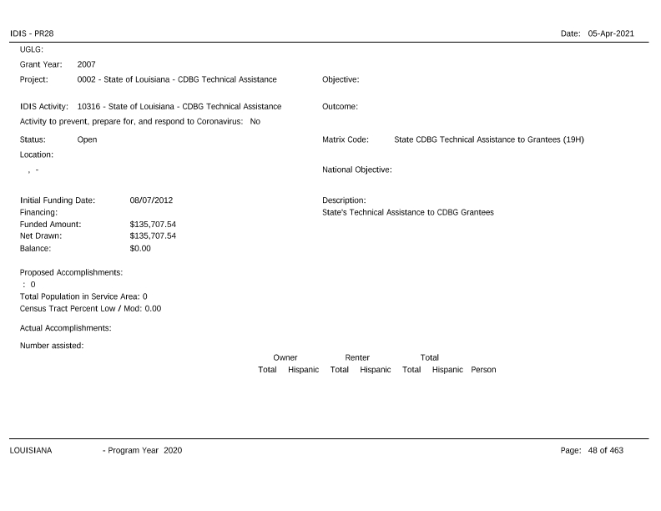
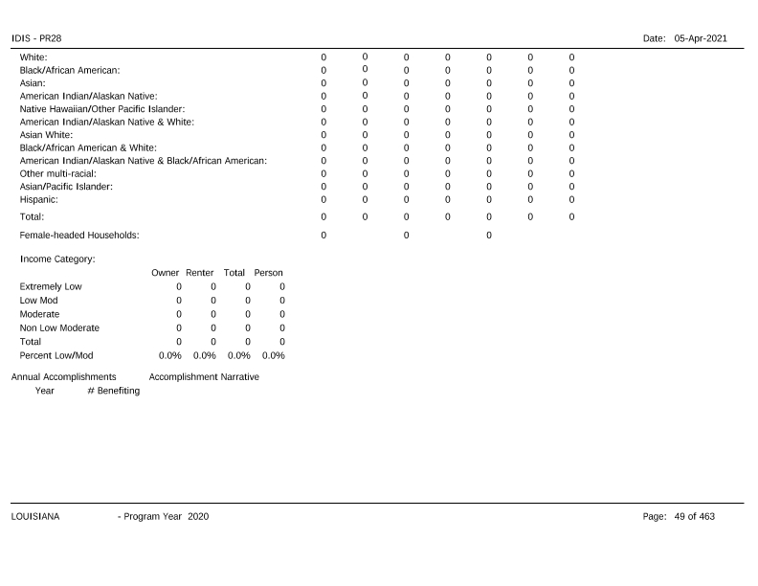
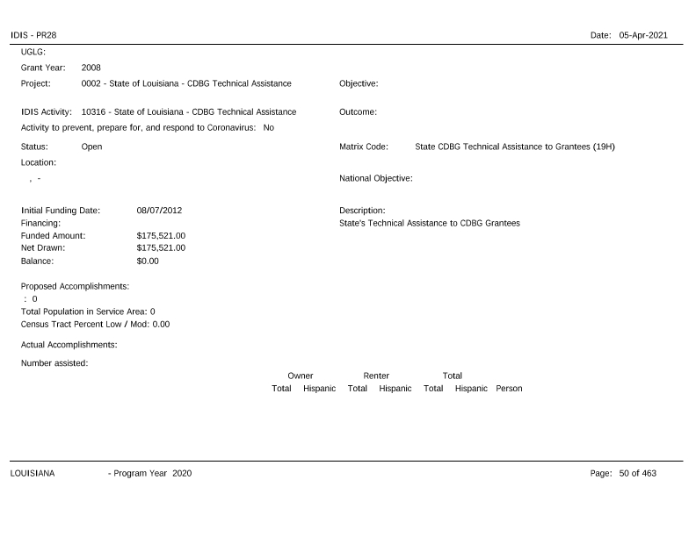
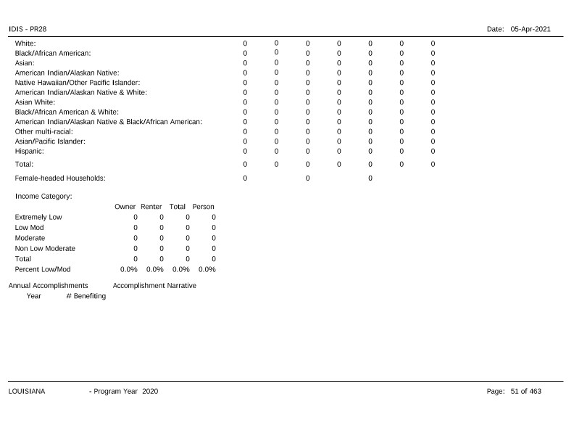
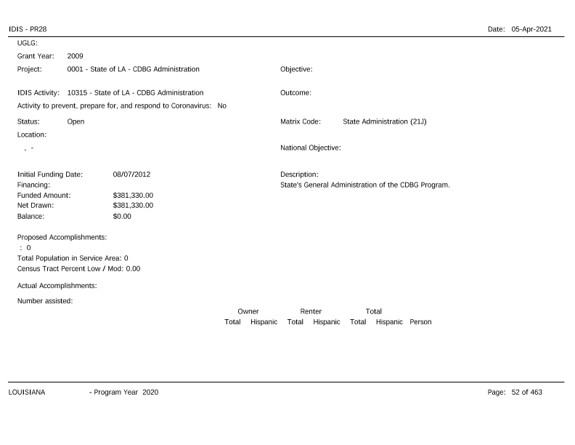
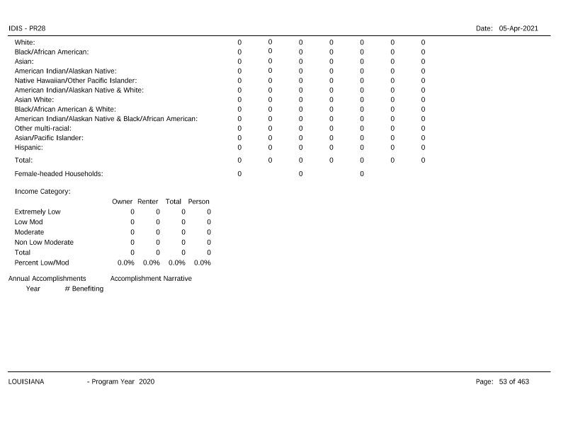
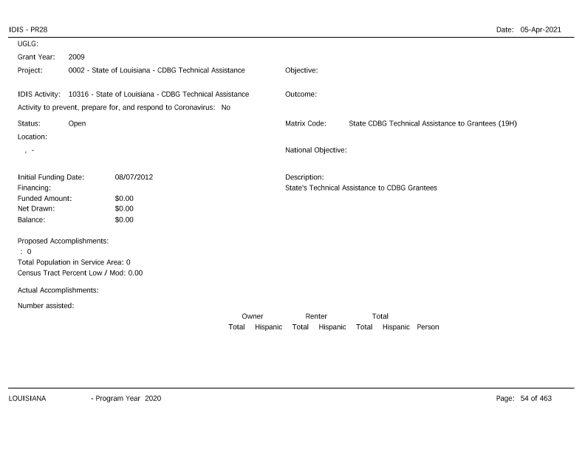
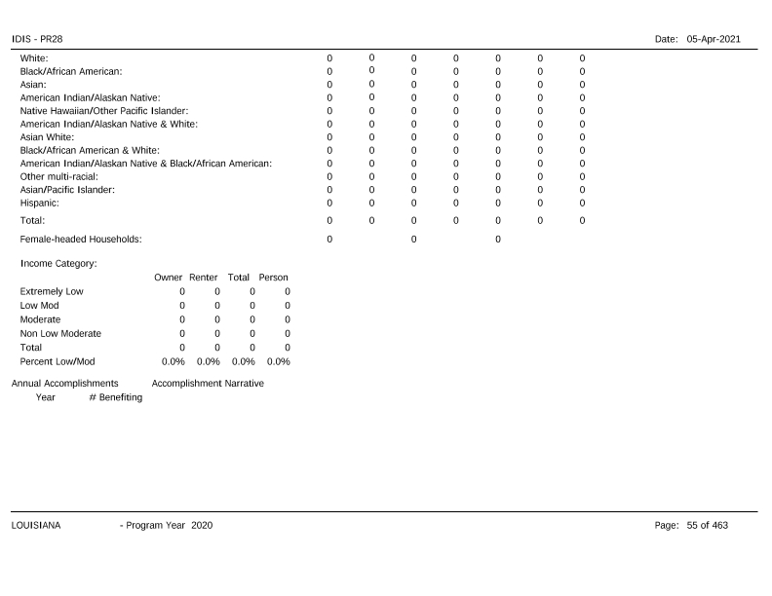
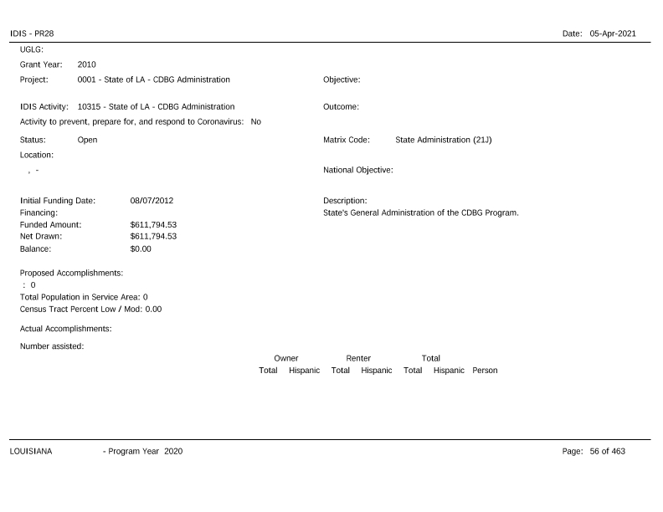
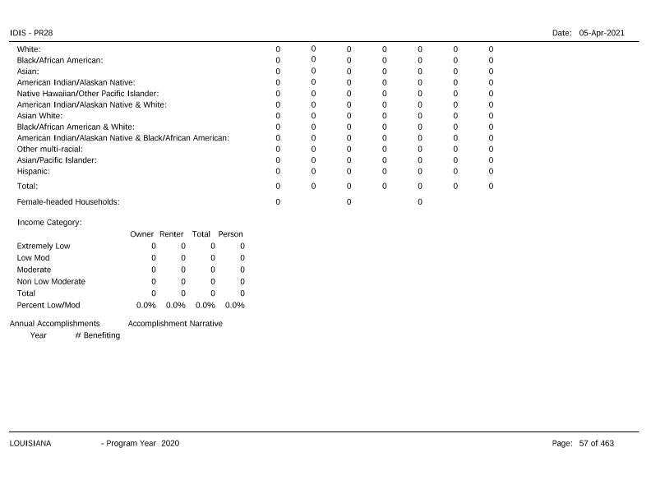
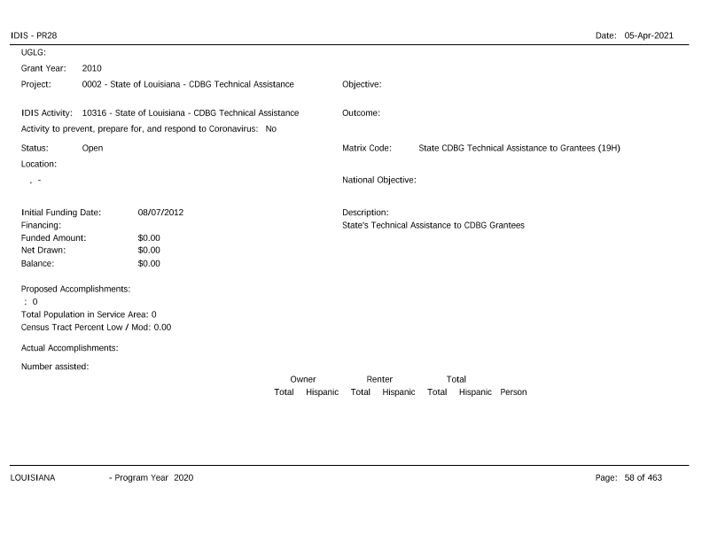
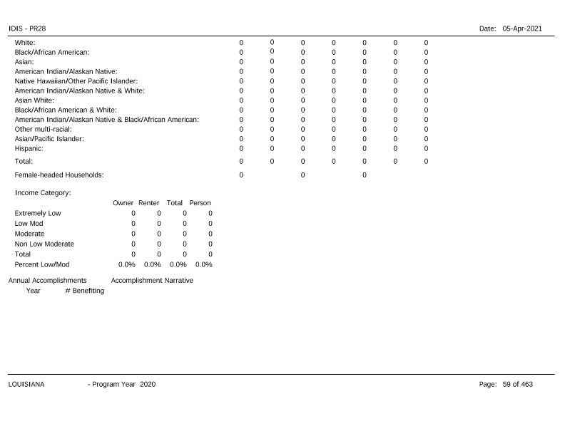
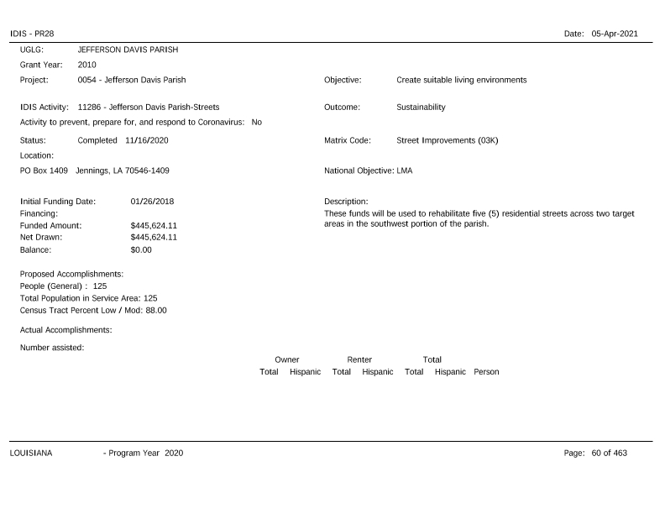
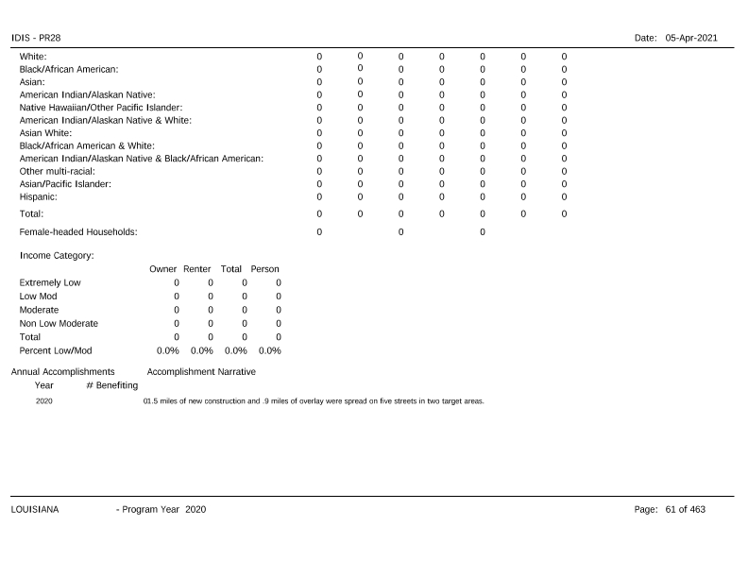
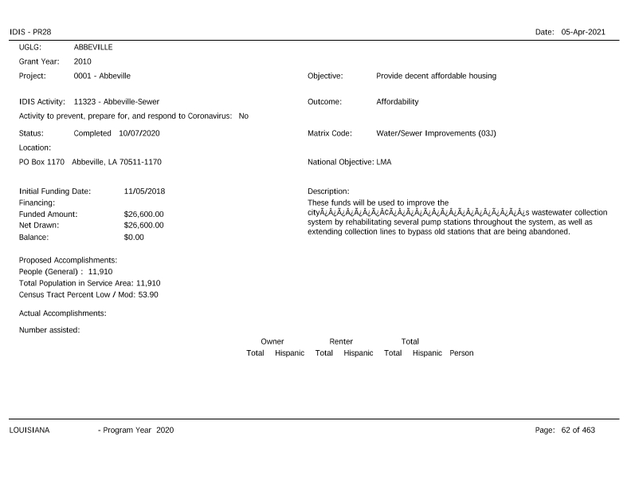
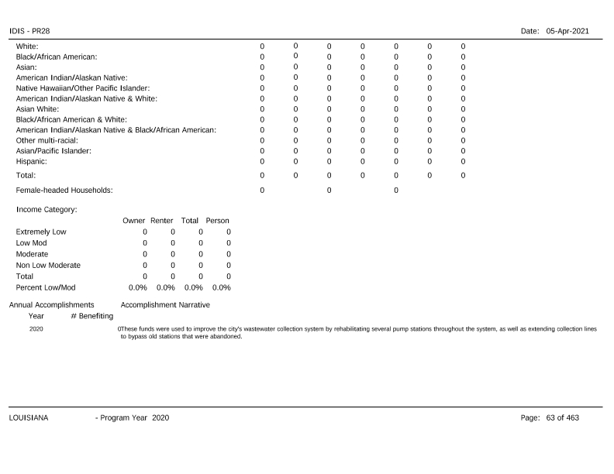
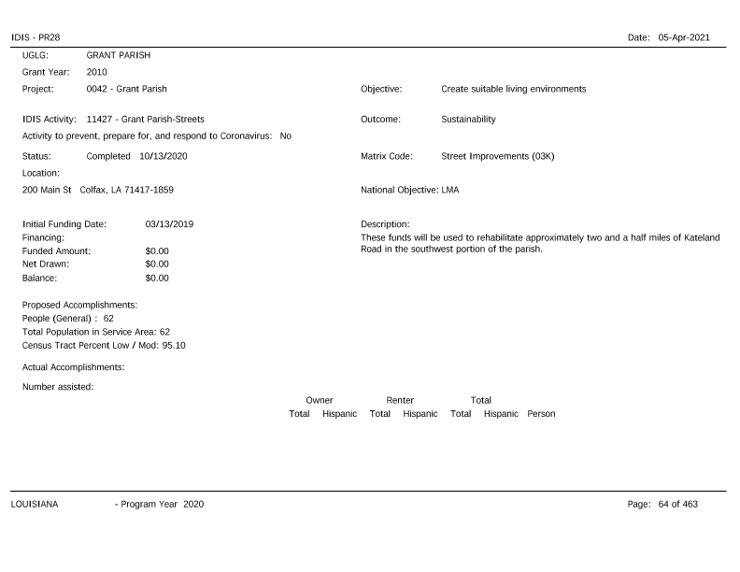
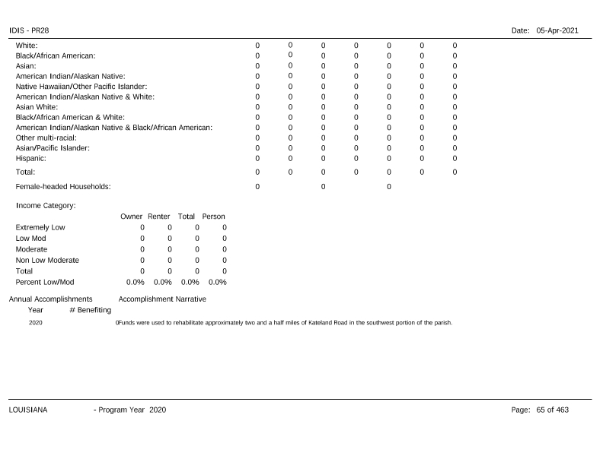
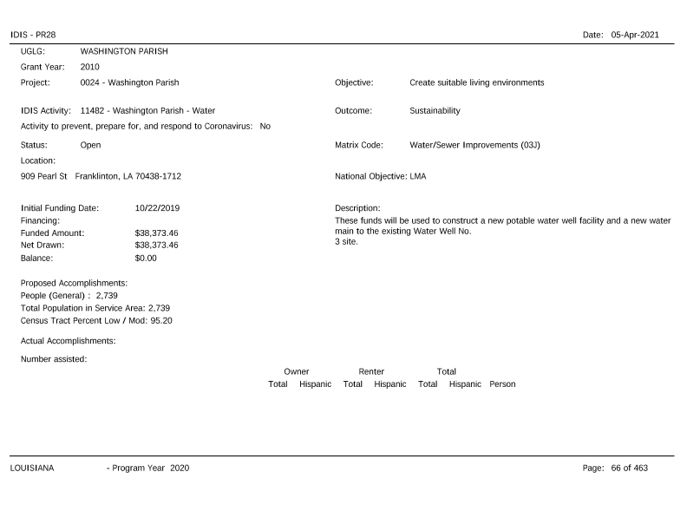
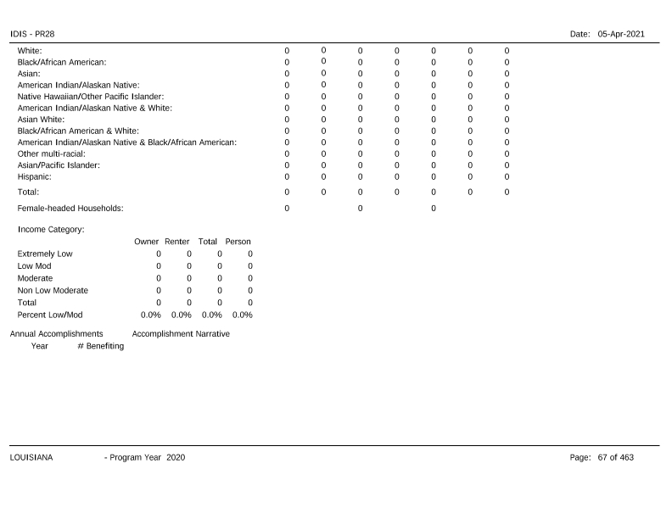
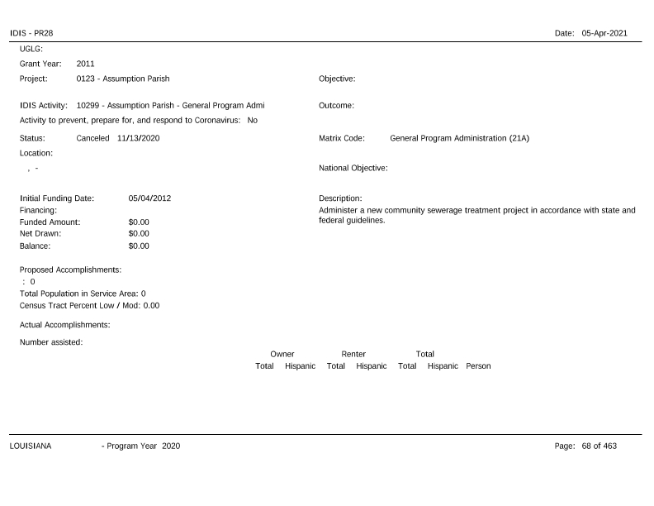
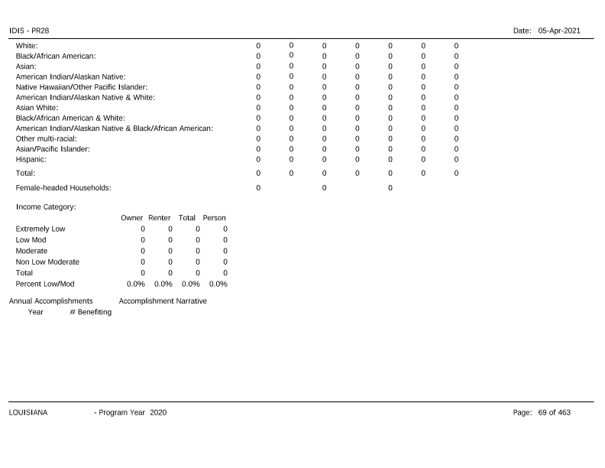
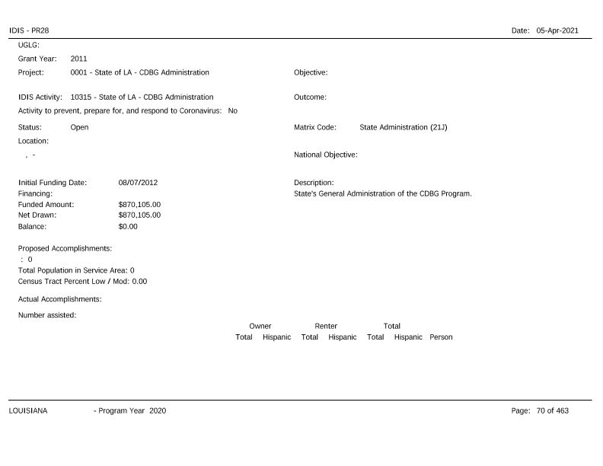
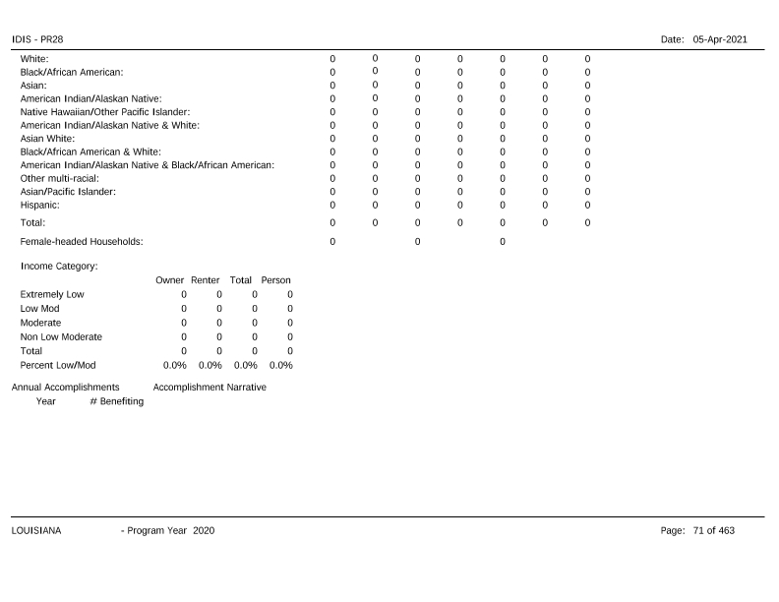
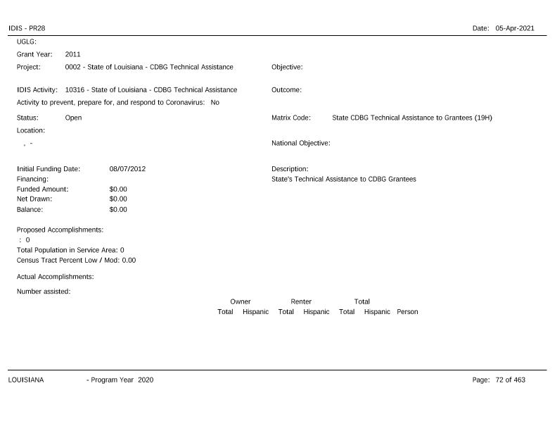
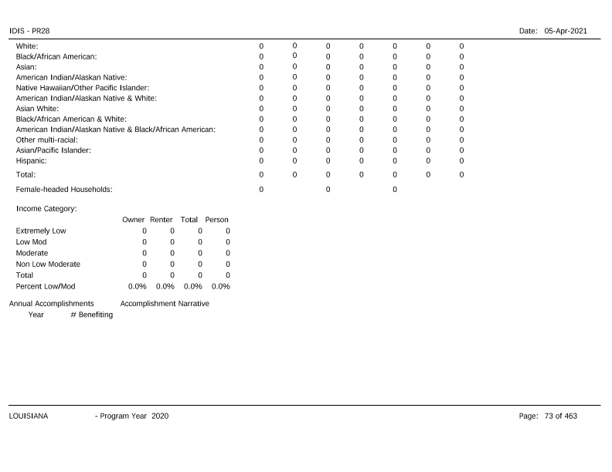
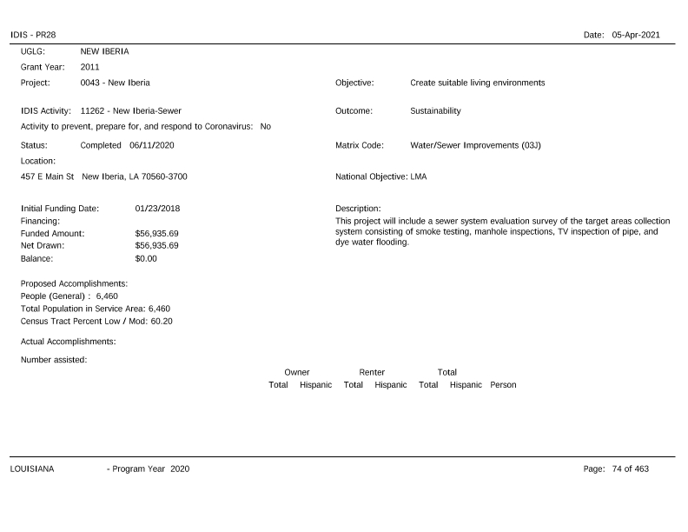
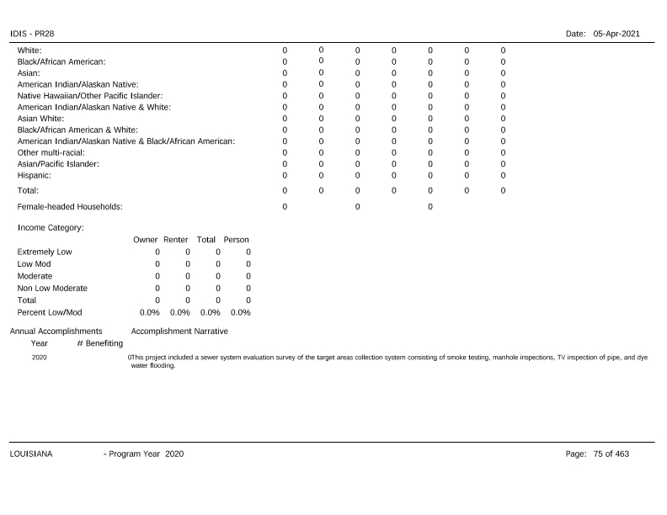
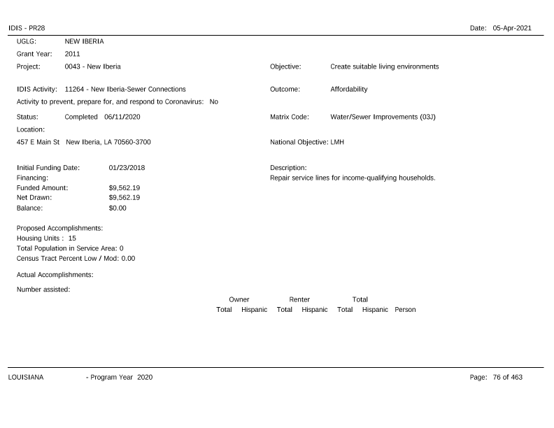
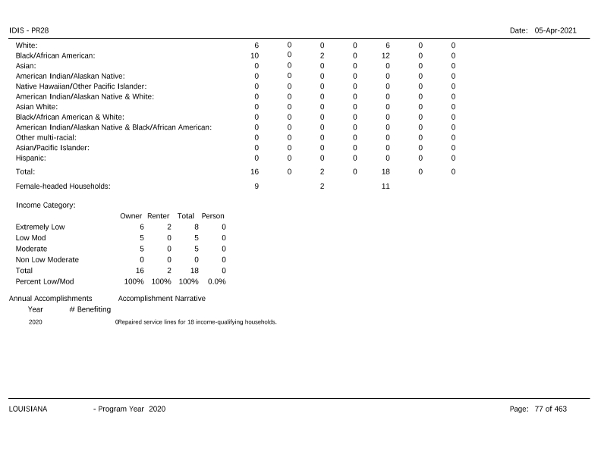
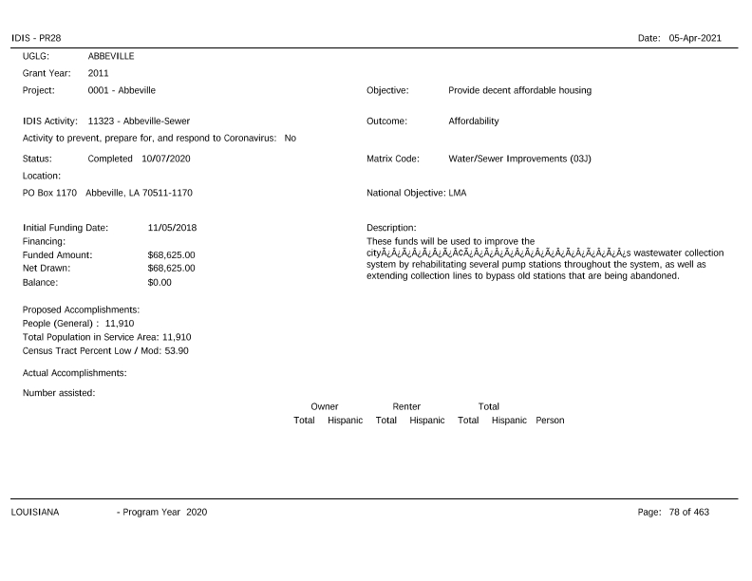
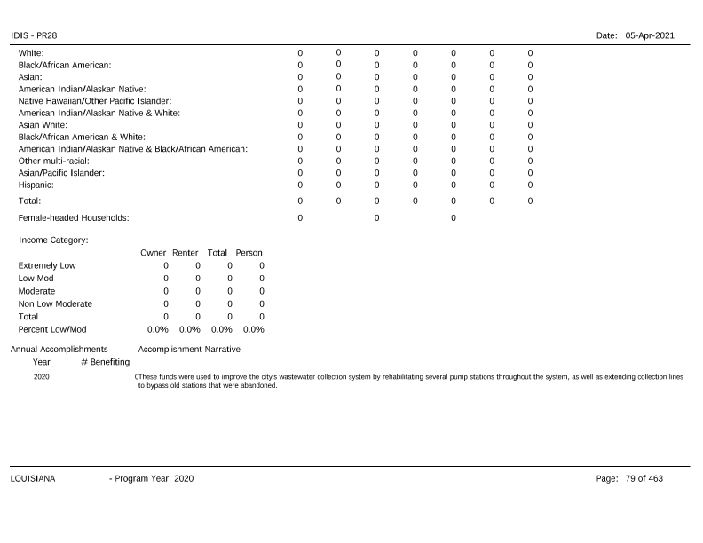
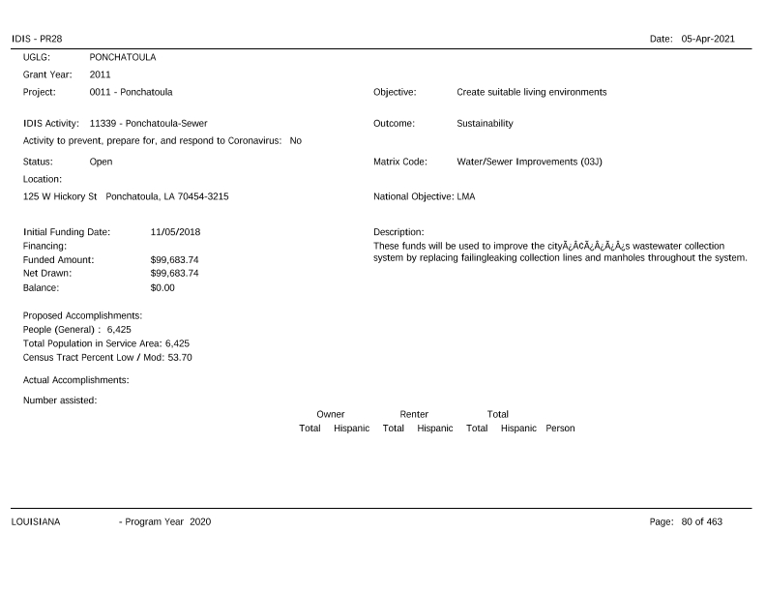
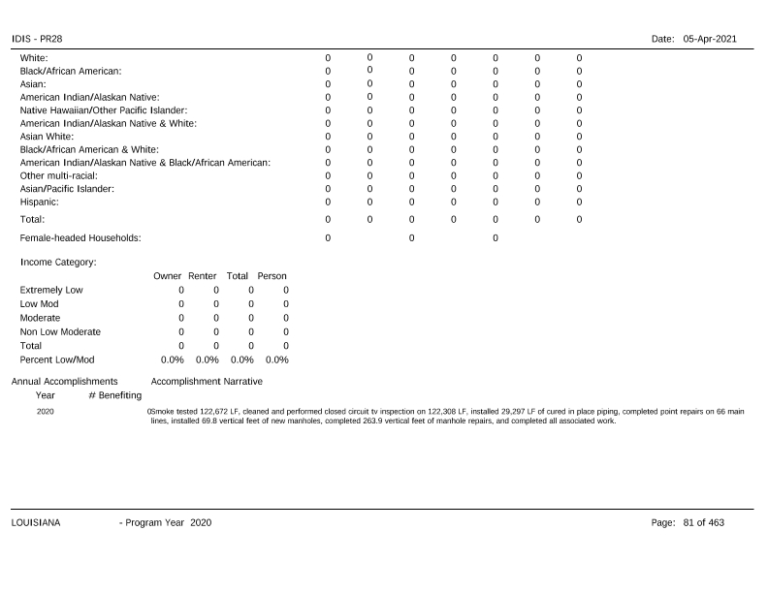
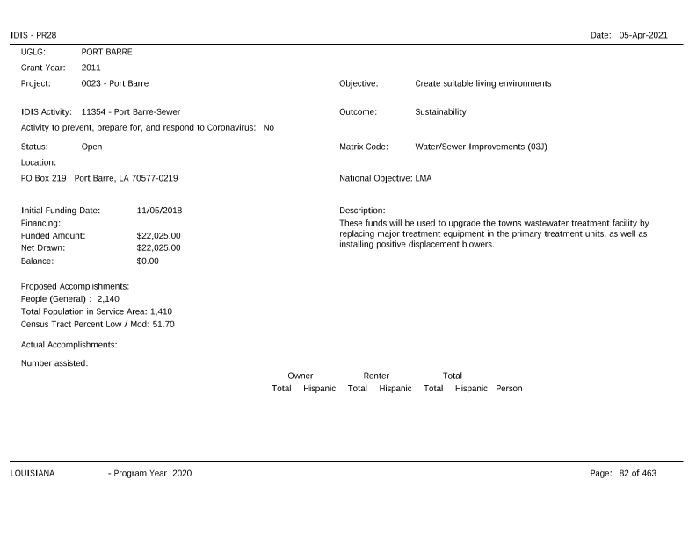
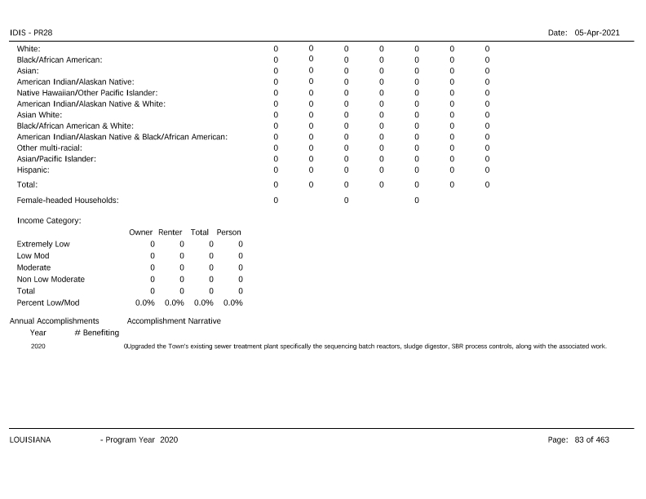
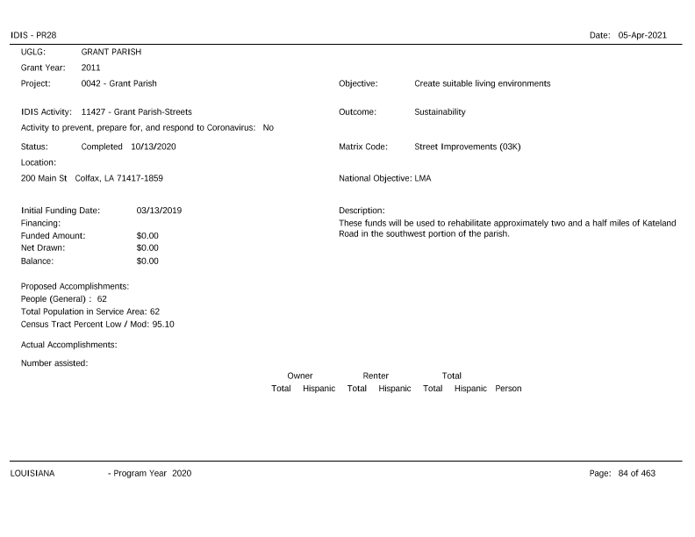
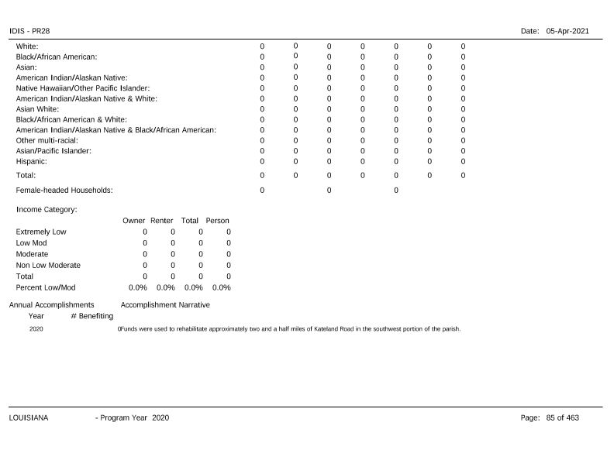
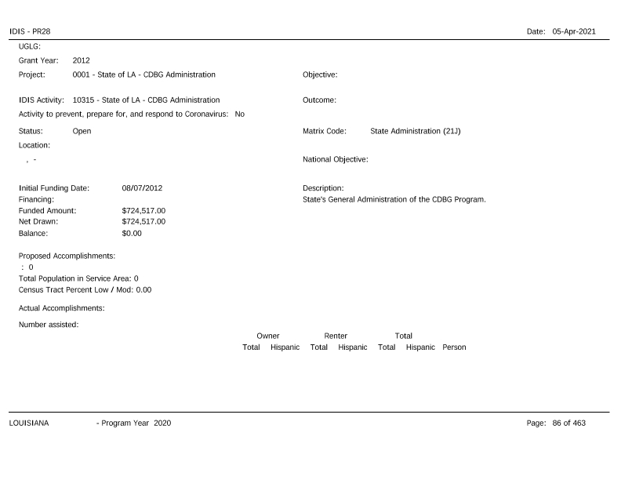
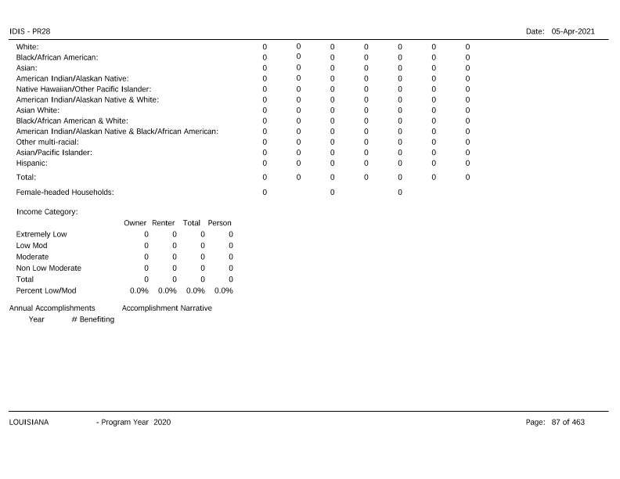
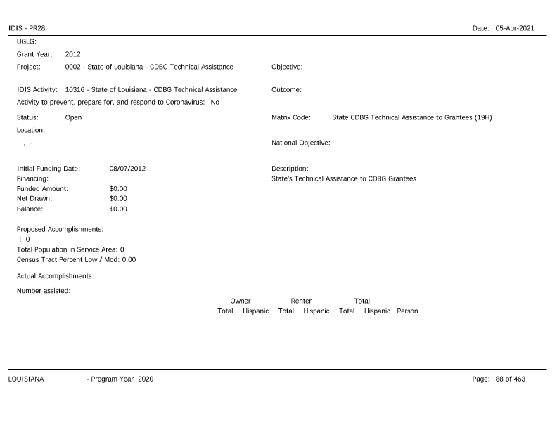
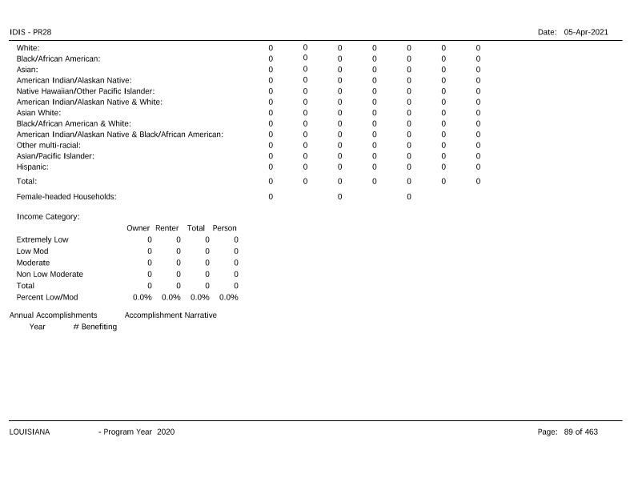
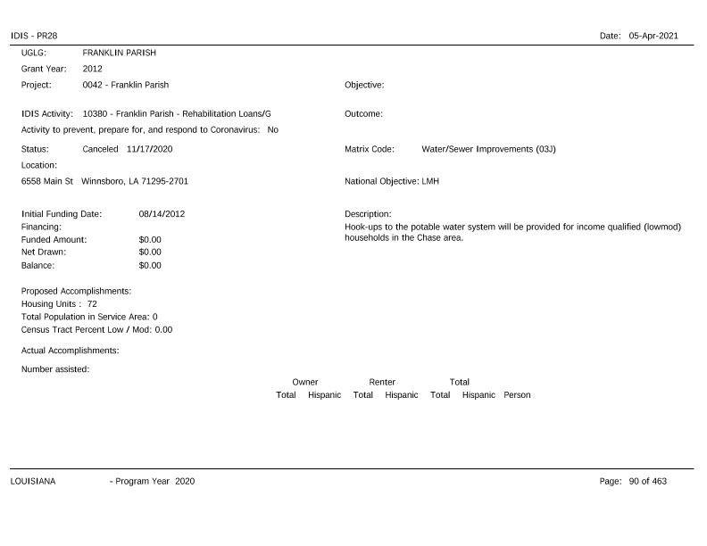
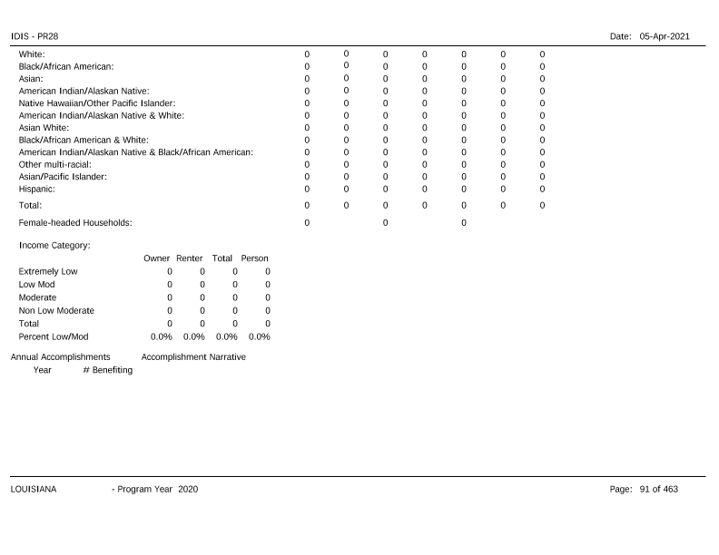
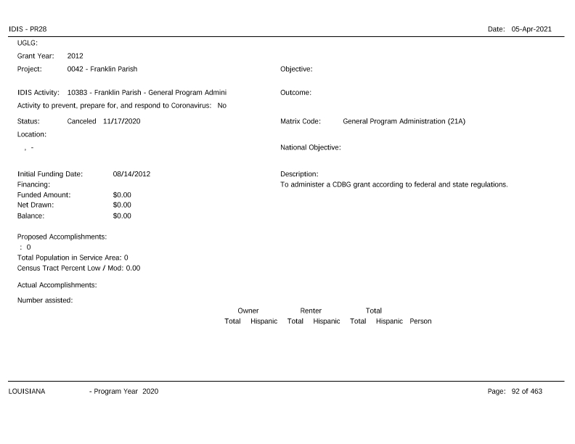
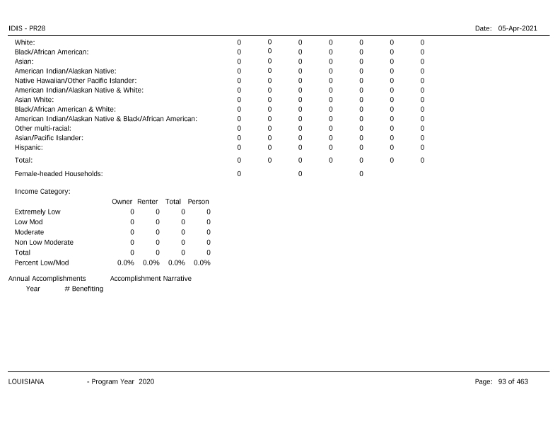
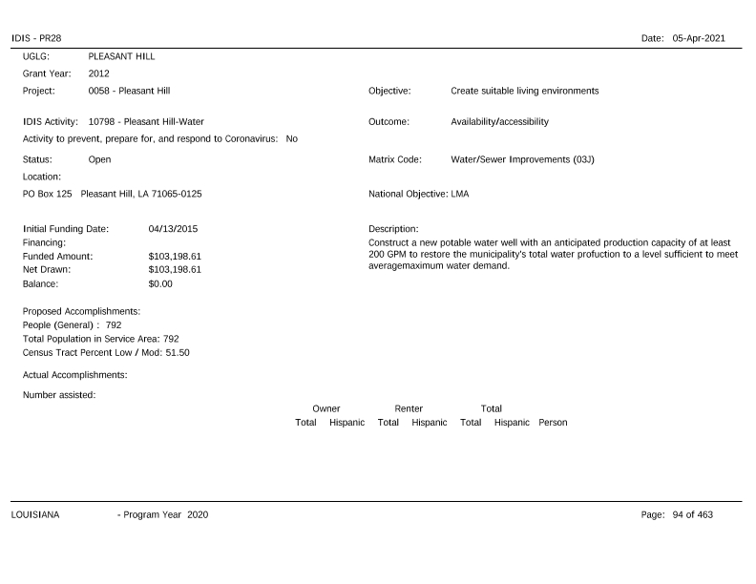
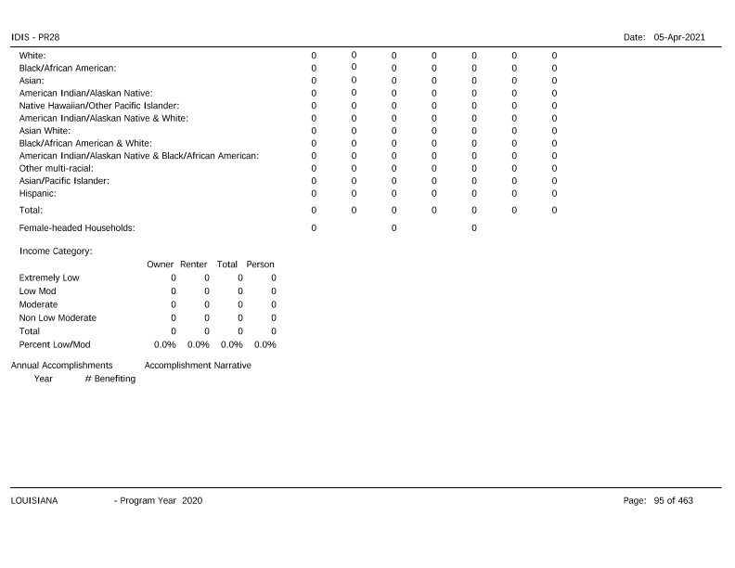
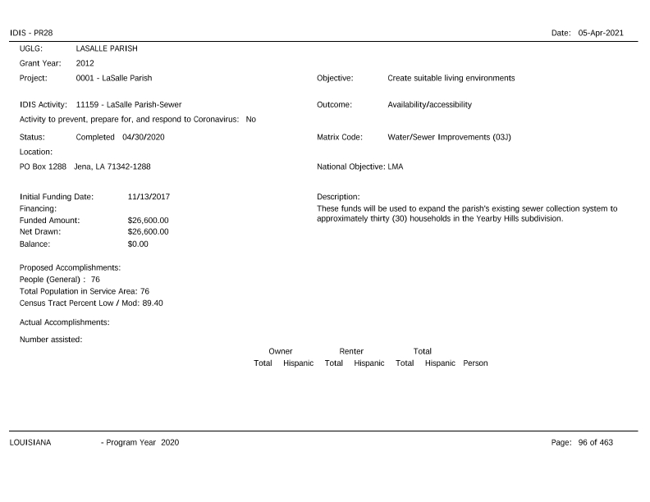
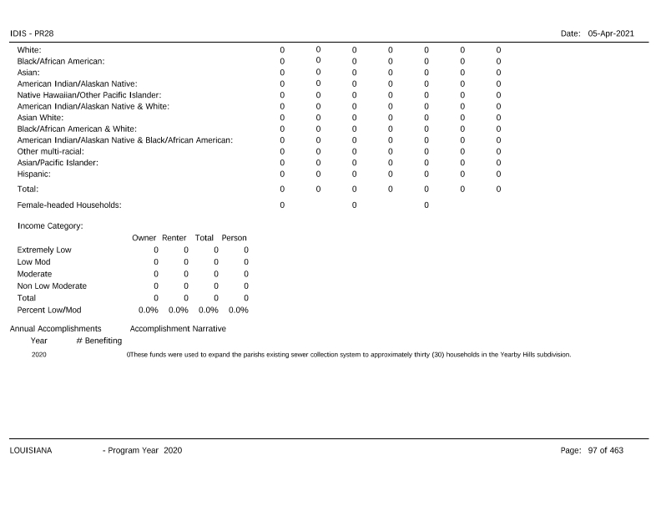
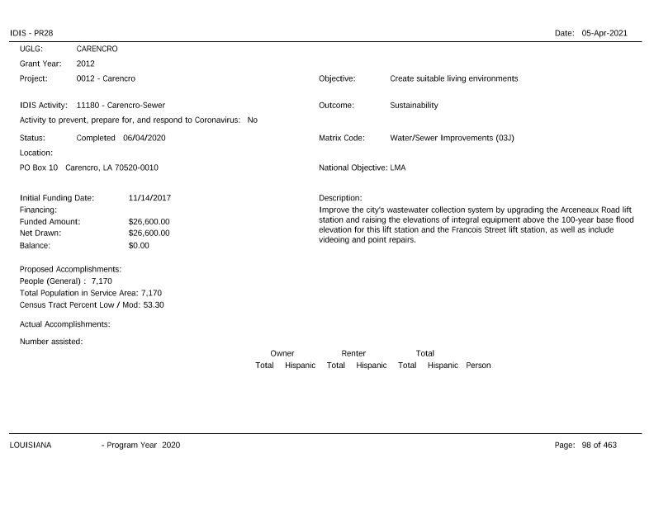
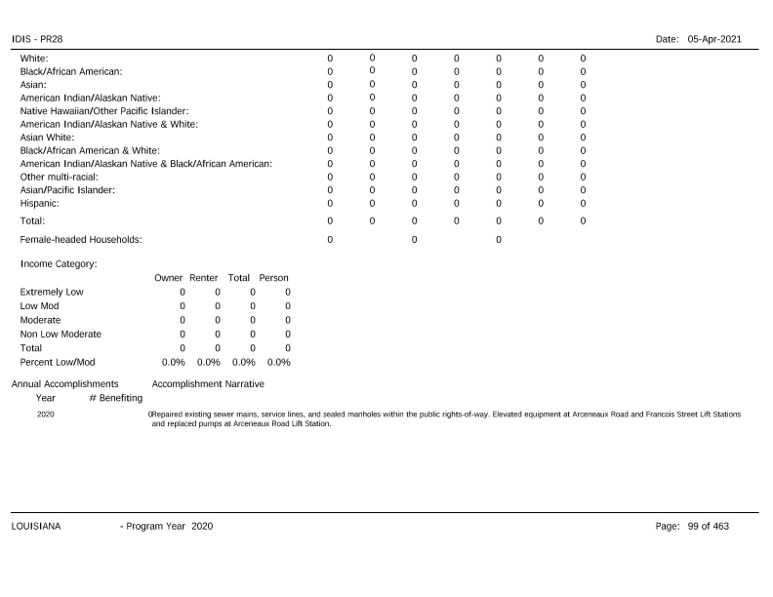
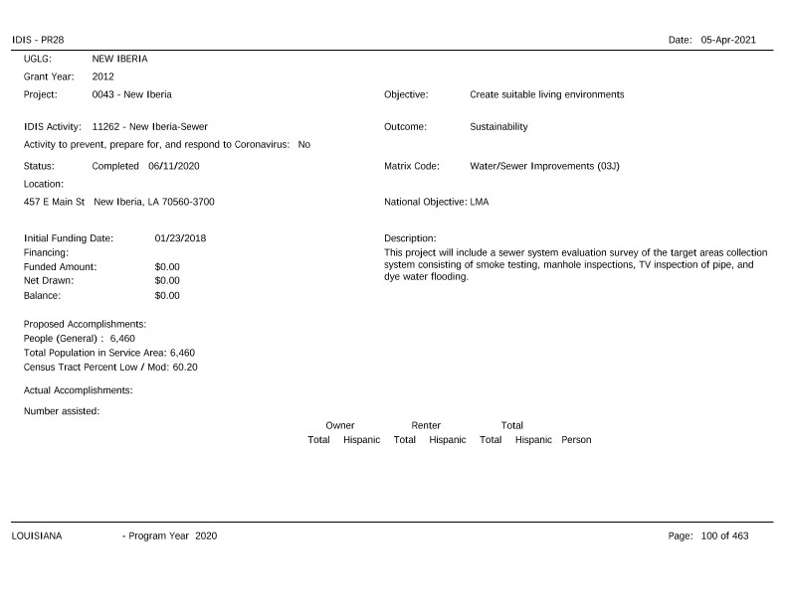
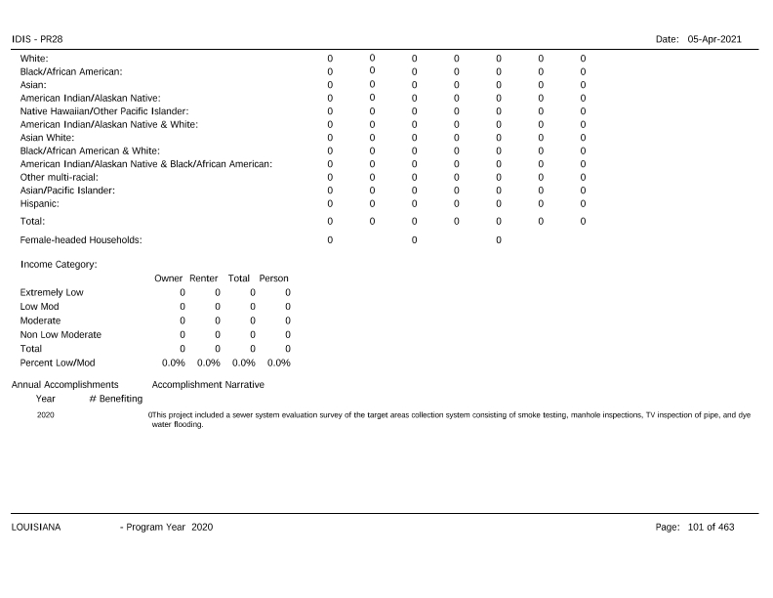
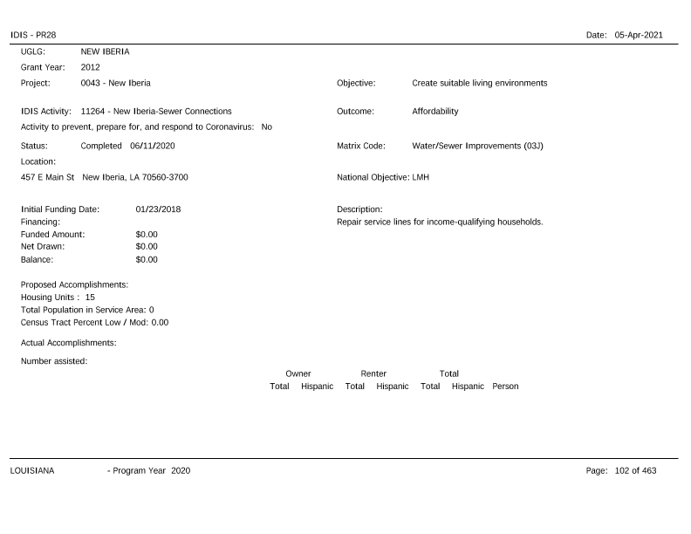
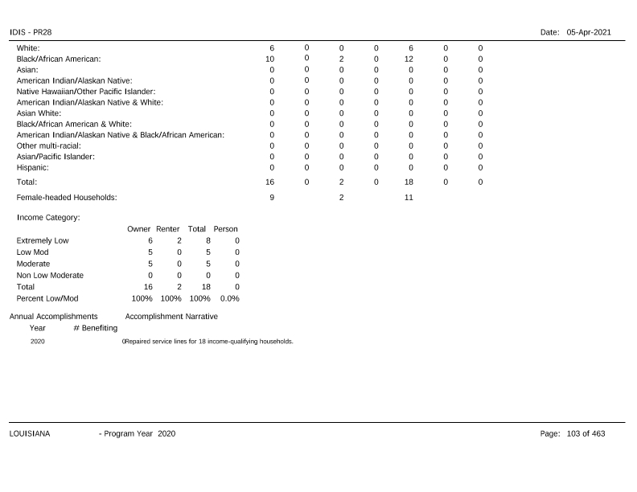
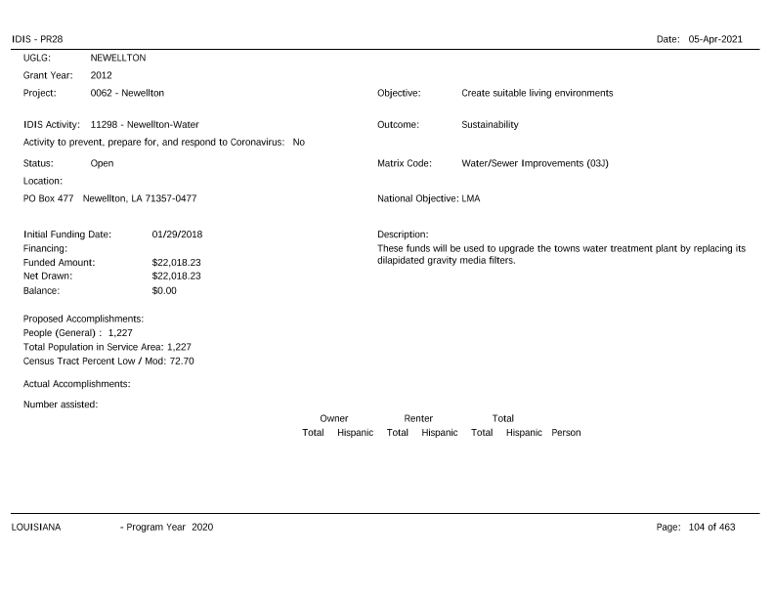
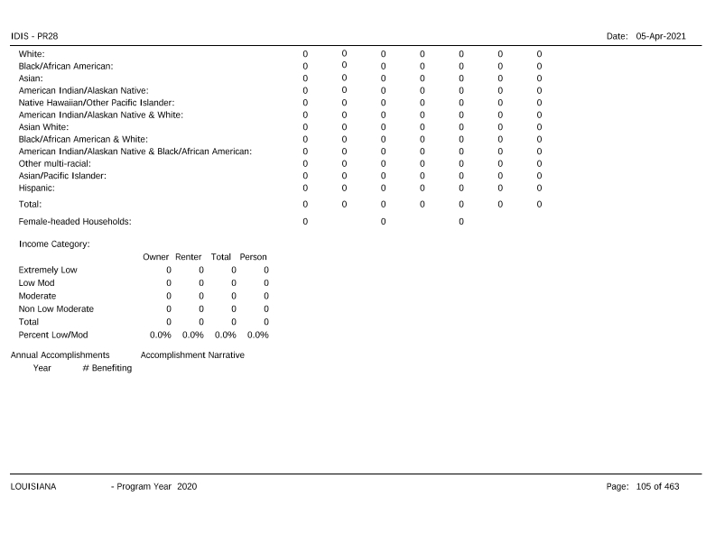
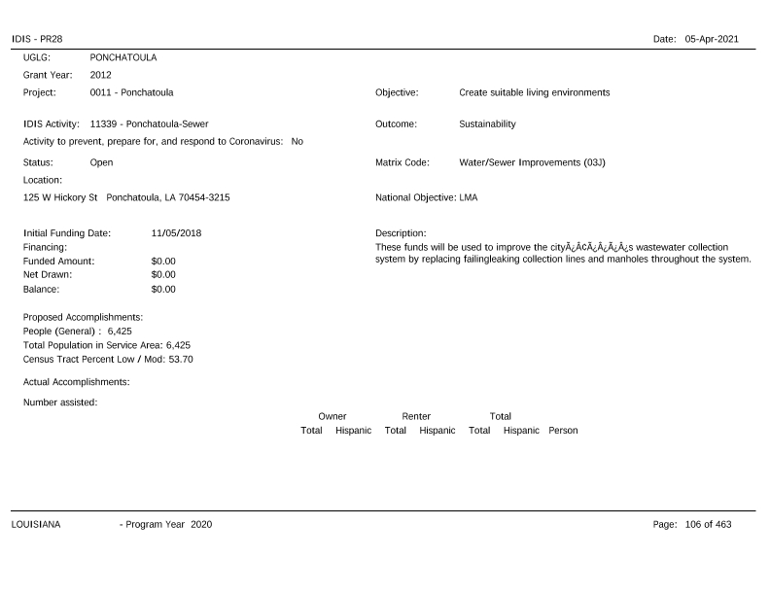
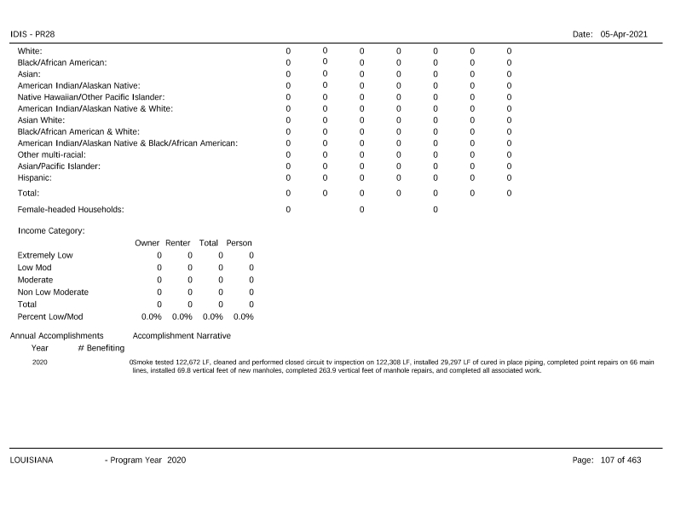
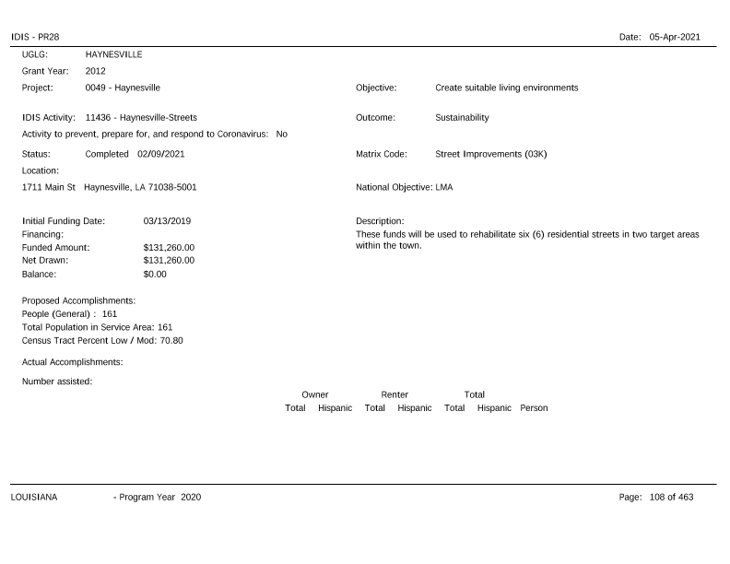
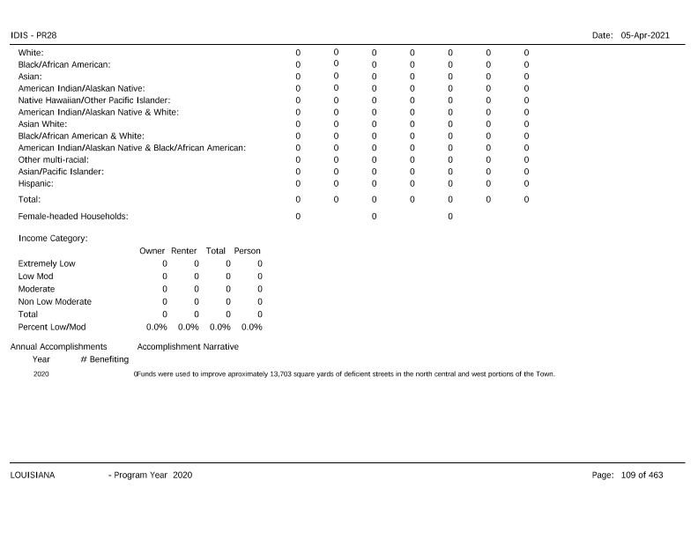
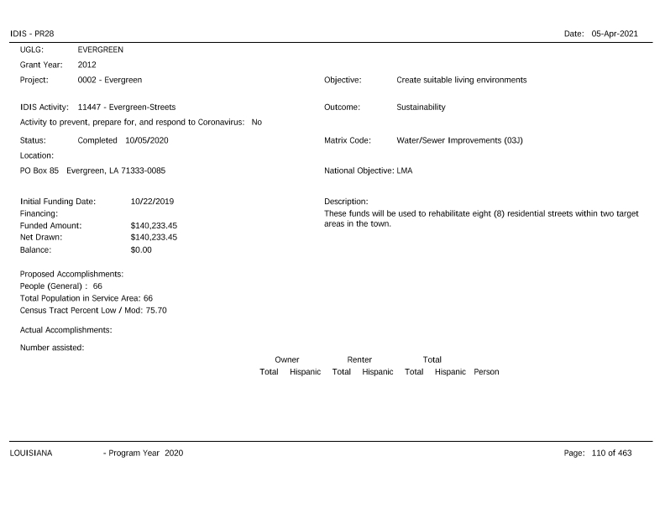
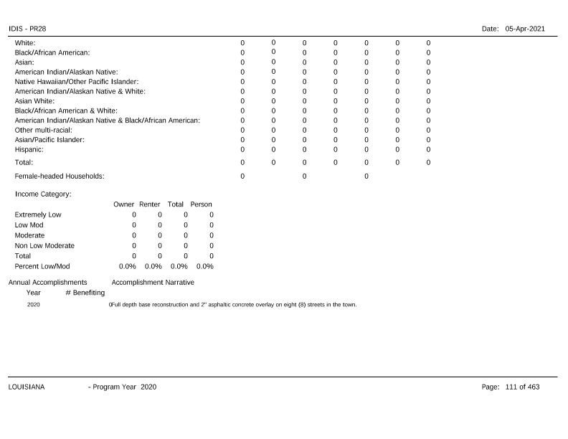
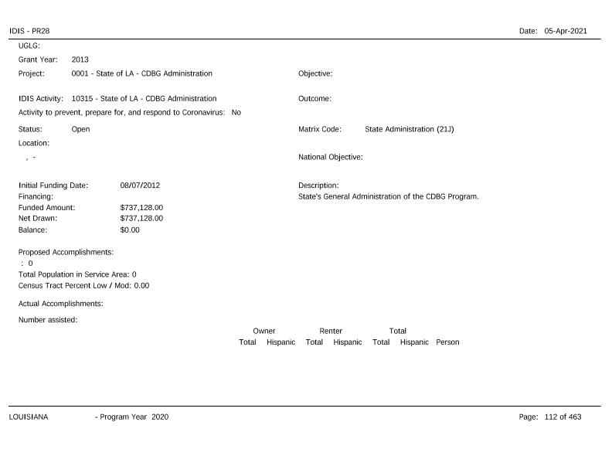
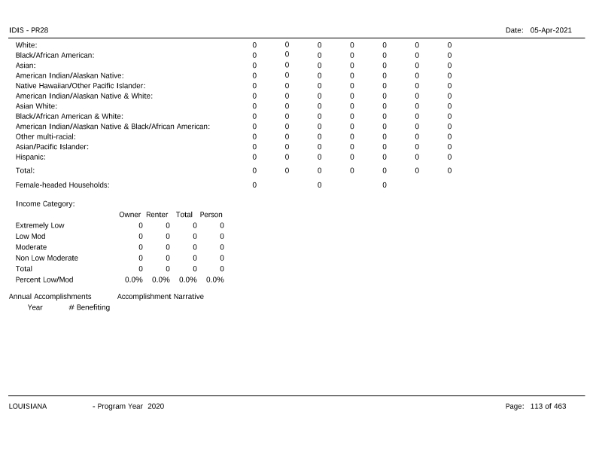
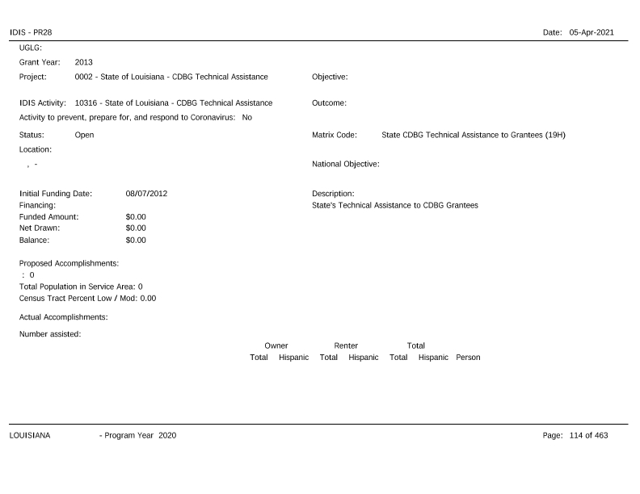
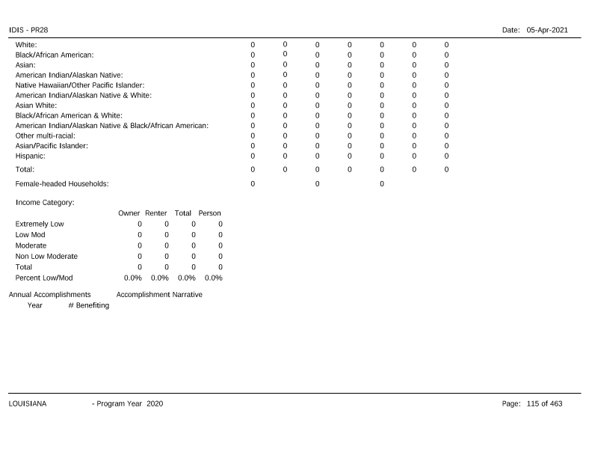
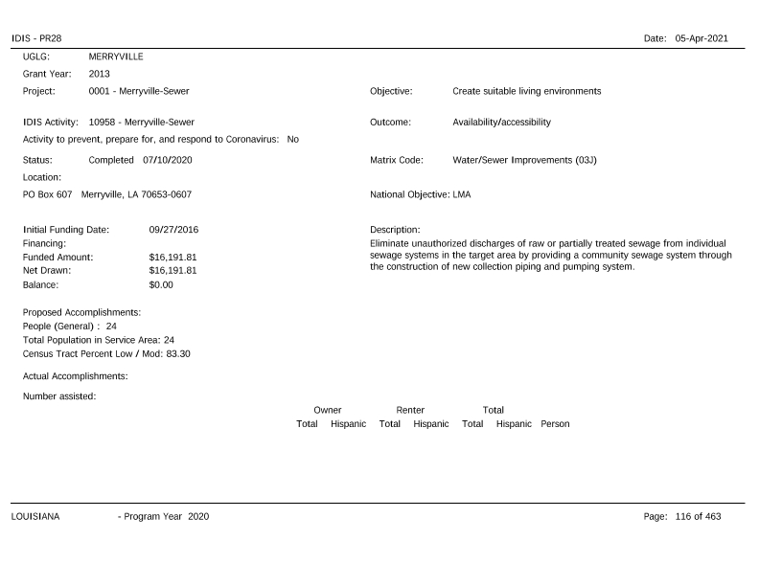
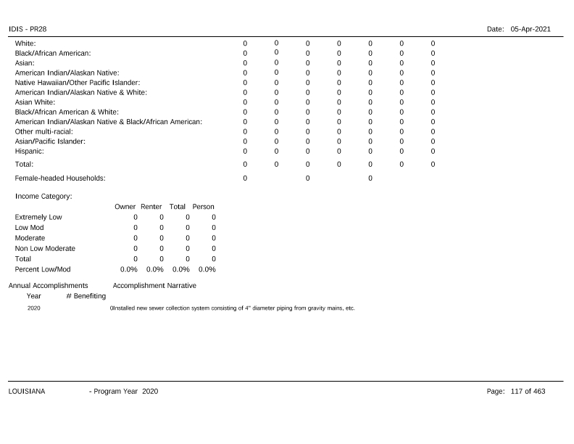
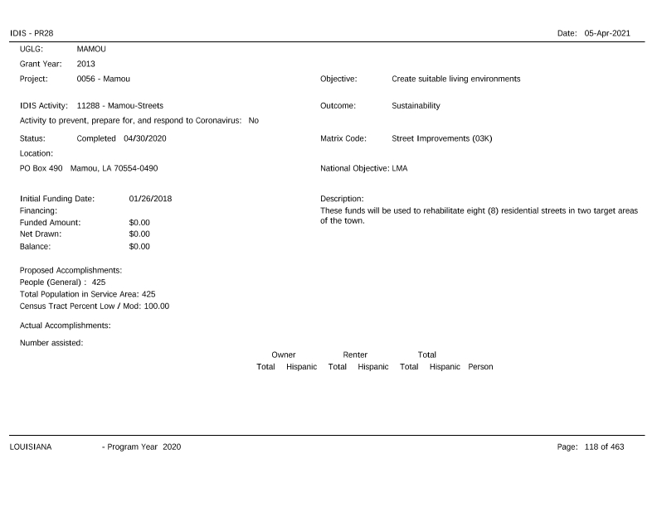
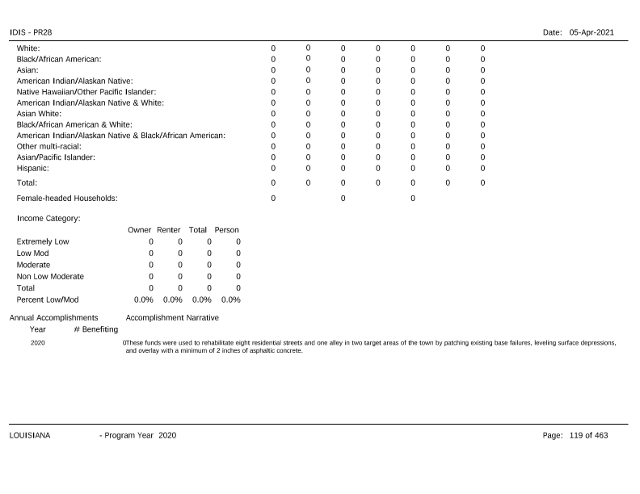
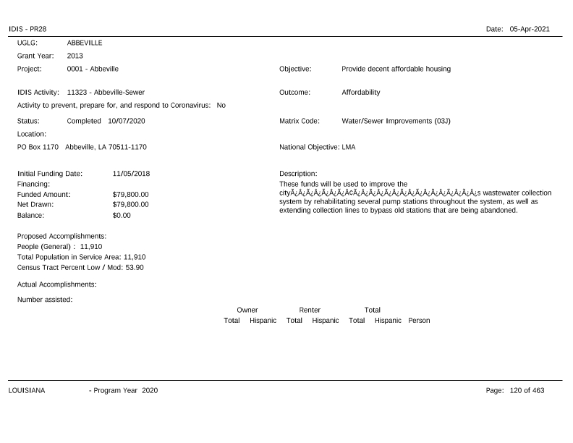
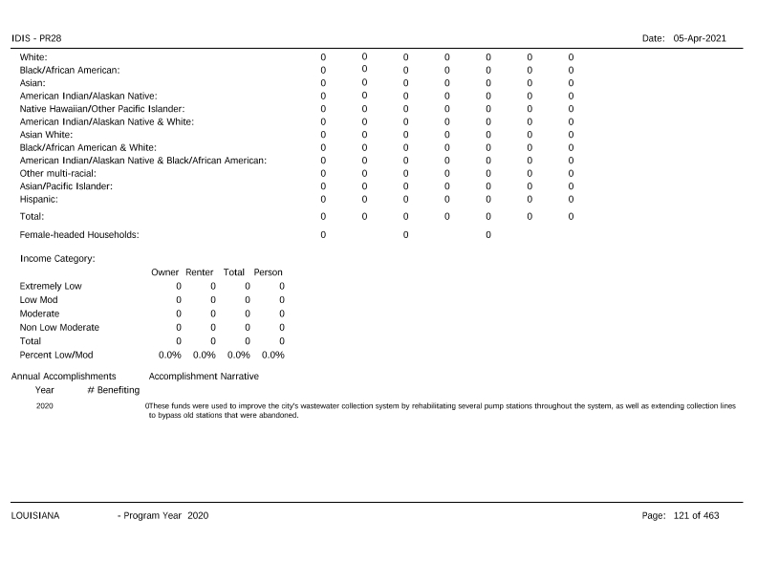
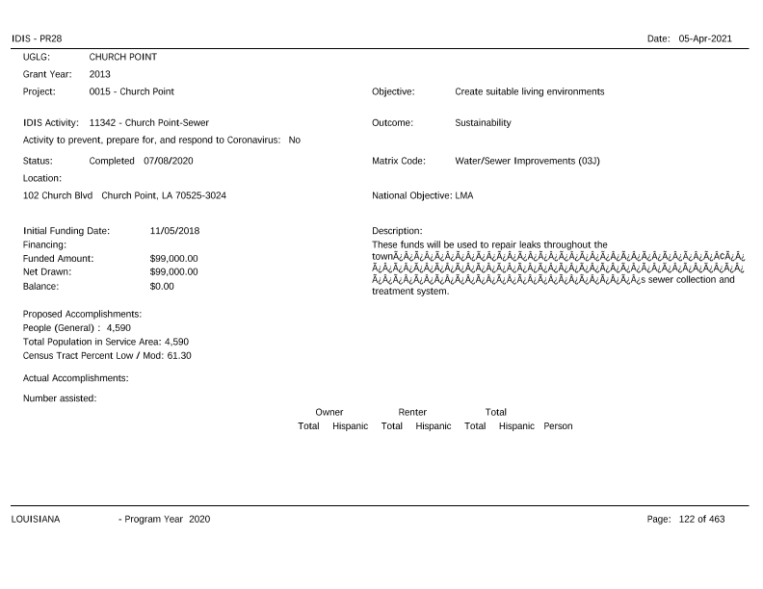
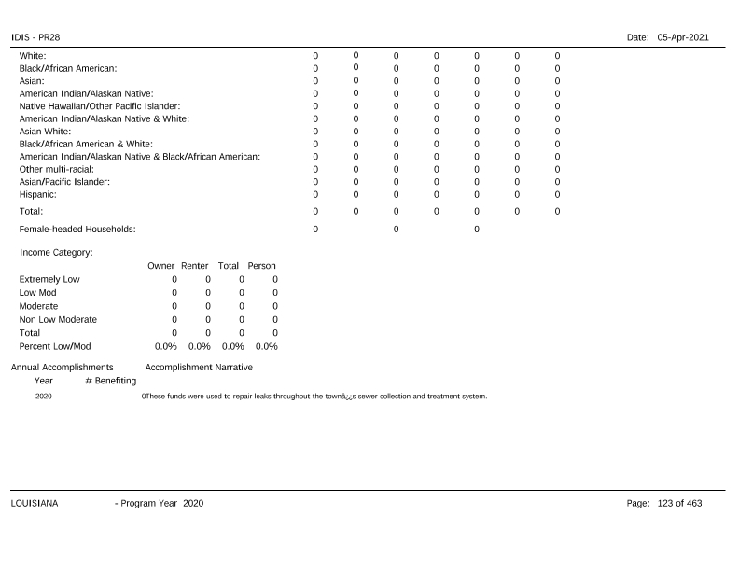
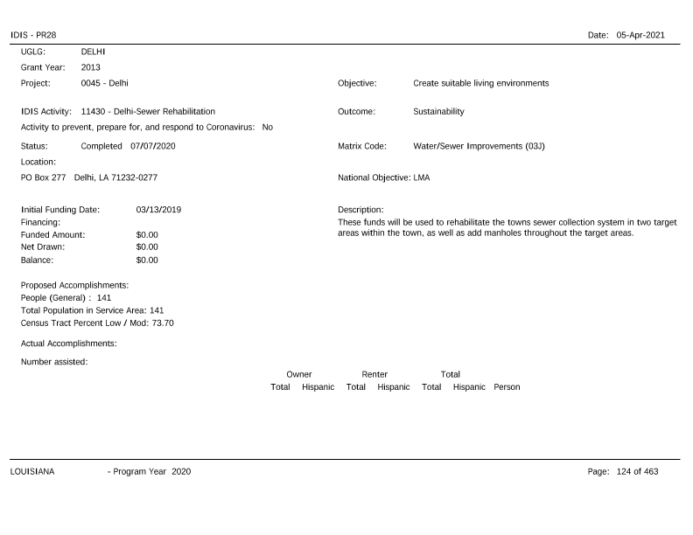
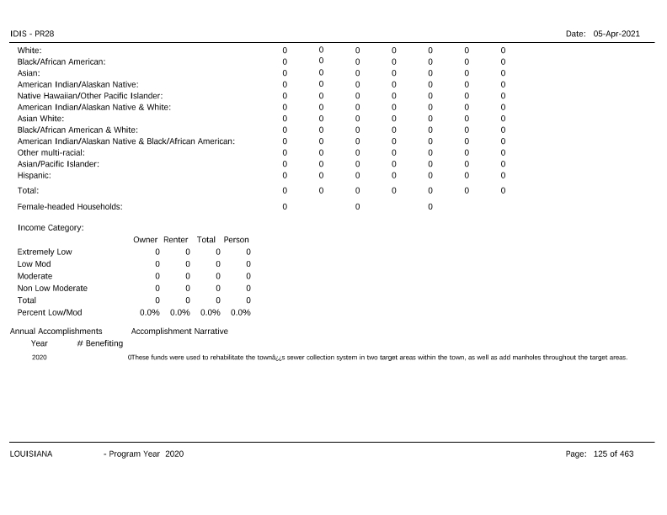
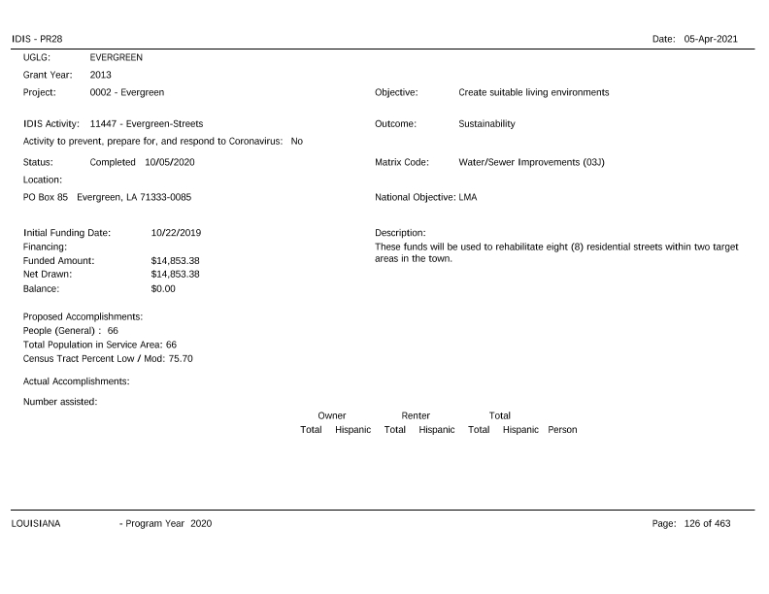
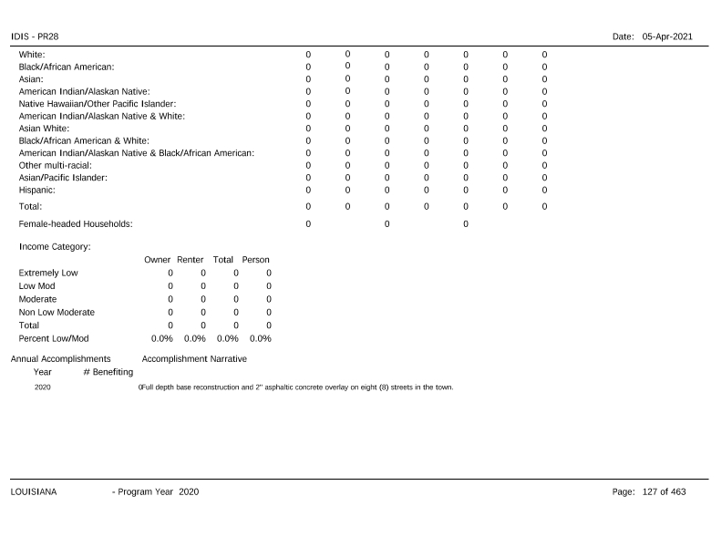
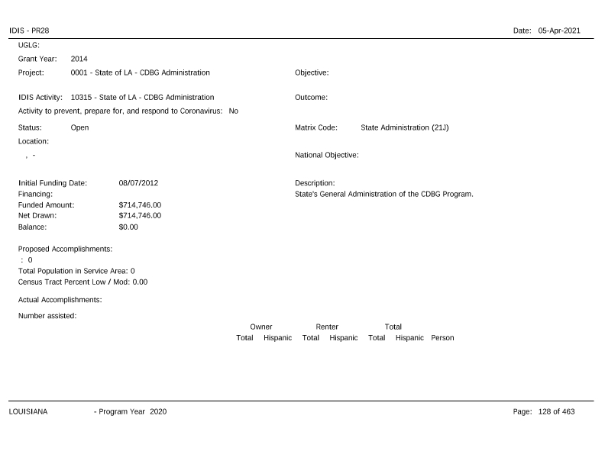
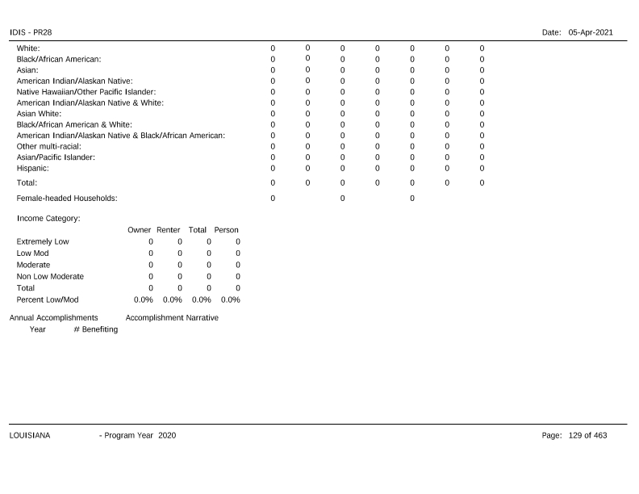
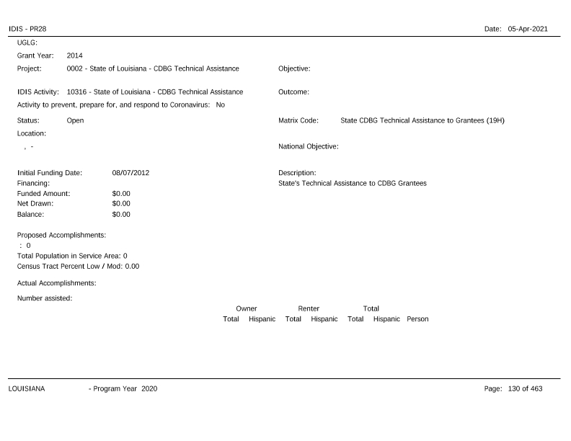
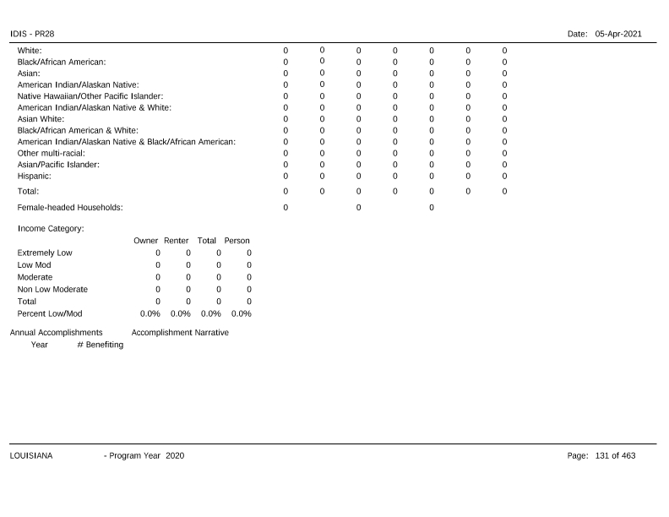
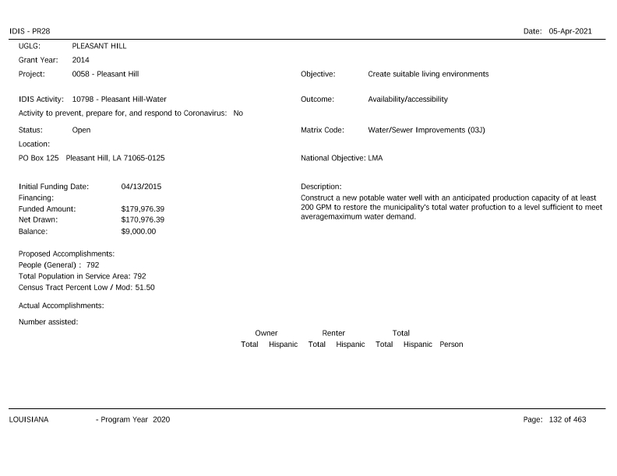
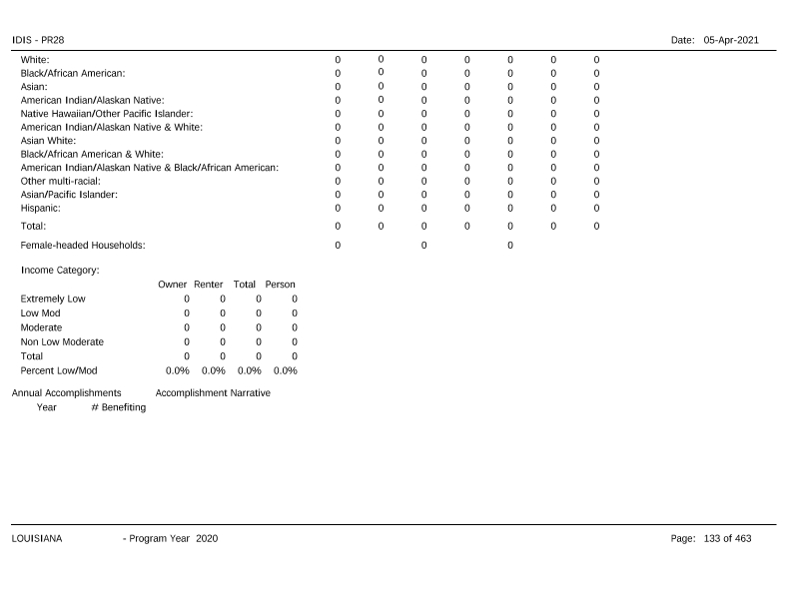
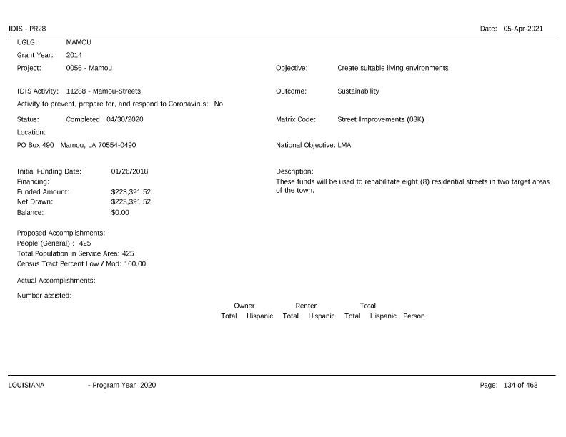
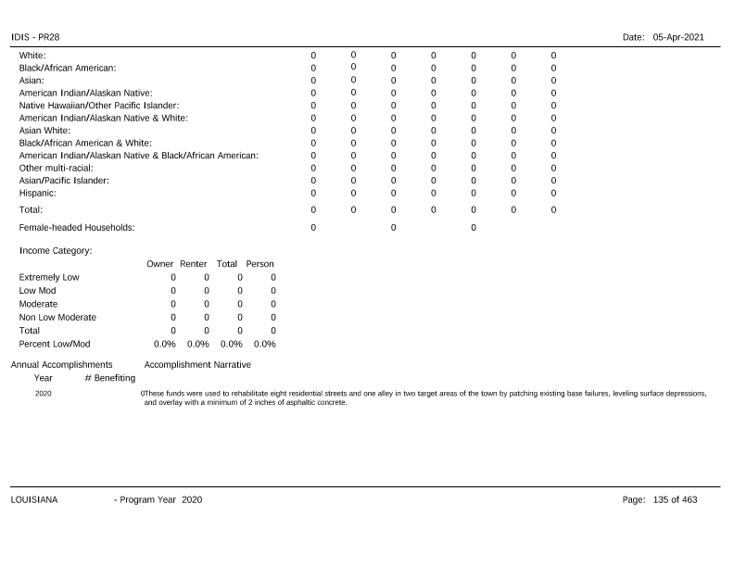
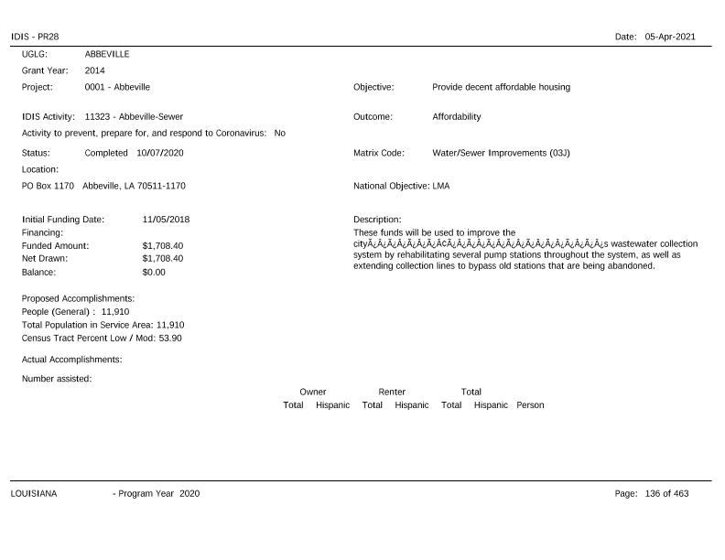
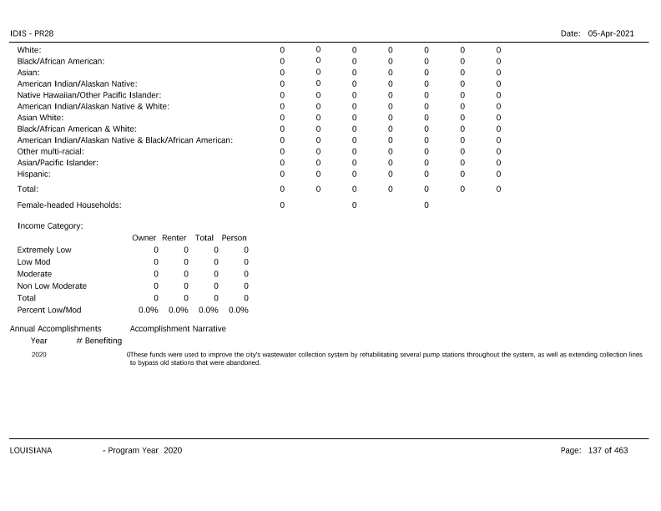
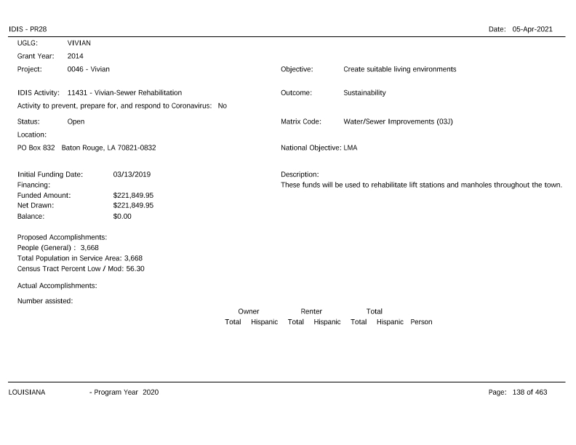
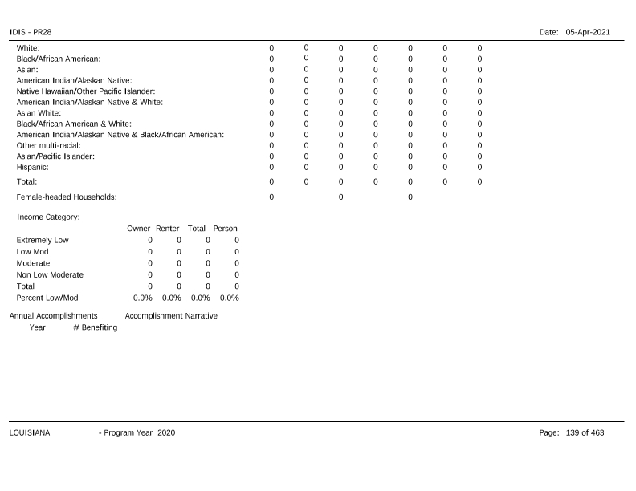
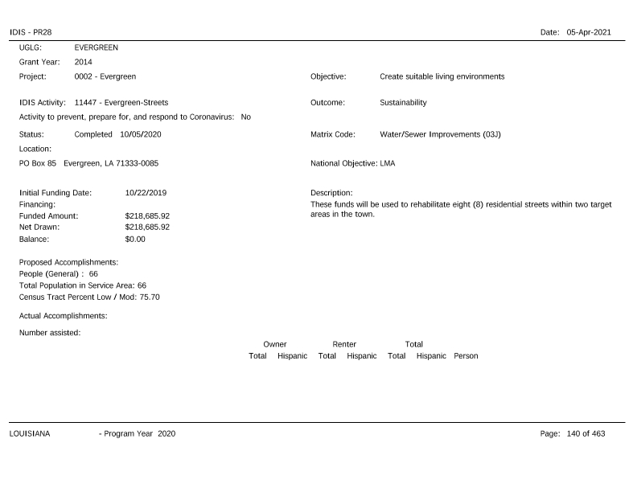
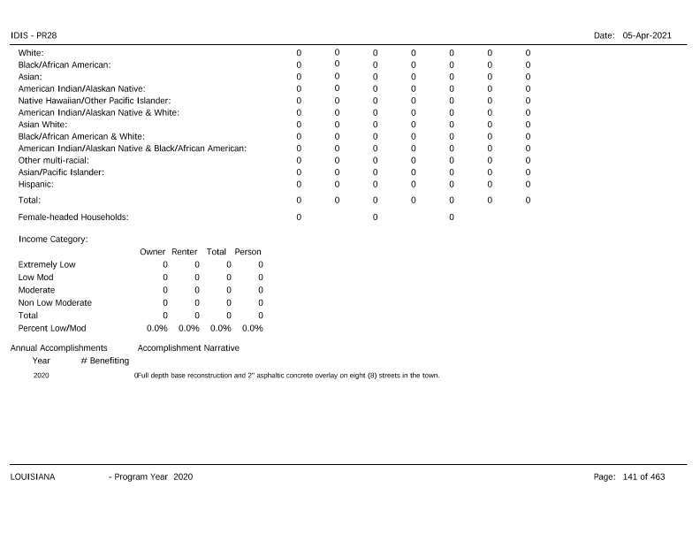
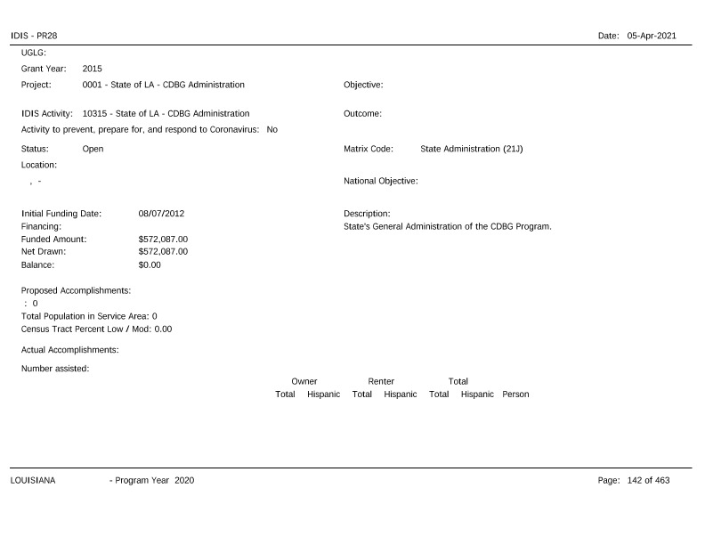
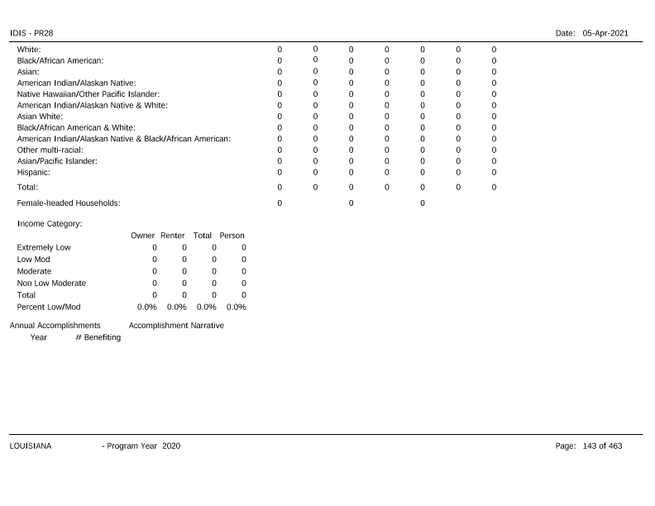
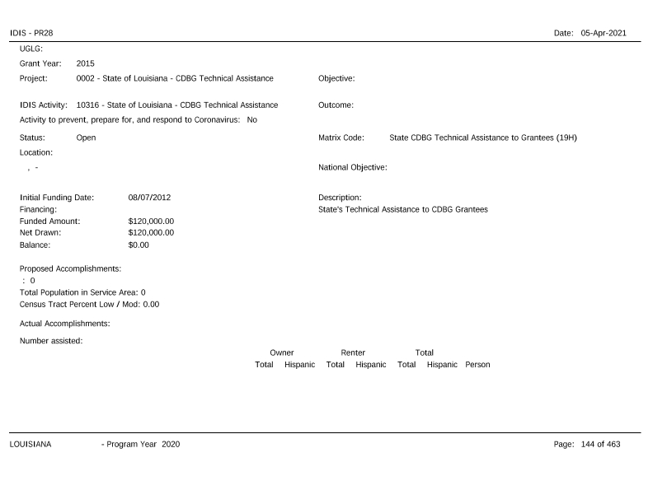
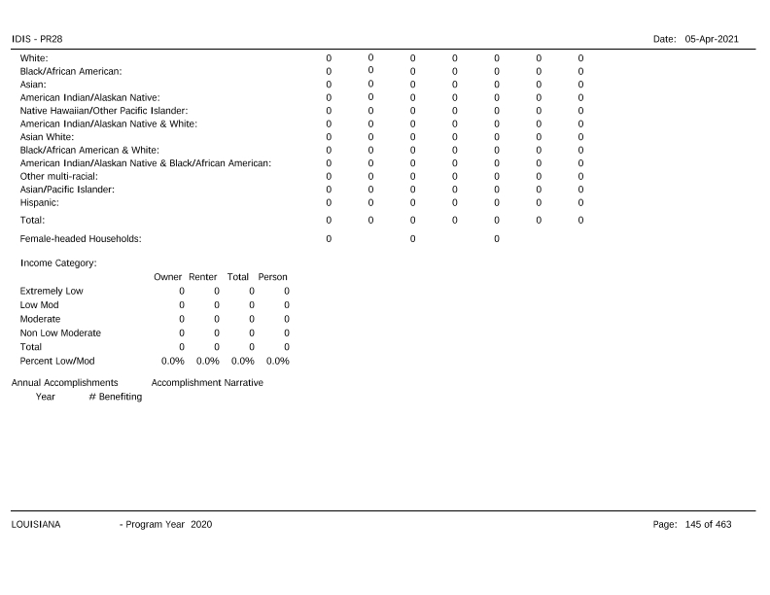
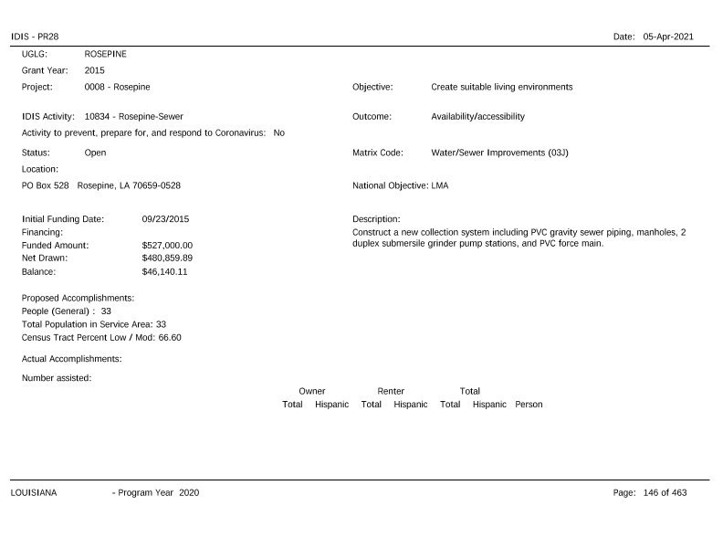
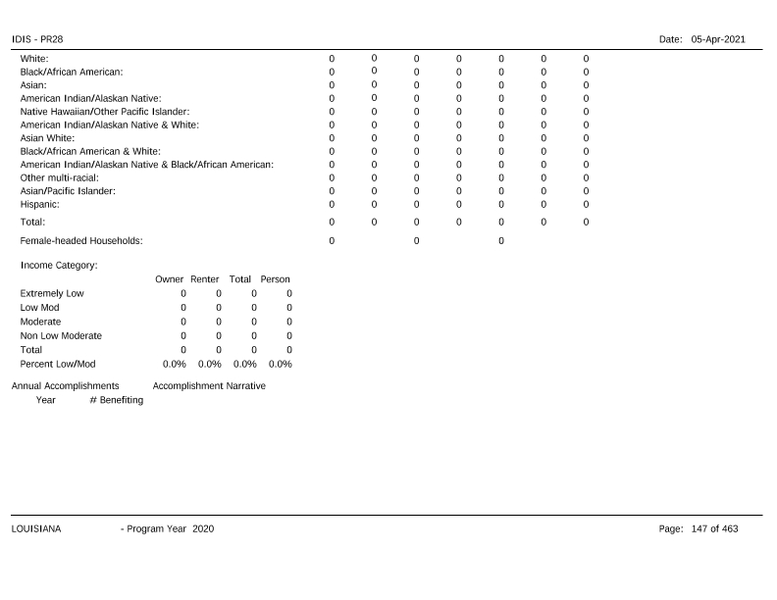
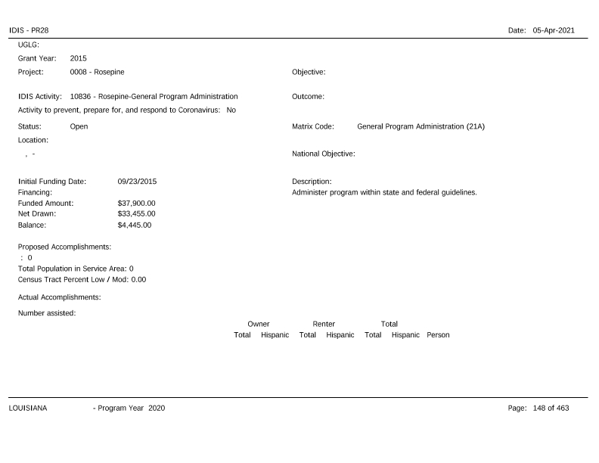
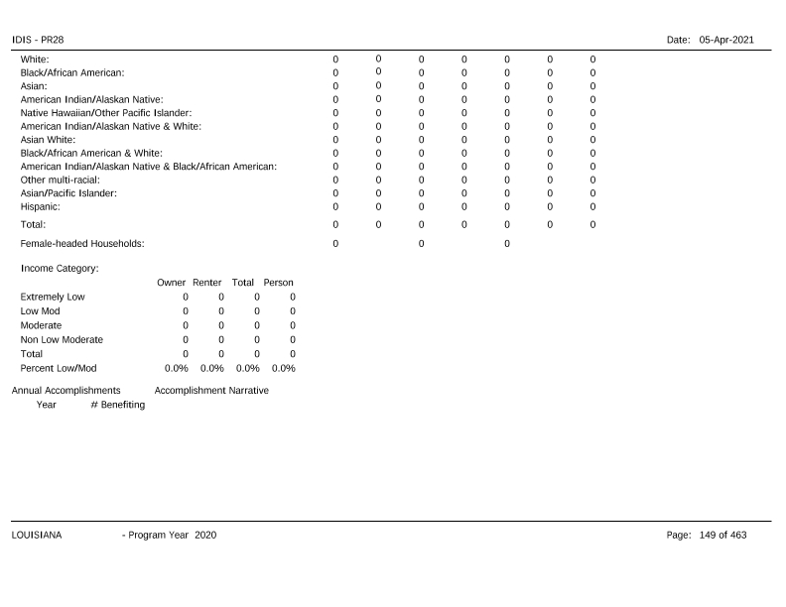
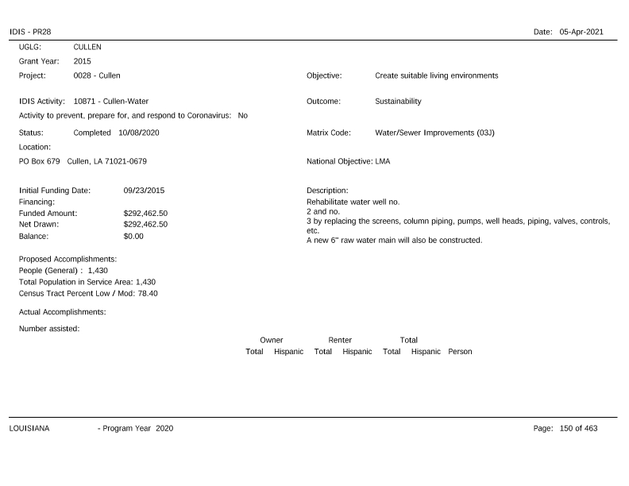
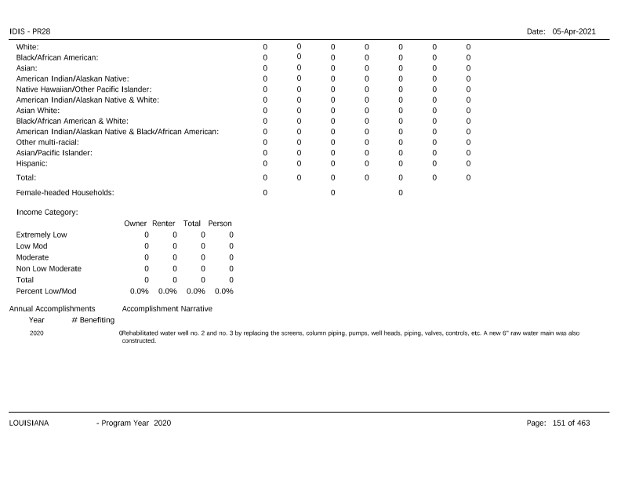
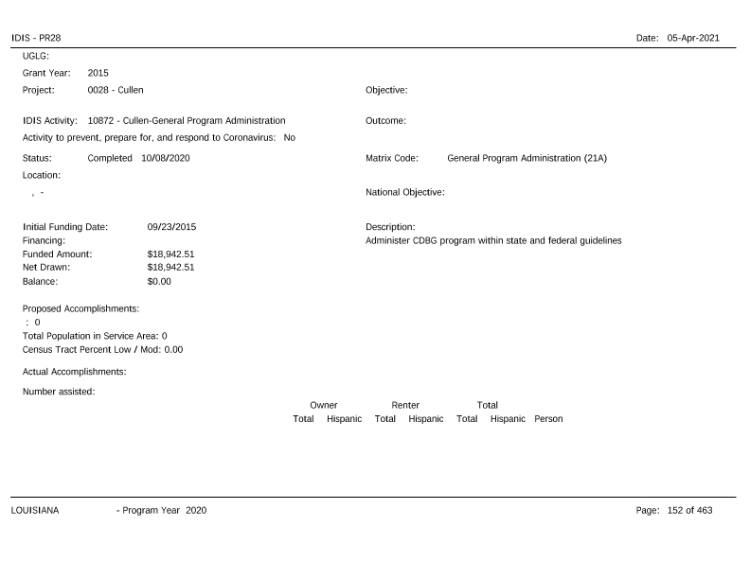
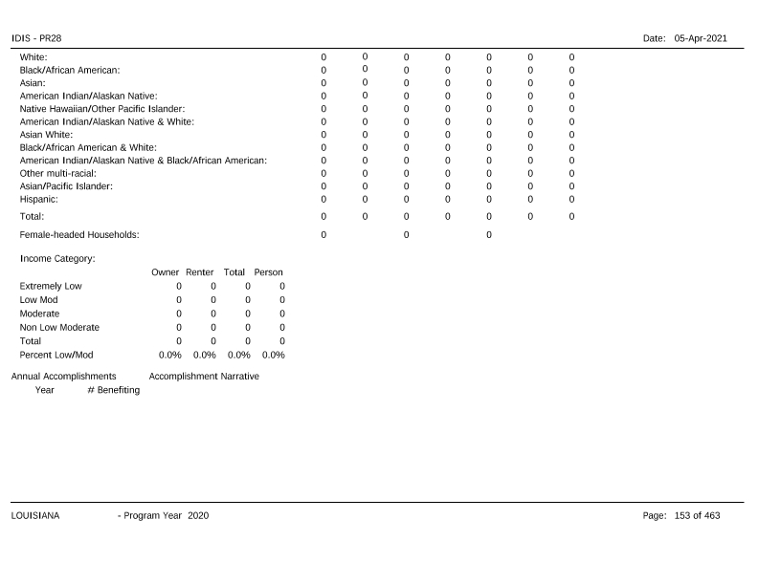
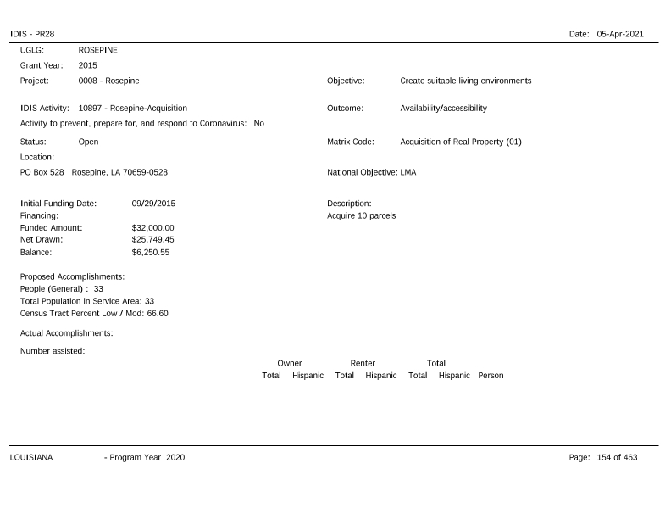
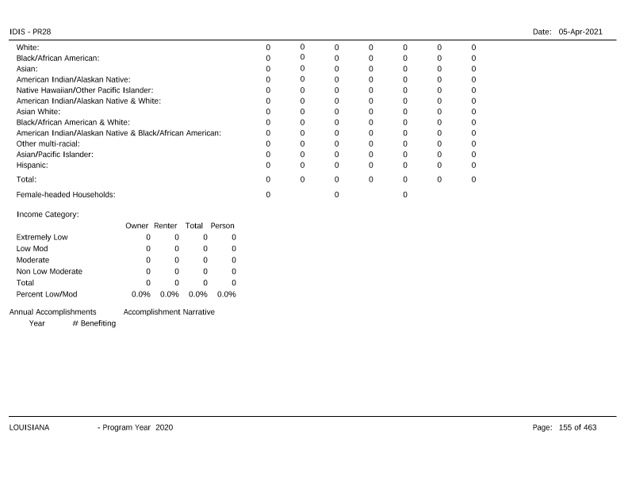
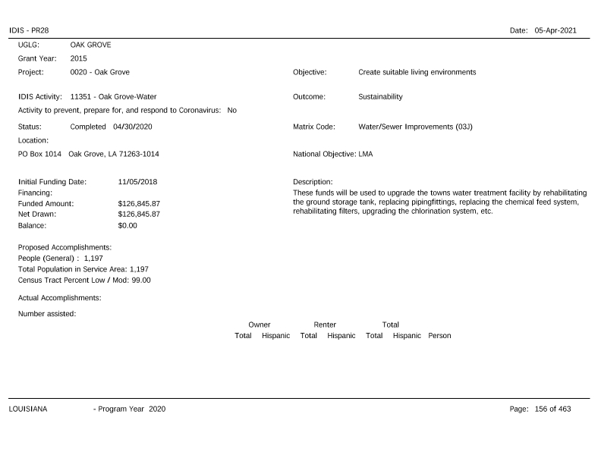
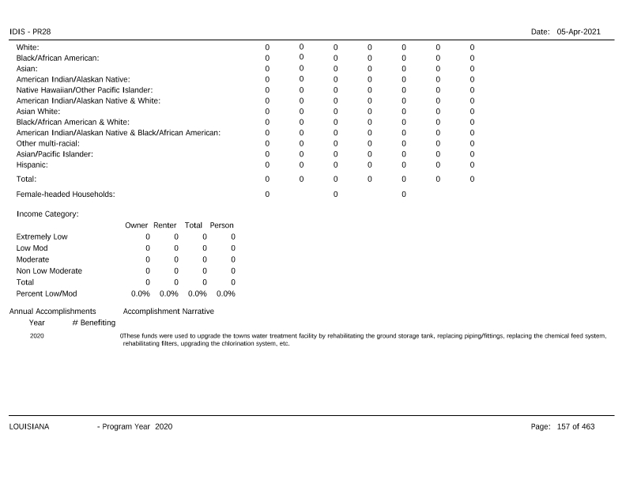
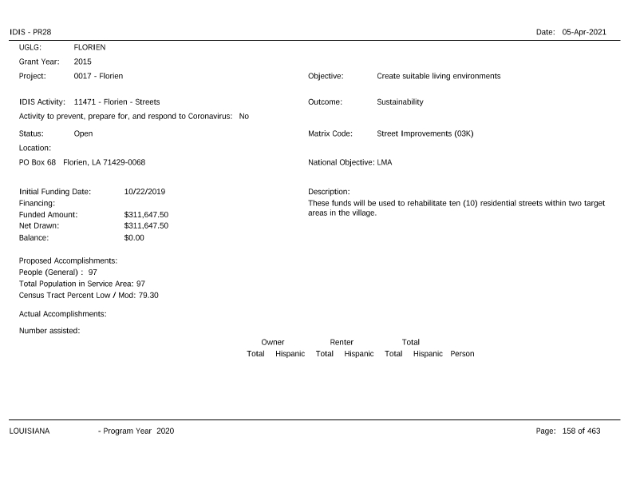
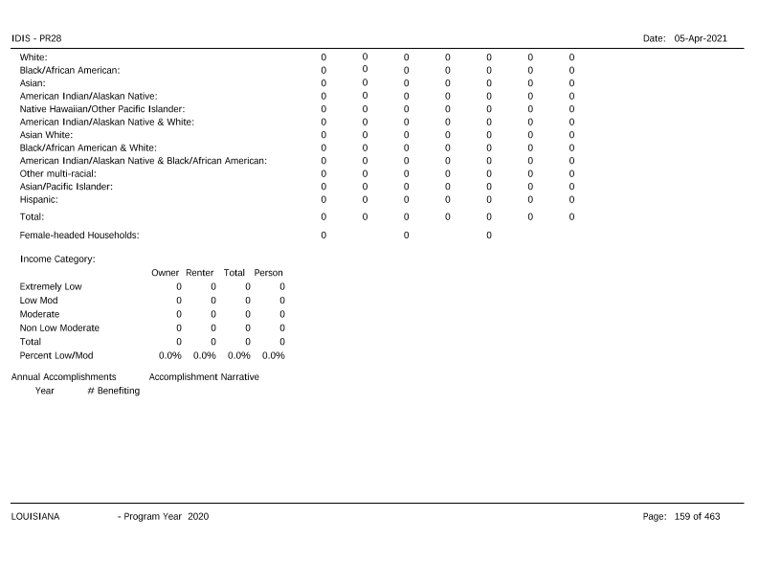
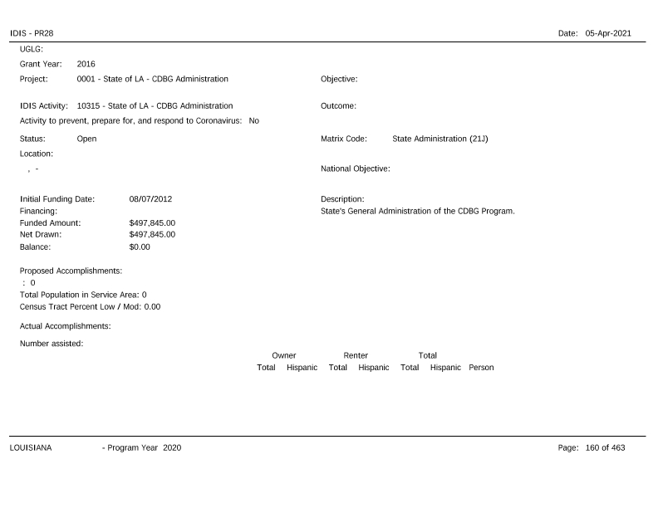
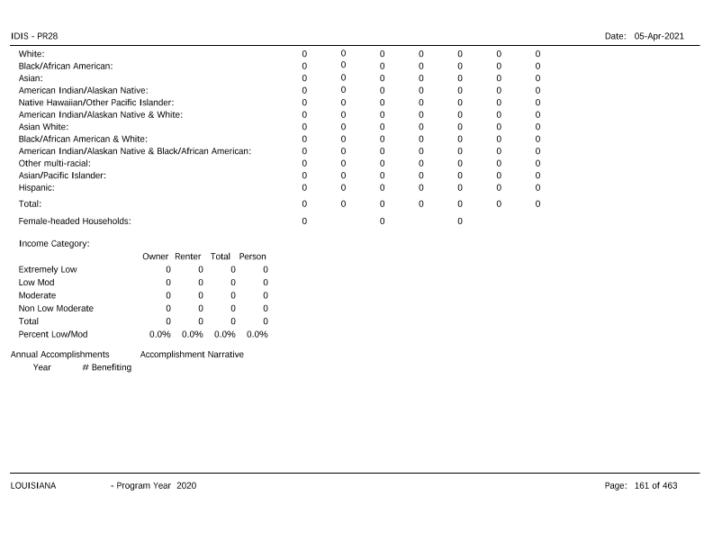
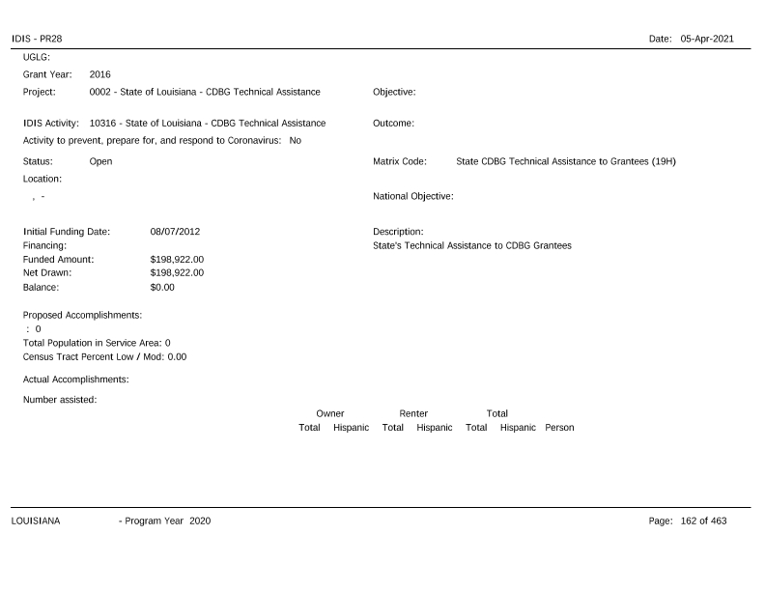
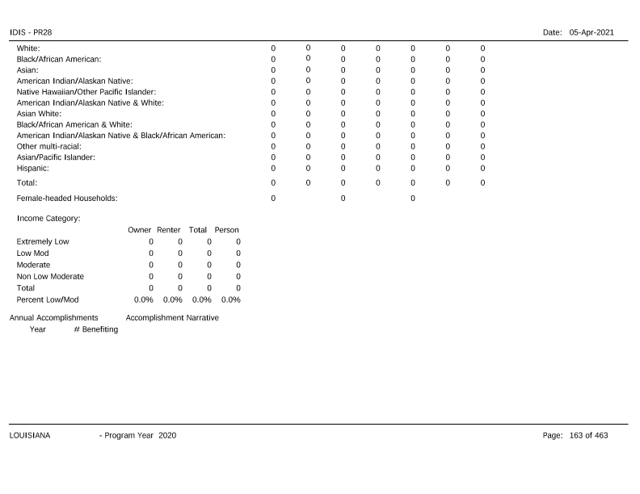
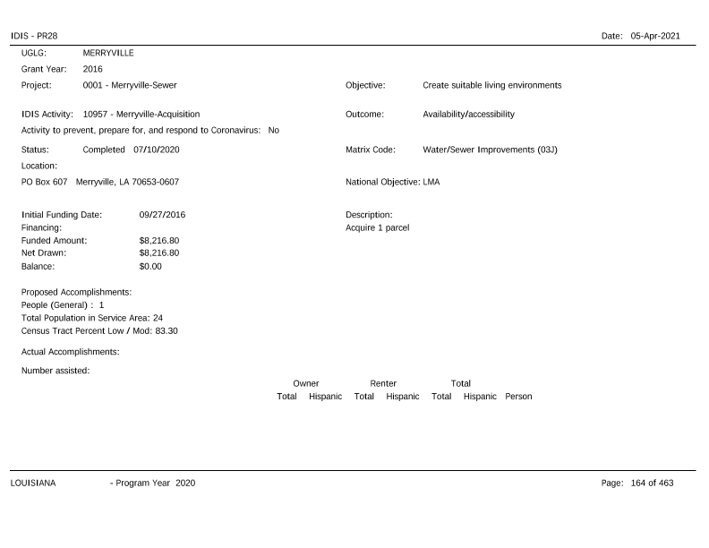
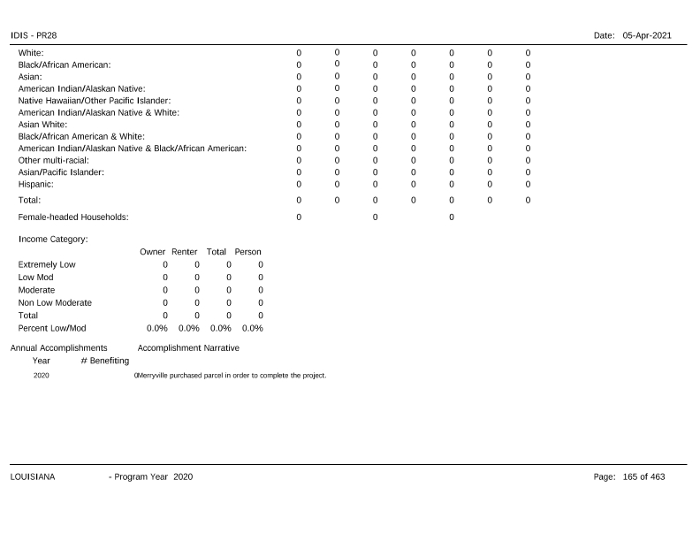
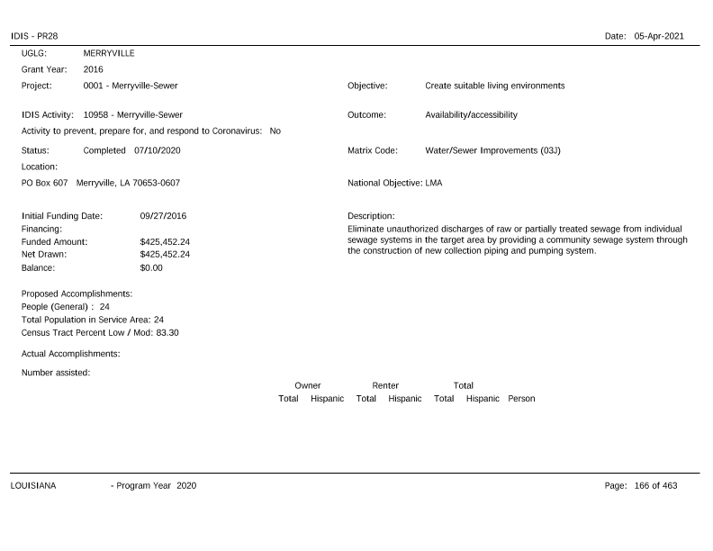
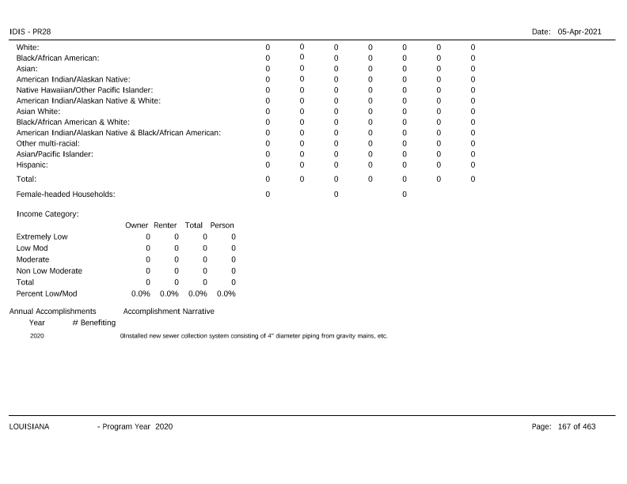
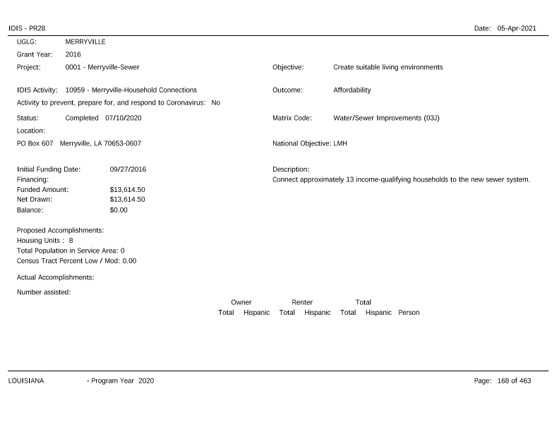
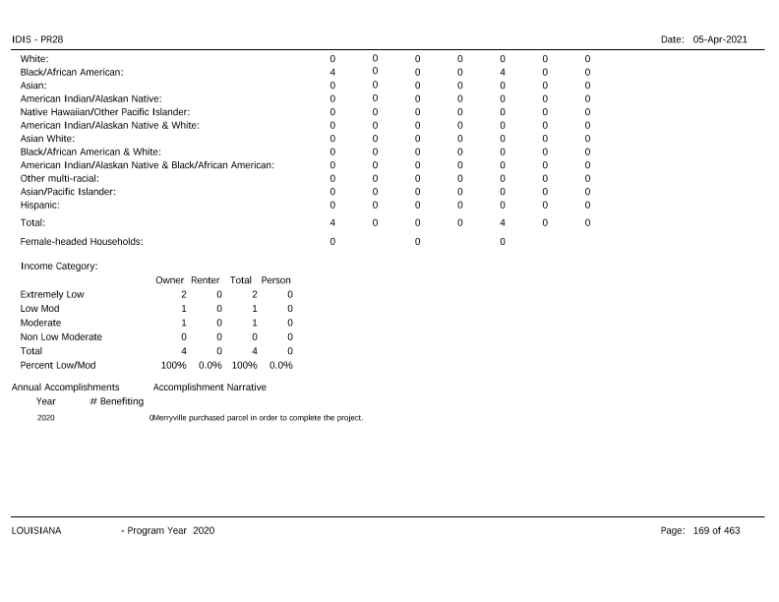
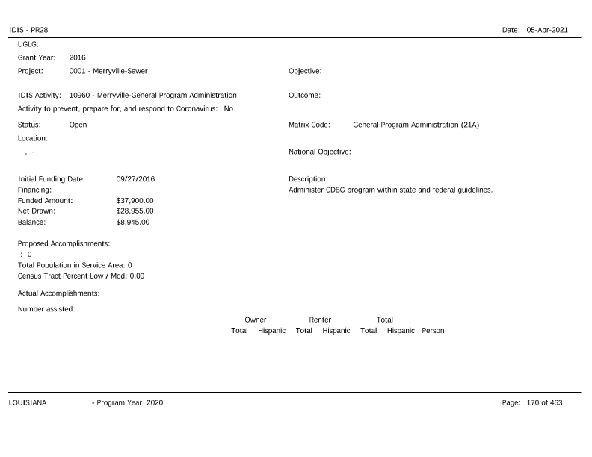
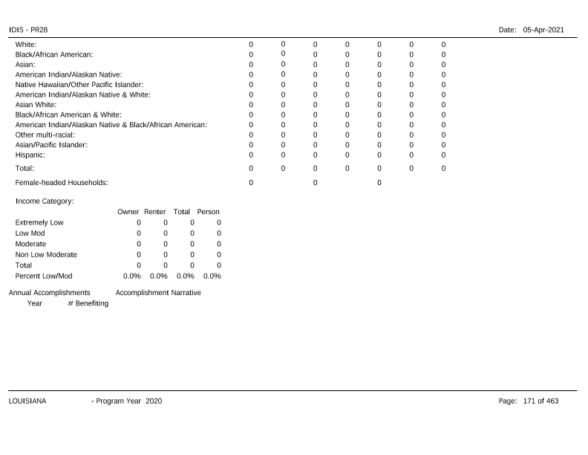
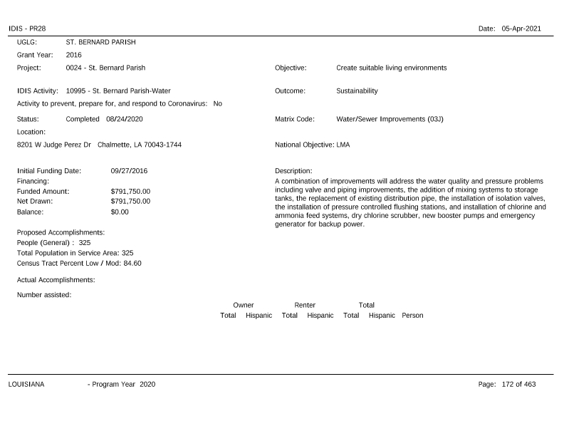
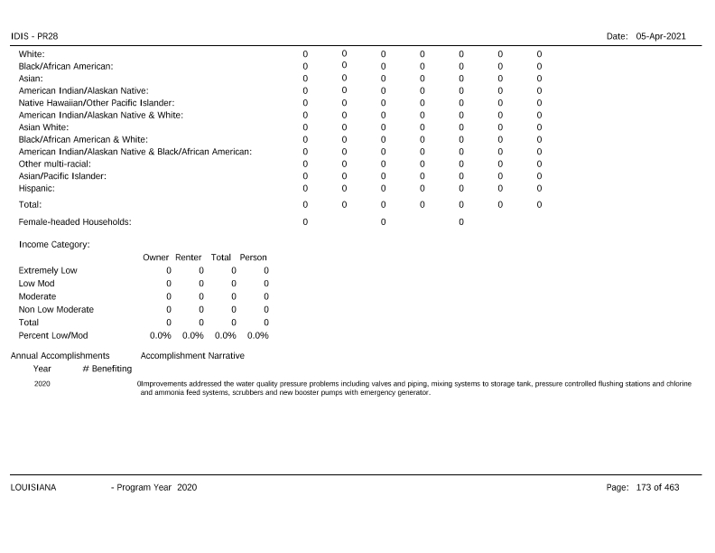
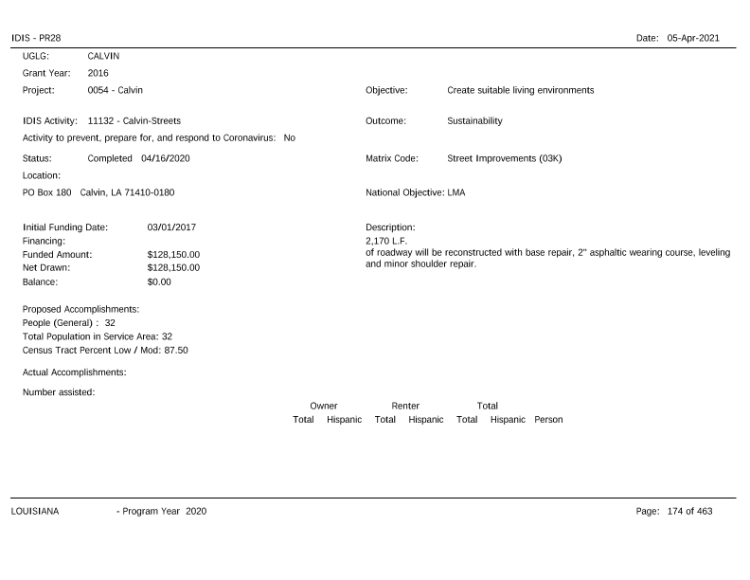
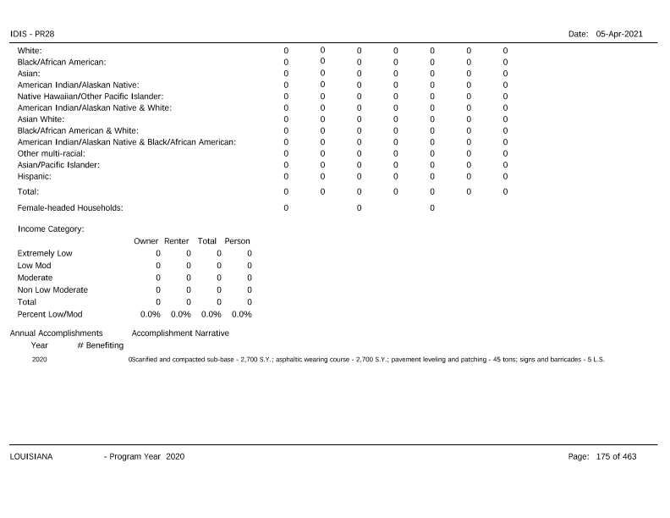
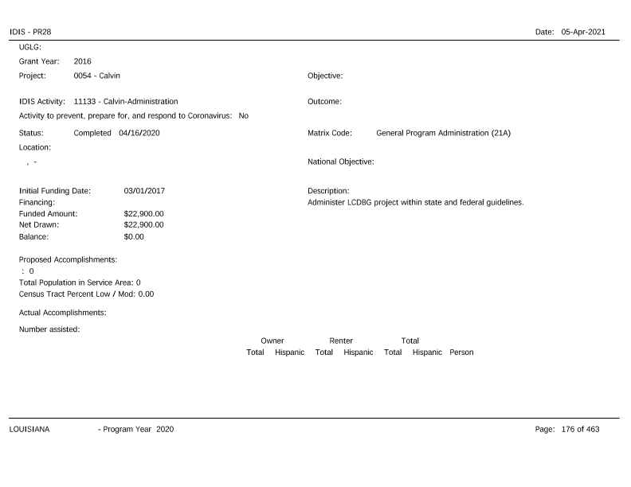
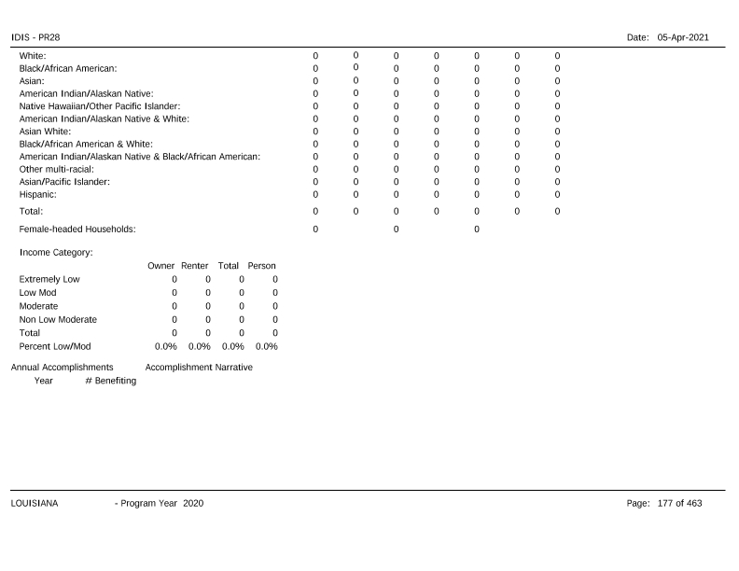
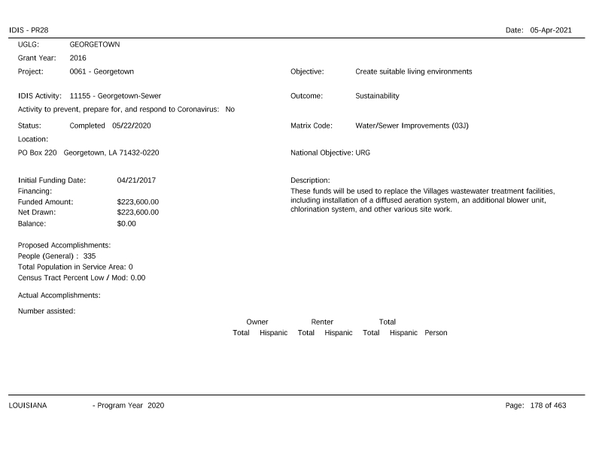
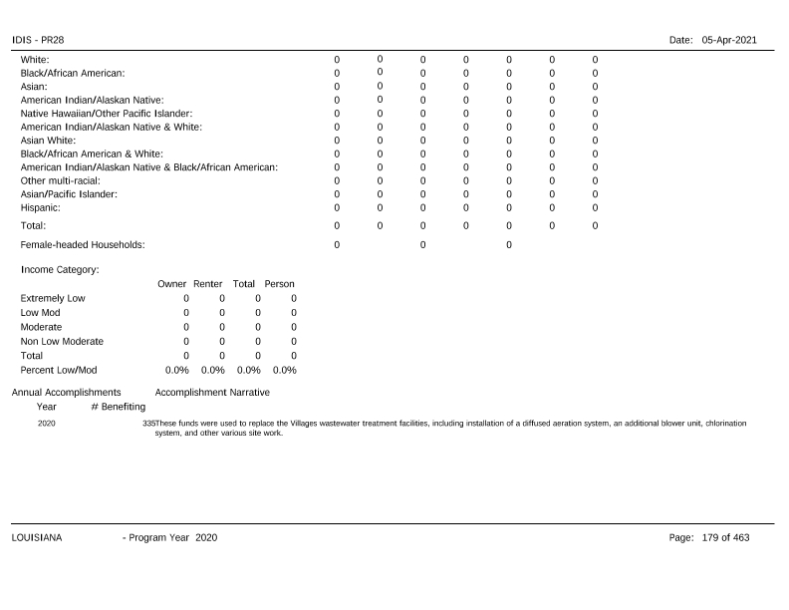
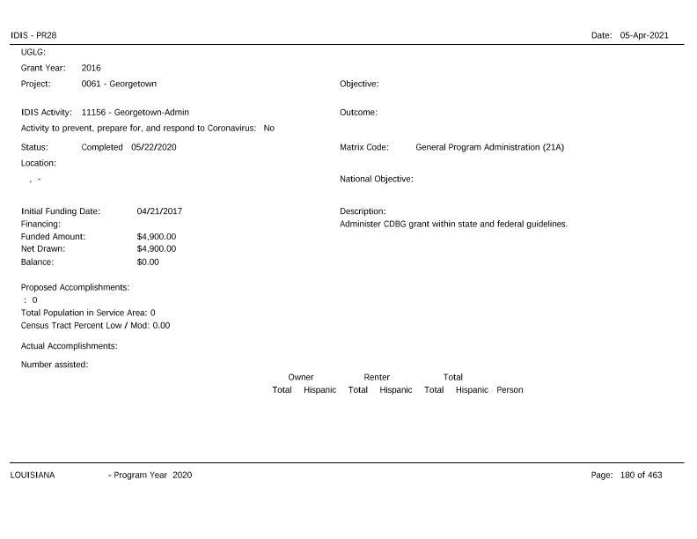
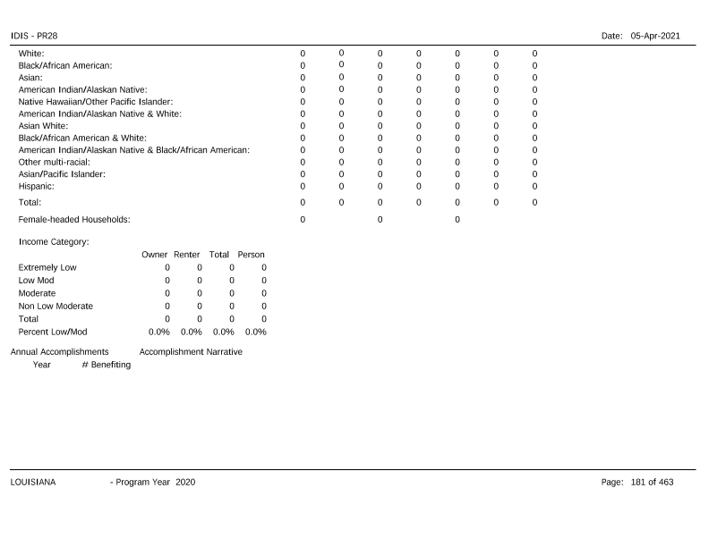
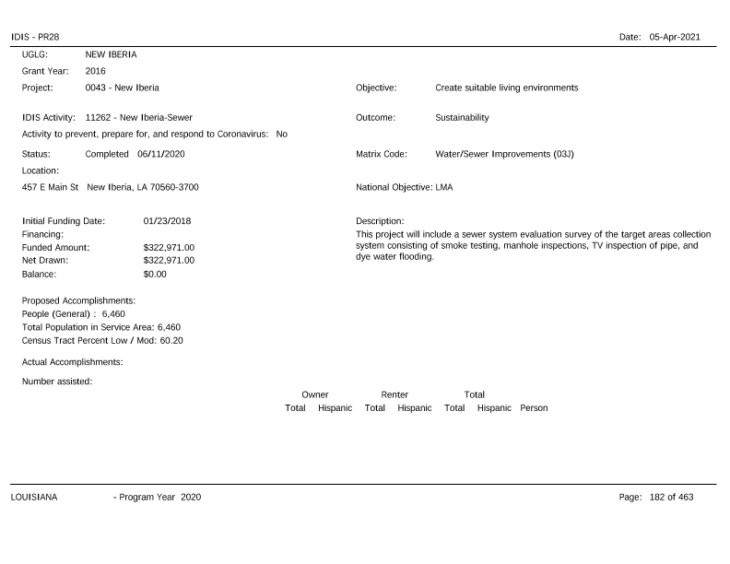
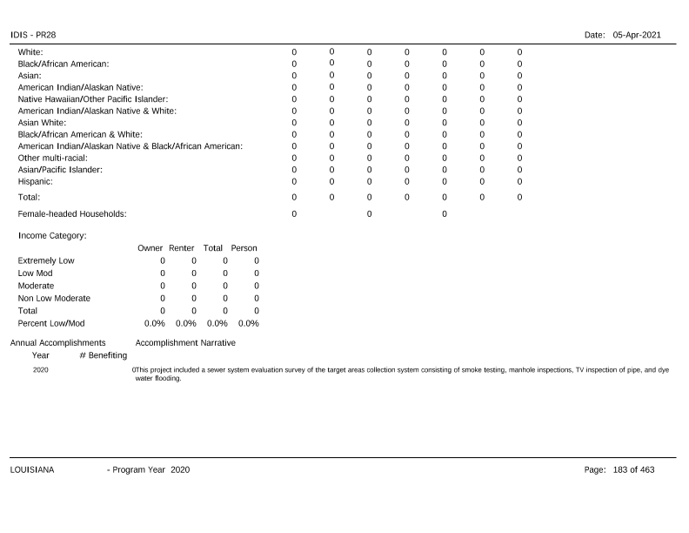
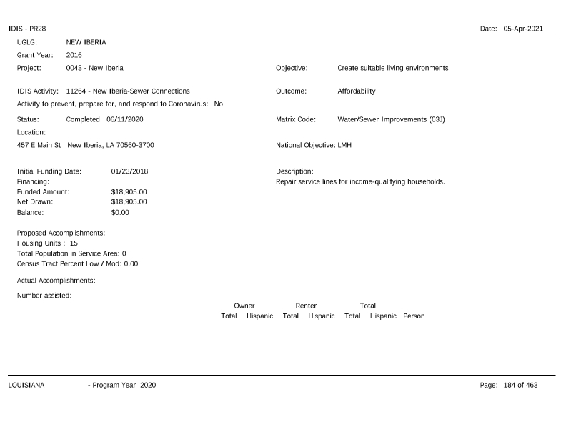
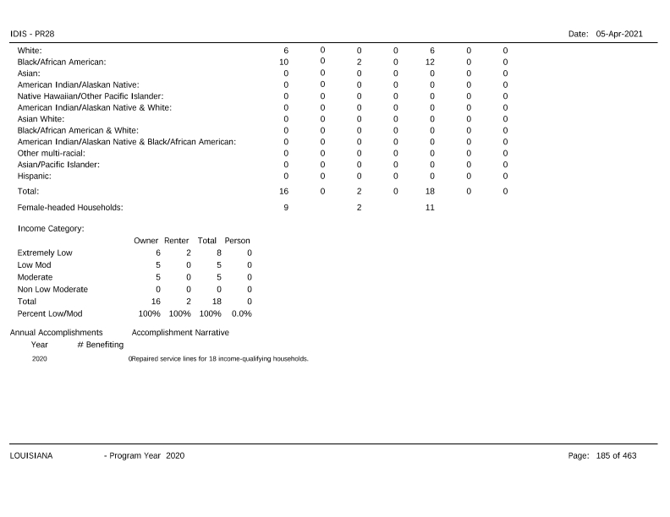
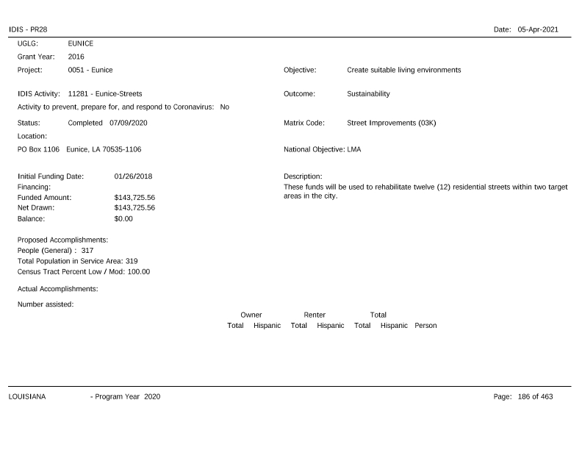
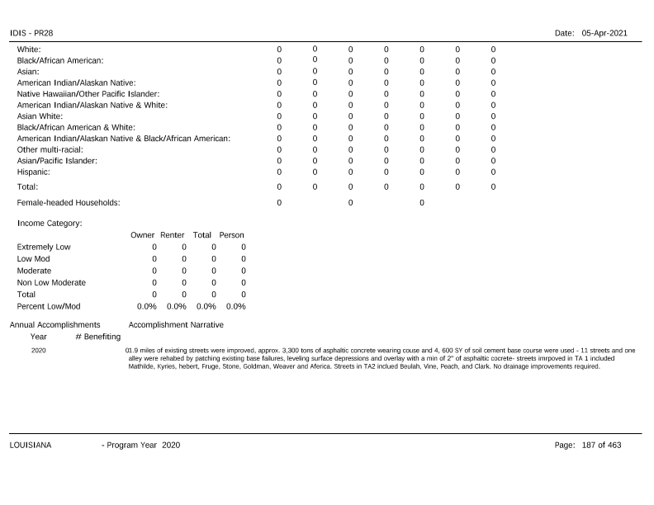
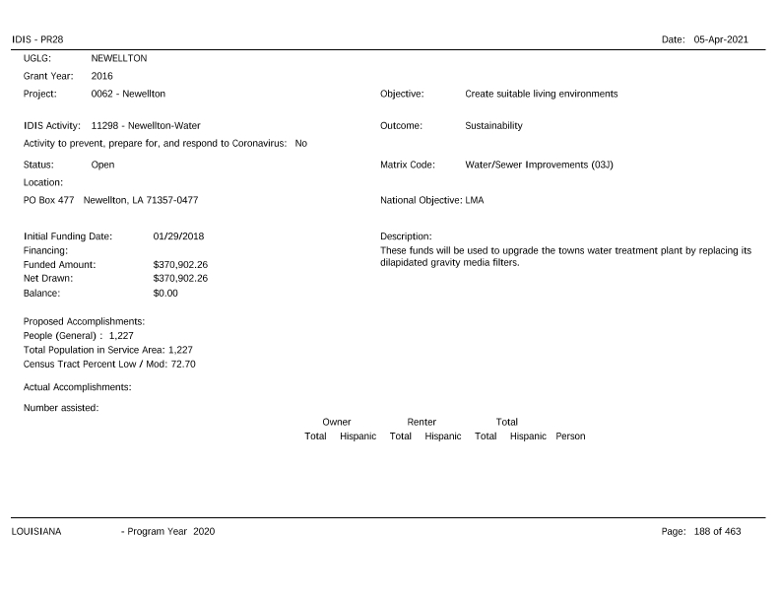
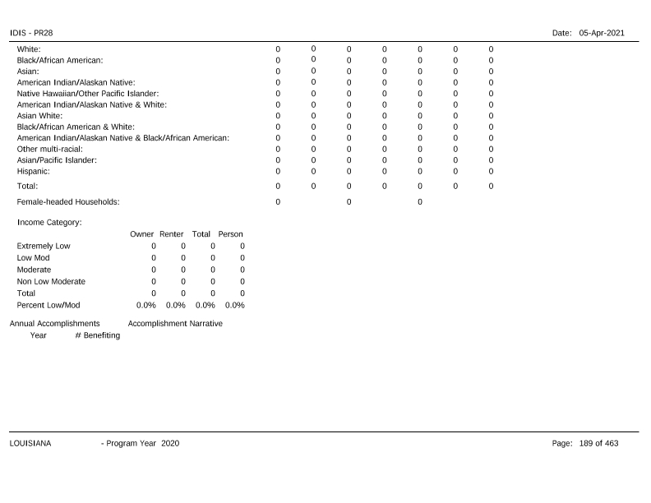
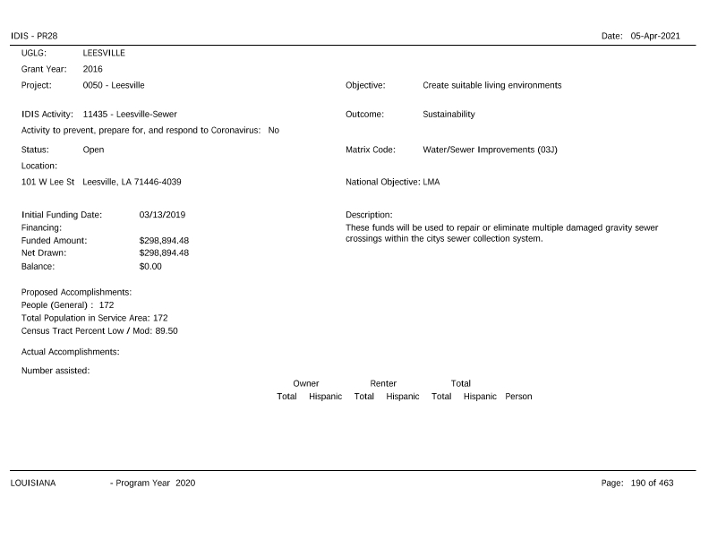
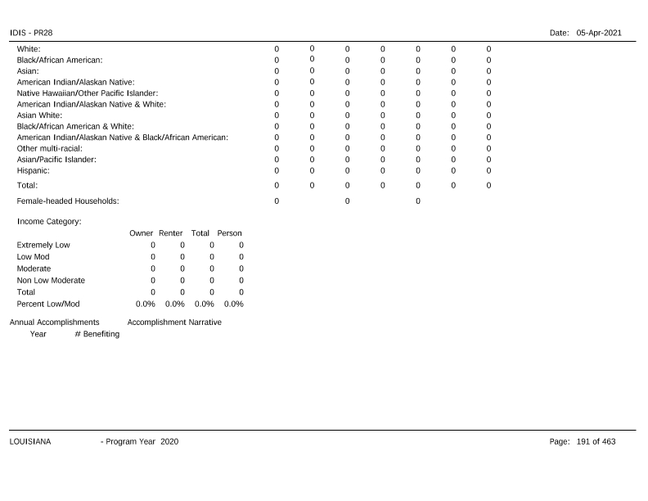
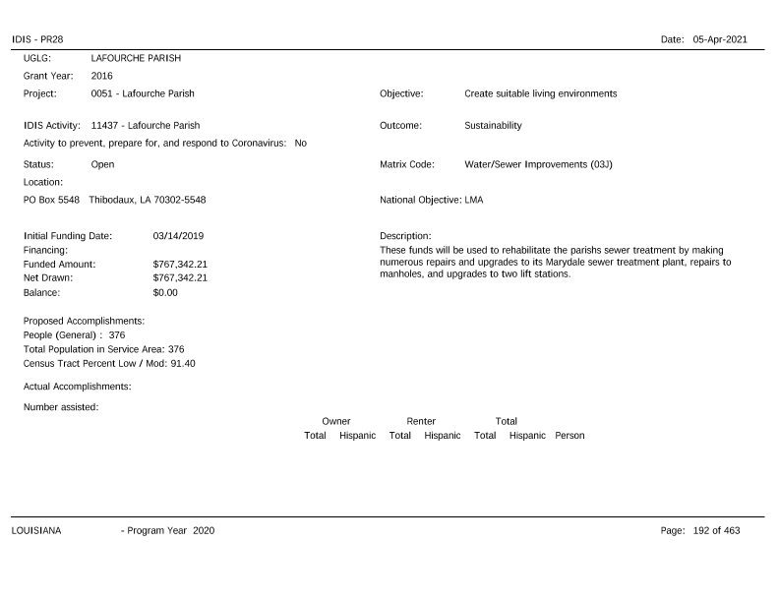
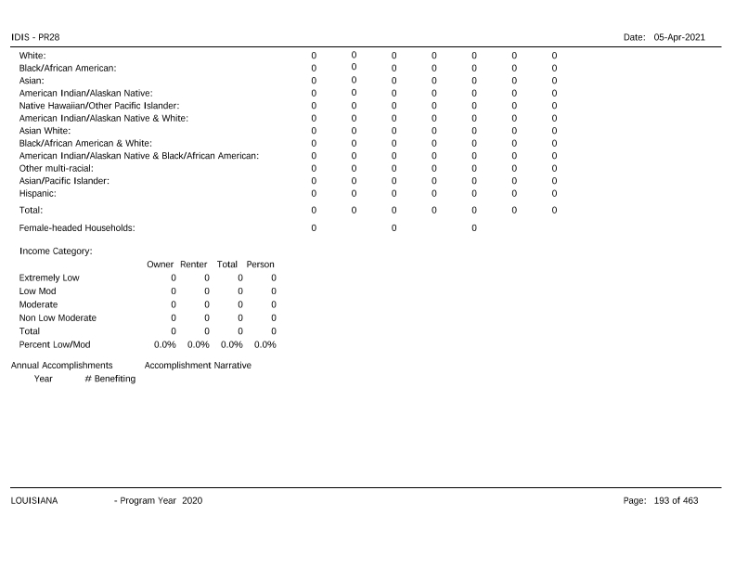
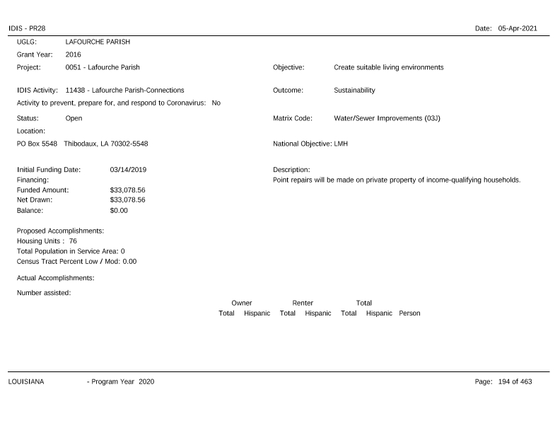
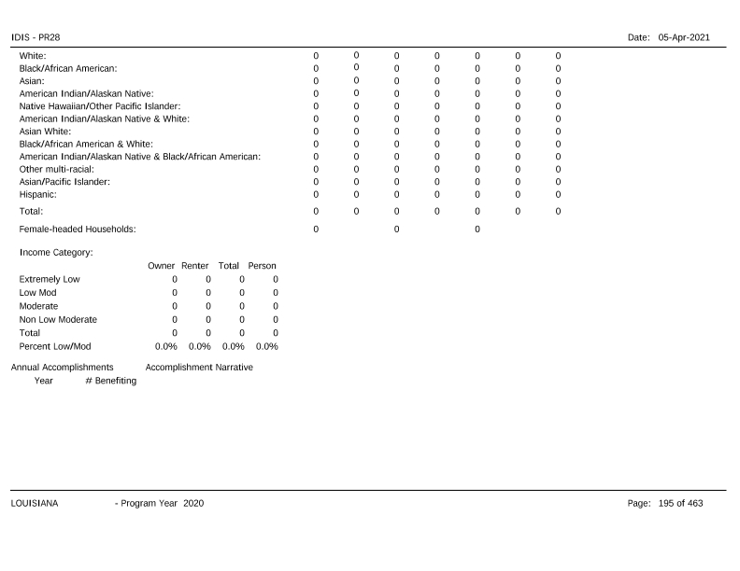
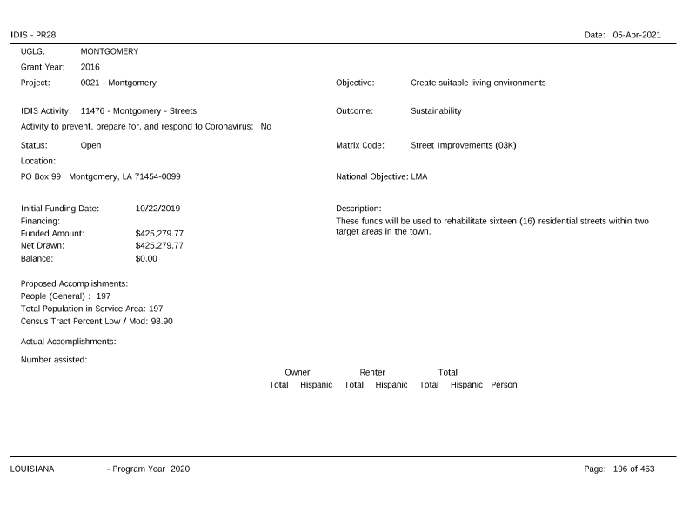
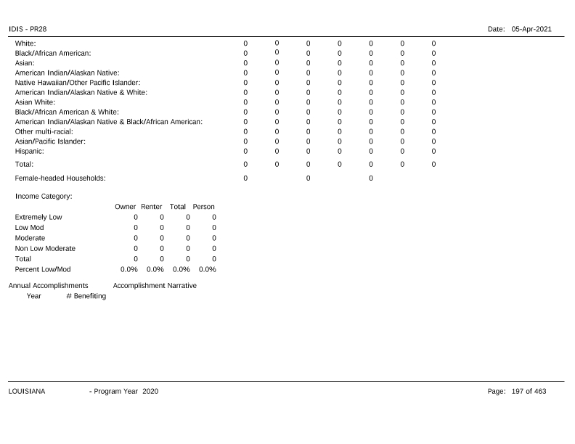
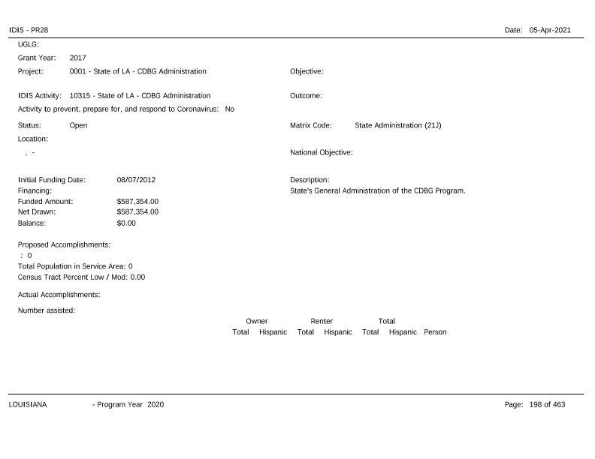
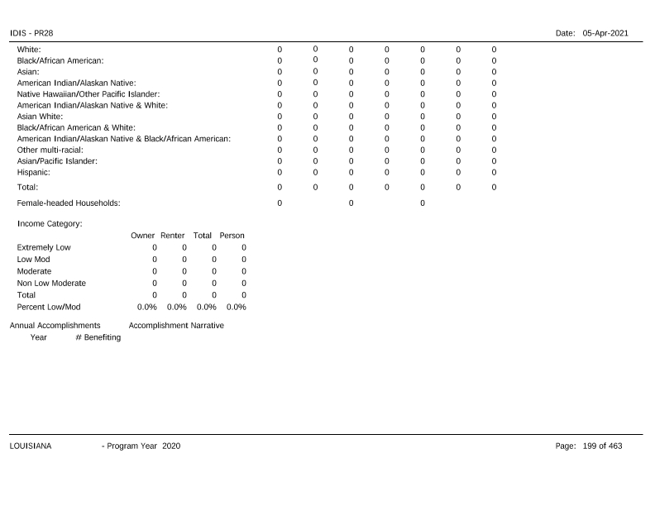
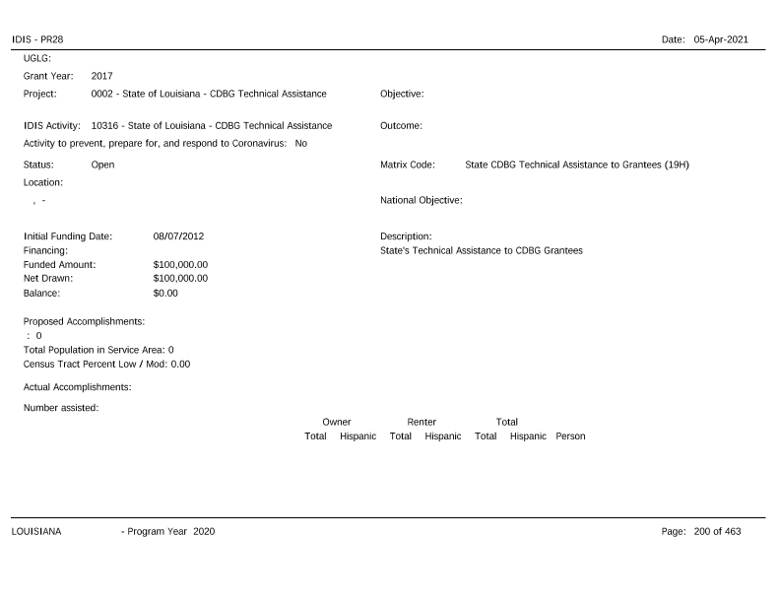
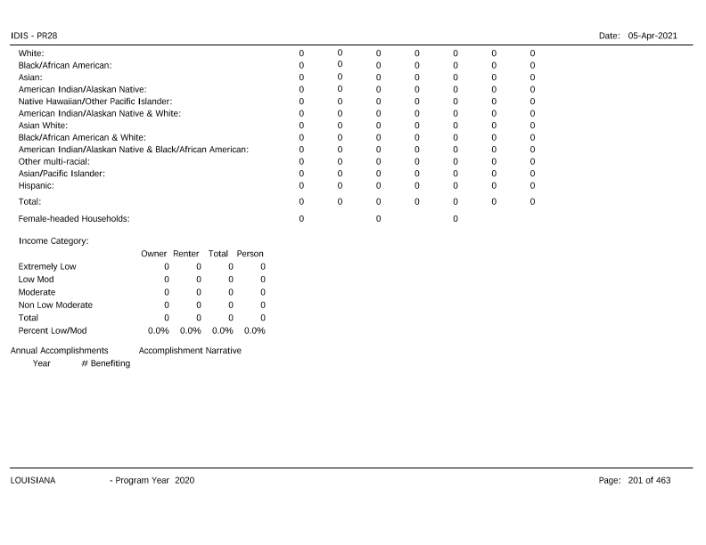
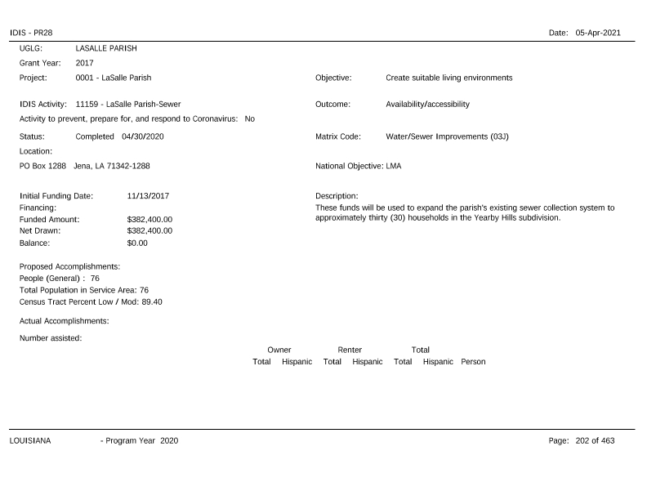
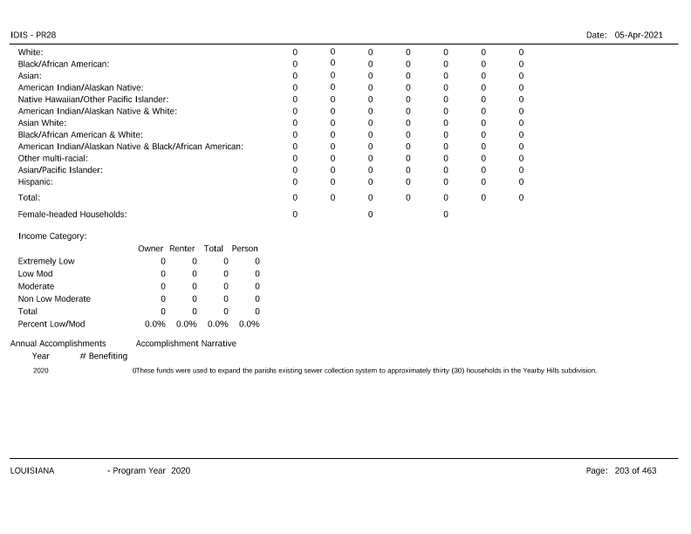
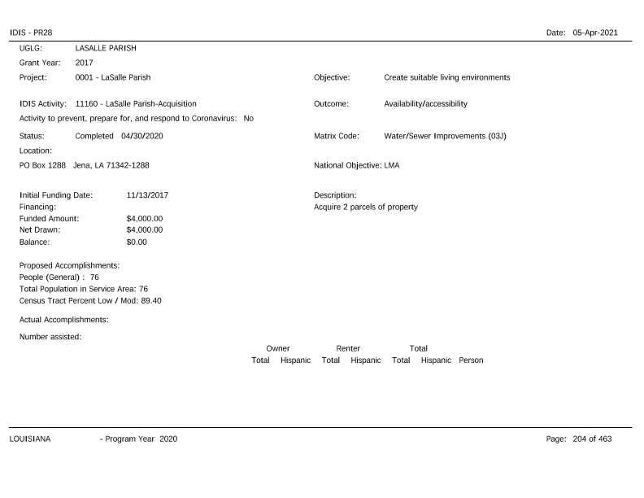
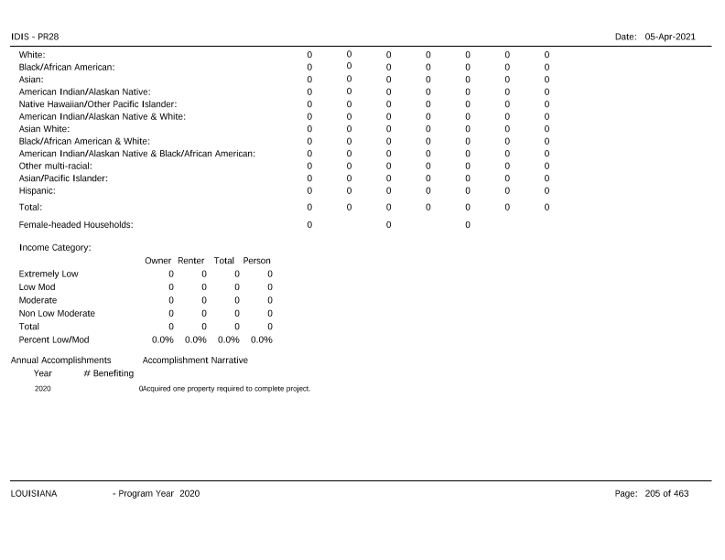
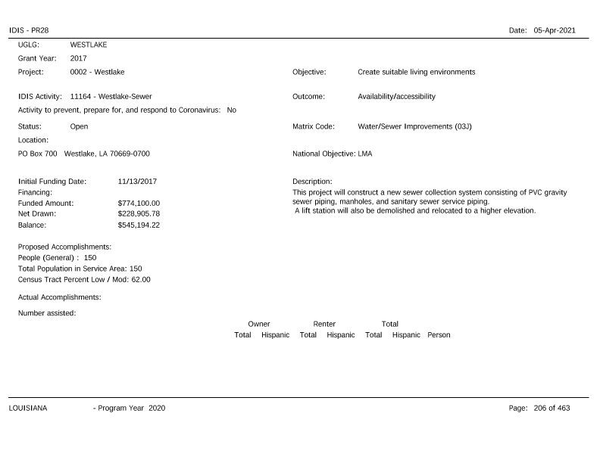
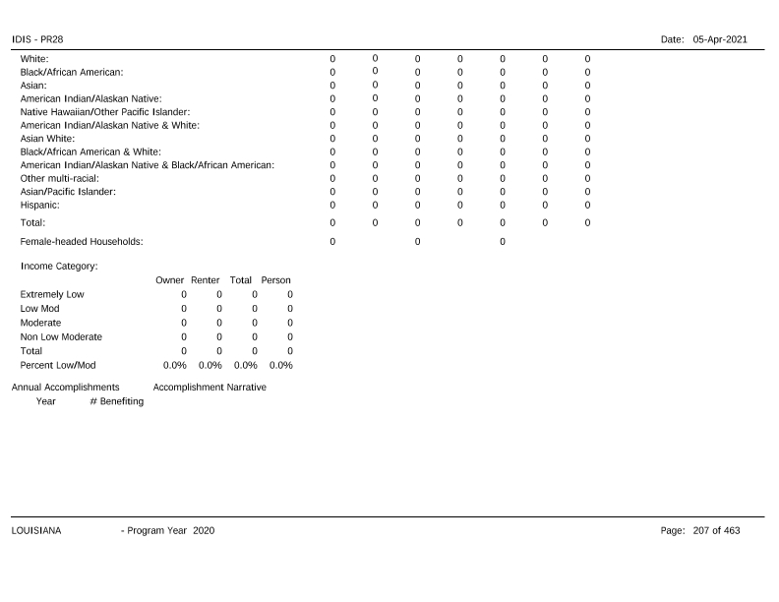
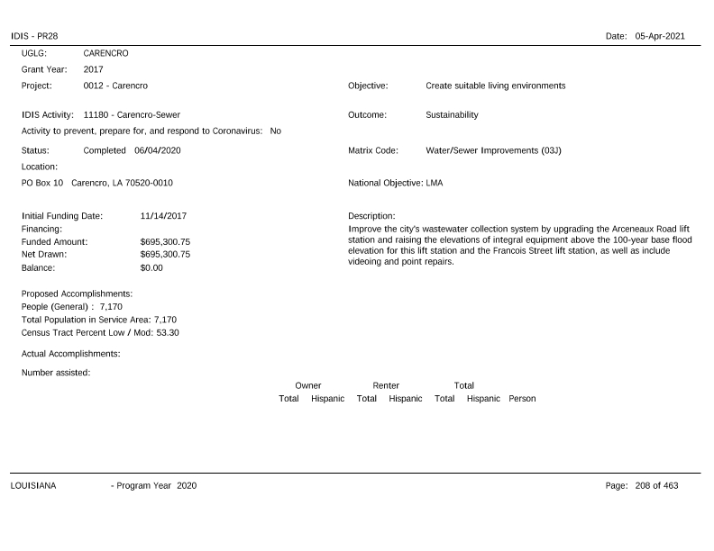
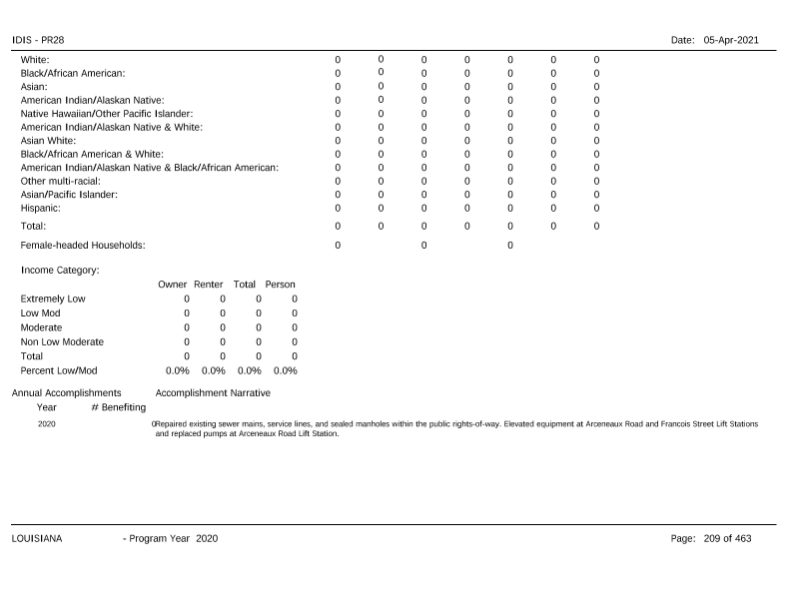
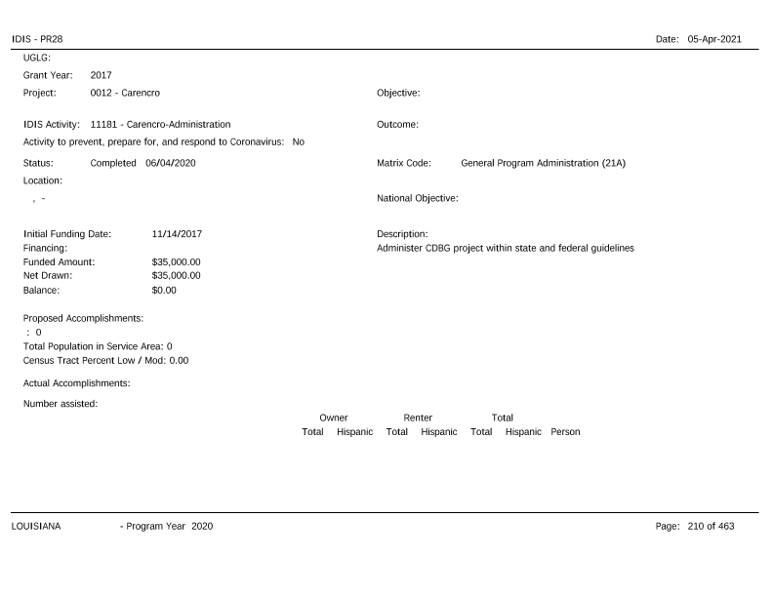
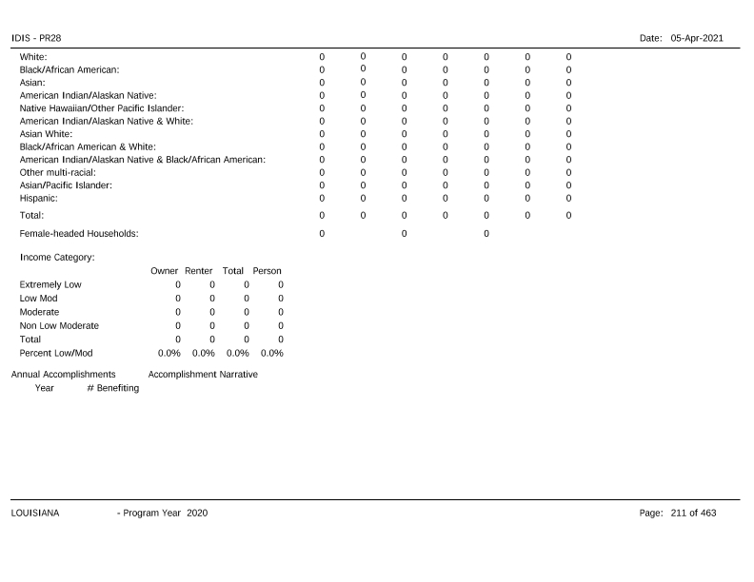
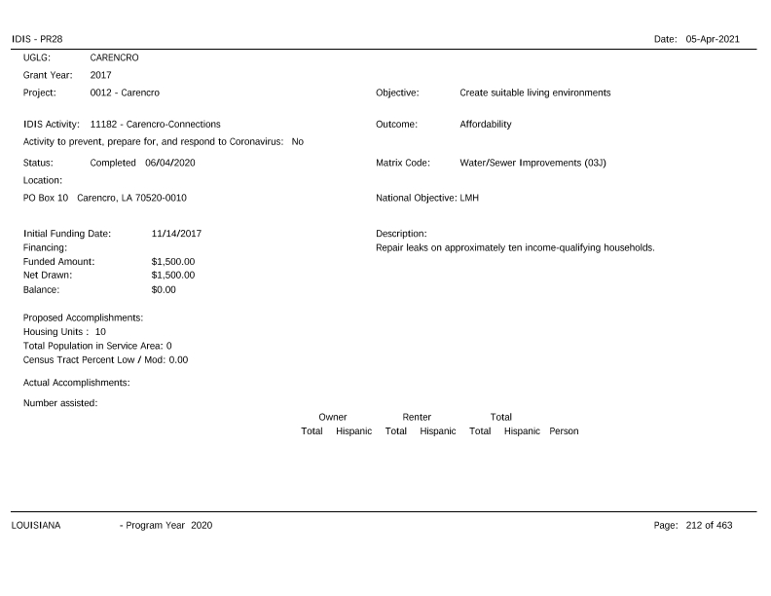
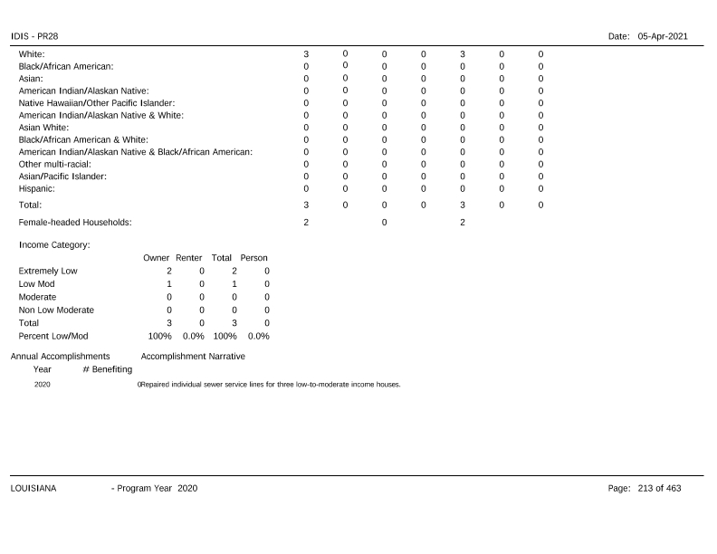
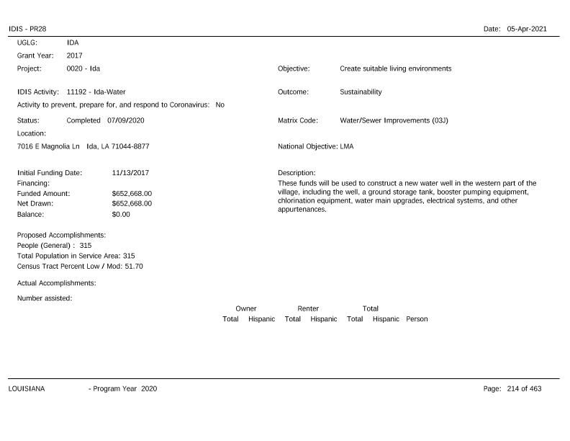
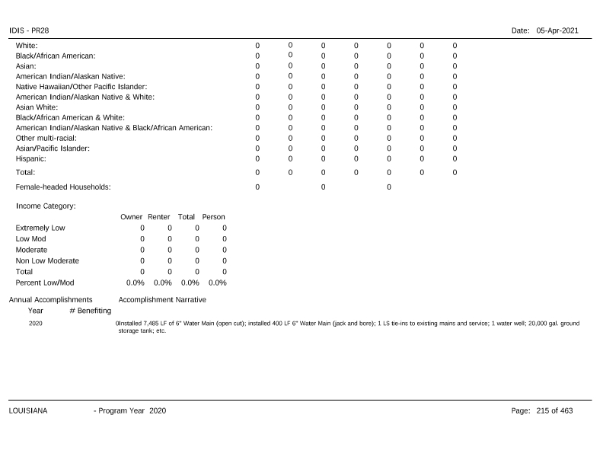
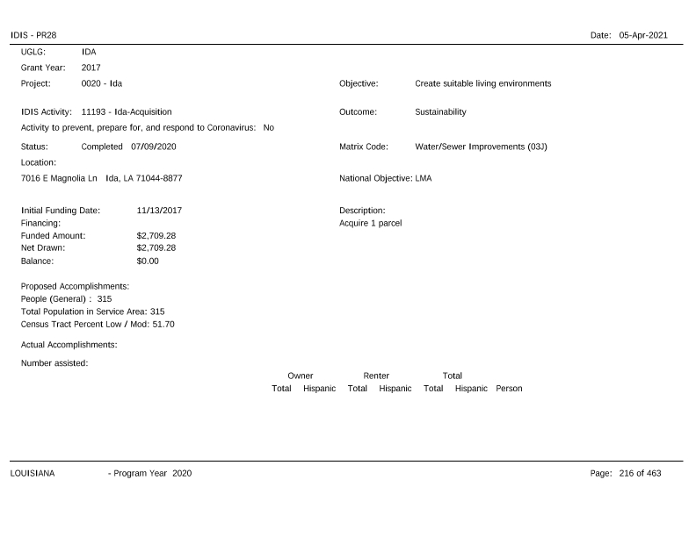
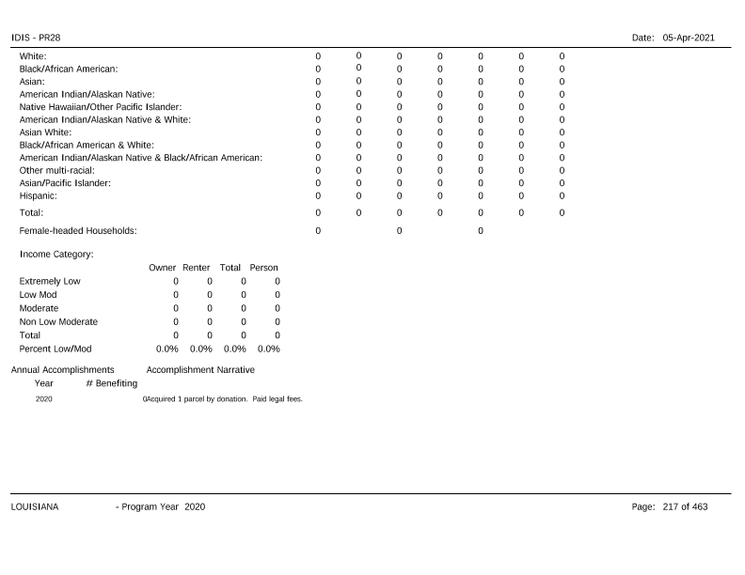
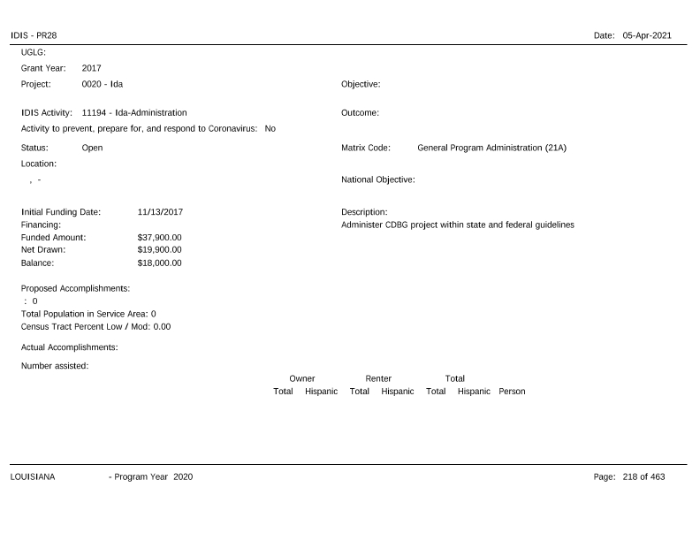
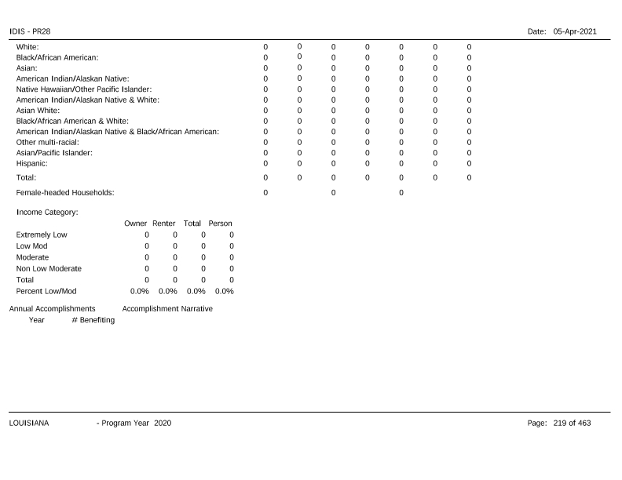
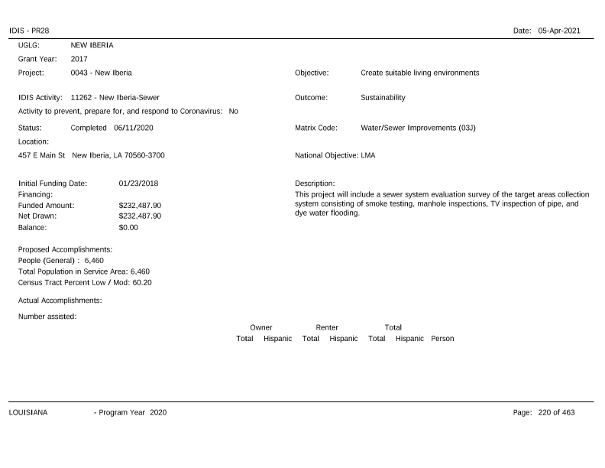
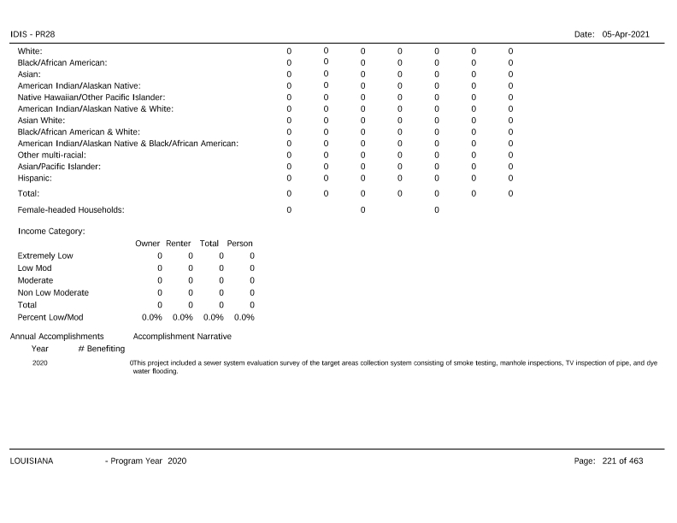
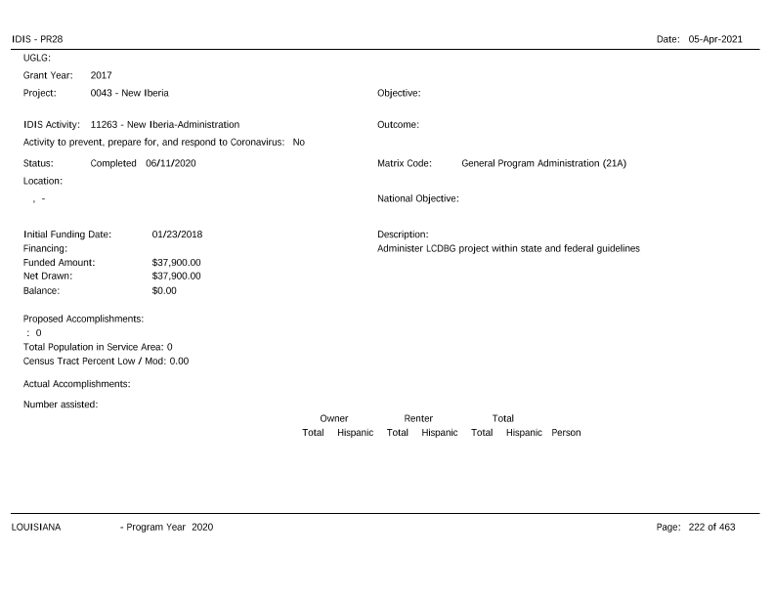
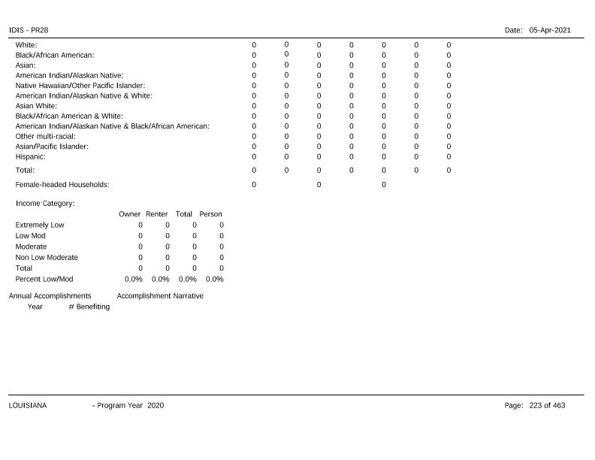
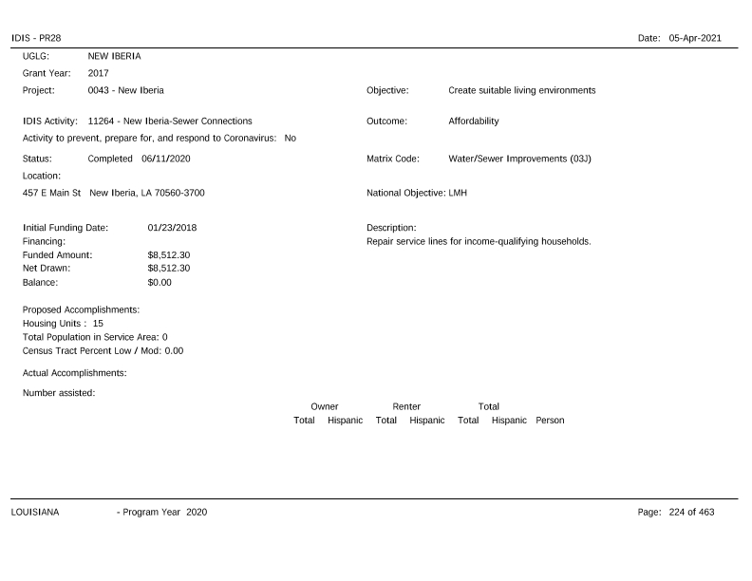
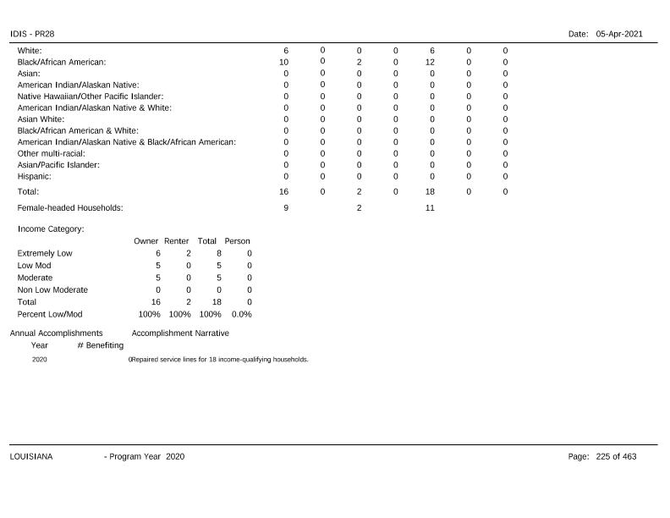
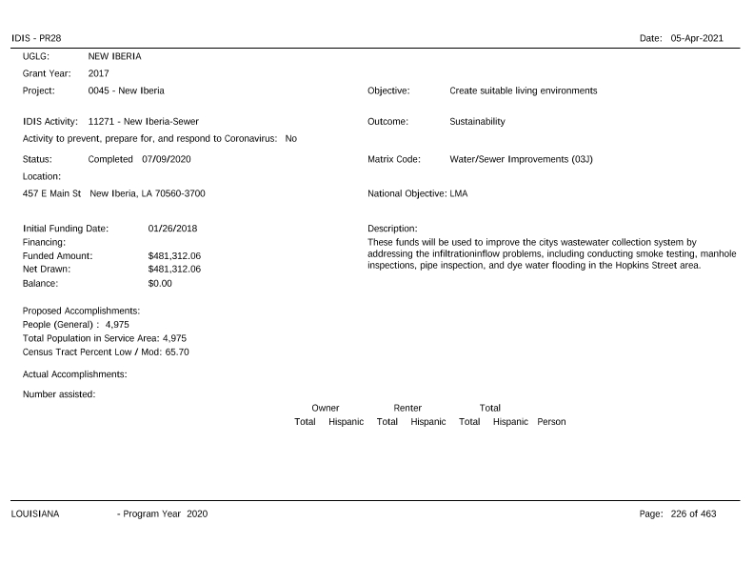
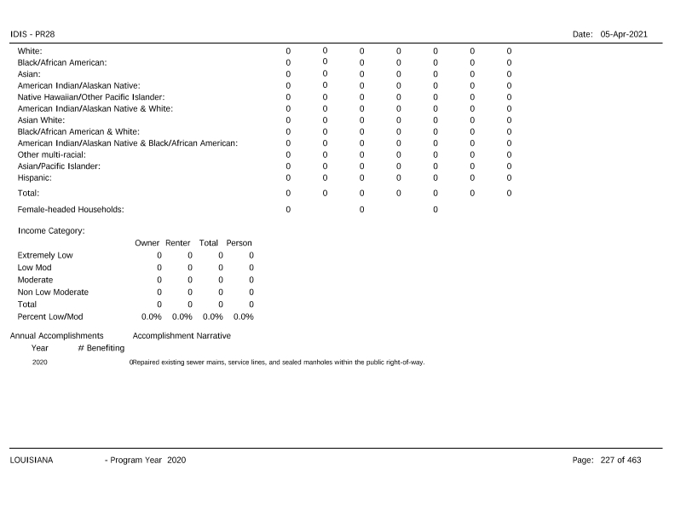
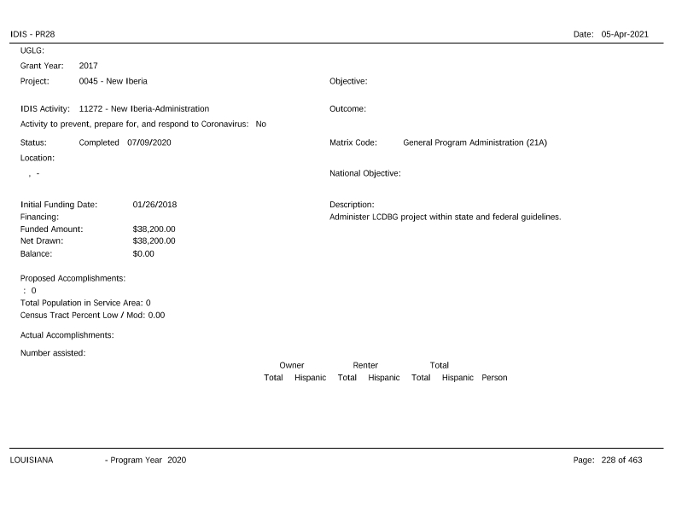
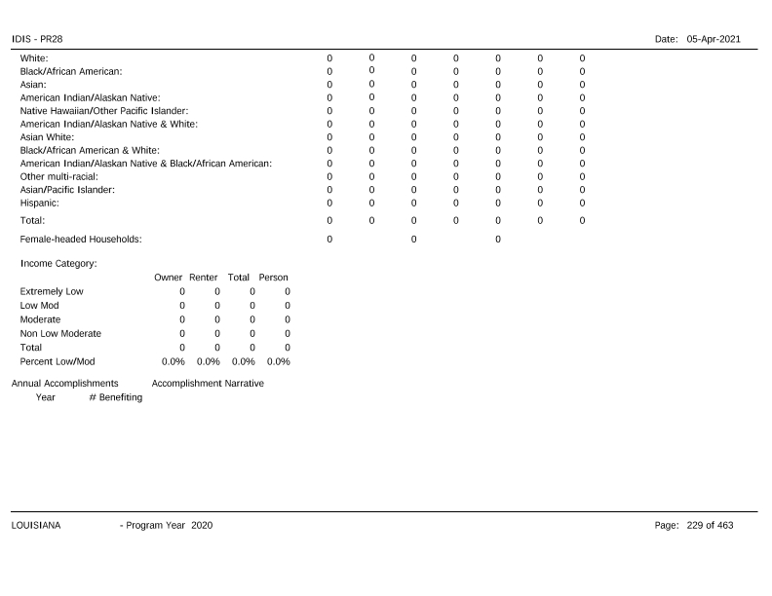
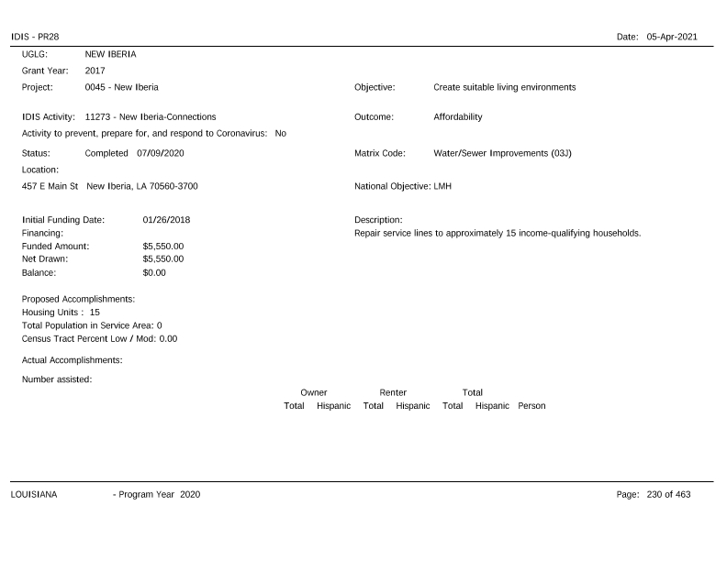
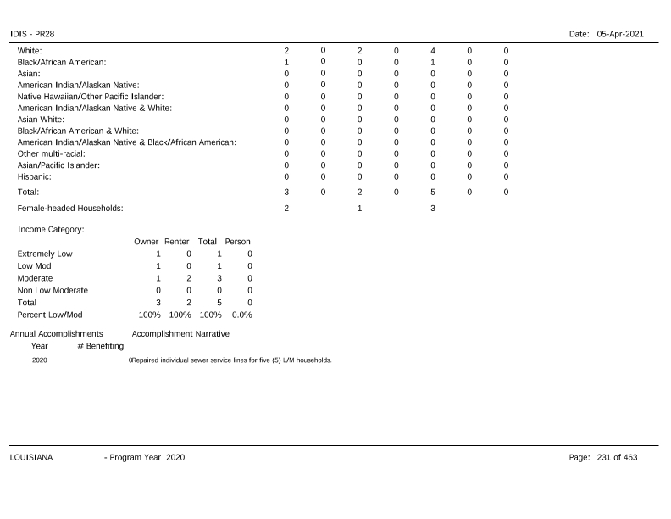
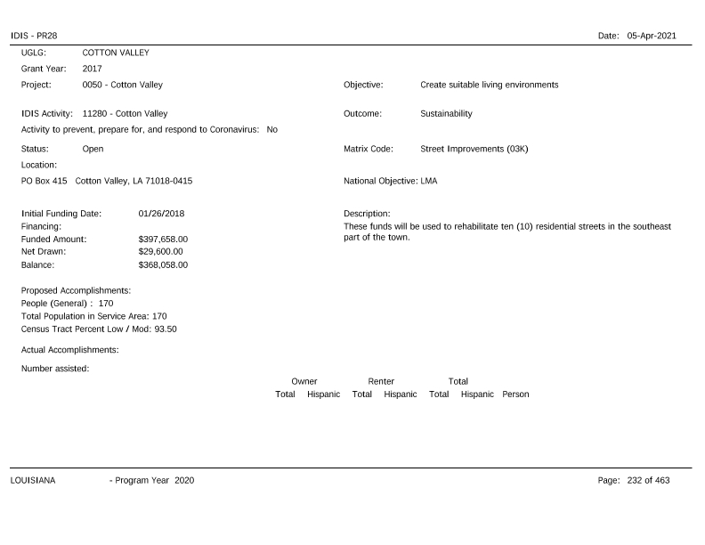
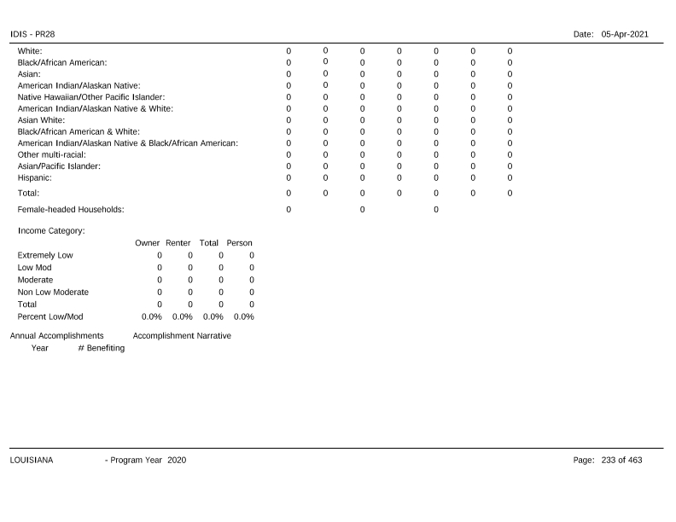
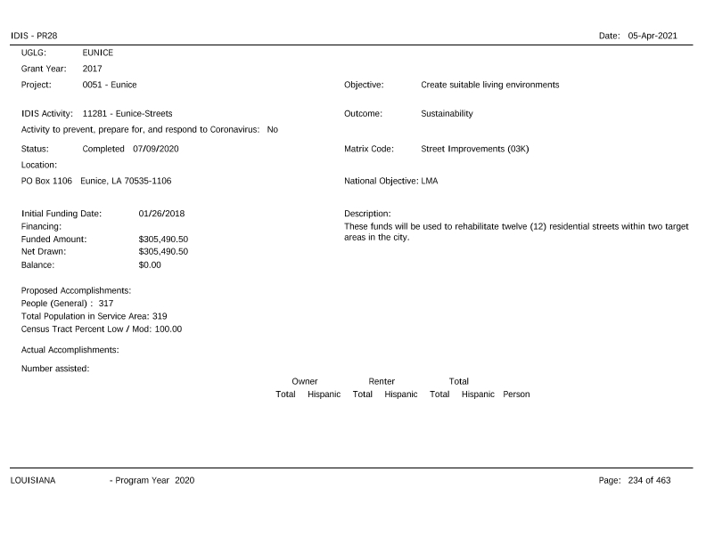
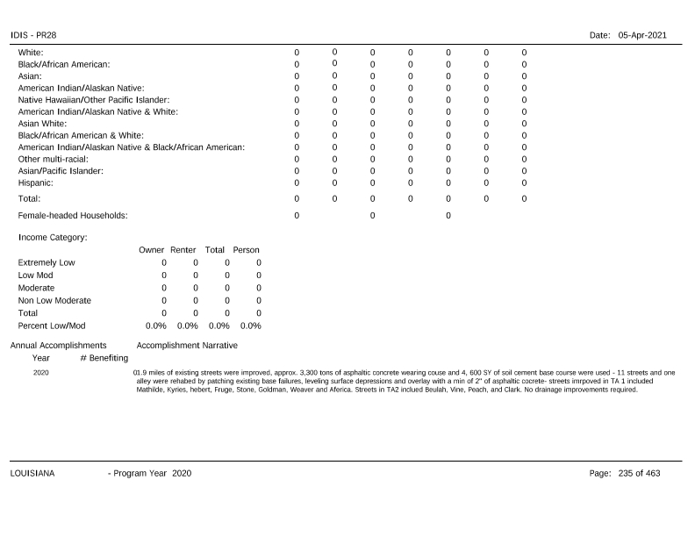
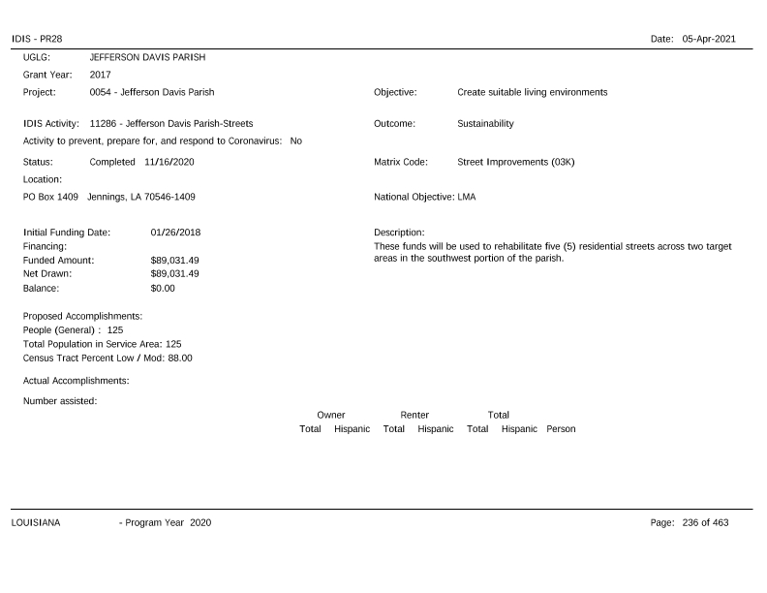
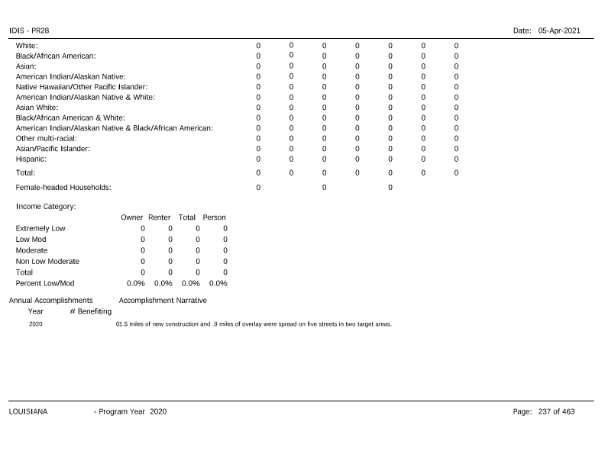
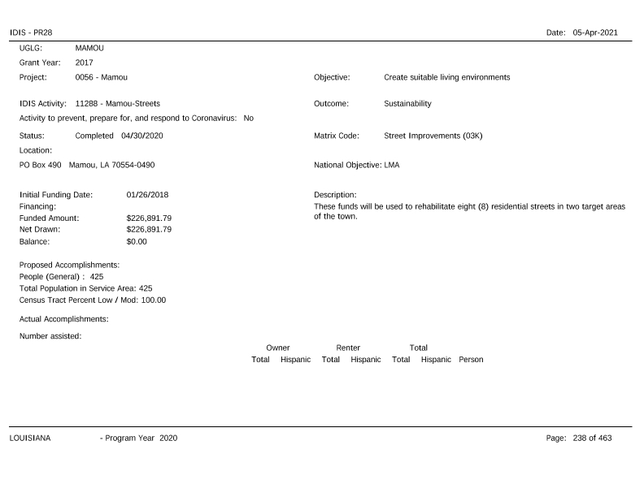
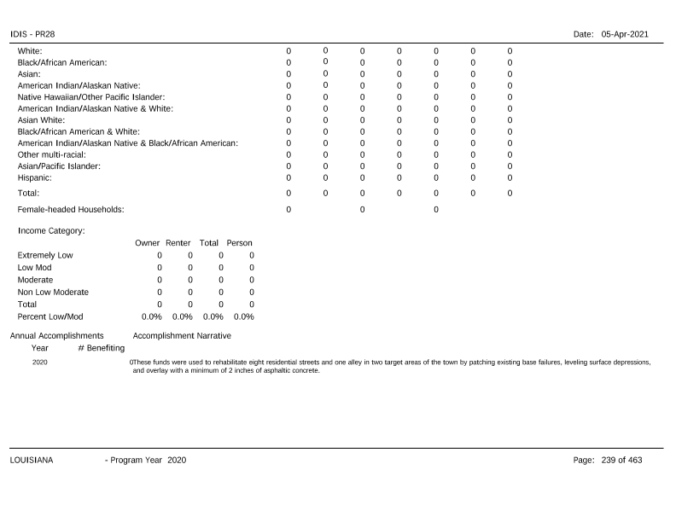
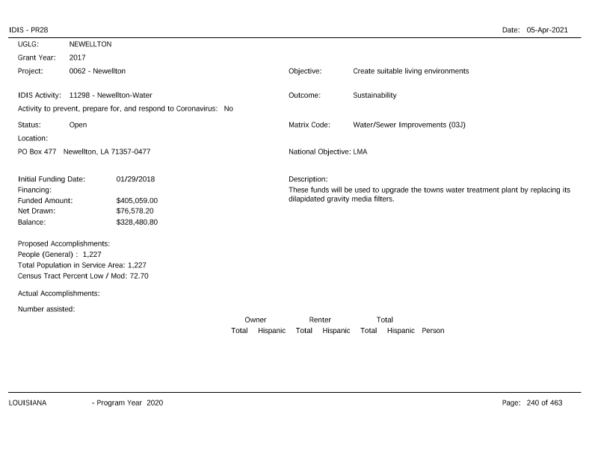
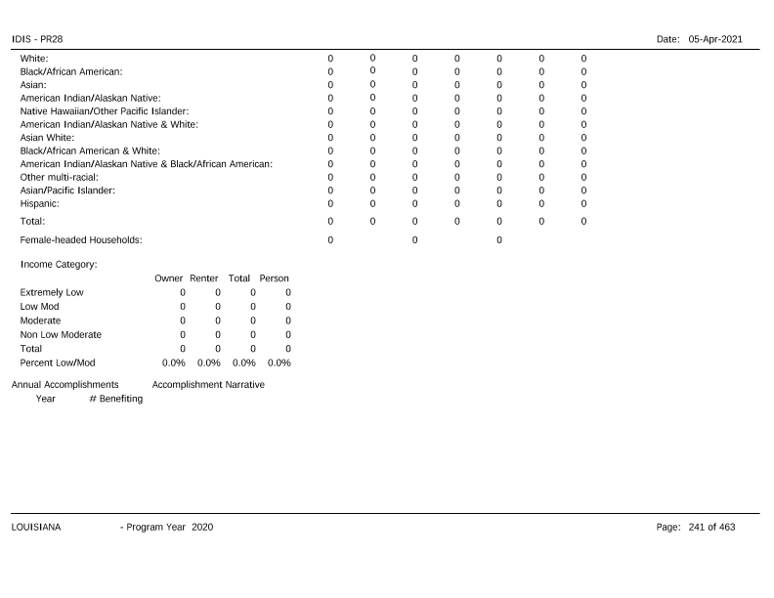
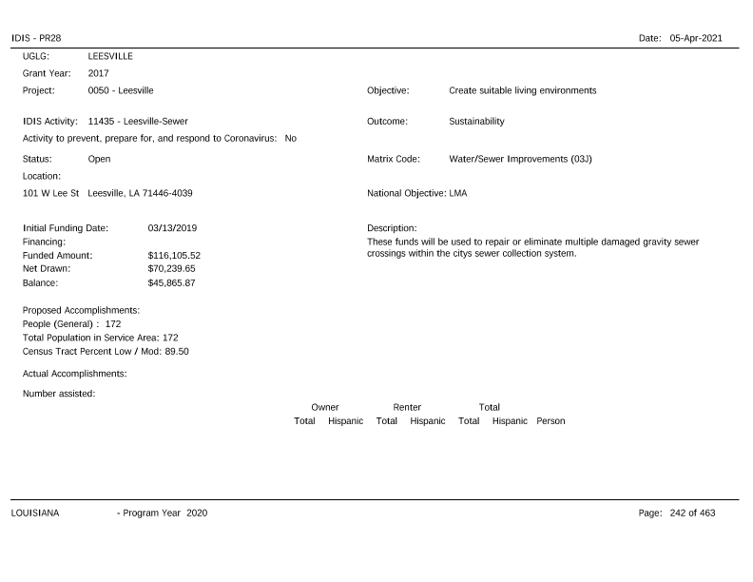
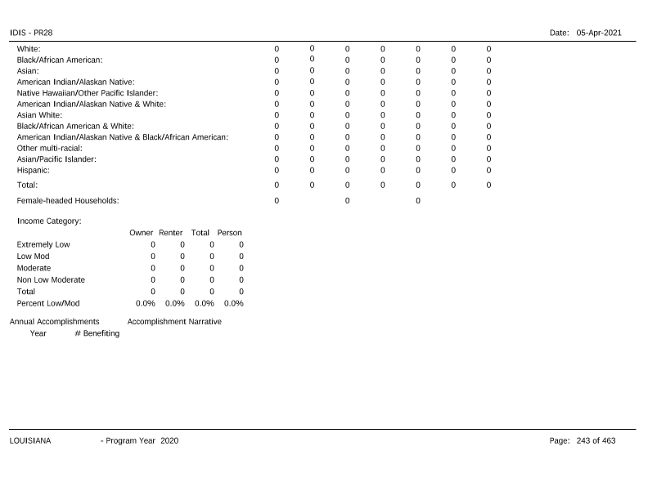
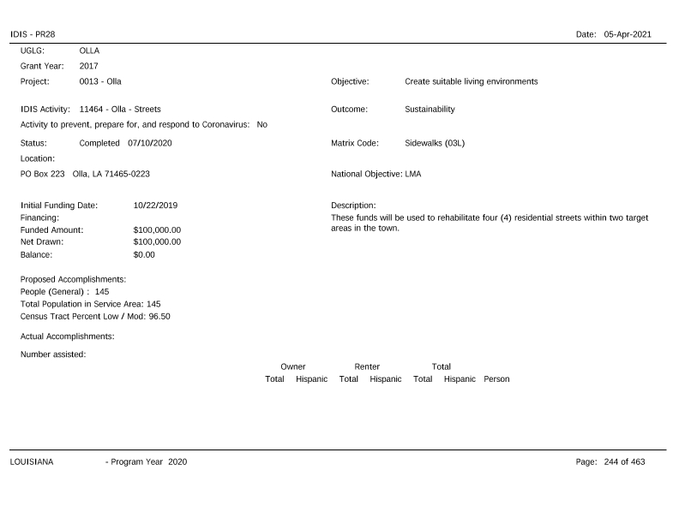
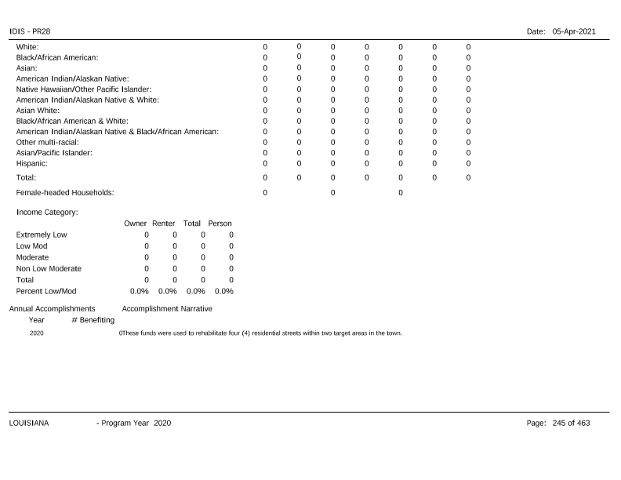
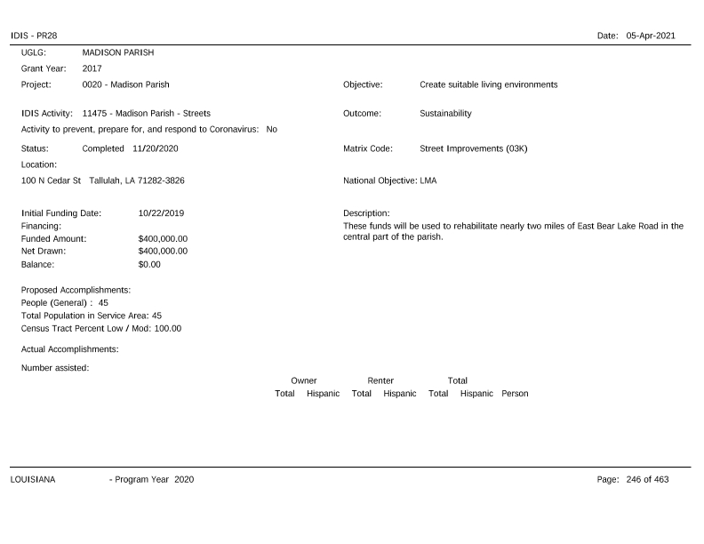
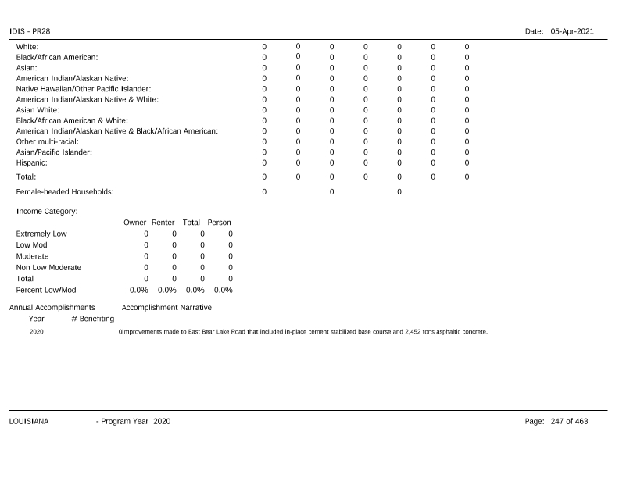
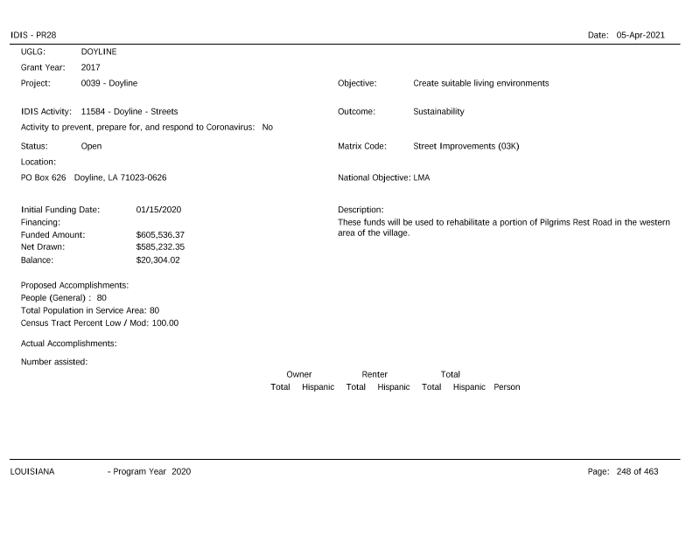
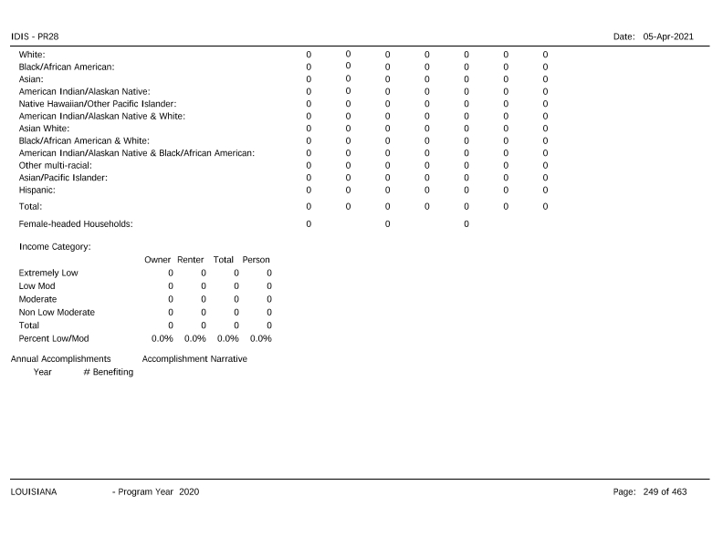
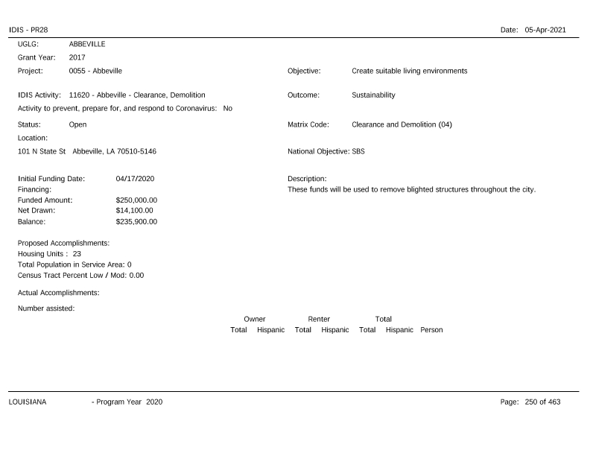
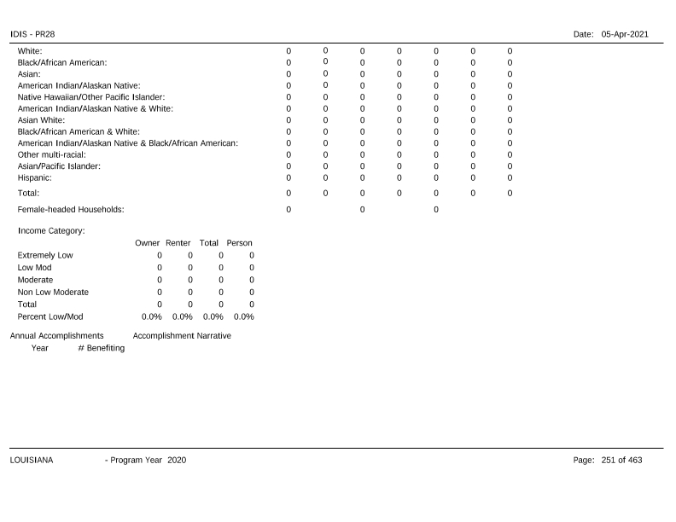
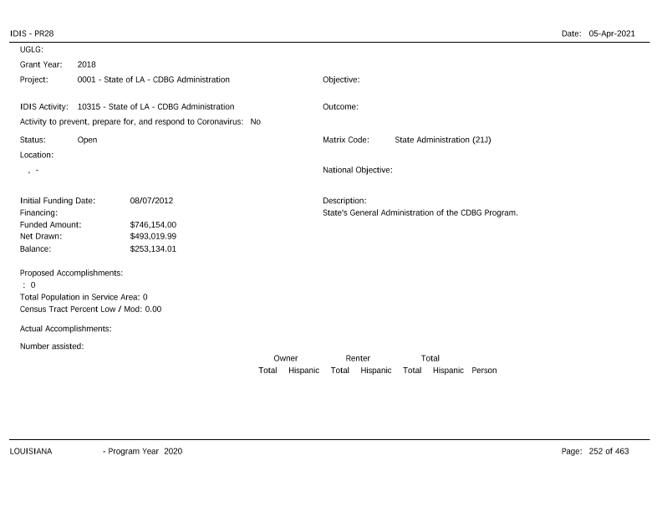
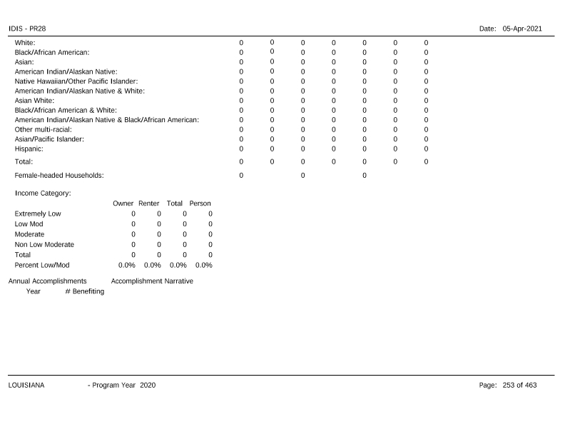
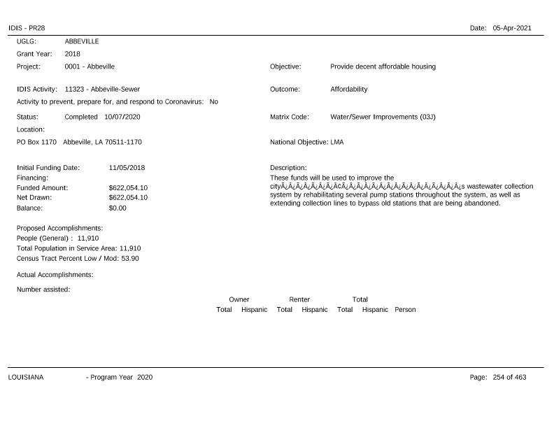
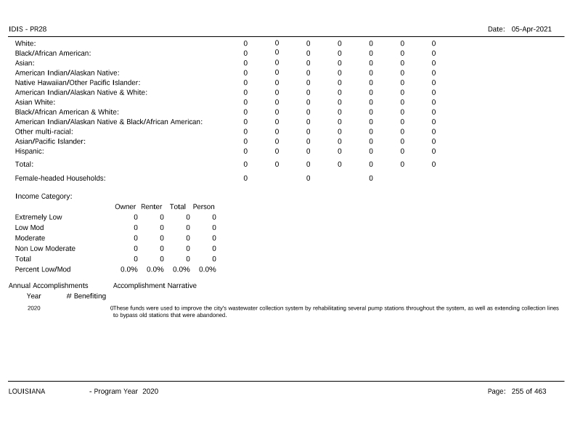
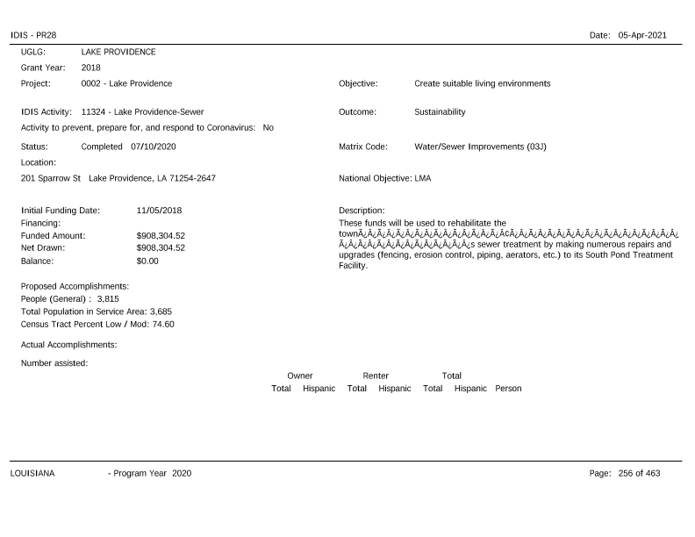
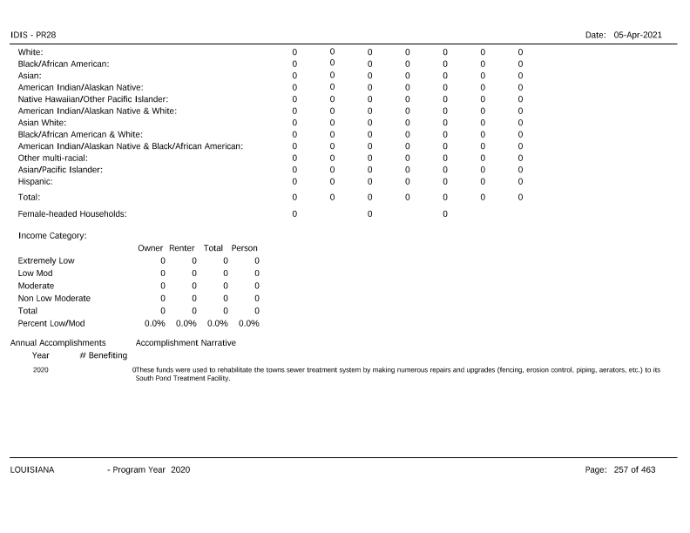
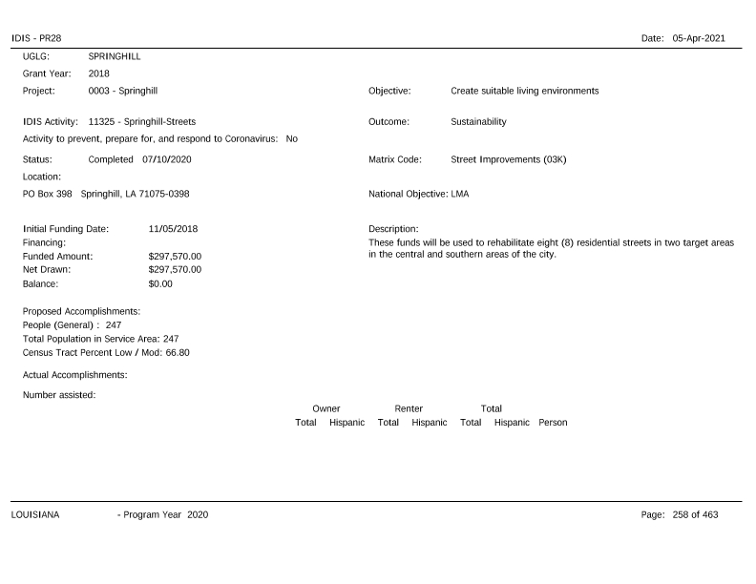
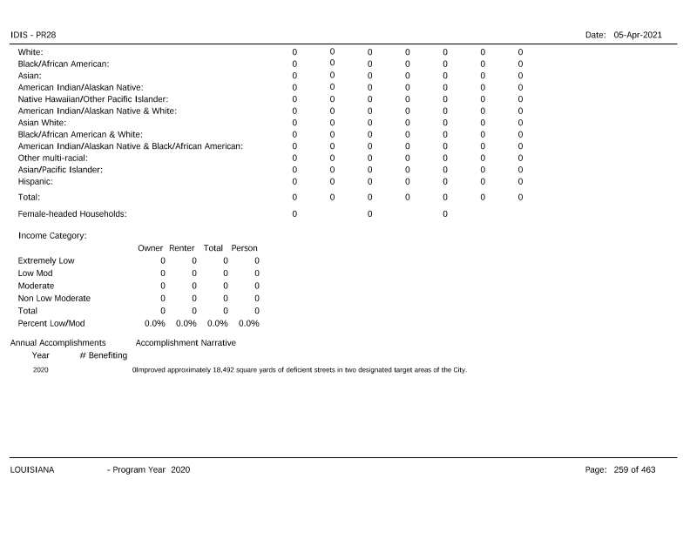
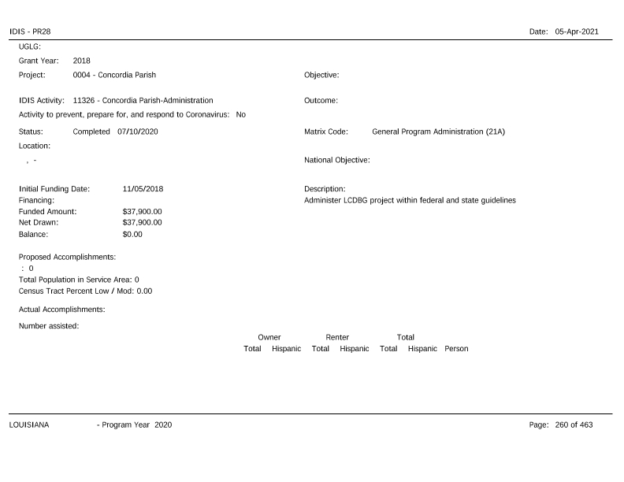
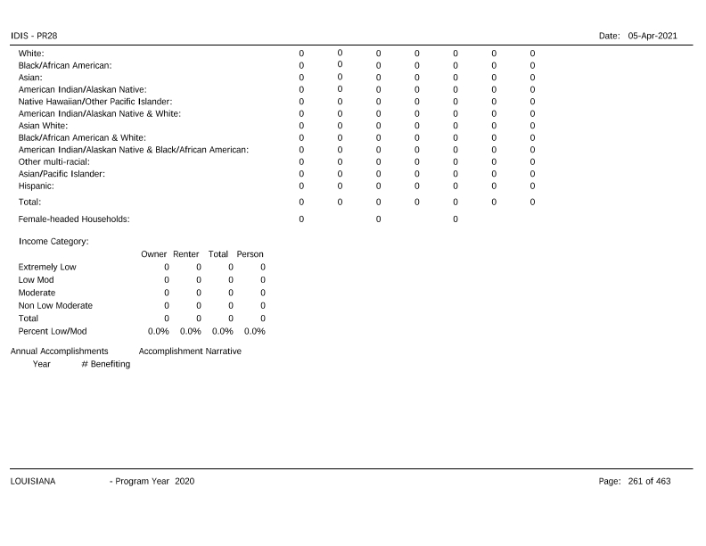
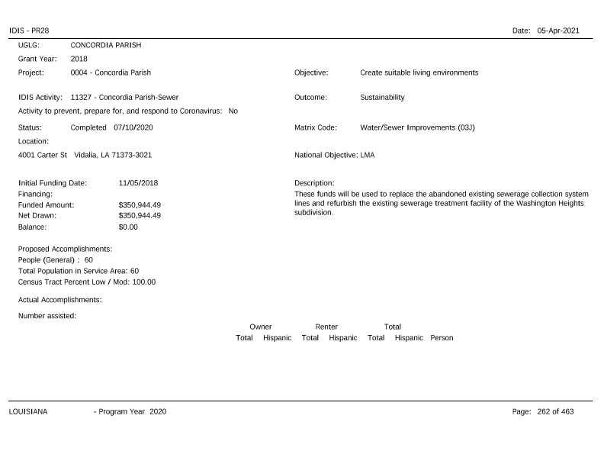
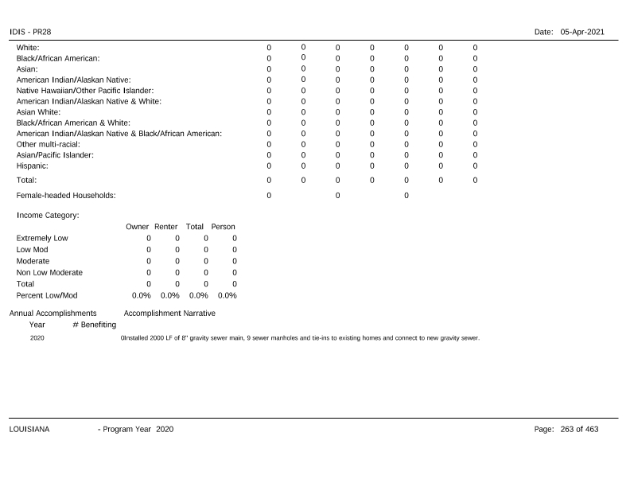
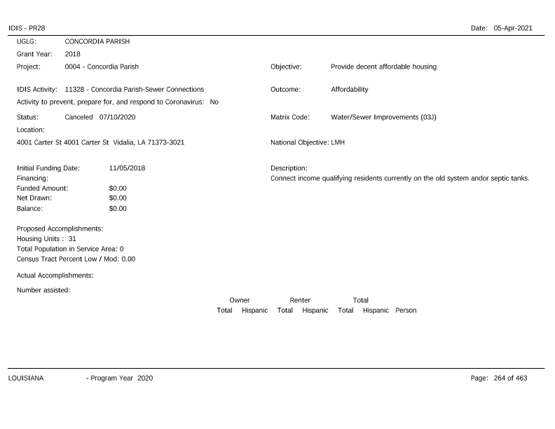
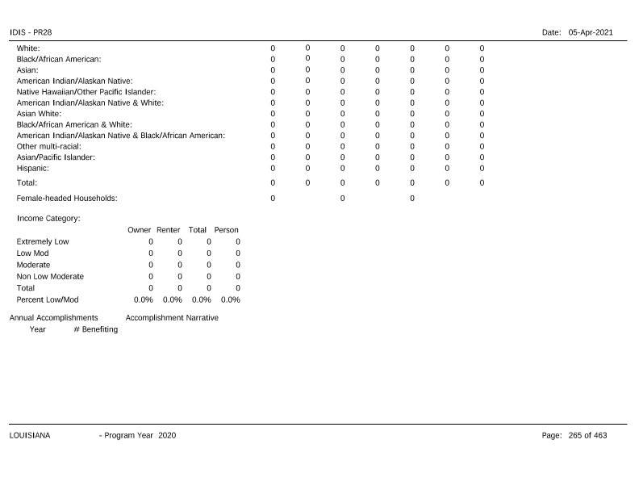
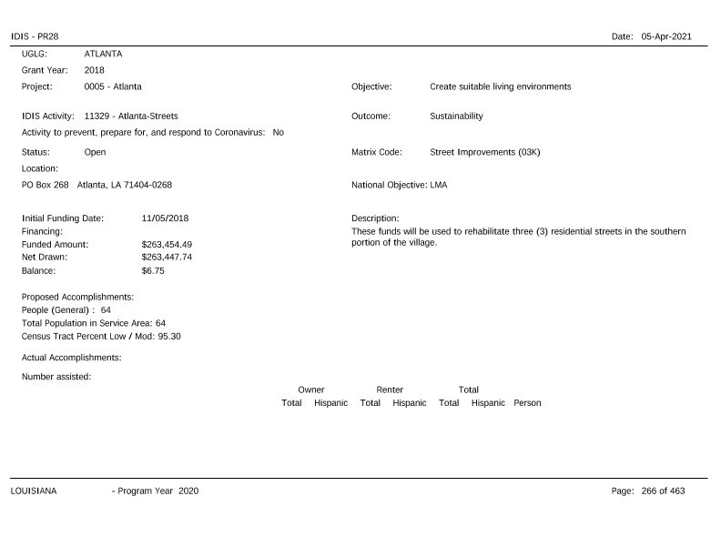
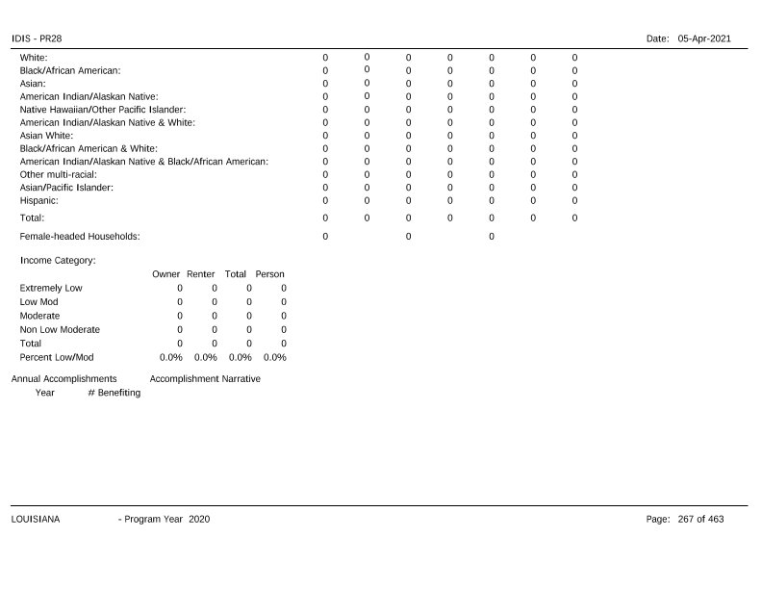
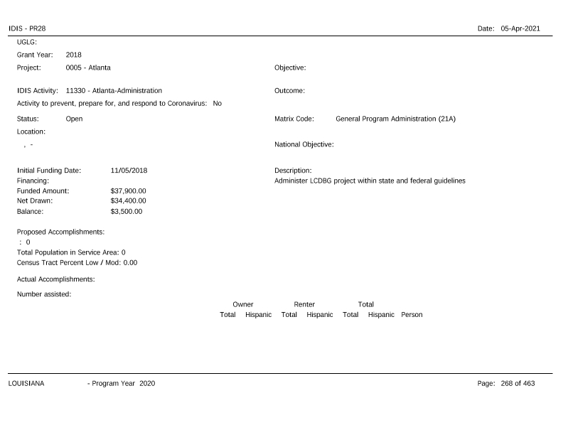
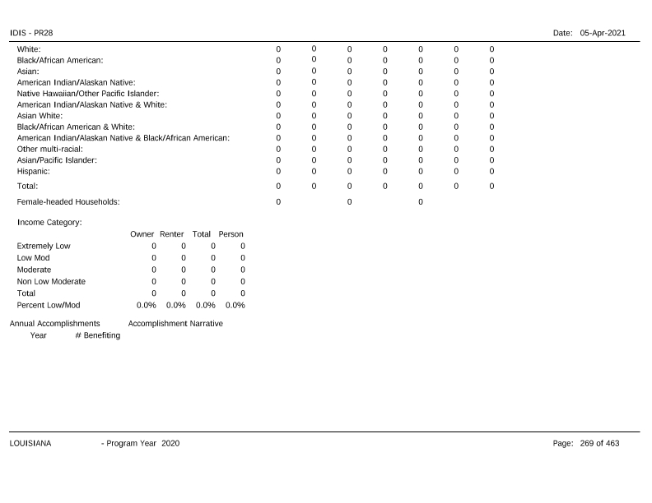
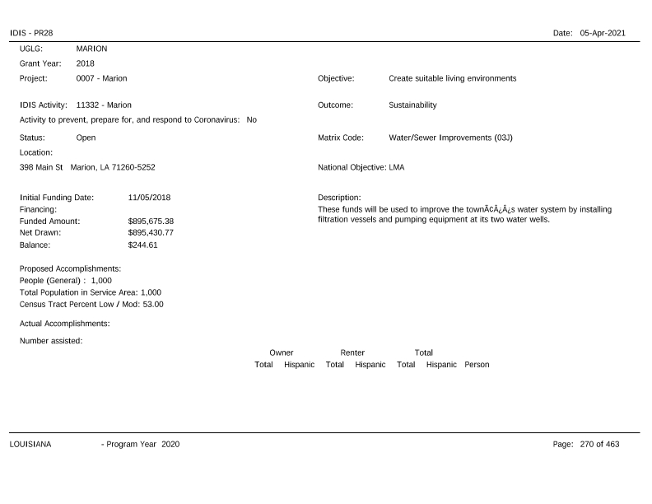
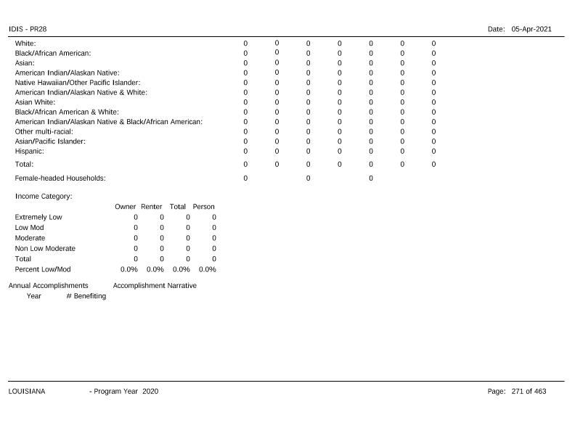
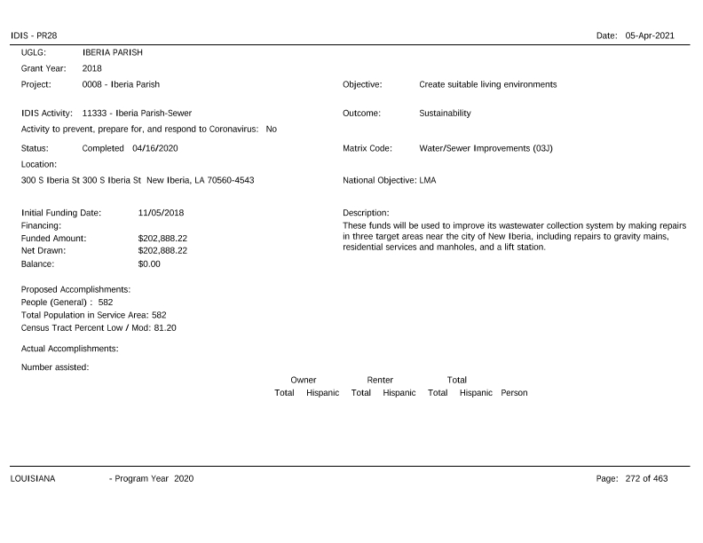
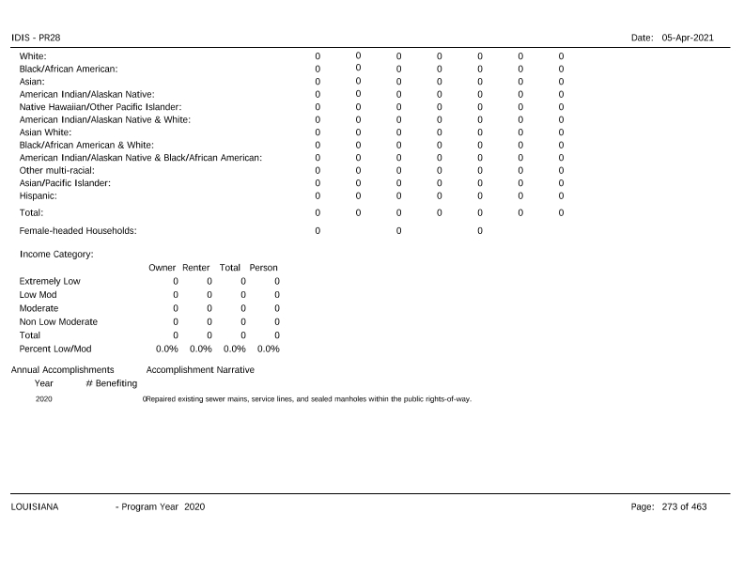
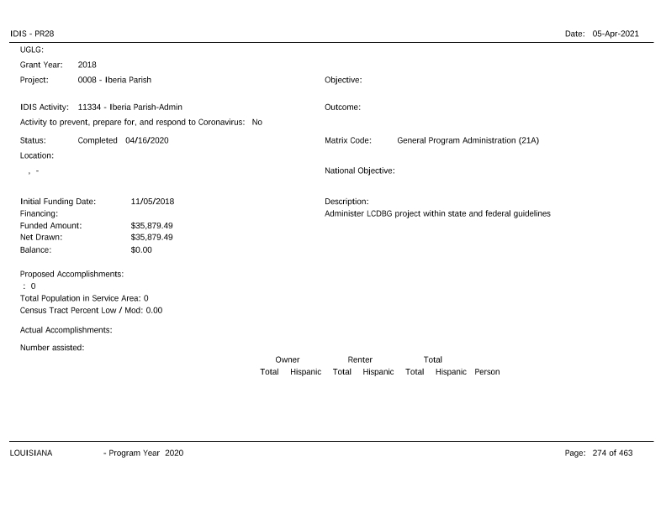
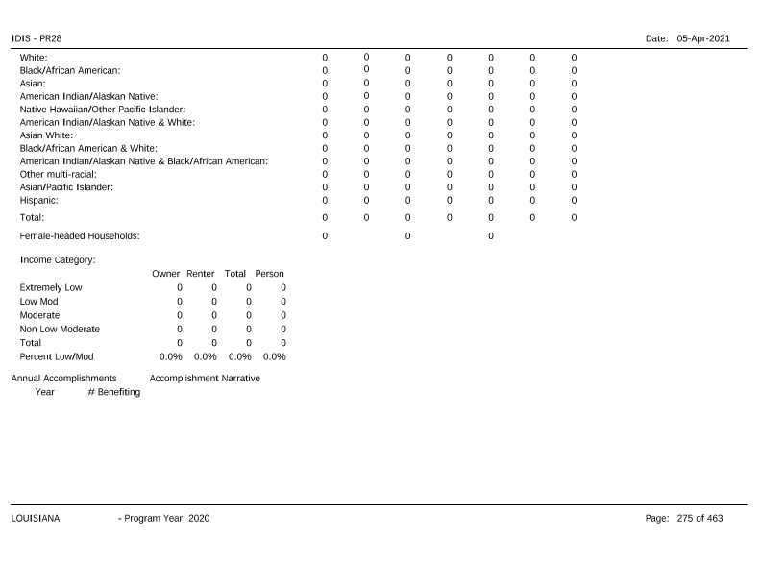
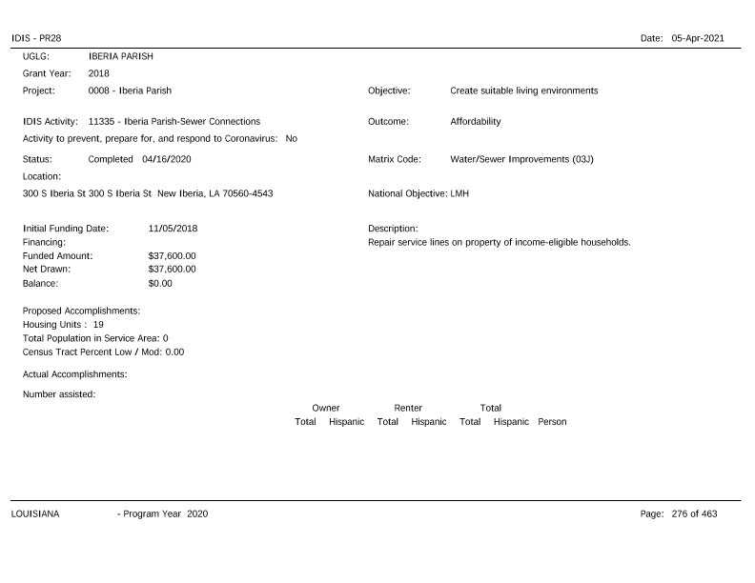
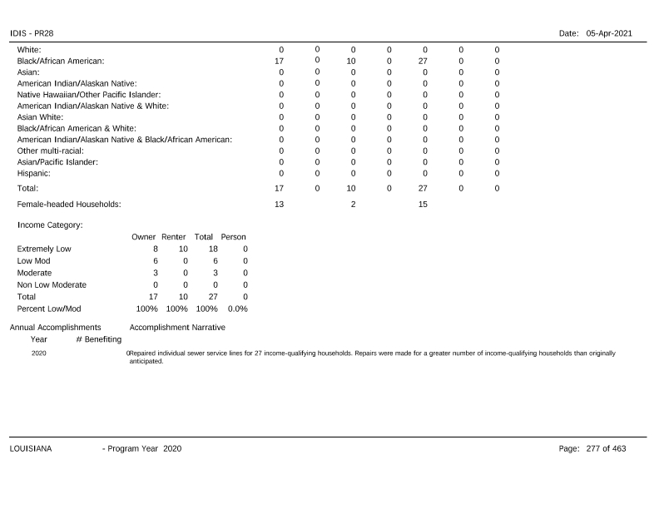
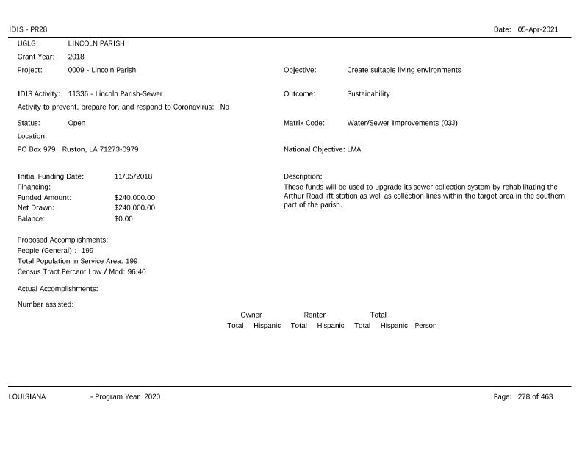
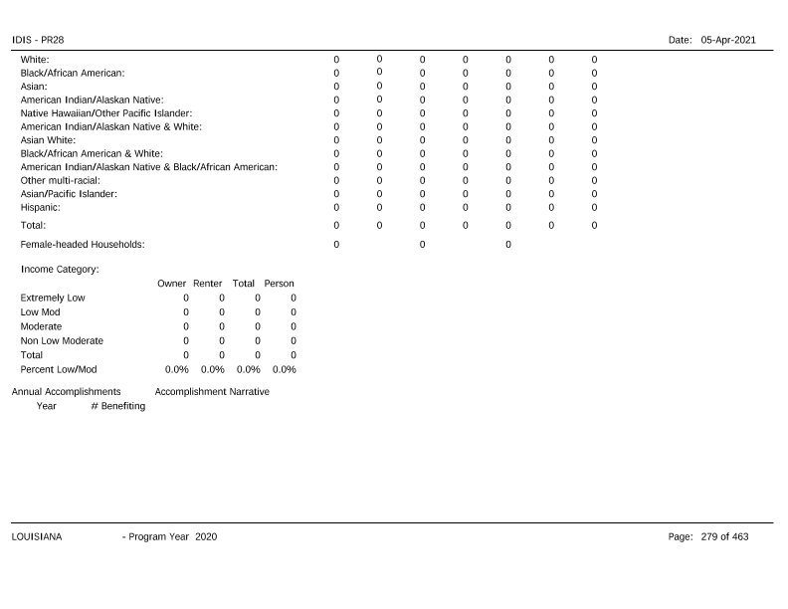
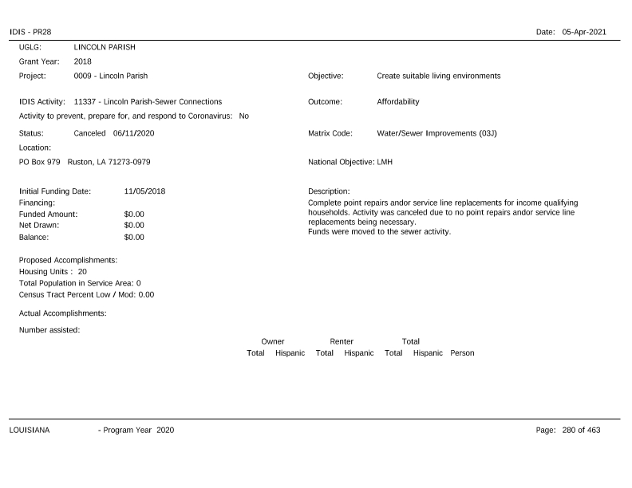
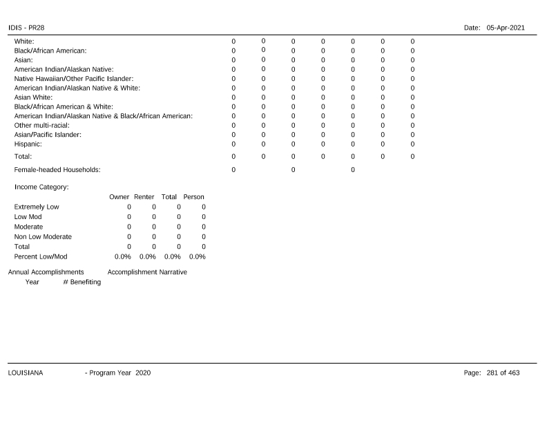
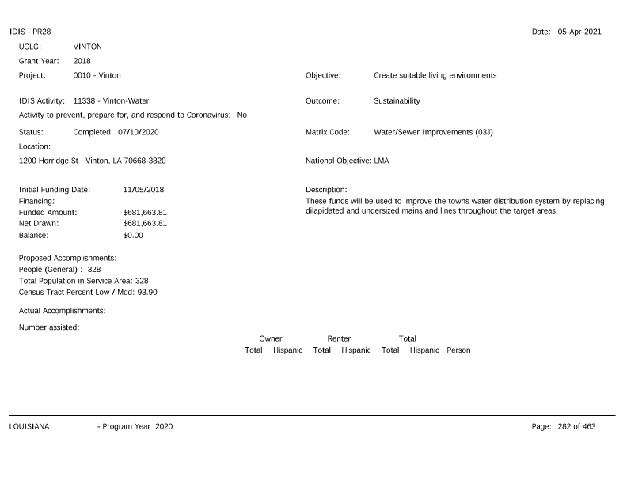
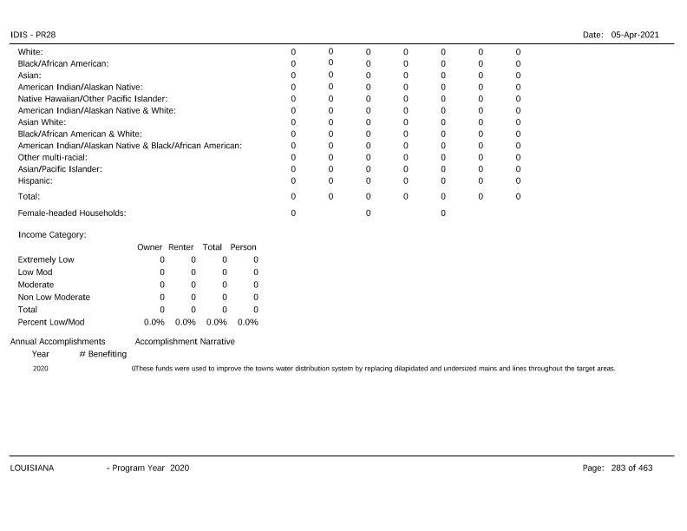
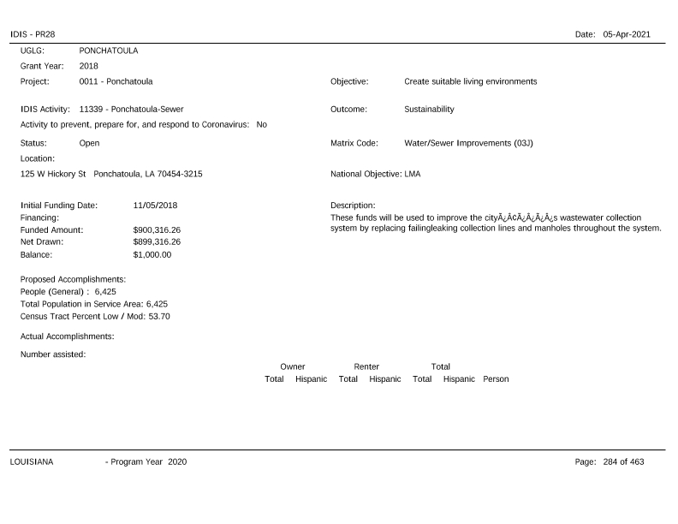
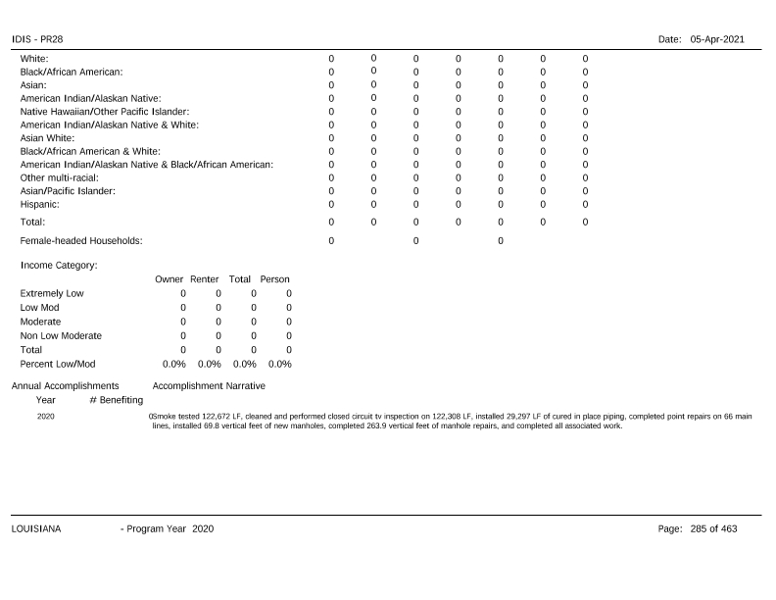
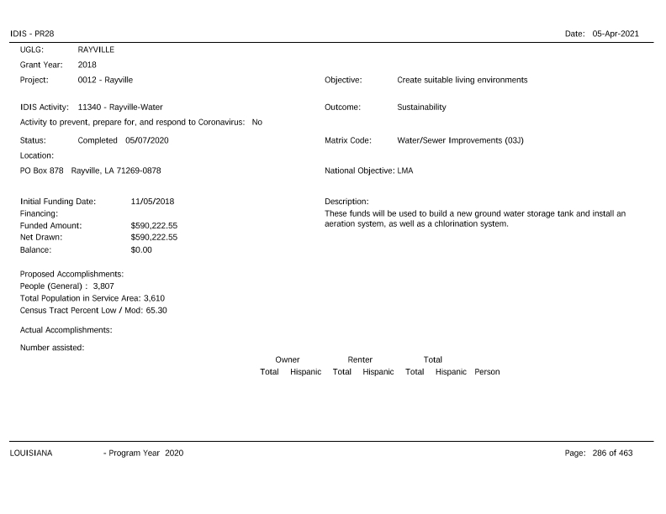
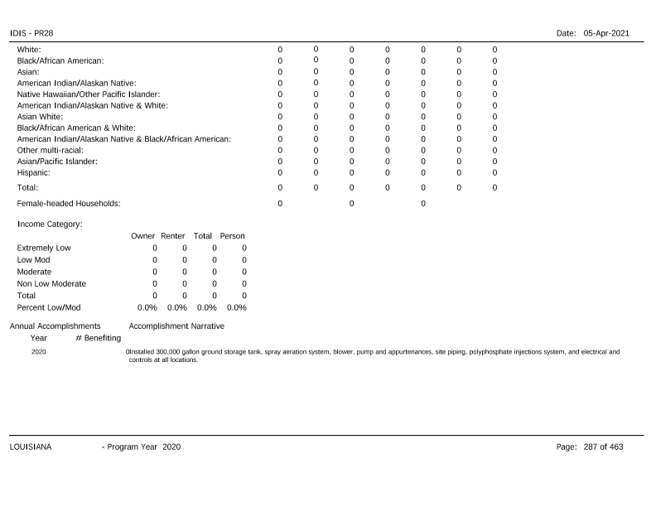
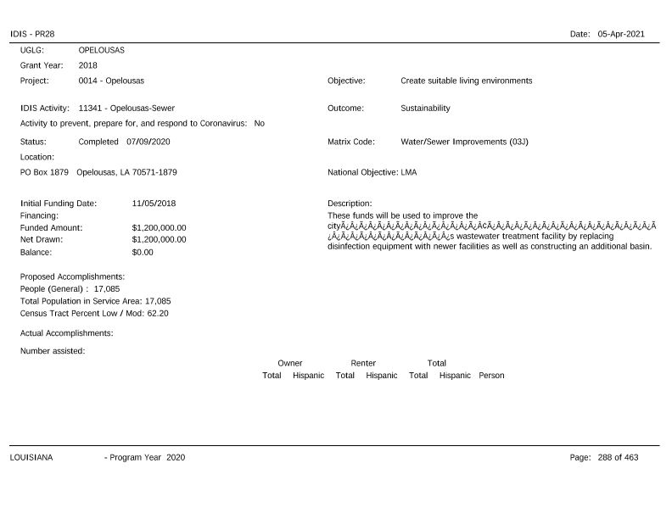
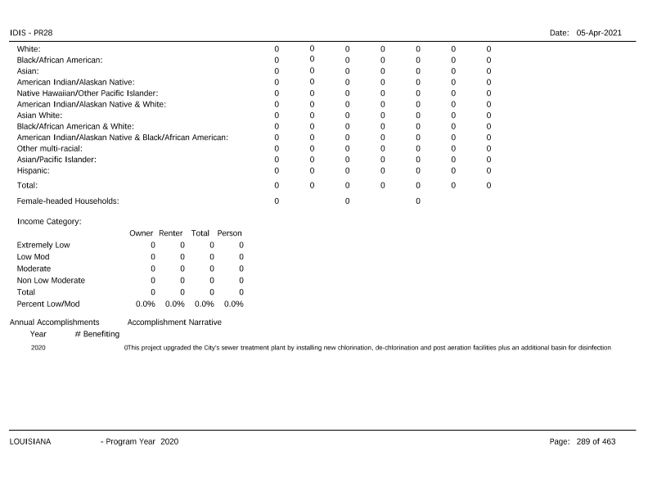
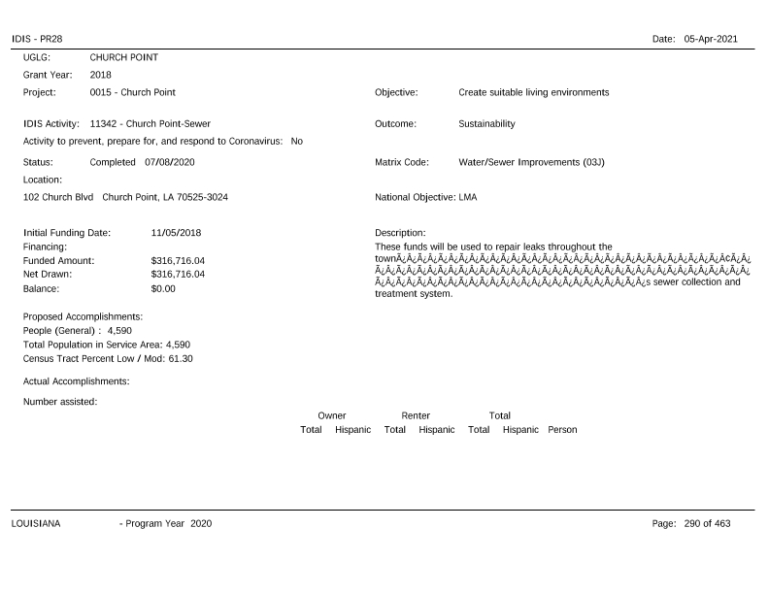
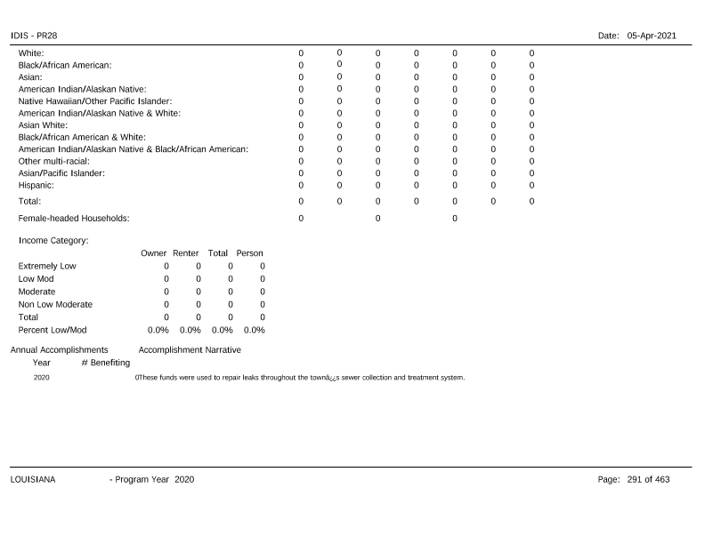
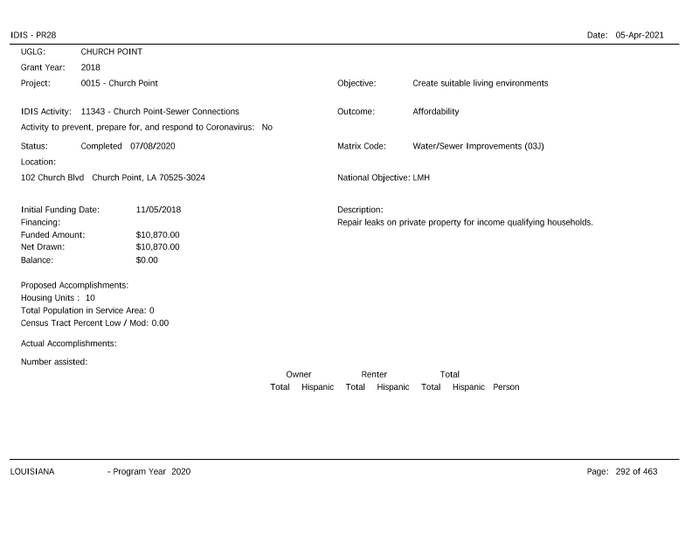
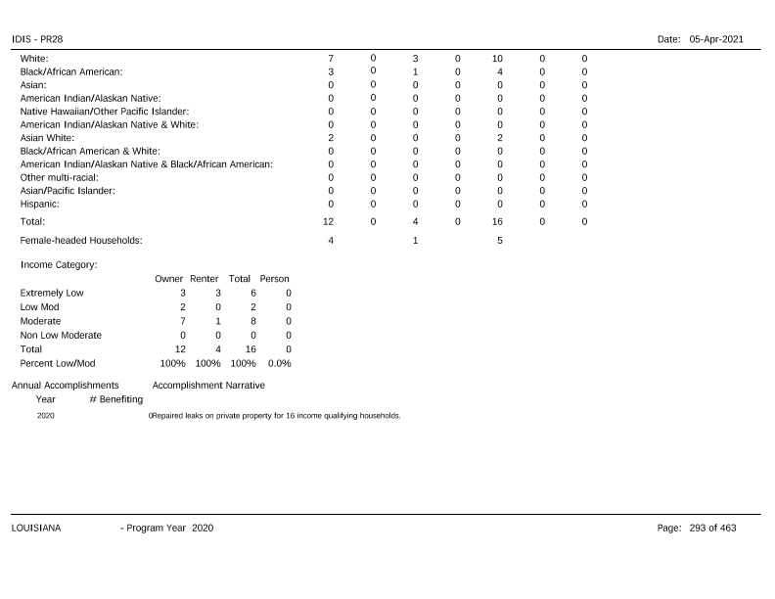
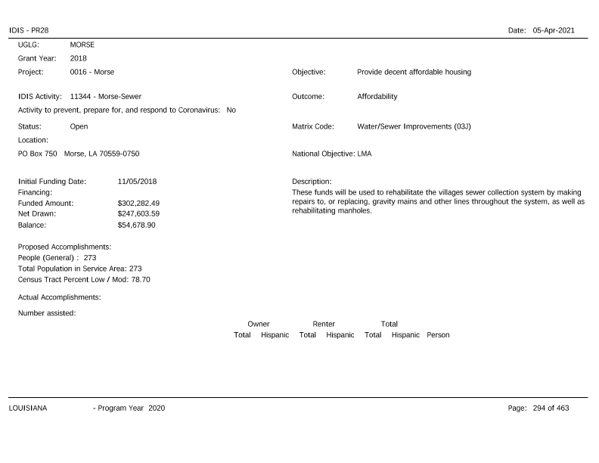
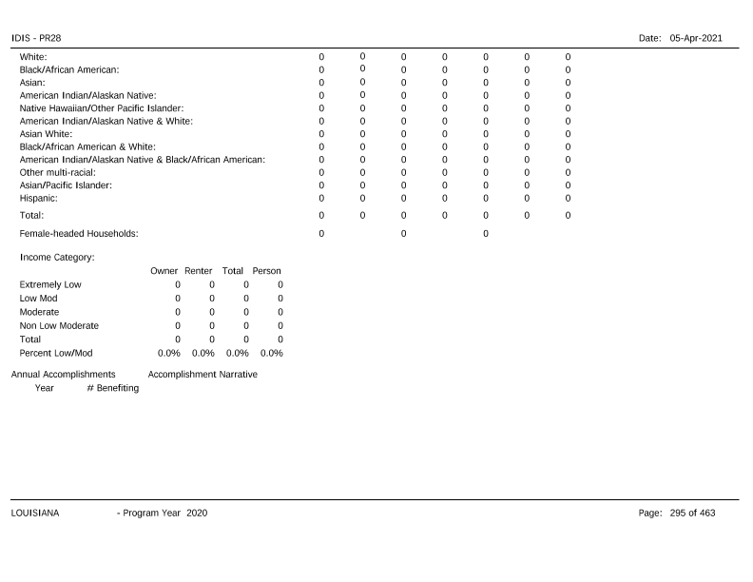
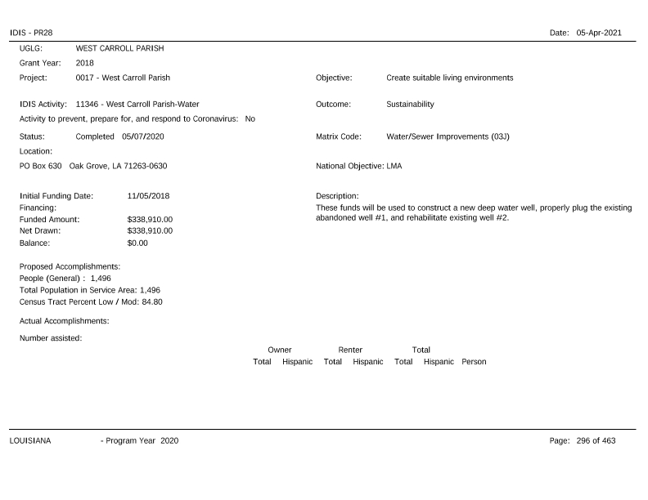
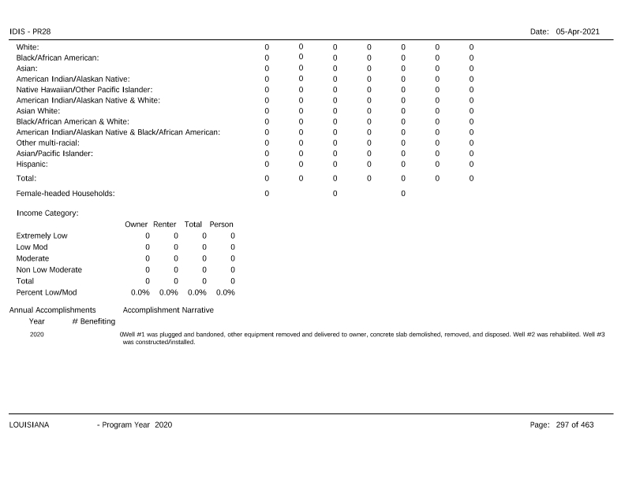
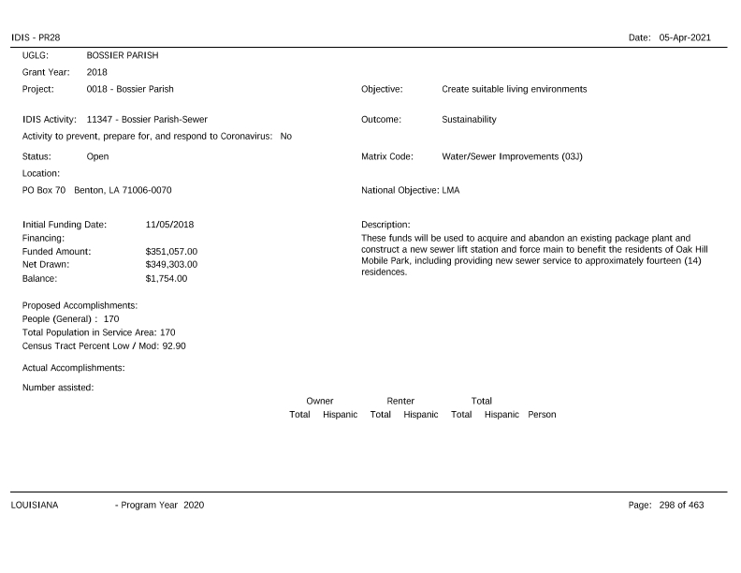
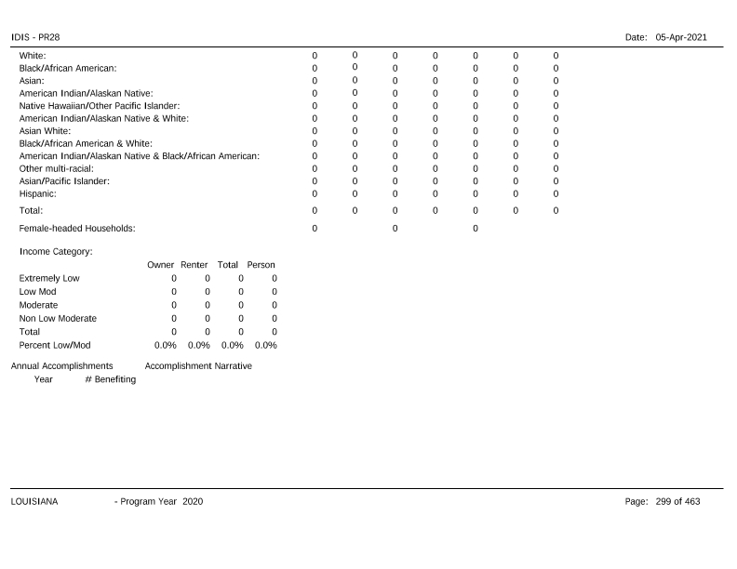
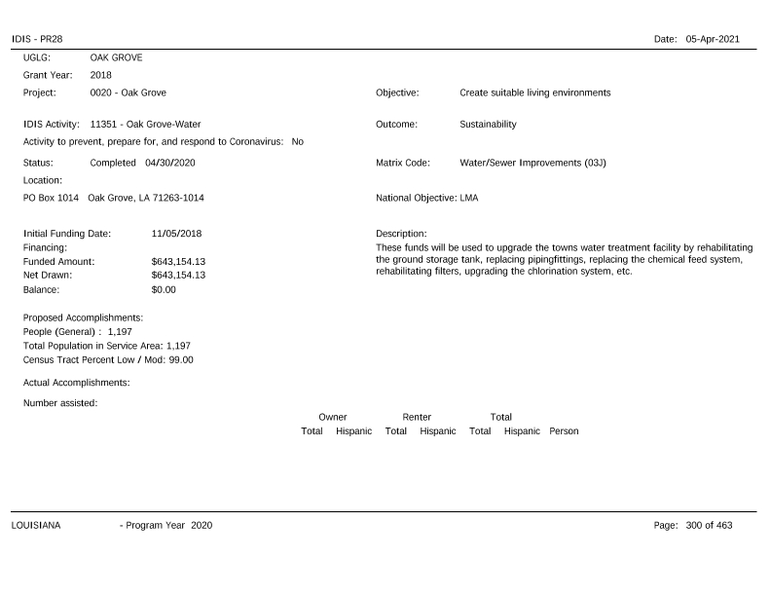
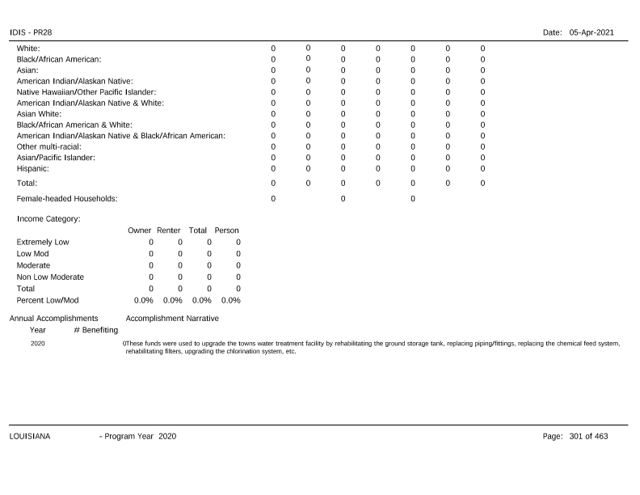
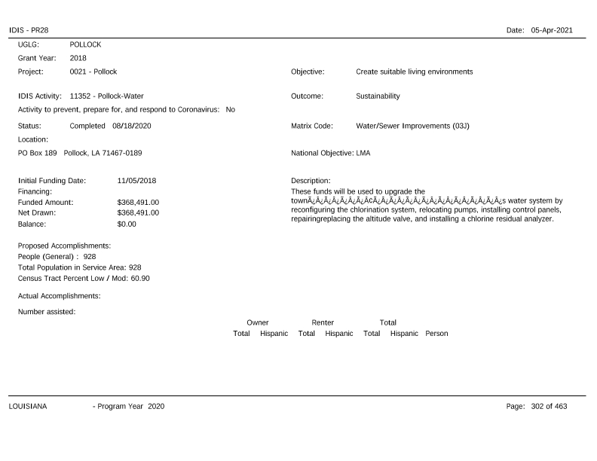
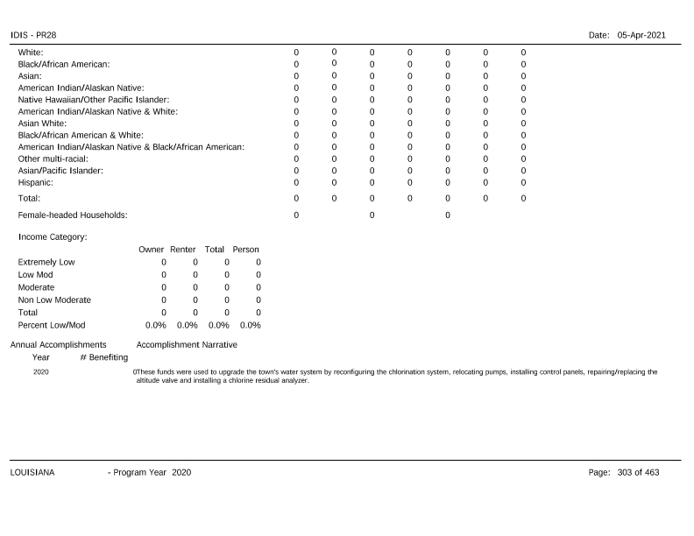
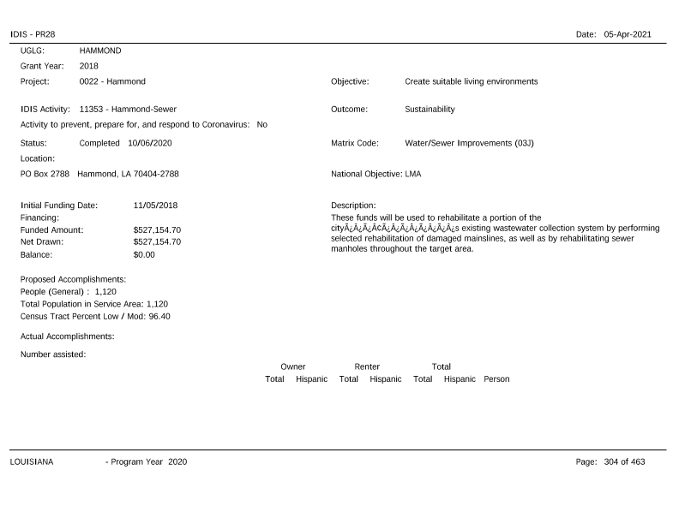
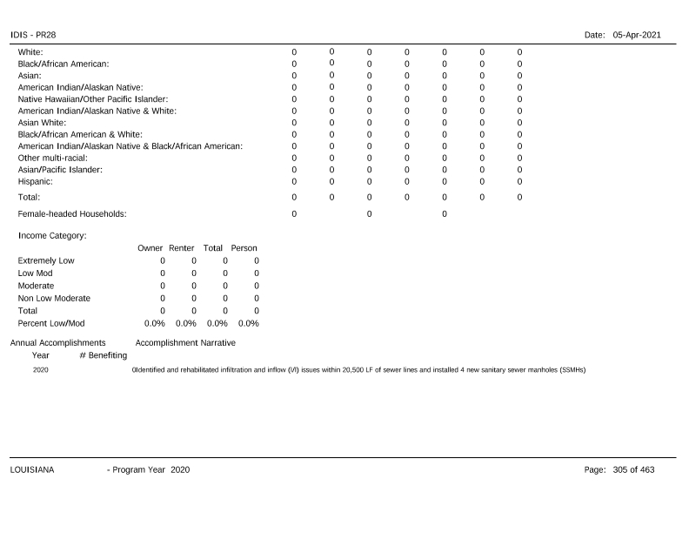
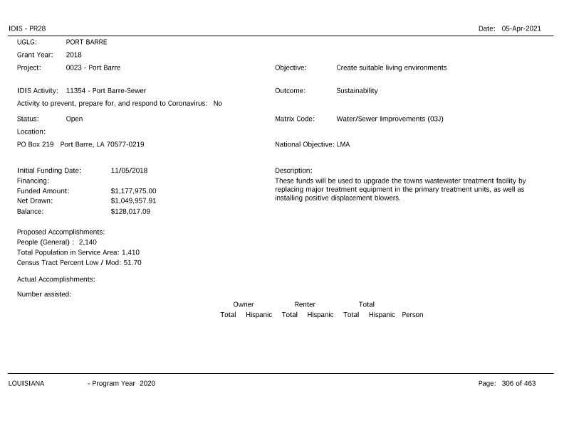
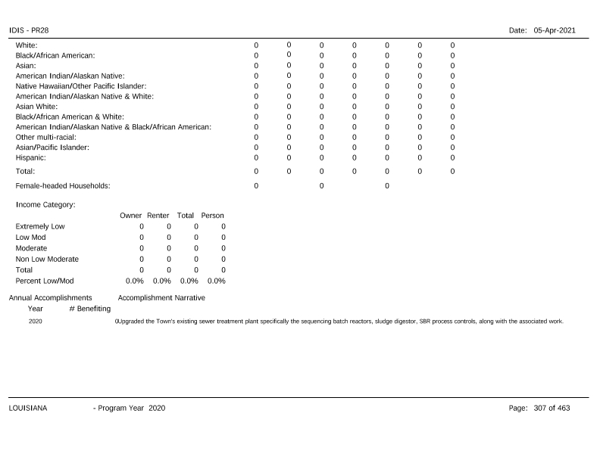
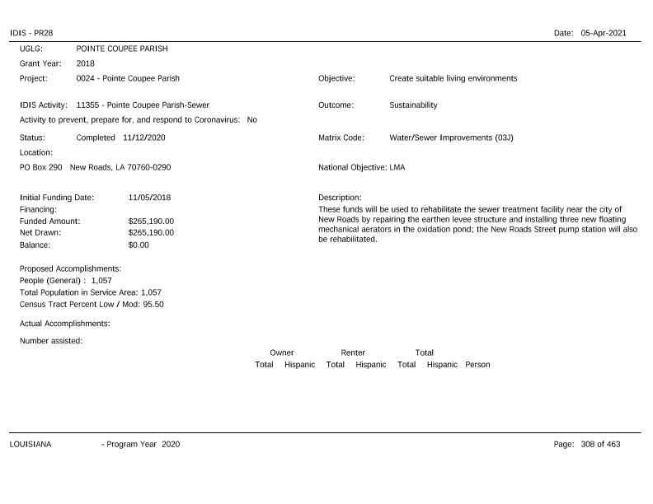
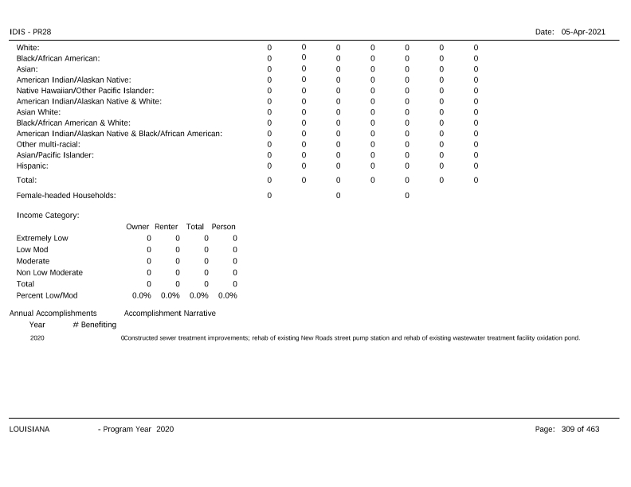
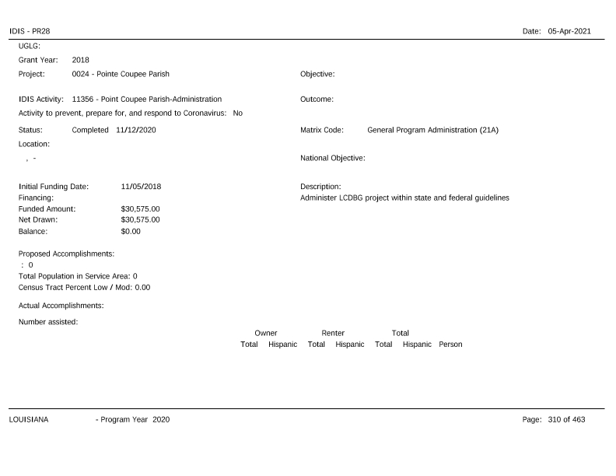
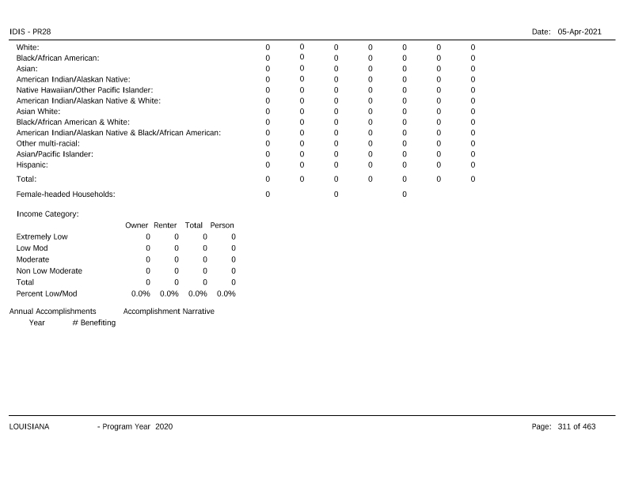
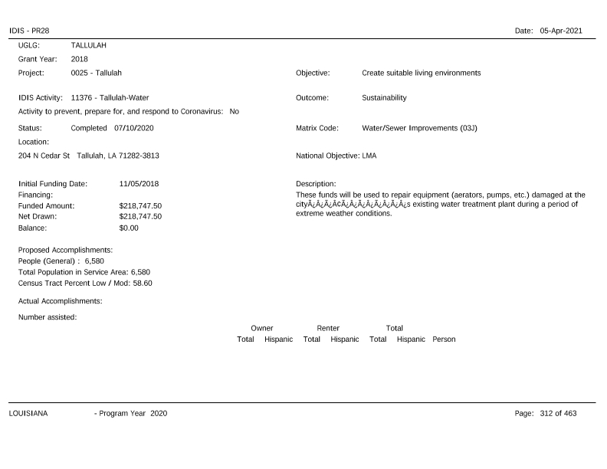
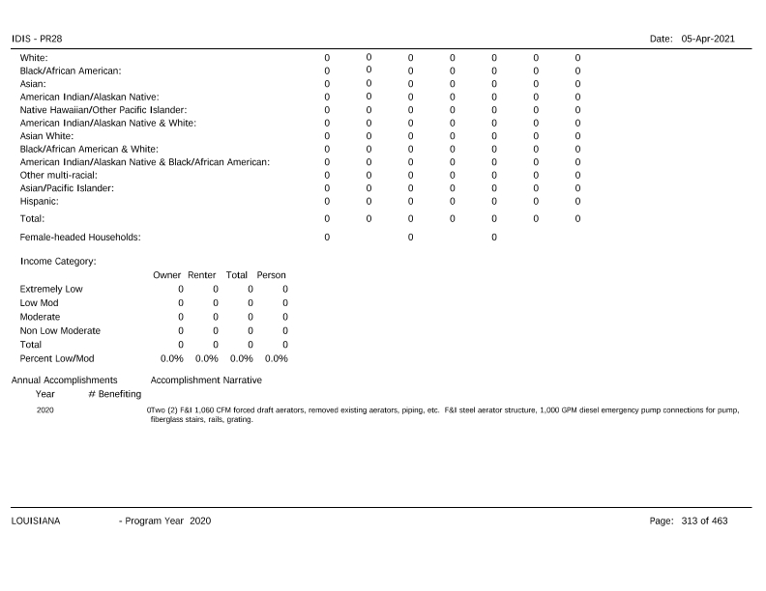
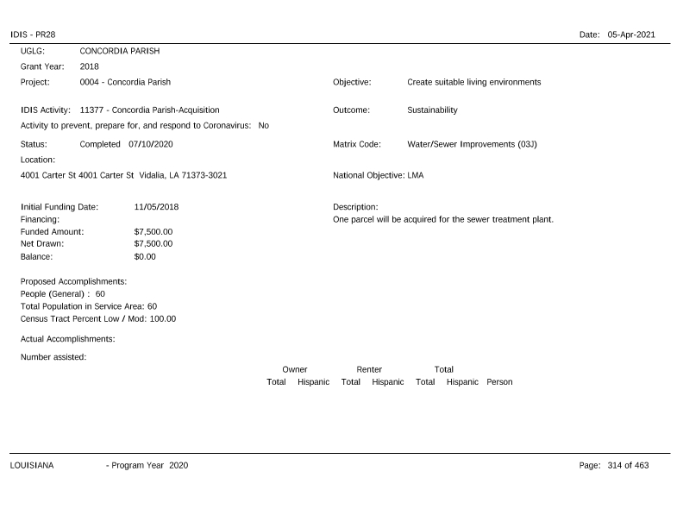
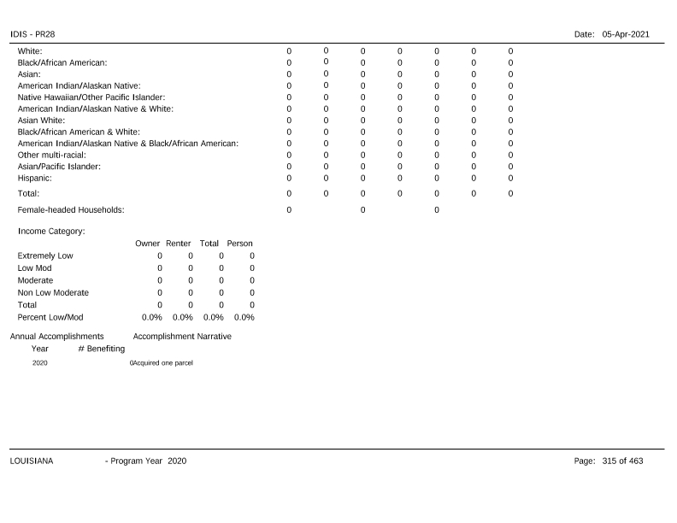
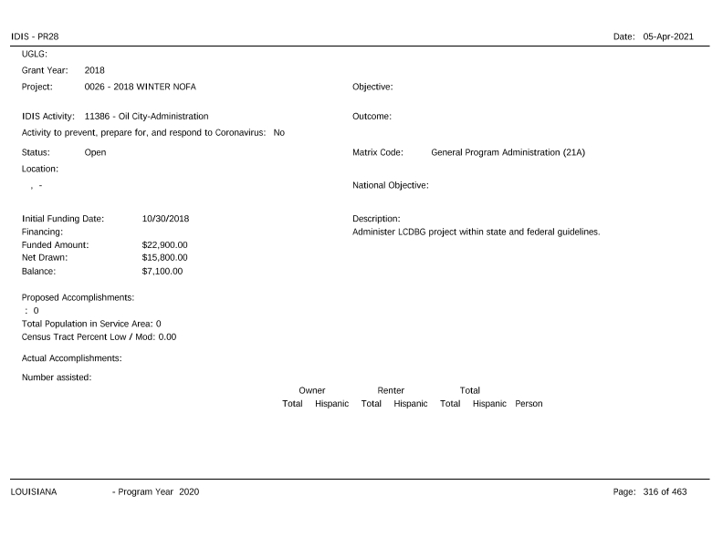
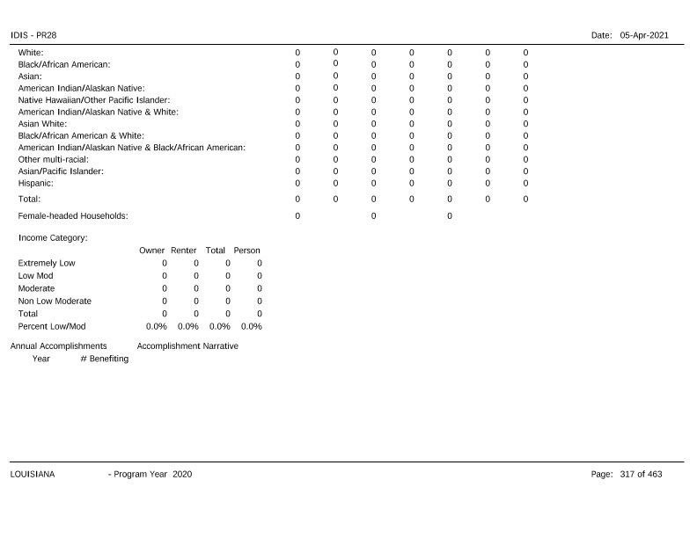
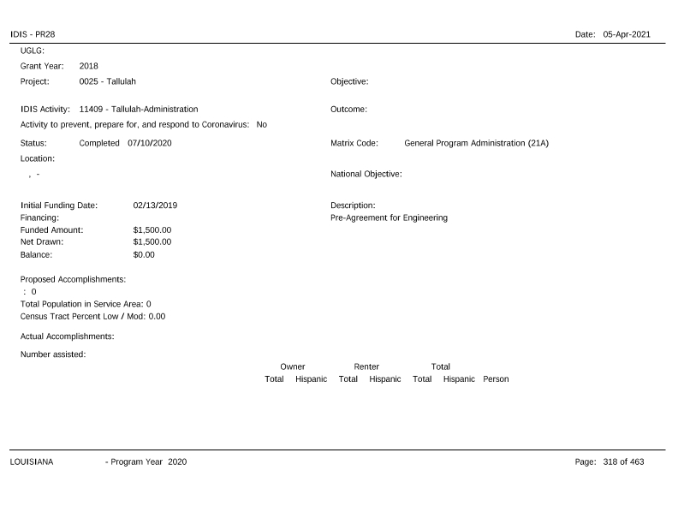
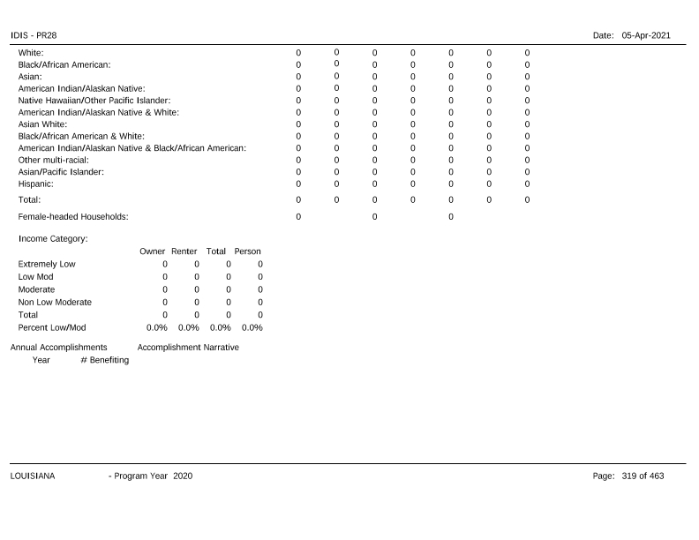
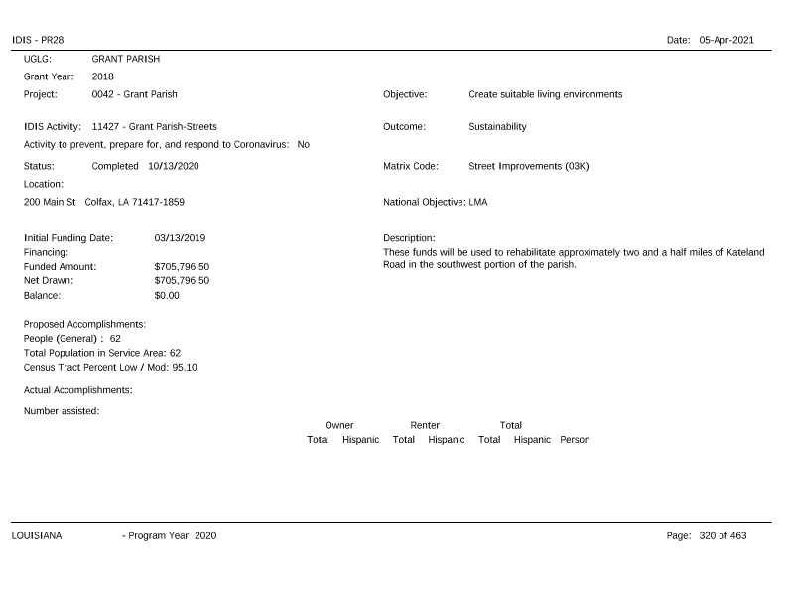
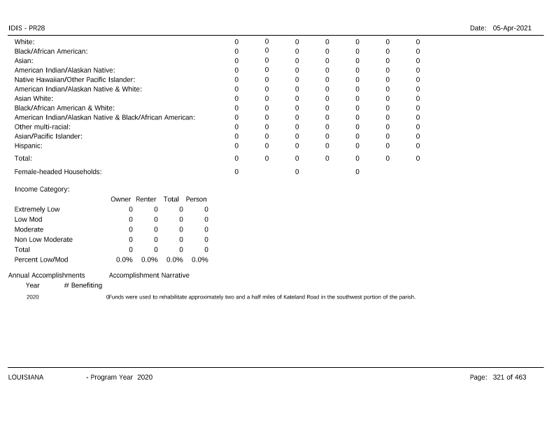
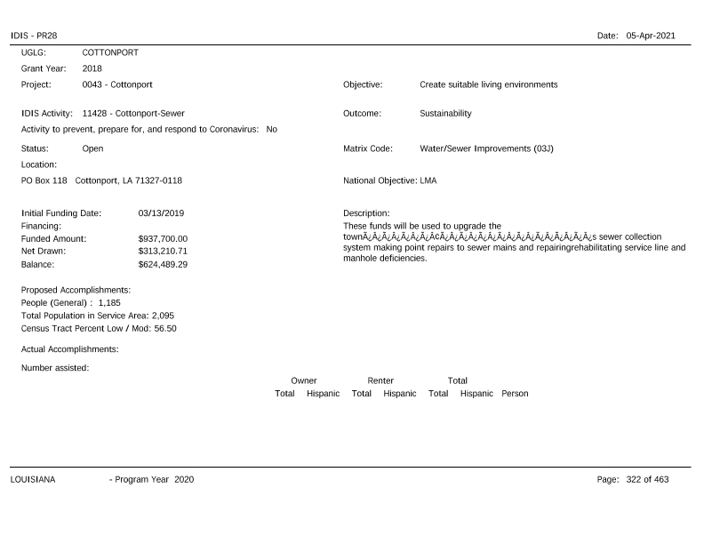
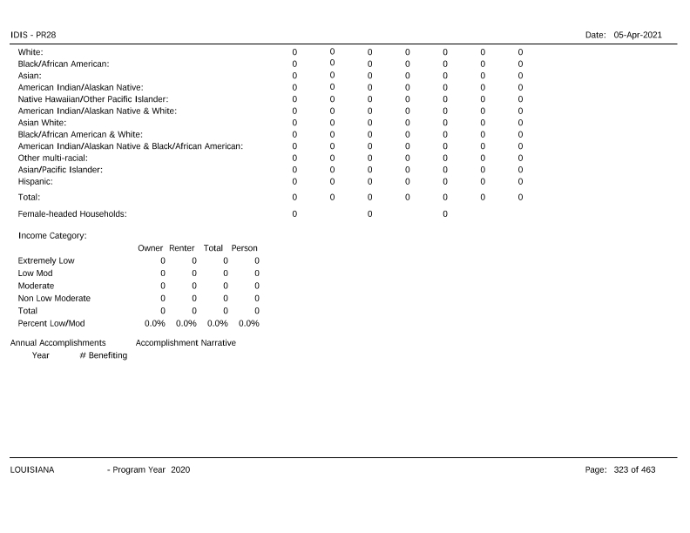
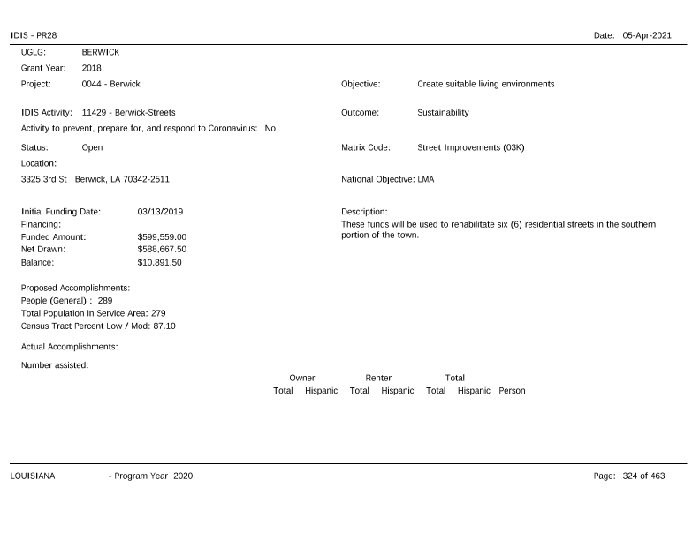
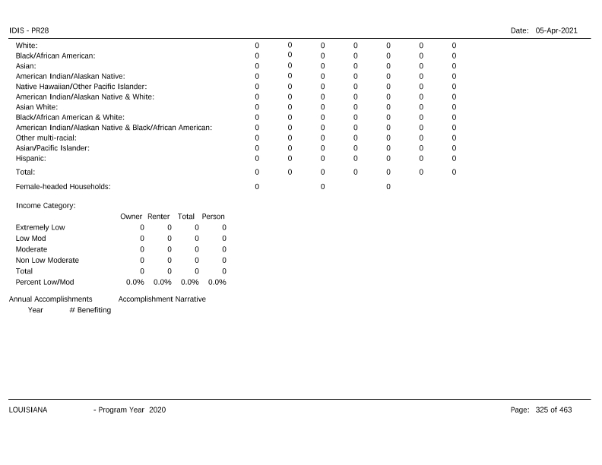
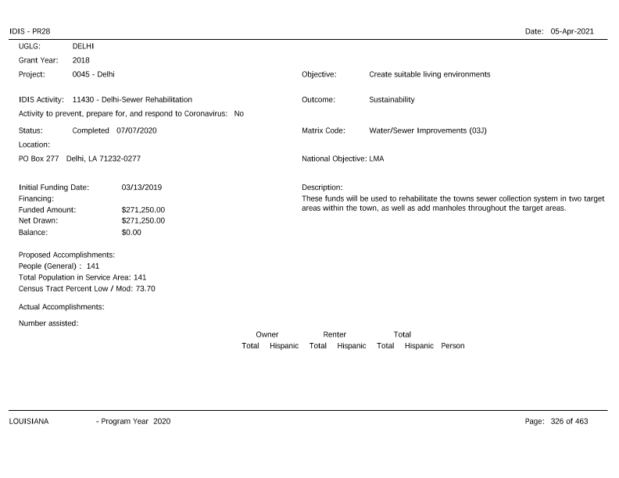
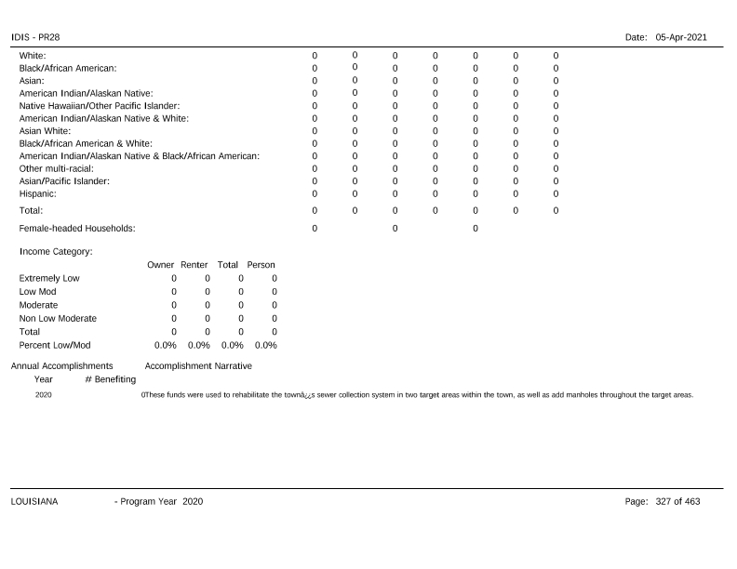
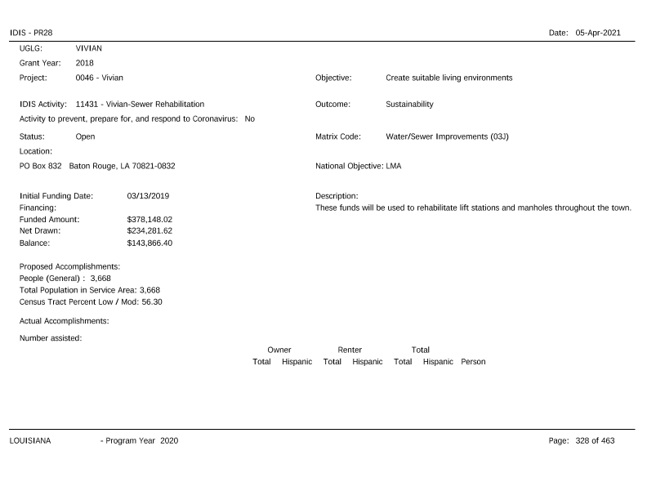
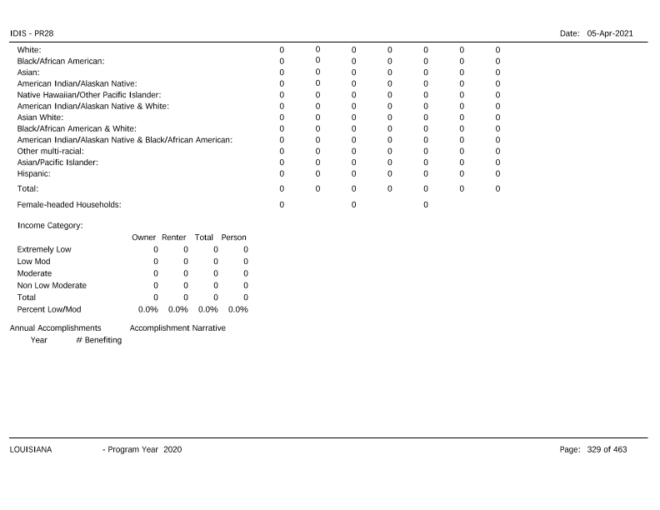
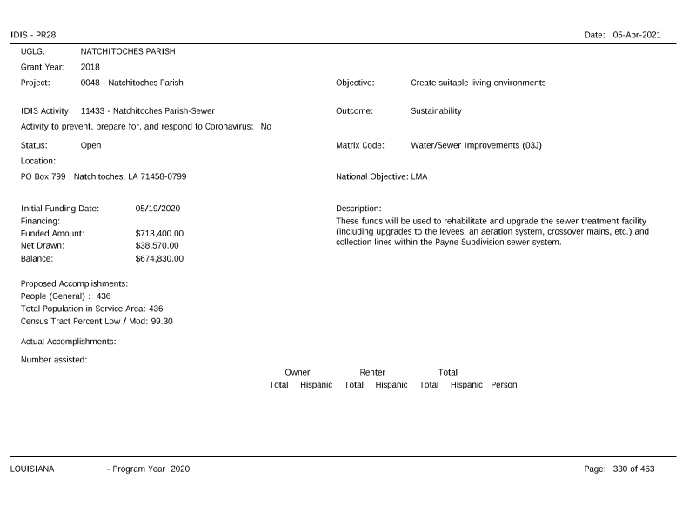
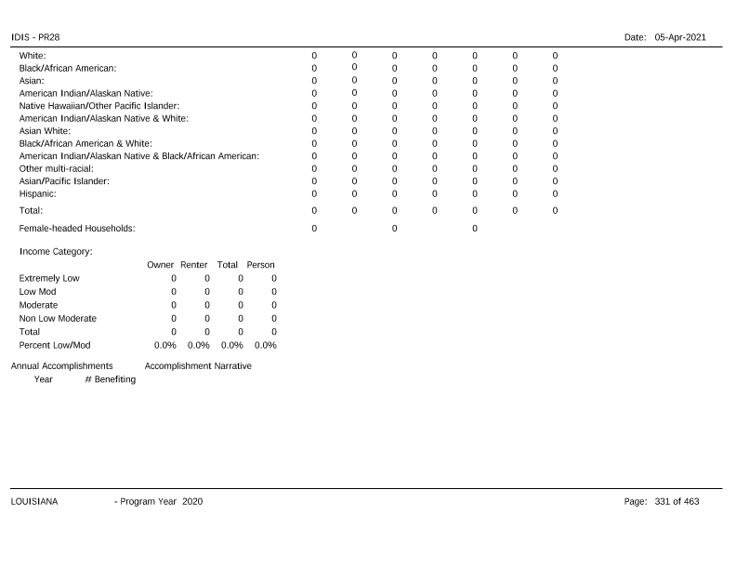
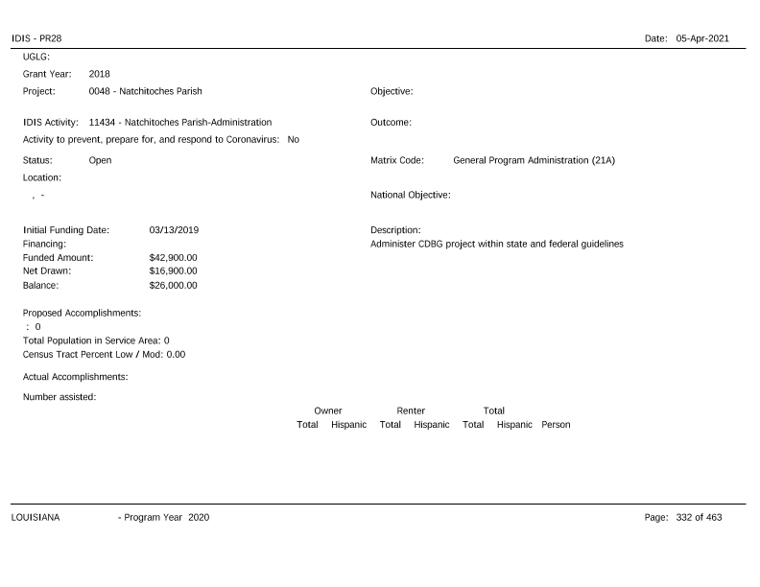
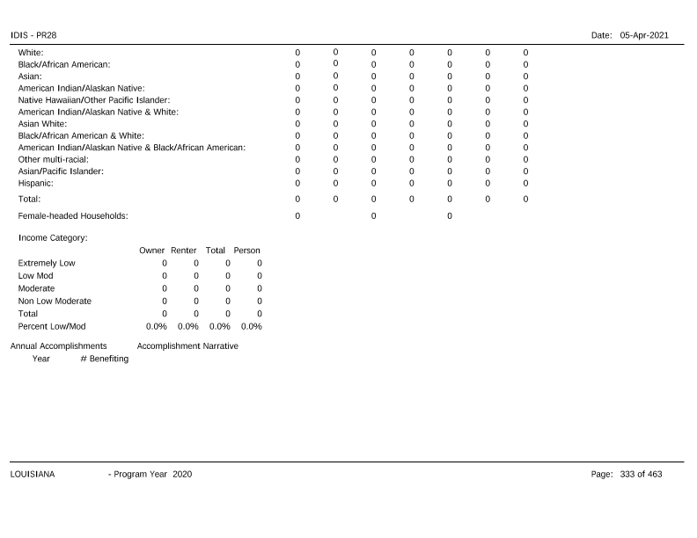
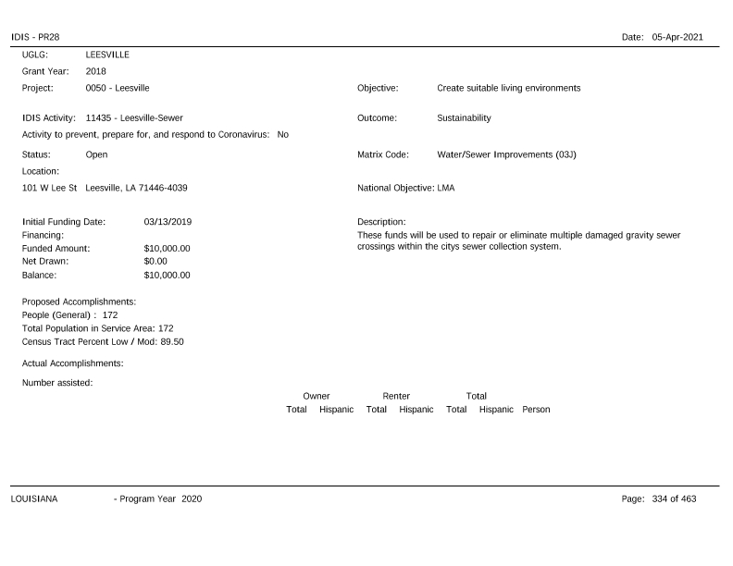
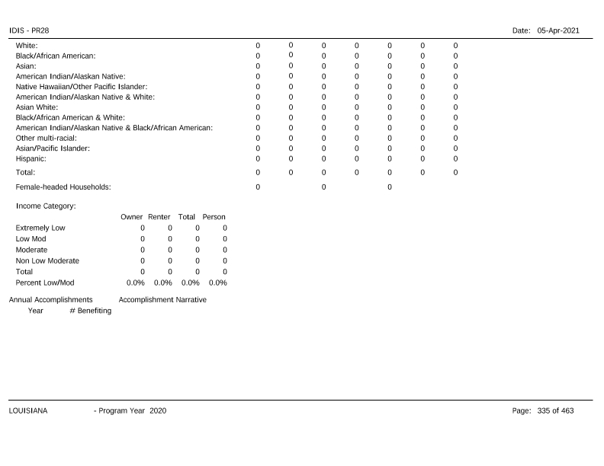
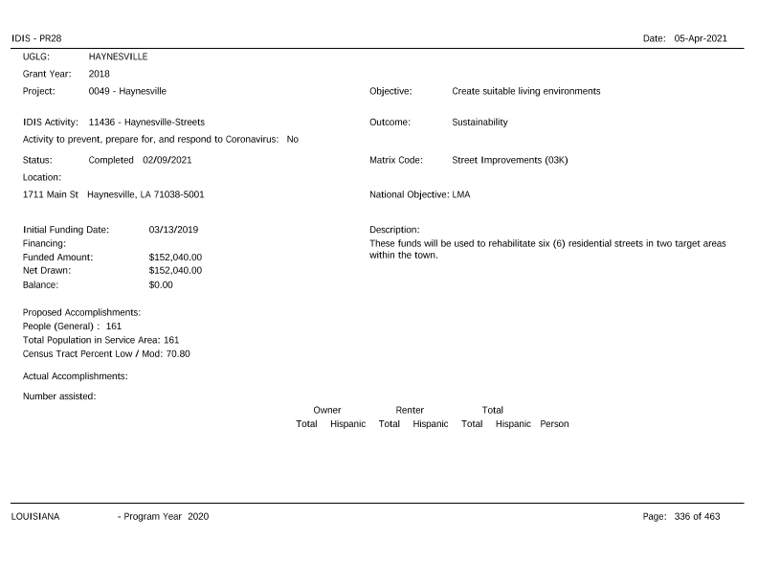
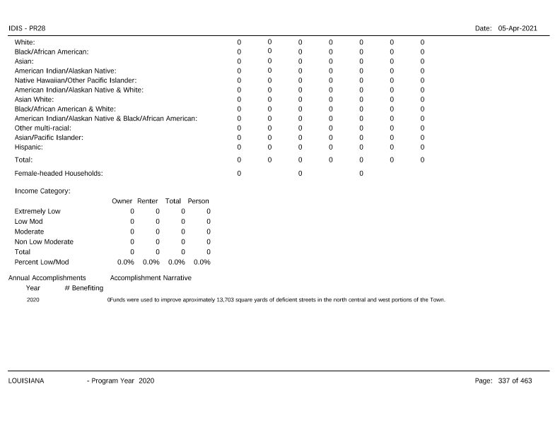
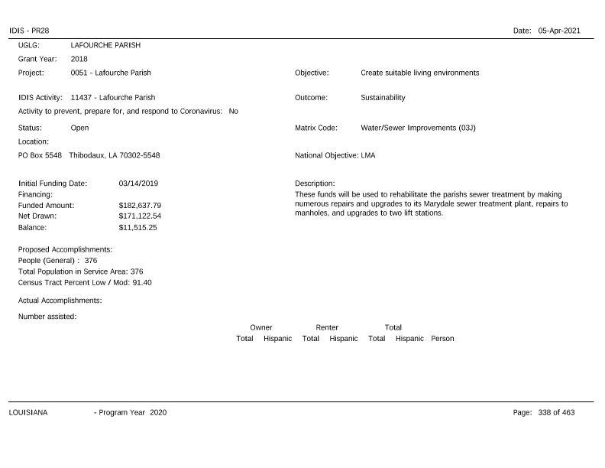
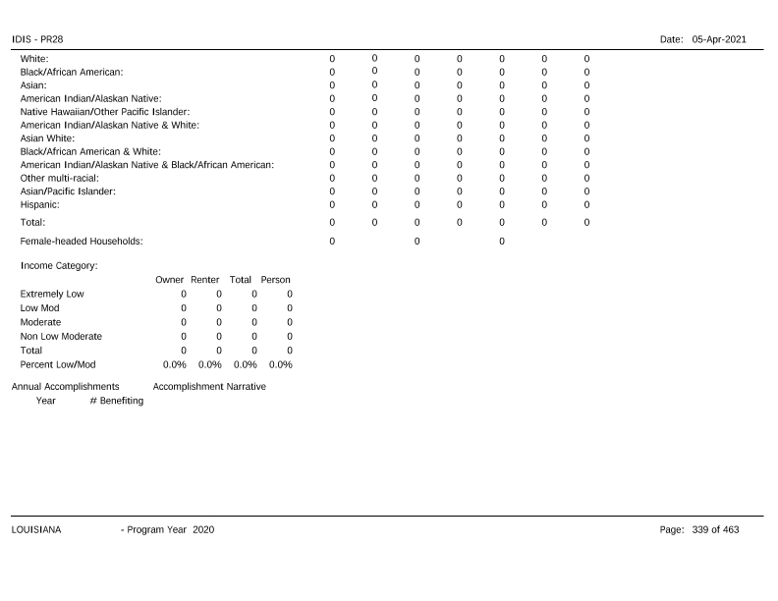
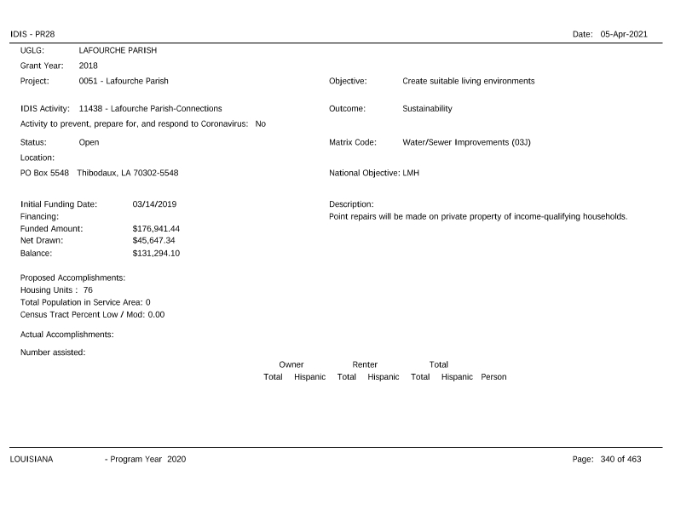
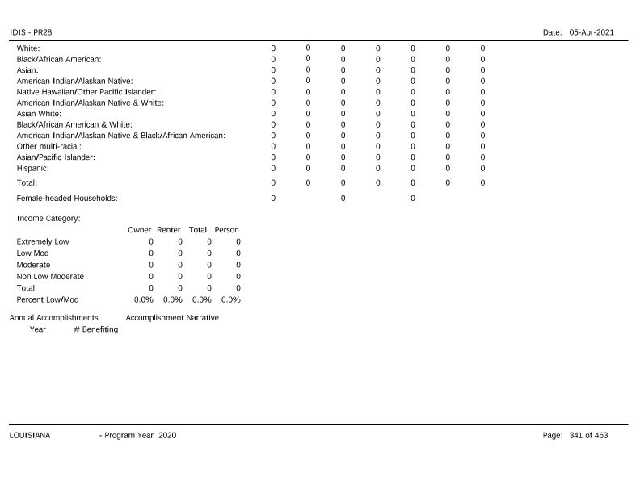
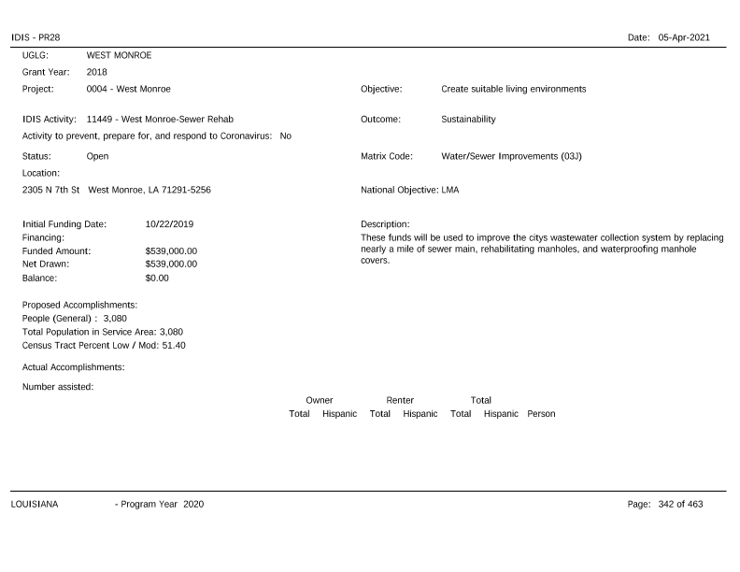
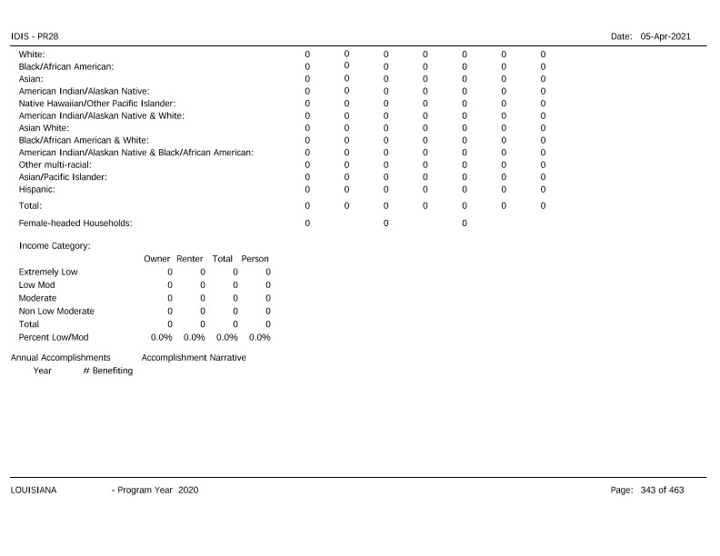
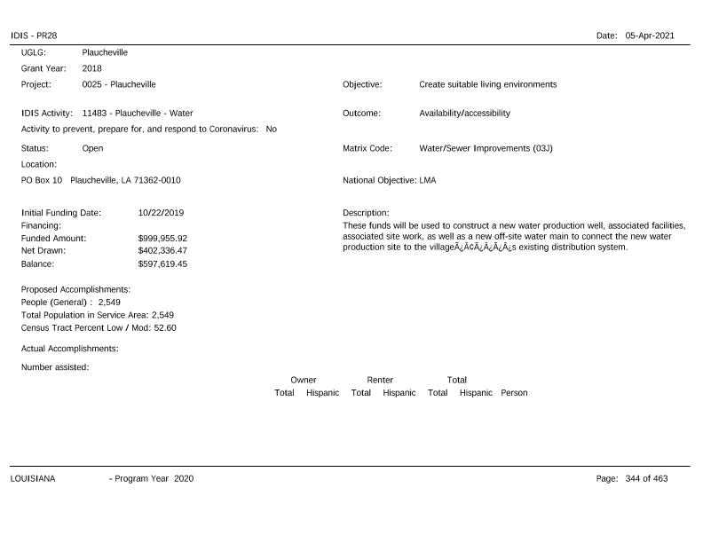
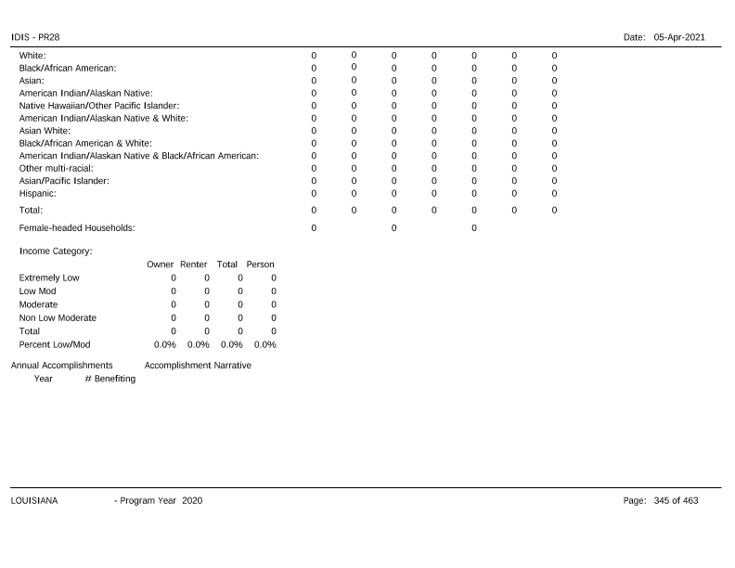
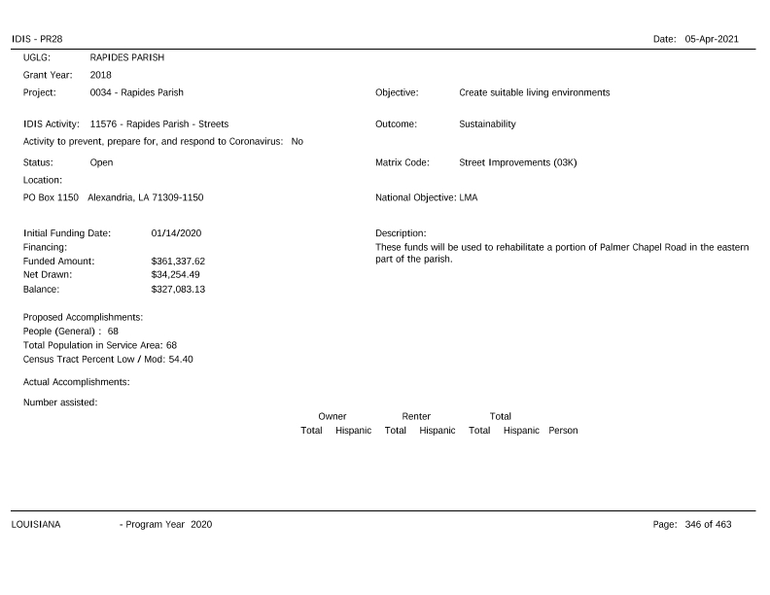
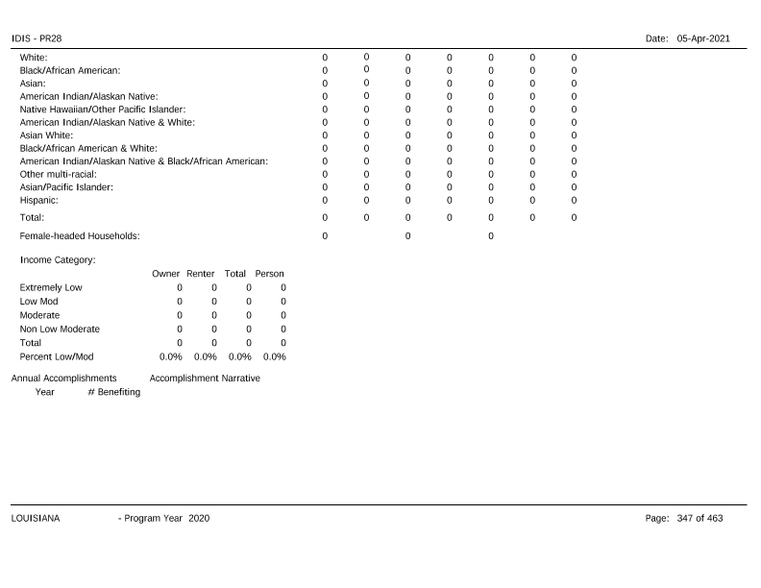
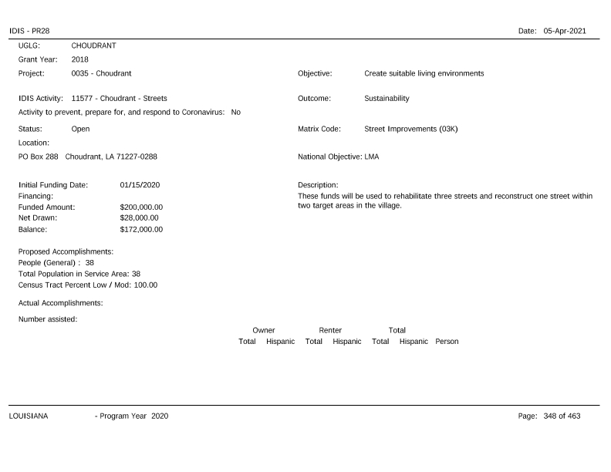
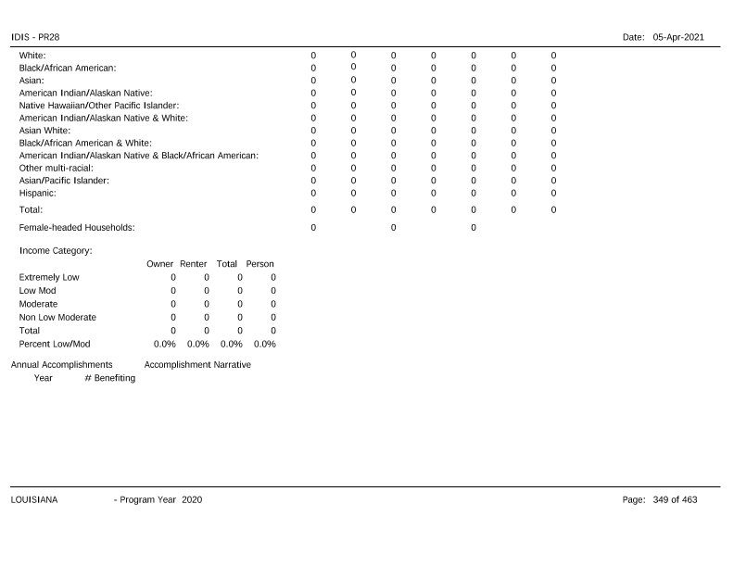
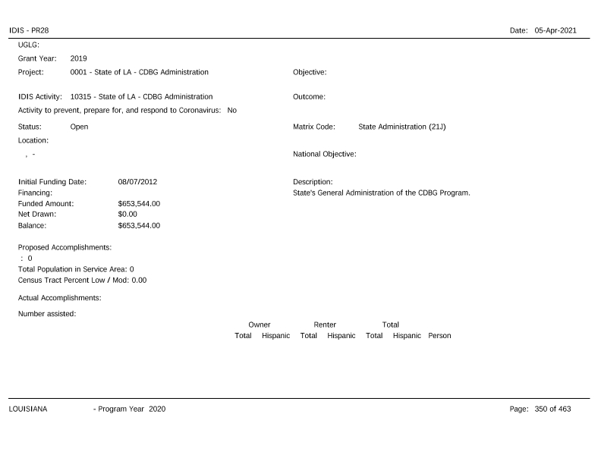
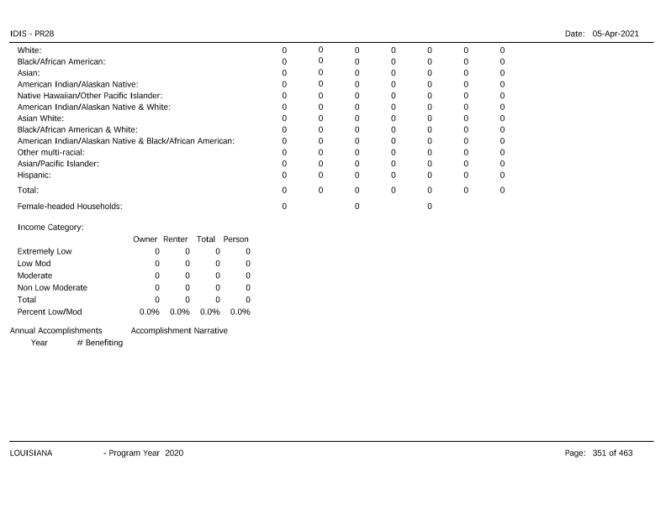
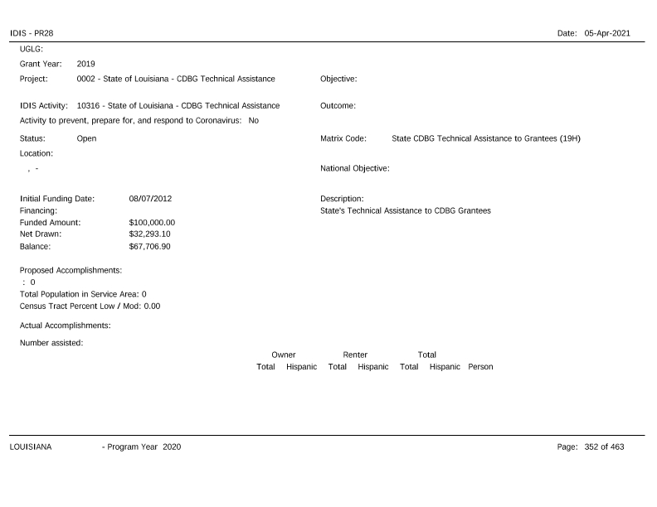
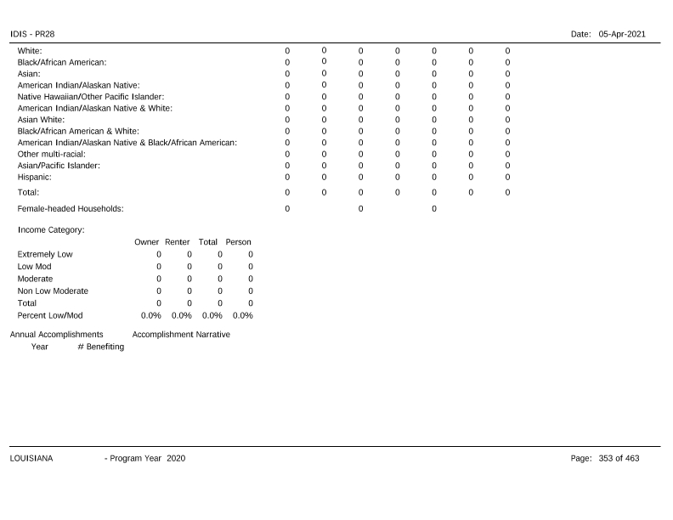
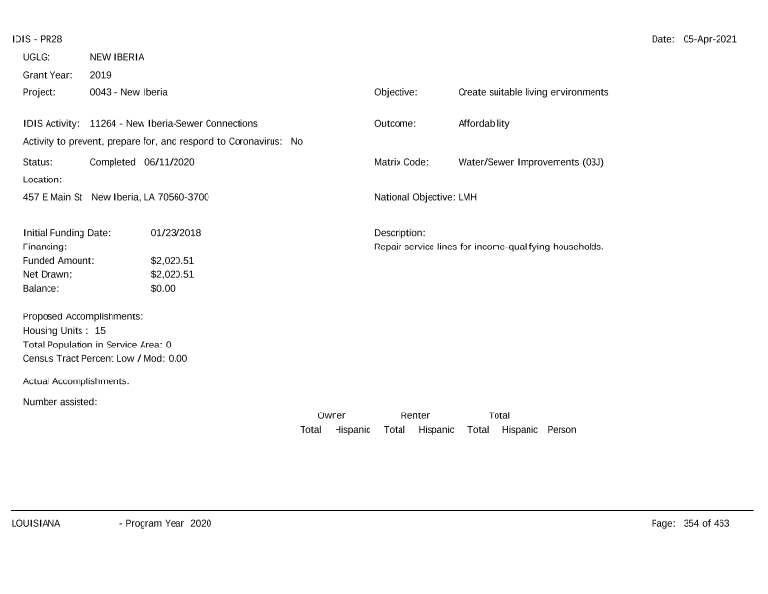
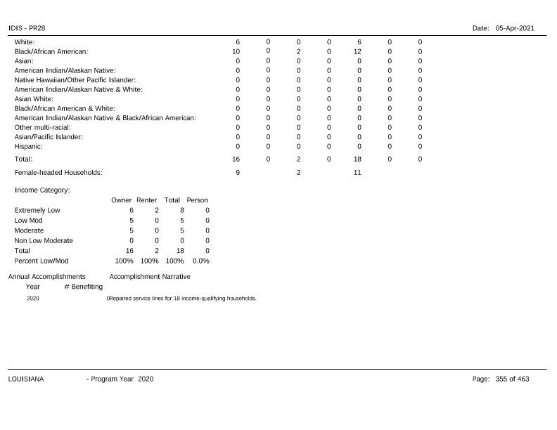
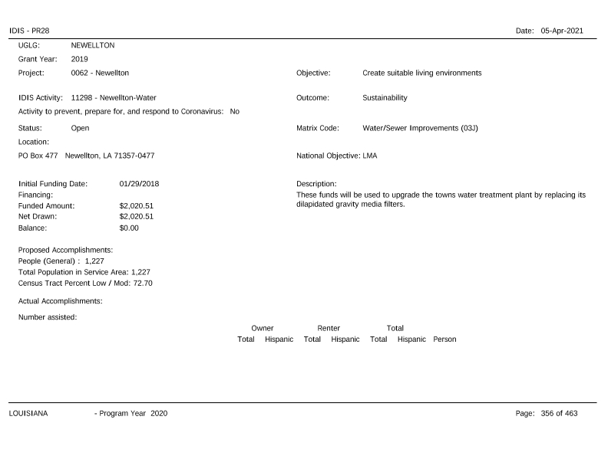
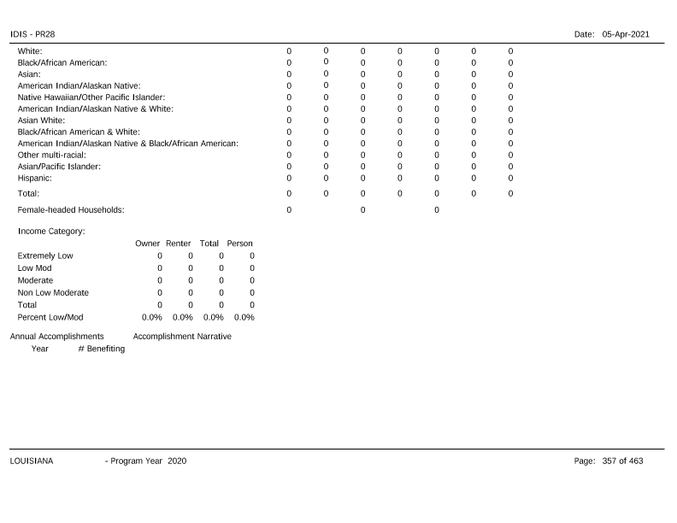
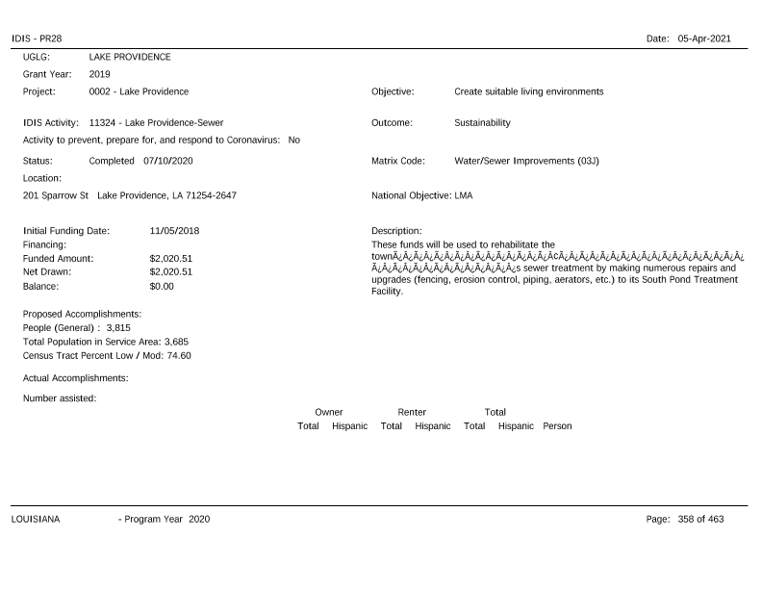
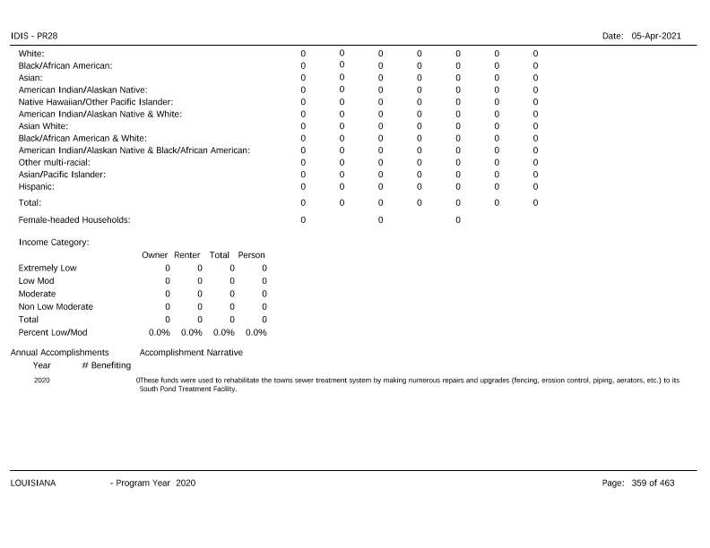
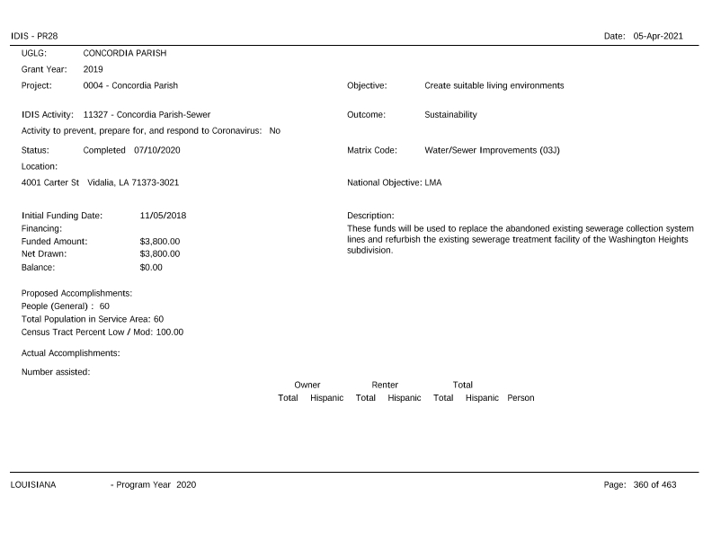
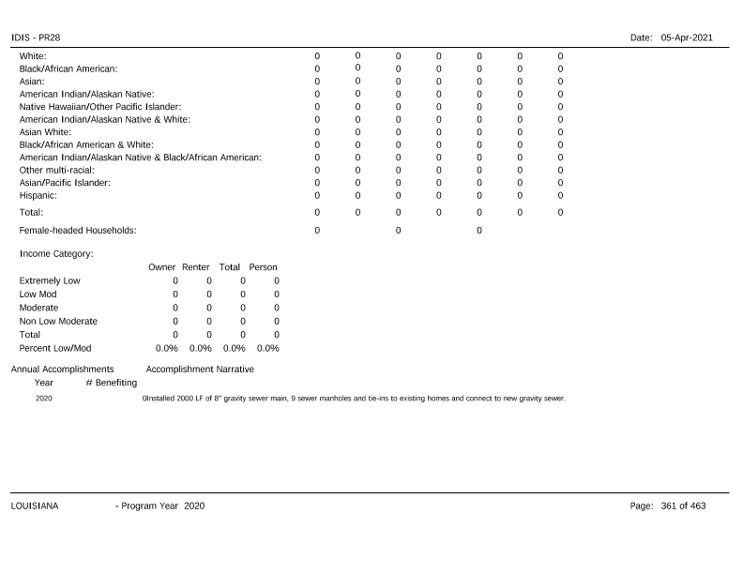
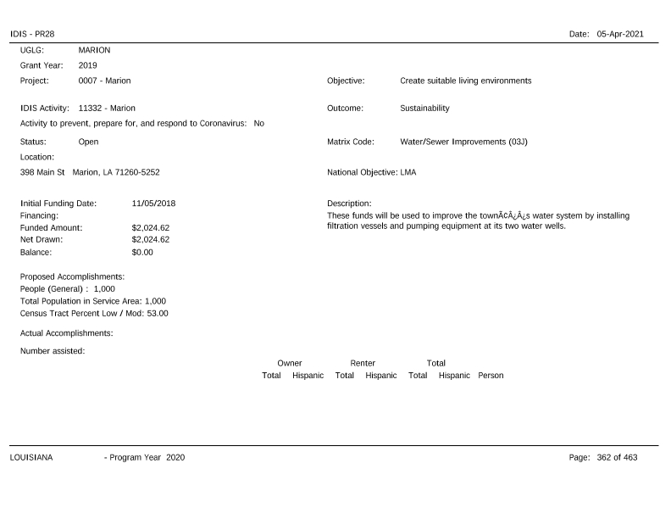
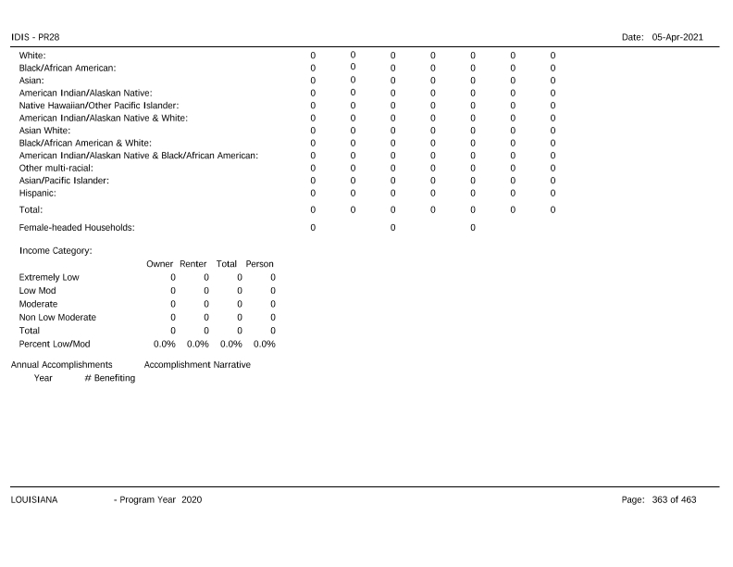
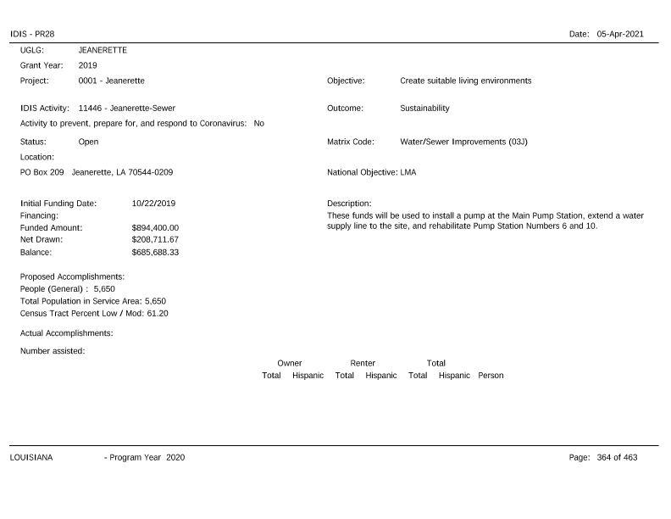
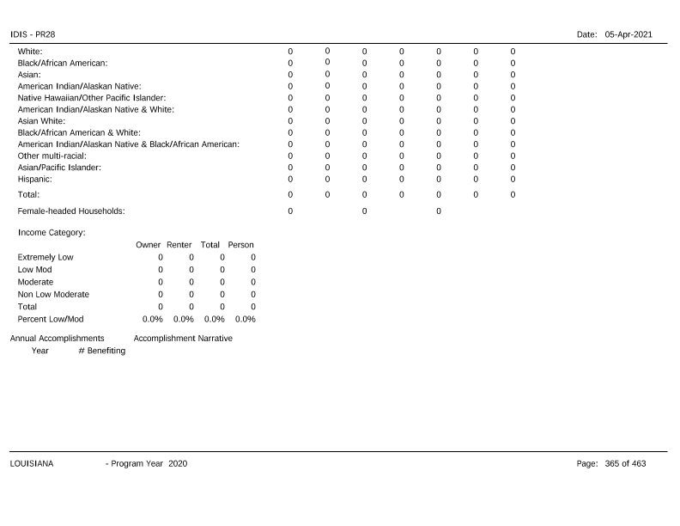
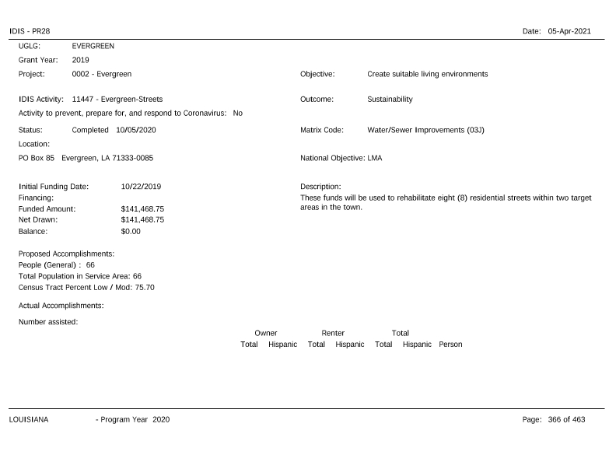
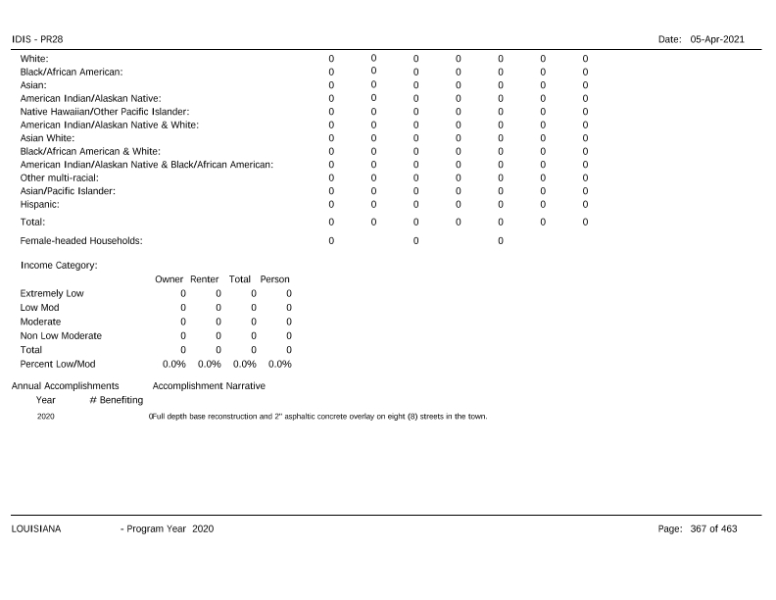
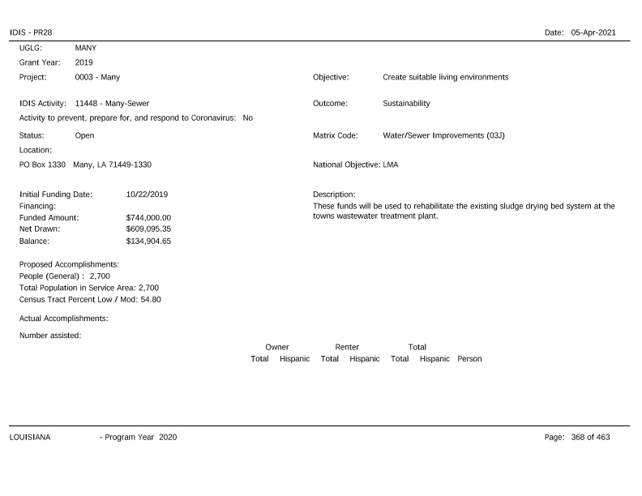
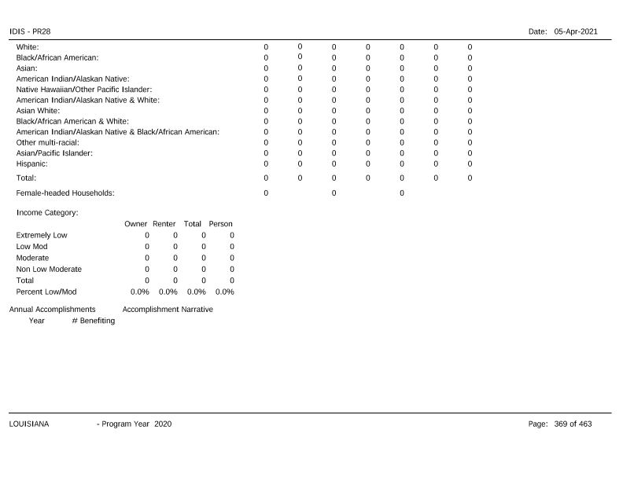
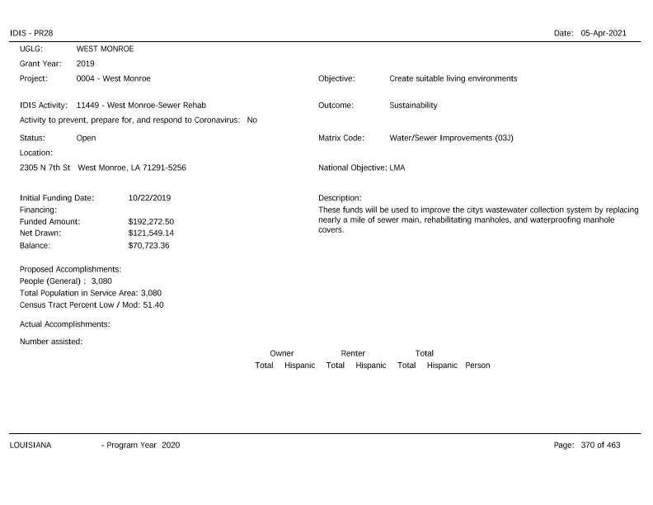
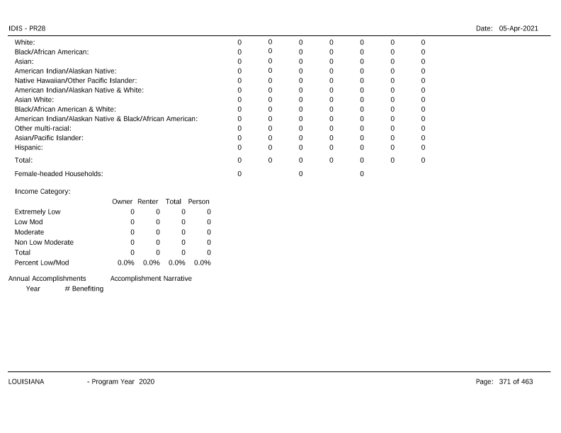
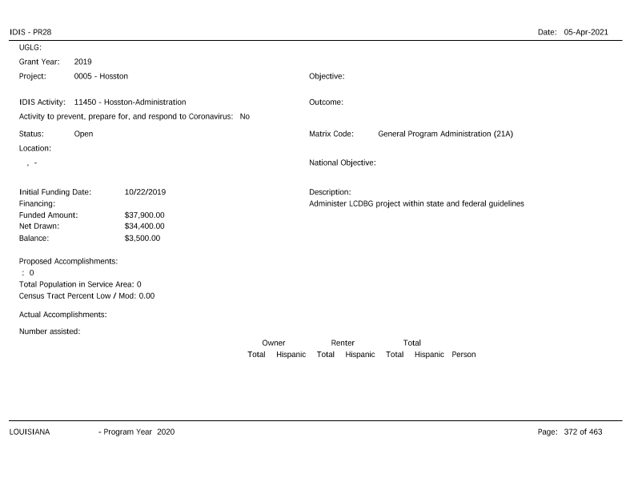
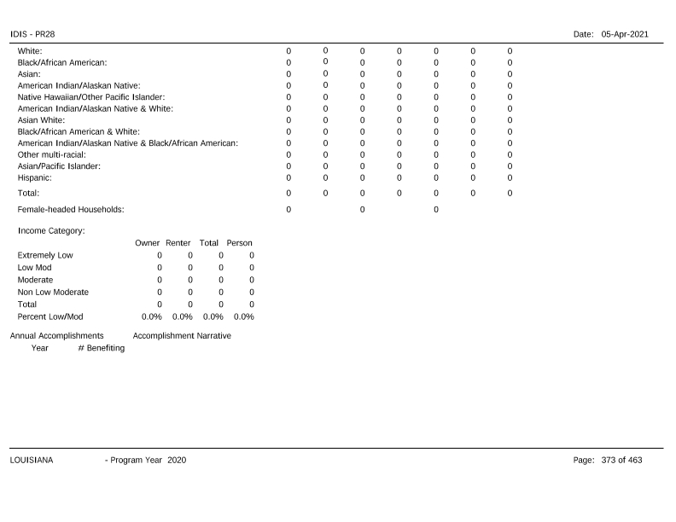
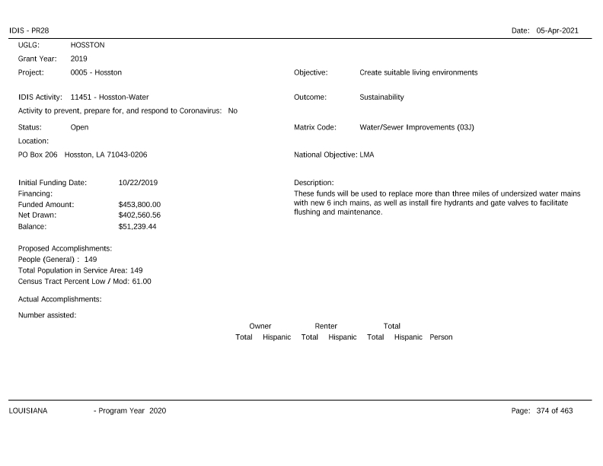
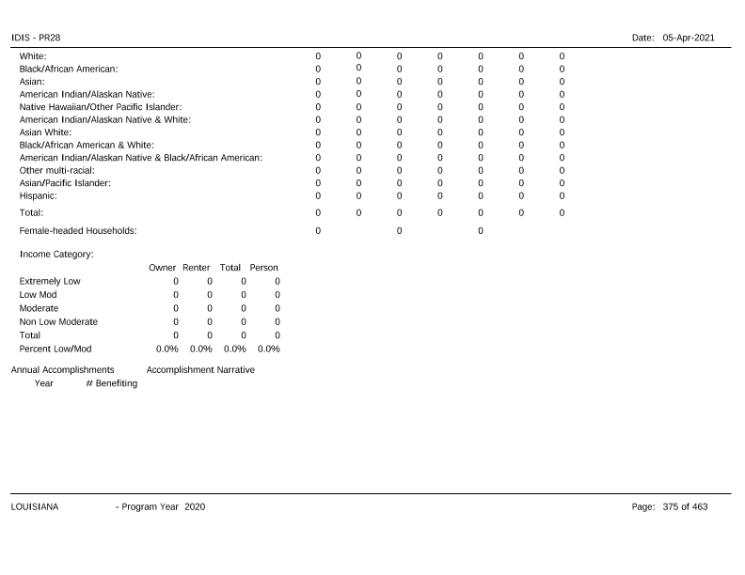
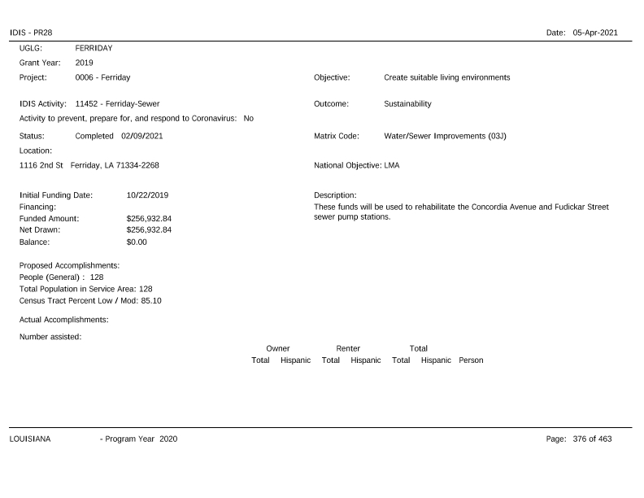
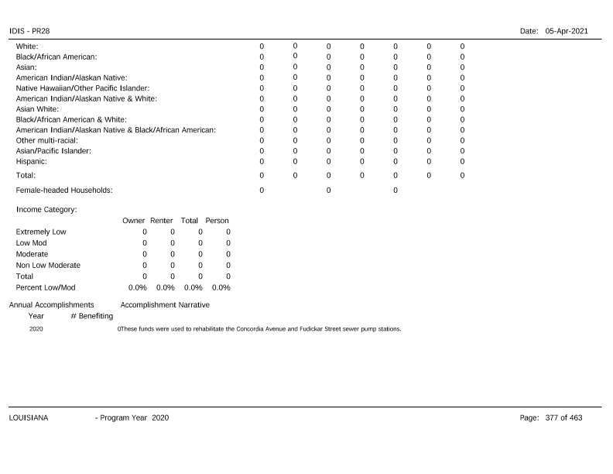
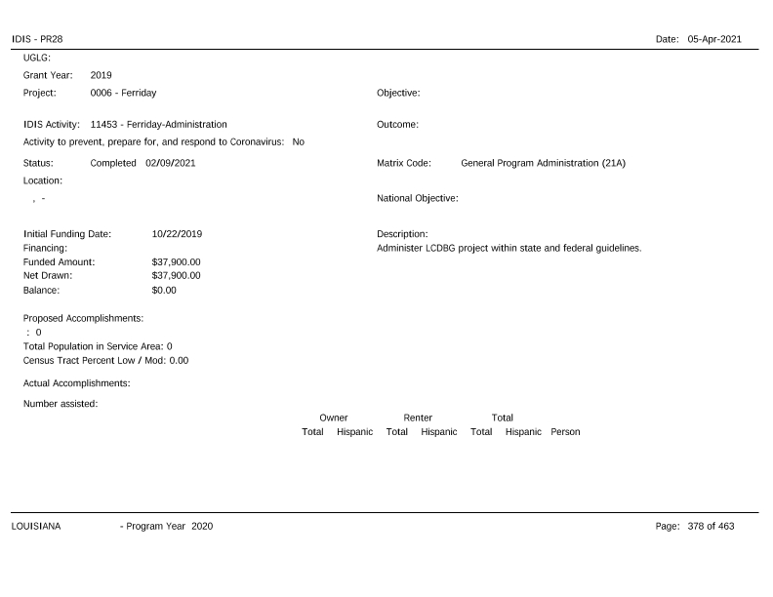
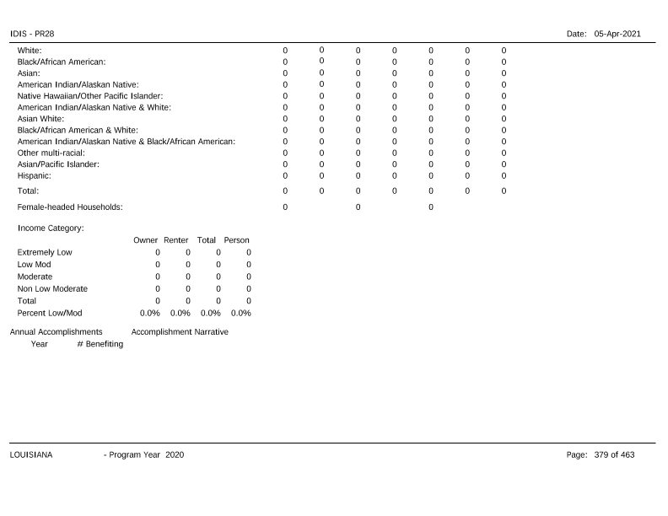
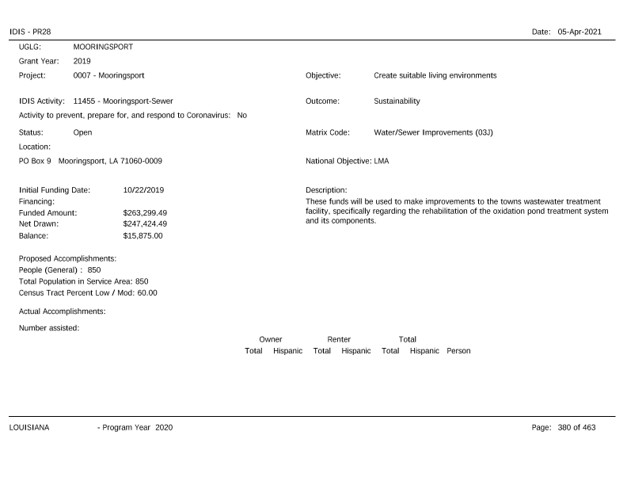
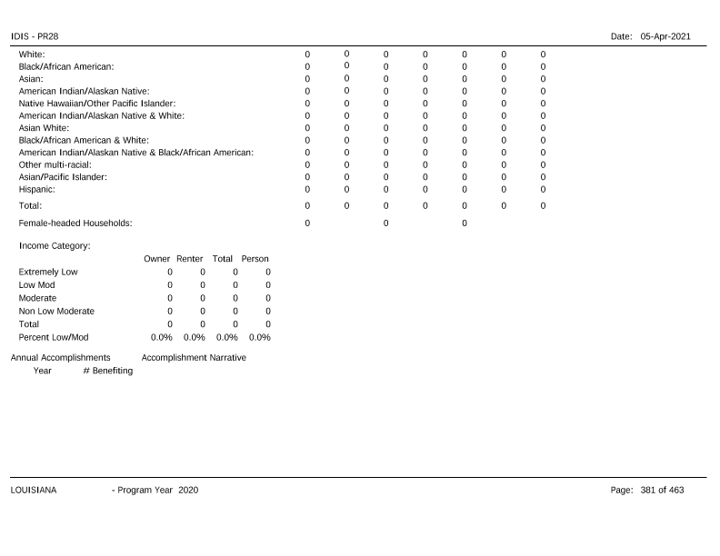
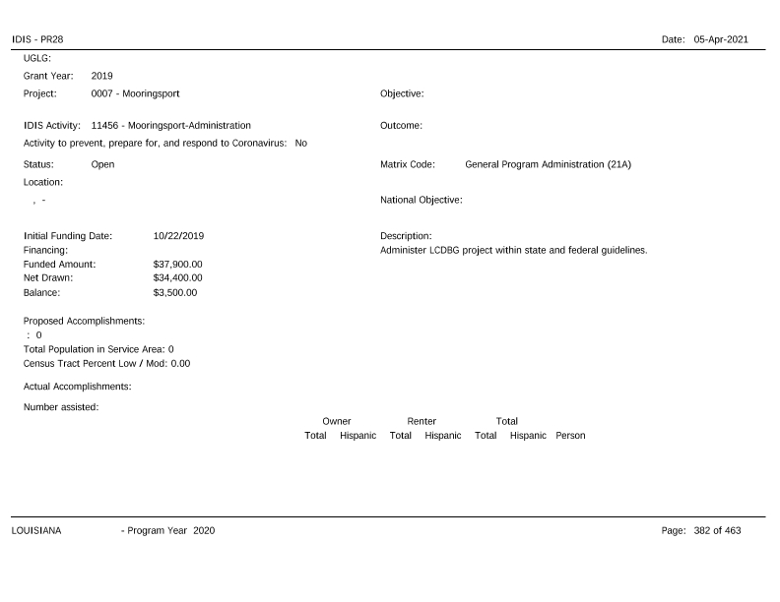
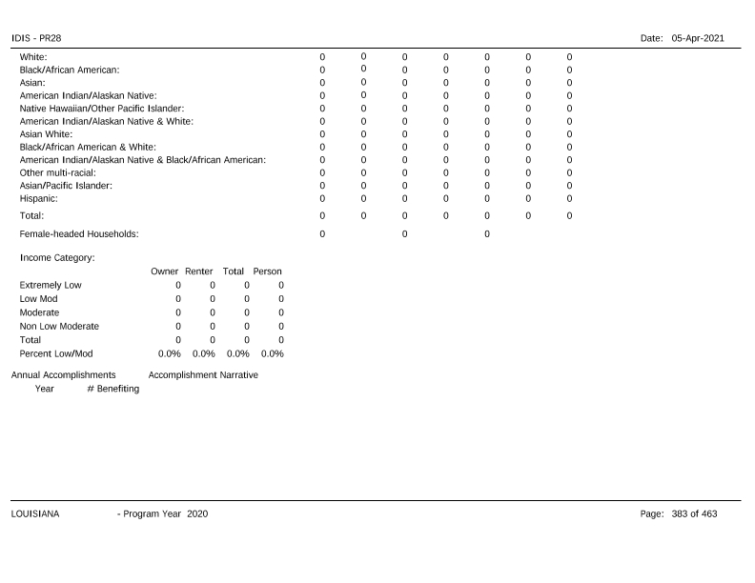
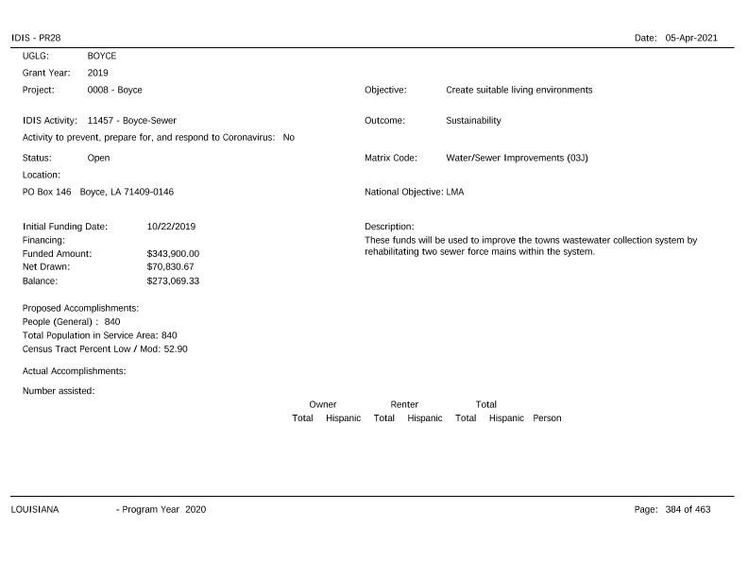
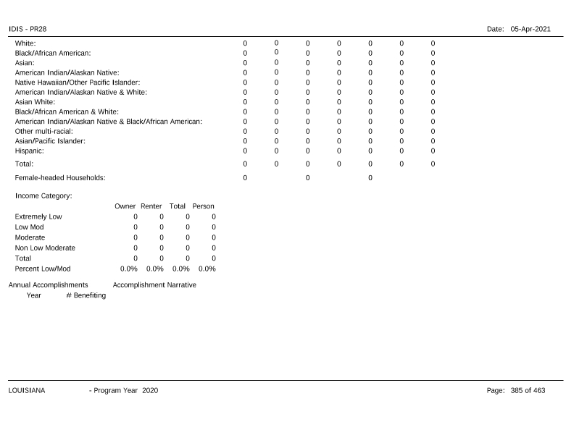
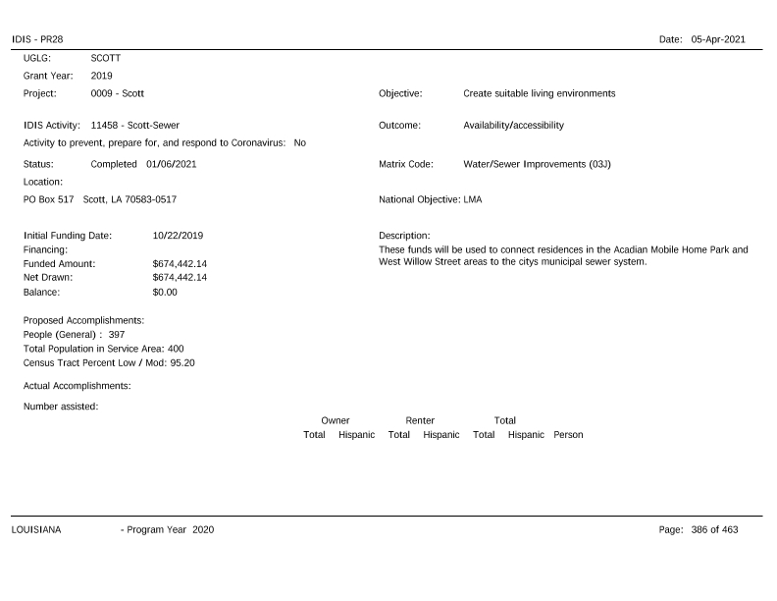
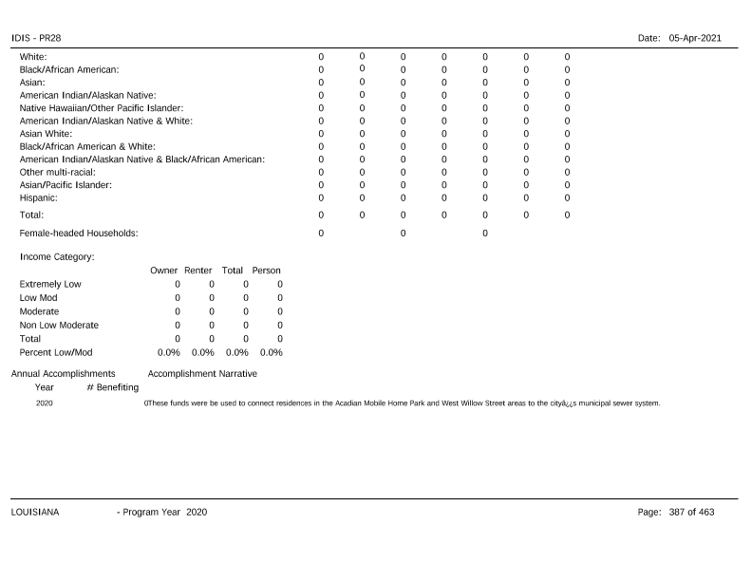
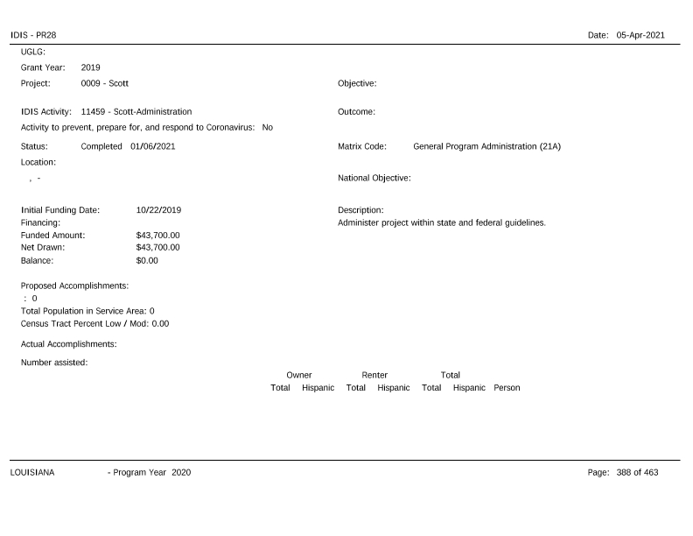
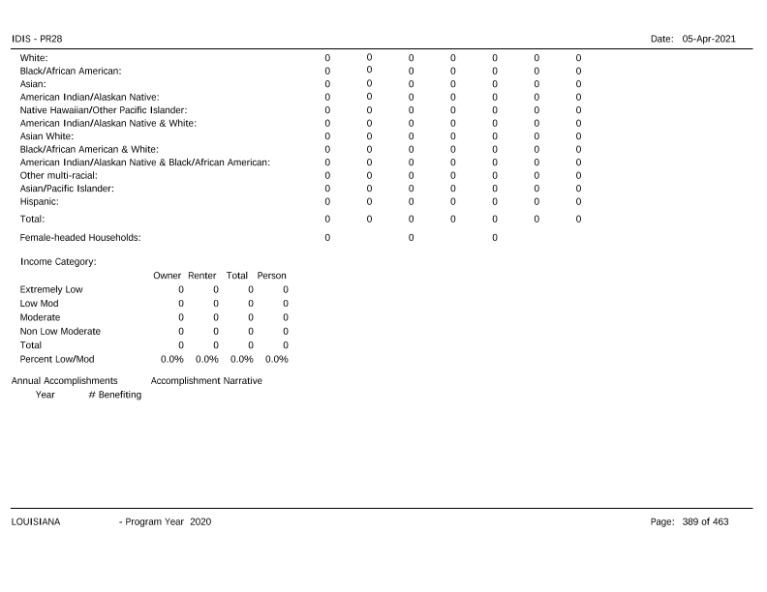
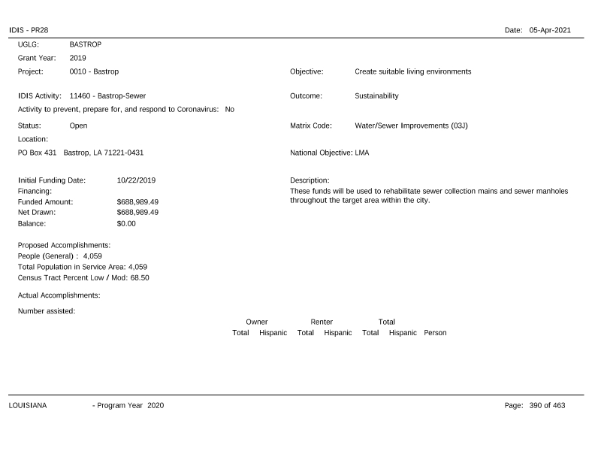
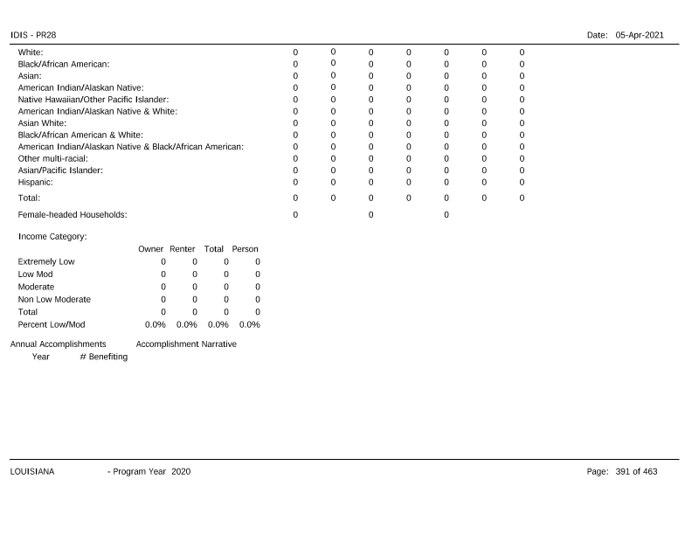
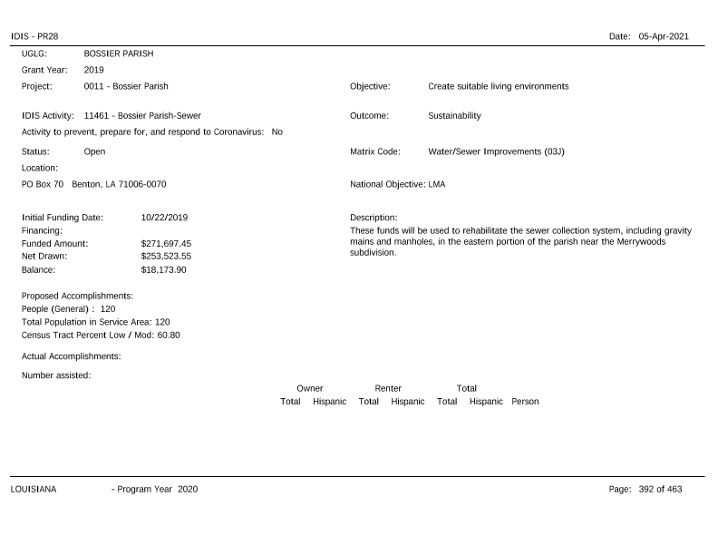
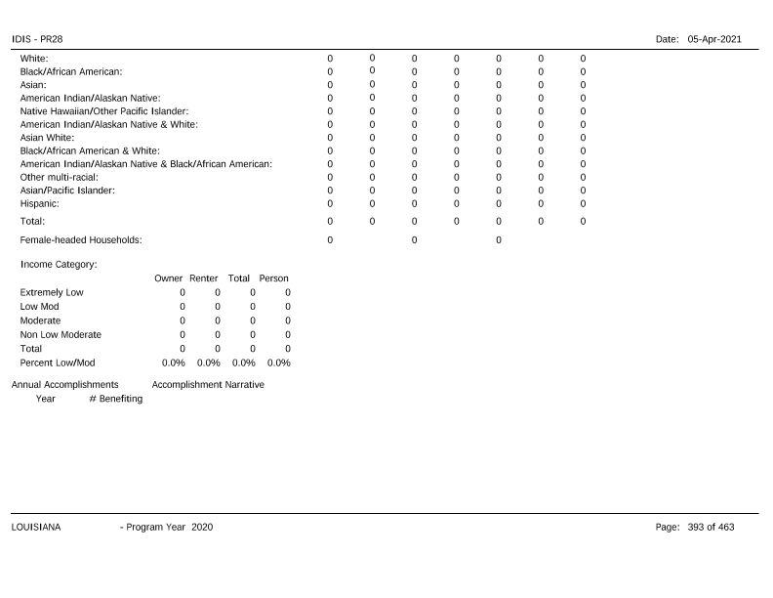
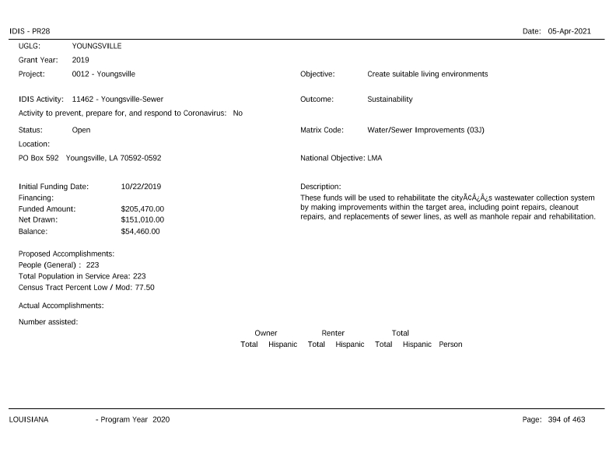
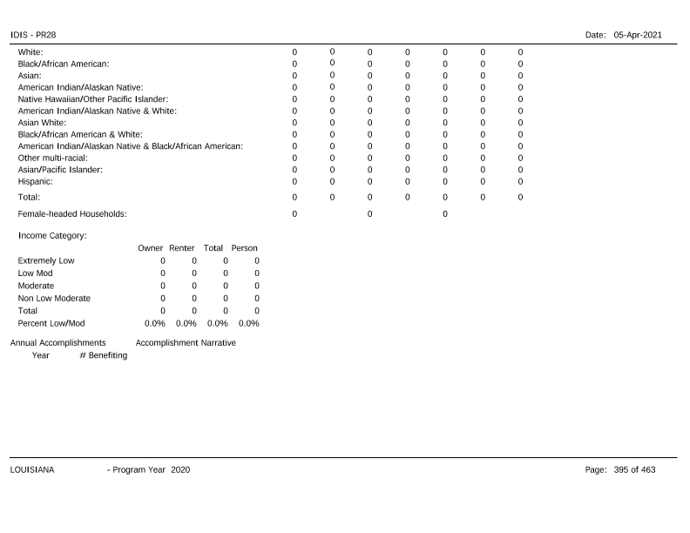
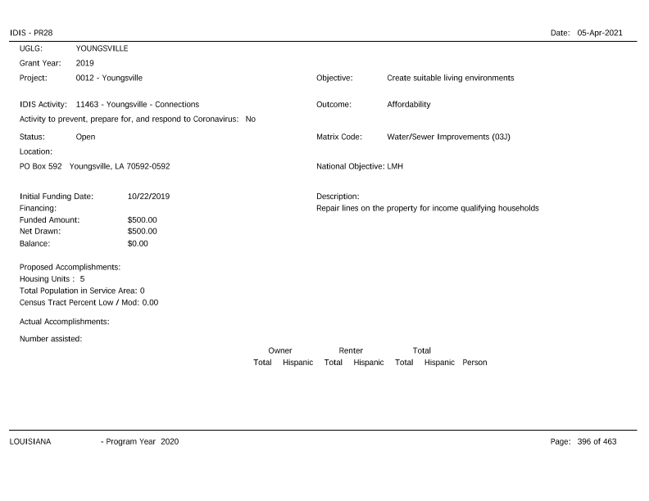
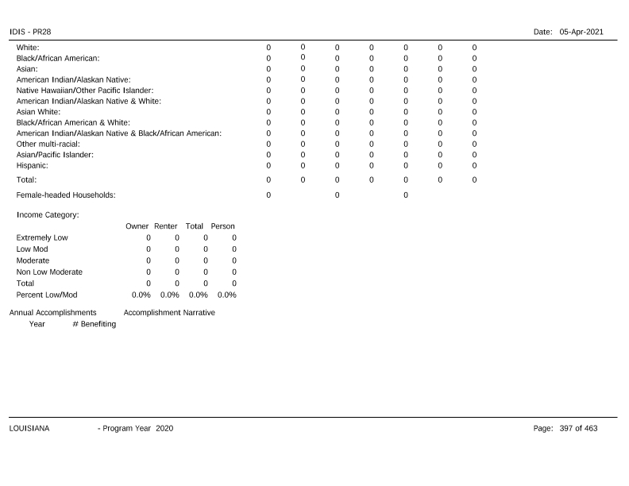
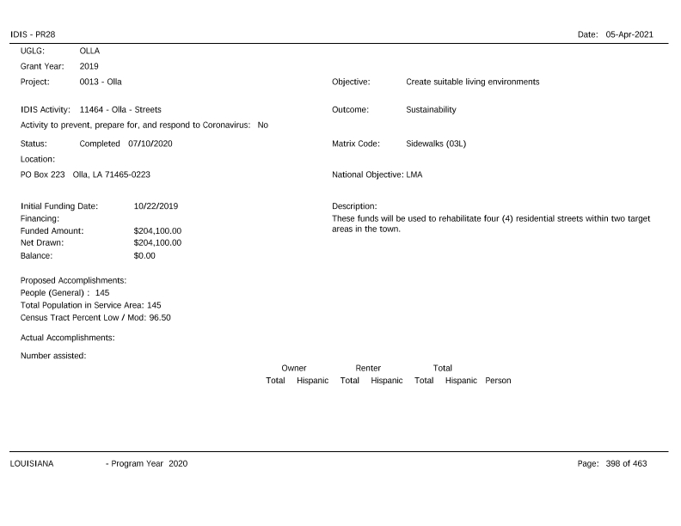
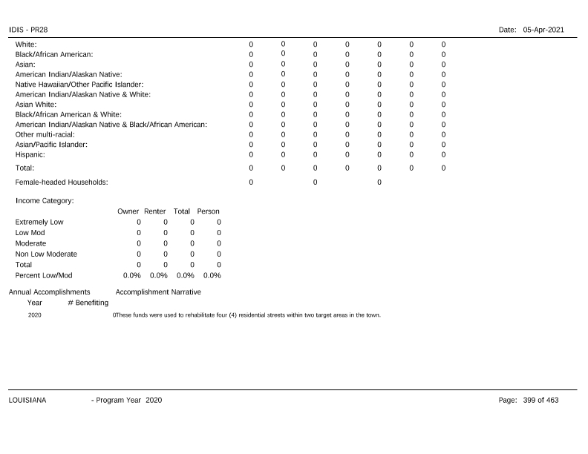
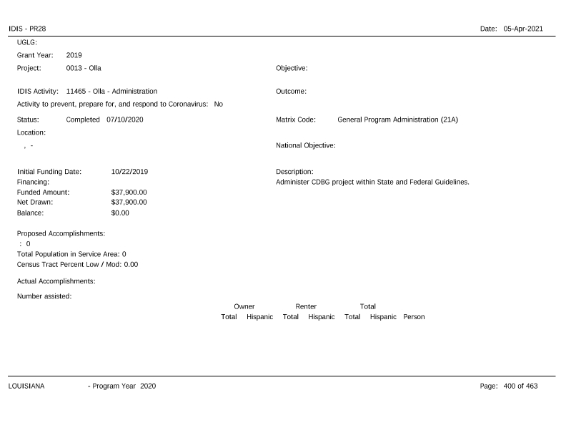
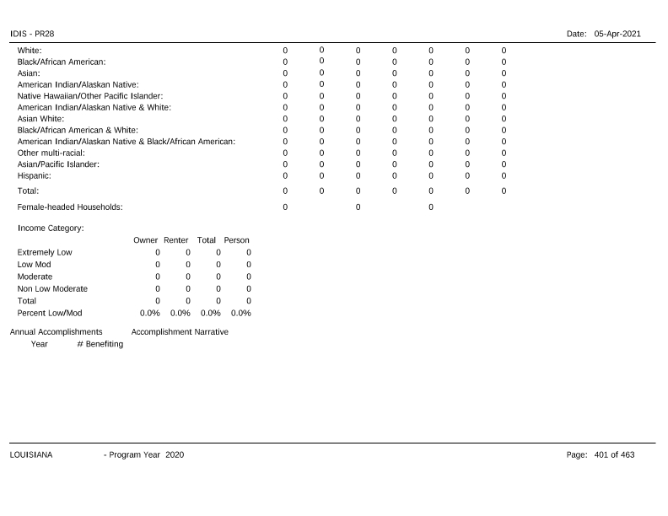
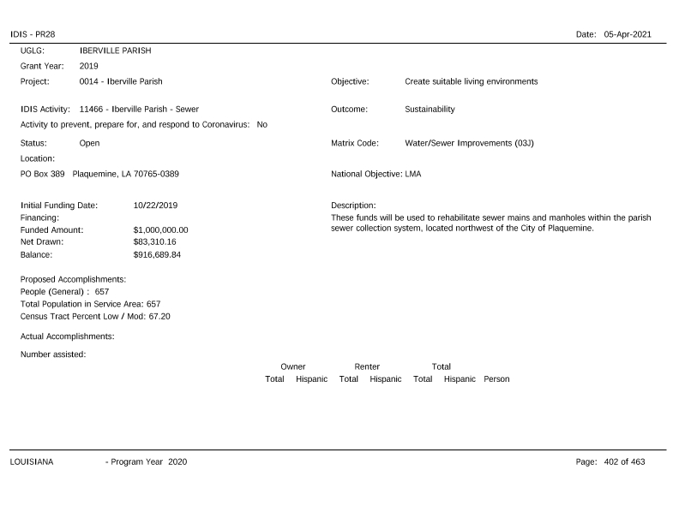
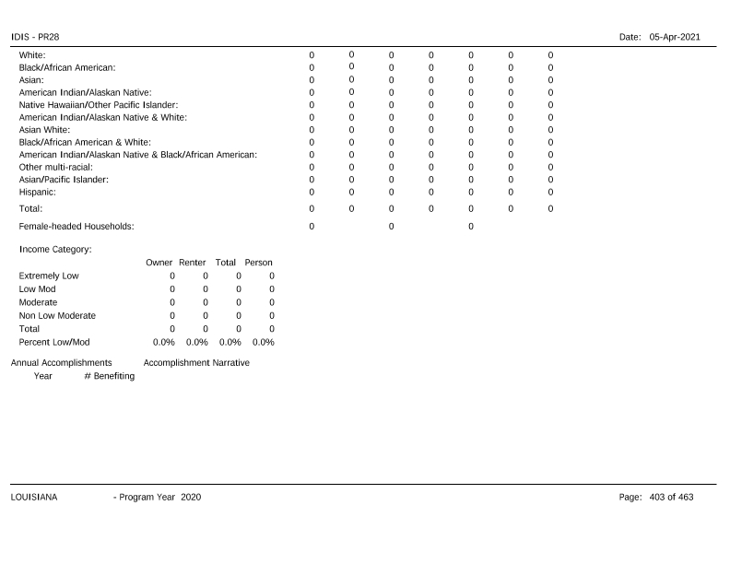
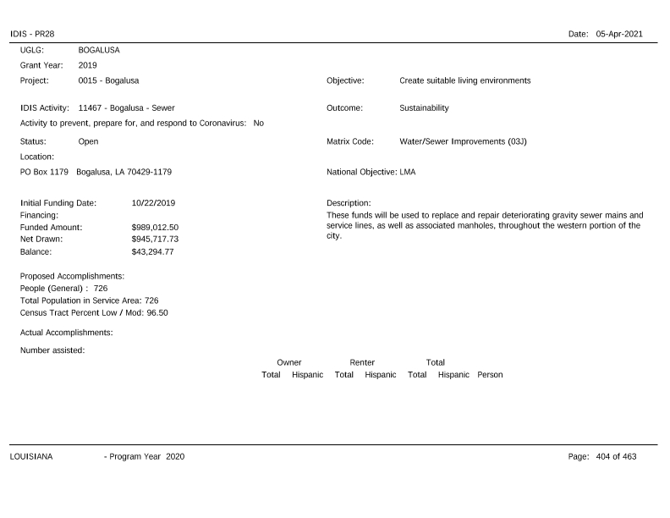
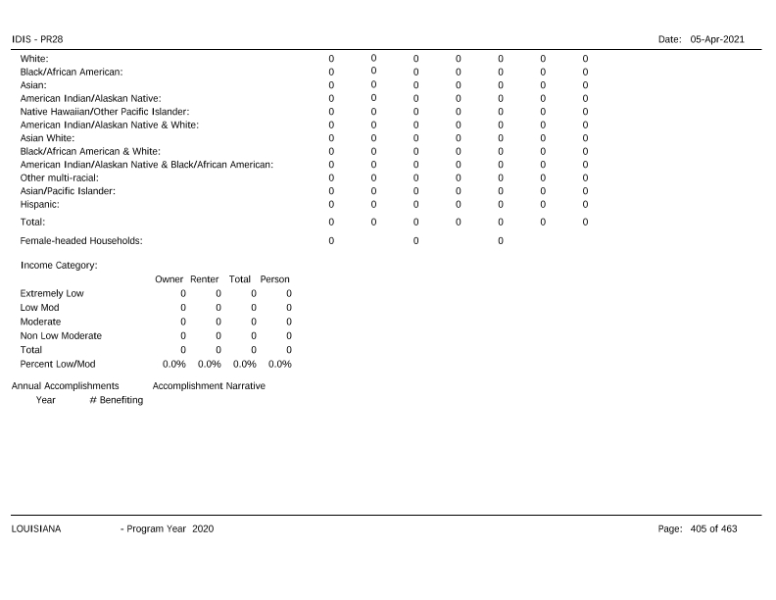
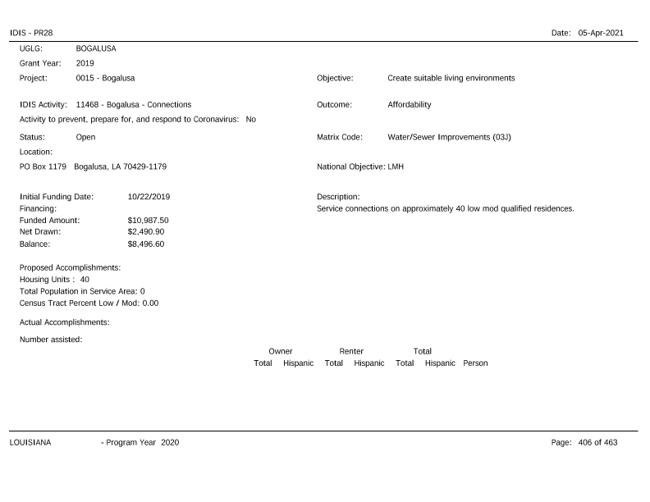
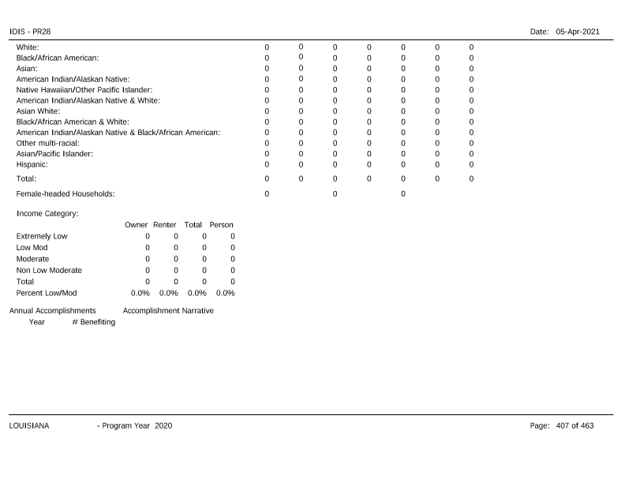
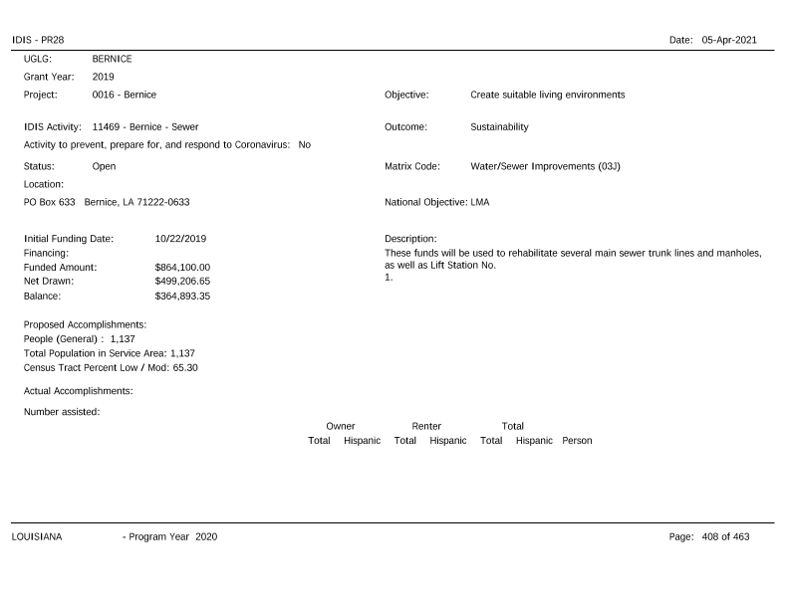
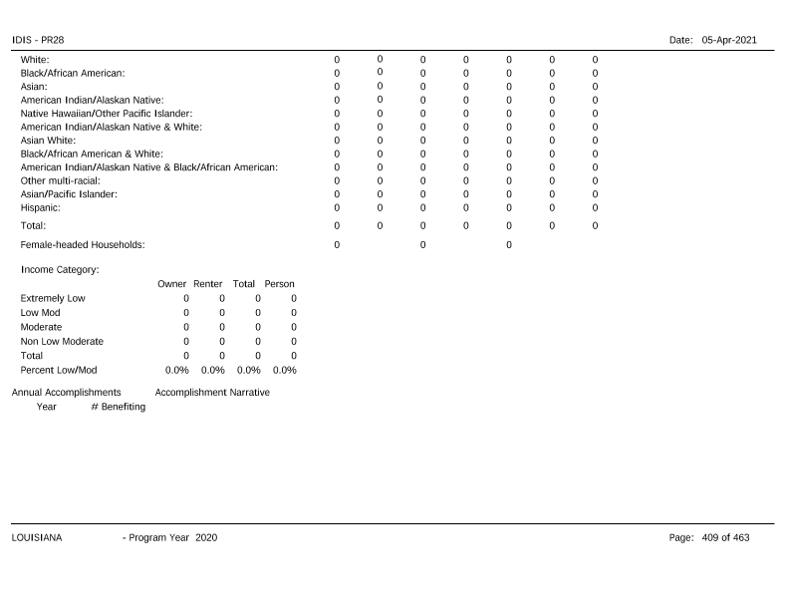
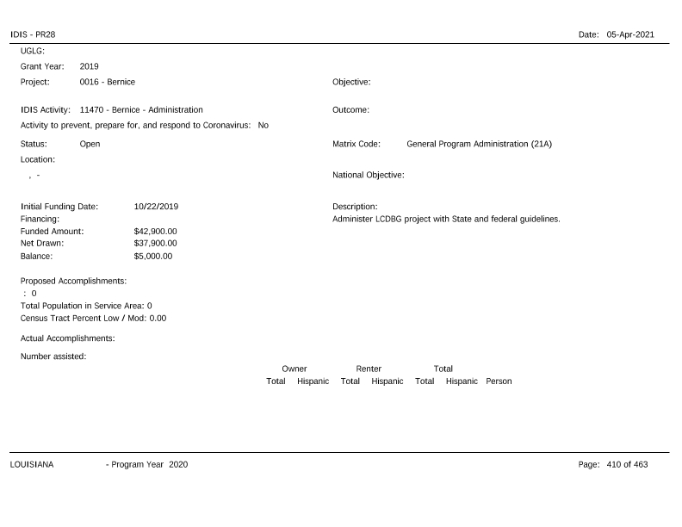
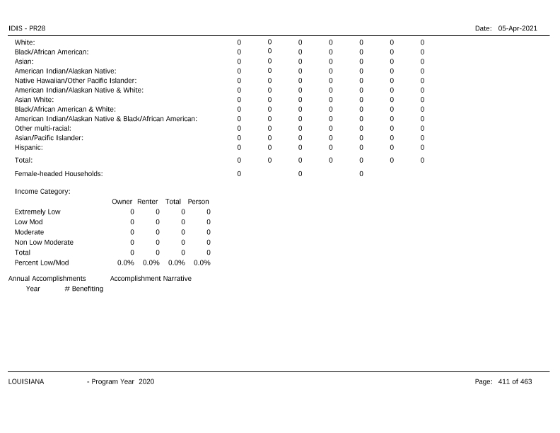
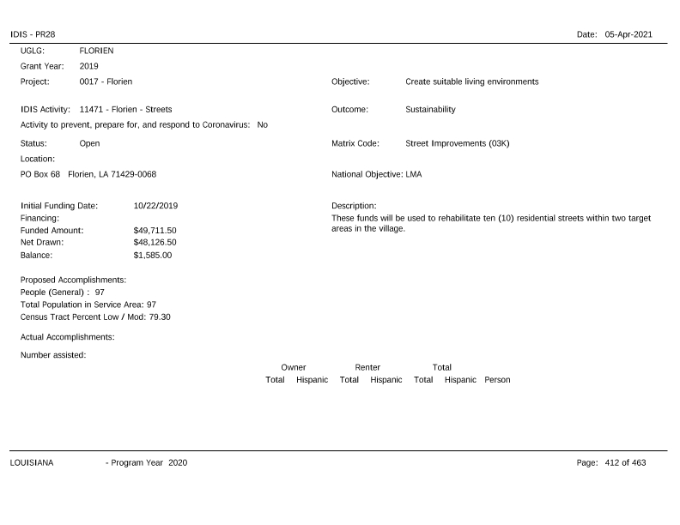
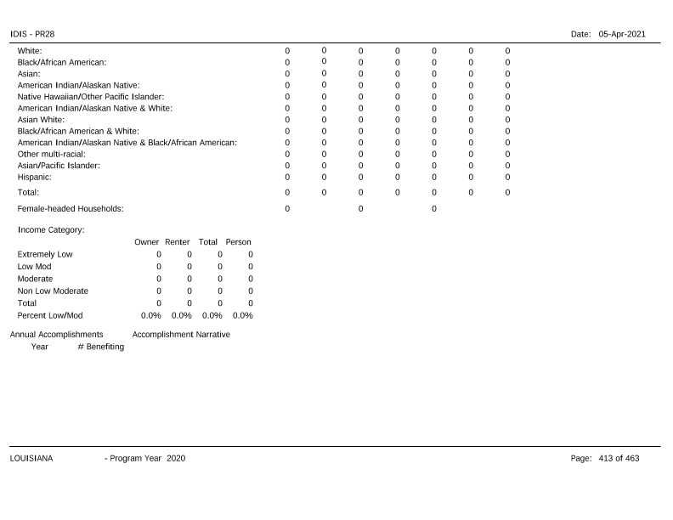
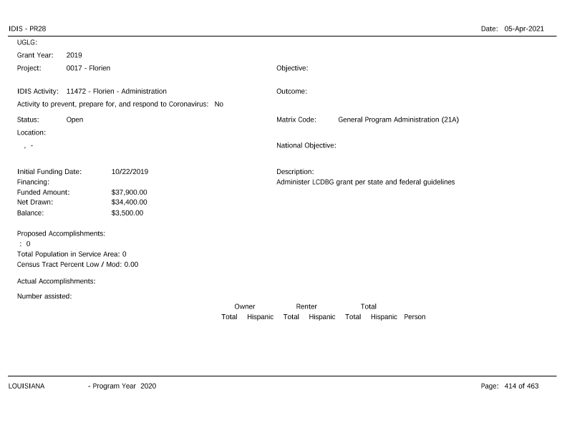
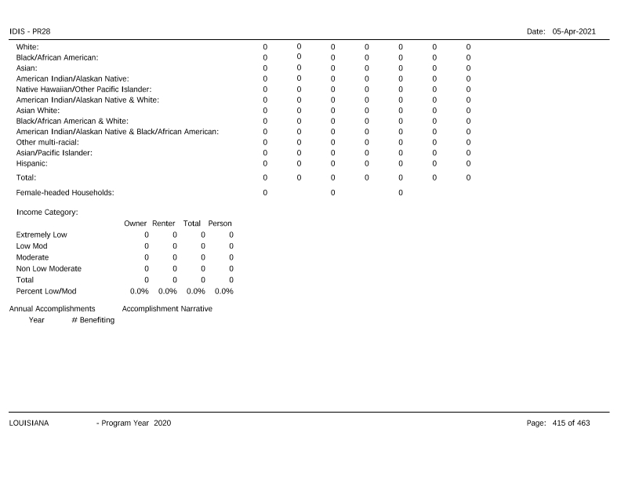
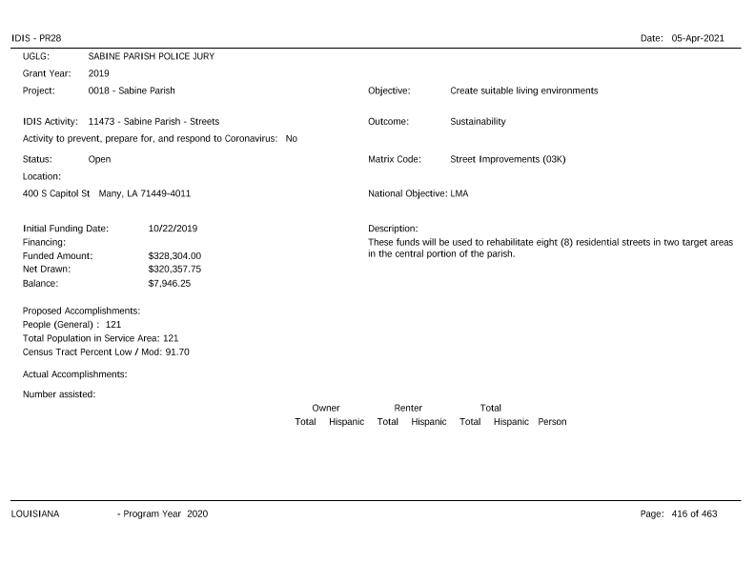
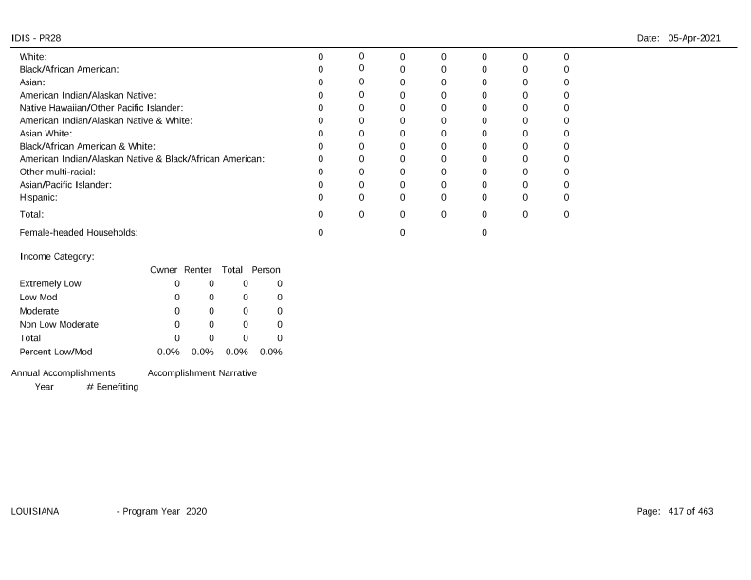
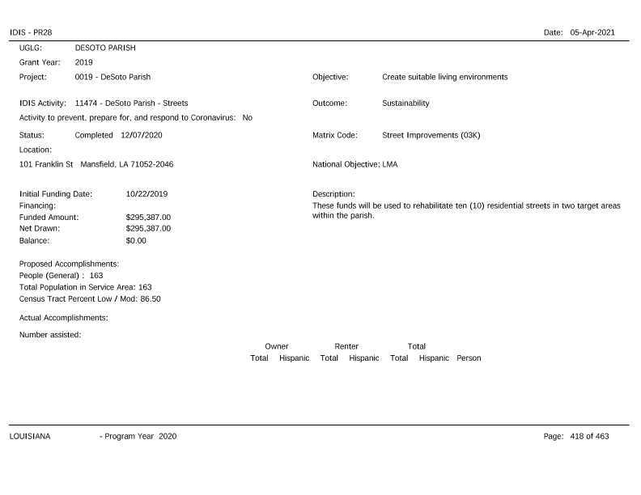
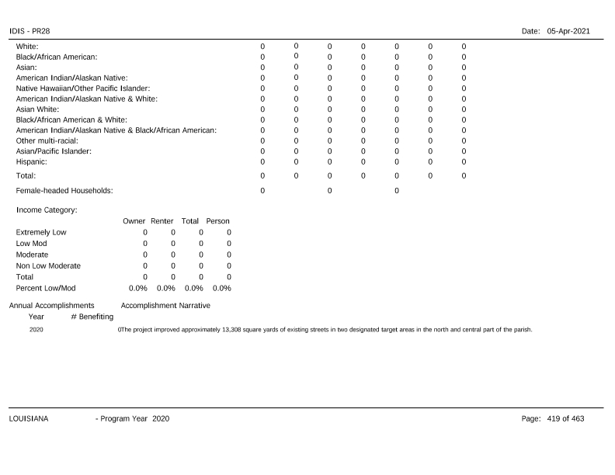
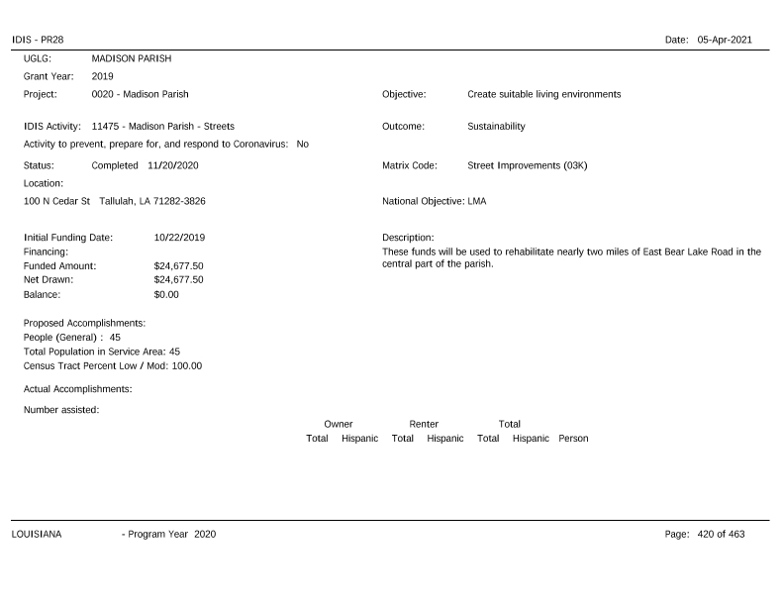
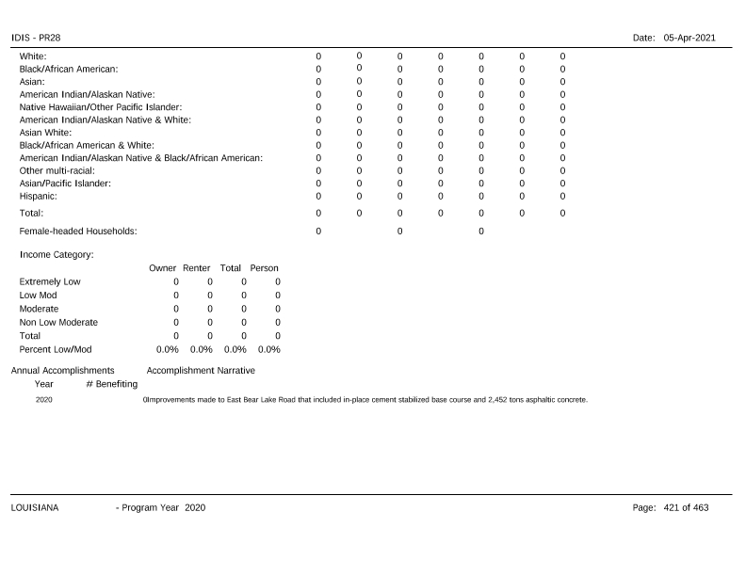
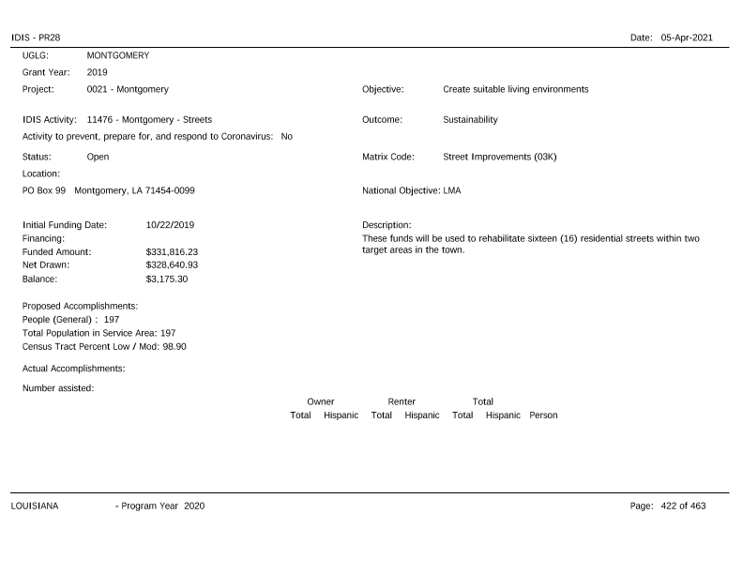
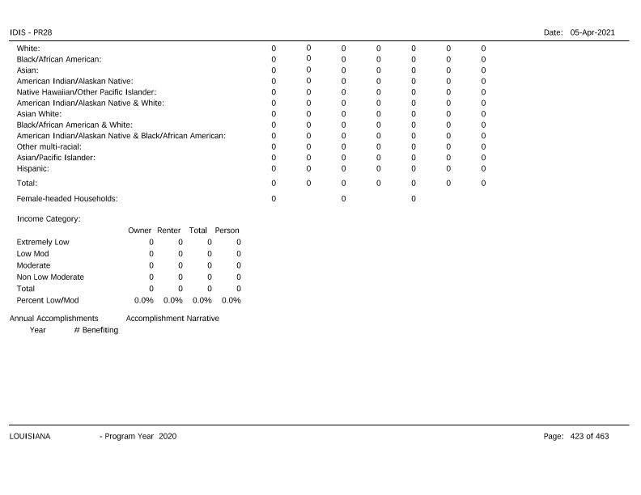
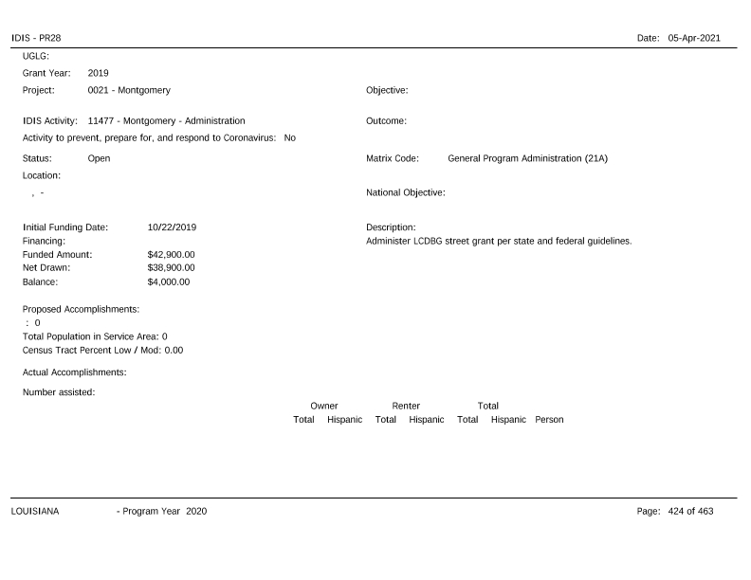
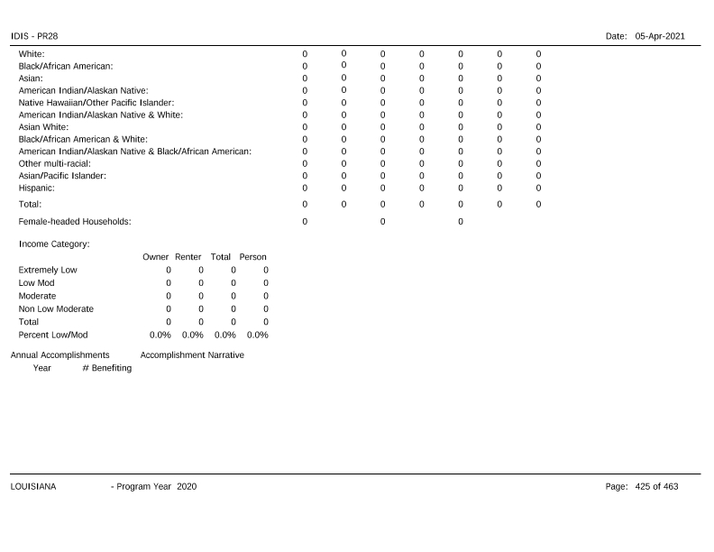
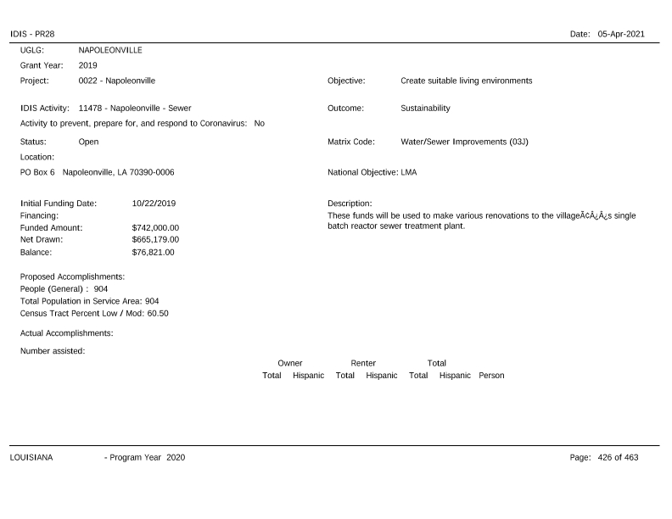
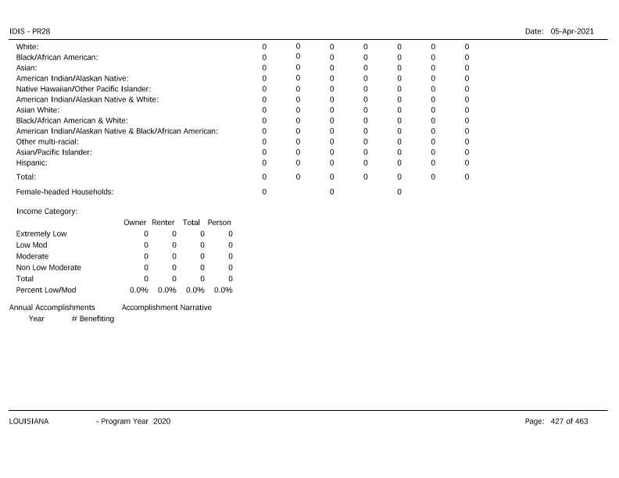
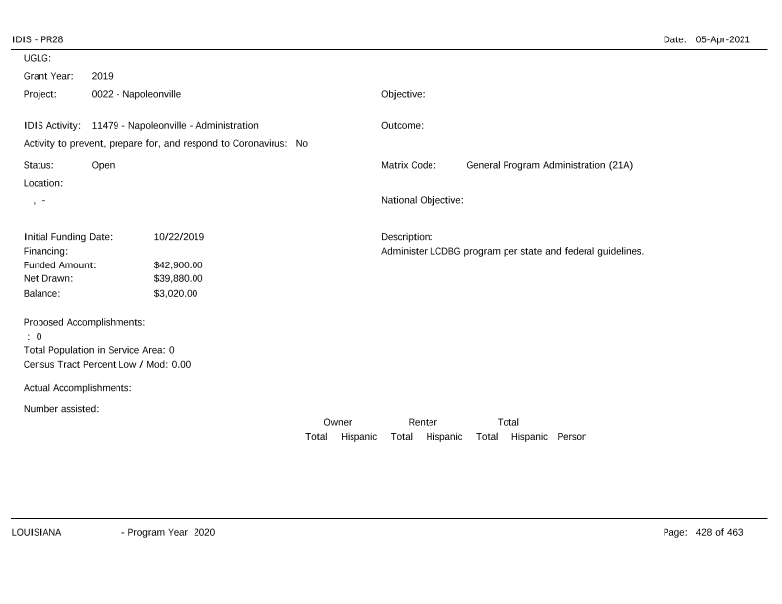
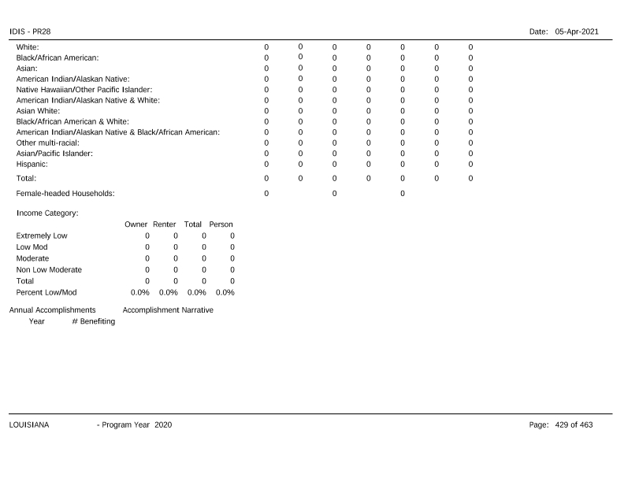
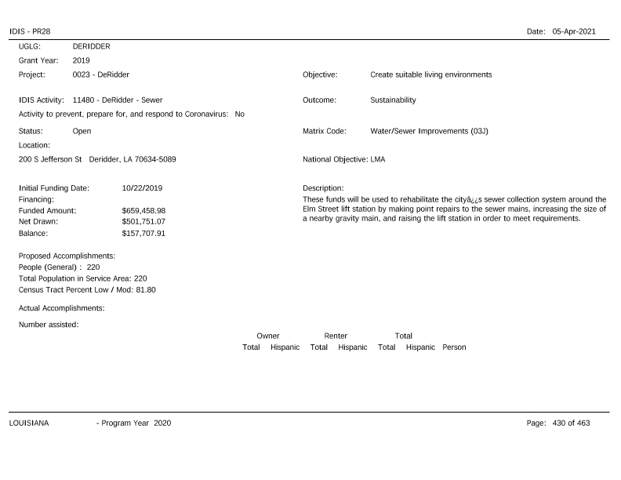
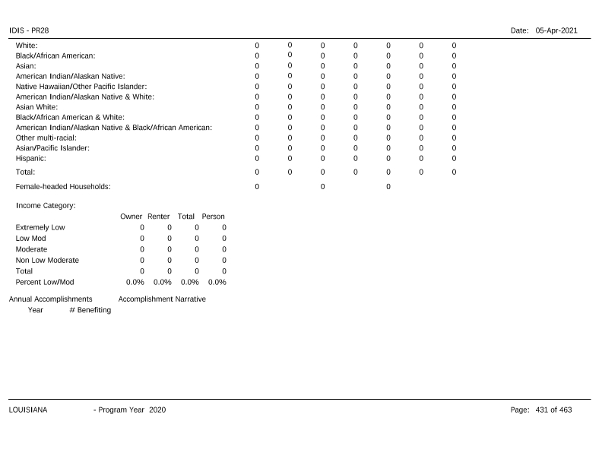
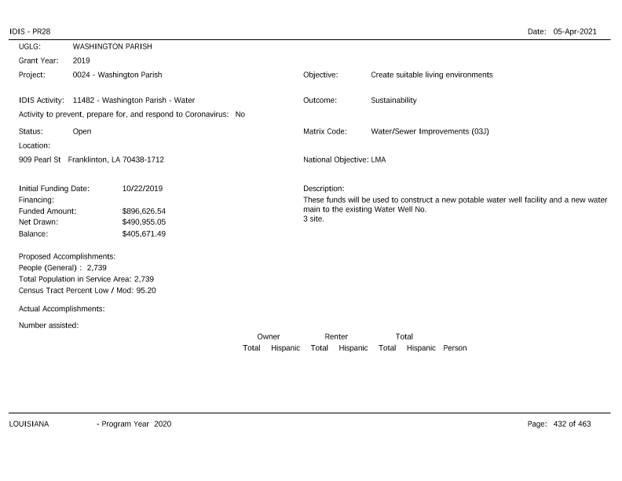
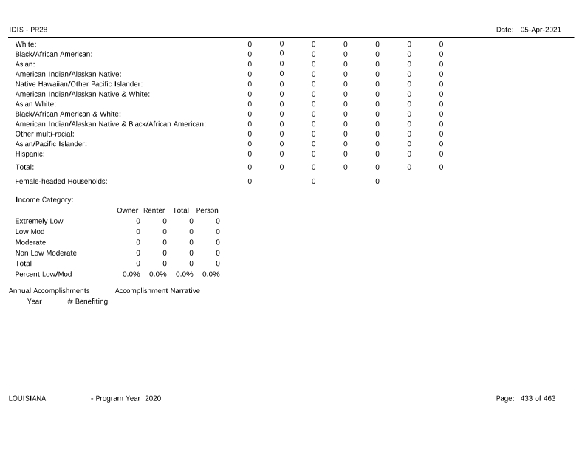
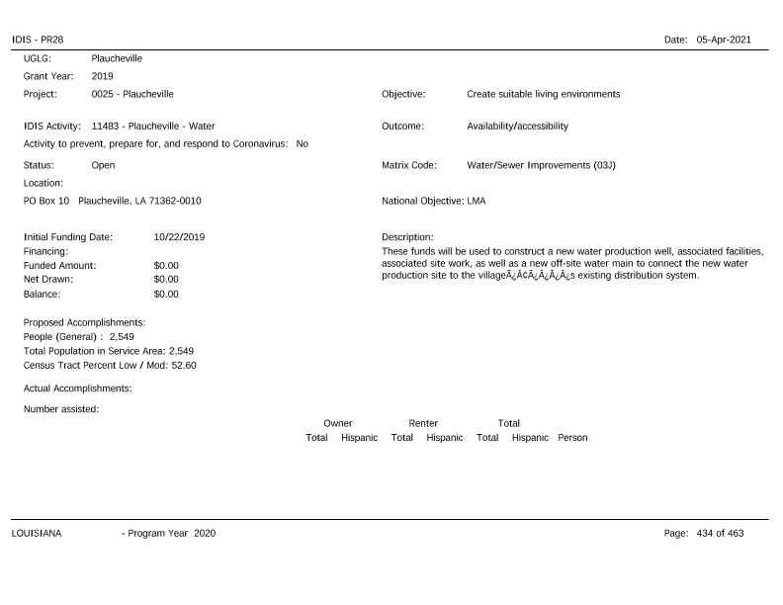
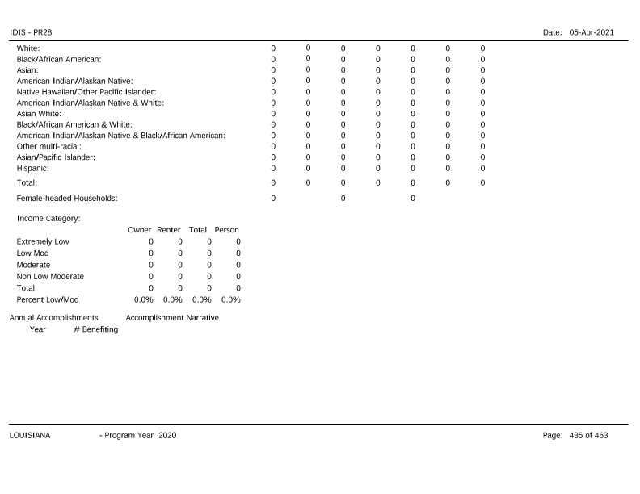
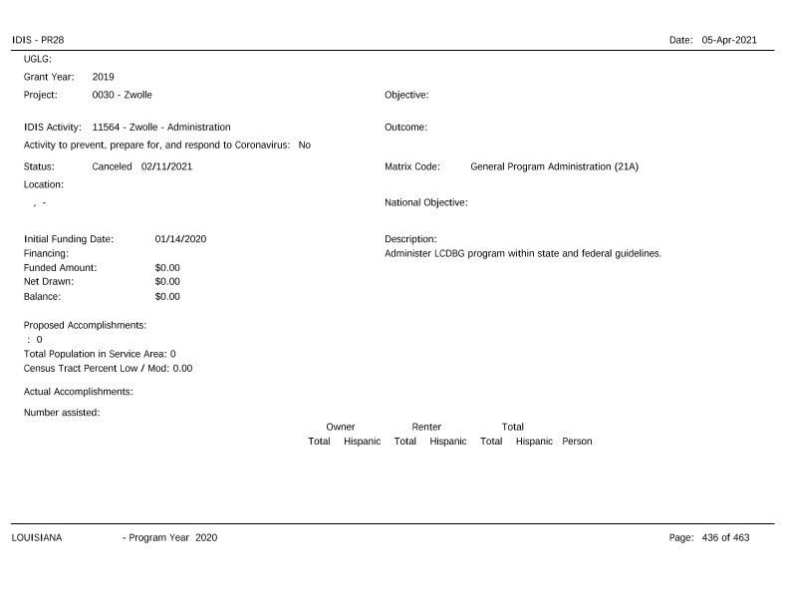
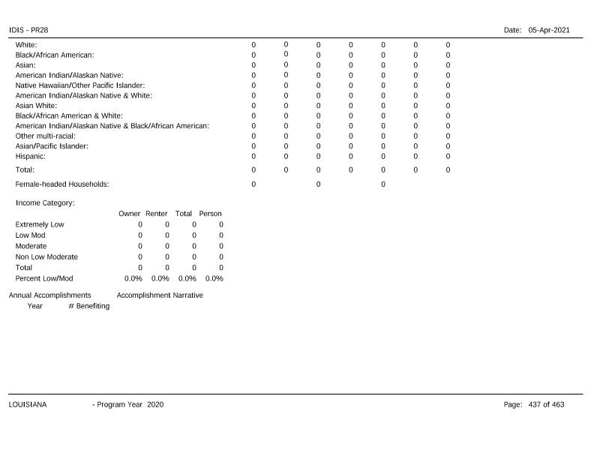
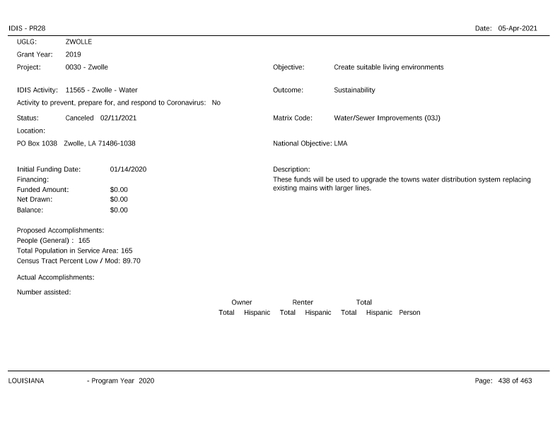
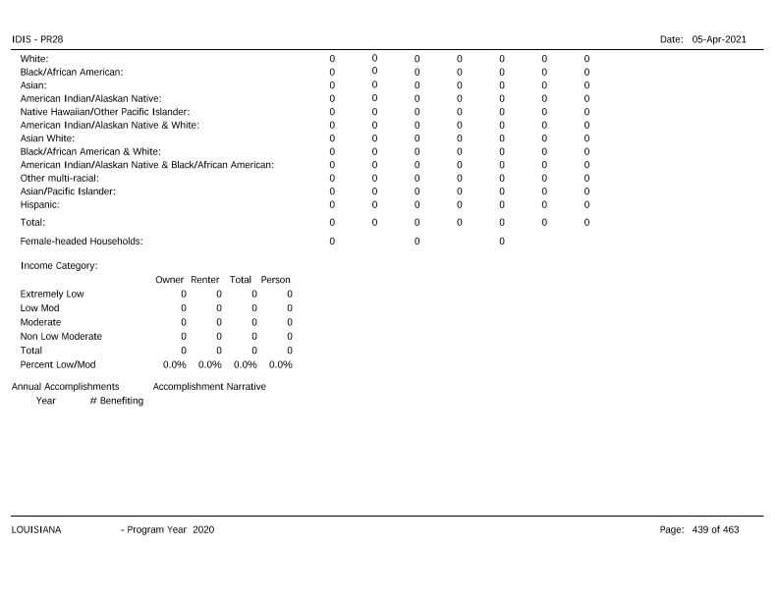
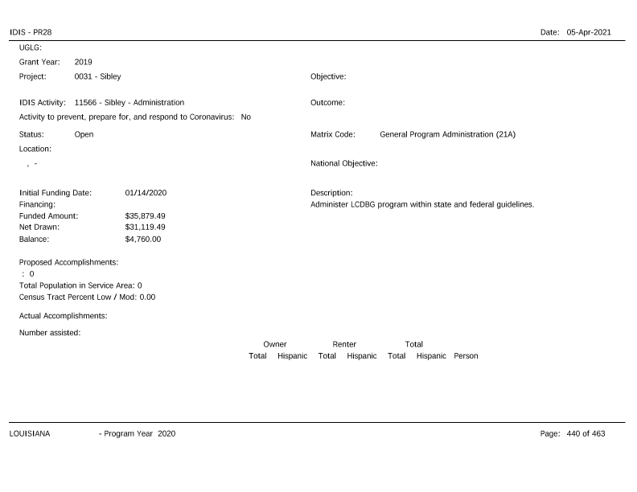
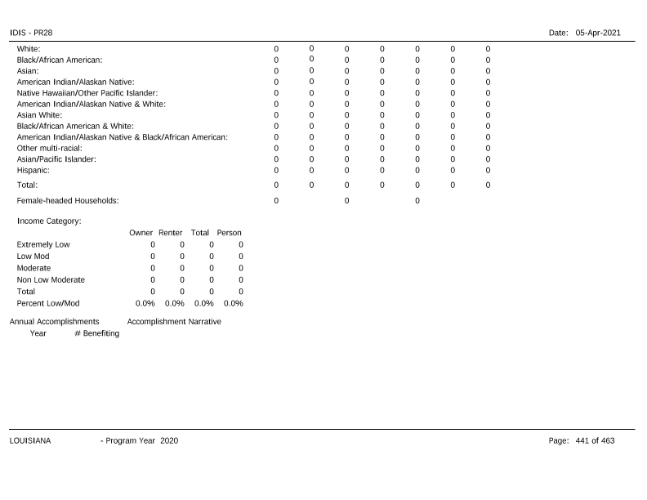
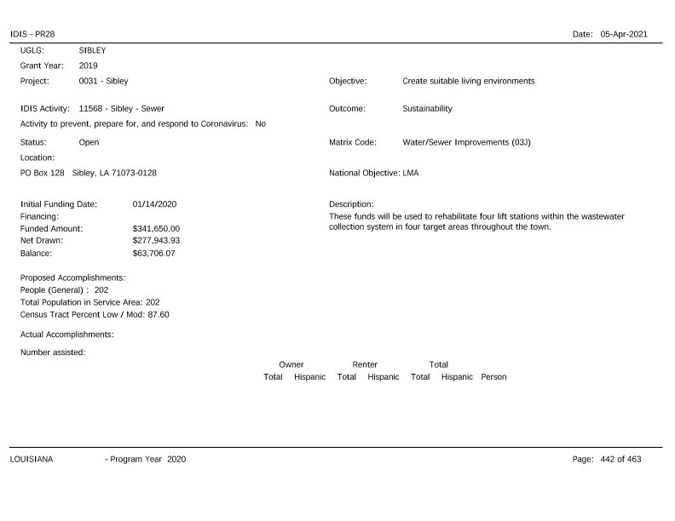
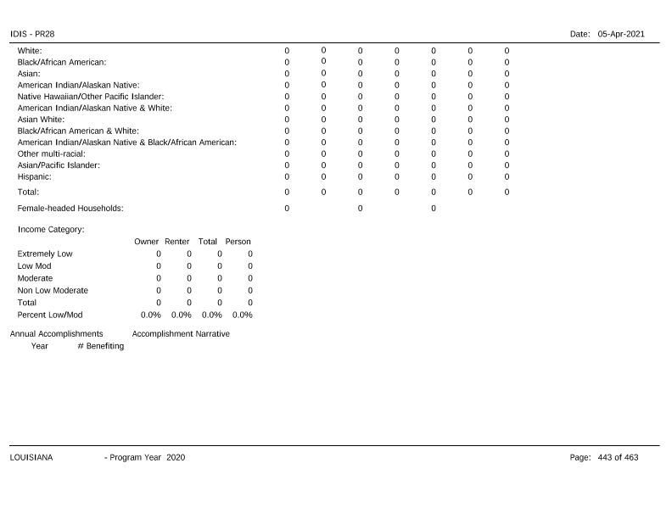
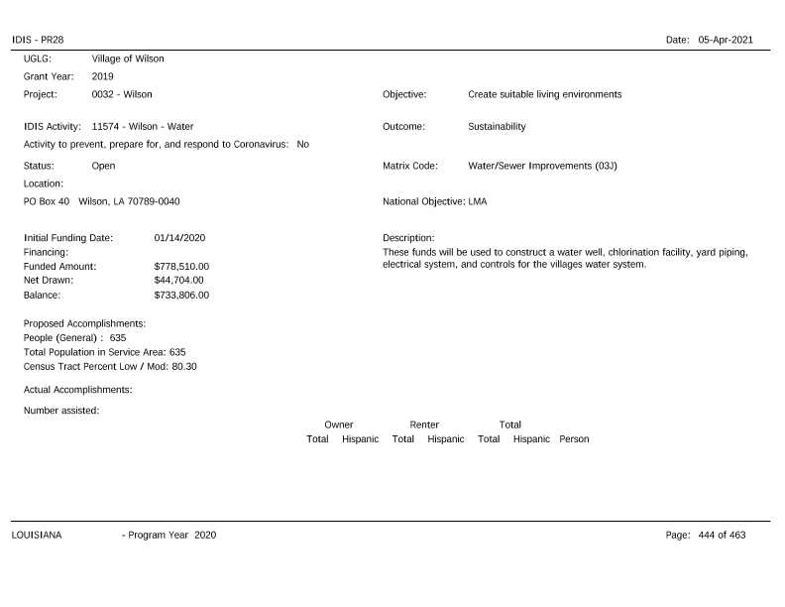
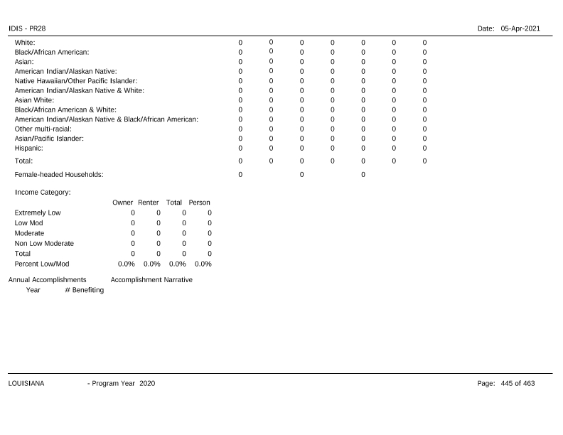
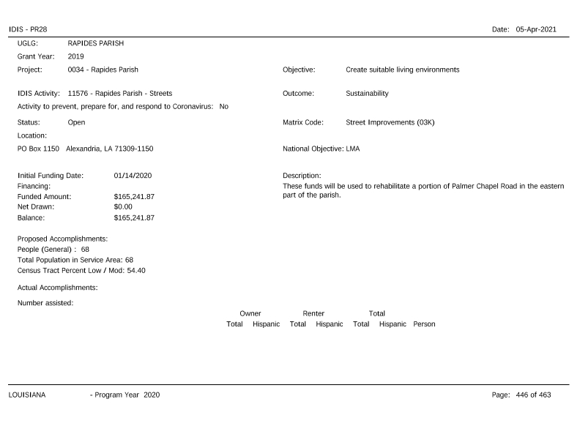
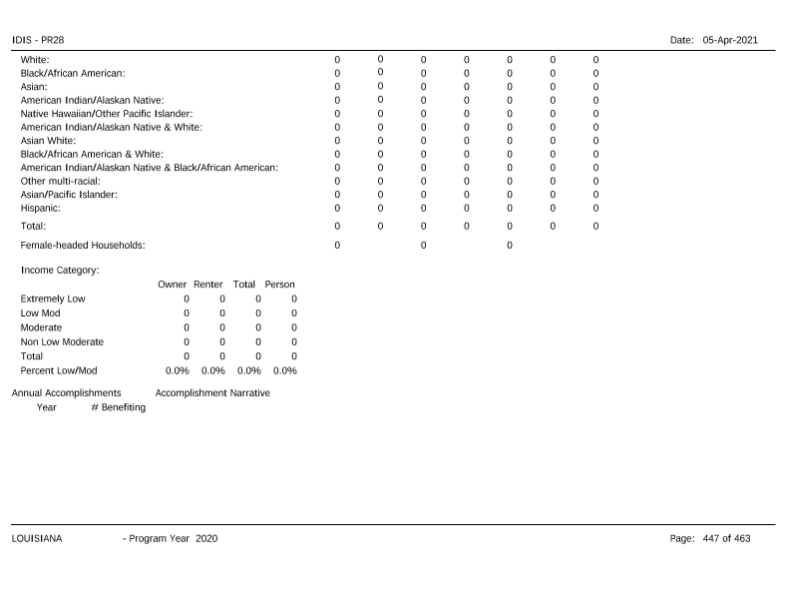
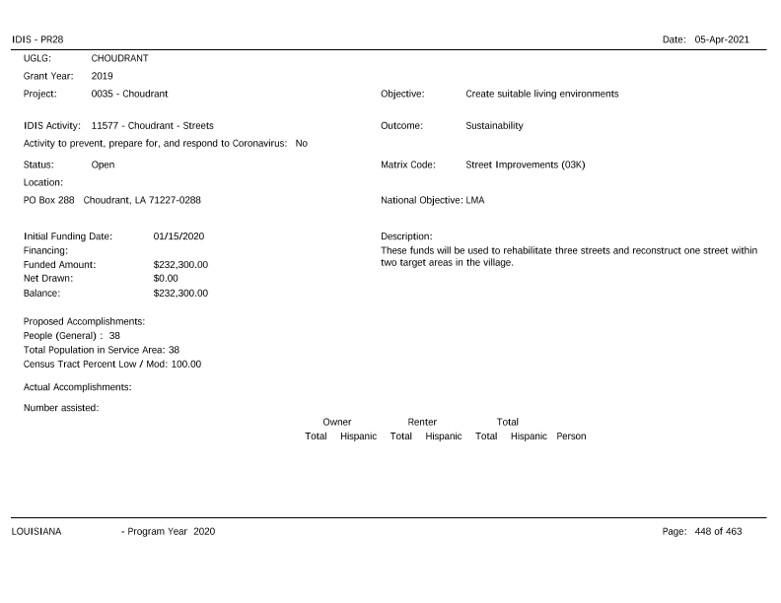
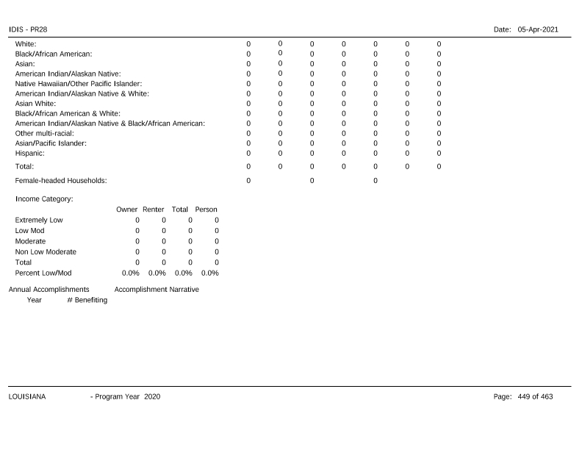
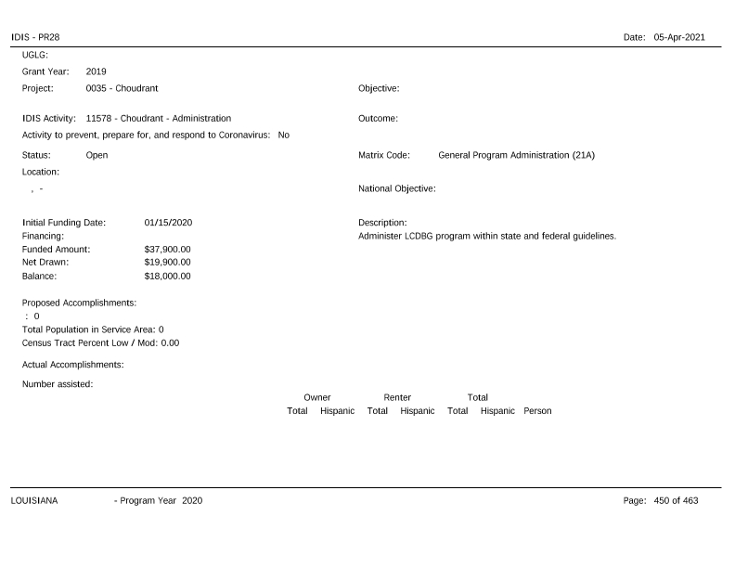
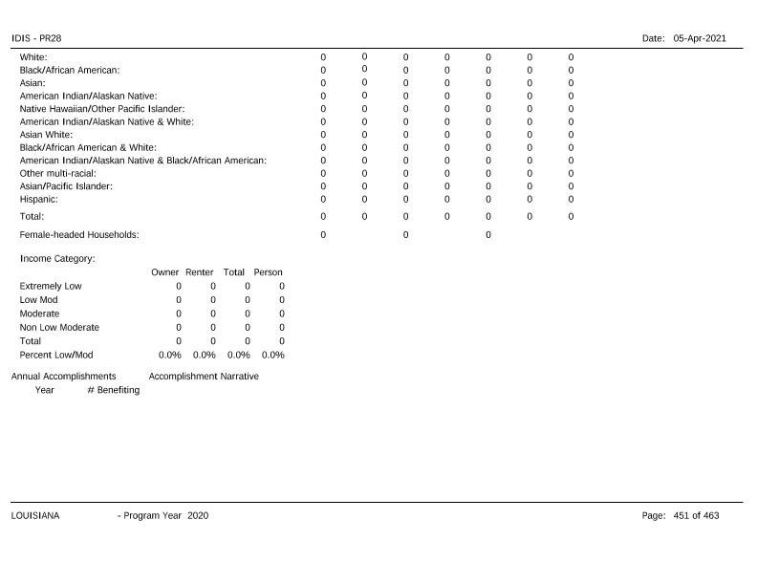
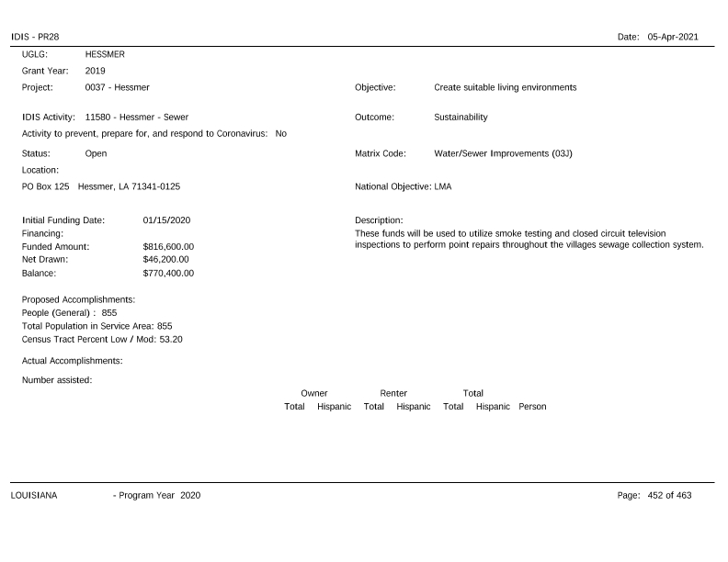
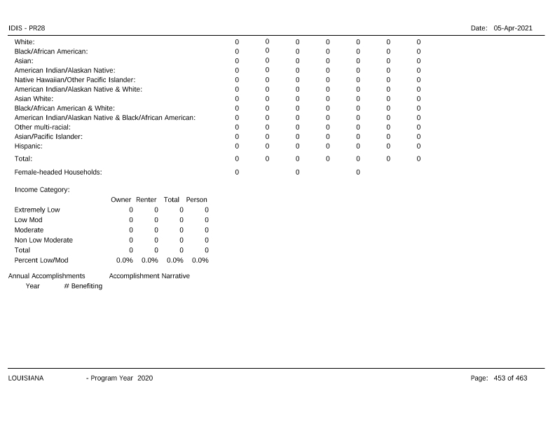
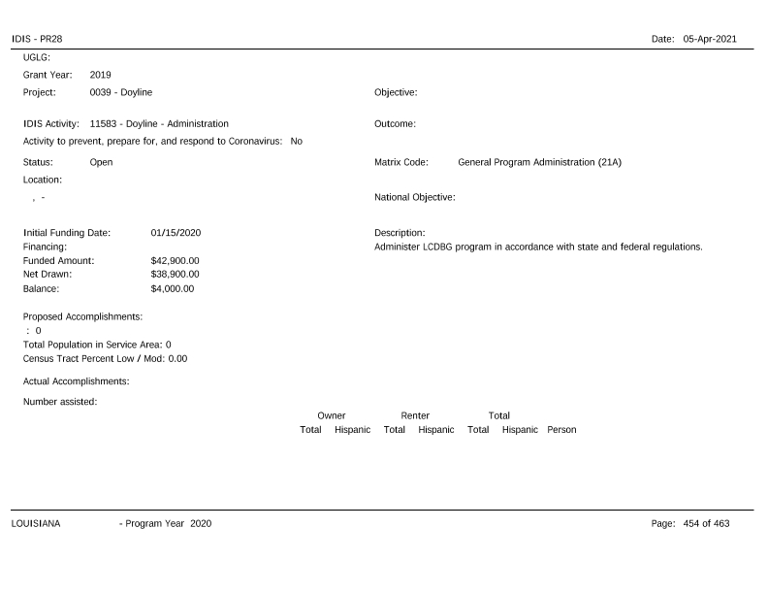
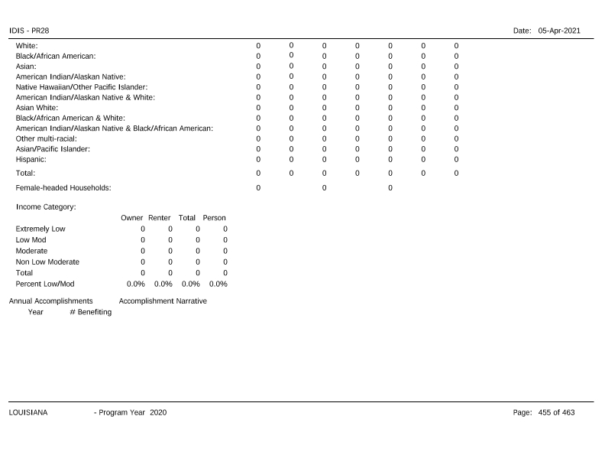
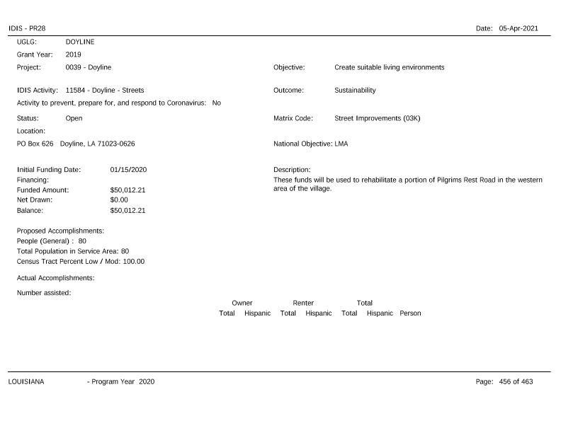
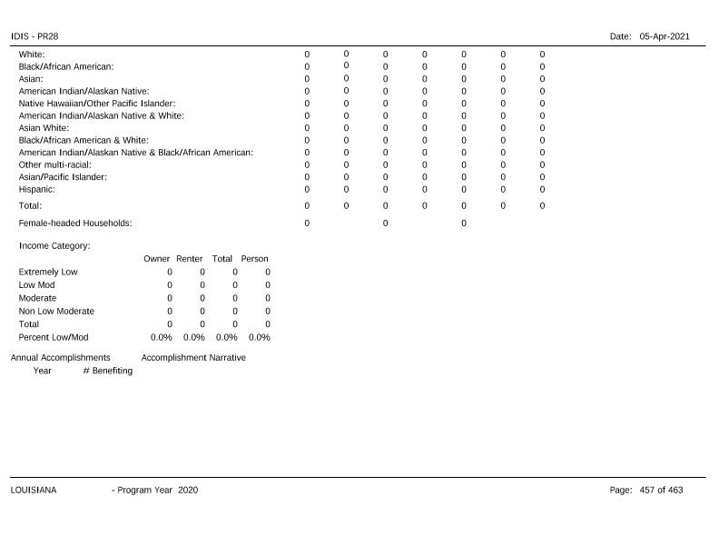
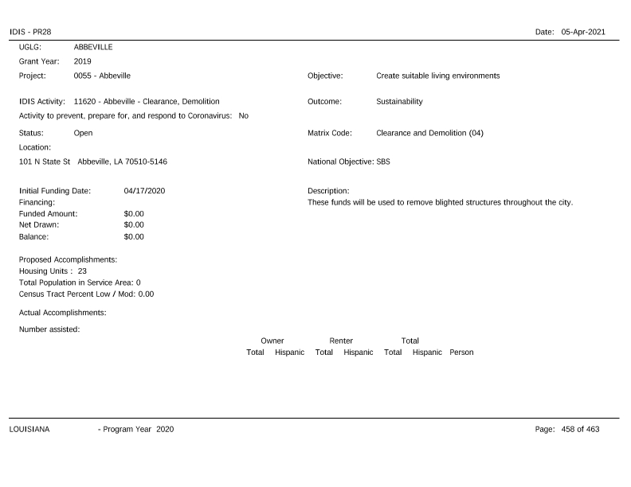
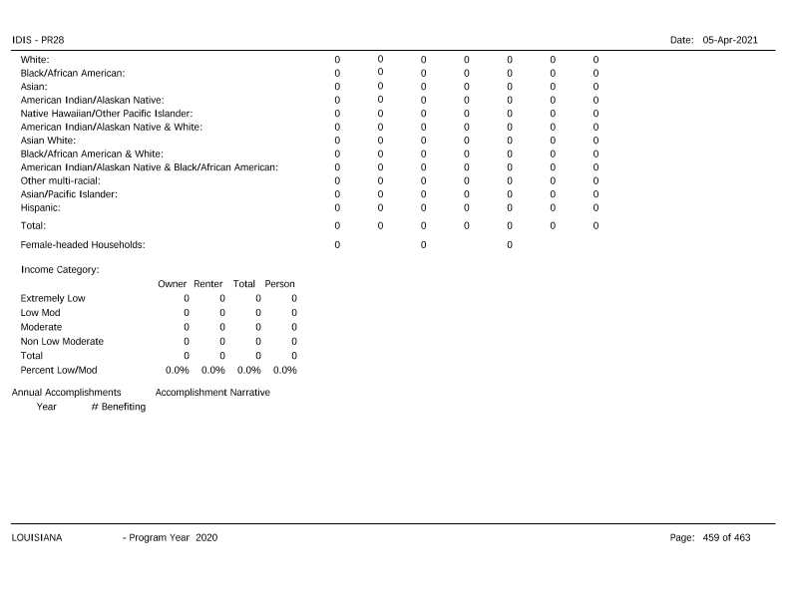
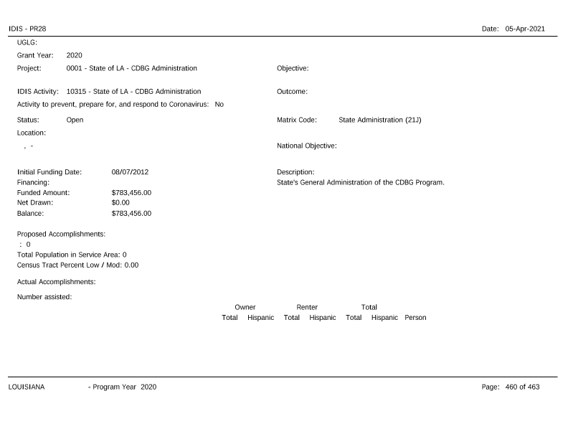
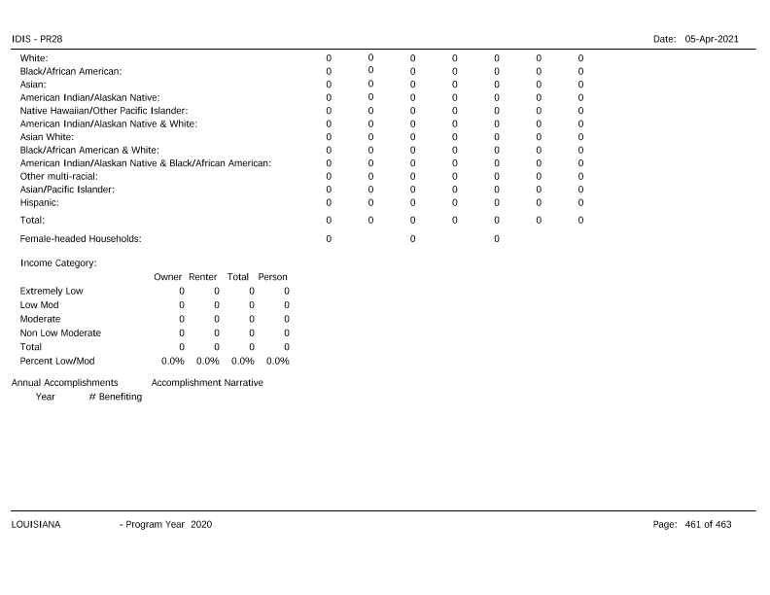
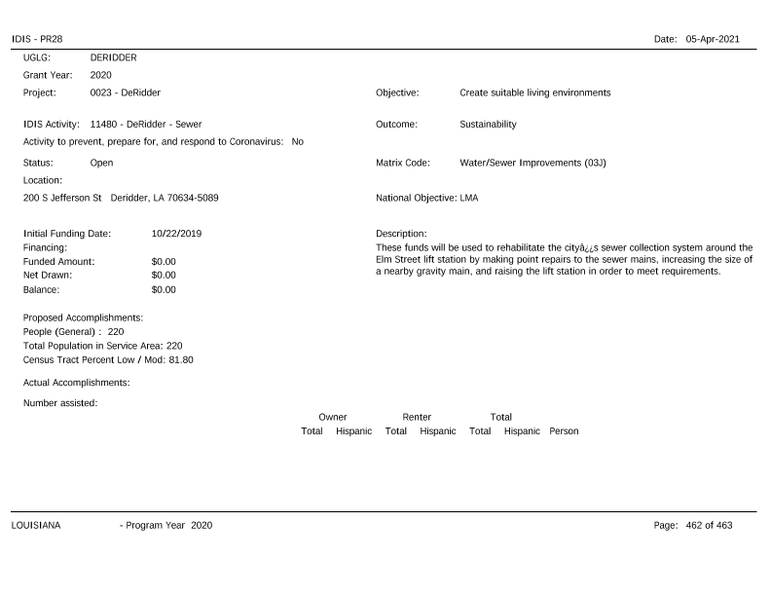
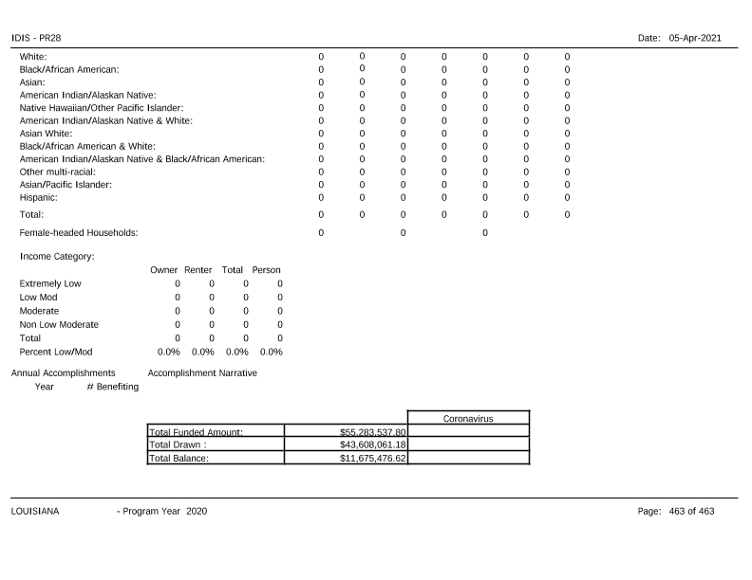

FY 2020 HOME Projects Monitoring Summary (Attachment 3)
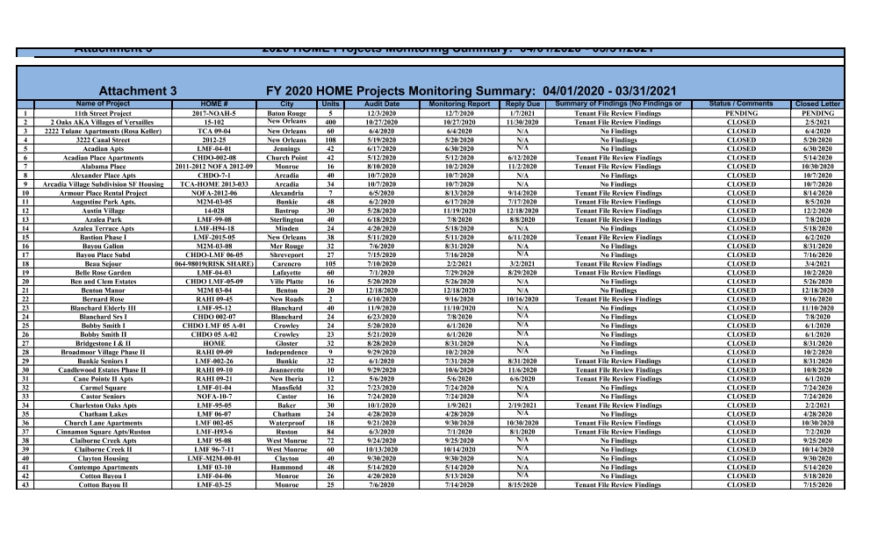
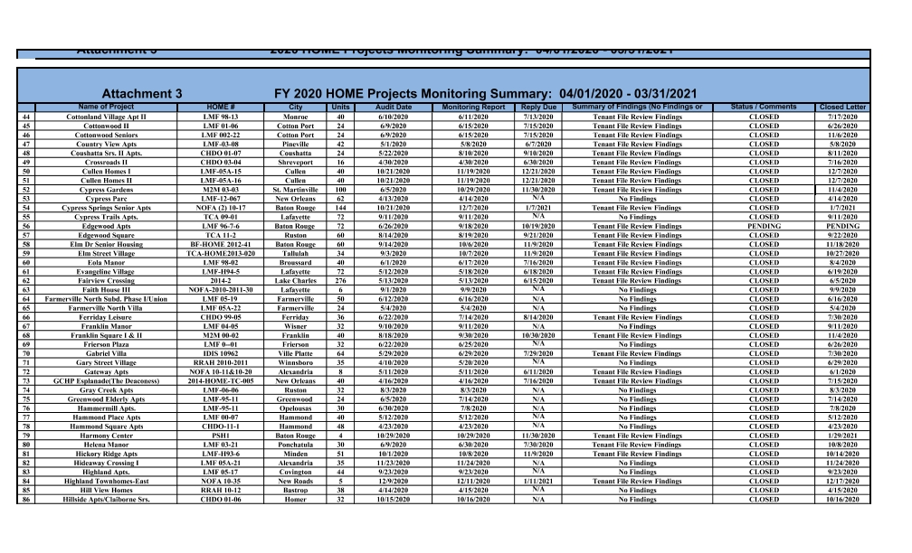
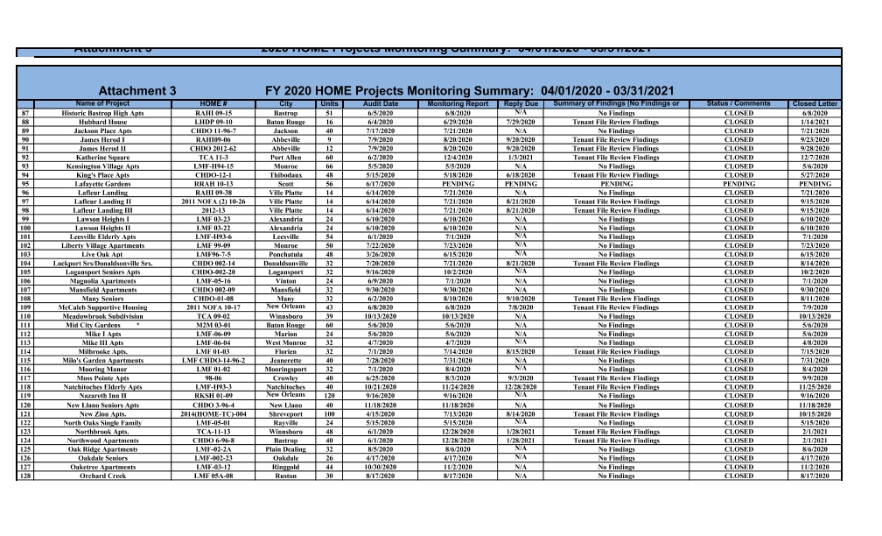
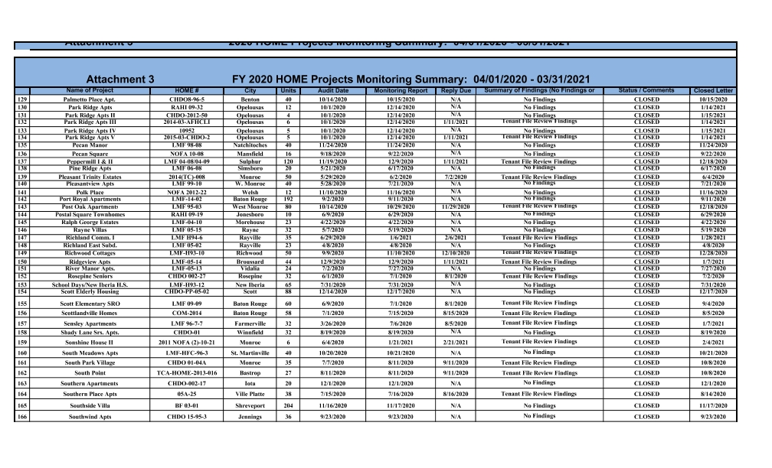
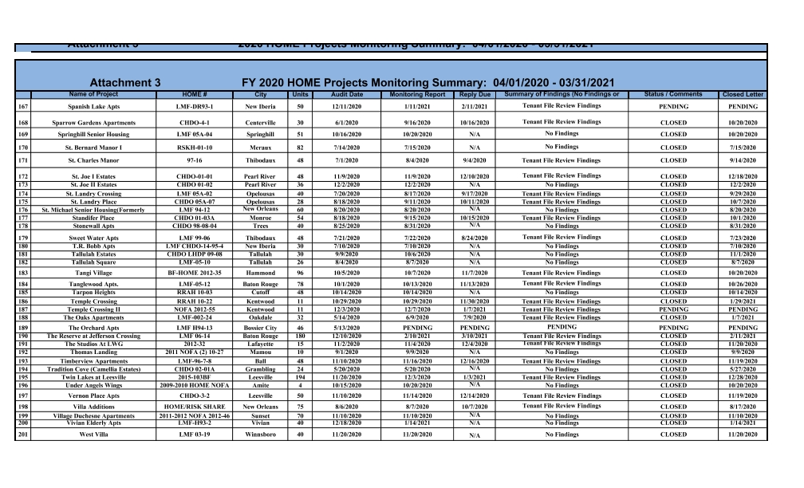
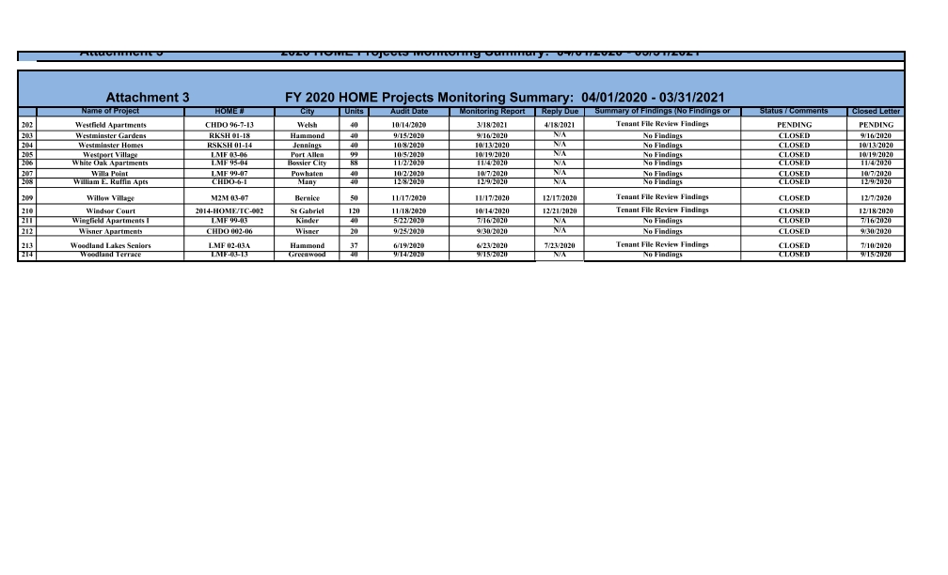

PR23 - HOME Summary of Accomplishments (Attachment 4)
