# Manage User Data

1. Log in to the [Vendor Portal](https://lagoverpvendor.doa.louisiana.gov/irj/portal) with your ID (11 digit vendor number that begins with a “V”) and your personal password.
2. Click on “Manage User Data” under “Detailed Navigation” on the left.
3. Find the user that you wish to change by searching the multiple criteria and clicking “find”. If you would like to search more than one user at a time, simply click “find”. Do not complete any of the corresponding fields and all the users of the company will appear.

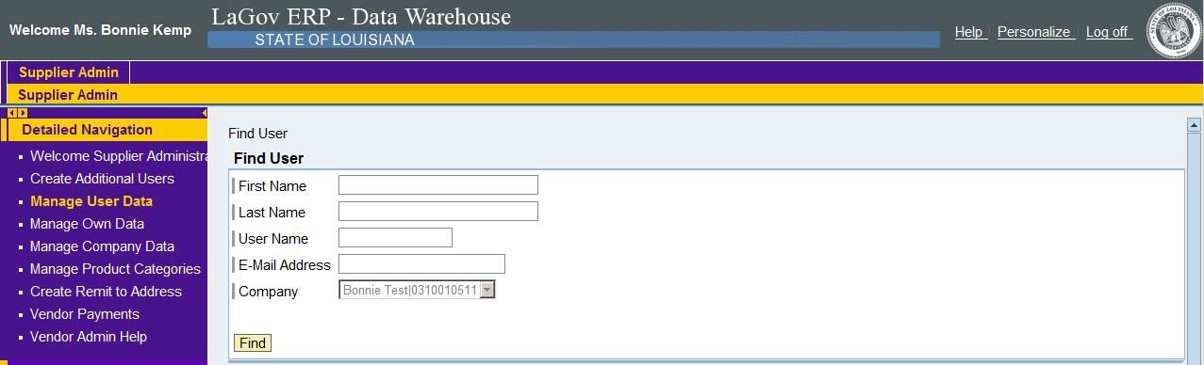

1. The following screen will appear.

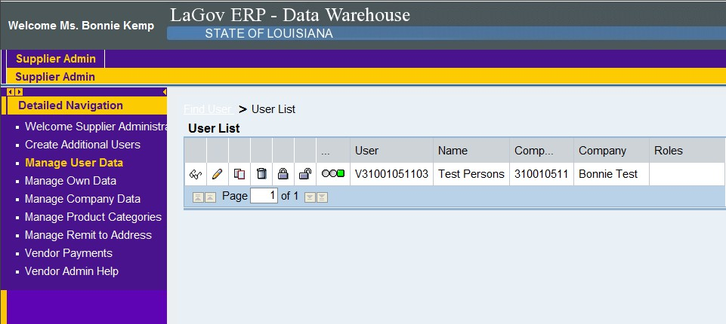

Select (click) the icons in the table to perform various functions regarding the users.

* Display Icon (Eyeglasses): Displays information for user
* Process Icon (Pencil): Allows information for user to be changed/modified
  + Note: Administrative users are able to change profile information for ALL users within their company, including their roles and passwords
* Copy Icon (Paper): Allows information for user to be copied so re-entry is not required
  + Note: This icon is helpful when adding Additional Users with the same role/contact information It can also be beneficial if the Administrator User wants to simply change the role of a user.
* Remove Icon (Trashcan): Allows the user to be removed from the company profile
* Information Lock Icon (Padlock in Locked Position): Allows the user account to be locked to prevent log-in
* Unlock Icon (Padlock in Unlocked Position): Allows the user account to be unlocked to enable log in

When you click the pencil (Process Icon), the following screen will appear and then you will make your necessary changes

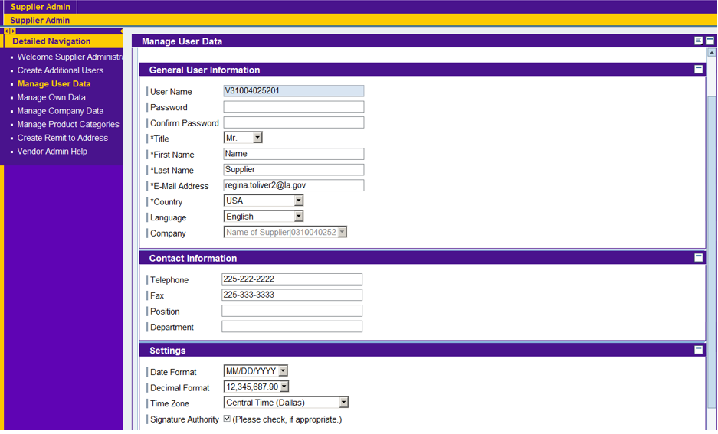

Scroll to the top and click save.

