GENERAL SAFETY
PROGRAM

Loss Prevention Unit
Office of Risk Management
Division of Administration

20260701

CONTENTS

GENERAL SAFETY PROGRAM

 | Page
Overview | 3
Components of a General Safety Program | 5
Management Policy Statement | 5
Assignment of Safety Responsibility | 5
Safety Rules | 5
Agency Classification | 6
Safety Meetings | 6
Training | 8
Safety Committees | 10
Procedures for Inspection | 10
Procedures for Incident/Accident Investigation | 12
Job Safety Analysis | 12
Return to Work | 13
Record Keeping | 13
Bloodborne Pathogens | 14
First Aid | 15
Emergency Preparedness Program | 16
Hazardous Materials | 16

 | Page
List of Exhibits | 18
Exhibit A: Office of Risk Management Rules (R.S. 39:1543)  Exhibit B: Management Policy Statement Guidelines  Exhibit C: Sample Assignment of Safety Responsibility  Exhibit D: Suggested Safety Rules  Exhibit E: Sample Procedures for Conducting Safety Meetings  Exhibit F: Procedures for Setting up a Training Program  Exhibit G: Sample Inspection Procedures  Exhibit H: Sample Procedure for Incident/Accident Investigation  Exhibit I: Sample Procedure for Job Safety Analysis  Exhibit J: List of Required Records  Exhibit K: Bloodborne Pathogens/First Aid Requirements  Exhibit L: Sample Components of an Emergency Preparedness Plan  Exhibit M: Sample Hazard Communication & Material Safety Program | 19  22  24  26  27  30  34  39  44  50  51  56  62
Exhibit N: Sample Transitional Return to Work Plan 67
OVERVIEW

Legislation establishing the Office of Risk Management (ORM) and the Loss Prevention (LP) Unit (R.S. 39:1543) calls for a comprehensive loss prevention program [“plan”] for implementation by all state departments. To comply with existing statutes, departments shall develop individual written safety plans and ensure that the plans are implemented. (See Exhibit A, Title 37 Insurance in the Louisiana Register.) These rules require that each state agency, board and commission with more than 15 employees shall implement an operational loss prevention plan to protect employees from injury.

At a minimum, a written loss prevention plan as developed by the department shall be implemented by each agency and billing/location code within the department. A departmental/generic General Safety Plan is one that is broad and covers the entire department.

Ideally, an agency-specific plan should be created for each location. Such a plan covers/addresses specific or unusual processes, procedures, systems for agencies within a department that exceed the broad, general requirements of the department.

It is possible for some agencies to operate under some Departmental/Generic components of the General Safety Plan, as well as have other site-specific components of their General Safety Plan.

The sample policies and procedures described in this manual are included as examples only. Each agency should use the samples as a basis for writing and implementing its own individualized safety plan.

NOTE: This information is provided as a reference only. All questions regarding legal issues shall be addressed to the agency’s legal counsel.

This comprehensive loss prevention plan is organized around the following components:

- General Safety Program
- Driver Safety Program
- Bonds, Crime, and Property Program
- Equipment Management Program (if applicable)
- Water Vessel Safety Program (if applicable)
6. Flight Operations Program (if applicable)
7. Any other program developed by the Loss Prevention Unit of the Office of
Risk Management for the prevention of and/or reduction in events that
may cause injury, illness, property damage, or any other damage/loss.

All employees shall be made aware of the departmental or agency site-specific loss prevention plan upon orientation. Documentation shall include either employees’ signatures (for written copy) or read receipt (for electronic copy) acknowledging receipt of the plan and/or how to access the plan. Each location shall maintain a minimum of one (1) hard copy available for review by employees at all times or provide access to the program electronically.

Annual Loss Prevention Audit or Compliance Review (CR)

All state agencies and facilities shall be audited every 3 years by the Loss Prevention Unit concerning implementation of their loss prevention plan (Act 11, Extraordinary Session 1998, R.S. 39:1543). During the non-audit years, a compliance review (CR) shall be conducted by a Loss Prevention Officer (LPO). Each agency is encouraged to conduct a self-audit prior to either the audit or the compliance review. Agencies shall receive their audit or CR within the same time frame each year.

The LPO assigned to those locations shall schedule a CR/audit visit during the period that a CR/audit is traditionally conducted at each location.

Compliance with these rules is one factor in determining the insurance premium paid by the agency in the next fiscal year. See Title 37, Insurance in the Louisiana Register.

Agencies implementing the operational loss prevention plan described here may benefit in many ways. First, and most importantly, employees and clients may enjoy a safer work environment. Second, fewer accidents may reduce absenteeism. Third, increased productivity may result because of safer work methods. Fourth, the agency may experience reduced insurance premiums in following or subsequent fiscal years as a result of lower accident rates and claims.

COMPONENTS OF A GENERAL SAFETY PROGRAM
FOR STATE FACILITIES

The following section describes the required components of a general safety program for state agencies and facilities, which shall be presented to new employees during orientation, documented, and made accessible to all employees.

The agency shall furnish a complete list(s) of employees that includes those who were considered: new hires, active employees, and those who received a promotion/demotion to a position with new duties at any time during the audited fiscal year (FY). The list shall include the names of all such employees, whether they remained with the agency or left at any time during the audited FY.

Management Policy Statement

Top management's responsibility for safety begins with a clear statement of its commitment to a safe environment for employees and clients of the agency. The departmental (and any agency) management policy statement shall include the concept that safety is an integral part of every operation in all agencies and facilities. The statement shall also describe management's expectation of employees concerning safety. Management shall ensure that supervisors and employees are aware of their responsibility for safety, and management shall develop a system of accountability to ensure that all employees adhere to safety policies and procedures at all times.

(See Exhibit B, Sample Management Policy Statement)

Assignment of Safety Responsibility

Agency management shall be responsible for the assignment of people responsible for safety practices at the agency and its facilities (R.S. 1543(B)). Typically included in the definition of responsibility are executive management, loss prevention representatives, maintenance department, supervisors, or foremen, and all other employees. Other levels may be included as appropriate.

Written safety responsibilities shall include the agency’s policy for those employees who do not comply. A copy of the safety responsibilities shall be given to all employees at orientation and such action documented. Additionally, safety responsibilities shall be reviewed with employees upon any change in position that would place him/her in a different category.

(See Exhibit C, Sample Assignment of Safety Responsibility)

Safety Rules

Each state agency or facility shall develop written safety rules that apply to its own operation. The agency shall maintain a set of general safety rules that apply to all employees and, if appropriate, a set of site-/task-specific rules. As determined by each agency, site-/task-specific safety rules are necessary where hazardous activities/operations/tasks exist and other general safety rules are inadequate/fail to reduce or eliminate recognized/potential hazards.
The rules shall be written in terms that are easily understood and they shall be enforceable. Each employee shall receive a written copy of or be provided with electronic access to both sets of safety rules for the facility, and such action documented. Documentation shall include either employees’ signatures (for written copy) or “read receipt” (for electronic copy) acknowledging receipt of either the rules and/or how to electronically access the rules. All employees at all levels shall be required to follow the rules. It is required that safety rules shall be reviewed annually. It is further required that these rules be posted in the facility for review by all employees.

(See Exhibit D, Suggested Safety Rules)

Agency Classification

Effective July 1 of each FY, the Office of Risk Management classifies each audited state agency as either Class A or Class B based upon the results of the agency’s most recent audit or compliance review. This classification determines how often, monthly or quarterly, the agency is required to conduct safety meetings and building inspections.

Class A agency – An audited agency which receives a non-compliant score on the audit or compliance review will be required to conduct safety meetings and building inspections on a monthly basis effective July 1 of the upcoming FY. A Class A agency may elect to meet more often than monthly.

Class B agency – An audited agency that receives a compliant score on the audit or compliance review will be required to conduct safety meetings and building inspections on a quarterly basis effective July 1 of the upcoming FY. A Class B agency may elect to meet more often than quarterly.

ORM will notify the state agency prior to July 1 should there be a change in the agency’s classification from the prior FY.

Safety Meetings

  - Class A agencies shall conduct and document safety meetings on a monthly basis.
  - Class B agencies shall conduct and document safety meetings on a quarterly basis.

Safety meetings are required for supervisors and all employees of each work unit. It is strongly recommended that the required meetings are held at the same time each quarter or month depending on the agency’s prior year audit/CR results. A legible record (scanned, electronic, or hard copy) shall be kept showing all applicable items listed below:

- Topics discussed (must be included in course name if using an online platform in place of a scanned or hard copy),
- Employees receiving the information,
- Instructor’s name,
- Teaching aids used,
- Date of meeting,
- Total number of employees on staff,
- Total number of employees in attendance,
- Original signatures of employees on attendance sheets, or employee’s initials next to typed names on attendance sheets or verification of “received and read by” e-mails,
- Certificates of completion,
- Transcripts, and
- Employee suggestions or follow up.

If using Success Factors, you have the ability to add up to 300 characters to the title of your meeting, which allows sufficient space for the safety topic to appear on the training transcript and certificate of completion.

Transcripts of meetings, certificates of course completion, and “read receipts” without the safety meeting topic clearly indicated will not be accepted.

Agencies shall provide a means of ensuring that those employees who cannot attend the meetings have access to the material presented during the meeting.

NOTE: Safety meetings conducted electronically are acceptable as long as there is a record of receipt of the information by the employee (e.g., e-mail return receipt).

All agencies shall strive for 100% employee participation, with 75% being the minimum allowable attendance for each meeting to count toward the monthly/quarterly requirements of the ORM general safety audit.

Agencies whose audit/CR is rolled up to a higher level (i.e., conducted as one with other locations that all report to the same billing code location) can request, in writing, approval by the ORM Loss Prevention Manager to have their safety meeting attendance combined with that of the other roll up locations to calculate one overall attendance percentage for the billing code location.

In order to qualify for a roll-up audit or CR, locations must share the following:

- identical loss prevention programs
- identical safety meeting materials/content
- the same safety coordinator (whenever practical)
- the same physical location (whenever practical)

To demonstrate their total support for workplace safety and health as well as the loss prevention program, department/agency heads shall participate in all safety meetings. Alternatively, the highest ranking official (or his/her management designee) present on the day of the meeting shall attend and their presence, as well as that of all other employees, documented.

A makeup meeting should be provided and documented for any absent employee and/or management representative. All makeup meetings must occur within the same month or quarter (depending on your agency classification). Any exception to this must be submitted in writing to the ORM Loss Prevention Manager for review/approval.

Safety meetings may vary from formal presentations to informal discussions of safety problems. The meetings shall be educational and motivational, and shall also demonstrate management's concern for safety. Employees’ suggestions at safety meetings have often resulted in the implementation of new safety policies and procedures that have reduced hazards, increased productivity, and improved work methods. Safety meeting topics shall apply to all employees in attendance and documentation of all meetings shall be available for review at the next audit or compliance review.

A maximum of 25% of the required meetings are allowed to be “policy review only” meetings. The remainder of the meetings may include policy as well, but they must also cover specific safety and health topics, encourage discussion when possible, and strive for a variety of content from year to year. New material is available from ORM, its Third-Party Administrator (TPA), and/or its broker of record.

(See Exhibit E, Sample Procedures for Conducting Safety Meetings)

Training

Safety-related training shall be provided to all employees who must perform new tasks or operate new equipment or whose safety performance is not satisfactory. The safety-related training, whether conducted by a supervisor on the job or by a training specialist, shall include instruction in correct work procedures, use of safety equipment, and availability of assistance. Additionally, safety-related training shall cover a review of the basics pertaining to a specific topic and also the agency’s specific policy on such. All safety-related training, whether formal or on the job training (OJT), shall be documented.

A legible record (scanned, electronic, or hard copy) shall be kept showing all applicable items listed below:

- Topics discussed (must be included in course name if using an online platform in place of a scanned or hard copy),
- Employees receiving the information,
- Instructor’s name,
- Teaching aids used,
- Date of training,
- Total number of employees on staff,
- Total number of employees in attendance at the training,
- Original signatures of employees on attendance sheets, or employee’s initials next to typed names on attendance sheets or verification of “received and read” by e-mails,
- Certificates of completion,
- Transcripts, and
- Employee suggestions or follow up.

Agency heads/designees shall ensure that trained people are conducting safety meetings, inspecting the work area, investigating accidents, analyzing jobs for safety, and demonstrating leadership skills in safety.

The agency’s loss prevention coordinator and representatives shall have documented proof of attendance at least once every five years on the ORM Loss Prevention Program course.

All agencies are required to have a documented review of written policies/plans with employees and conduct documented awareness on the following topics. Such awareness shall be completed within 90 days of hire and additionally as indicated thereafter, and may count toward the monthly/quarterly safety meeting requirements.

- Drug-Free Workplace (once every 5 years)

All training specified above, as well as required training for any other topics listed elsewhere throughout the entire Loss Prevention Manual, must be conducted within the indicated timeline for that topic, regardless of the date parameters allowed by the agency’s chosen training platform.

Documentation must:

- include topic(s) (i.e. main subject material and policy review),
- include name(s) of instructor(s) and monitor(s),
- indicate actual length of instructor-led training,
- be signed and dated by instructor and maintained for audit purposes,
- include attendees who are given full credit for the entire program and those attendees excluded due to exiting training prior to completion (i.e., partial credit is not allowed),
- list specific attendees who exit and re-enter due to internet instability,
- and indicate their total, actual time of attendance.

While in-person training is always the preferred method, virtual training is an acceptable alternative provided that all of the following criteria are met:

- The qualified instructor is always present and available for interaction/questions.
- Require all participants to turn on their video feed, leave it on unobstructed, and remain in front of the camera for the entire duration of the training.
- Assign (and document via a roll call before and at the end) someone from the agency to monitor the screen the entire time to ensure that no one leaves, is distracted, or turns off their video feed.
- Limit class size to the max gallery screen allowed under the video settings in the online platform used. Will vary by screen size, but all cameras must be visible on a single monitor.
- Obtain a participant report (PDF only) from the online platform to use as the attendance sheet and to call roll before and after the training. Retain the attendance sheet for the audit/CR.

NOTE: If any part of the training involves physical skills, then that training must be conducted in-person.

An agency's drug-free workplace policy/awareness program should be in accordance with R.S. 49:1001 et seq. and any other relevant statute.

Agencies are encouraged to continue awareness and/or training on Violence in the Workplace, Sexual Harassment, and the Code of Governmental Ethics.
(See Exhibit F, Procedures for Setting up a Training Program)

Safety Committees

It is recommended that all participating agencies (i.e., those with 15 or more employees) form a safety committee and hold meetings on a periodic basis. The committee may consist of members from different work disciplines of the agency. The meetings may be a forum in which pertinent safety and health issues are discussed, such as:

- incident/accident forms
- theft and security
- reported hazards
- building inspection reports
- anonymous reports
- workplace assessments

Procedures for Inspection

- Class A agencies shall conduct and document signed and dated inspections on a monthly basis.
- Class B agencies shall conduct and document signed and dated inspections on a quarterly basis.

Inspections are required for all agency buildings/structures. It is strongly recommended that the required inspections are conducted at the same time each quarter or month depending on the agency’s prior year audit/CR results.

The operational general safety plan shall include general housekeeping safety rules and a procedure for conducting inspections of the facility to identify and correct hazards. A written report is to be completed for each inspection and kept for review at the next audit or compliance review. The report shall include identification of unsafe conditions or acts and the recommended corrective action.

Inspections serve two basic functions:

- To maintain a safe work environment and to control the unsafe actions of people.

- To maintain operational efficiency.

Regular interior and exterior inspections of all buildings (whether in use or not) shall reinforce to employees the importance of safety and management's commitment to safety. Buildings used as a primary residence only require an exterior inspection.

The inspections encourage employees to inspect their own work areas and identify unsafe conditions. Preferably, safety inspections should be made regularly, using a site-specific inspection technique such as a checklist, regardless of whether a problem has been reported.
The same form can be used for more than one building, provided: the buildings are all of the same structure type; all information on the form is applicable to all buildings listed; and all information is neat and legible.

Corrections of unsatisfactory conditions shall be made immediately, to meet accepted and approved standards even if no accidents have occurred. A systematic inspection technique such as a site-specific checklist is recommended for analyzing work areas and should include:

- Building Safety
- Electrical Safety
- Emergency Equipment
- Fire Safety
- Office Safety
- Storage Methods

All employees are responsible for immediately reporting any recognized, potentially hazardous condition or practice. Employees shall report any unsafe condition to the supervisor/appropriate party via the Hazard Control Log (Form HC-1-90) or other acceptable method.

The authorized person(s) shall take immediate temporary control of the area to prevent exposure until corrective action is taken. If a supervisor or the loss prevention representative cannot correct the hazard, they shall immediately report it to the next level of management.

Hazard Control Logs (or other similar reporting forms) shall be reviewed on a regular basis and signed/initialed and dated each time.

Procedures must be developed and distributed to all employees that cover: the purpose of the HCL, how and when to use it, and who maintains them.

If a hazard exists for more than 30 days, the supervisor or appropriate individual(s) shall notify the department and agency heads and ORM Loss Prevention Management.

The report of a hazard shall be retained in the affected work area until all hazards are corrected and made available for review at the next audit or compliance review.

Additionally, if applicable, any deficiency discovered during an inspection conducted by the
State Fire Marshal’s Office shall be corrected.

(See Exhibit G, Sample Inspection Procedures)

Procedures for Incident/Accident Investigation

Incidents/accidents may occur in spite of an emphasis on safety and regular inspections. When an incident/accident does occur, it shall be thoroughly investigated to determine the cause and any contributing factors to prevent a recurrence.

The appropriate investigation report (DA2000-employees only; DA3000-visitors, clients/inmates only OR equivalent forms) shall include information on the individual injured, a description of the incident/accident (bodily injury vs. property damage), a statement of what caused or might have caused the incident/accident, and any corrective action that has been taken or that should be taken to prevent recurrence. Agencies shall keep on file all incident and accident related DA2000 and/or DA3000 or equivalent forms for review by the Loss Prevention Officer.

NOTE: The DA2000 form is not required for motor vehicle accidents and MUST NOT be used. The DA2041 form is the only form required in such instances.

All information fields (including the root cause analysis section on the DA2000) on the forms shall be completed and reviewed for accuracy. Notations such as N/A (not applicable) are not acceptable.

The supervisor of the work unit involved is primarily responsible for conducting the incident/accident investigation and completing all related forms. Others, such as the loss prevention representative or safety committee, may be involved depending upon the nature and severity of the incident/accident.

The agency’s loss prevention coordinator shall receive documented training on, and train the agency’s loss prevention representatives on:

- Accident Investigations
- Inspections
- Safety Meetings
- Supervisor Responsibilities
- Job Safety Analyses

In the event of a fatality, or near fatality, ORM Loss Prevention Management shall be immediately notified via email or a phone call. A claim report should also follow.

(See Exhibit H, Sample Procedure for Incident/Accident Investigation.)

Job Safety Analysis

Another component of incident/accident investigation is job safety analysis (JSA). As a responsibility of the immediate supervisor/designee, the job safety analysis is a procedure to be used in reviewing work methods and identifying hazards that may result in incidents/accidents. There may have been unforeseen hazards during the design of the building, workstation, equipment, tools, or processes. Hazards may have developed after the work procedure was designed, or they may be the result of a change in the work procedure or personnel. All applicable JSAs must be reviewed in post-incident/accident situations and shall remain in effect as long as the equipment and/or task is present. Job safety analysis is one of the first steps in hazard prevention, incident/accident analysis and safety training because a hazard must be recognized before it can be eliminated. Therefore, job safety analysis shall be performed on all tasks:

- that have resulted in an incident/accident trend, death, or a change in job procedures or equipment;
- where the potential for injury could be severe; and/or
- that are infrequently performed.
Documented employee training on completed/existing JSAs should be conducted at least annually, and the JSAs should be kept in an area accessible to all employees.

There are three objectives in job safety analysis:

- To systematically evaluate jobs and work methods to eliminate hazards and potential hazards,
- To assist in the teaching of safe work procedures, and
- To provide a framework for incident/accident analysis.

(See Exhibit I, Sample Procedure for Job Safety Analysis)

Return to Work Program

In conjunction with reporting and investigating all incidents/accidents, it is critical that the agency have policies and procedures in place to get the injured employee(s) back to work as soon as possible thereafter, to the extent possible, as directed by the treating physician.

Pursuant to R.S. 39:1547, ORM has developed the attached Transitional Return to Work Plan (See Exhibit N).

In collaboration with the Office of the State Americans with Disabilities Act Coordinator (OSADAC), ORM has integrated the transitional return to work process into the overarching ADA accommodation process to assist agencies in satisfying their legal obligations under both state and federal law to provide reasonable accommodations to employees with disabilities, regardless of the cause of the medical condition.

The TPA’s Return to Work Coordinator (RTWC) will work closely with the agency to ensure that the following required steps are put in place by the employer:

- Develop a written Transitional Return to Work plan.
- Make all employees aware of its return to work plan.
- Modify regular job duties to accommodate restrictions placed by the treating physician.
- Evaluate and improve the program periodically.
- Maintain documentation of the agency’s Transitional Return to work efforts.

The development and implementation of the plan is mandatory. Agencies can use the attached plan as a model to assist in developing their own agency-specific Transitional Return to Work Plan.

Record Keeping

Good record keeping is essential to occupational safety and loss prevention. Without records, it is impossible to analyze or measure the success of a general safety program. Records supply the information to transform haphazard, costly, and ineffective safety methods into a planned program that controls unsafe conditions and/or acts that may contribute to accidents. A second important use of safety records is to compare the safety effort of a facility to others performing similar functions. This comparison enables an agency to evaluate its own safety accomplishments.
The following records from the previous two (2) fiscal years shall be available for review by the LPO at the next audit or compliance review: inspection reports, hazard control logs (or other similar reporting forms), job safety analyses, incident/accident investigations, and minutes of safety meetings.

All training/awareness records shall be available for the previous five (5) years.

Bloodborne Pathogens (BBP)

All agencies shall have a written bloodborne pathogens program that includes the following five (5) components:
- Exposure Determination - Each agency that has an employee(s) with occupational exposure shall prepare an exposure determination. This exposure determination shall contain the following:
A list of all job classifications, tasks, and procedures in which some/all employees in those job classifications have occupational exposure.
This exposure determination shall be made without regard to the use of personal protective equipment.
- Medical Evaluation for Affected Employees – Following a confirmation of an exposure incident, the agency shall make immediately available to the exposed employee a confidential medical evaluation and follow-up.
When the source individual is already known to be infected with HBV or HIV, testing for the source individual's known HBV or HIV status need not be repeated.
- Methods of Compliance – Universal precautions shall be observed to prevent contact with blood or other potentially infectious materials. Under circumstances in which differentiation between body fluid types is difficult or impossible, all body fluids shall be considered potentially infectious materials. This can be accomplished via the implementation of engineering and work practice controls and/or the use of personal protective equipment.

- Work Practice Controls – Steps the agency can take that reduce the likelihood of exposure by altering the manner in which a task is performed.

- Training - The training schedule shall be contingent upon the level of exposure to BBP. Employees shall be classified as high risk or low risk. Any uncertainty in classification of employees should be referred to ORM Loss Prevention Management for guidance. A legible record (scanned, electronic, or hard copy) shall be kept showing all applicable bulleted items listed on Page 8 above.

High Risk:

High-risk positions shall be identified and listed in the plan (e.g., Health Care Facilities/professionals, and other high-risk occupations). Workers with high-risk BBP occupational exposure shall receive training within 90 days of hire and at least once per year annually thereafter. Training records shall be maintained for five years. Training for high-risk employees shall be instructor-led by someone qualified and knowledgeable in such matters (e.g., healthcare professional, safety & health professional, EMT, First Aid/CPR instructor, Red Cross, etc.). The training material must be from a nationally known, credible provider (e.g., National Safety Council, Red Cross, etc.) or it must first be reviewed and deemed acceptable by ORM.

Employees with job titles OR who perform job duties related to the following categories (including but not limited to) of workers (and have reasonable occupational exposure to blood or other potentially infectious materials) shall be classified as high-risk: shelter workers (e.g., special needs, disaster recovery), child welfare workers, healthcare workers, lab technicians, police officers and others who carry weapons, first responders, firefighters, custodial staff, kitchen staff (that may handle sharp equipment), public safety workers, and plumbers, veterinarians, life guards, athletic trainers, and technicians who collect blood/tissue samples. The agency may classify additional employees as high-risk when appropriate.

NOTE: Employees who are trained in first aid and/or CPR are not deemed as high risk nor are they required to have annual bloodborne pathogens training unless these individuals are mandated by their agency to use their skills in the event of an employee or visitor emergency.

Low Risk (General Office/classroom personnel):

All low-risk employees shall participate in a BBP awareness/training program within 90 days of employment. If there are no BBP events, the awareness/training shall be required every five years thereafter. If an agency’s unit experiences a BBP event, the employees of that unit shall be required to retrain within the following 60 days. Awareness/training records shall be available for review at the next audit or compliance review and retained for a period of five years.

The plan shall include procedures for spills and spill cleanup. Spill kits (or equivalent supplies) shall be available, maintained, and stocked.

(See Exhibit K, Bloodborne and First Aid Requirements)

First Aid

All agencies shall have a written program for first aid that addresses the needs of employees and visitors. Each agency and facility should provide one person trained in CPR/First Aid at each job site on each shift unless they are in close proximity* to a medical facility.

*This will vary from location to location, based on such factors as: time, distance, and potential physical obstacles (e.g., railroad tracks running between your location and the medical facility). However, current industry practice recommends, in workplaces where serious accidents (e.g., falls, suffocation, electrocution, amputation) are possible, if there is no employee on the site who is trained to render first aid, emergency medical services must be available within 3-4 minutes. A somewhat longer response time of up to 15 minutes may be reasonable in workplaces, such as offices, where the probability of such serious work-related injuries is low.

A first aid kit with the proper supplies shall be maintained, stocked, and expired contents replaced as needed.

The need for first aid training is recommended in agencies:

- That have night shifts or minimal/partial crews,
- When medical facilities are closed, and/or
- When field crews are working at points far removed from professional help

Even in agencies that have complete in-house medical departments, other personnel trained in first aid who are first on the scene of an accident may provide life saving assistance and help transport injured persons safely.

(See Exhibit K, Bloodborne and First Aid Requirements)

Emergency Preparedness Program

In addition to general safety rules, special rules are needed to cover various types of emergency situations such as fire, natural disasters, proximity threats, or terrorism. Each agency and facility shall have a written emergency preparedness plan for such events and contact information for response personnel should be on file with the local police and fire departments.

Each agency shall conduct actual fire drills at least once per year. Requests for exceptions to conduct mock fire drills must be submitted to the ORM Loss Prevention Manager for review and approval.

(See Exhibit L, Components of an Emergency Preparedness Plan)

Hazardous Materials

The need to have a hazardous materials program is not based on the quantity of certain materials, but on the exposure potential for employees to those materials. Each agency shall conduct and document, at least annually:

- a complete inspection of all facilities, grounds, vehicles, and any other piece of state property that may contain hazardous materials;

- a full assessment, including a complete listing, of all materials found, a review of the Safety Data Sheet (SDS) for each; and

- a determination as to whether or not all on-site hazardous materials are only accessible by an outside entity and, therefore, there is no agency employee exposure potential. If so, then a program is not needed for those materials.

Special rules are needed to cover the handling, storing and usage of hazardous materials from receipt through disposal.

Therefore, if hazardous materials are found, and there is any potential for exposure to any agency employee, then the agency shall promulgate written policies and procedures to ensure the safety of everyone in their workplace. A substance is considered “hazardous” if it is classified as either a “physical hazard,” (flammables, explosives, ammunition, etc.) or a “health hazard” (carcinogen, hepatogen, mutagen, etc.).

The hazardous materials plan shall competently address the availability of and/or documented training on: proper handling, storage (cabinets), Safety Data Sheets (SDS), container labels, personal protective equipment (PPE), lab hoods and lab safety, required safety equipment and its training, and proper disposal of hazardous materials.

Training requirements should be appropriate for, and commensurate with, the nature of the work or exposure. Therefore:

- For those employees who are likely to encounter one or more hazardous materials in the course of a work shift:

Documented training on the Hazard Communication Program is required:

1) within 30 days of employment (full program); and
2) if working in a new area or with new hazardous materials (refresher only); and
3) whenever the department Head, department Safety Officer, or Supervisor
determines (refresher or full program); and
4) at least annually (full program).

- For those employees who are not likely to encounter one or more hazardous materials in the course of a work shift:

Documented training on the Hazard Communication Program is required:

1) once, within 30 days of employment (SDS and labels only); and
2) if promoted/transferred/assigned to a job/area involving exposure to one or
more hazardous materials (full program); and
3) whenever the department head, department safety officer, or supervisor
determines (refresher or full program).

A legible record (scanned, electronic, or hard copy) shall be kept showing all applicable bulleted items listed on Page 8 above.

(See Exhibit M, Sample Hazard Communication & Material Safety Program)
List of Exhibits

Exhibit A: Office of Risk Management Rules (R.S. 39:1543)

Exhibit B: Sample Management Policy Statement

Exhibit C: Sample Assignment of Safety Responsibility

Exhibit D: Suggested Safety Rules

Exhibit E: Sample Procedures for Conducting Safety Meetings

Exhibit F: Procedures for Setting up a Training Program

Exhibit G: Sample Inspection Procedures

Exhibit H: Sample Procedure for Incident/Accident Investigation

Exhibit I: Sample Procedure for Job Safety Analysis

Exhibit J: List of Required Records

Exhibit K: Sample Bloodborne Pathogens/First Aid Requirements

Exhibit L: Sample Components of an Emergency Preparedness Plan

Exhibit M: Sample Hazard Communication & Material Safety Program

Exhibit N: Sample Transitional Return to Work Plan

NOTE: All sample plans and programs provided throughout the Loss Prevention Manual can be modified as needed. They are intended to serve as a starting point and aid in assisting agencies to develop forms specific to their situation.
Exhibit A

Office of Risk Management Rules
Louisiana Register, Title 37 Insurance

RULE

Division of Administration
Office of Risk Management

The Office of Risk Management has the responsibility in accordance with the provisions of R.S. 39:1527, et seq. to manage all state insurance except as specifically otherwise provided to the contrary, and in accordance with R.S. 39:1527, et seq. the Office of Risk Management adopted the following rules.

- R.S. 39:1543 requires the development of a comprehensive loss prevention program for implementation by all state agencies, including basic guidelines and standards of measurement.

- In order to fully comply with this statute, a comprehensive loss prevention plan has been developed and the following components shall be implemented by every state department, agency, board, or commission that employs 15 or more employees.

  - Management Policy Statement - An expression of management philosophies and goals toward safety. Develop and implement a comprehensive safety program that shall include a statement of safety policy and responsibility.

  - Responsibility for Safety in an Organization - A written document to clearly define supervisory responsibilities at all levels. In each department in the executive branch of government there shall be a loss prevention representative designated by the department head.

  - Inspection Program - A program to maintain a safe work environment and control unsafe acts and/or conditions by regular and periodic facility inspections.

  - Job Safety Analysis - A procedure to review job methods and hazards that relate to the work environment. The job safety analysis shall be performed on all tasks or processes that have a higher-than-normal rate of producing bodily injury or property damage.

  - Investigation Program - A program to thoroughly investigate and identify the actual causes and contributing factors of losses as soon as possible in an attempt to prevent recurrences. Investigate the job-related accidents of employees of their departments, offices or agencies.

  - Safety Meetings - Meetings shall be conducted with employees on a monthly or quarterly basis unless otherwise specified by ORM. The purpose of these meetings is to: educate, inform, and motivate employees and to examine work practices for potentially unsafe acts that may produce bodily injury and provide a method to preclude recurrences. Establish a program to promote increased safety awareness by employees.

  - Safety Rules - General instructions developed by agencies regarding the employees' responsibilities.

  - Employee Training - Maintain a systematic method of training employees to perform their required tasks in a safe and efficient manner and to ensure all employees receive periodic refresher training.

  - Record Keeping - Implement a procedure for the uniform development and maintenance of loss prevention and control documents that shall be retained for review at the next audit or compliance review (unless otherwise specified). This shall include: inspection reports, accident investigation reports, the minutes of safety meetings, training records, and boiler and machinery maintenance records.

  - First Aid Program - Adoption of a first aid program that, when required, shall provide a trained first aid person at each applicable job site and shift. This policy covers all facilities and crews.

  - Equipment Management Program - Written preventive maintenance program that shall include, but is not limited to: a history of each piece of equipment, who is responsible, schedule of when maintenance shall be performed, list of equipment that shall be maintained, and how maintenance shall be performed.

  - Driver Safety Program - A program to provide a systematic method of screening, training, and accountability of employees who may be assigned or drive state-owned vehicles or personal vehicles on state business in the course and scope of their employment.

  - Water Vessel Operator Safety Program - Program to provide a systematic method of screening, training, and accountability for employees and supervisors required to assign or operate state-owned water vessels in the scope of their employment.

  - Aviation Safety Program - Program to provide a systematic method of screening, training, and accountability for employees and supervisors required to assign or operate state-owned aircraft in the scope of their employment.

  - Other Loss Prevention Programs - Any other loss prevention program developed by the Office of Risk Management, Loss Prevention Unit for the prevention and reduction in accident events that may cause injury, illness, or property damage.

    - The minimum requirements are in no way intended to require revisions of existing safety plans that meet or exceed these minimum requirements. However, these existing plans shall be submitted to the Loss Prevention Unit for review and acceptance.
    - The Loss Prevention Unit shall audit each department, agency, board or commission to ensure compliance of the development, implementation, and adherence to the program. The deadline for certification shall be June 30 of each year for insurance premiums for the following fiscal year. If an agency, board or commission is determined to be in compliance, the Unit shall issue a certificate of compliance that will result in a five percent credit in the billed premiums. Such compliance shall be certified by major risk groups as follows:

      - Workers Compensation (Regular)
      - Workers Compensation (Maritime)
      - General Liability
      - Auto Liability and Auto Physical Damage
      - Property and Inland Marine
      - Boiler and Machinery
      - Bond and Crime Risk
      - Aviation
      - Marine
Exhibit B

MANAGEMENT POLICY STATEMENT GUIDELINES

A major goal of agencies and units is to provide safe and efficient services to residents of the State of Louisiana. Each employee shall help to accomplish this goal through safe and efficient work practices. Employee safety is vital to our success. We accept the moral and legal responsibility of providing safe and healthy work conditions. Our objective is to implement a comprehensive safety plan that meets all federal, state, and local safety codes, and establishes and maintains safe and healthy conditions in our offices, facilities, and grounds.

This objective can be reached if all employees accept personal responsibility for their own safety and well-being. Safe work habits are an essential element of satisfactory job performance. Each employee is responsible for immediately reporting potentially unsafe conditions and work practices and taking effective temporary actions to minimize the risk to him/her and others.

Each individual is responsible for helping us reach our loss prevention goal of preventing personal injury and loss of property due to accidents.

Supervisors will be held accountable for the actions of their employees. They are responsible for ensuring that both they and their employees follow all safety rules, policies, and procedures.

It is our intention to provide good supervision, effective training, and safe equipment on the job. The success of our loss prevention program depends upon the efforts of all employees to minimize and eliminate all potential hazards.

(See sample policy statement on page 21).
SAMPLE MANAGEMENT SAFETY STATEMENT

Date

To: (agency/unit head)

From: (department head)

SUBJECT: Safety and Health Policy Statement

- Policy - It is the policy of the department/agency of to provide a safe work environment for its employees in order to protect them from accidents that not only directly impact their quality of life, but also has the added benefit of reducing the department’s insurance costs. This dual benefit ensures the safety and health of department employees and the protection of the taxpayer’s hard-earned dollars by keeping insurance costs down.

Therefore, each employee of this department/agency is instructed to devote daily attention to making his or her activities and/or operations as safe and accident free as possible by complying with this policy and the department’s safety/loss prevention program.

- Purpose - The purpose of this policy is to authorize the implementation of a safety program for all employees that will:

- Promote a safe, productive work environment for all employees and prevent injuries that are painful and potentially disabling.
- Since this policy and program have cost savings potential for both this department and the taxpayers of this state, this policy shall be applicable to all employees and all sections/units of this department/agency.

  - Questions - All questions concerning this policy should be directed to the
department’s loss prevention coordinator.

_______________________________ ______________ Signature Date
Exhibit C

SAMPLE ASSIGNMENT OF SAFETY RESPONSIBILITY

The ultimate responsibility for preventing accidents and controlling hazards rests with management. Safety should be managed like any other administrative function. Management should direct the safety effort by setting achievable goals and by planning, organizing, and controlling activities to achieve those goals. The keys to effective safety performance are management procedures that assign accountability. The following is a suggested list of responsibilities for various positions in the organization.

Department/Agency Head

- Has full responsibility for safety.
- Authorizes necessary expenditures to provide safe work conditions.
- Approves safety policies as formulated by the safety officer or safety committee.
- Participates in the safety program as recommended by the safety officer or committee (conducts safety tours, approves safety contracts, reviews and responds to safety reports, ensures safety awareness among key management personnel, evaluates safety program, reviews safety audits).
- Participates in all safety meetings.

Department/Loss Prevention Coordinator

A department loss prevention coordinator is responsible for the overall safety program of the department. They should have direct access to the department secretary. They should have open communication with all safety officers within each agency of their department. They should demonstrate leadership to the safety officers in carrying out their duties and responsibilities. This should include help and support in the development of agency programs and policies. Their duties should include but not be limited to:

- Primary responsibility for coordinating the safety operations at each facility or agency.
- Keeping and analyzing accident records.
- Conducting educational activities.
- Conducting activities to stimulate and maintain interest in safety among employees.
- Serving on the safety committee.
- Supervising and appraising accident investigations.
- Planning and directing a regular program of safety inspections.
- Checking for compliance with applicable safety laws and codes.
- Issuing regular reports showing safety performance and accident trends.

Agency Loss Prevention Representative

An agency loss prevention representative is responsible for the development and implementation of the agency safety program. They should have direct access to the head of the agency. Their duties should include but not be limited to:

- Planning and directing a regular program of safety inspections and accident investigations.
- Conducting safety meetings.
- Conducting activities to stimulate and maintain interest in safety among employees.
- Serving on the safety committee.
- Checking for compliance with applicable safety laws and codes.
- Communicating with departmental safety coordinator.

Maintenance Department

- Works with safety committee, agency loss prevention representative, and foremen to ensure safe work conditions.
- Executes work orders promptly.
- Cooperates in devising safety equipment, guards, and appliances.
- Maintains a regular maintenance schedule on all equipment and keeps maintenance records.
- Makes regularly scheduled inspections as instructed by safety department and makes reports.

Supervisor/Foreman

- Inspects work area for compliance with safe work practices and safety rules.
- Trains employees to work safely.
- Corrects unsafe conditions and unsafe acts.
- Obtains prompt first aid for the injured.
- Reports and investigates accidents and works with agency loss prevention representative to determine cause and correct any problems.
- Serves on safety committee.
- Holds crew safety meetings.
- Discusses safety with individual employees.

Employee

- Works in accordance with accepted safety practices.
- Reports unsafe conditions and practices.
- Observes safety rules and regulations.
- Makes safety suggestions.
- Serves on safety committees.
- Asks for assistance or further explanation when needed.
Exhibit D

SUGGESTED SAFETY RULES

The following are suggested safety rules for state facilities. Agencies may modify and add rules as needed:

- Smoke only in approved areas.
- Horseplay and fighting will not be tolerated in the workplace.
- Before beginning work, notify your supervisor of any permanent or temporary impairment that may reduce your ability to perform in a safe manner.
- Use personal protective equipment to protect yourself from potential hazards that cannot be eliminated.
- Operate equipment only if you are trained and authorized.
- Inspect the workstation for potential hazards and ensure that the equipment or vehicle is in safe operating condition before using it.
- Immediately report any recognized potentially unsafe condition or act to your supervisor.
- If there is any doubt about the safe work method to be used, consult the supervisor before beginning work.
- Immediately report accidents, near misses, and property damage to a supervisor regardless of the severity.
10. Supervisors should obtain special safety permits when required (e.g., hot work or
confined spaces).
11. Follow recommended work procedures outlined for the job including safe work
methods described in the job safety analysis.
12. Maintain an orderly environment and work procedure. Store all tools and equipment in
a designated place. Put scrap and waste material in a designated refuse container.
13. Report any smoke, fire, or unusual odors to your supervisor.
14. Use proper lifting techniques. For objects exceeding 50 pounds in weight, the
immediate supervisor shall determine specific methods for safe lifting.
15. Never attempt to catch a falling object.
16. If your work creates a potential slip or trip hazard, correct the hazard immediately or
use safety tape to tag the area before leaving it unattended.
17. Fasten restraint belts before starting any motor vehicle.
18. Obey all driver safety instructions.
19. Comply with all traffic signs, signals, markers, and people designated to direct traffic.
20. Adhere to departmental rules regarding first aid, evacuation routes, and fire
department notification.
21. Adhere to departmental rules and procedures specific to departmental operations.
22. Assist and cooperate with all safety investigations and inspections and assist in
implementing safety procedures as requested.
Exhibit E

SAMPLE PROCEDURES FOR CONDUCTING SAFETY MEETINGS

Prepare for Meeting

- One idea to produce excellent topics for safety meetings is to conduct frequent inspections of the various areas and work practices and note any unsafe activities or tendencies that need to be eliminated.
- Select an activity or topic to be used as a safety meeting topic that can benefit all employees in attendance. Examples of appropriate topics can include: a new job/ procedure/changes in an operation, an unsafe behavior or activity, or an annual review of the agency safety rules. Safety meetings can help identify and eliminate hazards before accidents occur.
- Safety Meeting Report shall list the topics to be discussed.
- Identify the methods used to conduct the meeting (e.g., classroom, distribution of reading materials, demonstrations, etc.)

Conduct the Meeting

- Meetings may be conducted in a classroom-like setting with lecture, video, and/or demonstrations.
- Information may be distributed via e-mail, handouts, and/or correspondence and employees shall be required to indicate that they “have received and read” the materials.
- Record the total number of employees participating vs. the total number of employees and calculate a percentage of employees who participated.

Document Attendance

Ensure an original signature is obtained from each employee in attendance at each meeting and that the documentation reflects the date on which the information was actually received. For those employees to whom the safety meeting information is provided electronically, maintain a record of receipt by each employee (e.g., e-mail return receipt).

The percentage of participation at each meeting can be calculated by dividing the total number of employees who attended by the total number of employees eligible to attend.

Keep a Record of the Meeting

- Copies of safety meeting report forms should be sent to the safety coordinator or agency head. The supervisor should keep originals.
- Sign-in sheets shall be available for review at the next audit or compliance review.
Agencies should use the form below or one that contains the same information. All previous safety meeting forms are no longer acceptable.

EXHIBIT E
SAFETY MEETING REPORT

Agency Quarter or Month ___________
Section % Participation (total # EE attending/total #EE)
Safety Manager/Instructor____________________ Date of Meeting
Subject of Meeting:

Materials/Methods Used:
I have received and read the materials regarding the safety meeting topic above.

Print Name Signature/Initials

_______________________________

_______________________________

_______________________________

_______________________________

_______________________________

_______________________________

_______________________________

_______________________________

_______________________________

_______________________________

Make copies of this sheet for additional signatures
EXHIBIT E
SAFETY MEETING REPORT

Comments/Suggestions/Remarks:

_______________________________

_______________________________

_______________________________

_____________________________

_______________________________

_______________________________

_______________________________

_______________________________

_______________________________

_______________________________

_______________________________

______________________________

_______________________________

_______________________________

______________________________

_______________________________

______________________________

Exhibit F

PROCEDURES FOR SETTING UP A TRAINING PROGRAM

Safety Training for Employees:

The purpose of employee safety training is to establish a systematic method of teaching employees to perform the required tasks in a safe and efficient manner. There are four primary objectives in employee safety training:

- To teach employees hazard recognition and methods of corrective action
- To involve employees in accident prevention
- To motivate employees to accept their safety responsibilities
- To provide employees with information on accident causes, occupational health hazards, and accident prevention methods

Steps in Conducting Employee Safety Training

1. Select appropriate training topics and schedule training by priority. Eleven training topics are recommended as essential to each agency or facility (examples include):

A. Safety Program Objectives

1. Rights and responsibilities of the employee
2. Authority and responsibilities of the supervisor
3. Safety policy/rules
4. Accident/incident reporting procedures
5. Job safety analysis
6. Accident experience and trends

B. Hazard Recognition and Control

1. Types of hazards
2. Preventive measures
3. Inspection procedures
4. Recording and reporting
5. Immediate temporary controls

C. Emergency First Aid Procedures

1. Recognizing first aid emergencies
2. Gaining control
3. Emergency care
D. Emergency Response Procedures

1. Alarm systems
2. Evacuation routes
3. Fire extinguisher training
4. Emergency Procedures

E. Personal Protective Equipment

1. What to use
2. When to use
3. Storage area
4. How to check, inspect, and maintain
5. How to dispose of contaminated PPE appropriately

F. Material Handling

1. High risk jobs
2. Proper lifting
3. Proper carrying

G. Slips, Trips, and Falls

1. Recognizing potential problems
2. Minimizing exposure

H. Unsafe Environmental Conditions

1. Outside (heat, cold, winds, rain, hurricanes, tornadoes)
2. Inside (noise, dust, vapor, fumes)
3. Other (fire, bomb threats)

I. Good Housekeeping Practices

1. Tools and equipment
2. Vehicles
3. Grounds
4. Work Area

J. Work from Elevations/Use of Ladders

1. Preventing a fall
2. Using proper fall protection devices

K. Safe Vehicle Operation

1. Pre-operational inspection
2. Control of common hazards
3. Rules of the road
4. Safety Belts
5. Reporting Vehicular Accidents
2. Develop a lesson plan for each training session. A complete lesson plan should
include the following:

- Title: Clearly identifies the topic.

B. Objectives: States what the trainee should know or be able to do at the end of the
training period. A well-written objective limits the subject matter, is specific, and
stimulates thinking on the subject.

C. Estimated Time of Instruction: States the length of the training session. Ample time
should be allowed to thoroughly cover the subject.

D. Materials: States which material(s) to be used in training including: equipment, tools,
charts, slides, films, videos, etc.

E. What the Instructor Will Do: Gives the plan of action. Indicates the method of
teaching (lecture, demonstration, class discussion, etc.). Provides directions for
instructor (show chart, write key words on chalkboard, etc.).

F. What the Employee Will Do: Indicates how employees will apply the material in the
training session.

G. Evaluation: Establishes an assessment method (test, discussion, demonstration)
for determining whether the training objectives are achieved.

H. Assignment: Provides employees with an opportunity to apply the material on the
job.

Safety Training for Supervisors/Foremen (Key Safety Person):

The immediate responsibility for preventing accidents and controlling work hazards falls upon the supervisor/foreman because safety and production are part of the same supervisory function. Some objectives of safety training for supervisors/foremen are as follows:

- To involve supervisors/foremen in the agency's accident prevention program.

- To establish a key safety person in each unit.

- To help supervisors/foremen understand their safety responsibilities.

- To provide supervisors/foremen and key safety person with information on causes of accidents and occupational health hazards and methods of prevention.

- To help supervisors/foremen and key safety person gain skill in accident prevention activities.

Suggested Safety Topics for Supervisors/Foremen:

A. Safety and the Supervisor/Foreman: The relationship between safety and productivity.

B. Know Your Accident Problems: Elements of an accident (unsafe acts, unsafe conditions), accident investigations, measurements of safety performance, accident costs.

C. Human Relations: Employee motivation, basic needs of workers, supervisor/foreman as a leader, alcohol and drug problems.

D. Maintaining Interest in Safety: Committee functions, employee relations, supervisor's role in off-the-job safety.

E. Instructing for Safety: Job instruction-training, procedure for conducting job safety analysis (JSAs)

F. Industrial Hygiene: Environmental health hazards (lighting, noise, ventilation, temperature).

G. Personal Protective Equipment (PPE): Eye protection, face protection, foot and leg protection, hand protection, respiratory protection, protection against radiation.

H. Industrial Housekeeping: Results of good housekeeping, responsibility of the supervisor/foreman.

I. Material Handling, Storage, and Disposal: Lifting and carrying, handling specific shapes, hand tools for material handling, motorized equipment, hazardous liquids and compressed gases.

J. Guarding Machines and Mechanisms: Principles of guarding, benefits of good guarding, types of guards, standards and codes.

K. Hand and Portable Power Tools: Selection, storage, and safe use of hand tools and power tools.

L. Fire Protection: Recognizing fire hazards, understanding fire chemistry, setting up fire brigades, supervisor's/foreman’s role in fire safety.

M. Inspections: Conducting inspections of the facility and employee work areas to identify and correct hazards.
Exhibit G

SAMPLE INSPECTION PROCEDURES

1. The head of each agency divides the grounds and facilities under their direct control into specific housekeeping units. Housekeeping responsibility for each unit is assigned to a specific manager or their designee.

2. The manager/designee meets with first-line supervisors/foremen and employees to explain the purpose and objectives of the inspection procedure. Each employee should be encouraged to assist in identifying, eliminating, or effectively controlling potential safety and fire hazards.

3. Managers/designees are responsible for conducting regularly scheduled (at least monthly in Class A agencies and quarterly for Class B agencies) inspections and for identifying and correcting conditions or practices that are potential safety or fire hazards.

Some examples of hazardous conditions are as follows:

- Slip or trip hazards (e.g., cords or torn/broken floor covers)

- Foreign materials that could cause loss of balance such as: food, grease, oil, liquids, mud, algae, trash, etc.

- Holes or protrusions such as: eroded, broken, or sunken walking surfaces

- Temporary accumulation of flammable or combustible materials

- Storage and use of hazardous material products and other hazardous materials

4. The manager/designee completes the site-specific inspection checklist for the area. The completed checklist for the area it covers shall be available for review at the next audit or compliance review.

5. All employees are responsible for reporting any potentially hazardous condition or practice
they find. The employee records the unsafe condition on the Hazard Control Log or other
similar reporting form that shall be kept in each operating area.

The first-line supervisor/foreman or loss prevention representative is responsible for checking the Hazard Control Log (or other similar reporting forms) daily and is authorized to take immediate temporary control of the area to prevent exposure to the hazard until corrective action is taken. If a supervisor or safety officer cannot correct the hazard, they shall immediately report it to the next level of management.

Procedures must be developed and distributed to all employees that cover: the purpose of the HCL, how and when to use it, and who maintains them.

6. If a hazard exists for more than 30 days, the supervisor shall send copies of the Hazard Control Log or other similar reporting forms to the department and agency heads and to the Office of Risk Management's Loss Prevention Unit.

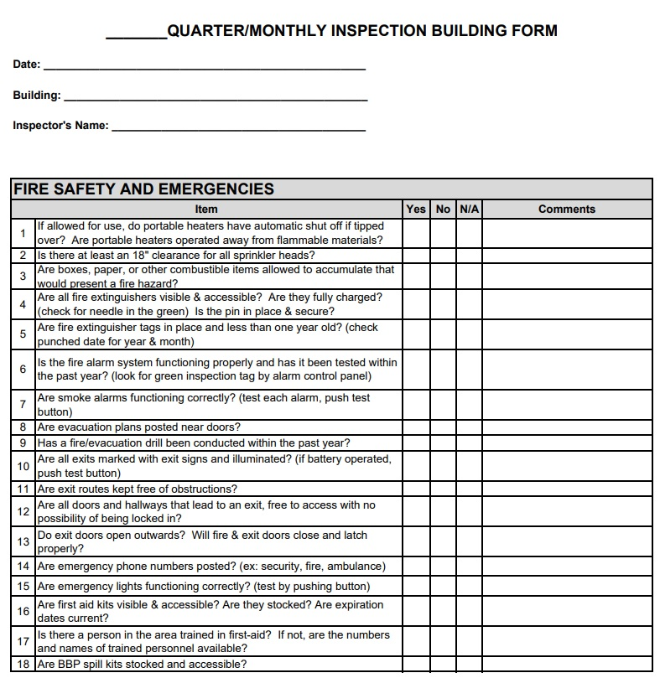
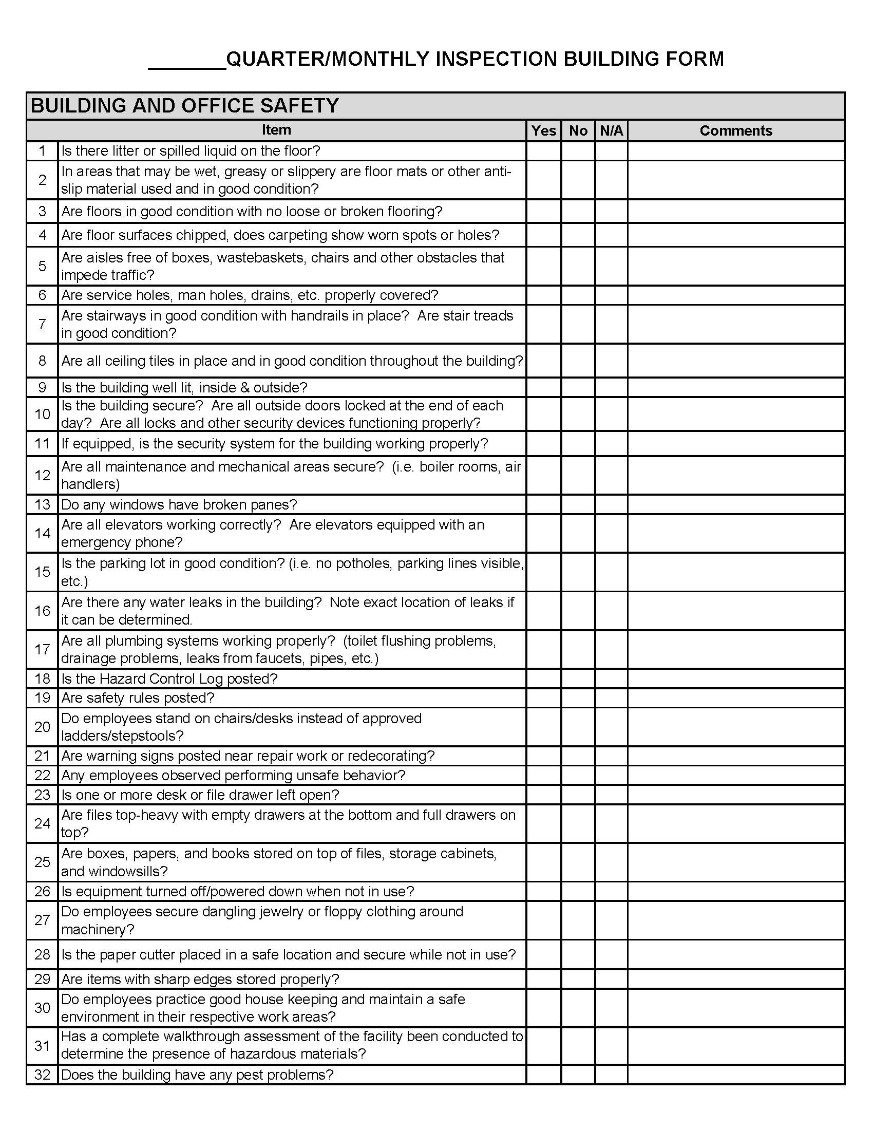
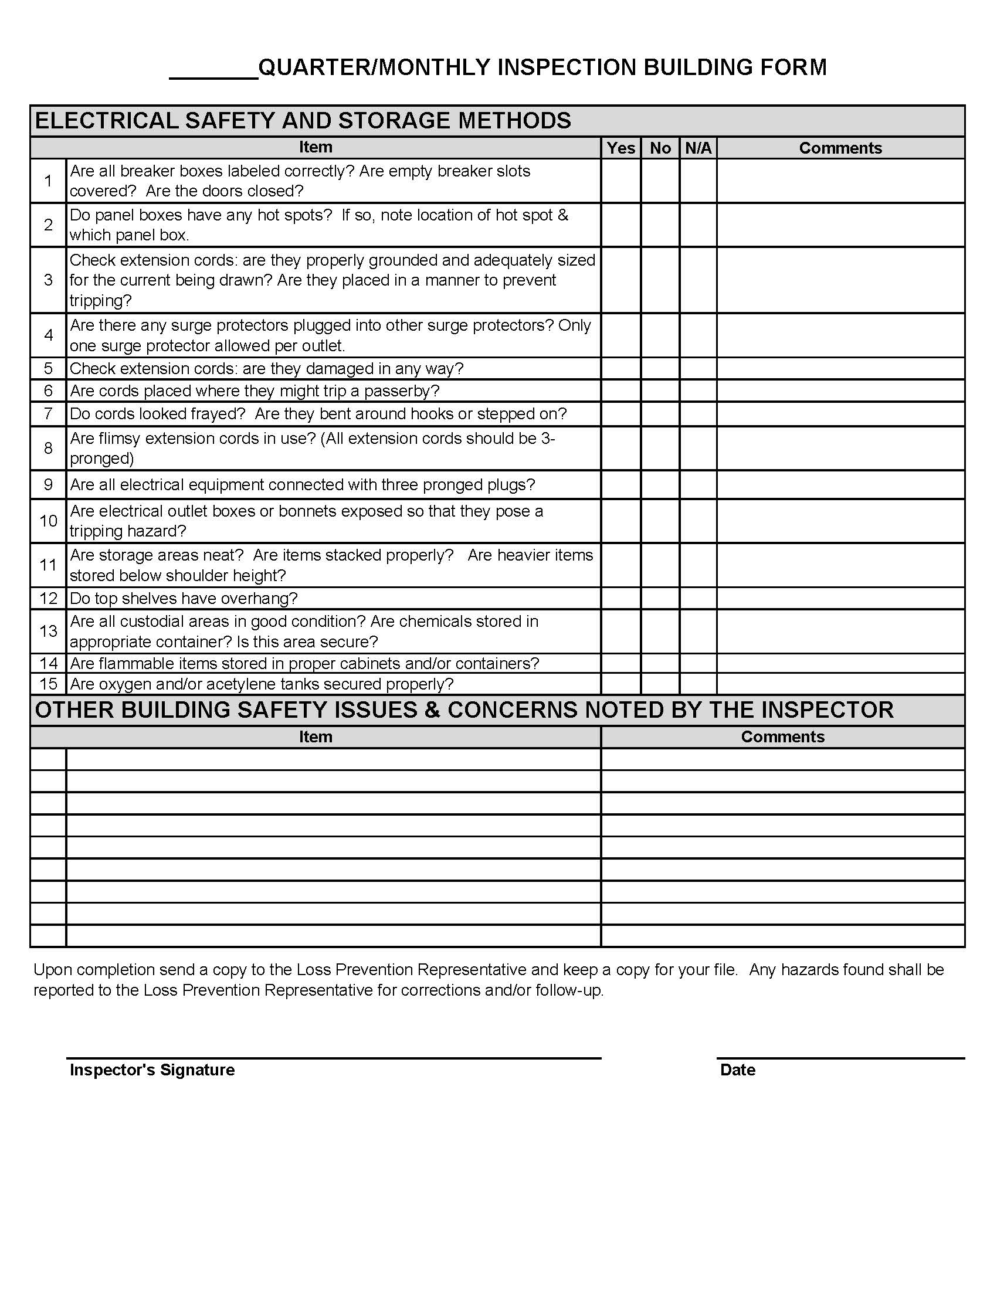
Hazard Log Form
Exhibit H

SAMPLE PROCEDURE FOR INCIDENT/ACCIDENT INVESTIGATION

An accident is defined as "an unplanned event(s) that caused personal injury or property damage." An incident is defined as “an unplanned event(s) that could have caused personal injury or property damage.” All incidents/accidents, including those occurring to non-employees, should be investigated by personnel responsible for the area in which the incident/accident occurred.

Incident/ Accident Reporting Form (DA2000-WC Only; DA3000-GL Only)

Incidents/accidents do not just happen; they are caused. The Incident/Accident Reporting Forms are used to assist in determining the causes and procedures to prevent the recurrence of similar incidents.

All spaces on the forms shall be completed. Notations such as N/A (not applicable) are not acceptable.

These forms are available on the ORM website. They appear under the section called “Forms” here:

https://www.doa.la.gov/doa/orm/forms/

If you do not have internet access, you can call your local Loss Prevention Officer to request one.

AFTER ACQUIRING NECESSARY MEDICAL AID FOR INJURED PERSONS, the supervisor should follow these steps in investigating the accident.

- If possible, ask the person or persons involved to describe what happened. Do not assign blame or fault; just get the facts.

- Survey the accident scene for information. If a camera is available, document the scene with photographs as necessary. Assemble and secure any objects that may have contributed to the incident/accident.

- Determine if there were any witnesses to the incident/accident and get their written description of the incident/accident.

- Take whatever steps are necessary to prevent recurrence until the condition can be permanently corrected.

- Complete the Incident/Accident Reporting Form (DA2000).

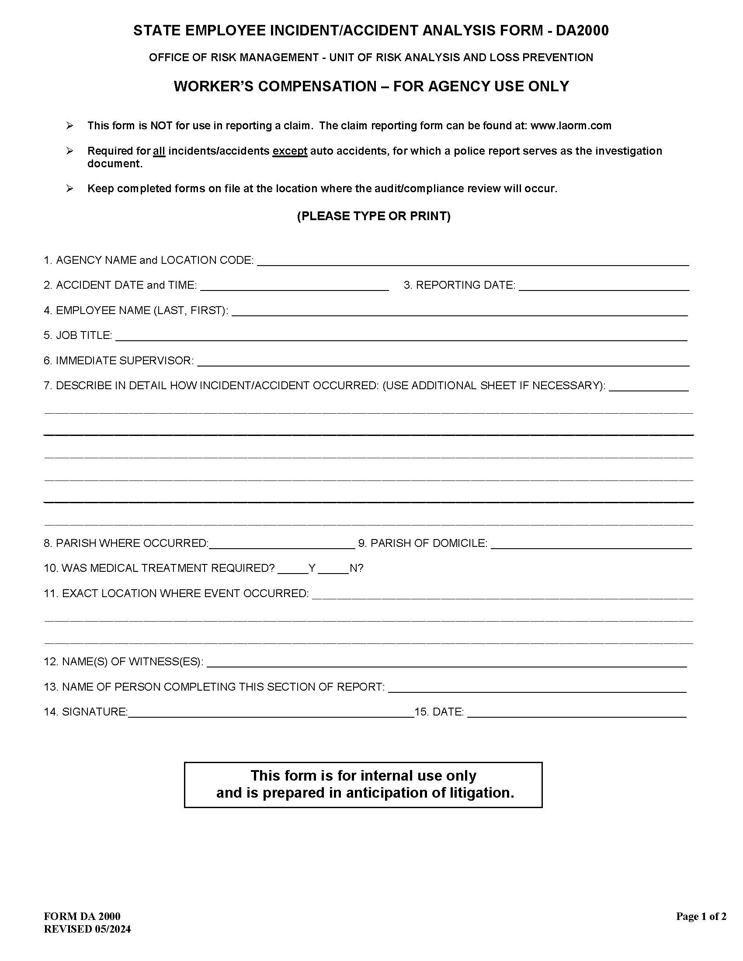
This form is prepared for internal use only and is prepared in anticipation of litigation.

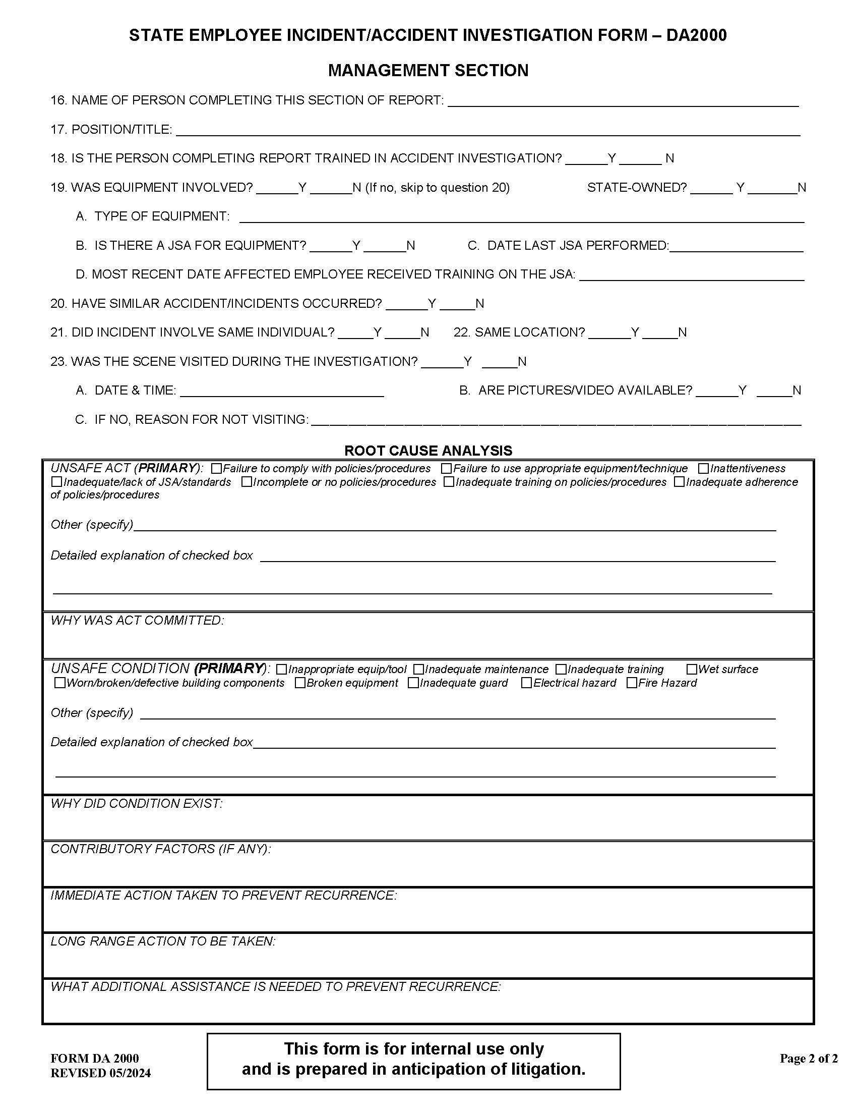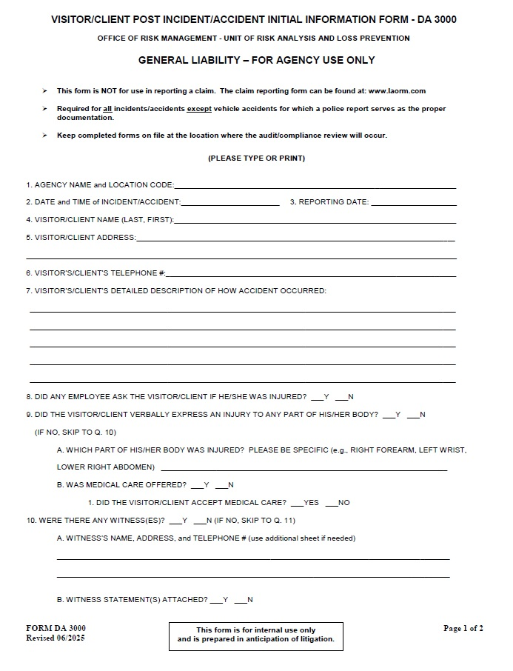

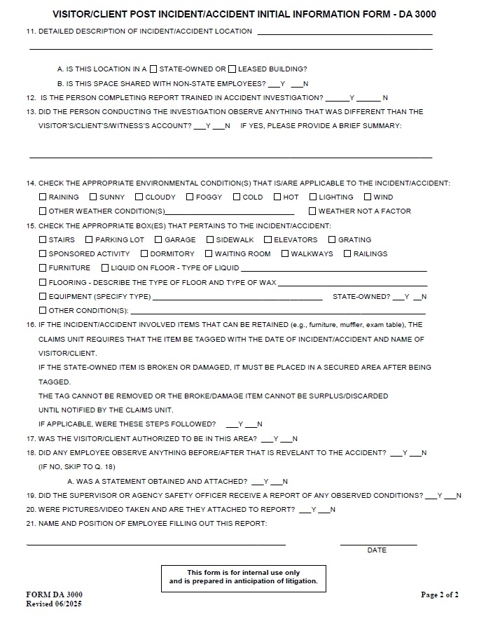
Exhibit I

SAMPLE PROCEDURE FOR JOB SAFETY ANALYSIS

When to Perform a Job Safety Analysis - A job safety analysis shall be performed on all jobs that have resulted in an incident/accident trend, death, or a change in a job procedure/equipment.

Job Safety Analysis Procedures

Step 1: Select the Job - In selecting jobs to be analyzed and in establishing the order of
analysis, the following factors should be considered. They are listed in order of
importance.

- Occurrence of Injuries: Jobs that have produced an incident or accident trend, or death, during the past five years shall be analyzed.

- Frequency of Accidents: Jobs that repeatedly produce accidents (trends) are candidates for a job safety analysis. The greater the number of accidents associated with the job, the greater its priority for a job safety analysis. Subsequent injuries indicate that preventive action taken prior to their occurrence was not successful.

- Potential Severity: Some jobs may not have a history of accidents but may have the potential for severe injury or property damage. The greater the potential severity, the greater its priority for a job safety analysis.

- New Jobs or a Change in a Job: New operations created by changes in equipment or processes obviously have no history of accidents, but their accident potential should be fully appreciated. A job safety analysis shall be made on every new job with potential hazards. Analysis should not be delayed until an accident or incident occurs.

- Death: Any accident that caused the death of an employee shall have a job safety analysis made as part of the investigation.

Step 2: Perform the Analysis- The supervisor/foreman or the agency loss prevention
representative responsible for the task shall perform the job safety analysis using
the Job Safety Analysis Worksheet (JSA-1-00). The supervisor or safety officer shall
conduct the job safety analysis with the help of employees who regularly perform
the task. The job being analyzed shall be broken down into a sequence of steps
that describes the process in detail. Avoid two common errors:

- Making the breakdown too detailed so that an unnecessarily large number of steps result; or

- Making the job breakdown so general that the basic steps are not distinguishable.
As a rule, the job safety analysis should contain fewer than 12 steps. If more steps are needed, the job should be broken into separate tasks.

Job safety analysis involves the following steps:

- Selecting a qualified person to perform the analysis.

- Briefing the employee demonstrating the task on the purpose of the analysis.

- Observing the performance of the job and breaking it into basic steps.

- Recording and describing each step in the breakdown.

- Reviewing the breakdown and description with the person who performed the task.

Select an experienced, capable, and cooperative person who is willing to share ideas. They should be familiar with the purpose and method of a job safety analysis. Sometimes it is difficult for someone who is intimately familiar with a job to describe it in detail; therefore, reviewing a completed job safety analysis before conducting one may help illustrate the terminology and procedure to be followed.

Review the breakdown and analysis with the person who performed the job to ensure agreement of the sequence and description of the steps. Variations of routine procedure should be analyzed also.

The wording for each step should begin with an action word such as "remove," "open," or "lift."

Step 3: Identify Hazards - Hazards associated with each step are identified. To ensure a
thorough analysis, answer the following questions about each step of the operation:

- Is there a danger of striking against, being struck by, or otherwise making injurious contact with an object?

- Can the employee be caught in, by, or between the objects?

- Is there a potential for a slip or trip? Can someone fall on the same level or to another level?

- Can employees strain themselves by pushing, pulling, lifting, bending, or twisting?

- Is the environment hazardous to one's health (toxic gas, vapor, mist, fumes, dust, heat, or radiation)?

Using the Job Safety Analysis Form (JSA-1-00), document hazards associated with each step. Check with the employee who performed the job and others experienced in performing the job for additional ideas. A reliable list may be developed through observation and discussion.
Step 4: Develop Solutions- The final step in job safety analysis is to develop a safe,
efficient job procedure to prevent accidents. The principal solutions for minimizing
hazards that are identified in the analysis are as follows:

- Find a new way to do the job. To find an entirely new way to perform a task, determine the goal of the operation and analyze the various ways of reaching this goal. Select the safest method. Consider work-saving tools and equipment.

- Change the physical conditions that create the hazard. If a new way to perform the job cannot be developed, change the physical conditions (such as tools, materials, equipment, layout, location) to eliminate or control the hazard.

- Change the work procedure to eliminate the hazard. Investigate changes in the job procedure that would enable employees to perform the task without being exposed to the hazard.

- Reduce the frequency of its performance. Often a repair or service job has to be repeated frequently because of another condition that needs correction. This is particularly true in maintenance and material handling. To reduce the frequency of a repetitive job, eliminate the condition or practice that results in excessive repairs or service. If the condition cannot be eliminated, attempt to minimize the effect of the condition.

Reducing the number of times a job is performed contributes to safer operations only because the frequency of exposure to the hazard is reduced. It is, of course, preferable to eliminate hazards and prevent exposure by changing physical conditions or revising the job procedure or both.

In developing solutions, general precautions such as "be alert," "use caution," or "be careful" are useless. Solutions shall precisely state what to do and how to do it. For example, "make certain the wrench does not slip or cause loss of balance" does not tell how to prevent the wrench from slipping. A good recommendation explains both "what" and "how." For example, "Set wrench jaws securely on the bolt. Test its grip by exerting slight pressure on it. Brace yourself against something immovable, or take a solid stance with feet wide apart, before exerting slow steady pressure." This recommendation reduces the possibility of a loss of balance if the wrench slips.

If a job or process is changed dramatically, it should be discussed with all personnel involved to determine the possible consequences of the changes. Such discussions check the accuracy of the job safety analysis and involve personnel in an effort to reduce job hazards.

Step 5: Conduct a Follow-up Analysis- No less than once per month, each
supervisor/foreman should observe employees as they perform at least one job for
which a job safety analysis has been developed. The purpose of these
observations is to determine whether or not the employees are doing the jobs in
accordance with the safety procedures developed. The supervisor should review
the job safety analysis before doing the follow-up review to reinforce the proper
procedures that are to be followed.
Step 6: Use of the Job Safety Analysis - The job safety analysis provides a learning
opportunity for the supervisor and employee. Copies of the job safety analysis
should be distributed to all employees who perform that job. The supervisor should
explain the analysis to the employees and, if necessary, provide additional training.

New employees or employees asked to perform new tasks must be trained to use the safe and efficient procedures developed in the job safety analysis. New employees should be taught the correct method to perform a task before dangerous habits develop, to recognize the hazards associated with each job step, and to use the necessary precautions to avoid injury or accidents.

Jobs that are performed infrequently require additional effort to minimize accident potential. Pre-job instruction addressing the points listed on the job safety analysis will serve as a refresher to employees who may have forgotten some of the hazards in performing the task and the proper procedure to be used to avoid these hazards.

Finally, the job safety analysis is an incident/accident investigation tool. When incidents/accidents occur involving a job for which a job safety analysis has been performed, the analysis should be reviewed to determine if proper procedures were followed or if the procedures should be revised.

Step 7: Record Keeping- Job safety analysis forms should be maintained in the
department that creates the documents and should be readily accessible to
employees. An index naming the task, date the job safety analysis was completed,
and date the analysis was revised should be maintained.
JSA FORM

JSA WORKSHEET (FORM JSA-1-00)
STATE OF LOUISIANA  JOB SAFETY ANALYSIS  TRAINING GUIDE | JOB: |  | DATE:
STATE OF LOUISIANA  JOB SAFETY ANALYSIS  TRAINING GUIDE | TITLE OF PERSON WHO DOES JOB: |  | SUPERVISOR: |  | ANALYSIS BY:
DEPARTMENT: | LOCATION: |  |  |  | REVIEWED BY:
REQUIRED AND/OR RECOMMENDED  PERSONAL PROTECTIVE EQUIPMENT: |  |  |  |  | APPROVED BY:
SEQUENCE OF BASIC JOB STEPS |  | POTENTIAL ACCIDENTS OR HAZARDS |  | RECOMMENDED-SAFE-JOB-PROCEDURES

JSA 1-00 STATE OF LOUISIANA
EXAMPLE JSA
JOB SAFETY ANALYSIS  EXAMPLE | JOB: Sharpening & Replacing a Rotary Mower Blade |  |  |  |  | DATE: 1/1/2000
JOB SAFETY ANALYSIS  EXAMPLE | TITLE OF PERSON WHO DOES JOB:  Yard Worker |  |  | SUPERVISOR:  John Jones |  | INDIVIDUAL PREPARING JSA: John Jones
DEPARTMENT: Maintenance Group | LOCATION: Outdoor Beautification
REQUIRED AND/OR RECOMMENDED
PERSONAL PROTECTIVE EQUIPMENT: Gloves & Safety Glasses
SEQUENCE OF BASIC JOB STEPS |  | POTENTIAL ACCIDENTS OR HAZARDS |  |  | RECOMMENDED SAFE JOB PROCEDURE
1. Disconnect spark plug wire.  2. Remove gasoline.  3. Invert mower.  4. Remove dull blade.  5. Check for bent blade.  6. Sharpen & balance dull blade.  7. Reassemble blade to mower.  8. Return mower to cutting position.  9. Reconnect spark plug wire.  10. Add gasoline.  11. Operate mower. |  | 1. Striking against housing Burn hand  2. Spillage – Fire –Inhalation.  3. Caught between (CB) Spilling gasoline Overexertion  4. Knuckles striking against blade.  5. None.  6. Cutting hand; striking against vice.  7. Striking against blade or housing.  8. Overexertion.  9. None.  10. Fire.  11. Normal operating hazards. |  |  | 1. Do not use excessive force. Allow mower to cool.  2. Ventilation. No smoking, proper container. Flush away with water (if necessary).  3. Tip properly. (Grass catcher chute up). Be sure cap is tight. Lift properly, use leg muscles.  4. Secure block blade – wooden block. Use gloves. Use proper size socket wrench with extender.  5. None.  6. Wear gloves. Avoid contact with sharp blade.  7. Block blade. Wear gloves. Avoid contact with sharp blade.  8. Use leg muscles, not back.  9. None.  10. Ventilate. No smoking. Proper container.  11. Check for excessive vibration or unusual noise.
EMPLOYEES ASSISTING IN DEVELOPMENT OF JSA __________________________________________________________________________________________________________________________________________________________________________________________________________________ |  |  | IS THERE DANGER OF:  A. STRIKING AGAINST OR BEING STRUCK BY  B. CAUGHT IN, BY, OR BETWEEN  C. SLIP, TRIP, OR FALL  D. PUSHING, PULLING, LIFTING, OR TWISTING  E. TOXIC GAS, VAPOR, FUMES, EXCESSIVE HEAT OR COLD

Exhibit J

LIST OF REQUIRED RECORDS

The following safety records shall be maintained by each agency for at least five years. Copies of forms describing the specific procedures as noted are included with exhibits or are provided on the ORM website.

Safety Meeting Documentation: Completed monthly or quarterly in each unit following safety meeting occurrences and maintained in the operating area for review at the next audit or compliance review. Copies may be sent to the department loss prevention coordinator or agency head.

(See Exhibit E, Sample Procedures for Conducting Safety Meetings.)

Training Documentation: Sign-in sheets and/or electronic “read receipts” shall be completed for all training sessions and maintained in the operating area for review at the next audit or compliance review.

Inspection Checklist: Inspection forms shall be completed monthly (Class A) or quarterly (Class B) in each work unit following a general safety inspection. The completed form shall be kept in the area it covers for review at the next audit or compliance review and shall be made available to the department loss prevention coordinator or agency head and the Office of Risk Management's Loss Prevention management upon request.

(See Exhibit G, Sample Inspection Procedures.)

Hazard Control Log (or other similar reporting forms): Shall be posted in a conspicuous location and made available as needed to identify potential hazards in each work unit. The original form should remain in the area it covers until the hazard has been corrected, and all completed forms will be kept on file until the next Loss Prevention audit or compliance review. Copies are sent to the agency head or department loss prevention coordinator, and ORM’s Loss Prevention Management if not corrected in 30 days. Copies shall be made available to ORM’s Loss Prevention management upon request.

(See Exhibit G, Sample Inspection Procedures.)

Post-Incident/Accident Analysis Forms: Complete a DA2000 or DA3000 form for each incident/accident that occurs whether or not it requires medical expense or lost time. A copy should be given to the loss prevention coordinator within the agency. These forms should not be used in lieu of the required claims reporting forms.

(See Exhibit H, Sample Procedure for Incident/Accident Investigation.)

Job Safety Analysis: Completed by supervisors in each work unit or by the agency loss prevention coordinator. Job safety analyses shall be performed for death, trends, new equipment or a change in procedures. Job safety analysis forms shall be maintained by the agency in the originating area. The documents should be readily accessible to employees and there should be an index naming the task and the date the job safety analysis was completed or revised.

(See Exhibit I, Sample Procedures for Job Safety Analysis.)
Exhibit K

SAMPLE BLOODBORNE PATHOGENS/FIRST AID REQUIREMENTS

SAMPLE

Bloodborne Pathogens
Exposure Control Plan

This sample plan was developed for use by the general population of state employees. Health care facilities and health care professionals as well as other occupations with a higher risk for exposure shall comply with state and federal standards, regulations, and laws.

The purpose of this program is to reduce or eliminate occupational exposure to blood and other potentially infectious materials to state employees. This exposure control plan can minimize or eliminate exposure through the use of protective equipment, training, clean up procedures, and medical protocol involving post exposure evaluation.

All bodily fluids will be considered infectious regardless of the perceived status of the source individual. Procedures for providing first aid and decontaminating/sanitizing contaminated areas will duplicate those developed and used by the health industry.

Bloodborne Diseases (not an all-inclusive list)

- Human Immunodeficiency Virus (HIV) causes AIDS
- Hepatitis B and C
- Syphilis
- Malaria

Preventive Measures

Use universal precautions: TREAT ALL BLOOD AND BODY FLUIDS AS POTENTIALLY INFECTIOUS.

- Unbroken skin provides some protection from bloodborne pathogens.
- Wear personal protective equipment (PPE) (examples: latex gloves, safety glasses, goggles, face shields, aprons, boots) whenever blood or body fluids are present or expected.
- Utilize engineering techniques (examples: tongs, recognized work practices, specialized equipment) whenever possible.

Decontamination Procedures

- Call a professional for proper decontamination and disposal.
- Obtain BBP clean up kits and either require employees to follow the manufacturer’s instructions that are provided with the kits or train employees on their use and disposal.

The following are the general guidelines for decontamination:

- After an accident, the contaminated area must be cleaned with the proper recommended decontamination solution.
- Cleaning equipment must be properly decontaminated.
- Wear required PPE.
- Restrict access to the area.
- Use disposable supplies whenever possible and dispose of properly.

Disposal: Disposal of all regulated waste shall be in accordance with applicable federal, state, and local regulations.

All waste with the possibility of contamination of BBP shall be placed in containers that are closeable, constructed to contain all contents, and prevent leakage of fluids during handling, storage, transportation or shipping. The waste must be labeled or color-coded prior to removal to prevent spillage or protrusion of contents during handling, storage, transportation, or shipping.

MEDICAL PROVISIONS

Preventive Vaccine

If the HBV vaccine is offered to an employee and the employee accepts it, it will be provided to the employee free of charge. Training by a knowledgeable person will be provided to the employee.

If an employee declines the offer of the HBV vaccine, then the employee is required to sign a declination statement. If, at any time, the employee changes his/her decision and decides to accept the offer of the HBV vaccine, then the series will be provided free of charge and training by a knowledgeable person will be provided to the employee.

Post-exposure Procedures

- Wash hands with antibacterial soap after contact.
- Flush eyes and face with fresh water for several minutes after contact.
- Follow agency’s notification/reporting procedures for an exposure.
- Follow agency’s written procedures for seeking medical counseling.

Other Exposure Hazards
- Surfaces contaminated with blood, vomit, feces.
- ALWAYS wear gloves and protective apron or clothing.
- Be alert for sharp objects, broken glassware, used syringes in trash.
- Do not pick up broken glass – use brush or broom & dustpan.
- Dispose of glass, sharp objects safely.
- Laundry (bloody or contaminated linens or sharp objects)

TRAINING: The training schedule shall be contingent upon the level of exposure to BBP:

High Risk: Health Care Facilities/professionals, and other high-risk occupations Workers with occupational exposure shall receive training within 90 days of hire and at least once per year annually afterwards.

Low Risk: General Office/Classroom personnel
All employees shall participate in a training program within 90 days of employment. If there are no BBP events, the training shall be required every five years thereafter. If an agency’s unit experiences a BBP event, the employees of that unit shall be required to retrain within the following 60 days.

Sample Guidelines for Avoiding the Spread of Infection

- Wash hands & remove protective clothing before eating, drinking, smoking, handling contact lenses, applying lip balm or cosmetics.
- Keep hands away from eyes, nose, mouth while cleaning.
- Frequent hand washing is best defense against spreading infection.

Summary

- Protect yourself on and off the job; know the facts.
- Practice good personal hygiene.
- Follow work rules, use gloves and protective clothing.
- Wash your hands often, after work or exposure.
- Keep areas clean – report problems immediately to supervisors.
Appendix A

EMPLOYEE’S REFUSAL TO TAKE HEPATITIS B VACCINATION

I understand that due to my occupational exposure to blood or other potentially infectious materials, I may be at risk of acquiring Hepatitis B virus (HBV) infection. I have been given the opportunity to be vaccinated with Hepatitis B vaccine at no charge to myself. However, I decline this vaccine, and understand that I continue to be at risk of acquiring Hepatitis B, a serious disease. If in the future, I continue to have occupational exposure to blood or other potentially infectious materials and I want to be vaccinated with Hepatitis B vaccine; I can receive the vaccination series at no charge to me.

__________________________ _________________________
Signature Witness

__________________________ _________________________
Employee’s Personnel No. Date

FIRST AID

Requirements for First Aid: All employees shall report any injury to the first aid station or appropriate personnel (immediate supervisor, safety officer, etc.) as soon as possible, at least before the end of the shift during which the accident occurred.

If available, a first aid station attendant, or someone who has completed a certified first aid course, will treat minor injuries and the employee will be returned to work. The employee shall be required to complete an Accident/Incident Report (DA2000). A description of the accident and names of witnesses (if any) are included on the form.

If a physician is needed, the employee may be given an Employer’s First Report of Injury Form for treatment to be given to the treating physician.

The employee will provide the agency with the treating physician’s diagnosis of the injury and the length of time he or she is expected to be unable to work.

In addition, agencies shall develop procedures to report and handle visitors and or non-employee accidents and injuries.

First Aid Training: Only someone who has completed a certified first aid or emergency response course or someone who has advanced medical training may administer first aid. Refresher training is required according to certification requirements.

First Aid Kit and Inventory Form: A first aid supply kit shall be maintained and inventoried periodically. An inventory list may be included in each first aid kit. Expiration dates on kit contents must be checked as well.

Emergency Eye Wash: In such situations where this is needed, typical protocol calls for a minimum of 15 minutes constant flushing time. This normally cannot be achieved via the use of small, portable, disposable containers of fluid found in many first aid kits. A fixed flushing station that uses an unlimited supply of uncontaminated fluid (e.g., potable water) is preferable.

Exhibit L

SAMPLE COMPONENTS OF AN EMERGENCY PREPAREDNESS PLAN

The purpose of the Emergency Preparedness Program is to ensure that each agency develops a plan for the safe evacuation of all people in the affected area and the rapid control of hazards during life threatening situations. This program includes procedures for:

  - Preventing and controlling emergency situations,
  - Warning employees of actual or impending disasters and preparing them for possible evacuation or shelter in place, and
  - Establishing safe evacuation routes.

Every organization must be prepared to effectively cope with the unique problems that arise in an emergency situation. Emergency preparedness is critical to protect employees, citizens, clients, students and property against incidents such as: fires, natural disasters, proximity threats, and terrorism. Effective planning for emergency situations can minimize the interruption of operations by providing a logical course of action during the emergency.

Emergency preparedness requires: a system for the prompt recognition of a serious situation; the availability of a well publicized, flexible, and tested plan; and clear delineation of the responsibilities of authorities and employees. Each organizational unit must stress the importance of being prepared in emergencies. Instructions for emergency situations should be posted in each facility and office. Emergency procedures should be established, implemented, and monitored by the agency.

Components of the Program

Emergency Control Committee: An emergency control committee should be organized by each agency. This committee develops plans for emergency situations. Control of emergencies such as fire, explosion, or toxic chemical releases require the coordination of the following: disaster communication, facility shutdown, employee evacuation or shelter in place, utility control, first aid and rescue, damage control, and notification of police and fire departments and hospitals.

A list of the names and titles of personnel involved in the emergency preparedness plan should be compiled in each agency and/or facility. Upper management is responsible for staffing and implementing the emergency control committee. The members' work and home phone numbers, as well as the estimated travel time from home to work, should be noted.

Emergency Alarms: A distinctive, reliable emergency signal that is capable of being heard in all areas of the facility shall be installed and tested in accordance with the applicable accreditation requirements. All employees should know how to activate the alarm, be familiar with the different warning signals, and know what actions to take upon hearing it.

Emergency drills (e.g., fire, natural disasters, and proximity threats) shall be conducted during all shifts at least annually.
Emergency First Aid: Some personnel at each facility should be trained in first aid techniques. If an injured person requires additional medical attention, employees should know how to send for an ambulance.
.
Emergency Power Systems: Automatic emergency power supply systems should be installed in areas where uninterrupted electrical service is essential for the preservation of life or property, such as in areas where precise procedures are performed (control room or operating room) or in areas where sensitive equipment is located (instruments or supplies requiring refrigeration). There should also be a manual control switch to activate the emergency power if the automatic system should fail. Alternative power sources and equipment should be maintained and regularly tested to ensure that the system is capable of supplying service within the time limits required by the specific operations.

Types of Emergency Plans

Fire Prevention and Control: Almost all fires are preventable, and control measures can limit the losses if a fire does occur. Fire prevention and control principles include the following:

- Prevention of fire starting by using fireproof construction materials, designing facilities to isolate hazardous areas, controlling operations, using preventive maintenance, and eliminating unsafe practices.

- Limit the spread of fire. Provide suitable fire barriers and keep the amount of stored combustibles to a minimum and housed in approved cabinets when appropriate.

- Maintain exits in facilities.

The following components are essential to a fire safety and prevention program:

Alarm System:

Prompt discovery of a fire is vital. Fire sensing and alarm systems should be reliable and should be designed for rapid discovery of a fire. An effective alarm system must:

- Be reliable and distinctive,
- Reach those trained to respond,
- Require immediate attention,
- Indicate the fire location, and
- Warn building occupants and area residents.

Agencies shall conduct at least one documented fire drill annually at each location.

Fire Suppression Equipment:

Fire protection shall be incorporated into the building design to achieve maximum effectiveness. Special processes presenting unique fire protection problems should be handled individually by fire protection engineers and the Office of Risk Management.

Water Supply:

Water is the most effective extinguishing agent for most fires. A reliable water supply is essential and should be sufficient to fulfill the demand of the automatic protection system for at least four hours. Water for firefighting should be stored separately from process and domestic water.

Distribution Systems: Pumping equipment may be required to produce the water pressure demanded by the firefighting operations.

Monthly Fire Extinguisher Equipment Inspection and Maintenance: The agency’s maintenance department representative shall be responsible for inspecting, testing, and maintaining all fire protection equipment, such as: pumps, hydrants, hose lines, automatic equipment, and portable extinguishers. Equipment testing also provides training opportunities for employees. Extinguishers shall also be inspected and certified by an outside contractor once a year.

Civil Disturbances: Civil disturbances are generally: riots and demonstrations, marches, groups that have become riotous, or a threatening individual.

- Restrict both employee and visitor movement in your area.
- Prepare for evacuation or relocation.
- Secure your area (lock doors, safes, files, vital records, etc.).
- Notify your local law enforcement immediately and then your agency head, safety coordinator, or supervisor.

Natural Disasters:

The following are some suggested procedures for handling natural disasters such as hurricanes, floods, or tornadoes:

- Formulate plans to isolate people from potential hazards.
- Only enter disaster areas if it is essential.
- Do not bring lanterns, torches, or lighted cigarettes into buildings that have been flooded or damaged because of the possibility of leaking gas lines or flammable materials.
- Do not touch fallen or damaged electric wires.
- Immediately leave the area upon discovering a leaking gas line.
- When a tornado warning is issued, take shelter immediately. The warning indicates that a tornado has been sighted in the area. Protect yourself from falling objects and flying debris. The best protection is an underground shelter, ditch, or a steel-framed or reinforced concrete building. If no shelter is available, go to the basement or inner hallway of the lowest floor of the building.

Proximity Threats: These occur near the location and can cause damage to life and
property and may require evacuation. Examples include:

Railroad, interstate, and water vessel disasters

- Obtain emergency response procedures from local municipality.
- Once notified, determine if voluntary or mandatory evacuation is required.
- Use applicable emergency response procedures as per the local municipality.
Local chemical or nuclear plant disasters – by law, all plants must report what is produced and include all of the following emergency procedures:

- Contact local/municipal government.
- Once notified, determine if voluntary or mandatory evacuation is required.
- Vertical, upwind, or downwind evacuation determined by type of incident.
- Shut down heating, ventilation, and air conditioning (HVAC) system if sheltering in place and the situation allows.

Aircraft Disasters

- Federal, state, and local authorities will assist once notification is received.
- Follow agency emergency action plan.

Terrorist Threats include:
Biological Weapons
Bomb scares/bombings
Chemical attacks
Cyber attacks
Nuclear weapons
Suspicious mail
Active Shooter

Bomb Threats:

Every threat should be taken seriously. If a bomb threat is received by mail, message, or telephone, record in writing the time and type of threat, location of bomb, expected time of detonation, if it is a male or female voice, and any other important information. If the threat is received by phone, keep the person on the phone as long as possible to determine any unusual voice characteristics such as raspiness, hoarseness, or stuttering. Try to notice any background noises. Ask why the bomb was placed there and whom the caller wishes to hurt. DO NOT HANG UP THE PHONE WHEN THE CALL ENDS. POLICE MAY BE ABLE TO REVERSE TRACE THE CALL. Report a bomb threat to a supervisor, who will contact the proper authorities. The phone number of local law enforcement shall be placed in conspicuous places throughout agencies.

It is important that each employee visually scan his/her work area before leaving to look for unusual packages or something out of the ordinary. Do NOT touch anything suspicious but report it immediately to law enforcement personnel as you arrive at your designated outside area. Local law enforcement has no way of knowing what belongs in a work area and what does not. It is necessary that employees identify suspicious objects/packages for the bomb squad. Only take your personal items with you.

Do not use a cell phone in or near the building or during the evacuation as this could trigger the bomb.

Do not return to your work area until you receive the all-clear signal from the authorized person.

SAMPLE BOMB THREAT CHECKLIST
Description Detail Report Caller's Voice - Circle as applicable
Questions to Ask: -Calm -Nasal
1) When is the bomb going to explode? -Angry -Stutter
-Excited -Lisp
2) Where is it right now? -Slow Raspy
-Rapid -Deep
3) What does it look like? -Soft -Ragged
-Loud -Clearing throat
4) What kind of bomb is it? -Laughter -Deep breathing
-Crying -Cracked voice
-Normal -Disguised
5) What will cause it to explode -Distinct Accent
-Slurred -Familiar
6) Did you place the bomb? Background Sounds:
Street noises-Factory machinery

7) If voice is familiar, who did it - Animal noises -Voices
sound like? - Clear -Static
- PA System -Music
-Long Distance -Local Call
8) What is your address? -House noises -Motor
9) What is your name? -Phone booth -Office machinery
-Other
Exact wording of threat:

Sex of Caller: Race: Threat Language:

-Well Spoken -Incoherent
Age: Length of call: -Foul -Taped
-Irrational -Message read by
threat maker

Number at which call was received: Time: Date:
Exhibit M

SAMPLE Hazard Communication & MATERIAl Safety Program

Sample: THese are guidelines only

Hazard Communication Plan for Non-Laboratory Agencies*

* These guidelines may NOT be sufficient for agencies with laboratory facilities.

Employers shall provide information to employees regarding the hazardous materials in the workplace and the hazardous properties of these materials. This information must be disseminated through a hazard communication program involving labeling, safety data sheets, employee training, employee access to written records, and a written hazard communication plan. The hazard communication program applies to any hazardous material, which is known to be present in the workplace in such a manner that employees may be exposed under normal conditions of use, or in a foreseeable emergency. Thus, the program does not extend to office personnel, other employees whose job performance does not involve potential exposure to hazardous materials, or to laboratory employees. The definition of "hazardous material" is extremely broad, and includes any material, which is a physical hazard or a health hazard. For determination of physical and health hazards associated with products not synthesized on-site, personnel should rely on the evaluation performed by the material manufacturer or importer transmitted via Safety Data Sheets (SDS).

Responsibilities: (agency Name)’s Hazard Communication Program is overseen by (Position of Responsible Person).

Hazardous Material Hygiene Officer shall:

- Determine when and what kind of employee exposure monitoring is required.
- Write and maintain the Hazard Communication Program and ensure that all parts of the program are properly implemented.
- Develop and maintain a Hazard Communication training program.
- Monitor procurement, use, and disposal of hazardous materials.
- Help develop Standard Operating Procedures for their hazardous operations.
- Perform random safety reviews.
- Review the Hazard Communication Program and Training programs at least yearly and make necessary changes.
Department Heads: Department heads or their designees (safety officers or supervisors) who have employees who work in areas where hazardous materials are stored, handled or used are responsible for:

- Creating and maintaining an inventory of all hazardous materials.
- Ensuring that all hazardous materials/products are properly labeled and that these labels are not removed or defaced.
- Maintaining copies of SDS for each hazardous material in the workplace and ensuring that they are readily accessible to employees when they are in their work areas.
- Informing employees of any operations in their work area where hazardous materials are present and the location and availability of the written hazard communication program, the inventory, and safety data sheets.
- Providing employees with training regarding hazards or practices specific to their work area at the time of their assignment and whenever a new hazard is introduced into their work area.
- Determining the required personal protective equipment (PPE) for the procedures and materials in use in their area.
- Ensuring that the proper personal protective equipment (PPE) is available in good condition and that the employees are trained and encouraged in its use.
- Developing safe procedures for work in their area, as well as written procedures for emergencies and evacuations, and train employees in those procedures.
- Inform employees about proper performance of non-routine tasks.

Employees are responsible for:

- Planning and conducting each operation according to the Hazard Communication Program.
- Maintaining area in good order.
- Using the required personal protective equipment.
- Reporting any exposures, injuries, or problems to supervisor and the Safety Officer.
- Reviewing SDSs prior to using a substance for the first time, and reviewing it periodically thereafter.

Contracting Officials: Contracting officials (purchasing agents, facilities maintenance and operations, architectural engineering services, and department heads) are responsible
for:

- Instructing all outside contractors to contact the US Department of Energy, Office of Environmental Health and Safety for specific information about hazardous materials within the agency that may pose a risk to contract employees.
- Contracting officers will require all contractors to provide the information concerning hazardous materials brought into any agency facility to perform contracted work before that work begins.

Hazardous Materials Inventory

The supervisor, or designee, is required to maintain a list of all hazardous materials known to be present in each work area (e.g. maintenance shop, section, etc.) and update the list at least annually.

The inventory must identify:
- Each hazardous material by the primary name on the label,
- The manufacturer or distributor of the material, and
- Chemical abstract number (CAS).

The inventory must
- Be kept in the work area in a suitable format, in a log sheet, or in a computer.
- List all hazardous materials found in the work area for which the supervisor is responsible including, but not limited to:
  - Laboratory chemicals, janitorial supplies, compressed gases, cleaning products,
  - Materials found in the maintenance departments (such as lubricating oils, solvents, etc.),
  - Specialty chemicals used by animal caretakers, illustrators, and printers.

Labeling requirements: The supervisor shall ensure that all hazardous materials are properly labeled. Labels shall list:

- At least the material identity,
- Appropriate hazard warnings, and
- The name and address of the manufacturer, importer, or other responsible party.

Portable containers of working solutions shall be labeled appropriately unless they are intended for immediate (during a day's work-shift) use by the employee who prepared it.
In this case, only the identity of the material must be supplied on the label.

The contents of all vessels (containing chemicals or products such as cleaning solutions) shall be identified by name on the container.

Products that are synthesized by the agency and distributed to outside parties shall be labeled if they contain hazardous materials in concentrations greater than one percent (or 0.1% for carcinogens). It is the responsibility of the laboratory synthesizing the product to develop this label.

Hazardous materials stored in bulk quantities, pipelines, and storage tanks are required to be adequately labeled.

Storage tanks or drums may be labeled collectively rather than labeling individual containers if they are not removed from the labeled area and if the hazards are the same. It is the responsibility of the department or area supervisor ordering and using these bulk materials to ensure adequate labeling.

Container labeling shall provide an immediate visual warning about the specific harm that may result from exposure to the material. If the manufacturer or supplier has adequately labeled the original container, transferring the information on that label to a secondary workplace container is appropriate. In many cases, the material manufacturer or supplier may cooperate by providing additional labels, upon request, with a hazardous material shipment.

In the event that the department needs to create labels, durable printed labels will be available in blank form with material names and an assortment of hazard symbols, which may be affixed to the basic label.

Personnel responsible for container labeling shall correct any outdated hazard warnings with the updated information as soon as they learn of any hazard characteristic changes.

Safety Data Sheets (SDS)

- The supervisor is responsible for acquiring and updating safety data sheets for all hazardous materials located in their work area.
- The safety data sheets shall be reviewed by all personnel using the material before it is used and kept in the work area so that they are readily accessible.
- To obtain specific safety data sheets, request them from the manufacturer or distributor, or search the Internet for assistance.
- Departments shall document their efforts to obtain SDSs from suppliers.
- Maintain a copy of letters requesting SDSs in the file until the SDSs are received.
- Hazardous materials purchased locally from retail stores may not come with SDSs. Under these circumstances, ask the retailer if they have the SDS or request it from the material manufacturer or supplier.
- If you have more than one safety data sheet for a hazardous material from the same manufacturer:
- Check the date.
- Use the most current one.
- Discard all others.
- To obtain further information or assistance in interpreting safety data sheets, contact the manufacturer or distributor.
- A safety data sheet shall be developed and sent with those products that are synthesized by the agency and distributed to outside parties if they contain hazardous materials in concentrations greater than one percent (or 0.1% for carcinogens). It is the responsibility of the laboratory synthesizing the product to develop and distribute the safety data sheet.
Employee Training and Information

Employees shall receive further hazard communication training:
- When working in a new area,
- Whenever a new material or procedure is introduced into the work place, or
- Whenever the department head, department safety officer, or supervisor feels that refresher training is in order.

This training shall include:

- Location and availability of the written Hazard Communication Plan.
- Physical and health hazards of materials in the work area and their locations.
- Methods and observation techniques used to detect the presence or release of a hazardous material.
- How to lessen or prevent exposure to these hazardous materials through usage of controls, work practices, and personal protective equipment (PPE).
- How to use safety data sheets information.
- How to read and understand labels.
- Contingency plans for medical and accident response.
- The proper use of any PPE required.
- Location of SDS file and hazardous materials inventory.
- All training shall be documented by recording the training session subject(s), date, and attendees. The agency shall maintain the official files. The supervisor shall also maintain a copy of these records.

Information about the agency’s hazard communication program shall be disseminated to all new employees. All new employees shall be trained by their supervisor concerning hazardous materials in the workplace at the time of initial assignment and whenever a new hazard is introduced into the work area.

Non-Routine Tasks

Employees performing "non-routine" tasks may be exposed to materials from unusual and unsuspected sources. These "non-routine" tasks may include, for example, periodic tank or boiler cleaning or the replacement of seals and gaskets. Written procedures shall be developed for every "non-routine" task by the supervisor of the employees who will perform the task. The information shall include material hazards associated with the performance of the tasks and appropriate protective measures required to perform the task safely. The procedures shall be included in the local copy of the hazard communication program.

The Office of Risk Management shall provide advice and guidance upon request.

EXHIBIT N

SAMPLE TRANSITIONAL RETURN TO WORK PROGRAM

TRANSITIONAL RETURN TO WORK (RTW) PLAN

I. AUTHORITY

The Transitional Return to Work (RTW) Plan for the [Insert Department Name] has been established in accordance with the following regulations:

• Office of Risk Management (ORM) [La. R.S. 39:1547 and Insurance Information
Notice 2025-3]
• R.S. 23:1020.1(B)(3); R.S. 23:1020.1(C)(2); R.S. 23:1226 of the Louisiana
Workers’ Compensation Law
• Americans with Disabilities Act (ADA), as amended [29 CFR 1630.1 – 1630.16]

II. OVERVIEW

The goal of ORM’s Transitional RTW program is to assist an employee who is injured on-the-job return to work as soon as medically possible within the physical restrictions determined by their physician until they are capable of returning to regular duty. This may be achieved through temporary modification of the injured employee’s job tasks, equipment, or work schedule as appropriate.

More expansively, the ADA requires employers, upon request, to provide workplace modifications, known as reasonable accommodations, to assist an employee with a disability in performing the essential functions of their job. The disability need not have occurred as a result of an on-the-job injury, which may be compensable as a workers’ compensation claim.

Thus, the [Insert Department Name] has an obligation to all employees, regardless of the cause of their medical condition, to provide reasonable accommodations to facilitate their expedient return to work.

III. PROCEDURE

For the workplace injury/illness of an employee, the [Insert Department Name] shall:

1. CLAIMS REPORTING: Electronically report the workers’ compensation claim immediately, but not later than 5 days after the injury or knowledge, via ORM’s Third-Party Administrator’s (TPA) online claims management system.

2. MEDICAL LIMITATIONS: If the workplace injury/illness results in “lost time,” meaning the employee is unable to work, the [Insert Department Name] shall provide the employee a Physician’s Modified Work Information Sheet for completion by the employee’s healthcare provider. Employees have the right to seek medical treatment from a healthcare provider of their choice for a work-related injury/illness. Employees are required to return the Physician’s Modified Information Sheet to Human Resources (HR) within 24 hours of receipt of the signed form from their treating physician.

3. ADA INTERACTIVE PROCESS: Upon receipt, the [Insert Department Name] shall consider a completed Physician’s Modified Work Information Sheet to be an ADA accommodation request. Such documentation shall substitute for any department-specific Request for Accommodation and/or Medical Inquiry forms. Based on such documentation, the [Insert Department Name] shall initiate the interactive process with the employee in order to fully understand their functional limitations and to discuss possible accommodation(s), if available, that would facilitate the employee’s return to duty status. The accommodation analysis and procedure shall be in accordance with the agency’s ADA policy mandated by La. R.S. 46:2594, which is [Insert Policy No. and Title].

4. ACCOMMODATION DETERMINATION: The final determination regarding the employee’s return to duty status, consistent with identified medical restrictions, shall be made by the Appointing Authority. This determination will be made in accordance with ADA requirements and considerations including: the employee’s ability to perform the essential functions of the job; the nature, extent and duration of accommodation(s) needed; and whether such accommodation(s) are reasonable or would impose an undue hardship on the [Insert Department Name].

• NOTE: The ADA does not require the removal of essential functions, displacement of an existing employee, or the creation of a new position as a reasonable accommodation for an employee with a disability.

IV. VOCATIONAL REHABILITATION

ORM, through its TPA, provides a RTW coordinator who is a licensed vocational rehabilitation specialist to serve as a liaison between employees and agencies, if warranted, on matters related to disability management and return to work planning. This RTW coordinator works with the employee (or legal representative) and agency representatives to facilitate the employee’s return to work, to include communicating with medical providers and providing progress reports to agency personnel. The RTW coordinator is responsible for ensuring that vocational rehabilitation standards are adhered to as required by law.

V. LOSS PREVENTION AUDITS

For purposes of the annual loss prevention audit, the [Insert Department Name] must maintain the following documentation throughout the audit year for all work-related injuries:

1. A completed Transitional RTW Audit Form (DA WC4000) to record the
status of its RTW program for each month; and
2. All completed Physician’s Modified Work Information Sheets received by the
department.

VI. QUESTIONS

Questions regarding this Transitional RTW Plan should be addressed to [Insert Name and Contact Information].

Effective Date: [Insert Date]

____________________________________
Agency Head Signature

