# Create Remit to Address

1. Log in to the vendor portal with your ID (11 digit vendor number that begins with a “V”) and your personal password.

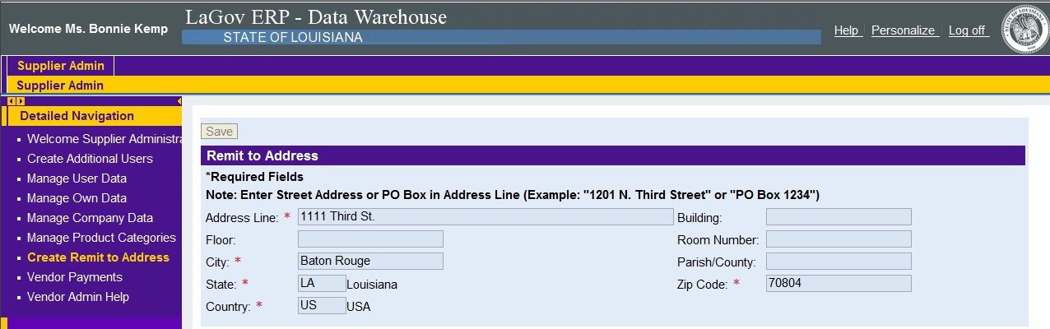

2. Click on “Create Remit to Address” under “Detailed Navigation” on the left. The following screen will appear.

This can only be used to **create** a remit to address. Enter the required information (*) for your remit to address and click “save” at the top of the screen.

If an existing remit to address needs to be changed, contact the Office of Statewide Reporting and Accounting Policy’s Vendor Section at:

Office of Statewide Reporting and Accounting Policy Vendor Section

P. O. Box 94095

Baton Rouge, LA 70804-9095

Email: [DOA-OSRAP-LAGOV@LA.GOV](mailto:DOA-OSRAP-LAGOV@LA.GOV)

Fax number: (225) 342-0960

Telephone number: (225) 219-6888