Vehicle Procurement Procedures
For LaGov / ProAct Agencies
IMPORTANT — Prior Approval Required
Prior approval from the Louisiana Property Assistance Agency (LPAA) must be obtained before entering an order for the Office of State Procurement (OSP) to process. LPAA’s approval document must be attached to the shopping cart or ProAct record. OSP will not place the order until this documentation is received.

1. Before You Order
All vehicles available on State contract can be found on the State’s Fleet Vehicle website. The fleet site contains all relevant information regarding vehicle availability, pricing, and the associated contracts.

Check order cutoff dates
Check for order cutoff dates for the vehicle you wish to order. This information is posted on each line item under the Status column as dates become available from the vendor.
- If no date is posted, the vehicle should be considered available.
- If the order cutoff date has passed, the vehicle is likely not currently available to order.
- You may confirm current vehicle availability directly with the vendor.

Complete an order sheet
Complete an order sheet for the vehicle. Order sheets for each vehicle are found on the website and contain the base vehicle pricing along with additional vehicle configurations and options.
Only the listed vehicle configurations and options are currently approved to order. Additions can be requested but must be approved by LPAA. Send your request to raymond.mcknight2@la.gov. You will be notified if the requested configuration and/or option is approved and added to the contract.

2. LaGov Agency — Shopping Cart Instructions
Complete the following steps to create and submit the shopping cart.
- Create the shopping cart, selecting the vehicle from the MDM catalog. Ensure the vehicle configuration chosen matches the configuration on the order sheet and the configuration approved by LPAA.
- Select P Group “OSP One Time Buy Bid Team” for the shopping cart item.
- Select LaGov Special Funding (LEAF or IPM) if the vehicle will be financed.
- Select “LPAA – Property Control” as the delivery address.
- Complete all other required shopping cart header and accounting information.
- Complete the shopping cart items, as detailed below.

Completing shopping cart items
- Price field: Enter the unit price shown on the order sheet.
Supplier text: Enter the option codes for any options being ordered under the heading “With the following options:”. Option codes are found on the order sheet. Also enter:
  - The desired exterior and interior colors (if multiple interior options exist).
  - The full Agency name in which the vehicle shall be titled.
  - The Agency’s contact person and telephone number.
Do not change the vehicle description. Failure to follow these instructions will delay your order.
Note — Standard Equipment and Options
Vehicles come with standard OEM equipment and, in some cases, other options. Some additional options require LPAA approval.

Approvals, asset flags, and ordering
- Attach the LPAA approval document to the shopping cart.
- Check the vehicle box and enter the LPAA Approval Number under the Agency tab.
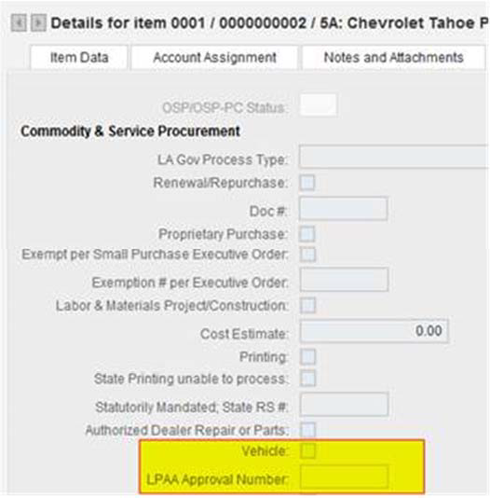

- Check the LaGov Capital Asset box so that an asset shell is created.
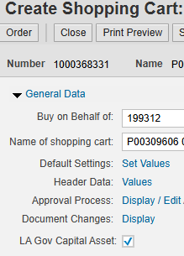
- Order the shopping cart. Agency approvals will be required.
- Once approved, OSP will begin processing the shopping cart.
Note — Combining and Separating Line Items
Combine requests for multiple vehicles of the same configuration into a single line.
If the request contains multiple vehicle types and/or configurations submitted to the same vendor, create a new line item for each.
If the request contains vehicles obtained from more than one vendor, create a separate shopping cart for each vendor.

3. Non-LaGov Agencies — ProAct Submission
Non-LaGov agencies submit a ProAct record as follows.
- Enter a ProAct record, selecting “One Time Buy” as the Type of Procurement and “Vehicles” as a Special Condition. Under Required Documentation, enter the LPAA approval number and check the box indicating that the approval document has been attached.
- Upload the LPAA approval document and vehicle order sheet in ProAct.
- Submit the ProAct record to OSP.
OSP will assign the ProAct record to the Buyer. OSP will not begin processing the order until the LPAA approval document and order sheet are received.

4. Process Order for Approvals
OSP uses the shopping cart or ProAct record to create a purchase order. OSP reviews the order for compliance with established guidelines and for necessary LPAA approvals.
- OSP changes the Goods Recipient to LPAA.
- OSP verifies that the LaGov Capital Asset box on the purchase order header has been checked for LaGov agencies. If it has not, the buyer will check it.
Note — Capital Asset Box
When the LaGov Capital Asset box is not selected prior to generation of the purchase order, the system generates an approval to the Agency Asset Accountant, who will approve the purchase order.

OSP P Group
OSP P Group will ORDER the purchase order, and workflow (approvals) will be started. Once approved, the purchase order will encumber and print, and OSP will sign and email copies to the vendor, agency, and LPAA.

5. Delivery of Vehicle to LPAA
LPAA inspects the vehicle to ensure compliance with order specifications. Upon acceptance, LPAA receives the vehicle in LaGov (MIGO transaction) on behalf of the agency. LPAA will call the agency contact specified in the purchase order supplier text to advise that the vehicle has been received in LaGov and is ready for pickup. The agency then initiates the payment process.
Note — Problems on Delivery
LPAA will notify OSP if problems exist with the vehicle upon delivery and will not create the MIGO document until the vendor corrects the problem, thereby preventing payment. The agency will be notified in this event.

The original invoice, certificate of origin, and odometer statement will be delivered to LPAA by the vendor. These original documents must be presented by the agency to the Department of Motor Vehicles for vehicle titling and registration purposes, and will be given to the agency at the time of vehicle pickup.
IMPORTANT — Payment Deadline
The vendor will mail a copy of the invoice directly to the agency’s “Invoice to Address” stated on the purchase order. Payments must be made within 30 days; otherwise, the vendor has the right to repossess the vehicle from LPAA without recourse by the agency.

6. Vehicle Pickup from LPAA
- The agency must present a copy of transaction code FB03, reflecting that payment has been processed and indicating the check number, prior to release of the vehicle. LPAA will verify the FB03 information.
- The agency furnishes the vehicle decals. LPAA will apply the agency’s decals to the vehicle prior to release.
- LPAA will release titling and registration documents at the time of vehicle pickup.

