# Create Additional Users

1. Log into the [vendor portal](https://lagoverpvendor.doa.louisiana.gov/irj/portal) with your ID (11 digit vendor number that begins with a “V”) and your personal password.
2. Click on **Create Additional Users** under Detailed Navigation on the left and the following screen will appear.

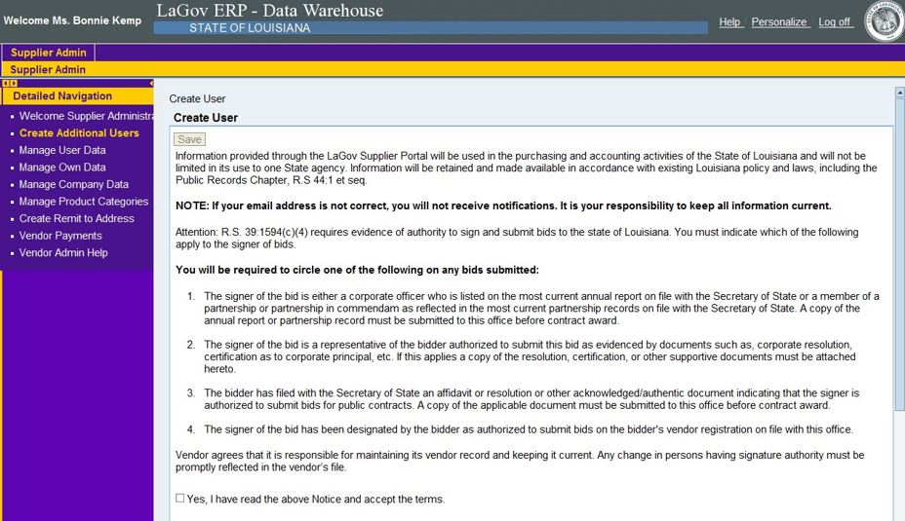

1. Read the above click the **yes** box. NOTE: Do not click **save**  at this time. Once the entire page is completed, then you will be directed to scroll back up and click the **save** button at that time.
2. Complete the general user information, contact information and settings. All fields with an asterisk (*) are required.

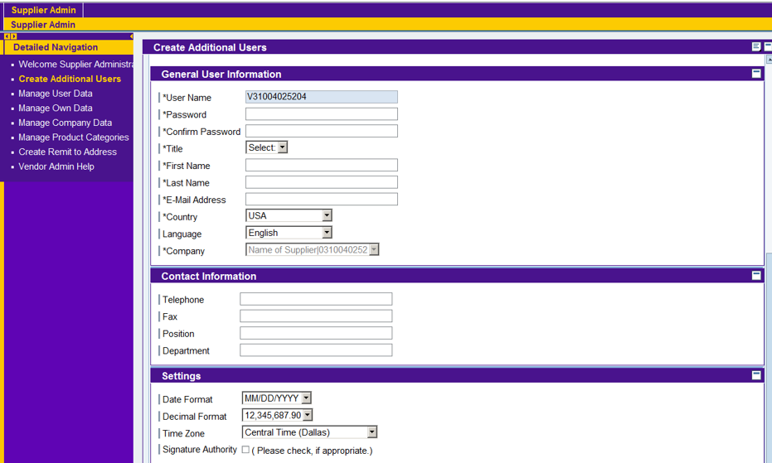

The fields should be filled out as follows:

* User Name: This field will not allow you to make any changes. It defaults to your name (ID) with a different suffix
* Password: Create a unique password for the additional user and make a note of it
  + Must have at least 8 characters
  + Must have at least 1 numeric character (0-9)
  + Must have a least 1 alpha character, upper or lower case (A-Z or a-z)
* Confirm Password: Re-enter the password for confirmation
* Title: Select from the drop down
* First Name: First name of the additional user
* Last Name: Last name of the additional user
* Email Address: Email address of the additional user
* Country: Select from drop down
* Language: Language of the additional user
* Company: This field will not allow you to make any changes
* Telephone: telephone number of the additional user
* Fax: Fax number of the additional user
* Position: Additional user’s position with the company
* Department: Additional user’s department with the company
* Date Format: Use the drop down to select the preferred date format for the additional user
* Decimal Format: Keep as the default setting
* Time Zone: Use the drop down to select the appropriate time zone for the additional user
* Signature Authority: Check the box if the additional user has signature authority

Scroll to the top and click **Save**. (Not shown on screenshot, but will be available)

1. Review the added user. If you wish to edit, click **change** at the top of the screen, make the modifications, and then click **save**. To delete an additional user, go to the **Manage User Data** on the left navigation area. See help script on Manage User Data.

NOTE: It is your responsibility to notify the additional user of their user name (11 digit vendor ID that begins with a “V”) and the temporary password that you created for them. You and your additional user(s) will receive an email notification of solicitations that are posted to LaPAC in your chosen product categories.