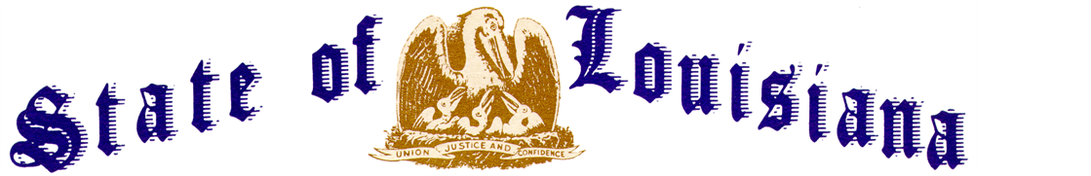
Executive Department
Office of the Governor
Executive Order Number JML 26-054
__________________________________________________________________________

STATE OF EMERGENCY -
SUSPENSION OF EARLY VOTING
________________________________________________________________________

WHEREAS, an election is currently scheduled statewide for June 27, 2026, including Second Party Primary and Municipal General elections;
WHEREAS, the early voting period for this election is underway and began on Friday, June 12, 2026, at 8:30 a.m. and is scheduled to end on Saturday, June 20, 2026, at 6:00 p.m., excluding Sunday, June 14, 2026, and Friday, June 19, 2026 (due to the Juneteenth Holiday);
WHEREAS, the National Weather Service has issued a Flash Flood Warning for central Louisiana effective Thursday, June 18, 2026, with significant widespread showers and thunderstorms creating significant impact;
WHEREAS, parishes statewide may require assistance from the State to provide resources to protect the life, safety, and welfare of the citizens of Louisiana;
WHEREAS, due to the impact of severe weather, the Twelfth Judicial District Court order the closure of its courthouse, which is the sole early voting location for the Parish of Avoyelles, for the remainder of Thursday, June 18, 2026;
WHEREAS, R.S. 18:401.1(A) provides a process, “to ensure maximum citizen participation in the electoral process and provide a safe and orderly procedure for persons seeking to qualify or exercise their right to vote, to minimize to whatever degree possible a person's exposure to danger during declared states of emergency, and to protect the integrity of the electoral process…”;
WHEREAS, R.S. 18:401.1(B) provides, in pertinent part, “[t]he governor may, upon issuance of an executive order declaring a state of emergency or impending emergency, suspend or delay any qualifying of candidates, early voting, or elections. The governor shall take such action only upon the certification of the secretary of state that a state of emergency exists.”;
WHEREAS, on June 18, 2026, the Secretary of State certified to the Governor that a state of emergency exists that would affect the electoral process, pursuant to La. R.S. 18:401.1;
WHEREAS, the Secretary of State has recommended an executive order be issued to suspend early voting in the parish of Avoyelles for Thursday, June 18, 2026, with early voting to resume in this parish at 8:30 a.m. on Saturday, June 20, 2026.
NOW THEREFORE, I, JEFF LANDRY, Governor of the State of Louisiana, by virtue of the authority vested by the Constitution and laws of the State of Louisiana, order and direct as follows:
Section 1: Early Voting is hereby suspended for the remainder of Thursday, June 18, 2026, in the parish of Avoyelles. Early voting shall resume in this parish at 8:30 a.m. on Saturday, June 20, 2026.
Section 2: These elections shall continue to be held and conducted under the applicable provisions of the Louisiana Election Code, La. R.S. 18:1, et seq.
Section 3: This Order is effective upon signature and shall remain in effect from Thursday, June 18, 2026, until Saturday, June 20, 2026, unless amended, modified, terminated, or rescinded earlier by the Governor, or terminated by operation of law.

IN WITNESS WHEREOF, I have set my hand officially and caused to be affixed the Great Seal of Louisiana in the City of Baton Rouge, on this 18th day of June 2026.

__________________________________________
JEFF LANDRY
GOVERNOR OF LOUISIANA

ATTEST BY THE
SECRETARY OF STATE

__________________________________
Nancy Landry
SECRETARY OF STATE

