Expenditures made under the authority of Act 3 of the 2026 Regular Legislative Session (RLS) of the Louisiana Legislature are subject to the provisions of the Preamble of Act 3, as well as Title 39 of the Louisiana Revised Statutes (R.S.).

MID-YEAR ADJUSTMENTS (BA-7s)

Section 2.A. of Act 3 provides for the addition of Federal Funds, Fees and Self-generated Revenues, Statutory Dedications and Interagency Transfers. R.S. 39:73(C) provides for transfers from one program to another with the approval of the Commissioner of Administration and the Joint Legislative Committee on the Budget (JLCB). Any BA-7 request to increase Fees and Self-generated Revenues or Statutory Dedications must have the revenues recognized by the Revenue Estimating Conference (REC) according to Act 419 of the 2013 RLS {R.S. 39:54(A)}.

The BA-7 form is updated following every regular legislative session. Check the Office of Planning and Budget (OPB) website and use the most recent version. The revised BA-7 form (MS Excel file) and questionnaire (MS Word file) are available on the OPB’s website under “Forms, Guidelines and Memos – Mid-year Adjustment (BA-7) Forms”. BA-7 requests requiring JLCB approval must be submitted electronically to the following:

- Office of Planning and Budget email: OPB.DOA@la.gov;
- Office of Planning and Budget assigned Analyst;
- Office of Planning and Budget assigned Manager;
- Legislative Fiscal Office email: fiscaloffice@legis.la.gov; and
- Joint Legislative Committee on the Budget (JLCB): Jaymi Foster (fosterj@legis.la.gov) and Brittany Lea (leab@legis.la.gov).

This request must be submitted a minimum of 16 working days prior to consideration by JLCB (see Preamble Section 17.A. of Act 3 of the 2026 RLS). This Letter of General Appropriation package includes the schedule for submission of BA-7s requiring JLCB approval. The person(s) from each agency most knowledgeable about items on the JLCB agenda must be present at these hearings to answer detailed questions.

The Division of Administration (DOA) takes a firm position on timely submission and full justification of BA-7 requests. The agency deadline noted on the JLCB BA-7 schedule is the last possible day for submission. However, submission of a BA-7 on the deadline date does not guarantee the BA-7 will be on the agenda for the next JLCB meeting. To allow sufficient time for a thorough analysis by OPB, BA-7 requests should be submitted as early as possible, rather than on the deadline. As a reminder, the 2027 RLS begins Monday, April 12, 2027. The scheduling of a JLCB meeting is difficult during a legislative session; therefore, it is recommended to plan ahead and submit BA-7s prior to that time frame. BA-7s not submitted in accordance with scheduled deadlines will be considered only when extreme circumstances requiring immediate action exist.

REMINDER: OPB will not accept a request using previous BA-7 forms or when the BA-7 form and/or questionnaire is incomplete. If information (financial or performance) on the BA-7 form and questionnaire is insufficient to justify the request, OPB will return the BA-7 request for further information. If a BA-7 is not submitted in time for a thorough analysis, it will not—except when OPB determines extreme circumstances requiring immediate action exist—be placed on the JLCB agenda.

Budget adjustments requiring BA-7 approval should not be made prior to completion of the BA-7 approval process (“After the Fact” BA-7s), as these BA-7 requests may be denied.

APPROPRIATION ACCOUNTABILITY

The commitment item category allocations reflected were determined during the FY 2026-2027 appropriation process. The initial spread of the agency’s budget must reflect the amount appropriated by commitment item category. Movement between commitment item categories will require a separate online workflow approval process in the LaGov Financial Management System subsequent to the initial budget spread.

Each agency is responsible for allocating appropriations to the proper Fund Center and Commitment Item. Specifically, the Personal Services categories – Salaries (5110000), Other Compensation (5120000), Related Benefits (5130000), and Personal Services expenditures within Other Charges (5600000) – should be spread down to the lower commitment item level.

Each agency, by program, must also spread the Office of Technology Services (OTS) Fees to the IAT- Technology Services (5950058) commitment item within the Interagency Transfers commitment item category (5950000). The OTS fees amount will be provided by each agency’s assigned OPB analyst. The deadline for spreading the agency’s budget at the commitment item level is August 28, 2026.

OPB will review and act on all FMBB budget supplements and budget returns. For FMBB budget transfers, OPB will only review transfers at certain levels of appropriation (see table on the following page).

- A Budget Supplement is used to increase the overall budget appropriation via the BA-7 process.
- A Budget Return is used to decrease the overall budget appropriation via the BA-7 process.
- A Budget Transfer is used to transfer budget across funds, funds centers, and commitment items. A budget transfer may or may not be part of the BA-7 process and should have a net zero effect to the program.

The entry of a budget supplement, budget return, or budget transfer (between MOF and/or between Agency Programs) is part of the overall process, which includes an offline approval process (i.e., a BA-7), and online workflow process using these FMBB transactions. It is important to notify the necessary approval entities throughout the LaGov document approval process.

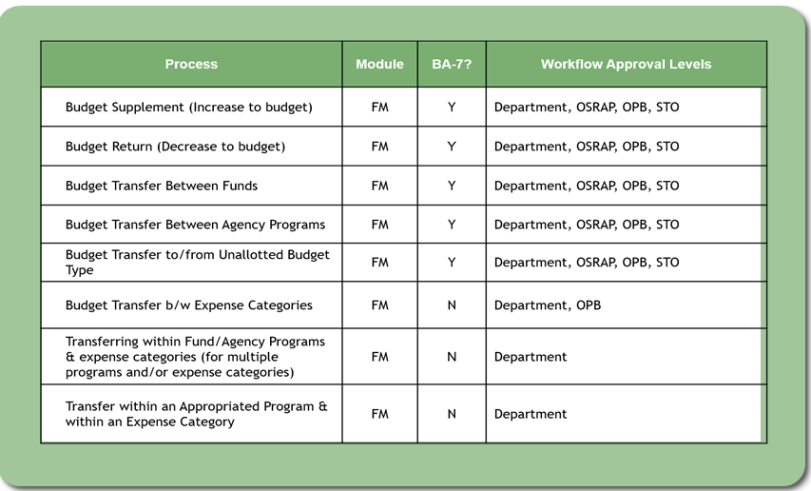

For agencies providing Excel sheets for an FMBB transaction, please email the request and file to the assigned OPB analyst. The OPB analyst will forward the request to the LaGov team to upload the adjustment into ECC once approved.

Incomplete or insufficiently justified proposals will be returned without action. Furthermore, any transfer of funding from the Salaries commitment item category may effectively result in a subsequent reduction of positions associated with that funding. Failure to spread or realign the budget into the proper commitment items and organizations may cause delays in transaction processing in the current year and complications in analysis and development of the ensuing fiscal year budget.

AGENCY COST ASSESSMENTS FOR STATE EMPLOYEES GROUP BENEFITS AND STATE RETIREMENT SYSTEMS

Act 3 of the 2026 RLS Preamble, Sections 8.D and 8.E contain language regarding the cost assessment allocation proposed by the Office of Group Benefits, and language that may affect the budget unit of each agency regarding the state retirement allocation. The costs of these allocations must be reflected when spreading budgets.

The retirement rates for FY 2026-2027 are:

Louisiana State Employees Retirement System (LASERS),
• Rank and File, 29.3%
• Judges and Court Officers, 32.9%
• Legislators, 32.2%
• Corrections Primary, 27.3%
• Corrections Secondary, 33.4%
• Wildlife, 42.1%
• Peace Officers, 31.8%
• Alcohol and Tobacco, 33.4%
• Bridge Police, 31.4%
• Judges (Act 992 of 2010), 31.5%
• Hazardous Duty (Act 992 of 2010), 35.8%
Teachers Retirement System of Louisiana (TRSL),
• Regular Teachers, 19.1%
• Higher Education, 18.9%
• Lunch Plan A, 19.1%
• Lunch Plan B, 19.1%

Louisiana State Police Retirement System (LSPRS),
• Regular, 35.9%

UNEMPLOYMENT COMPENSATION PAY

The state unemployment compensation program is self-insured. Louisiana Works processes and pays unemployment insurance claims filed by eligible former workers of the state. Each agency is directly responsible for payment to the department.

It is vital to pay these claims timely, because Louisiana Works’ assessment of interest and penalties on delinquent bills is severe. Under the provisions of R.S. 23:1543(A), Louisiana Works assesses an interest fee of 1% per month, then adds the interest amount to the unpaid balance and charges a 5% penalty on the sum of those two amounts. The penalty is progressive, meaning the amount for month two is 10%; for month three, 15%; and so on, to a maximum of 25% per month. For example, the first month of penalty and interest payment on an unpaid balance of $745,000 is calculated as follows:

$745,000 X .05=$37,250; ($745,000 + 37,250) X .01=$7,823 or total penalties and interest of $45,073.

Based on the calculations above, the penalty and interest for the second month would be $87,698 and for the third month, $141,760.

POSITION CONTROL

Only employees in the permanent state work force are paid from commitment items 5110010, 5110025, and/or 5981000, in accordance with LaGov Uniform Chart of Accounts definitions:
5110010 - Salaries-Classified-Regular: Compensation paid to full-time or part-time classified employees hired on a continuing basis;
5110025 - Salaries-Unclassified-Regular: Compensation paid to full-time or part-time unclassified employees hired on a continuing basis; and
5981000 - AUX Programs-Salaries: Salaries related to auxiliary programs.
Payments for salaries from these commitment items for employees in the classified and unclassified state service are limited to those employees with permanent or probationary status. Any changes to positions, either number or classification, are subject to the provisions of R.S. 39:84. Furthermore, all requests for personnel action submitted to State Civil Service should reflect the proper commitment item for the position affected.

To the extent that position information is in the LaGov HR system, it is imperative the information is maintained regarding the appropriate salary code, as OPB will use the LaGov HR system to examine filled positions and vacancies in FY 2026-2027 and determine salary recommendations for FY 2027-2028.

All positions, other than those paid out of the Other Compensation commitment item, should be considered authorized Table of Organization (T.O.) and Authorized Other Charges positions. Positions in the Other Compensation commitment item should be considered non-T.O. positions. Authorized Other Charges positions must conform to at least one of the criteria below:

- The agency does not have the authority to hire and terminate the employee.
- The position is seasonal but not permanent.
- The position has legislative authority to be excluded from the authorized T.O.

All positions for which the department has the authority to employ and terminate the individuals, and the positions are designated for more than one (1) year, should be placed in the authorized T.O. If there is a reason to deviate from this policy, please contact the assigned OPB budget analyst.

CONTENTS OF COMPLETE APPROPRIATION LETTER PACKAGE

The following documents are included in the Appropriation Letter package. Please ensure the proper personnel acquire all these documents. These documents can be accessed by email or OPB website.

- Letter of General Appropriation
- Schedule for BA-7s requiring JLCB approval
- Act 3 of the 2026 RLS should be reviewed for any special language affecting appropriations and gubernatorial vetoes
- Initial LaGov ECC FM Budget Load File
- Enacted Report Package
- Performance Standards at Appropriated

If you have any questions regarding the agency’s appropriation, or need additional information, please contact the assigned OPB budget analyst.

Sincerely,

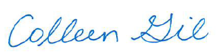

Colleen Gil
State Director of Planning and Budget

CG: EV

Attachments

