BONDS, CRIME, & PROPERTY
PROGRAM

LOSS PREVENTION UNIT
OFFICE OF RISK MANAGEMENT
DIVISION OF ADMINISTRATION

20260701

CONTENTS

BONDS, CRIME, & PROPERTY PROGRAM

Introduction 2

Components of the Louisiana Bonds, Crime, & Property Program 2

Responsibilities 2

Department and Agency heads 3

Supervisors or program designee 3

Employees 3

Bonds, Crime, & Property Coverage 4

Guidelines for Developing a Bonds, Crime, & Property Program 5

Security 6

Key Control 7

Sample Security Planning Template 8

Sample Authorization Form 12

BONDS, CRIME, AND PROPERTY
PROGRAM

Introduction

The Bonds, Crime, & Property Program is intended to protect the state from financial and/or property losses resulting from any act and/or omission by any state public officials, appointees and employees in the performance of their respective duties.

The Office of Risk Management (ORM) policy guidelines outlined in this document are not a substitute for the accounting control guidelines established by the Office of Statewide Reporting and Accounting Policy (OSRAP). Conformance by an agency with all relevant OSRAP policies regarding fiscal controls and safeguards shall satisfy ORM’s requirements. The agency shall be responsible for complying with any other ORM requirement or exception not specifically addressed by OSRAP policy, as relates to this program.

The purpose of the Bonds, Crime, & Property Program is to:

- Assign responsibility for developing and managing fiscal controls in state agencies.

- Establish each individual's accountability for the performance of his/her duties in compliance with the agency's fiscal control program.

- Reduce the state's exposure and losses and to safeguard state assets against theft, robbery, abuse, etc.

- Maintain the public's confidence in the ability of state officials, appointees, and employees to conduct the state's business in an honest and professional manner.

Components of Louisiana Bonds, Crime, and Property Program

1. Agency Policy and Procedures:

A. Responsibilities

Each agency is responsible for developing and implementing a written Bonds,
Crime & Property Loss Control Program that shall include:

B. Procedures (for managing assets and the fiscal internal control system to minimize
potential losses and damages)

These procedures shall address, at a minimum:

- Handling/processing negotiable items such as: cash, checks, and postage stamps.

- Controlling inventories, including disposal thereof.

- Employee accountability for equipment assigned to them.

- The securing of vaults and safes, cash boxes, and filing cabinets containing negotiable items.

- Purchasing procedures.

C. Implementation of training programs for employees. Training may include formal
and on-the-job training. All training shall be documented.

D. Investigation/reporting procedures, including use of the DA3000, for incidents involving
losses/damages to assets (e.g., property, negotiable items) that include corrective
action to prevent recurrence. There must be a method for reporting discrepancies or
problems to supervisors and/or management, as well as timely submission of the claim
to the Third-Party Administrator (TPA).

E. The responsibilities and accountability for managers, supervisors, and employees
who have duties requiring Bonds, Crime, & Property coverage.

These policies/procedures shall be given to employees involved in the fiscal control program and form the basis of the Bonds, Crime, & Property Program. Only those individuals authorized and trained to manage or handle cash, property, stamps, fees, licenses, permits, securities, and other State assets shall be assigned to those duties. “Manage” is defined as including “approval of transactions and/or directing the approval of transactions.”

The TPA will, upon request, assist agencies in organizing, directing, implementing, and controlling a Bonds, Crime, & Property internal control program that minimizes the potential for financial and/or property losses.

Department and Agency Heads

These individuals are responsible for the implementation of an internal fiscal control program that includes operating guidelines and the specific duties of all employees involved in the program. Department heads or their designees are responsible for reviewing the fiscal control program regularly for efficiency and effectiveness. Recommendations contained in internal control audits should be implemented promptly.

Supervisors or Program Designee

Supervisors must ensure that employees are properly trained in the program’s policies, procedures, and guidelines so that all safeguards are followed at all times. Supervisors should review the program’s internal controls to ensure protection of the state's assets and property from losses. No safeguard of the internal control plan is to be eliminated or bypassed.

Employees

Employees are expected to follow the program fiscal controls and to report any deviations. Deviations include but are not limited to:

- deliberate recording of a transaction with inadequate documentation, inadequate information, and/or approval
- deliberate omission of information in a financial/statistical report
- failure to safeguard an asset (e.g., equipment: left in an insecure environment
[such as a laptop with no lock], left on a desk, or in an unlocked room)
- unauthorized use (e.g., personal use of a computer and/or use of
unauthorized/unlicensed programs on a computer)
- failure to safeguard fiscal/personal information (e.g., computer left unattended
with ‘desktop’ open)
- failure to secure files with confidential information (should use encryption
and/or password protection)

The employees shall report the deviation in accordance with agency policies/procedures. The specified individual should forward the deviation to the appropriate person at ORM.

2. Bonds, Crime, & Property Coverage

Fidelity Bonds: The Employees Faithful Performance Blanket Bond covers loss sustained by insured because of dishonest or fraudulent acts of employees or by failure of employees to faithfully perform duties. The following mandatory areas are covered:

- Property Manager Bond: This bond covers dishonest or fraudulent acts or failure to faithfully perform duties in connection with the handling and control of state property, resulting in loss to insured.

- Notary Bond: This bond guarantees that a notary public will comply with applicable laws and regulations.

- Postal Bond: This bond guarantees that a post office contract, branch, or station located at such places as a university or college shall faithfully discharge all duties required under rules and regulations of the U.S. Postal Service. It must account for, deliver, and pay over monies, mail matters, and other properties that come in its possession to the proper post office official.

- Public Official Bond: This bond is required for state elected or appointed officials to fill positions of trust. It protects against dishonest and fraudulent acts as well as a person's failure to perform duties required.

- Crime (Inside/Outside Premises): Money and Securities; Depositors Forgery (usually secured by Combination Crime Policy): This policy should cover all perils except those that are excluded by the policy on money and securities including outside premises while conveyed by messenger. Property other than money and securities is insured against robbery or burglary. Coverage is provided against loss through forgery or alteration of checks drawn by insured. The Crime Policy shall also provide coverage for property damage to a safe during an attempted or actual robbery.

Cyber events where the insured receives and acts upon a fraudulent instruction that is allegedly coming to them from a vendor, client, or management instructing them to transfer funds, money or securities are covered under the crime policy. Cyber events involving attacks that re-route state funds are also covered by this policy as well.

3. Guidelines for Developing a Bonds, Crime, and Property Program

Each agency shall establish a system of internal accounting and administrative controls in accordance with applicable federal and Louisiana state statutes and regulations utilizing the following guidelines:

- Reasonable Assurance - Internal control systems relative to fiscal matters shall provide reasonable assurance that the objectives of the system will be accomplished. This standard recognizes that the cost of internal control should not exceed the benefits derived.

- Competent Personnel - Employees exercising oversight and control shall achieve (unless already possessing) adequate education, experience, and/or training as soon as possible upon hire to accomplish their assigned duties.

- Internal Control Guidelines - Specific internal control guidelines on fiscal matters shall be developed for each applicable agency function. Each goal must be complete, logical, and applicable to the specific activity and are to be consistent with the accomplishment of the overall objectives of internal controls, including but not limited to:

- Obligations and costs are in compliance with applicable law.

- Funds, property, and other assets are safeguarded against waste, loss, fraud, unauthorized use, or misappropriation.

- Revenues and expenditures applicable to agency operations are to be properly recorded and accounted for. This will permit the preparation of reliable financial and statistical reports required to maintain accountability over the assets.

- Documentation - Internal control systems, (i.e., control objectives, internal control techniques, accountability for resources) and all transactions and events shall be clearly documented. Documentation shall be readily available, including for all damages/losses. Transactions shall be classified properly upon recording and execution.

- Separation of Duties - Key duties (e.g., authorizing, approving, and recording transactions; issuing or receiving assets; making payments; reviewing or auditing) shall be assigned to separate individuals to minimize the risk of loss to the state. Internal control depends largely on the elimination of opportunities to conceal errors or fraud. Internal fiscal control requires the assignment of work in such a manner that no one individual controls all phases of an activity or transaction, thereby minimizing the possibility that errors or irregularities will go undetected.

- Supervision - Proper supervision shall be provided to ensure that approved procedures are followed. Lines of personal responsibility and accountability shall be clearly defined.

- Access to Resources - Access to resources shall be limited to authorized personnel. Access includes both direct physical access and indirect access through the preparation or processing of documents that authorize the use or disposition of resources. Periodic internal audits shall be made comparing the physical resources with the recorded accountability to determine whether the two agree (e.g., petty cash; physical inventories – supplies, food; check stock). The frequency of the audit shall be determined by the vulnerability of the asset.

- Addressing Audit Findings - Managers should promptly evaluate findings and recommendations reported by auditors, determine proper action and, within established time frames, implement actions that correct the findings.

4. Security

The goal of a successful security plan is to ensure the safety and security of each state employee and visitor/client while also securing state property and its contents (regardless of current value). Each agency is responsible for implementing a documented, site-specific security plan, which includes property control procedures. The security plan must provide a means of controlling access to state agency buildings for state employees as well as clients/visitors and vendors. Means for access control may include but are not limited to:

- Door locks
- Alarm systems (regardless of contents or their value)
- Lighting
- Surveillance cameras
- Security guards
- Entrance phones
- ID cards
- Electronic swipe cards
- Keypads
- Locked desks, cabinets, and doors

The security plan should include assignment of responsibilities as well as employee accountability and lockdown procedures. Other points to consider while developing a security plan are:

- Parking lot security
- Campus/Grounds security
- Cyber/Data security
- Alternative entrances (i.e. loading docks)
- Past incidents in the building or the vicinity of the building
- Hours of operation
- Nature of the business the agency conducts

The security plan should be re-evaluated at least annually and as the situation necessitates.

5. Key Control

All state agencies shall have site-specific policies and procedures in place for key control. Key control shall include responsibility for keys, security badges, access cards, security systems, etc. These procedures are for security of the agency’s physical plant, property, and most importantly, employees. The policy and procedures shall cover, at a minimum:

1. Issuance and return of keys/cards,
2. Reporting lost or stolen key(s),
3. Changing locks/codes (when applicable), and
4. Employee responsibility for handling keys.

Agencies should maintain an inventory log that indicates employees who were issued keys, the date the key(s) were issued (and returned), what areas the key(s) access.

See attachment for sample policy/procedure and forms.

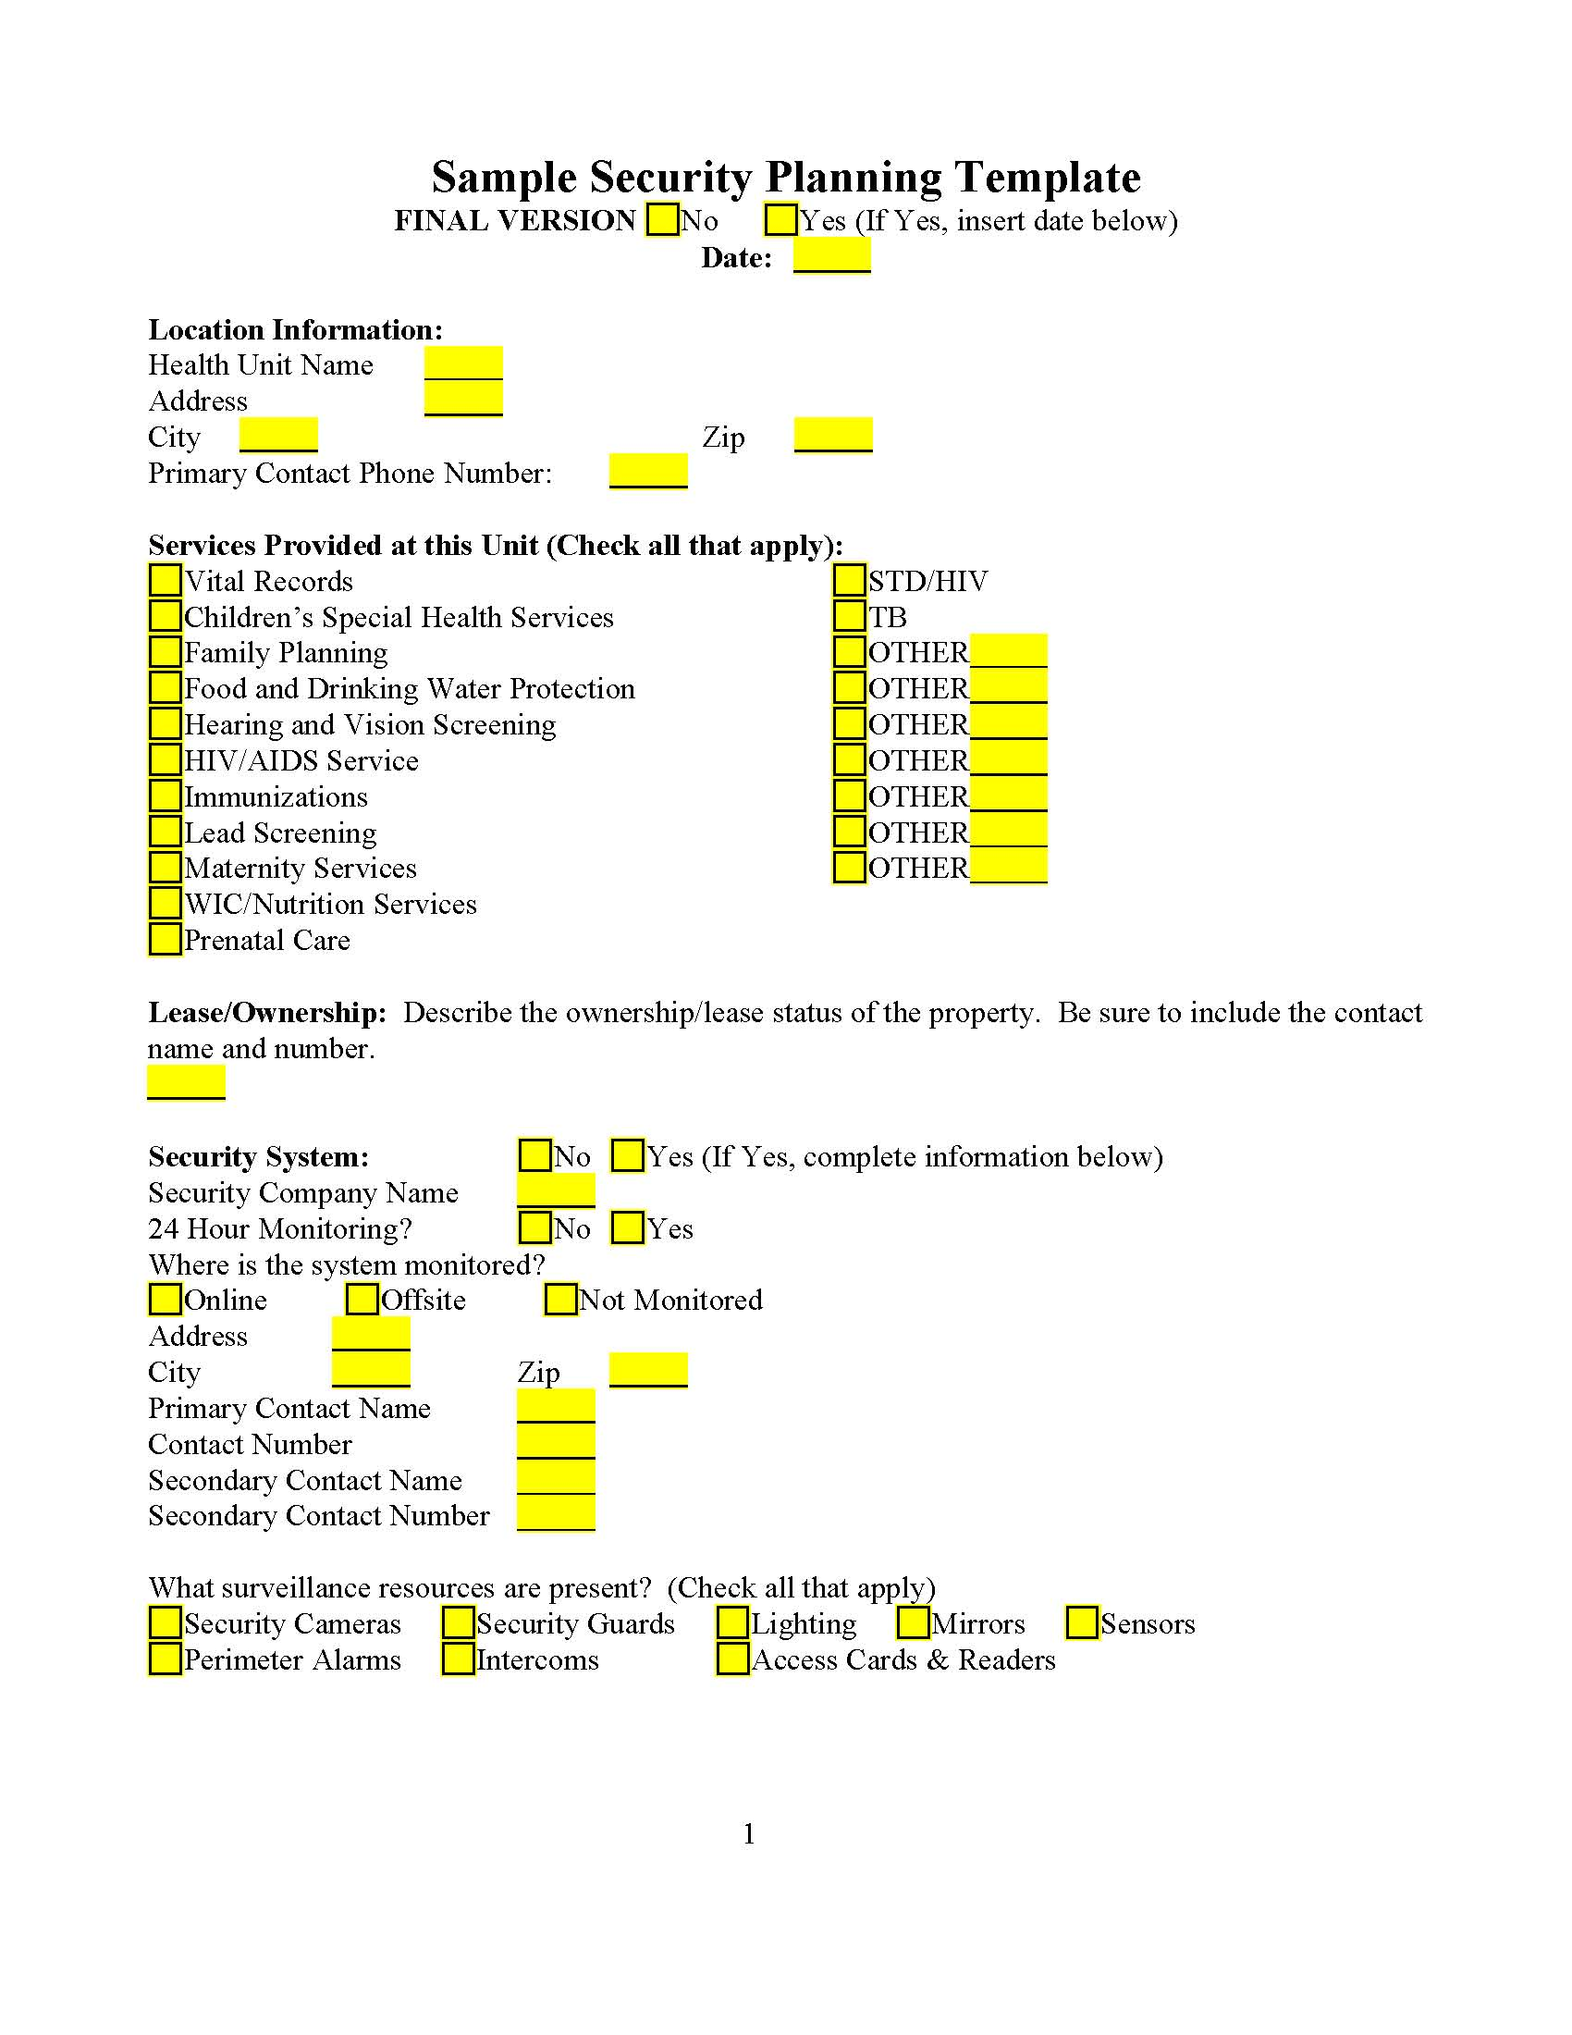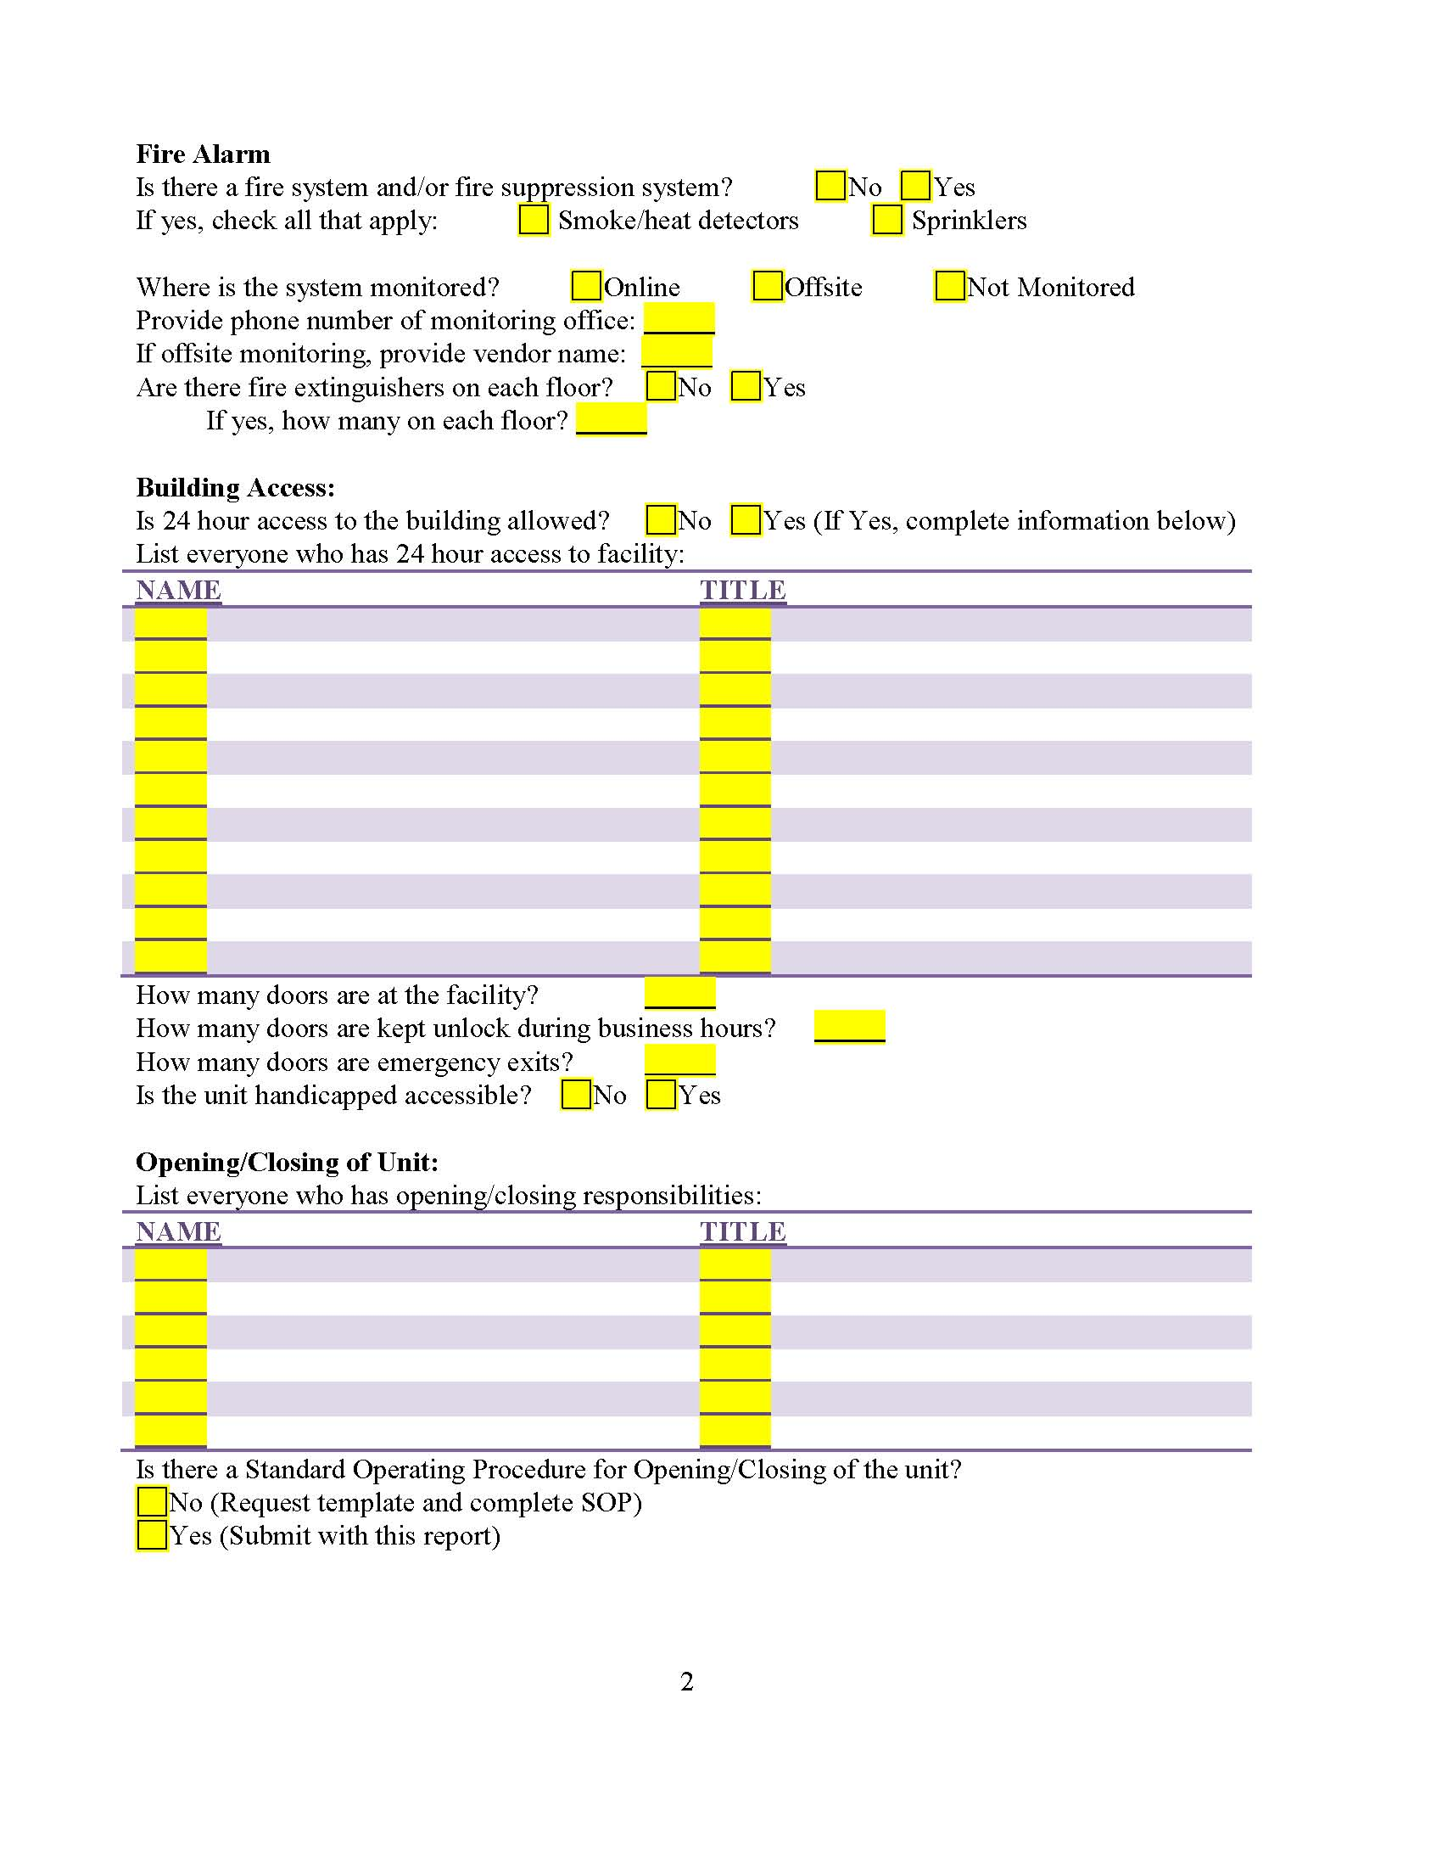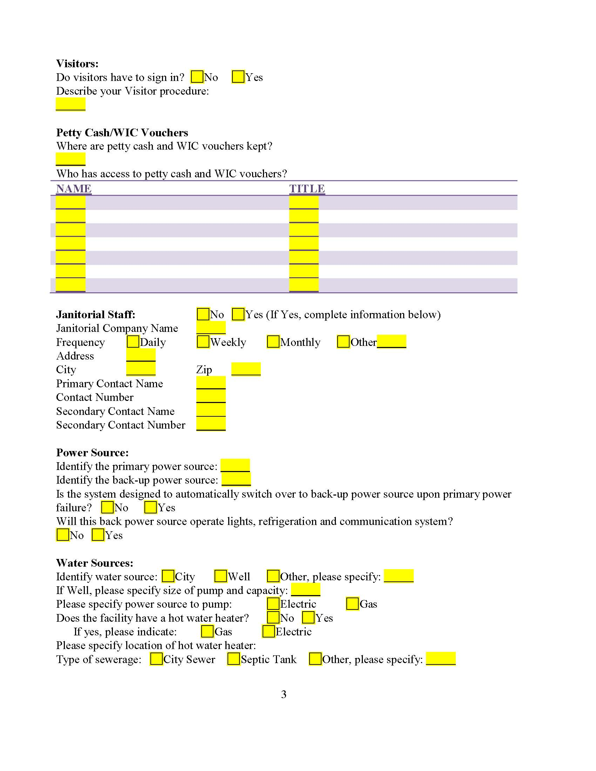
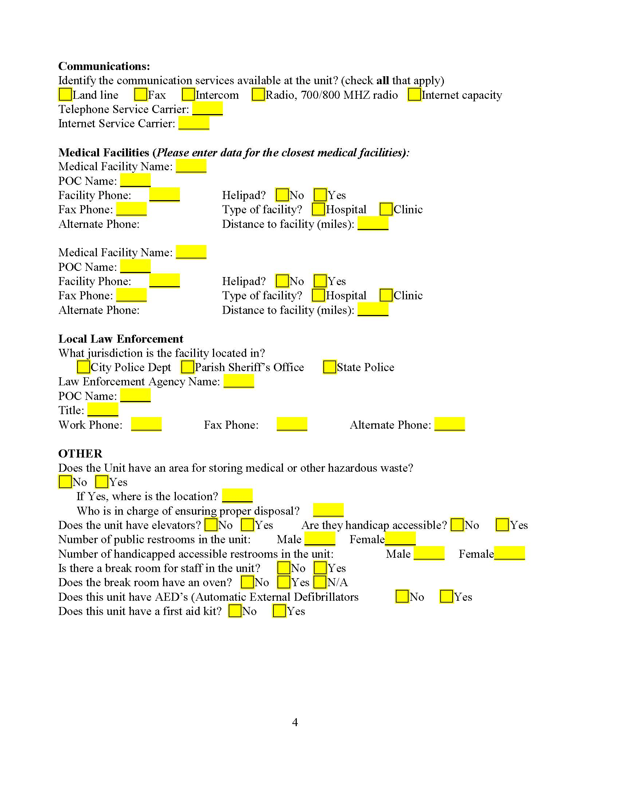

SAMPLE AUTHORIZATION FORM

Authorization for Building Access Card and/or Building Office Key

Specify Option: Building/Office Key_______Building Access Card______

Employee Name: ___________________________

Agency Name: _____________________________

Classification: ______________________________

Justification: _______________________________

I recommend that a building access card/office key be issued to the above named employee for the period of _______________________ (specify dates or separation).

__________________________ ___________________
Supervisor Date

Approved by: ____________________________ Date _______________

I acknowledge receipt of Building Access Card number: _________________

I acknowledge receipt of Building/Office Key to room number: ____________

I accept responsibility for the card/key and will not allow another person use of the card/key without the consent of the director and/or building manager. If the card/key is lost or stolen, I will report it to the director and the building manager immediately. I understand that upon separation from employment, the card must be returned no later than the date of separation.

_________________________________ ____________________
Employee Signature Date

I acknowledge that the above named employee returned the assigned building access card/key.

_________________________________ ____________________
Supervisor/Manager Date

