# Create Additional Users

1. Log in to the [Vendor Portal](https://lagoverpvendor.doa.louisiana.gov/irj/portal) with your ID (11 digit vendor number that begins with a “V”) and your personal password.
2. Click on “Create Additional Users” under “Detailed Navigation” on the left and the following screen will appear.

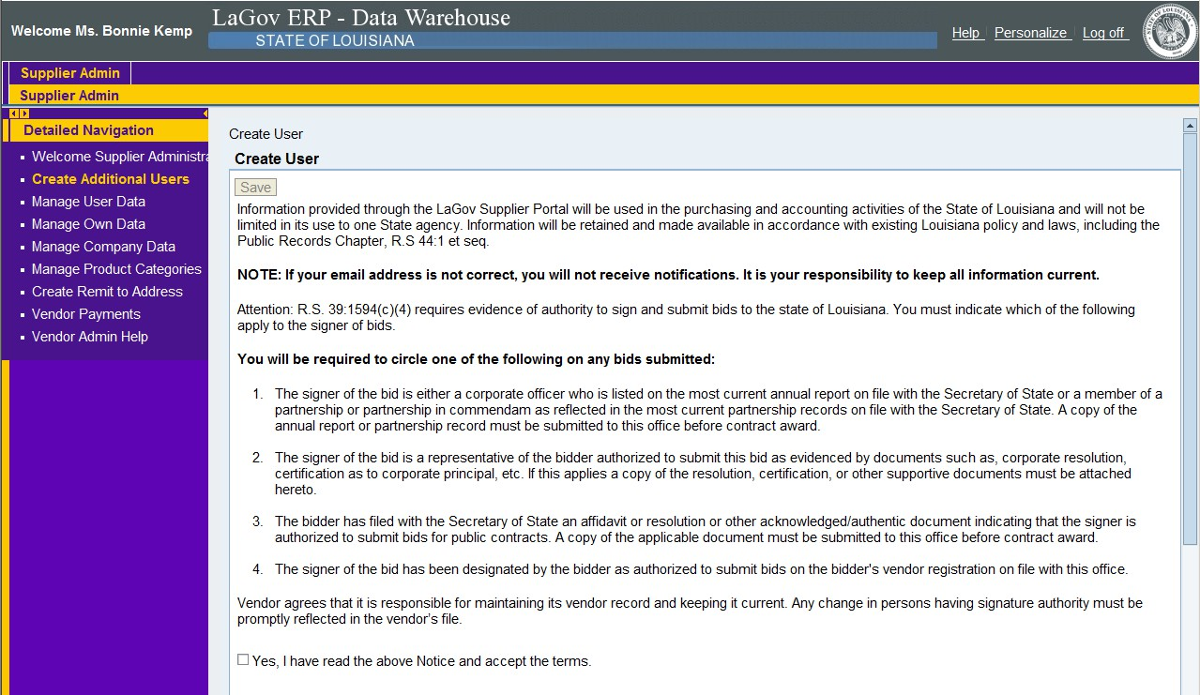

1. Read the above and click the “yes” box. DO NOT click “save” at this time. Once the entire page is completed, then you will be directed to scroll back up and click the “save” button at that time.
2. Complete the general user information, contact information and settings. All fields with an asterisk are required.

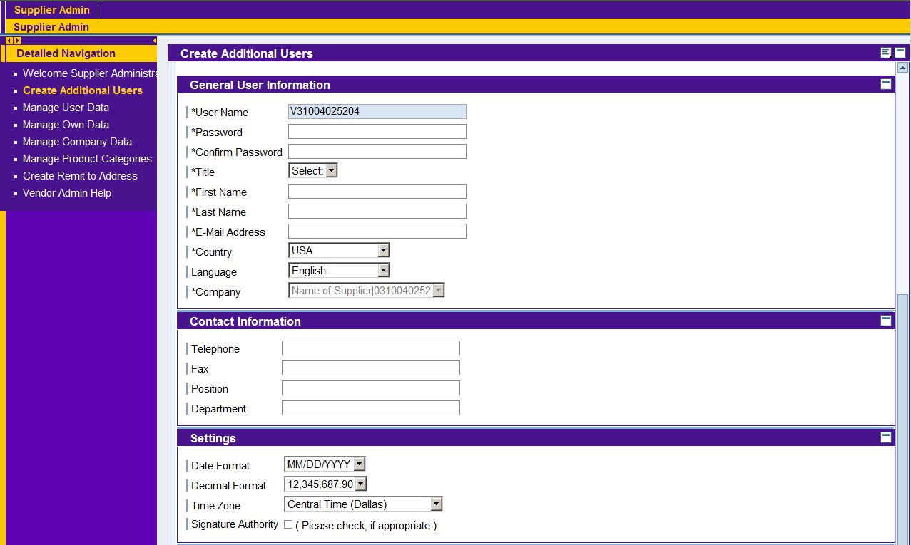

* + User Name: This field will not allow you to make any changes. You will notice that the user name defaults to your user name (ID) with a different suffix, which in this case is “02”.
  + Password: Create a unique password for the additional user and make a note of it.
  + Confirm Password: Re-enter the password for confirmation. Password requirements:
    - Must be at least 8 characters long
    - Must have at least 1 numeric character (0-9)
    - Must have at least 1alpha character, upper or lower case (A-Z or a-z)
  + Title: Select from the drop down box.
  + First Name: First name of the additional user.
  + Last Name: Last name of the additional user.
  + E-mail Address: Email address of the additional user.
  + Country: Select from the drop down box.
  + Language: Language of the additional user.
  + Company: This field will not allow you to make any changes.
  + Telephone: Telephone number of the additional user.
  + Fax: Fax number of the additional user.
  + Position: Additional User’s position with the company.
  + Department: Additional User’s department with the company.
  + Date Format: Use the drop down box to select the preferred date format for the additional user.
  + Decimal Format: Keep as a default setting.
  + Time Zone: Use the drop down box to select the appropriate time zone for the additional user.
  + Signature Authority: Check the box if the additional user has signature authority.

Scroll to the top and click “save”. (Not shown in the above screen but will be available for you.)

1. Review the added user. If you wish to edit, click “change” at the top of the screen, make the modification and then click “save”. To delete an additional user, go to the “Manage User Data” on the left navigation area. See help script on “Manage User Data”

NOTE: It is your responsibility to notify the additional user of their user name (11 digit vendor ID that begins with a “V”) and the temporary password that you created for them. You and your additional user(s) will receive an email notification of solicitations that are posted to LaPAC in your chosen product categories.