# Create Remit to Address

1. Log into the [vendor portal](https://lagoverpvendor.doa.louisiana.gov/irj/portal) with your ID (11 digit vendor number that begins with a “V”) and your personal password.
2. Click on **Create Remit to Address** under Detailed Navigation on the left and the following screen will appear.

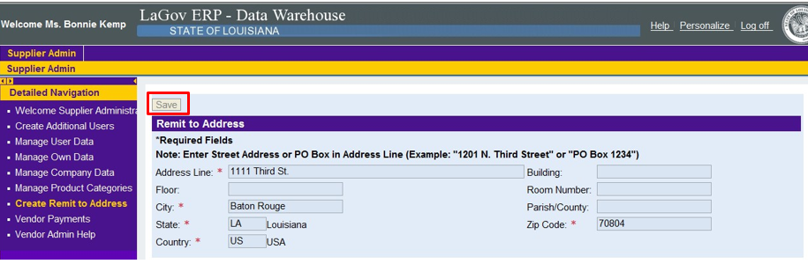

This can only be used to CREATE a remit to address. Enter the required information (*) for your remit to address and click **Save** at the top of the screen.

If an existing remit to address needs to be changed, contact the Office of Statewide Reporting and Accounting Policy’s Vendor Section at: [doa-osrap-lagov@la.gov](mailto:doa-osrap-lagov@la.gov) or (225) 219-6888