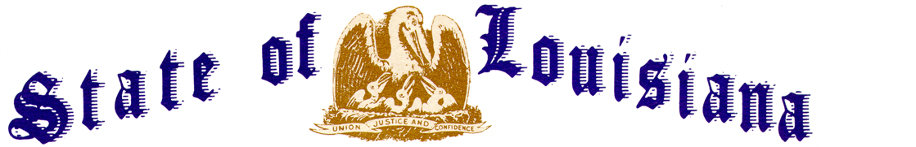
Executive Department
Office of the Governor
Executive Order Number JML 26-010
_____________________________________________________________________________

STATE OF EMERGENCY -
SUSPENSION OF EARLY VOTING
_____________________________________________________________________________

WHEREAS, several special elections have been set for February 7, 2026, including Special Legislative Primary Election (State Senator, 3rd Senatorial District, Parishes of Orleans and St. Bernard, State Representative, 37th Representative District, Parishes of Calcasieu and Jefferson Davis, State Representative, 60th State Representative District, Parishes of Assumption and Iberville, State Representative, 97th Representative District, Parish of Orleans, and State Representative, 100th Representative District, Parish of Orleans);
WHEREAS, the early voting period for this election is scheduled to begin on Saturday, January 24, 2026, at 8:30 a.m. and end on Saturday, January 31, 2026, at 6:00 p.m.;
WHEREAS, the National Weather Service has issued a Winter Storm Watch for much of the State effective Friday, January 23, 2026, with mixed snow, sleet, and ice expected to create significant impacts across the State;
WHEREAS, the National Weather Service has issued Cold Weather Advisories for much of the State beginning Saturday, January 24, 2026, with additional advisories and updates anticipated as forecast confidence increases;
WHEREAS, icy precipitation and accumulations are forecast to create hazardous conditions that will severely impact roadways, cause tree damage, and lead to power and other infrastructure outages;
WHEREAS, further impacts are anticipated due to extreme cold temperatures, with hard freezes expected to persist into next week in the southern parishes of the State and subfreezing temperatures continuing for 70 to 90 hours in the northern parishes;
WHEREAS, prolonged freezing temperatures have the potential to damage water systems, cause pipe failures, and disrupt essential services;
WHEREAS, extended power outages during periods of extreme cold present a serious threat to vulnerable populations;
WHEREAS, parishes statewide may require assistance from the State to provide resources to protect the life, safety, and welfare of the citizens of Louisiana;
WHEREAS, this is expected to be a prolonged winter event lasting through Monday, January 26, 2026;
WHEREAS, in response to this event, I have issued Executive Order JML 26-006, declaring a state of emergency across the entire state of Louisiana;
WHEREAS, the Commissioner of Administration has closed state offices statewide on Monday, January 26, 2026, due to the extreme weather;
WHEREAS, R.S. 18:401.1(A) provides a process, “to ensure maximum citizen participation in the electoral process and provide a safe and orderly procedure for persons seeking to qualify or exercise their right to vote, to minimize to whatever degree possible a person's exposure to danger during declared states of emergency, and to protect the integrity of the electoral process”;
WHEREAS, R.S. 18:401.1(B) provides, in pertinent part, “[t]he governor may, upon issuance of an executive order declaring a state of emergency or impending emergency, suspend or delay any qualifying of candidates, early voting, or elections. The governor shall take such action only upon the certification of the secretary of state that a state of emergency exists”;
WHEREAS, on January 23, 2026, the Secretary of State certified to the Governor that a state of emergency exists that would affect the electoral process, pursuant to R.S. 18:401.1;
WHEREAS, the Secretary of State has recommended an executive order be issued to suspend early voting in the parishes of Assumption, Calcasieu, Iberville, Jefferson Davis, Orleans, and St. Bernard on January 26, 2026, with early voting to resume in these parishes at 8:30 a.m. on Tuesday, January 27, 2026.
NOW THEREFORE, I, JEFF LANDRY, Governor of the State of Louisiana, by virtue of the authority vested by the Constitution and laws of the State of Louisiana, order and direct as follows:
Section 1: Early Voting is hereby suspended on Monday, January 26, 2026, from 8:30 a.m. until 6:00 p.m., in the parishes of Assumption, Calcasieu, Iberville, Jefferson Davis, Orleans, and St. Bernard. Early voting shall resume in these parishes at 8:30 a.m. on Tuesday, January 27, 2026.
Section 2: These elections shall continue to be held and conducted under the applicable provisions of the Louisiana Election Code, R.S. 18:1, et seq.
Section 3: This Order is effective upon signature and shall remain in effect from Friday, January 23, 2026, until Saturday, February 21, 2026, unless amended, modified, terminated, or rescinded earlier by the Governor, or terminated by operation of law.

IN WITNESS WHEREOF, I have set my hand officially and caused to be affixed the Great Seal of Louisiana in the City of Baton Rouge, on this 23rd day of January 2026.

__________________________________________
JEFF LANDRY
GOVERNOR OF LOUISIANA

ATTEST BY THE
SECRETARY OF STATE

__________________________________
Nancy Landry
SECRETARY OF STATE

