# Welcome Supplier Administrator

1. Log in to the [LaGov Vendor Portal](https://lagoverpvendor.doa.louisiana.gov/irj/portal) with your ID (11 digit vendor number that begins with a “V”) and your personal password.

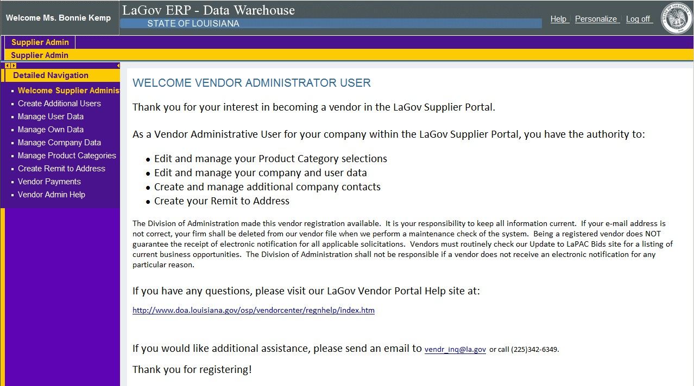

<http://www.doa.la.gov/pages/osp/vendorcenter/regnhelp/index.aspx>

1. Once you have registered, you can click in the left navigation pane to perform administrator functions. Help scripts exist for each of the topics on our [Vendor Registration Page](https://www.doa.la.gov/doa/osp/vendor-resources/).