DRIVER SAFETY
PROGRAM

LOSS PREVENTION UNIT
OFFICE OF RISK MANAGEMENT
DIVISION OF ADMINISTRATION

20260701
CONTENTS

DRIVER SAFETY PROGRAM

Introduction 2

Components of Louisiana’s Driver safety program 2

Agency Policies and Procedures 2

Responsibilities 2

Dept./Agency Heads, Drv. Safety Coor., or Pgm. Desig. 2

Supervisors 3

Employees 3

Authorization process 4

Preventive Maintenance 5

Training 5

Claims reporting/Accident investigation 6

Accident Reporting 6

Safety Audits and Record Keeping 6

Fleet management 7

Glossary 8

Appendix 10

Authorizing Drivers 11

How to Review an ODR 12

Official Certification of Driving Record (Sample) 13

Driver License Restriction Codes 14

Authorization and Driving History Form DA 2054 (Blank Sample) 15

Contractor Authorization and Driving History Form DA 2055 (Blank Sample) 17

Vehicle Checklist (Sample) 19

Accident Report DA 2041(Sample) 20

Authorization and Driving History Log (Sample) 21
DRIVER SAFETY PROGRAM

Introduction

R.S. 39:1543 requires the development of a comprehensive loss prevention program, for implementation by all state agencies, including basic guidelines and standards of measurement. The driver safety program is part of the Loss Prevention Program required by the Office of Risk Management (ORM) in accordance with LAC Title 37. Its purpose is to provide a systematic method of screening, training, and accountability for employees and supervisors required to assign or drive state-owned vehicles or personal vehicles on state business. ORM is required by state law to assess premiums to each state agency.

The following materials are included to assist administrators, supervisors, and loss prevention representatives in managing and implementing safe driving by state employees. A glossary and sample forms are included and described later in this section of the manual.

Components of Louisiana’s Driver Safety Program

- Agency Policies and Procedures:

  - Responsibilities – Each agency shall implement a written safe driving program. This program shall include rules defining:

    - Who shall be permitted to drive on state business.
    - Identifying employees authorized to operate motor vehicles under the agency’s control. Only those employees authorized by their agency head or designee shall be permitted to operate their personal vehicle or a state (owned or leased) vehicle on state business.
    - Policies shall outline the roles and responsibilities of managers, supervisors, and employees in driver safety. These policies shall be issued to all drivers and form the basis for the agency’s driver safety program.

Upon request, the Third-Party Administrator (TPA) shall assist agencies in organizing, directing, implementing, controlling, and providing training for a driver safety program that minimizes the adverse impact of motor vehicle accidents.

Department/Agency: Heads, Driver Safety Coordinators, or Program Designees

These individuals are responsible for implementation of the driver safety program and shall stress the importance of the department’s Driver safety program to all employees. Prior to authorizing state employees to drive, they are responsible for completing all of the following steps for employees that are authorized to drive:

- Verifying that each driver has a valid and properly classed driver’s license.
- Obtaining official driving records (ODRs) no longer than every twelve (12) months, reviewing them no later than forty-five (45) days from the date the ODR is obtained, and ensuring that employees meet all program requirements to be authorized to drive.
- Certifying that each employee has completed an ORM-recognized defensive driving course (e.g., LPOST, Loss Prevention instructor-led, National Safety Council, FLI, etc.) within 90 days of entering the program.
4. Signing and dating, along with the employee (if applicable), the Driving Authorization and
History Form (DA 2054). The DA2054 form can be used more than once if the authorized
agency representative signs and dates the supplemental signature sheet and attaches it to
the DA2054. The original form cannot be modified.
5. Notifying the appropriate supervisors which employees have been authorized to
drive or not authorized to drive.
6. Maintaining at each audited location a signed and dated list of employees who have been
authorized to drive or employees not authorized to drive at each audit location. (See
appendix).
- The list must be signed and dated at least annually and no later than twelve months from the previous list.
- The list shall be created/updated no more than 45 days from the date the ODRs are run.
- Employees who are hired or terminated throughout the year are not required to be added to or deleted from the authorized or unauthorized list more than annually except if it is determined in the year that they should be considered a high-risk or otherwise defined unauthorized driver, at which point they should be removed from the authorized list or added to the unauthorized list.
- The new list should be signed and dated and kept along with the existing list.
7. Ensure that policies and procedures are established and implemented; and
8. Training courses are conducted and documented.

Supervisors

Supervisors shall:

- Provide time for each authorized employee to complete the ORM on-line defensive driving course, ORM instructor- led defensive driving course, or another ORM-recognized defensive driving course.
- Allow only authorized employees to drive on state business.
- See that all vehicles provided to these employees are in safe operating condition, including
the use of a monthly checklist (e.g., DA424 or the MV3/4).
- Follow through that all deficiencies noted during the inspections are corrected and such
actions documented.
- Ensure that all accidents and incidents are properly reported and said records are maintained.

Employees

1. Employees shall only operate those vehicles for which they are licensed and insured.
2. Employees who are authorized to drive state vehicles are responsible for the safe
operation of those vehicles.
3. Drivers shall report any unsafe condition or accident involving state vehicles to their
supervisor or designee. Accidents by employees in their personal vehicle after hours need
not be reported unless the employee was ticketed.
4. Employees who drive their personal vehicle on state business shall be required to sign the
DA2054 form attesting that they currently carry at least the required minimum vehicle
Insurance.
5. Employees shall immediately report any revocation of their driver’s license or any moving
violations received to their supervisor, but no later than their next scheduled workday. Said
reporting applies whether on state or personal/private business and whether in a state or
personal/private vehicle.
- Employees shall not use a wireless telecommunications device while driving in a state-
owned, leased, or private vehicle that is being driven on state business. This includes
writing, sending, or reading a text-based communication and engaging in a call. Use of a
wireless telecommunications device is permissible for passengers in such vehicles.
Exceptions:
1. Report a traffic crash, medical emergency, or serious road hazard.
2. Report a situation in which the person believes his personal safety is in jeopardy.
3. Report or avert the perpetration or potential perpetration of a criminal act against
the driver or another person.
4. Engage in a call or write, send or read a text-based communication while the motor
vehicle is lawfully parked.

  - Authorization Process: Prior to approval by their agency head or his/her designee, the employee shall complete the DA 2054. The information on this form is used to acquire the ODR from the department of Public Safety, Office of Motor Vehicles. An ODR shall be obtained annually (i.e., no longer than every twelve (12) months between records). The DA2054 and the ODR are then submitted to the agency head or designee for review and compliance with requirements to be authorized to drive.

If an employee possesses an out-of-state license, the agency must either acquire a certified copy of the ODR from that state or require the employee to do so at his/her own expense. It is the agency’s responsibility to designate which employees are authorized to drive or NOT authorized to drive on state business.

The authorization process shall include:

- An annual review of the employee’s ODR.
- Only individuals possessing a current and proper class driver’s license shall be authorized by an agency to drive a motor vehicle on state business.
- Verifying (via the DA2054) that the employee can provide proof of liability insurance if he/she will use a personal vehicle to conduct state business. Requiring the employee to furnish proof is strictly up to each agency.
- Completing and passing of an ORM-recognized defensive driving course within 90 days of entering the program and a minimum of every three years thereafter.
- Developing a signed and dated list either of employees authorized to drive or employees NOT authorized to drive. Any person who is determined in the year to be a high-risk driver should be removed from the authorized list or added to the unauthorized list, whichever list the agency is updating. Such list must be kept at, or continuous access to it be provided for, each audited location at all times.
6. Determining when driving responsibility shall be taken away from an employee because of
moving violations, revocation of license, or lack of insurance for their private vehicle.

Within 45 days of obtaining the ODR, the agency head or designee shall review the ODR and
sign and date the DA 2054. NOTE: If there are no changes to the driver information, then the
DA2054 may be used on more than one occasion if the authorized agency personnel date and
sign the supplemental signature sheet and attach it to the DA2054 (See Appendix).

High-risk drivers shall not be authorized to drive vehicles on state business from the date of discovery for a minimum of twelve (12) months. High-risk drivers are those individuals:

- Having three or more convictions, guilty pleas, and/or nolo contendere pleas for moving violations within the previous twelve (12) month period or
- Having a single conviction, guilty plea, or nolo contendere plea for operating a vehicle while intoxicated, hit and run driving, vehicular negligent injury, reckless operation of a vehicle, or similar violation within the previous twelve (12) month period.

If an employee is not authorized to drive, that employee and his/her supervisor shall be notified in writing that they shall not drive on state business. The immediate supervisor and the fleet control officer shall be notified that this employee shall not be given authority to drive on state business, and that employee’s name shall be added/removed to/from the appropriate list.

C. Preventive Maintenance - The agency shall develop a preventive maintenance procedure and
a preventive maintenance schedule for each vehicle included in the program. It is
recommended that the agency follow the suggested manufacturer’s preventive maintenance
(PM) on vehicles.

D. Training – The TPA shall, upon request, assist each agency in implementing documented
driver safety training programs that address the needs of the agency and in identifying
training aids and resources that can be used for driver safety.

All authorized drivers shall successfully complete an ORM-recognized defensive driving
course within ninety (90) days of entering the program and shall complete a refresher course
at least once every three years unless their class of license requires other additional training
or testing.

A legible record (scanned, electronic, or hard copy) shall be kept showing all applicable items
listed below:

- Topics discussed (must be included in course name if using an online platform in place of a scanned or hard copy),
- Employees receiving the information,
- Instructor’s name,
- Teaching aids used,
- Date of training,
- Total number of employees on staff,
- Total number of employees in attendance at the training,
- Original signatures of employees on attendance sheets, or employee’s initials next to typed names on attendance sheets or verification of “received and read” by e-mails,
- certificates of completion,
- transcripts, and
- Employee suggestions or follow up.

Drivers who have convictions on their motor vehicle records shall be required to retake a recognized driving course within ninety (90) days of notification of a conviction. One such course, entitled High-Risk Driver, can be found here:

https://www.doa.la.gov/Pages/orm/Training.aspx

NOTE: Retaking the driving course due to a conviction does not reset the employee’s refresher training date.

E. Claims Reporting/Accident investigation – Upon request, the TPA will assist agencies in
conducting investigations into claims resulting from accidents involving vehicles used on
state business.

2. Accident Reporting

A. A vehicular accident is defined as any incident in which the vehicle comes in contact with
another vehicle, person, object, or animal that results in death, personal injury, or property
damage, regardless of: who was injured, what was damaged or to what extent, where it
occurred, or who was responsible.

All accidents shall be reported to the employee’s immediate supervisor and the Driver Safety Coordinator by the driver of the state vehicle on the day of the accident. If the driver is not able to complete the Louisiana State Driver’s Accident Report Form (DA 2041), then the driver’s supervisor will complete the report to the best of his/her ability for the employee. The supervisor may enter identifying information and attach the police report. The DA 2041 shall be completed within 48 business hours after any vehicle accident while on state business and forwarded to the TPA’s Claims Unit. The DA 2041 form can be downloaded from: https://www.laorm.com. (See appendix).

If the accident involves a workers’ compensation claim, it must be reported to the TPA. A completed DA2000 form is no longer required for automobile accidents.

(Note: When an accident occurs in either an employee’s personal vehicle or a rental vehicle while he/she is on state business, complete the DA2041 and note whether or not the vehicle is rented or personal.)

A copy of the Uniform Motor Vehicle Traffic Accident Report (police report) shall accompany the DA 2041 or should be sent to the TPA’s Claims Unit as soon as it is received by the agency. Do NOT delay submission of the DA 2041 waiting on the police report.

    - Failure of an authorized driver to report any vehicular accident may be cause for
suspension of driver authorization.

    - The supervisor of the authorized driver involved in an accident shall review the accident report within two working days of the accident for completeness of information. Incomplete reports shall be returned for completion or corrected information. The supervisor may assist the individual in completing the report. All accidents require completion of the DA 2041.

    - The supervisor (or safety coordinator, if appropriate) may consider what corrective action(s) may be necessary for accidents thought to be preventable. The corrective action(s) may include: temporary suspension of driving privileges, special training, physical examination, etc.

    - Agency heads, or the designee, will review the Accident Report Form, the Uniform Motor Vehicle Traffic Accident Report (police report – if one was completed), and the Authorization and Driving History Form (DA 2054).

3. Safety Audits and Record Keeping:

The TPA shall, upon request, assist agencies in reviewing and analyzing the driver safety program to ensure it is properly designed to have the intended impact. Data concerning the type, frequency, and amount of claims shall be provided to the agency. By providing this data, the Unit assists the agencies in identifying where losses are occurring and how the losses may be reduced or eliminated.

Driver safety program records shall be maintained at the agency location and/or a central location designated by the agency for review. Specifically, for each of the following:

- DA2054 forms, ODRs, high-risk driver documentation (e.g., re-training records, letters), vehicle inspection forms, preventive maintenance records - from both of the previous two (2) fiscal years.

    - DA 2041 forms or claims reporting system forms and proof (e.g., copy of sent email receipt, copy of TPA claims report, or fax receipt) of their submission within the 48-hour required timeframe

- Driver training (initial, refresher) documentation – from the two (2) most recent training sessions.

However, agencies shall maintain at, or provide continuous access to, each audited location a list of employees who have been authorized to drive or employees not authorized to drive at each audit location.

4. Fleet Management:

Each agency that provides for the use of state vehicles by employees to conduct official business
is expected to adhere to the requirements of the State’s Fleet Management Program (Title 4,
Part V, subchapter F; Title 34, Part XI of the Louisiana Administrative Code).
GLOSSARY

- Louisiana State Driver Safety Program Accident Report (DA 2041): This form is completed for any vehicular accident that occurs while being operated on state business. It is critical that employees and supervisors understand their roles in reporting accidents and accurately describing what occurred in a vehicular accident.

- Agency Head: The highest authority within a subsidiary of a department.

- Authorization and Driving History Form (DA 2054): Record that is maintained by the agency on each employee who drives on state business. The form shows:
- The employee’s current personal information (name, license number)
- Employment information (supervisor)
- When an employee was authorized to drive
- The date of his/her last defensive driving class
- Certification by the employee that he/she maintains liability insurance as required by
state law
- The signature of the agency head or designee authorizing the employee to drive

D. Department Head: The highest authority within the branches of state government.

E. Designee: Individual(s) specifically designated by the department/agency head to act on their
behalf.

F. Driver Safety Coordinator: Individual appointed by department/agency head to plan, organize,
direct, and control the driver safety program for the agency.

G. Guilty Plea: The admission of guilt from the defendant to each charge of the commission of a
violation.

H. High-Risk Driver: Individuals having three or more convictions, guilty pleas, and/or nolo
contendere pleas for moving violations or individuals having a single conviction, guilty plea, or
nolo contendere plea for operating a vehicle while intoxicated, hit and run driving, vehicular
negligent injury, reckless operation of a vehicle or similar violation, within the previous twelve (12)
month period.

I. Hit and Run: The intentional failure of the driver of a vehicle involved in or causing any accident,
to stop such vehicle at the scene of the accident, to give his identity, and to render reasonable
aid.

J. Moving Violation: A moving violation occurs whenever a vehicle is in motion. Examples of
moving violations include: speeding, running a stop sign or red light, driving without
a license, making a left turn from the right-hand lane.

K. Negligent Injury: The inflicting of any injury upon the person of a human being when caused
proximately or caused directly by an offender engaged in the operation of, or in actual physical
control of, any motor vehicle, aircraft, watercraft, or other means of conveyance whenever any of
the following conditions exist:

  - The operator is under the influence of alcoholic beverages.
  - The operator’s blood alcohol concentration is 0.08 percent or more by weight based upon grams of alcohol per one hundred cubic centimeters of blood.
  - The operator is under the influence of any controlled dangerous substance listed in Schedule I, II, III, IV, or V as set forth in R.S. 40:964.
  - The operator is under the influence of a combination of alcohol and one or more drugs that are not controlled dangerous substances and which are legally obtainable with or without prescription.
  - The operator is under the influence of one or more drugs that are not controlled dangerous substances and which are legally obtainable with or without a prescription and the influence is cause by the operator knowingly consuming quantities of the drug or drugs that substantially exceed the dosage prescribed by the physician or the dosage recommended by the manufacturer of the drug.

L. Nolo Contendere: “No contest” – has the same effect as a plea of guilty, as far as the sentence is
concerned, but may not be considered as an admission of guilty for any other purpose.

M. Official Driving Record (ODR): Record maintained by the Office of Motor Vehicles on each driver in the
State of Louisiana containing history of driver violations and accidents.

N. Reckless Operation: The operation of any motor vehicle, aircraft, vessel, or other means of
conveyance in a criminally negligent or reckless manner.

O. State Business: Any legal and lawful activity conducted/engaged in by an employee or agent of the
State of Louisiana, on behalf of and benefiting the state in the course and scope of their duties.

P. State Vehicle: Any licensed vehicle owned, leased, and/or rented by the State of Louisiana.

Q. Unauthorized (“NOT authorized”) Driver: A driver shall be considered “NOT” authorized if any of the
following occur:

- Meets the high-risk driver definition
- Does not complete/pass the ORM-recognized driver course within the allowed time period
- He/she does not hold a valid driver’s license
- The ODR isn’t cleared of all flags as noted in item #5 of “How to review an ODR” (in Appendix)
- The Authorization and Driving History Form (DA 2054) has not been completed and signed by both
the employee and agency head/designee annually.
- Is a student not employed by the State of Louisiana.

R. Vehicular Operation While Intoxicated: A vehicle operator shall be considered under the influence
when:

- The operator is under the influence of alcoholic beverages; or
- The operator’s blood alcohol concentration is 0.08 percent or more by weight based on grams
of alcohol per one hundred cubic centimeters of blood; or
- The operator is under the influence of any controlled dangerous substance listed in Schedule I, II,
III, IV, or V as set forth in R.S. 40:964; or
- The operator is under the influence of a combination or alcohol and one or more drugs that are
not controlled dangerous substances and which are legally obtained with or without a prescription.

S. Vehicular Accident: Any collision in which the vehicle comes in contact with another vehicle,
person, object, or animal – which results in death, personal injury, or property damage (regardless of:
who was injured, what was damaged or to what extent, where it occurred or who was responsible).

T. Wireless Telecommunications Device: Any type of instrument, device, or machine that is capable
of transmitting or receiving telephonic, electronic, radio, text, or data communications, including but
not limited to a cellular telephone, a text-messaging device, a personal digital assistant, a computer,
or any other similar wireless device that is designed to engage in a call or communicate text or data.

APPENDIX

Steps for Authorizing Drivers

Process for Reviewing an Official Driving Record (ODR)

Examples of:
Official Driving Records (ODR)
Driver’s License Restriction Codes
Authorization and Driving History Form (DA 2054)
Louisiana State Driver’s Accident Report Form (DA 2041)
Sample Vehicle Inspection Checklist
Authorizing Drivers

- Agency head or designee reviews the Official Driving Record that is requested and issued by
the applicable State Office of Motor Vehicles to ensure the employee does not meet the high-
risk driver definition (see ODR Review Instructions).

- Agency head or designee verifies that the employee has passed an ORM recognized defensive driving course within ninety (90) days of entering the program and is repeated every three (3) years.

- Employee shall read and sign the Employee Acknowledgement/Authorization section
of the Authorization and Driving History Form (DA 2054).

- If the employee meets all of the above requirements, that employee may be authorized to drive on state business.

- Only the agency head or his/her designee may review and authorize an employee to drive on state business. The authorization form shall be signed and dated by the agency head or his/her designee. The ODR shall be attached to the DA 2054 or other acceptable authorization format.

- A signed and dated list indicating who is authorized to drive or not authorized to drive on state business shall be completed after all employee records have been reviewed and then released to the proper supervisor/fleet control manager. This list shall be available at the audited location for the Loss Prevention Officer’s review upon request.

7. The department head or his/her designee is allowed to deem contractors as authorized
drivers for official state business only. An executed DA2055 form is required, along with the
driver’s ODR and documentation of driver training, in advance of the authorized travel.
How to Review an ODR (Official Driving Record)

(See sample ODR form on p.13)

- Verify the employee name, address and license number match the information on the Driving Authorization Form (DA2054).

- Check the license expiration date.

- Check the license class and any restrictions that may affect the employee’s ability to drive.

- Verify any violations that were received in the past twelve months and whether these violations meet the high-risk driver definition in your agency’s policy.

- Make sure the following flags are not noted on the record above the violations section:

NI = No Insurance (i.e., NO LIABILITY SECURITY COVERAGE on the vehicle.)

- Individual’s driver’s license is blocked against renewal or re-issuance.
- DOES NOT mean a driver’s license suspension is imposed.
- If authorized by the agency, individual can still operate only a state-owned/leased/rented vehicle on state business (since the state’s insurance on such vehicles is primary). Use of a personal vehicle is prohibited until the NI flag has been resolved.

Revoked = The individual’s registering privileges are withdrawn.

Suspended = A suspension of the individual’s driving privileges

For further clarification, please contact ORM Loss Prevention Management.


Louisiana Department of Public Safety and Corrections
Office of Motor Vehicles
P.O. Box 64886
Baton Rouge, LA 70896

OFFICIAL CERTIFICATION OF DRIVING RECORD

Accident involvement indicated does NOT mean the individual was at fault or given a citation.

This document is for official agency use only.
This Official Online Driving record was issued: Date: / / Time:

3

DATE BIRTH DATE SEX LICENSE NO CLASS EXP DATE RESTRICITIONS

2
/ / M E NO RESTRCITIONS

1
NAME/ADDRESS
ENDR: NONE
71409 DIS 3
PER STATUS: SUS /AF/NI/*PUL* EX
5
N/C
03-19-02 SPEED EXCESS OF POSTED MAXIMUM 02-04-01

4

ALEXANDRIA JUDICIAL
PRIVATE VEHICLE

NUMBER OF ACCD: 0 NUMBER OF CONVS: 1 NUMBER OF RECORDS: 1

0104
DRIVER LICENSE RESTRICTION CODES

(This partial list represents those codes listed on the back of a Class E license. For a complete list,
please contact the Louisiana Department of Public Safety at: www.dps.state.la.us)

0, 00 NO RESTRICTION

01 CORRECTIVE LENS (Glasses/contacts).
02 OPERATING A VEHICLE ONLY WITH LICENSED DRIVER. In the case of applicants seventeen (17) years of age and above, this restriction will be issued to individuals needing more practical driving experience. An "02" restricted license may be renewed and it is permissible to include a "07" (motorcycle endorsement) with such a license. (See Section I, Policy/Procedure Statement #21.00).
In the case of applicants fifteen (15) or sixteen (16) years of age, this restriction shall be issued on all first time applications. A motorcycle endorsement may be placed on a learners permit for those 15 or 16 years of age, however, they are restricted to operating within a distance of three miles from the applicant's residence, unless a parent, tutor, or other person having custody is temporarily staying or residing at another location, where the applicant would be restricted to operating within three miles of that location. (See Section I, Policy/Procedure Statement #1 for various Class Requirements, and #6.1 for Driver Education Requirements).
03 USING LEFT OUTSIDE REARVIEW MIRROR. The restriction will be added to individuals who have impaired vision worse than 20/40 in either or both eyes. The "03" restriction does not mean that eyes cannot be improved.
04 EYES CANNOT BE IMPROVED. This is an information code designed to avoid the continued referral of an applicant whose vision cannot be improved.
Should not be added unless specified by the eye doctor.
05 AUTOMATIC TRANSMISSION. This will be added for applicants who have lost one or both legs, or have lost the use of one or both legs. If the applicant wears one or two artificial limbs, a driving test may be necessary to determine if he/she has adapted sufficiently for the safe operation of a motor vehicle without the necessity of the "05" restriction. In this case, restriction #40 (wearing artificial limb) would be required.
06 POWER STEERING. This is to be used when a physical handicap hinders the strength or movement of the applicant's arms. This would compensate for the loss of mobility of the arms to control the steering.

08 DAYTIME DRIVING ONLY. This restriction will apply when the applicant's visual acuity is not 20/70 or better in each eye or upon the recommendation of a vision specialist.

09 SPECIAL RESTRICTION. May be used for any restriction which is not covered with a specific restriction code, or when there are four (4) or more restrictions to be used. This special code should be suitable and appropriate to enable the applicant to operate a motor vehicle safely. Anytime this restriction is used, it must be completely explained to the applicant, whether it is for a new license issuance or a renewal. This restriction is hereby abolished. With new programming (6/01), computer will allow 6 endorsements. Also the use of the 60 restriction (Restriction Card) will be used if necessary.

43 SPECIFIC VISUAL FOR CDL. (Effective 12-01-90, must be used in conjunction with restriction #53). This restriction is to be used whenever CDL applicants can only achieve 20/40 (Snellen) visual acuity in one eye. EXAMPLE: Applicant is blind in one eye, but achieves 20/40 with or without corrective lenses in the good eye. Applicant must have been employed as a commercial vehicle driver continuously since March 31, 1990.

M MOTORCYCLE
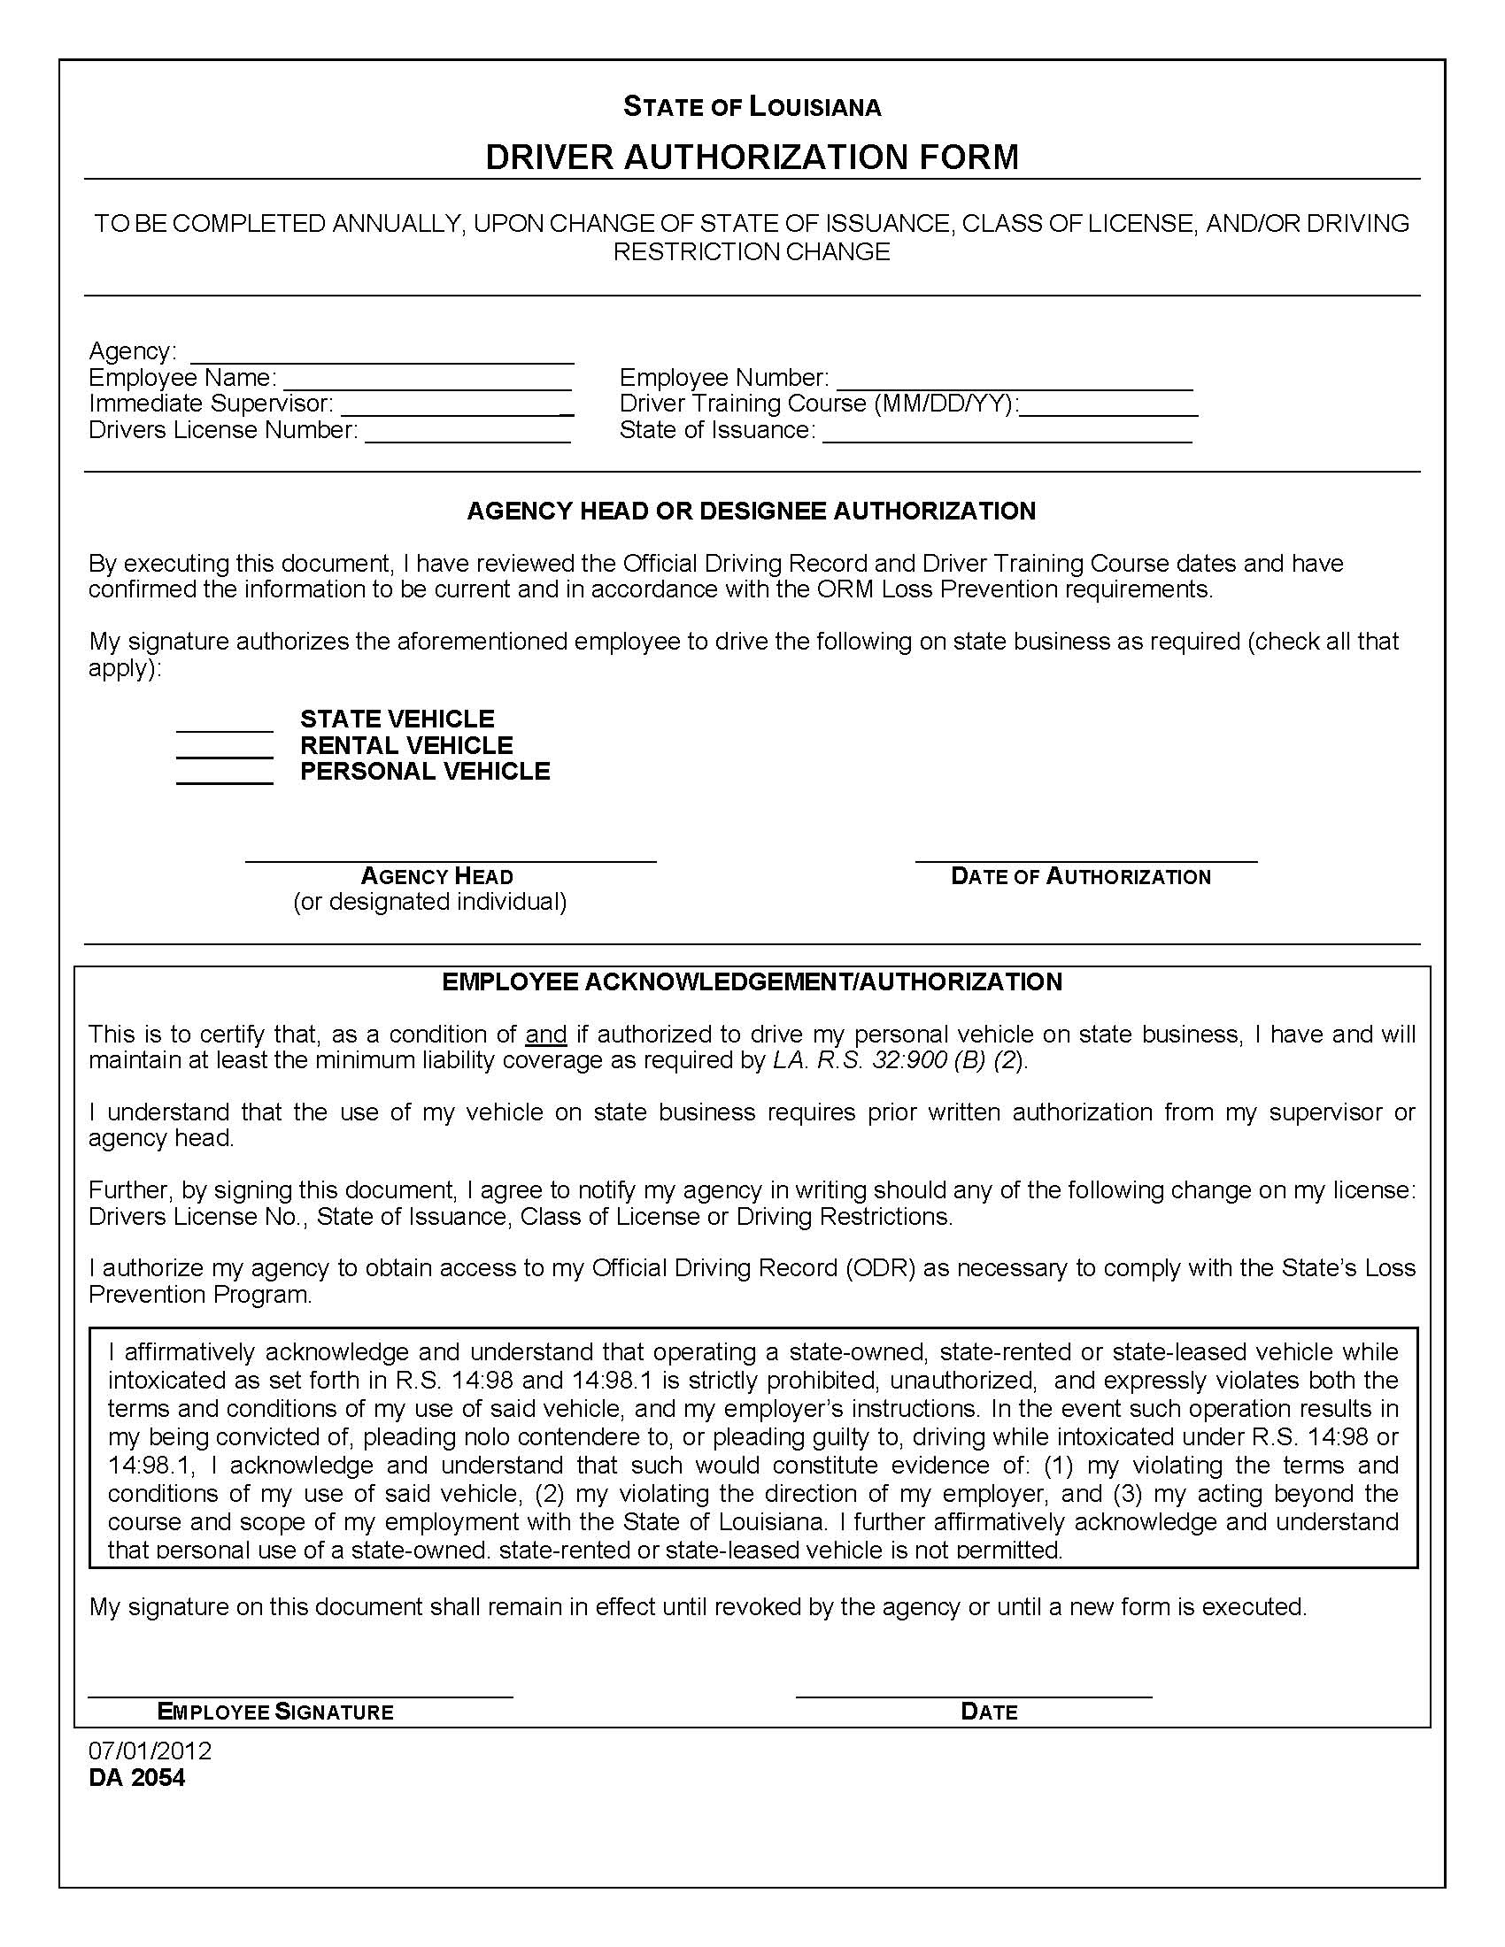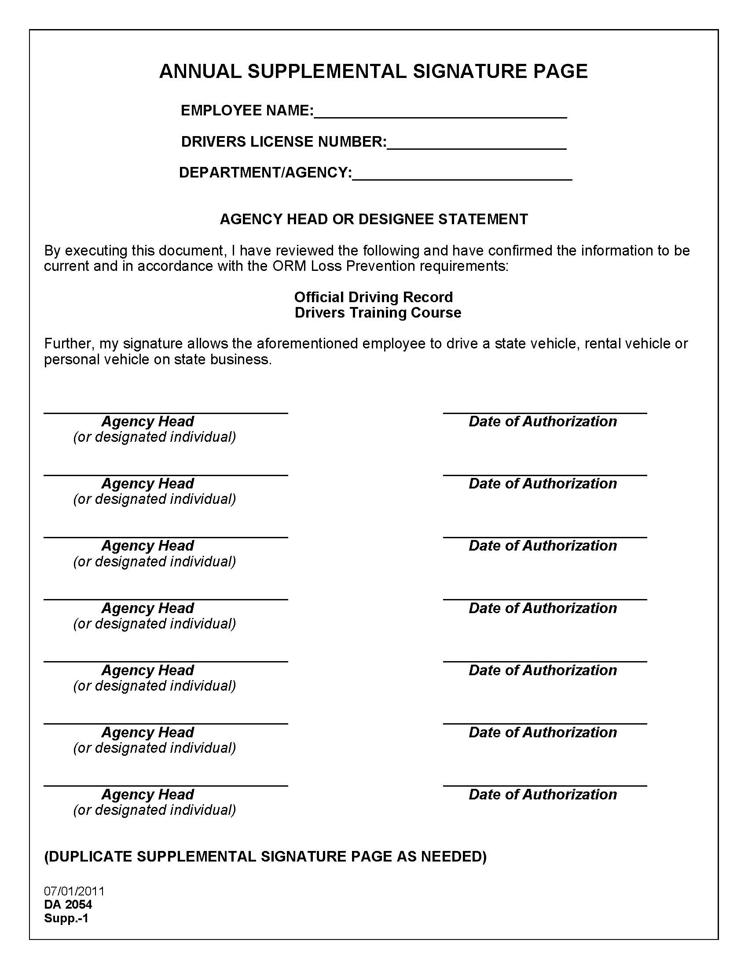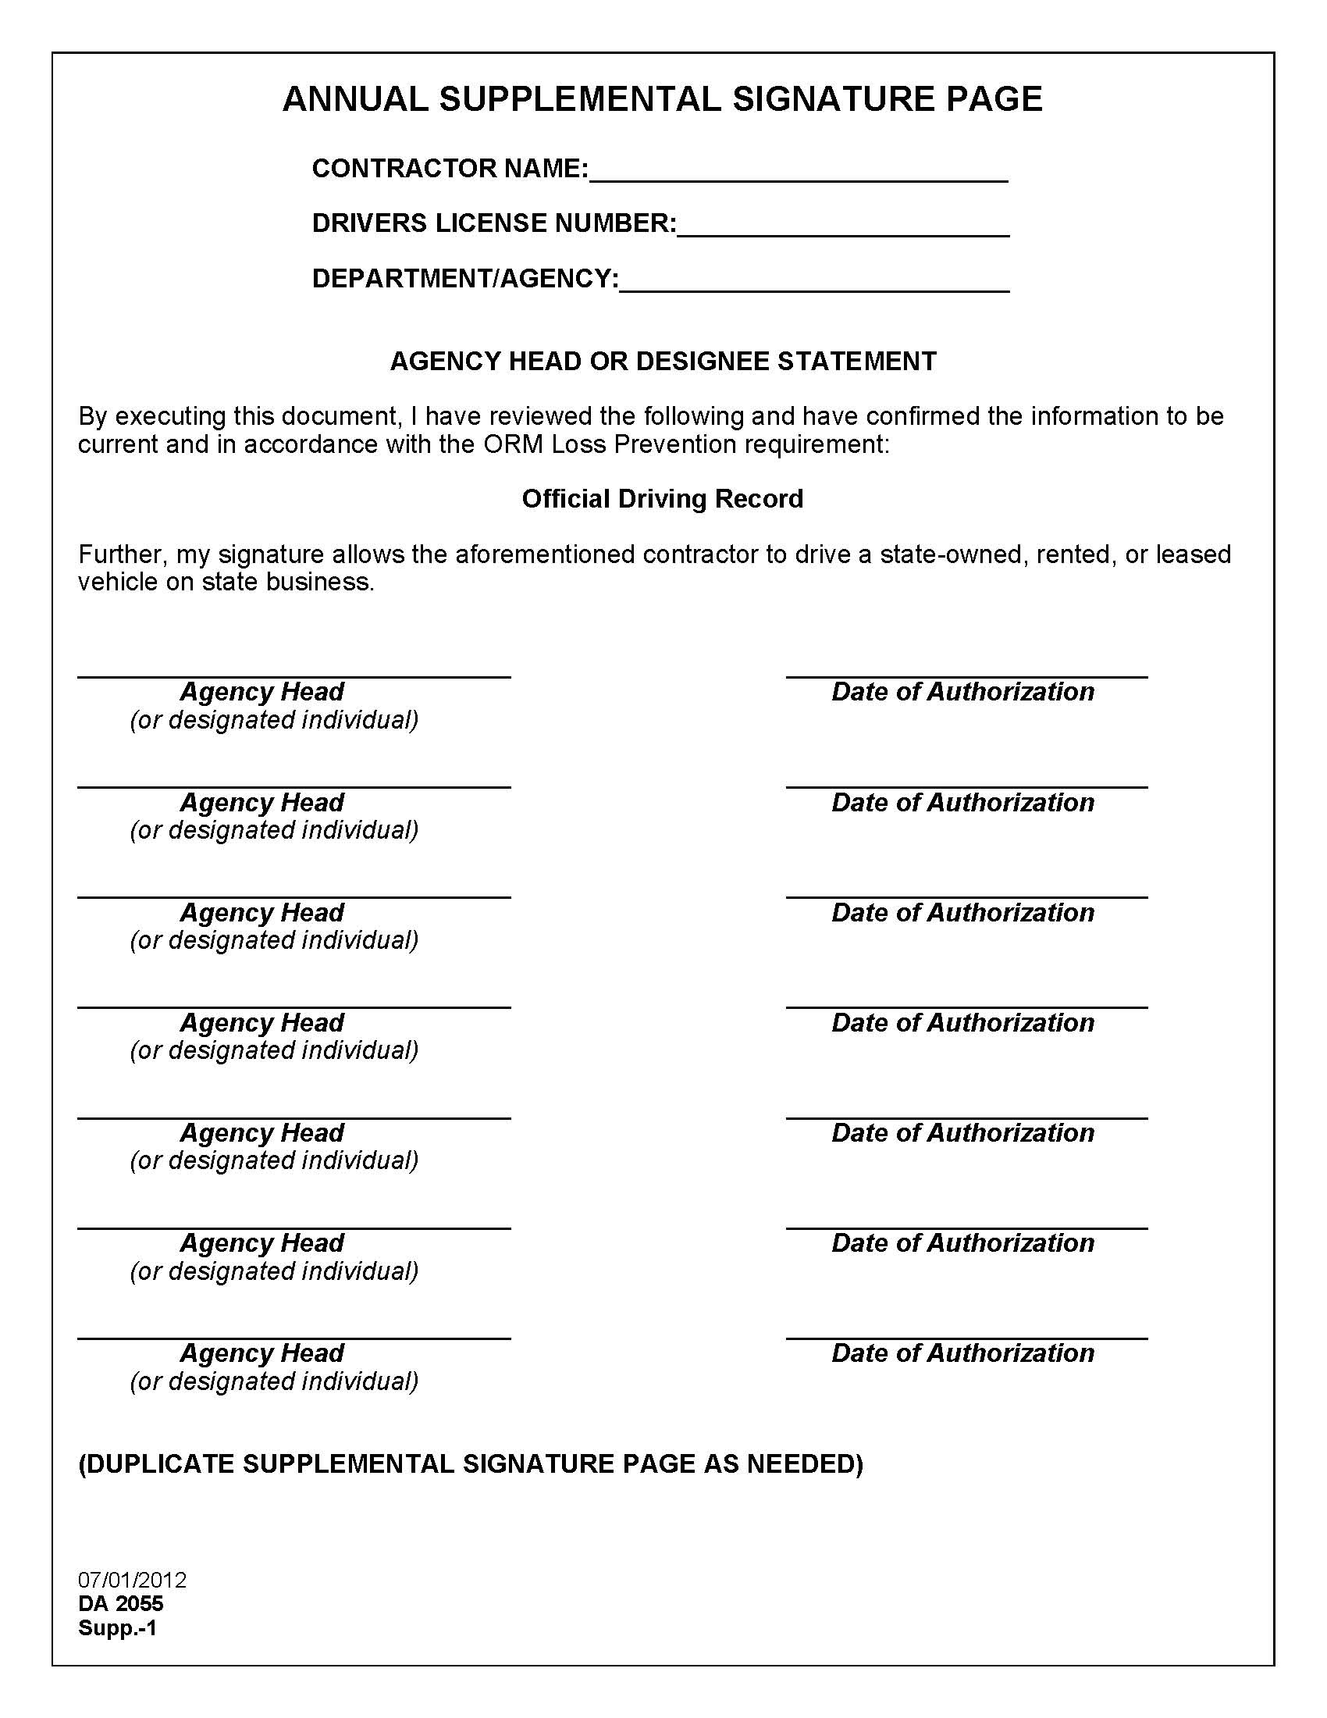
DA 2041
Rev. 12/98
ACCIDENT REPORT
LOUISIANA STATE DRIVER SAFETY PROGRAM

Submit report to ORM
within 48 hours of accident
Supervisor  to complete  first 4 items | 1. agency Name |  |  |  |  |  |  |  |  |  |  |  |  |  |  |  | 2. Person to Contact |  |  |  |  |  |  |  |  |  | 3. Phone  [ ] - |  |  |  |  |  |  |  |  |  | 4. Loc. Code
5. State Vehicle Driver’s Name |  |  |  |  |  |  |  |  |  |  |  |  |  |  |  |  | 6. Driver’s Social Security No.  - - |  |  |  |  |  |  |  |  |  | 7. Date of Accident  / / |  |  |  |  |  |  |  |  |  | 8. Time of Accident  AM  PM
9. Exact Location of Accident (Use street markers, mileage markers, etc., to pinpoint location)

10.
DESCRIBE
HOW ACC.
HAPPENED
11.Seat Belt in Use
Yes No
STATE VEHICLE INFORMATION

If other then vehicle damage, fill in as much as possible under “Other Vehicle” section substituting property owner information for vehicle driver.
12. State Vehicle Driver’s Address (Street No) |  |  |  |  |  |  |  |  | City |  |  |  |  | State |  |  |  |  | Zip Code |  |  |  |  |  |  | 13. Home Phone  [ ] - |  |  |  |  |  |  |  |  |  | 14. Work Phone  [ ] -
15. Driver’s License No. |  |  |  |  |  | 16. Age |  |  | 17. Sex  M F |  | 18. Vehicle’s Owner’s Name and Address
19. Year Vehicle |  |  |  | 20. Make Vehicle |  |  |  |  | 21. Model Vehicle |  |  |  | 22. Body Type |  |  |  |  |  |  |  |  |  | 23. Vehicle Lic. No. / Equip No. / VIN
24A. Where can the Vehicle be Seen? |  |  |  |  |  |  |  |  |  |  |  |  |  |  |  | 24B. Describe Damage
OTHER VEHICLE INFORMATION

If more than one vehicle is involved, submit additional sheet with information on other vehicle(s).
25. Other Vehicle Driver’s Name |  |  |  |  |  |  |  |  |  |  |  |  |  |  |  |  |  | 26. Driver’s Social Security No.  - - |  |  |  |  |  |  |  |  |  | 27. Driver’s License No. |  |  |  |  |  |  | 28. Age |  |  |  |  | 29. Sex  M F
30. Other Vehicle Driver’s Address (Street No.) |  |  |  |  |  |  |  |  | City |  |  |  |  |  | State |  |  |  |  | Zip Code |  |  |  |  |  |  |  | 31. Home Phone  [ ] - |  |  |  |  |  |  | 32. Work Phone  [ ] -
33. Vehicle Owner’s Name and Address (Street No.) |  |  |  |  |  |  |  |  |  |  |  |  |  |  | City |  |  |  |  |  |  |  |  |  | State |  |  |  | Zip Code
34. Year Vehicle |  |  | 35. Make Vehicle |  |  |  |  | 36. Model Vehicle |  |  |  | 37. Body Type |  |  |  |  |  |  |  |  |  |  |  | 38. Vehicle I.D. No. or Lic. No. |  |  |  |  | 39. Where can the vehicle be seen?
40. Other Vehicle Insurance Co. |  |  |  |  |  |  |  |  |  |  |  |  |  |  |  |  |  |  |  |  |  |  |  |  |  |  |  |  | 41. Policy No.
42. Describe Damage |  |  |  |  |  |  |  |  |  |  |  |  |  |  |  |  |  |  |  |  |  |  |  |  |  |  |  |  |  |  |  |  |  |  |  |  |  | 43.Estimated Amount  $ .
INJURED
44. Name and Address |  |  |  |  |  |  |  |  |  |  |  |  |  |  |  |  |  |  |  |  | 45. Phone  [ ] - |  |  |  |  |  |  |  |  | 46.  PED | 47.  Ins. Veh. |  | 48.  Other Veh. |  |  |  |  |  | 49. Police Investigated?  Yes No
44. Name and Address |  |  |  |  |  |  |  |  |  |  |  |  |  |  |  |  |  |  |  |  | 45. Phone  [ ] - |  |  |  |  |  |  |  |  | 46.  PED | 47.  Ins. Veh. |  | 48.  Other Veh. |  |  |  |  |  | 49. Type Report  State  Sheriff City
44. Name and Address |  |  |  |  |  |  |  |  |  |  |  |  |  |  |  |  |  |  |  |  | 45. Phone  [ ] - |  |  |  |  |  |  |  |  | 46.  PED | 47.  Ins. Veh. |  | 48.  Other Veh. |  |  |  |  |  | 49. Report No. (Item No.)
WITNESSES OR PASSENGERS
50. Name and Address |  |  |  |  |  |  |  |  |  | 51.  Witness  Passenger |  |  |  |  |  |  |  |  |  |  |  | 52. Phone  [ ] - |  |  |  |  |  |  |  | 53.  PED |  | 53.  Ins. Veh. |  | 53.  Other Veh. |  |  |  |  | 53. (Specify)
50. Name and Address |  |  |  |  |  |  |  |  |  | 51.  Witness  Passenger |  |  |  |  |  |  |  |  |  |  |  | 52. Phone  [ ] - |  |  |  |  |  |  |  | 53.  PED |  | 53.  Ins. Veh. |  | 53.  Other Veh. |  |  |  |  | 53. (Specify)
54. State Driver’s Signature |  |  |  |  |  |  |  |  |  |  |  |  |  |  |  |  |  |  |  |  |  | 55. Name of Driver’s immediate Supervisor and Phone No. |  |  |  |  |  |  |  |  |  |  |  | [ ] -

AUTHORIZATION AND DRIVING HISTORY LOG (SAMPLE)
