# Vendor Payments

1. LaGov [Vendor Payment](https://prdits.doa.louisiana.gov/venpay) Search Screen is displayed.

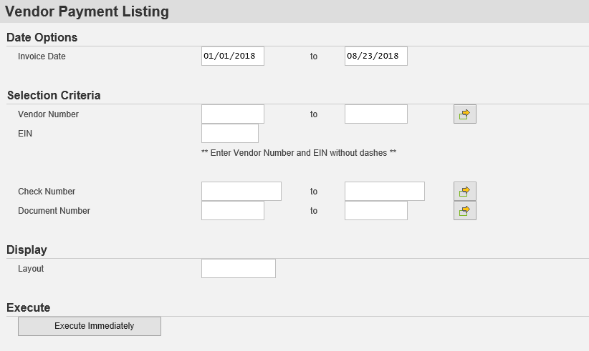

**Search Field Descriptions:**

**Invoice Date:** REQUIRED FIELD The date of the vendor invoice (not the date of the check) is what should be entered in this field. The two fields allow you to enter a range of dates. Be sure to set these dates far enough in the past and future to capture the date of any invoices that would be part of the received payment.

**Vendor:** REQUIRED FIELD This is your LaGov Vendor number. It will be a nine digit number. Leave off the “V” preceding the number and minus the “01” digits at the end. Your vendor number can be found on your printed check stub. If you need additional assistance in locating your vendor number, you can also search and find it through this online LaGov Vendor Number Search: https://wwwcfprd.doa.louisiana.gov/OSP/LaPAC/vendor/srchven2.cfm

**EIN:** REQUIRED FIELD Enter your Tax ID Number or your Social Security Number (if that is the number associated with your vendor record) without any dashes.

**Check Number:** This is the number of the check on which you are researching payment. It is not a required field. It is recommended to leave this blank when conducting a search.

**Document Number:** This is an internal system number associated with the payment. It is not a required field. It is recommended to leave this blank when conducting a search.

**Layout:** This field customizes the way the information returned in the search is displayed. This is not a required field. It is recommended to leave this blank when conducting a search.

1. Enter the search criteria (it is best to only to enter the required information of Vendor Number and EIN along with a wide invoice date search parameter).
2. Click “Execute Immediately” at the bottom of the search screen.

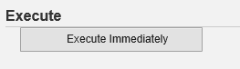

1. The search results screen will display basic payment information.

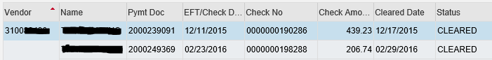

*If payment information is NOT displayed, ensure that (1) you are entering your vendor number and EIN correctly; (2) the invoice date range is sufficient; and (3) your payments are coming from a state agency utilizing the LaGov system. If the state agency issuing your payment is not utilizing LaGov, you will need to use the ISIS payment search to find payment information* (*https://wwwcfprd.doa.louisiana.gov/vendsearch/index2.cfm).*

1. To view additional payment details, double click any cell on the line you wish to “inquire”. Additional detailed information will display.

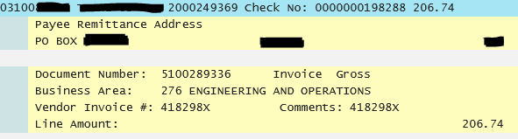

*When viewing additional payment details, if there are a significant number of invoices returning for a single payment; you will need to click on the green check in order to view all of the details. Once all of the check details have been displayed, clicking on the green check*

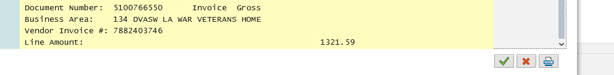

*again will close the detailed display.*