# **TOOLKIT FOR DOA WEB ACCESSIBILITY DESIGNEES**

## **OVERVIEW**

As a web accessibility designee, you are responsible for ensuring compliance with the Web Content Accessibility Guidelines (WCAG) for any web pages, mobile apps and/or social media accounts maintained by your DOA Section(s). This also includes ensuring the accessibility of any documents or forms, such as PDF’s, Word documents, Excel spreadsheets, etc. that your Section makes publicly available on its website.

## **TOOLS**

The Tools section includes a number of different applications, training videos and other learning resources that may be utilized to help with your web accessibility duties.

### **Umbraco**

This is the Content Management System (CMS) used to manage the content posted by your Section on the doa.la.gov website. If you do not already have an account login for Umbraco, please email [Tai.Istre@la.gov](mailto:Tai.Istre@la.gov) (OTS) to request access.

* Umbraco User Guide: Once logged in, access by selecting Media 🡪 Content Manager Resources 🡪 Umbraco User Guide.

### **WebAIM WAVE**

WAVE is a free tool that helps to identify potential WCAG accessibility errors. Complete the following steps in order to install and use the WAVE extension to your Google Chrome browser.

1. Install the Extension: Go to <https://wave.webaim.org/extension/> and select “WAVE Chrome Extension at the Google Web Store”
2. Add to Chrome: Click “Add to Chrome” and confirm installation
3. Run WAVE: Navigate to the webpage you want to check, and then click the Extenion icon as displayed in Google Chrome Extension button and select WAVE Evaluation tool from the Chrome toolbar
4. View Results: WAVE will display an interface on the left side of the page, highlighting issues with icons and offering details on each issue, including references and potential solutions

Keep in mind that it can only scan one webpage at a time, so if your Section has multiple pages on its site, the WAVE Extension must be run on each page separately.

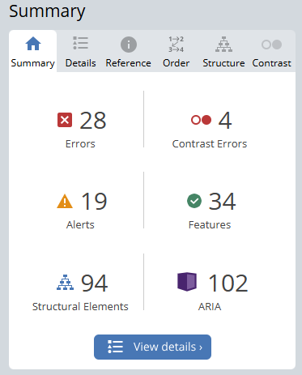Once the Summary results appear, you should focus on those items identified as Errors and Contrast Errors [color coded in red]. These are critical accessibility issues that need to be fixed. Yellow Alerts indicate potential issues that may need to be evaluated and prioritized once all red errors have been resolved.

Other colored notices provide reporting information about structural elements (blue); ARIA, which is behind-the- scenes coding (purple); and features (green).

* [Introduction to WAVE](https://youtu.be/ITUDiTgAZY0) [video]
* [WAVE Quick Reference Guide: Testing Web Content for Accessibility](https://webaim.org/resources/evalquickref/#:~:text=Watch%20the%20overview%20video%20on,page%20code%20with%20WAVE%20icons.)
* [Quick Start for Evaluating and Testing Web Accessibility](https://youtu.be/LHUmoPJgOEU?si=U4IvQf-WwDUEtynZ) [video]

### [**TPGi’s Colour Contrast Analyser (CCA)**](https://www.tpgi.com/color-contrast-checker/)

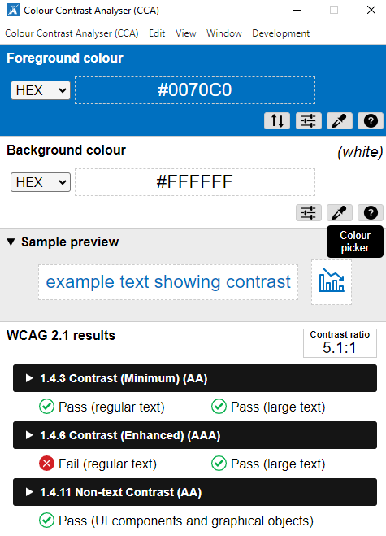WCAG guidelines require certain color contrast ratios between the foreground and background colors used for text. This is to ensure that there is enough visual difference between colors that people with low vision or color blindness can distinguish them. You may need to submit an OTS help desk ticket in order to request to have the Colour Contrast Analyser installed on your computer.

Once installed, select the eyedropper icon under the Foreground colour heading. Next, you go to the document or website you want to test and click your mouse on the foreground color. Repeat these steps for the Background colour as well. It will then show you the contrast ratio and a Pass/Fail indicator.

### **Microsoft Word Accessibility Checker**

Microsoft Word offers a built-in Accessibility Checker in order to identify issues that may make a document difficult for people with disabilities to use. Similar to WAVE, the Word Accessibility Checker will produce Inspection Results that are categorized as either Errors (most serious issues), Warnings (less serious but still make it difficult to access), and Tips (other issues that might make the document more readable for people with disabilities).

Depending on the version you are operating, the Accessibility Checker may be accessed by selecting File 🡪 Check for Issues 🡪 Check for Accessibility (OR) Review 🡪 Check Accessibility.

* [Check the accessibility of your document](https://support.microsoft.com/en-us/office/video-check-the-accessibility-of-your-document-9d660cba-1fcd-45ad-a9d1-c4f4b5eb5b7d) [video]
* [Improve accessibility with alt text](https://support.microsoft.com/en-us/office/video-improve-accessibility-with-alt-text-9c57ee44-bb48-40e3-aad4-7647fc1dba51) [video]
* [Improve accessibility with heading styles](https://support.microsoft.com/en-us/office/video-improve-accessibility-with-heading-styles-68f1eeff-6113-410f-8313-b5d382cc3be1) [video]
* [Create accessible links in Word](https://support.microsoft.com/en-us/office/video-create-accessible-links-in-word-28305cc8-3be2-417c-a313-dc22082d1ee0) [video]
* [Create accessible tables in Word](https://support.microsoft.com/en-us/office/video-create-accessible-tables-in-word-cb464015-59dc-46a0-ac01-6217c62210e5) [video]

### **Microsoft Excel Accessibility Checker**

The built-in Accessibility Checker in Microsoft Excel works similarly to the one in Word. Depending on the version you are operating, the Accessibility Checker may be accessed by selecting File 🡪 Check for Issues 🡪 Check for Accessibility (OR) Review 🡪 Check Accessibility.

* [Best practices for making Excel spreadsheets accessible](https://support.microsoft.com/en-us/office/accessibility-best-practices-with-excel-spreadsheets-6cc05fc5-1314-48b5-8eb3-683e49b3e593#bestpractices_win)
  + [Create accessible tables](https://support.microsoft.com/en-us/office/accessibility-best-practices-with-excel-spreadsheets-6cc05fc5-1314-48b5-8eb3-683e49b3e593#createaccessibletables_win)
  + [Use an accessible template](https://support.microsoft.com/en-us/office/accessibility-best-practices-with-excel-spreadsheets-6cc05fc5-1314-48b5-8eb3-683e49b3e593#usetemplate_win)
  + [Add text to cell A1](https://support.microsoft.com/en-us/office/accessibility-best-practices-with-excel-spreadsheets-6cc05fc5-1314-48b5-8eb3-683e49b3e593#addtexttoa1_win)
  + [Add alt text to visuals](https://support.microsoft.com/en-us/office/accessibility-best-practices-with-excel-spreadsheets-6cc05fc5-1314-48b5-8eb3-683e49b3e593#bkmk_altvisuals_win)
  + [Create accessible charts](https://support.microsoft.com/en-us/office/accessibility-best-practices-with-excel-spreadsheets-6cc05fc5-1314-48b5-8eb3-683e49b3e593#createaccessiblecharts_win)
  + [Rename worksheets](https://support.microsoft.com/en-us/office/accessibility-best-practices-with-excel-spreadsheets-6cc05fc5-1314-48b5-8eb3-683e49b3e593#bkmk_renamesheet_win)
  + [Delete blank worksheets](https://support.microsoft.com/en-us/office/accessibility-best-practices-with-excel-spreadsheets-6cc05fc5-1314-48b5-8eb3-683e49b3e593#bkmk_deletesheets_win)
  + [Test the accessibility of your worksheets](https://support.microsoft.com/en-us/office/accessibility-best-practices-with-excel-spreadsheets-6cc05fc5-1314-48b5-8eb3-683e49b3e593#testa11y_win)

### **Adobe Pro PDF Accessibility Checker**

Making an accessible PDF document is a complex process. It starts with ensuring the accessibility of the source document (such as Word or Excel) before converting it to PDF. Once converted, there are numerous steps involved, such as adding fillable form fields and descriptions, setting the tab order, tagging the PDF, etc.

It is recommended that you use PDF’s as a “format of last resort.” This means providing content in other file formats (such as Word or Excel) if possible. If it must be a PDF, then you must ensure it is formatted for accessibility.

* [Workflow for creating accessible PDFs](https://helpx.adobe.com/acrobat/using/creating-accessible-pdfs.html)
* [Create and verify PDF accessibility](https://helpx.adobe.com/acrobat/using/create-verify-pdf-accessibility.html)
* [Accessibility features in PDFs](https://helpx.adobe.com/acrobat/using/accessibility-features-pdfs.html)
* [Reading Order tool for PDFs](https://helpx.adobe.com/acrobat/using/touch-reading-order-tool-pdfs.html)
* [Edit document structure with the Content and Tags Panels](https://helpx.adobe.com/acrobat/using/editing-document-structure-content-tags.html)
* [Creating Accessible PDFs with Adobe Acrobat Pro DC](https://www.youtube.com/watch?v=ndNuOHeA4CI) [video by UA Technology Accessibility]

### **Map Accessibility**

If your website includes a map, please be aware that the map must be made accessible. This can be complicated depending on the type of map, how it was designed, and the extent of information presented. Some resources that may be of assistance regarding how to make maps accessible include:

* [Accessibility Guide for Interactive Web Maps](https://mn.gov/mnit/assets/Accessibility%20Guide%20for%20Interactive%20Web%20Maps_tcm38-403564.pdf) [developed by the State of Minnesota]
* [Accessibility Guide for Static Digital Maps](https://mn.gov/mnit/assets/static-map-accessibility-guide_tcm38-375672.pdf) [developed by the State of Minnesota]
* [Making Maps Accessible in PDF Documents](https://www.doi.gov/ocio/section508/video2) [video by Sr. Product Manager for Adobe]

## **NEXT STEPS**

First, do some hands-on experiments! Go through the various links and resources provided to understand what tools are available and how they work. Test them out on various webpages or documents that your Section provides to the public to see what kind of issues may be identified.

Then, by September 30, 2025, please be sure to complete the following steps of the [Web Accessibility Roadmap](https://www.doa.la.gov/media/lyja4sy4/web-accessibility-roadmap-revised-06092025.docx):

* Step 6: Complete accessibility testing for all of your Section’s major web properties (as listed on your previously submitted inventory).
* Step 7: Submit an action plan to [Rikki.David@la.gov](mailto:Rikki.David@la.gov) that summarizes the accessibility issues identified for each major web property, as well as who/when/how such issues will be brought into compliance.