FY 2026 CLEARANCE PROGRAM APPLICATION

LOUISIANA COMMUNITY DEVELOPMENT BLOCK GRANT PROGRAM

**SECTION A – APPLICANT INFORMATION**

|  |  |
| --- | --- |
| 1. Name of Applicant |  |
| 2. Mailing Address: |  |
| 3. Type of Entity: |  |
| 4. Federal Tax ID Number: |  |
| 5. Fiscal Year End Date: |  |
| 6. Unique Entity Identifier (UEI): |  |
| 7. Legislative Districts: |  |
| 8. National Objective: |  |
| 9. Amount of CDBG Funds Requested: |  |
| 10. Chief Elected Official (printed): |  |
| 11. Title: |  |

**Signature: ________________________________________________ Date**: ________________________

**SECTION B – CONTACT INFORMATION SUMMARY**

**CHIEF ELECTED OFFICIAL: ADDITIONAL LOCAL GOVERNMENT CONTACT PERSON:**

|  |  |  |  |  |
| --- | --- | --- | --- | --- |
| **(Name)** |  |  | **(Name)** |  |
| **(Title)** |  |  | **(Title)** |  |
| **(Street/PO Box)** |  |  | **(Street/PO Box)** |  |
| **(City)** | **(Zip)** |  | **(City)** | **(Zip)** |
| **(Telephone)** | **(Fax No)** |  | **(Telephone)** | **(Fax No)** |
| **(Email)** |  |  | **(Email)** |  |

**ADMINISTRATIVE CONSULTANT:ADDITIONAL LOCAL GOVERNMENT CONTACT PERSON:**

|  |  |  |  |  |
| --- | --- | --- | --- | --- |
| **(Name)** |  |  | **(Name)** |  |
| **(Firm)** |  |  | **(Title)** |  |
| **(Street/PO Box)** |  |  | **(Street/PO Box)** |  |
| **(City)** | **(Zip)** |  | **(City)** | **(Zip)** |
| **(Telephone)** | **(Fax No)** |  | **(Telephone)** | **(Fax No)** |
| **(Email)** |  |  | **(Email)** |  |

**SECTION C – PROJECT DESCRIPTION**

Process that was used to identify proposed structure(s) and take possession or assert legal authority to demolish structure(s). Also identify and attach local ordinance(s) utilized and any permitting procedures. A list identifying all structures must be included with this application.

**SECTION D – PROPOSED CLEARANCE/DEMOLITION INVENTORY**

**COMPLETE THE FOLLOWING BACKGROUND INFORMATION IN ITS ENTIRETY FOR E ACH PROPERTY IDENTIFIED.**

|  |  |
| --- | --- |
| Provide a description of the property proposed for demolition and removal. | |
| Identification of property | Size  _____________ sq feet |
| Location | Building or construction material |
| Previous Use:  Residential _________  Commercial _________  Industrial _________ | One story ________  Two or more stories ________ |
| Approximate date built | Date last in use or service |
| Date first cited for violation or recommendation for demolition | Date of order entered condemning the property or otherwise adjudicated |
| Identify legal authority (municipal ordinance) | |
| Describe the specific condition of blight or physical decay of the designated property. | |

|  |
| --- |
| Check conditions of property that apply:  Blighted property ________ Unlawful structure ________  Unsafe structure __________ Public nuisance _________  Dilapidated Dangerous Unfit for human condition _______ occupancy structure _______ |
| Identify remediation measures that will be needed:  Lead Based Paint __________ Hazardous materials _______  Asbestos ________________ Other: (Explain) ___________  None known _____________ |

**SECTION E – LOUISIANA CDBG PROGRAM STATEMENT OF ASSURANCES**

*This document* ***may not*** *be modified.*

This applicant hereby assures and certifies that:

**1. Legal Authority**

It possesses:

* 1. Legal authority to apply for the grant and to execute the proposed project, and its governing body has duly adopted or passed as an official act a resolution, motion or similar action authorizing the filing of the application, including all understandings and assurances contained therein, and directing and authorizing the applicant's chief executive officer and/or other designated official representatives to act in connection with the application and to provide such additional information as may be required; and
  2. Has developed its application, including its projected use of funds, so as to give maximum feasible priority to activities that will benefit low and moderate income persons or aid in the prevention or elimination of slums or blight. (The requirement for this certification will not preclude the State from approving an application where the applicant certifies and the State determines, that all or part of the proposed project activities are designed to meet other community development needs that have arisen during the preceding twelve-month period and have particular urgency because existing conditions pose a serious and immediate threat to the health or welfare of the community and where other financial resources are not available to meet such needs.)

**Citizen Participation**

It has or will comply with all citizen participation requirements, which include, at a minimum, the following:

Provides for and encourages citizen participation, with particular emphasis on participation by persons of low- and moderate-income who are residents of slum and blighted areas and of areas in which funds are proposed to be used;

Provides citizens with reasonable and timely ADA compliant access to local meetings, information, and records relating to the unit of local government's proposed and actual use of CDBG funds;

Provides for technical assistance to groups representative of persons of low and moderate income that request such assistance in developing proposals with the level and type of assistance to be determined by the grantee;

Provides for public hearings to obtain citizen views and to respond to proposals and questions at all stages of the community development program, including at least the development of needs, the review of proposed activities, and review of program performance, which hearings shall be held after adequate notice, at times and locations convenient to potential or actual beneficiaries, and with accommodations for the disabled. This shall include one public hearing prior to the submission of the CDBG application;

Solicit and provide for a timely written answer to written complaints and grievances, within fifteen (15) working days where practicable, and;

Identify how the needs of non-English speaking residents will be met in the case of public hearings where non-English speaking residents can be reasonably expected to participate.

**National Objective**

The applicant’s Community Development Block Grant program has been developed so as to give maximum feasible priority to activities that will benefit low- and moderate-income households, will aid in the prevention or elimination of slums or blight, or meet community development needs having a particular urgency.

It has determined that the proposed activity will meet the identified community development needs of its jurisdiction and will carry out its proposed activity in a manner that will significantly benefit the residents of its jurisdiction. Any CDBG expenditures that serve beneficiaries outside the jurisdiction will not be unreasonably disproportionate to the benefits to its residents.

**4. NEPA Environmental Review**

Its chief executive officer, chief elected official, or other officer of applicant approved by the State will consent to assume the status of a responsible entity as defined by 24 CFR 58.2(a)(7) in compliance with the National Environmental Policy Act of 1969 insofar as the provisions of such Act apply to the Louisiana Community Development Block Grant Program. With regard to environmental impact, it will comply with the National Environmental Policy Act of 1969 and Section 104(f) of the Housing and Community Development Act of 1974 (42 USC 5304(d). Also included in this requirement is compliance with Executive Order 11988 relating to the evaluation of flood hazards, Section 102(a) of the Flood Disaster Protection Act of 1973 (Public Law 93-234) regarding the purchase of flood insurance, the National Historic Preservation Act of 1966 (54 USC 300101), the Clean Air Act (42 USC 7401), the Farmland Protection Act of 1981 ( USC 4201), the Endangered Species Act of 1973 (16 USC 1531), the Wild and Scenic Rivers Act of 1968 (16 USC 1271), HUD Environmental Standards (24 CFR Part 51), and implementing regulations (36 CFR 800.8)

**5. Uniform Administrative Requirements**

It will comply with the applicable federal grant management regulations, policies, guidelines, and/or other requirements as they relate to the application, acceptance, and use of federal funds: 2 CFR Part 200 (Uniform Administrative Requirements, Cost Principles, and Audit Requirements for Federal Awards).

It has the ability to comply with the Financial Management requirements in Subpart D, the Cost Principles requirements in Subpart E and the Audit requirements in Subpart F. In particular it assures it will be responsible for the preparation of appropriate financial statements in accordance with the requirements of 2 CFR 200.508.

**6. Nondiscrimination/Equal Access**

It will comply with the following regarding nondiscrimination laws and practices:

* 1. **Title VI of the Civil Rights Acts of 1964** (Pub. L. 88-252) (42 U.S.C. 2000d) as amended, and the regulations issued pursuant thereto (24 CFR Part 1), which provides that no person in the United States shall on the grounds of race, color, or national origin, be excluded from participation in, be denied the benefits of, or be otherwise subjected to discrimination under any program or activity for which the applicant receives federal financial assistance and will immediately take any measures necessary to effectuate this assurance.
  2. **Title VIII of the Civil Rights Act of 1968** (Pub. L. 90-284) as amended; and will administer all programs and activities related to housing and community development in a manner affirmatively furthering fair housing.
  3. **Executive Order 11063 (1962)**, as amended by Executive Order 12259, requiring equal opportunity in housing by prohibiting discrimination on the basis of race, color, religion, sex or national origin in the sale or rental of housing built with federal assistance.
  4. **Executive Order 11246 (1965)**, as amended by Executive Orders 11375, prohibiting discrimination on the basis of race, color, religion, sex or national origin in any phase of employment during the performance of federal or federally-assisted contracts in excess of $2,000.
  5. **Section 109 of the Housing and Community Development Act of 1974**, as amended and the regulations issued pursuant thereto (24 CFR Part 570.602) which provides that no person in the United States shall, on the grounds of race, color, national origin, or sex, be excluded from participation in, be denied the benefits of, or be subjected to discrimination under, any program or activity funded in whole or in part with funds provided under this Part. The policies and procedures necessary to ensure enforcement of section 109 are codified in 24 CFR part 6.
  6. **Section 504 of the Rehabilitation Act of 1973**, as amended. Under Section 504, the requirement to make reasonable accommodations applies to any changes that may be necessary to provide equal opportunity to participate in any federally assisted program or activity. This includes a change, adaptation or modification to a policy, program, service, facility, or workplace which will allow a qualified person with a disability to participate fully in a program, take advantage of a service, live in housing, or perform a job. Reasonable accommodations also include any structural changes that may be necessary. Reasonable accommodations may include changes which may be necessary in order for the person with a disability to use and enjoy a dwelling, including public and common use spaces, or participate in the federally assisted program or activity.
  7. **The Americans with Disabilities Act of 1990** prohibits discrimination based on disability in programs and activities provided or made available by public entities.
  8. **The Age Discrimination Act of 1975** prohibits discrimination based on age in programs and activities receiving federal financial assistance.
  9. **The Fair Housing Act** (42 U.S.C. 3601-3619), Executive Order 12892, Section 104(b)(2) of Housing and Community Development Act of 1974, as amended, and implementing regulations at 24 CFR Subtitle B, Subchapter A prohibit discrimination in the sale, rental, and financing of dwellings, and in other housing-related transactions based on race, color, religion, sex (including gender identity and sexual orientation), familial status, national origin, and disability. It also requires that all programs and activities relating to housing and community development in a manner to affirmatively further fair housing.

**7. Anti-Displacement/Relocation**

It will:

1. to the greatest extent practicable under State law, comply with the acquisition and relocation requirements **Uniform Relocation Assistance and Real Property Acquisition Policies Act of 1970**, as amended, and will comply with the HUD implementing regulations at 24 CFR Part 42 the DOT implementing regulations at 49 CFR 24; and
2. Follow a residential anti-displacement and relocation assistance plan and it will comply with **Section 104(d) of the Housing and Community Development Act of 1974**, as amended in connection with any activity assisted with funding under the CDBG program; and
3. Minimize displacement of persons as a result of activities assisted with such LCDBG funds.

**8. Procurement**

That it will conduct all procurement activities utilizing Federal funds in a manner consistent with the procurement requirements of 2 CFR 200.318-326. In particular it assures that it will exclude from competition any contractor or vendor who assists the applicant in the development or drafting of specifications or scopes of work for such solicitations or any other actions that would confer an unfair competitive advantage in accordance with the requirements of 2 CFR 200.319(a).

**Conflict of Interest**

It will enforce standards for conflicts of interest which govern the performance of their officers, employees, or agents engaged in the award and administration, in whole or in part, of State CDBG grant funds ([24 CFR §570.611](https://www.law.cornell.edu/cfr/text/24/570.611)).

**Debarred Contractors**

It certifies that neither the applicant or its staff are presently debarred, suspended, proposed for debarment, declared ineligible, or voluntarily excluded from participation in federal assistance programs, in any proposal submitted in connection with the CDBG program, per the Excluded Party List System located at <https://www.sam.gov/SAM/>. In addition, the applicant will not award contracts to or otherwise engage the services of any contractor while that contractor (or its principals) is debarred, suspended, proposed for debarment, declared ineligible, or voluntarily excluded from participation from the covered transaction, in any proposal submitted in connection with the CDBG program under the provisions of [24 CFR Part 24](https://www.law.cornell.edu/cfr/text/2/part-2424).

**Architectural Barriers**

It will require every building or facility (other than a privately owned residential structure) designed, constructed, or altered with funds provided under this part to comply with the requirements of the Architectural Barriers Act of 1968 (42 U.S.C. 4151-4157) and the Americans with Disabilities Act (42 U.S.C. 12131; 47 U.S.C. 155, 201, 218 and 225).

**Section 3**

It will comply with Section 3 of the Housing and Urban Development Act of 1968 (24 CFR part 75), as amended, requiring that to the greatest extent feasible opportunities for training and employment be given to lower-income residents of the project area and contracts for work in connection with the project be awarded to eligible Section 3 business concerns.

**Access to Records**

It will provide access to (1) the State, Representatives of HUD, the Inspector General, and the General Accounting Office to all books, accounts, records, reports, files, and other papers, or property pertaining to the administration, receipt and use of CDBG funds and necessary to facilitate such reviews and audits, and (2) It shall provide citizens with reasonable access to records regarding the past use of CDBG funds and ensure that units of general local government provide citizens with reasonable access to records regarding the past use of CDBG funds consistent with State or local requirements concerning the privacy of personal records.

**Cost Recovery**

It will not attempt to recover any capital costs for public improvements financed in whole or in part with LCDBG funds, through assessments against properties owned and occupied by low and moderate income persons including any fees charged or assessed made as a condition of obtaining access to such public improvements.

**Excessive Force**

It will adopt and enforce a policy prohibiting the use of excessive force by law enforcement agencies within its jurisdiction against any individual engaged in non-violent Civil Rights demonstrations in accordance with 42 U.S.C. 5304 (l).

**Anti-Lobbying**

It certifies its compliance with restrictions on lobbying required by [24 CFR Part 87](https://www.ecfr.gov/current/title-24/part-87), together with disclosure forms, if applicable. It will comply with the **Hatch Act** ([5 U.S.C. §1501, et seq](https://www.law.cornell.edu/uscode/text/5/part-II/chapter-15).) regarding political activity of employees.

**Program Income**

It acknowledges that proceeds recovered from a charge filed as a lien against a parcel of real estate improved as a direct result of benefit derived from this program shall constitute program income as defined by 24 CFR 570.489(e) and shall be returned to the State if received less than 5 years after expiration of the grant agreement between the State and the unit of general local government.

**Labor Standards**

It will comply with the following regarding labor standards:

1. **Section 110 of the Housing and Community Development Act of 1974**, as amended.
2. **Davis-Bacon and Related Acts** as amended (40 USC 276(a)) regarding the payment of prevailing wage rates.
3. **Contract Work Hours and Safety Standards Act** (40 USC 3702) regarding overtime compensation.
4. **Copeland Act of 1934** (41 USC 51-58) prohibiting “kickbacks” of wages in federally assisted construction activities.

**19. Domestic Preference Requirements for Federal Financial Assistance to Non-Federal Entities**

This agreement is subject to the Build America, Buy America Act (BABAA) requirements under Title IX of the Infrastructure Investment and Jobs Act (“IIJA”), [Pub. L. 177-58](https://www.congress.gov/117/plaws/publ58/PLAW-117publ58.pdf). Absent an approved waiver, all iron, steel, manufactured products, and construction materials used in this project must be produced in the United States, as further outlined by the Office of Management and Budget’s Memorandum M-22-11, Initial Implementation Guidance on Application of Buy America Preference in Federal Financial Assistance Programs for Infrastructure, April 18, 2022.

**Right to Report**

It will comply with the requirements of the [Violence Against Women Act Reauthorization Act of 2022](https://www.govinfo.gov/content/pkg/PLAW-117publ103/pdf/PLAW-117publ103.pdf) for U.S. Department of Housing and Urban Development (HUD) recipients to support an individual’s right to seek law enforcement or emergency assistance. This includes:

1. Reporting on the existence of laws or policies they have adopted that impose penalties based on requests for law enforcement or emergency assistance or based on criminal activity that occurred at a covered property.
2. Certify that they are in compliance or describe the steps they will take to comply within 180 days of the report to HUD.

**Lead Based Paint**

It will, as necessary, devise, adopt and carry out procedures with respect to CDBG assistance that fulfill the objectives and requirements of the **Lead-Based Paint Poisoning Prevention Act** (42 U.S.C. 4821-4846), the Residential Lead-Based Paint Hazard Reduction Act of 1992 (42 U.S.C. 4851-4856), and implementing regulations at 24 CFR Part 35, subparts A, B, J, K, and R of this title.

Signing these assurances means that the municipality/parish agrees to implement its program in accordance with these provisions. Applicant further acknowledges in addition to the previous cited provisions that if it is awarded funds it will be responsible for compliance and enforcement of applicable Federal laws (42 U.S.C. 5301-5320) and regulations (24 CFR Part 570) including the Subpart K requirements (24 CFR 570.601-614) of the Community Development Block Grant program and such provisions for the proper administration of the program made by this Office of Community Development, Division of Administration as allowed by 24 CFR 570.480(f).

Failure to comply can result in serious audit and/or monitoring findings that require repayment of funds to the State or expending municipality/parish funds to correct deficiencies. A training session will be held to describe these requirements to all funded applicants. Municipality/parish staff attendance will be mandatory. Failure to attend this session, as required, will result in a monetary penalty assessed against the municipality/parish.

SIGNATURE OF CHIEF ELECTED OFFICIAL

TYPED/NAME AND TITLE OF CHIEF ELECTED OFFICIAL

DATE

**SECTION F – APPLICANT DISCLOSURE REPORT**

All applicants for LCDBG funding must include a Disclosure Report as part of the application for funding. Instructions for completing the Disclosure Report, as prepared by HUD, are also included below. The Disclosure Report form, along with instructions, can be found on the HUD Clips website located at: <https://www.hud.gov/sites/dfiles/OCHCO/documents/2880.pdf>

Part I, Question 1 should be checked “No”. The applicant must check Question 2 as appropriate, then sign and date the bottom of the form.

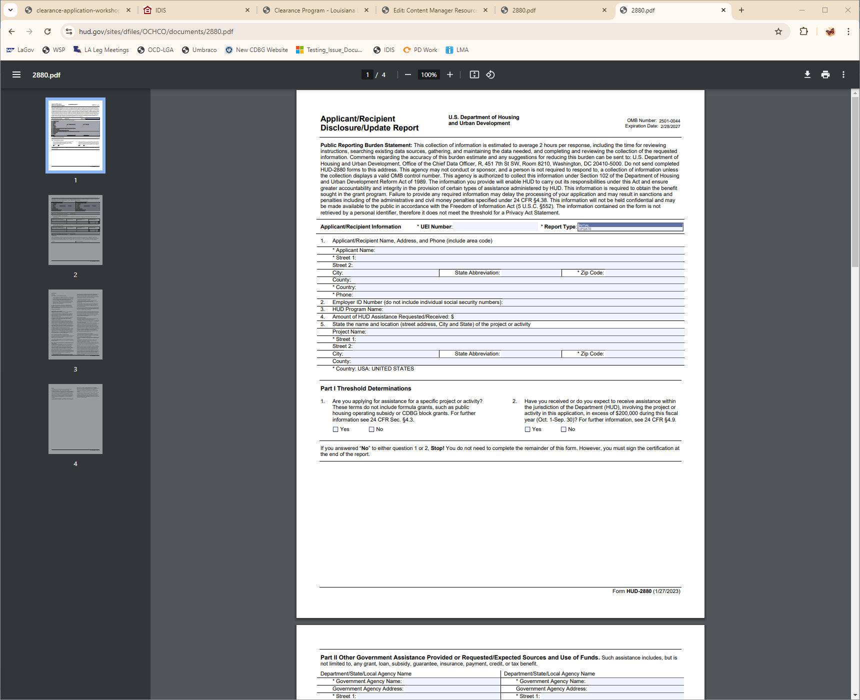

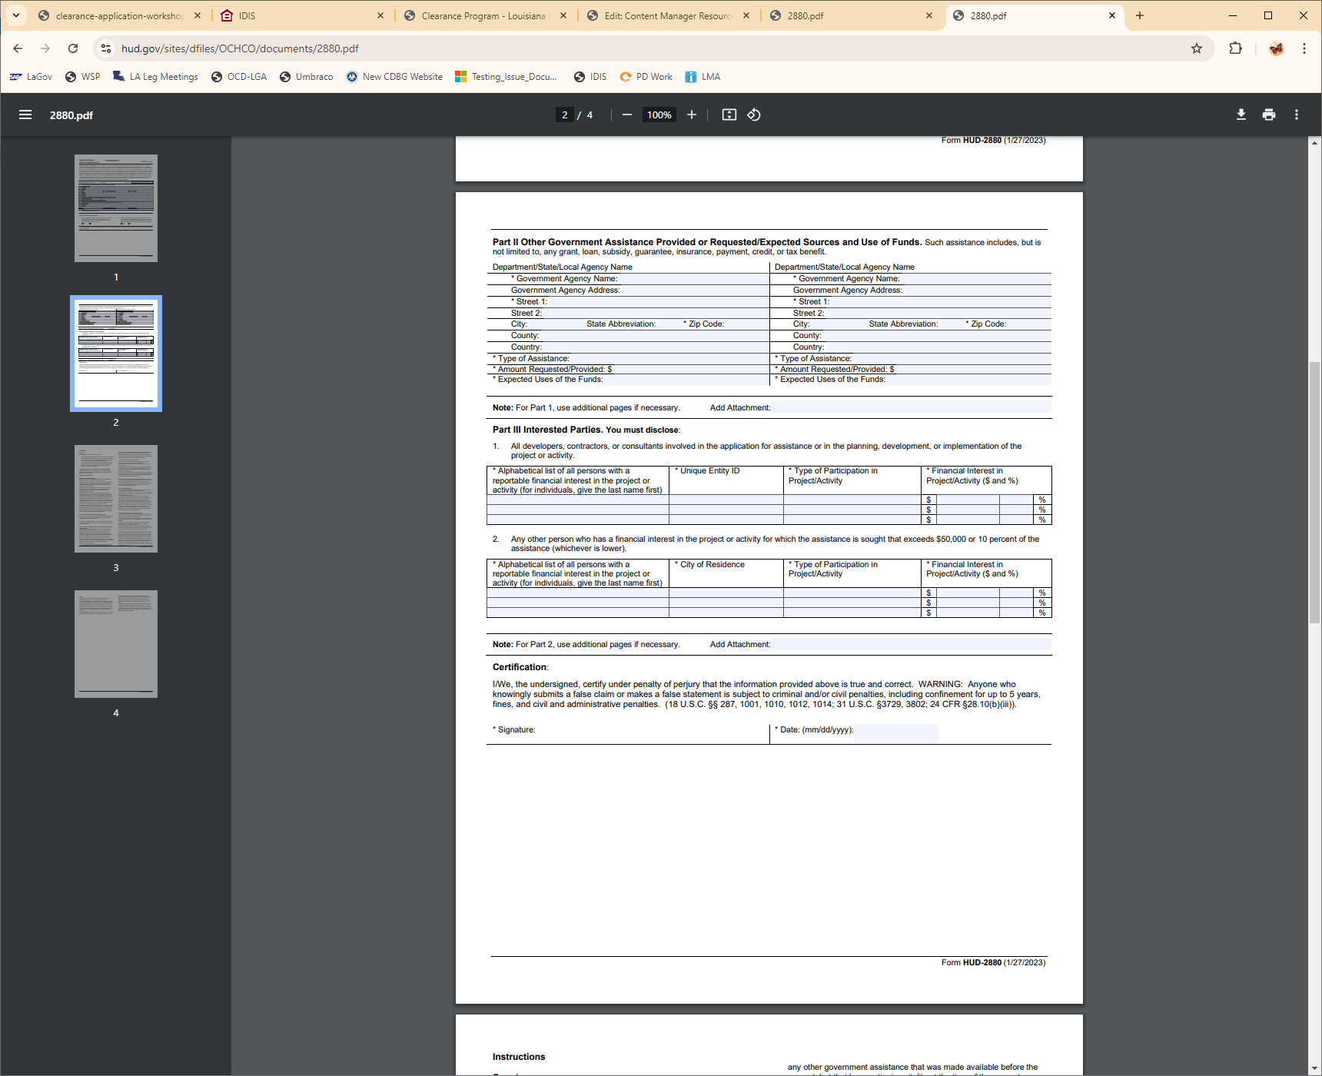

**SECTION G – COST ESTIMATE**

Provide estimated cost details (demolition, permitting, removal, abatement, etc.) of proposed sites, including the basis for determining the costs.

|  |  |  |
| --- | --- | --- |
| **COST FACTORS** | **AMOUNT** | **BASIS OF DETERMINATION** |
| Demolition |  |  |
| Testing |  |  |
| Remediation, if applicable |  |  |
| Administrative Fees |  |  |
| Legal Fees |  |  |
| Other (Identify) |  |  |

**Identify all structures to be demolished. Local/other funds must also be included as well as the use of those funds.**

|  |
| --- |
|  |

**SECTION H – Certifications**

|  |
| --- |
| * **Prior Approval to Demolish**   I certify that our local government has approval to demolish all structures included in this application.  **A resolution adopted by our local government unit stating the structures that have been approved is attached. The structures are also identified on the cost estimate and map and there is completed Inventory form (Section D) for each.**  ________________________________ _________________________  Signature of Chief Elected Official Date |
| * **Legal Services (If Applicable)**   I certify that our local government will pay all of the legal fees that are incurred during the preparation and/or implementation of this program.  **A resolution adopted by our local government unit stating that it will be responsible for all legal fees related to this program is attached.**  ________________________________ _________________________  Signature of Chief Elected Official Date |
| * **Federal Funding Accountability and Transparency Act Reporting**   Please mark whether the following is accurate for your local government:  Did your local government receive both of the following in the most recent completed fiscal year?   1. 80 percent or more of your annual gross revenues in U.S. federal contracts, subcontracts, loans, grants, subgrants, and/or cooperative agreements; and 2. $25,000,000 or more in annual gross revenues from U.S. federal contracts, subcontracts, loans, grants, subgrants, and/or cooperative agreements?   Yes, the above statements are accurate for my local government.  No, the above statements are not accurate for my local government.    Signature of Chief Elected Official Date |

**SECTION I – CITIZEN PARTICIPATION REQUIREMENTS**

A copy of the public notice and **original** proof of publication must be included in the application package.

**SECTION J – BUDGET/COST SUMMARY FORM**

Read instructions prior to completing.

|  |  |  |  |  |  |  |
| --- | --- | --- | --- | --- | --- | --- |
| I. Costs by Activity | | | | | | |
| A. Activity | B. LCDBG | | C. Other | D. Total | | E. Source of Other Funds[1] |
| 1. |  | |  |  | |  |
| 2. Administration |  | |  |  | |  |
| 3. |  | |  |  | |  |
| Total |  | |  |  | |  |
|  | | | | | | |
| II. Line Item Budget – LCDBG Funds Only | | | | | For State Use Only | |
| 1. Demolition | | $ | | | $ | |
| a. Legal Fees | | $ | | | $ | |
| 2. Other | | $ | | | $ | |
| 3. Other | | $ | | | $ | |
| 4. TOTAL AMOUNT REQUESTED | | $ | | | $ | |

|  |  |  |
| --- | --- | --- |
| III. Contract Execution Dates  (only if scheduled to be paid using LCDBG funds and procured prior to implementation) | | |
| **Name of Firm** | **Contract Execution Date** | **Amount of Contract** |
|  |  |  |
|  |  |  |

**Budget Cost Summary Instructions**

SECTION I: COSTS BY ACTIVITY

Column A: List each activity on a separate line. Administration is not eligible for CDBG funds under this program.

Columns B, C, D, & E: For each activity, complete the cost columns. Indicate the LCDBG funds requested in Column B. Combine all other funds being used to accomplish the activity in Column C. Add LCDBG (B) and Other (C) and record the result in Column D Total. In Column E, identify the sources of the funds listed in Column C.

Include all costs related to an activity in the cost columns. For example, include the demolition costs, abatement costs, legal fees, etc.

If other funds are being injected in a clearance project, refer to the Certifications form in Section H and the corresponding instructions.

SECTION II: LINE ITEM BUDGET

Include LCDBG costs only in this budget. In this section, the costs shown in the LCDBG column of Costs by Activity in Section I should be broken down by the type of cost.

SECTION III: CONTRACT EXECUTION DATES

If LCDBG funds will be used for legal costs and the applicant has procured either prior to award and implementation of the grant, enter the name of the firm(s) that the applicant has contracted with, the date the contract between the applicant and the firm was executed, and the dollar amount of the contract. An executed contract must be in place prior to services being performed for the project when using LCDBG funds to pay for these services. The program cannot reimburse the applicant for expenditures that are incurred prior to the existence of an executed contract between the applicant and the firm.

**SECTION K – MAP**

A map indicating the location of concentrations of minorities and concentrations of low- and moderate-income persons, showing number and percent for both groups by jurisdiction, (if minorities and/or low- and moderate-income persons are evenly disbursed throughout the jurisdiction then the applicant must include such a statement on the map). **All proposed structures must be indicated on the map.**

**V. DISPLACEMENT Policy**

In accordance with federal law 42 5304(d) and regulations, the State must require each recipient locality to prepare and implement a residential antidisplacement and relocation assistance plan. That plan must include:

(a) A requirement that all low/moderate income dwelling units that are demolished or converted to a use other than low/moderate income housing as a direct result of the use of LCDBG assistance will be replaced and

(b) A relocation assistance component.

The State will review and determine whether any subgrantee activity will cause temporary or permanent displacement as a result of the operation of its LCDBG program. If the State determines that the demolition of any structure would cause an individual, family, or business to be displaced as a result of any activity, then that structure would be removed from consideration. If removal of a structure causes the application’s cost to be reduced below the $150,000 minimum, that application will not be considered.

LCDBG funds will not be utilized for any relocation or replacement costs under this program. The subgrantee will be responsible for funding the relocation or replacement costs cited on the following page.

**Guide for Residential Antidisplacement and Relocation Assistance Plan under Section 104(d) of the**

**Housing and Community Development Act of 1974, as Amended**

Consistent with the goals and objectives of activities assisted under the Housing and Community Development Act of 1974, the (jurisdiction) will take the following steps to minimize the displacement of persons from their homes.

1. All public facilities projects (water, sewer, gas, et cetera) will be designed so that there will be no displacement of any residences or businesses;

2. No homes will be demolished that can be rehabilitated;

3. There will be no displacement of any residential or business occupants on LCDBG projects.

If displacement does occur, then the following requirements apply:

In the event the activities of this program shall result in displacement of any person(s), the (jurisdiction) shall provide the displaced person(s) as defined by 24 CFR 570.606(b)(2)(i) with relocation assistance at the levels described in, and in accordance with the requirements of 49 CFR part 24. The contact person for antidisplacement in (jurisdiction) is ________________ who can be reached at (address and telephone number).

All replacement housing will be provided within three years of the commencement of the demolition or rehabilitation relating to conversion. Before obligating or expending funds that will directly result in such demolition or conversion, the (jurisdiction) will make public and submit to the State the following information in writing:

1. A description of the proposed assisted activity;

2. The general location on a map and approximate number of dwelling units by size (number of bedrooms) that will be demolished or converted to a use other than as low/moderate income dwelling units as a direct result of the assisted activity;

3. A time schedule for the commencement and completion of the demolition or conversion;

4. The general location on a map and approximate number of dwelling units by size (number of bedrooms) that will be provided as replacement dwelling units;

5. The source of funding and a time schedule for the provision of replacement dwelling units; and

6. The basis for concluding that each replacement dwelling unit will remain a low/moderate income dwelling unit for at least ten years from the date of initial occupancy.

The (jurisdiction) will provide relocation assistance, as described in 570.606(b)(2), to each low/moderate income household displaced by the demolition of housing or by the conversion of a low/moderate income dwelling to another use as a direct result of assisted activities.

1. If other funds are being injected in a clearance project, refer to the Certifications form in Section H and the corresponding instructions.